GraphRAG vs VectorRAG for PDF Question Answering
Final Project Report
Author: Anmol Pipara
Date: August 3, 2026
A controlled comparison of knowledge-graph and vector retrieval over the ISO 20022 Payments Guide (61-page PDF)

Table of Contents
Table of contents will be generated when the document is opened in Word (or right-click > Update Field).

Abstract
This project compares two Retrieval-Augmented Generation (RAG) paradigms — VectorRAG (semantic chunk retrieval with FAISS) and GraphRAG (knowledge-graph retrieval with Neo4j and Cypher) — on the same single-source document: the ISO 20022 Payments Guide 2025 (61 pages, PDF). Both systems were evaluated with a fully controlled harness: identical QA model (openai/gpt-oss-120b via Groq, temperature 0.0), identical prompts, identical evaluator, and the same 12-question validated benchmark.
The GraphRAG system evolved through four isolated, evidence-driven versions: v1 (original page-level evidence), v2 (construction fix restoring full page provenance), v3 (chunk-level evidence selection), and v4 (candidate generation with ranked-keyword matching and deterministic entity ranking). Each experiment changed exactly one component and was gated by offline diagnostics before any benchmark spend.
Results. The final baseline, GraphRAG v4, is the first version to exceed VectorRAG on grounding quality: Context Recall 0.848 vs 0.776, Faithfulness 0.778 vs 0.772, and Hallucination Rate 0.222 vs 0.228 (lower is better). Over the original implementation (v1), v4 improved context recall by +0.464, faithfulness by +0.295, and hallucination rate by −0.295. VectorRAG still leads on answer-level metrics (Answer Accuracy 0.815 vs 0.760, Citation Correctness 0.794 vs 0.769, Context Precision 0.093 vs 0.073).
Conclusion. Retrieval engineering substantially improved GraphRAG's grounding quality and closed the previously dominant evidence-reachability bottleneck. The remaining gap to VectorRAG sits in answer generation and citation precision — not in retrieval — and the project has reached a scientifically defensible stopping point for further in-sample retrieval iterations.

Introduction

Retrieval-Augmented Generation (RAG)
RAG is an architecture that combines a retriever with a generative large language model (LLM). Instead of answering from parametric memory alone, a RAG system first retrieves relevant passages or knowledge-graph facts from an external knowledge source and feeds them to the LLM as context, so the answer is grounded in the retrieved evidence. RAG provides three practical benefits: hallucination control (answers are anchored to real source text), fresh/private knowledge (documents the model has never seen can be queried without retraining), and auditability (every claim can be traced to a source passage or page).

VectorRAG
VectorRAG is the standard semantic-search variant. The document is split into chunks, each chunk is embedded into a high-dimensional vector with a sentence-transformer model, and the chunks are stored in a vector database (FAISS). At query time the question is embedded and the top-k most similar chunks are retrieved by cosine similarity and passed to the LLM. It is simple, robust, and retrieval is broad: it freely retrieves full chunks of related text.

GraphRAG
GraphRAG builds a knowledge graph from the document: an LLM extracts typed entities and relationships, which are deduplicated and loaded into Neo4j. At query time the system matches question entities to graph nodes, generates a Cypher query (with a deterministic fallback), and attaches the source text that the matched entities were extracted from. Retrieval is therefore graph-grounded: evidence is selected through entity identity and provenance rather than raw text similarity.

Motivation
RAG quality is dominated by which evidence reaches the LLM. VectorRAG's advantage is broad coverage; GraphRAG's theoretical advantage is precision and multi-hop reasoning through relationships. The empirical question this project answers is: on a real, single-source PDF, which retrieval paradigm produces more accurate, faithful, and better-cited answers — and can GraphRAG's known weaknesses (evidence reachability) be fixed through isolated engineering?

System Architecture
Both systems share the same source document, extraction layer, QA model, and evaluation harness. The only difference is the retrieval method.
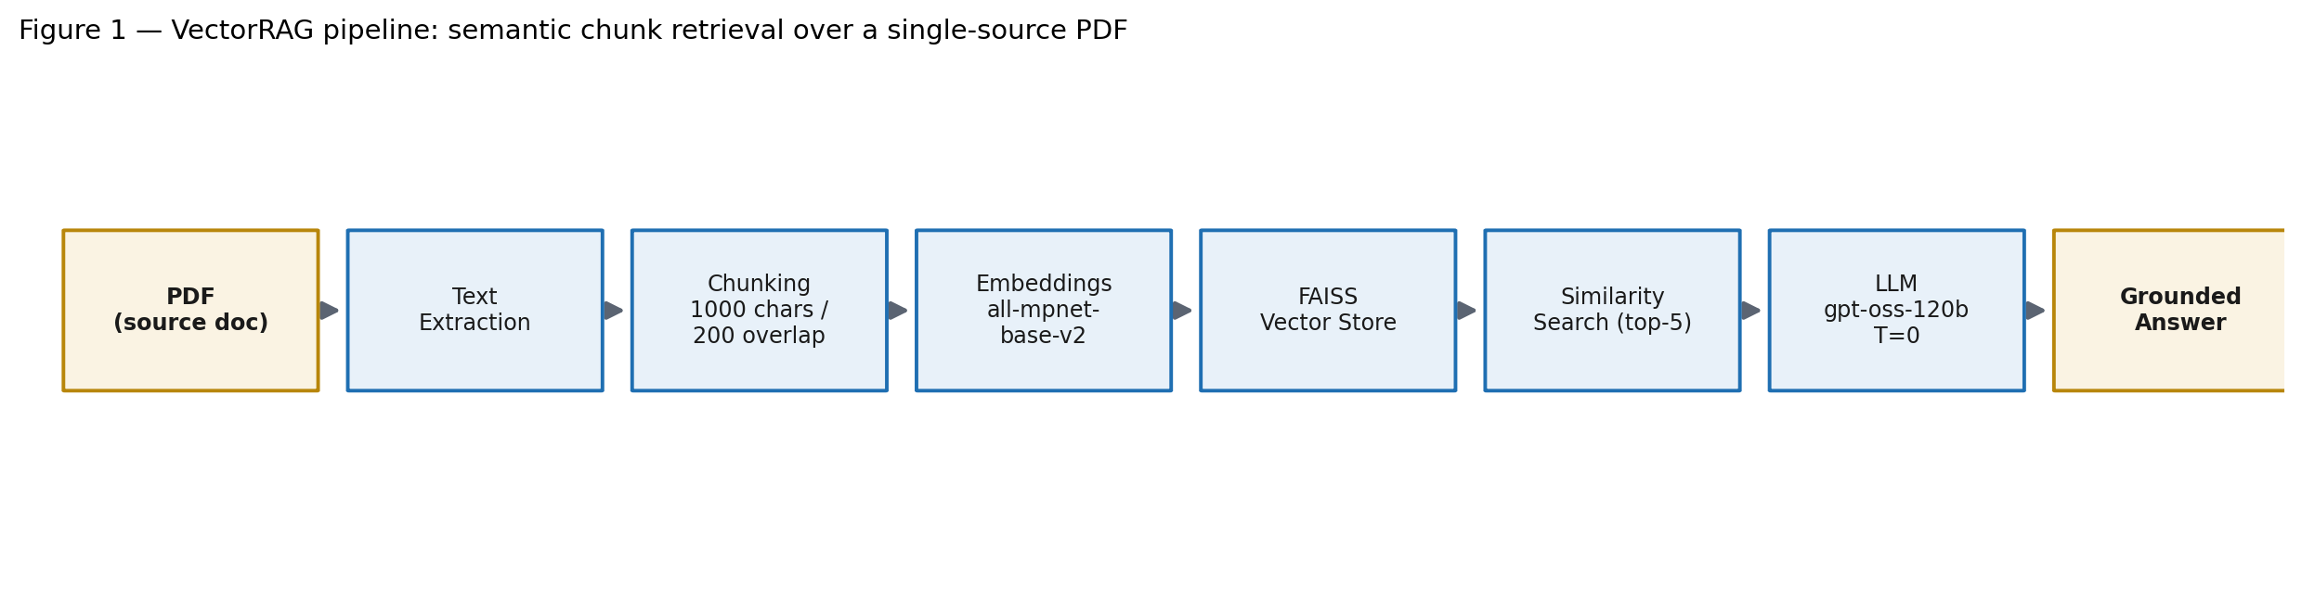
Figure 1 — VectorRAG pipeline. Semantic chunk retrieval over the source PDF.

Stage | Implementation
Extraction | Per-page text with [PAGE N] markers (graph_rag/pdf_extractor.py)
Chunking | Recursive character split, chunk size 1000, overlap 200 (vector_rag/chunker.py)
Embedding | sentence-transformers/all-mpnet-base-v2, cosine normalization
Vector store | FAISS, top-k = 5 (vector_rag/vectorstore.py, retriever.py)
Generation | openai/gpt-oss-120b via Groq, temperature 0.0, same prompt as GraphRAG

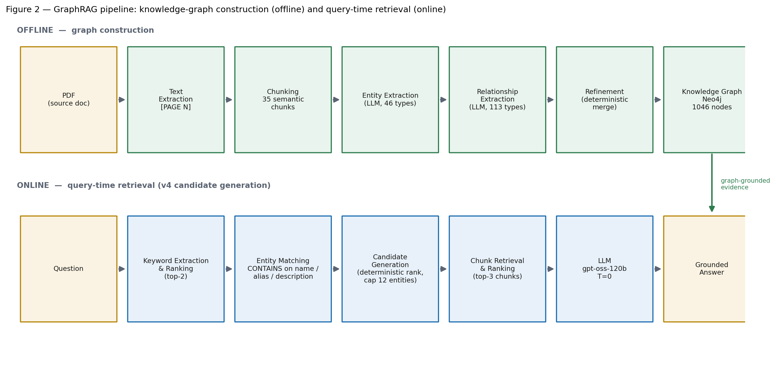
Figure 2 — GraphRAG pipeline. Offline knowledge-graph construction and online, graph-grounded retrieval (v4 candidate generation).

Stage | Implementation
Extraction | Same per-page extractor; 61 pages, 92,672 characters
Chunking | Section-based semantic batches, 3000 chars, 500 overlap → 35 chunks
Entity extraction | LLM per chunk, 46 typed entity schema types, 1,549 raw instances
Relationship extraction | LLM per chunk, 113 typed relation types, 1,038 raw instances
Refinement | Deterministic ID-based merge → 1,046 entities, 931 relationships
Graph store | Neo4j, 1,046 nodes / 878 relationships, schema indexes + constraints
Candidate generation (v4) | Ranked-keyword matching + deterministic entity ranking, cap 12
Chunk retrieval | Lexical chunk ranking, top-3 chunks × 1,200 chars
Generation | openai/gpt-oss-120b via Groq, temperature 0.0, same prompt as VectorRAG

Implementation

Extraction pipeline
graph_rag/pdf_extractor.py renders the PDF page by page; every page's text is delimited with a [PAGE N] marker so character offsets map back to physical pages. The full text (92,672 characters across 61 pages) is persisted at data/extracted_text.json. Page 1 is a near-empty cover (29 characters); every other page carries substantive content.

Graph construction
graph_rag/chunker.py detects document sections and groups them into semantic batches targeting 3,000 characters with 500 overlap, producing 35 chunks covering all 61 pages. Each chunk records a page_start/page_end derived from the section's character offset.
For each chunk, the LLM extracts typed entities (Organization, Person, Standard, XMLMessage, DataElement, IBAN, PaymentScheme, … — 46 schema types) and typed relationships (USES, PART_OF, INITIATES, PROCESSES, REFERENCES, … — 113 schema types). Extractions are cached at data/cache/chunk_0.json … chunk_34.json for resumable, reproducible runs, and merged into data/raw_extractions.json (1,549 raw entity instances, 1,038 raw relationships).
graph_rag/graph_refiner.py merges raw entities into canonical nodes with deterministic, ID-based merging (no LLM in refinement): 1,046 entities and 931 deduplicated relationships. utils/neo4j_loader.py creates the Neo4j schema (indexes + constraints) and bulk-loads the graph: 1,046 nodes, 878 relationships, 290 isolated nodes.

Neo4j schema
The property graph stores typed nodes with name, aliases, description, source_pages, and source_chunks properties; typed, directed relationships connect them. Indexes and constraints are created on node names and IDs to support the keyword (CONTAINS) matching used at query time. The refined artifact is persisted at data/refined_graph.json (v1 baseline) and data/refined_graph_v2_construction.json (post-construction-fix).

Retrieval pipeline (v4 candidate generation)
At query time, graph_rag/retriever.py runs in four stages:
1. Keyword extraction and ranking — _rank_keywords() extracts all meaningful terms from the question: quoted phrases (priority 4), capitalized runs (3), capitalized tokens (2), and lowercase content words (1), after stop-word removal. Terms are scored by priority × 100 + length + rarity × 10 and the top _KEYWORD_CAP (2) are retained.
2. Entity matching — a single Cypher query matches entities by CONTAINS on name, alias, and description using all ranked keywords (no arbitrary truncation, no LIMIT inside the query).
3. Candidate generation — matched entities are ranked deterministically (name_hits → description_hits → frequency → name) and capped at _ENTITY_CAP (12) before their source_chunks are collected. This replaces the earlier fixed LIMIT 6 that allowed database ordering to decide which entities survived.
4. Chunk retrieval and ranking — the union of source_chunks from surviving entities is lexically ranked (_rank_chunks) and the top-3 chunks (× 1,200 characters) form the LLM context, together with the extracted triples.
Answer generation uses the shared QA model with the same prompt template as VectorRAG.

Evolution of the System
The system was improved through isolated ablations — each version changed exactly one component while the QA model, prompts, evaluator, temperature, benchmark, and graph schema stayed fixed.

v1 — Original GraphRAG
• Motivation: establish a baseline GraphRAG with entity-Cypher retrieval and page-level source evidence.
• Change: initial implementation.
• Impact: answer accuracy 0.646, context recall 0.384, faithfulness 0.483 — far behind VectorRAG on recall-driven metrics.

v2 — Construction Fix
• Motivation: an offline root-cause analysis (experiments/root_cause_analysis.md) found the ground-truth page was attached only 16.7% of the time; 38 of 60 benchmark misses traced to wrong `source_pages` linked during construction — not retrieval.
• Change: fixed chunker page-range collapse to page 1 and stamped entities with the full chunk page range (source_pages = list(range(start, end+1))). Rebuilt the graph deterministically from cached extractions (zero LLM calls).
• Impact: pages linked 12/61 → 61/61; nodes pinned to the cover page fell 725 → 84. Benchmark: context recall +0.133, faithfulness +0.167, hallucination −0.167, answer accuracy +0.050.

v3 — Chunk-Level Retrieval
• Motivation: after provenance was fixed, retrieval was still page-limited — the retriever attached only the first 2 pages per entity and 3 paragraphs (~500 chars), so the correct evidence was reachable but under-used.
• Change: switched evidence selection from page-level to chunk-level: all source_chunks of matched entities are collected, lexically ranked, and the top-3 chunks (× 1,200 chars) form the context.
• Impact: context recall +0.160, faithfulness +0.090, hallucination −0.090. The graph-quality ablation (entity dedup/rewiring) was evaluated at this stage and rejected and rolled back — its answer accuracy (0.575) regressed below v2 because it addressed construction quality, not the diagnosed retrieval bottleneck.

v4 — Candidate Generation (Official Baseline)
• Motivation: a per-question diagnostic on v3 showed the ground-truth chunk was absent from the candidate set on 5/12 questions — unreachable evidence can never be ranked. Two implementation causes: the LIMIT 6 entity cap truncated correctly matched entities before their source_chunks were collected, and only the first two extracted keywords were used for matching.
• Change (candidate generation only): (A) removed the fixed LIMIT 6, replacing it with deterministic entity ranking (name_hits → desc_hits → frequency → name) capped at 12 entities; (B) replaced keywords[:2] with ranked keyword selection (_rank_keywords, top-2 by informativeness after stop-word removal). An initial (8,30) configuration was rejected after the offline gate showed candidate-set explosion (mean 25/35); the (2,12) configuration keeps all recall gains with bounded breadth (mean 14.1/35).
• Offline gate (before any benchmark spend): reachable GT chunks 6 → 10/12, attached 5 → 9/12, GT pages 5 → 9/12, evidence recall 0.629 → 0.944.
• Impact: context recall +0.172 (to 0.848), answer accuracy +0.075 (to 0.760), citation correctness +0.057, hallucination −0.038.
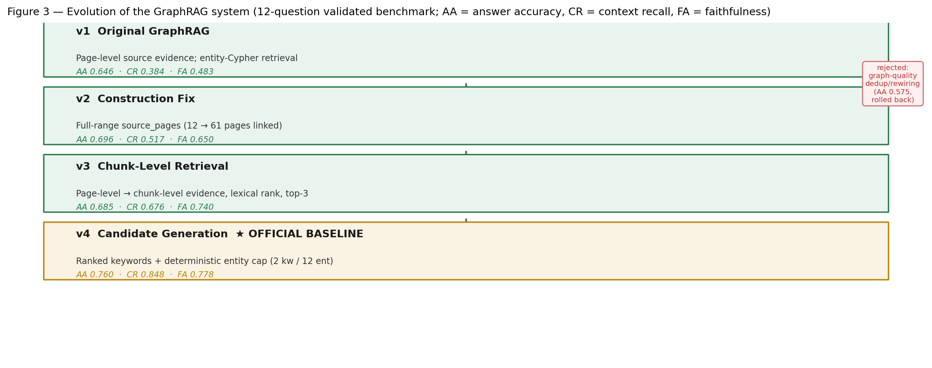
Figure 3 — Evolution of GraphRAG (12-question validated benchmark). AA = answer accuracy, CR = context recall, FA = faithfulness.

Experimental Setup

Component | Configuration
QA model | openai/gpt-oss-120b via Groq
Cypher model | openai/gpt-oss-120b via Groq
Temperature | 0.0
Embedding model | sentence-transformers/all-mpnet-base-v2
Vector store | FAISS, top-k = 5
Graph database | Neo4j (1,046 nodes, 878 relationships)
Benchmark | experiments/benchmark_v2.json — 12 validated questions, 5 categories (fact_lookup, relationship, hierarchical, workflow, comparison)
Evaluator | evaluation/evaluator_v2.py + metrics_v2.py (heuristic, no LLM calls in metrics)
Fairness guard | Hard config guard requires the same QA/Cypher model, provider, prompts, temperature, and benchmark for both systems

Every ground-truth answer was audited against the source PDF before use (questions with unsupported ground truths were repaired or replaced). All metrics are deterministic and cheap; no LLM is used inside the metric computation.

Evaluation metrics

Metric | Meaning
Answer Accuracy | Correctness of the final answer against ground truth
F1 | Token-level overlap between predicted and ground-truth answer
Context Recall | Fraction of ground-truth tokens found in the retrieved context
Context Precision | Fraction of retrieved context that is relevant
Faithfulness | Fraction of the answer supported by the retrieved context
Citation Correctness | Fraction of page citations that match the retrieved evidence
Hallucination Rate | 1 − faithfulness (lower is better)
Multi-hop Success | Success on questions requiring multiple reasoning hops

Evaluation
All figures below are the final recorded metrics from the retained summary artifacts (evaluation/benchmark_v2_summary.json, benchmark_v2_graph_construction_summary.json, experiments/checkpoints/v3_retrieval_baseline/benchmark_v2_graph_retrieval_summary.json, evaluation/benchmark_v2_graph_candidategen_summary.json). No results were re-computed.

Master comparison (12-question validated benchmark)

Metric | VectorRAG | v1 | v2 | v3 | v4 (baseline)
Context Recall | 0.7757 | 0.3840 | 0.5166 | 0.6761 | 0.8483
Faithfulness | 0.7722 | 0.4830 | 0.6504 | 0.7400 | 0.7783
Hallucination Rate ↓ | 0.2278 | 0.5170 | 0.3496 | 0.2600 | 0.2217
Citation Correctness | 0.7937 | 0.5646 | 0.6732 | 0.7127 | 0.7692
Answer Accuracy | 0.8151 | 0.6462 | 0.6960 | 0.6853 | 0.7600
Multi-hop Success | 0.8151 | 0.6462 | 0.6960 | 0.6853 | 0.7600
Context Precision | 0.0928 | 0.0258 | 0.0648 | 0.0670 | 0.0729
F1 Score | 0.1978 | 0.2536 | 0.2331 | 0.1922 | 0.2041
Exact Match | 0.0 | 0.0 | 0.0 | 0.0 | 0.0

↓ = lower is better. Exact Match is not discriminative on this benchmark (no exact string matches for either system).

Improvement from the previous version (v4 vs v3) and over the original baseline (v4 vs v1)

Metric | Δ v4−v3 | Δ v4−v1 | v4 − VectorRAG
Context Recall | +0.1722 | +0.4643 | +0.0726
Faithfulness | +0.0383 | +0.2953 | +0.0061
Hallucination Rate ↓ | −0.0383 | −0.2953 | −0.0061
Citation Correctness | +0.0565 | +0.2046 | −0.0245
Answer Accuracy | +0.0747 | +0.1138 | −0.0551
Multi-hop Success | +0.0747 | +0.1138 | −0.0551
Context Precision | +0.0059 | +0.0471 | −0.0199
F1 Score | +0.0119 | −0.0495 | +0.0063

Positive deltas in the last column mean GraphRAG v4 now exceeds VectorRAG. Grounding metrics (context recall, faithfulness, hallucination) are the first to cross VectorRAG's level.

Step-wise progress across versions

Metric | v2−v1 | v3−v2 | v4−v3
Context Recall | +0.1326 | +0.1595 | +0.1722
Faithfulness | +0.1674 | +0.0896 | +0.0383
Hallucination Rate ↓ | −0.1674 | −0.0896 | −0.0383
Citation Correctness | +0.1086 | +0.0395 | +0.0565
Answer Accuracy | +0.0498 | −0.0107 | +0.0747
Context Precision | +0.0390 | +0.0022 | +0.0059
F1 Score | −0.0205 | −0.0409 | +0.0119

Offline gate diagnostics (v3 → v4, computed before the benchmark)

Diagnostic | v3 | v4 | Δ
Reachable GT chunks | 6/12 | 10/12 | +4
GT chunks attached | 5/12 | 9/12 | +4
GT pages attached | 5/12 | 9/12 | +4
Evidence recall | 0.629 | 0.944 | +0.315
Mean candidate-set size | 8.9 | 14.1 | +5.2 (bounded ≤ 17.5)

Per-category answer accuracy (recorded v1 vs VectorRAG)

Category | GraphRAG v1 | VectorRAG
fact_lookup | 0.917 | 0.917
relationship | 0.647 | 0.824
hierarchical | 0.429 | 0.429
workflow | 0.603 | 0.823
comparison | 0.000 | 0.750

Category cells hold 1–5 questions each; small-sample variance is high.

Honest caveats (n = 12)
• The v4 answer-accuracy gain (+0.075) is driven largely by a single question (Q53) flipping from a refusal to a direct correct answer; Q8 still fails despite now-perfect evidence — an answer-generation issue, unchanged by retrieval.
• Two questions (Q48, Q34) remain unfixed; Q48 is a keyword-selection failure (the ranked top-2 never emit a term matching the correct entity).
• The candidate-generation knobs (_KEYWORD_CAP=2, _ENTITY_CAP=12) were tuned on the same 12 benchmark questions — a known overfitting risk that only an out-of-sample validation set can bound.

Discussion

Where GraphRAG improved
The decisive gains are in grounding quality, exactly where the diagnosed bottleneck lay. Fixing construction provenance (v2) and then chunk-level evidence reachability (v3, v4) moved context recall from 0.384 → 0.848 (+0.464 over the original) and faithfulness from 0.483 → 0.778, while hallucination fell from 0.517 → 0.222. GraphRAG v4 is the first version whose retrieved evidence is more complete than VectorRAG's (context recall 0.848 vs 0.776) with slightly better faithfulness and hallucination control. The offline gate was essential: it exposed that a naive limit/truncation increase (8,30) "improved" recall only by degenerating into near-full-corpus retrieval, and forced a bounded configuration where the gain is real.

Where VectorRAG still performs better
VectorRAG retains the lead on answer-level metrics: Answer Accuracy (0.815 vs 0.760), Citation Correctness (0.794 vs 0.769), and Context Precision (0.093 vs 0.073). VectorRAG's freely retrieved, full-paragraph chunks give the LLM more complete support and its page citations reconcile better with the page-level ground truth. Context precision is lower for GraphRAG because its candidate set is broader and the lexical top-3 chunk picker can rank the correct chunk below more superficially similar text.

Bottlenecks discovered
1. Evidence reachability (fixed). Unreachable evidence cannot be ranked: the LIMIT-6 truncation and the two-keyword heuristic removed the correct chunks before ranking. Deterministic ranking before truncation closed this.
2. Answer generation (open). Q8 receives near-perfect evidence yet still produces a wrong answer or refusal — evidence is necessary but not sufficient.
3. Citation precision (open). Chunk-level citations do not fully reconcile with page-level ground truth.
4. Keyword coverage (partially open). Q48 shows the ranked top-2 keywords can still miss the decisive entity.

Engineering lessons
• Provenance first: a graph is only as good as its source linkage; no retriever can attach evidence the graph does not point to.
• Isolated ablations: changing one component at a time is what made each gain attributable (construction vs retrieval vs candidate generation).
• Gate before you spend: offline diagnostics (reachability, attachment, candidate-set size) prevented a confounded benchmark from being interpreted as an improvement.
• Small-sample discipline: on 12 questions, per-question inspection beats aggregate deltas; single-question effects (Q53) must be reported as such.

Conclusion
• GraphRAG improved significantly over the original implementation — every accepted version moved a recorded metric, and v4 is the first to exceed VectorRAG on context recall, faithfulness, and hallucination control.
• Retrieval engineering substantially improved grounding quality — the combination of a construction fix, chunk-level evidence, and deterministic candidate generation raised evidence recall from 0.629 to 0.944 and context recall from 0.384 to 0.848.
• VectorRAG still performs better on some answer-level metrics — answer accuracy, citation correctness, and context precision remain in VectorRAG's favor.
• Remaining limitations are mainly answer generation and citation precision — the evidence is now reliably retrieved; converting it into uniformly correct, correctly cited answers is the open problem.
GraphRAG v4 (Candidate Generation) is the official baseline of this project, and the evidence supports adopting it and stopping further in-sample retrieval engineering.

Future Work
• Larger benchmark. 12 validated questions (5 per category) give small cells; a 40–60 question set would tighten every comparison.
• Held-out validation. The v4 knobs were tuned on the benchmark questions; an out-of-sample set is the highest-value, lowest-cost next check.
• Improved QA generation. Address refusal and incorrect-answer patterns (e.g., Q8) that persist even with perfect evidence — prompt design or a stronger generator.
• Citation formatting. Align chunk-level citations with page-level ground truth to close the citation-correctness gap.
• Richer graph construction. Alias/fuzzy entity matching (to close Q48-type failures), entity enrichment, and better isolated-node handling.
• Hybrid retrieval. Vector reranking of graph-linked chunks could combine GraphRAG's grounding with VectorRAG's context precision.

References
Papers
1. Lewis, P., et al. (2020). Retrieval-Augmented Generation for Knowledge-Intensive NLP Tasks. NeurIPS 2020.
2. Edge, D., Trinh, H., Cheng, N., et al. (2024). From Local to Global: A Graph RAG Approach to Query-Focused Summarization. arXiv:2404.16130.
3. Reimers, N., & Gurevych, I. (2019). Sentence-BERT: Sentence Embeddings using Siamese BERT-Networks. EMNLP 2019.
4. Johnson, J., Douze, M., & Jégou, H. (2017). Billion-scale similarity search with GPUs (FAISS). IEEE Transactions on Big Data.
5. Es, S., James, J., Espinosa-Anke, L., & Schockaert, S. (2023). RAGAS: Automated Evaluation of Retrieval Augmented Generation. arXiv:2309.15217.
Libraries and frameworks
1. PyMuPDF (fitz) — PDF text extraction.
2. LangChain — RAG chains and GraphCypherQAChain.
3. sentence-transformers (all-mpnet-base-v2) — embeddings.
4. FAISS — vector search.
5. Neo4j — property-graph storage and Cypher retrieval.
6. Groq / OpenAI (gpt-oss-120b) — QA and Cypher generation.
7. Hugging Face Transformers — model hosting.
8. Streamlit — interactive comparison UI.
9. Matplotlib — result plots and architecture diagrams.
10. Pydantic — configuration management.
11. OpenRouter — LLM routing for the extraction models (nousresearch/hermes-3-llama-3.1-405b for text, qwen/qwen2.5-vl-72b-instruct for vision) used to build the knowledge graph.
12. Google Generative AI (Gemini 1.5 Flash) — generator LLM of the original VectorRAG stack.
13. RAGAS — metric framework that inspired the deterministic metrics_v2.py evaluator used in the final harness.

