# **2.4 Guided Exercise: Preventing IP Spoofing**

|  |  |
| --- | --- |
| **Resources** | |
| Files | None |
| Machines | Ubuntu Server |

In this exercise you will need to configure the Ubuntu Server to avoid IP Spoofing.

Login to Ubuntu Server and once logged in run the command “sudo gedit /etc/host.conf”. Sudo will ask the user password and enter “Pa$$w0rd”. The host configuration file will open. The host.conf configuration file contains configuration information specific to the resolver library

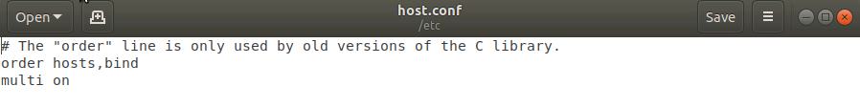

Make the changes shown in the screenshot below which you will simply change the word multi to nospoof.

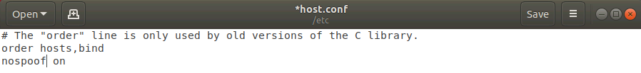

By adding the value nospoof on the resolver library, it will attempt to prevent hostname spoofing for enhanced security.

After making the changes press SAVE to to save the changes and then close the file.