# **3.6 Guided Exercise: Configuring Windows Firewall**

|  |  |
| --- | --- |
| **Resources** | |
| Files | None |
| Machines | Windows 10, Windows Server 2012 |

In this exercise, you are required to configure the firewall on the Windows machines.

Login to Windows 10 and enable the Firewall.

Click on the Start button and then write on the search box Firewall.

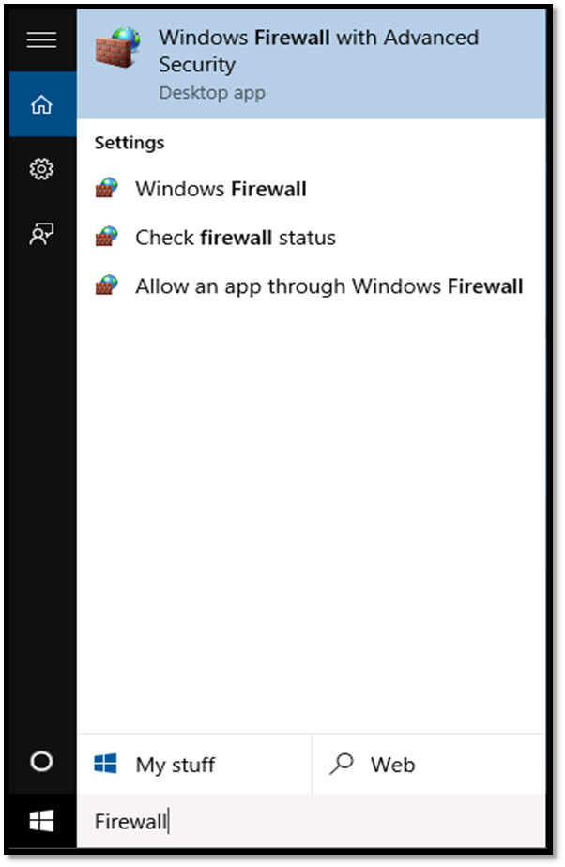

The select the Windows Firewall. Once the Windows Firewall window opens click on “**Turn Windows Firewall on or off”.**

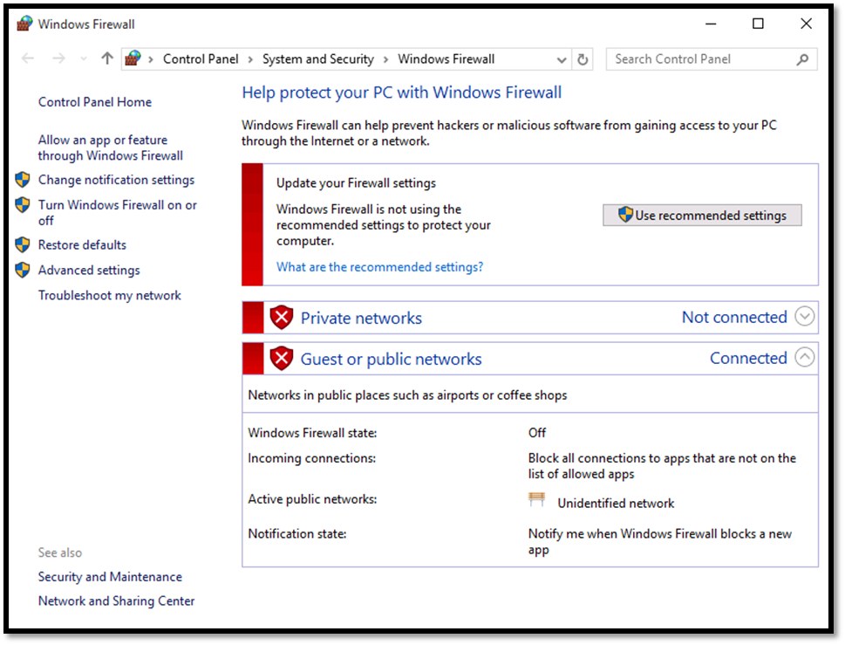

On the Customize Settings window of Firewall select both radio buttons “**Turn on Windows Firewall”** for Private and Public network settings and then click OK.

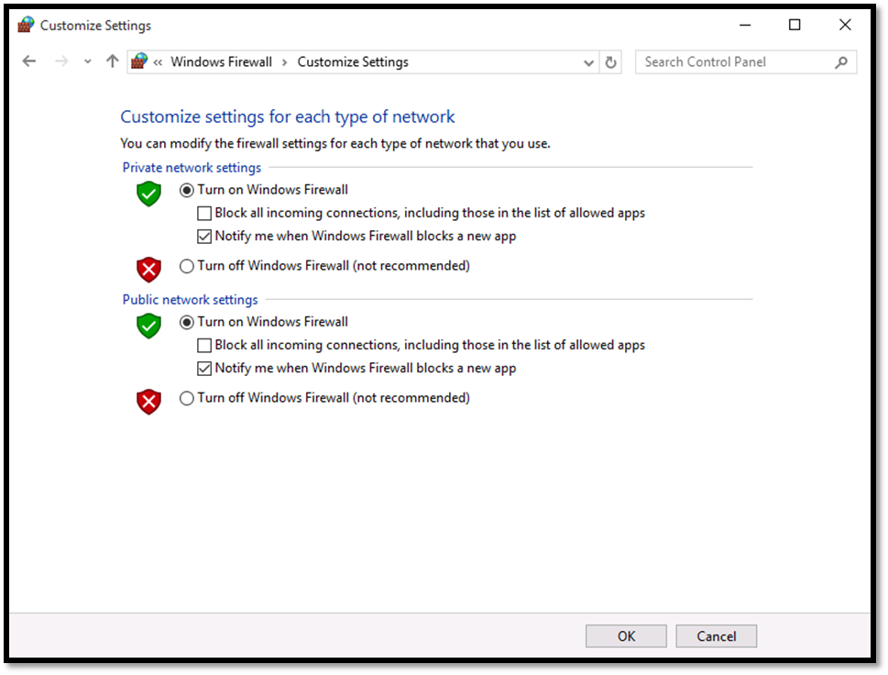

Login to Windows Server and enable the Firewall.

Click on the Start button and write Firewall.

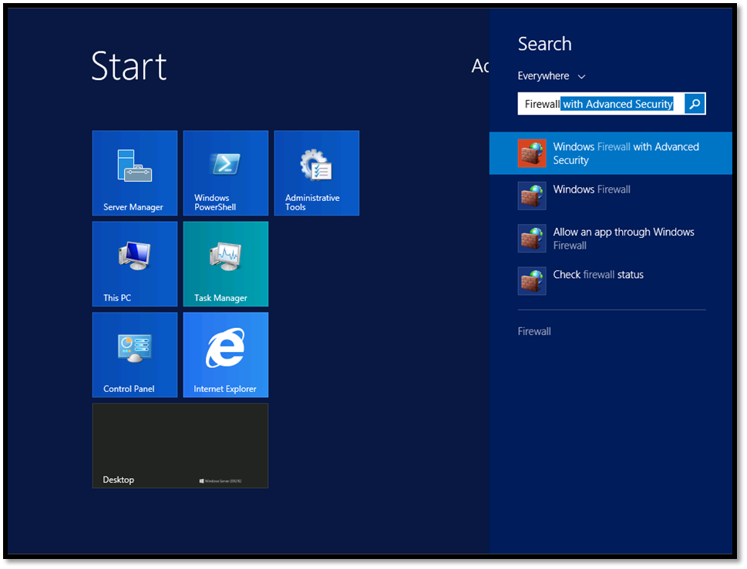

Click on Windows Firewall and the Windows Firewall window will be revealed.

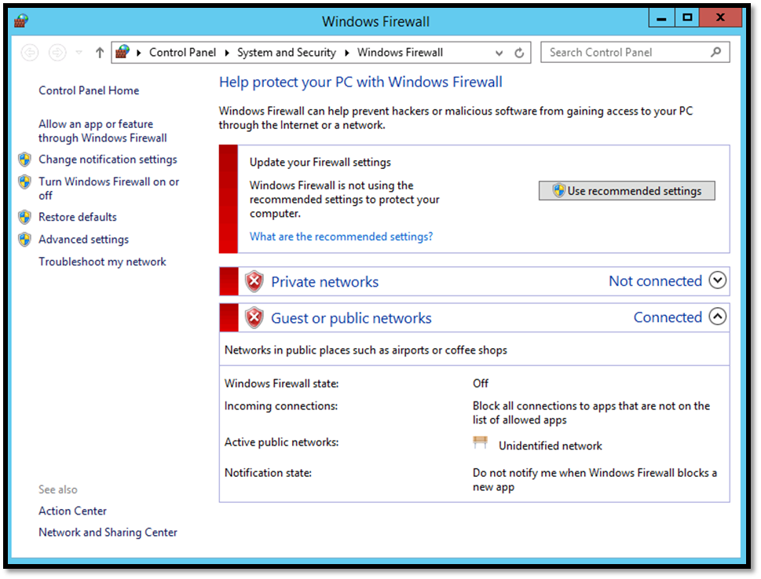

From the Windows Firewall window click on “**Turn Windows Firewall on or off”**and the Customize Settings window will be shown.

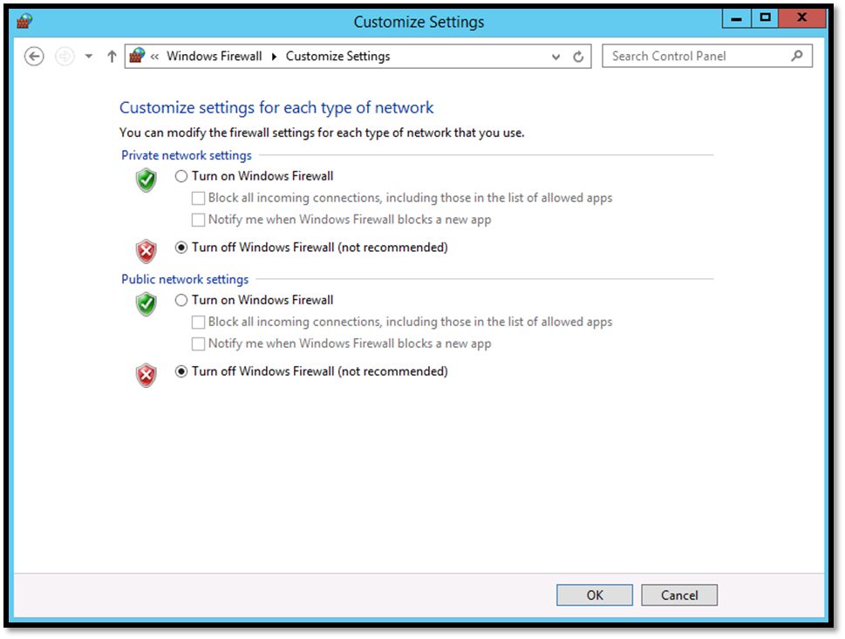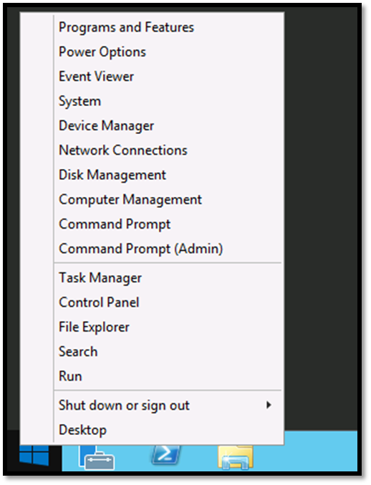  
On the Customize Settings window of Firewall select both radio buttons “**Turn on Windows Firewall”** for Private and Public network settings and then click OK.

Right click on the Windows Server Start button and select Command Prompt (Admin).

On the command prompt run the command ping 192.168.1.10.

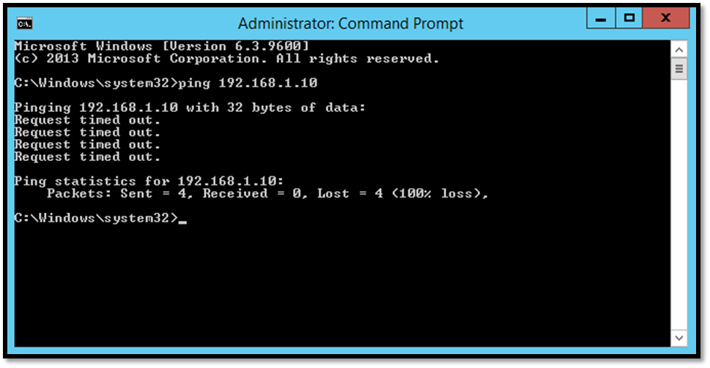

Because we have enabled the firewall, it blocks ICMP packets.

In Windows 10 Firewall enable the Inbound rule titled “File and Printer Sharing (Echo Request – ICMPv4-In)”

Click on the Start button and then write on the search box Firewall.

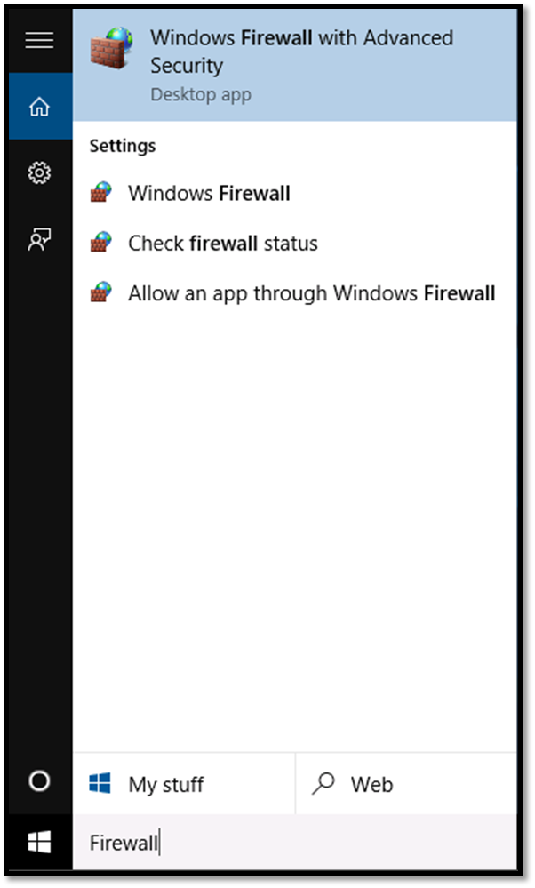

From  the Windows Firewall  window click on Advanced Settings  and the Windows Firewall with Advanced Security will open.

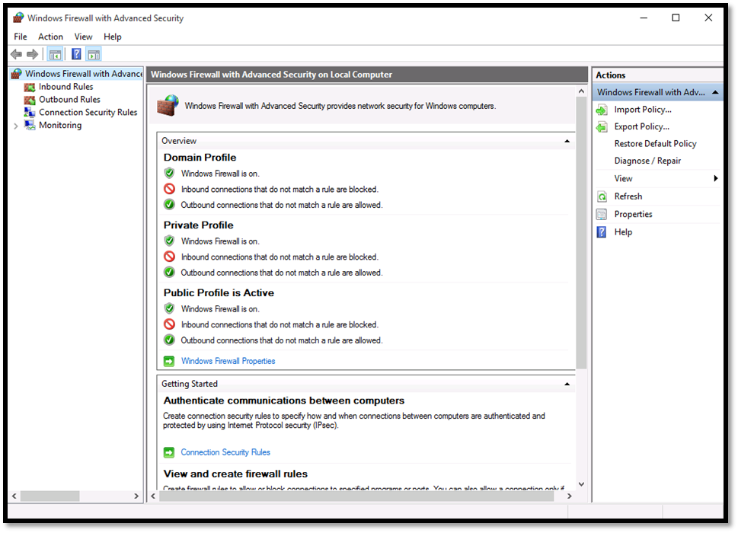

Click on Inbound Rules and enable the rules File and Print Sharing (Echo Request – ICMPv4-In) for both profiles Private and Domain. Enable them by right clicking on each rule and select Enable Rule.

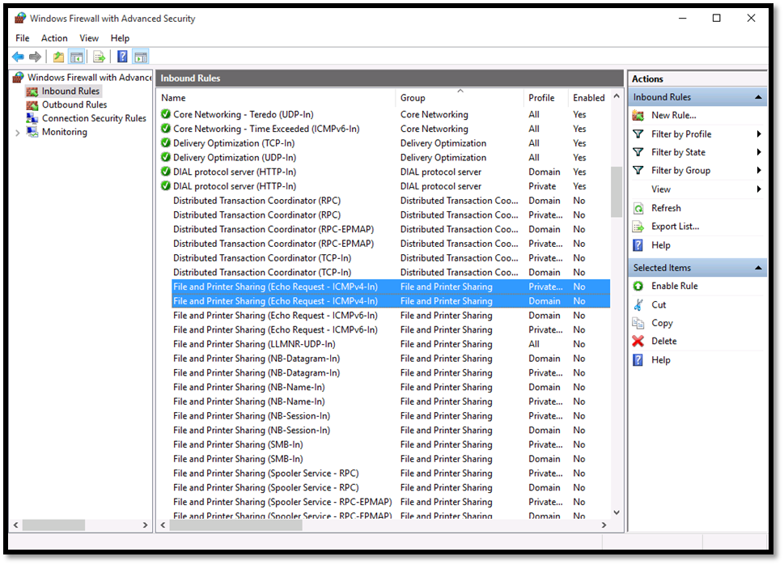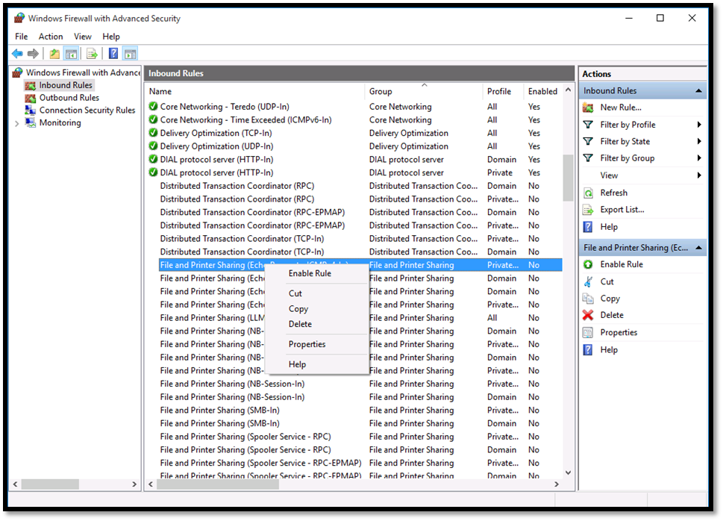

In Windows Server enable the Inbound rule titled “File and Printer Sharing (Echo Request – ICMPv4-In)”.

Click on the Start button and write Firewall.

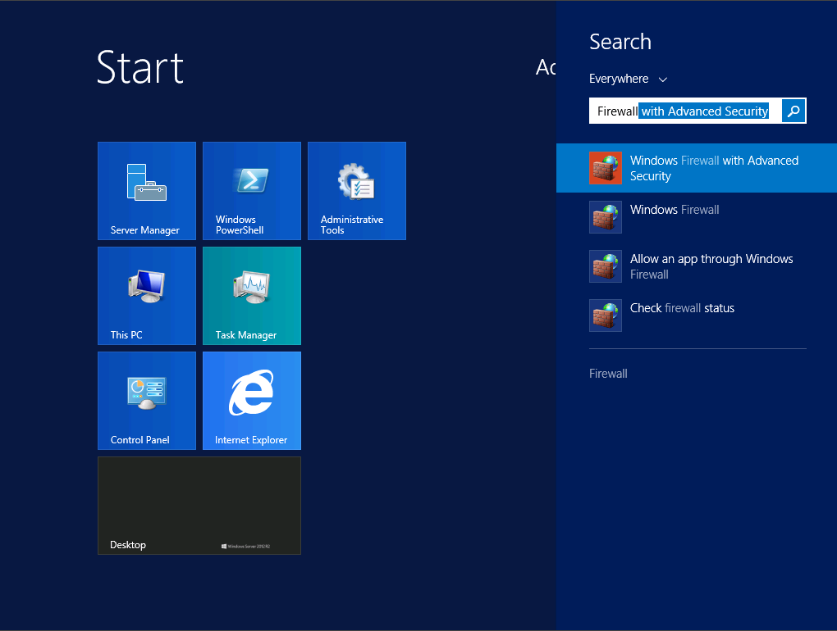  
Click on Windows Firewall and the Windows Firewall window will be revealed.

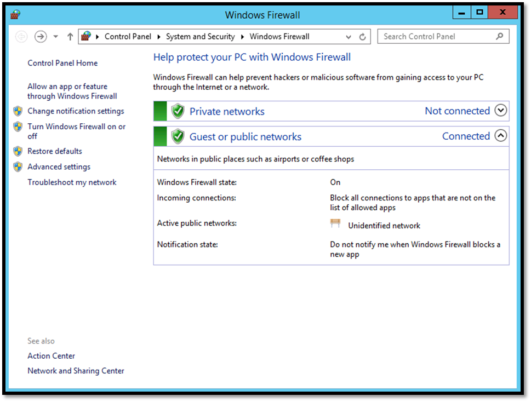

Click on the Advanced Settings and the Windows Firewall with Advanced Security window will open.

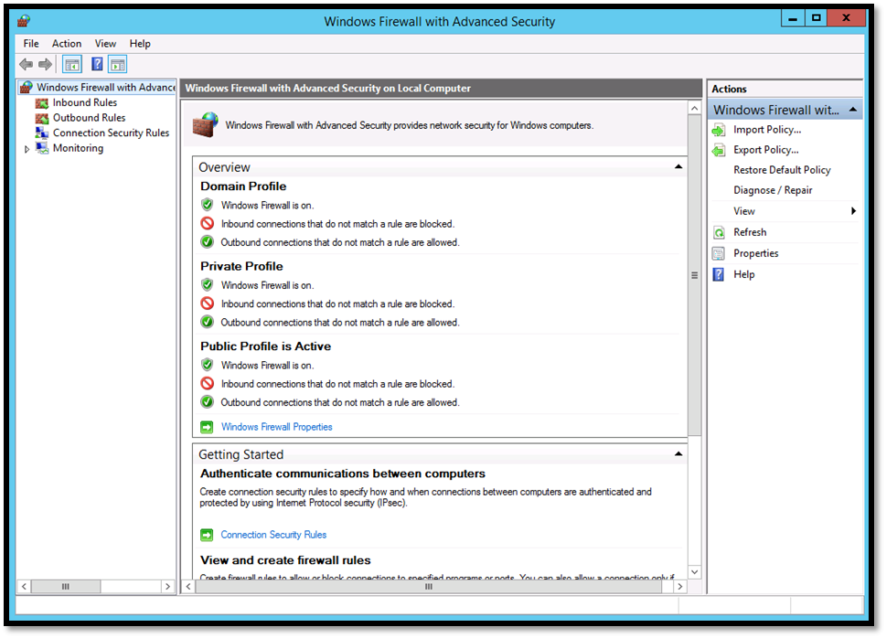

Click on Inbound Rules, select the rule “File and Printer Sharing (Echo Request – ICMPv4-In)” and enable it.

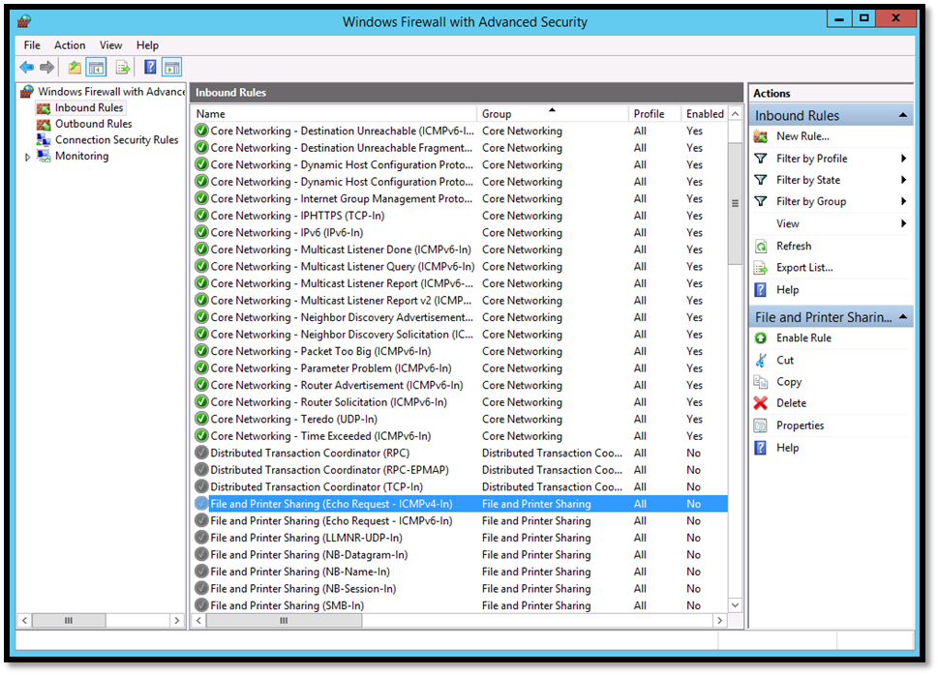

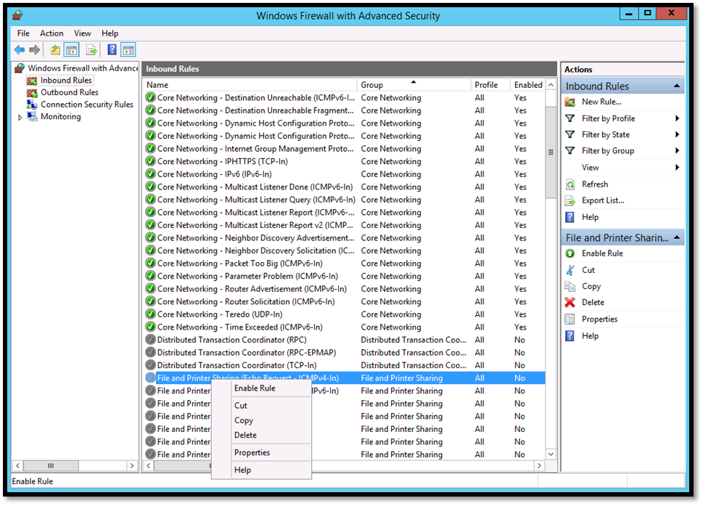

In Windows 10 use the ping command to ping Windows Server (192.168.1.20)

Right click on the Start button and click on “Command Prompt (Admin)”  and then Yes on the pop up window.

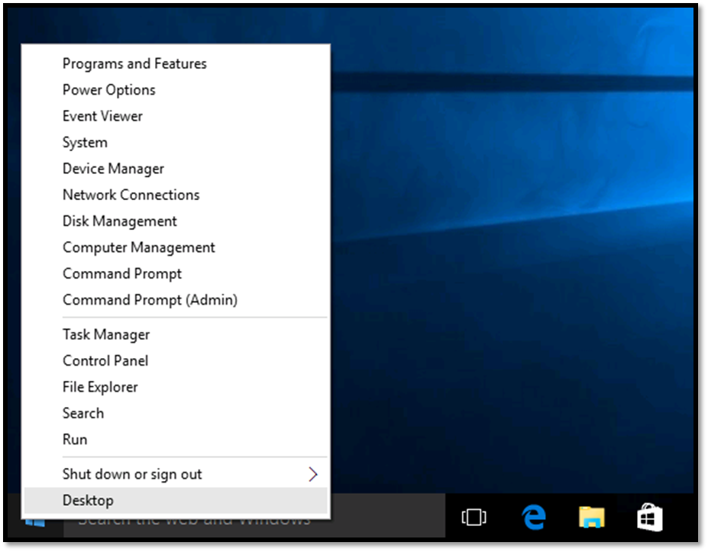

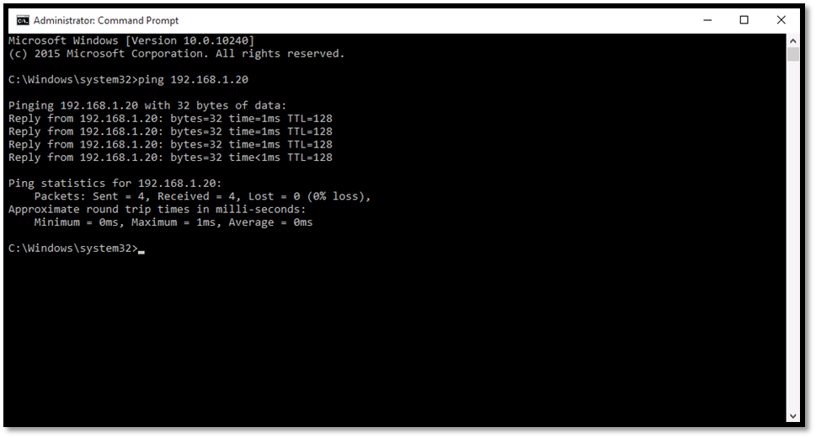

The server replies to the ICMP pings because we have enabled the rule on the Firewall.