**flight-fare-Prediction**

This Project uses ML, python and flask to predict flight fare.

**Problem Statement**

Travelling through flights has become an integral part of today’s lifestyle as more and more people are opting for faster travelling options. The flight ticket prices increase or decrease every now and then depending on various factors like timing of the flights, destination, and duration of flights various occasions such as vacations or festive season. Therefore, having some basic idea of the flight fares before planning the trip will surely help many people save money and time.

**Goal**

The main goal is to predict the fares of the flights based on different factors available in the provided dataset.

**Approach**

The classical machine learning tasks like Data Exploration, Data Cleaning, Feature Engineering, Model Building and Model Testing. Try out different machine learning algorithms that’s best fit for the above case.

**Dataset**

Dataset:<https://www.kaggle.com/nikhilmittal/flight-fare-prediction-mh>

**Project Various Step**

**Data Exploration**

I started exploring datasets using pandas, NumPy,matplotlib and seaborn.

**Data visualization**

Ploted colleration matrix to get insights about dependend and independed variables. Made chats like( Bocxplot,countplot,distplot,pairplot).

**Model Selection**

During this project many Models were build however I selected RandomForest Regressor because of best result.

**Hyperparameter Optimization**

Using Randomizedsearch CV and GridSearch CV to select the best parameter for training the model

**Model Dump**

As per selected trained model is dumped to pickled format for app development.

**Demo**

Link: https://flight-fare-predict-009.herokuapp.com/predict

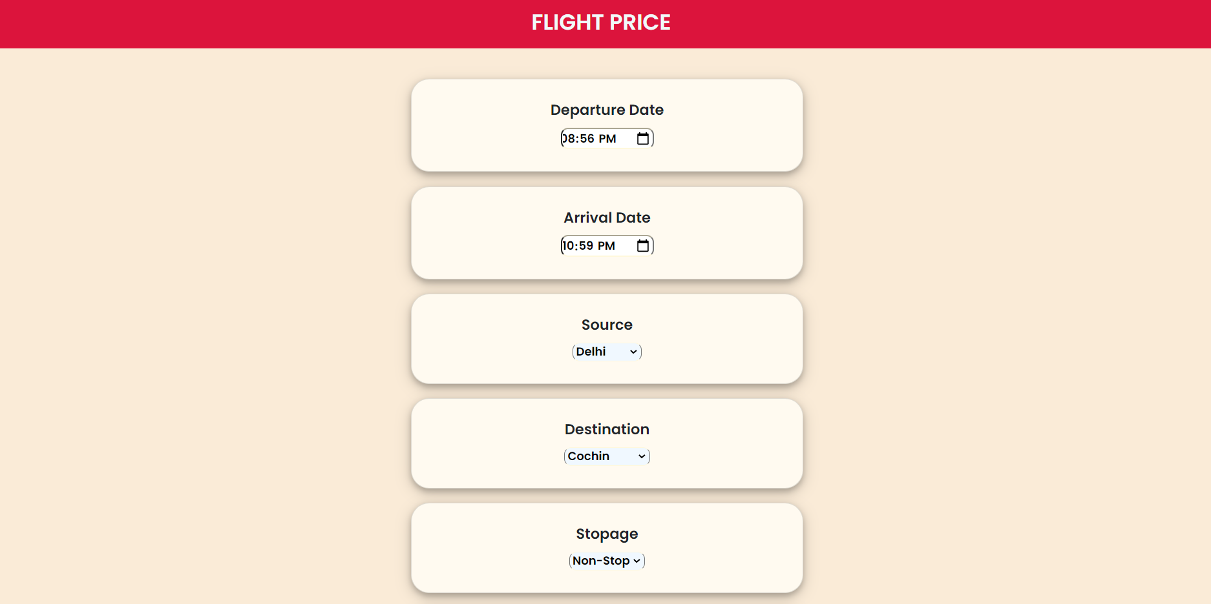

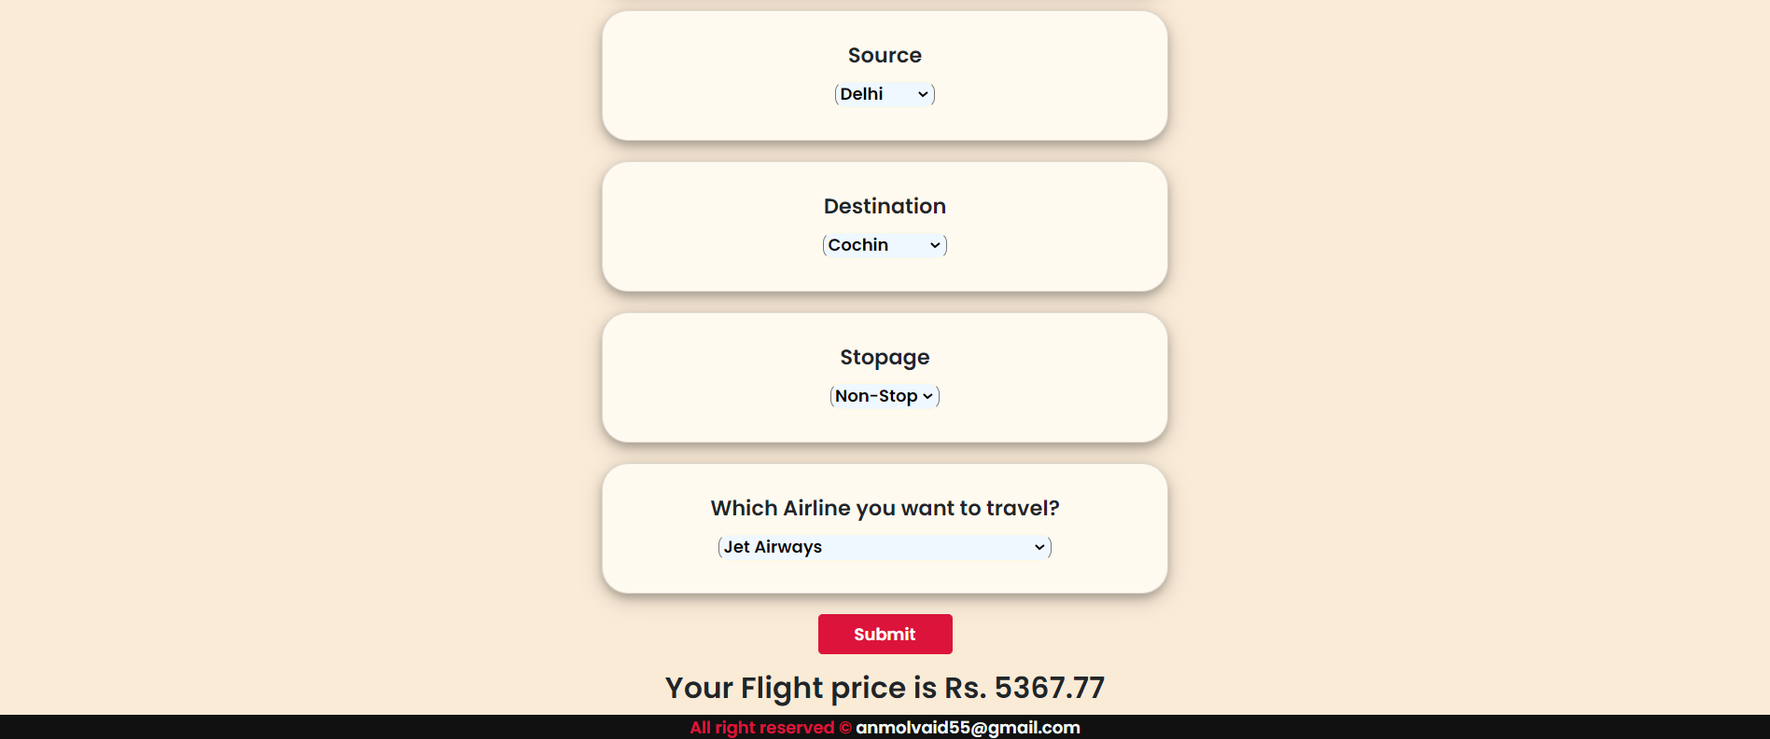

**Motivation**

What to do when you are at home due to this pandemic situation? I started to learn Machine Learning model to get most out of it. I came to know mathematics behind all supervised models. Finally it is important to work on application (real world application) to actually make a difference.

**Installation**

The Code is written in Python 3.6.10. If you don't have Python installed you can find it here. If you are using a lower version of Python you can upgrade using the pip package, ensuring you have the latest version of pip. To install the required packages and libraries, run this command in the project directory after cloning the repository.

**Deployement on Heroku**

Login or signup in order to create virtual app. You can either connect your github profile or download ctl to manually deploy this project.

[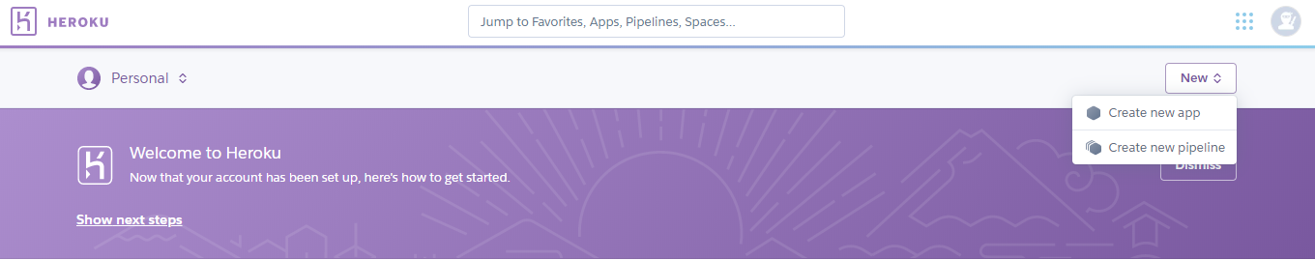](https://user-images.githubusercontent.com/79400466/147852160-0b9befad-bdf5-49da-bbac-372396832d09.png)

Our next step would be to follow the instruction given on Heroku Documentation to deploy a web app.

**Technologies Used**

[](https://user-images.githubusercontent.com/79400466/147852214-b2eff13b-914e-43eb-84ad-f3492cc69229.png)

**Future Scope**

* Use multiple Algorithms
* Optimize Flask app.py
* Front-End