Wireframe

FLIGHT FARE ESTIMATOR

|  |  |
| --- | --- |
| **Written By** | **Anmol Vaid** |
| **Document Version** | **1.0** |
| **Last Revised Data** | **11-Dec-2021** |

Document Version Control:

|  |  |  |  |
| --- | --- | --- | --- |
| **Version** | **Date** | **Author** | **Comments** |
| 1.0 | 11-Dec-2021 | Anmol Vaid |  |
|  |  |  |  |

Contents

1. Web Portal 3

1.1 Departure Date 3

1.2 Arrival Date 3

1.3 Source 3

1.4 Destination 3

1.5 Stopage 3

1.6 Which Airline you want to travel 3

# Web Portal

Below is web portal.

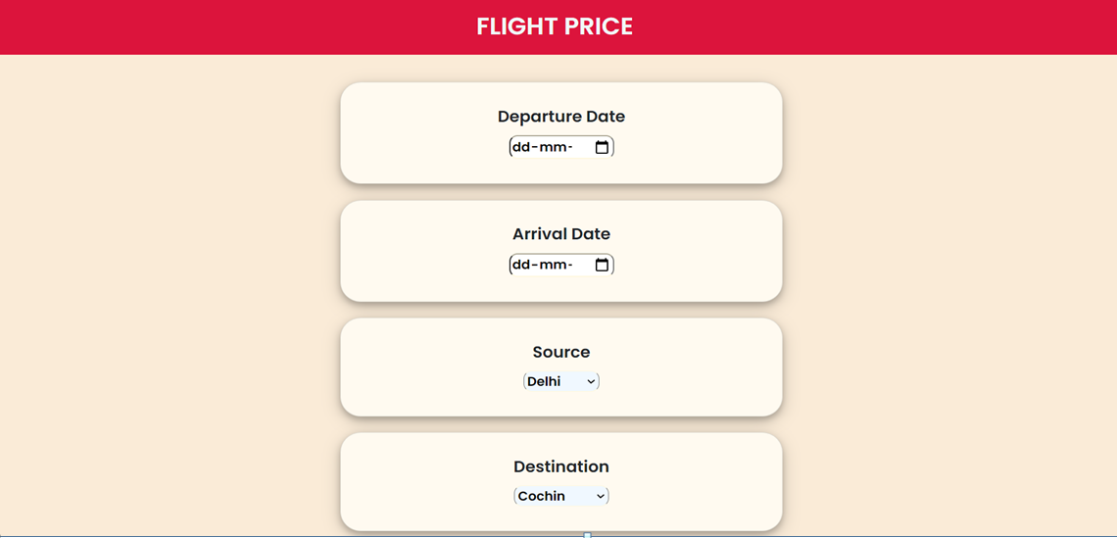

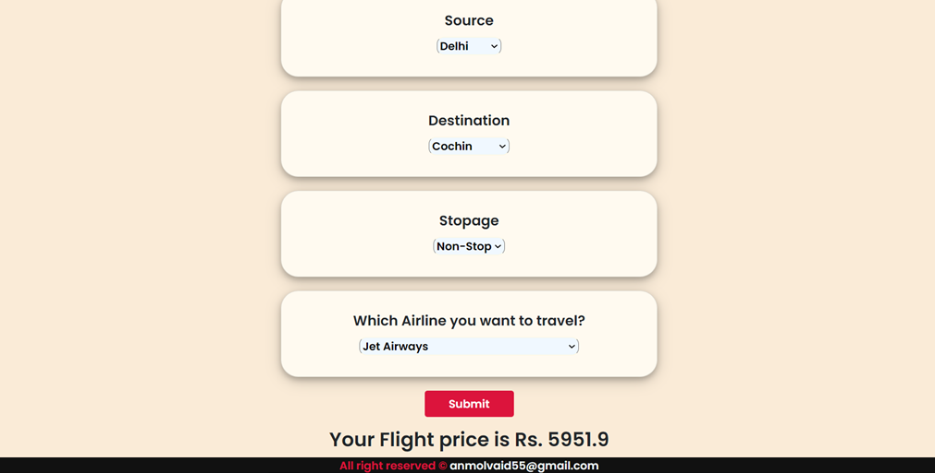

## Departure Date

User need to select date of departure date and time in format dd-mm-yyyy

## Arrival Date

User need to select date of arrival date and time in format dd-mm-yyyy.

## Source

Here user needs place from where flight will be on-boarded.

## Destination

Here user needs place from where flight will be de-boarded.

## Stopage

Here user needs to select number of stops.

## Which Airline you want to travel

Below are options user can select to travel:

* Air_India
* Multiple_carriers
* SpiceJet
* Vistara
* GoAir
* Multiple_carriers_Premium_economy
* Jet_Airways_Business
* Vistara_Premium_economy
* Trujet