**Sustain-Web: Website Carbon Emission Estimator**

**FEASIBILITY STUDY REPORT**

***Submitted by:***

Anmol Virdi (19103017)

Nandini Jaryal (19103070)

***Under the guidance of:***

Dr. Geeta Sikka

CSE Department, NIT Jalandhar

***A report submitted for the partial fulfillment of the course:***

MAJOR PROJECT



**COMPUTER SCIENCE AND ENGINEERING DEPARTMENT**

**DR. B.R. AMBEDKAR NATIONAL INSTITUTE OF TECHNOLOGY, JALANDHAR**

**(144011)**

**ACADEMIC YEAR: 2022-2023**

# TABLE OF CONTENTS

**TABLE OF CONTENTS** **2**

**DOCUMENTATION HISTORY** **3**

**GROUP MEMBERS’ DETAILS** **3**

**TITLE OF THE PROJECT** **4**

**ABSTRACT** **4**

**KEYWORDS** **4**

**DESCRIPTION** **4**

**PREVIOUS WORK** **6**

**PROJECT SCOPE AND CONTRIBUTION** **6**

**TECHNICAL FEASIBILITY** **6**

**RISK ANALYSIS** **7**

**WORK PLAN / SCHEDULE** **7**

**SUGGESTED DELIVERABLES** **7**

**REFERENCE** **7**

# DOCUMENTATION HISTORY

|  |  |  |
| --- | --- | --- |
| **Sr. No.** | **Revision history** | **Date** |
| 1. | First | 01.11.2022 |
|  |  |  |

# GROUP MEMBERS’ DETAILS

|  |  |  |  |  |
| --- | --- | --- | --- | --- |
| **Sr. No.** | **Roll No.** | **Name** | **Branch** | **Contact** |
| 1. | 19103017 | Anmol Virdi | B-Tech. (CSE) | anmolv.cs.19@nitj.ac.in |
| 2. | 19103070 | Nandini Jaryal | B-Tech. (CSE) | nandinij.cs.19@nitj.ac.in |

# TITLE OF THE PROJECT

The title Sustain-Web simply means Sustainable Web Design. As the name suggests, this application is meant to promote sustainable web design and instruct developers to take care of their code and make it environment-friendly.

# ABSTRACT

Websites today come with a whole host of bells and whistles, from garish animations to autoplay video. If you hate those features, you’re right to: not only are they annoying – they are also bad for the planet.

According to online carbon calculator Website Carbon, the average website produces 1.76g of CO2 for every page view; so a site with 100,000 page views per month emits 2,112kg of CO2 every year.

The more complex a website is, the more energy it requires to load – and the greater its climate impact. Scale that up to the whole internet and you’ve got a big problem.

Awareness about internet pollution is growing, in part thanks to a breed of eco-minded companies designing websites in line with carbon minimisation principles. “Until quite recently, the environmental impact of the internet wasn’t something that people really thought about,” says Vineeta Greenwood, account director at design agency Wholegrain Digital. “However, we are in a state of climate emergency, and creating a sustainable internet is just one action that we can and must take.”

This application serves the purpose

# KEYWORDS

Carbon footprint, Web Development, Selenium, Python, Sustainable Web Design, Carbon emissions, Carbon emissions, Global Warming, Page transfer size.

# DESCRIPTION

“Sustain-Web” is a web app that calculates the environmental impact of a web page and displays the breakdown and measures that can be taken to improve it.

Sustain-Web tests 115 best practices from the reference book published by Eyrolles, with contributions by more than 34 business experts. It also considers the underlying subsea cable factors.

The factors being considered in the carbon emission estimation process includes page transfer size and location of data center and underlying subsea cable length. Not only does this app display the estimated carbon footprint but also suggests ways to developers to reduce these emissions associated with their website.

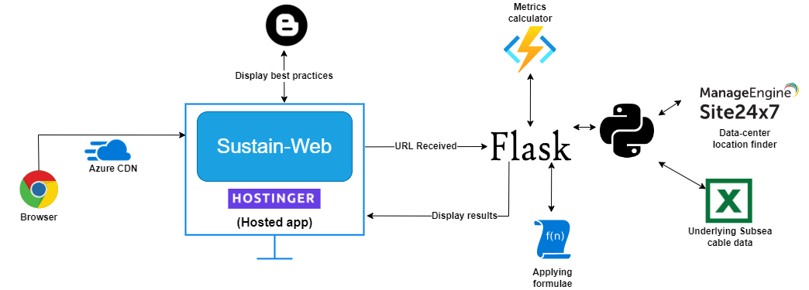

This free app connects developers with sustainable web designing fundamentals. Clients can directly submit their website’s URL and hit the analyze button. This triggers a backend program which first calculates all the factors and then applies appropriate formulae to calculate the appx carbon emissions associated with the website.

The factors include stuff like number of empty tags, wrong tags, number of script files linked, number of style sheets linked, API Calls, empty image tags, etc. Then it tries to find the data center of the website. If found, it checks if the underlying subsea cable length data is present. If present, it calculates the carbon emission due to underlying subsea cable as well. This gives more accurate prediction for carbon footprint of that website.

Not just this, this app guides developers regarding how they can reduce these factors. After the results are displayed, it suggests clients to remove the tags/factors, etc. This web application will also have a blog section where it will mention all the best practices which promote sustainable web design.

Altogether, the purpose of this app is to reduce carbon emissions associated with websites by altering website contents to improve data center life.

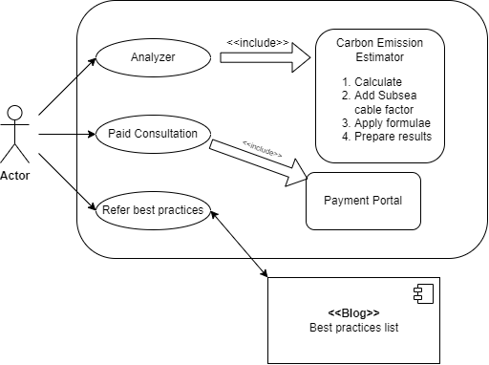

# PREVIOUS WORK

There are many applications serving the purpose that led us to make this project.

Some of the common ones are:

1. <https://digitalbeacon.co/>
2. <https://theshiftproject.org/en/carbonalyser-browser-extension/>
3. <https://chrome.google.com/webstore/detail/websitefootprint/jlpnojjijmliogpegigbllcnpckflnik?hl=en>
4. <http://www.ecometer.org/>
5. <https://pengyilabs.com/co2-calculator/>
6. <https://www.wholegraindigital.com/blog/granola-2/>
7. <https://www.thegreenwebfoundation.org/green-web-check/>
8. <https://www.carbonfootprint.com/>
9. <https://app.electricitymap.org/zone/CD>

However, no app is considering the underlying sea cable factor as well as factors like non-universal fonts, etc.

# PROJECT SCOPE AND CONTRIBUTION

The target audience for this project is the Developers as well as people who have their businesses online. This app guides developers regarding how they can reduce carbon footprint of their website. This web application will also have a blog section where it will mention all the best practices which promote sustainable web design.

# TECHNICAL FEASIBILITY

This project requires flask backend as well as Selenium to fetch data center location. The rest of the tech stack (HTML, CSS, Python, BeautifulSoap) are relatively easiter to implement. Normal usage of selenium is feasible. But this project requires it to be used in the background, i.e., no-sandbox mode. This is possible with the use of python-chromedriver container. Hence, knowledge of these technologies needs to be acquired to build this project.

# RISK ANALYSIS

Every project, major or minor, is prone to risks. One of the risks that we may encounter is that learning about some new technology required (Microservices, UI testing in no-sandbox mode) or about some concept related to some other technology might take some time, hence causing unnecessary delay. In order to tackle such risk, we would divide the project in different applications and hence, it would ensure that other functionality is available and is unaffected by the requirement of new knowledge by one application.

Another problem could be inconsistency in team work due to any unavoidable circumstances or improper communication that could cause delay in completion.

# WORK PLAN / SCHEDULE

As it is our very first project work, we need to learn different technologies to be used in this project. Our work plan is to start making the front end of the web app and side by side learning the required technologies. We have decided to complete our project in phases, so that with every new phase we will introduce a new feature that requires some new technology. Thus, we can learn the technology required for a particular feature and then implement it, so in case we face any kind of problem with the new feature, it will not affect our previous work. Our main focus would be towards the completion of the project in the given time with all the desired/proposed features.

# SUGGESTED DELIVERABLES

After the completion of the project, the following items are expected to be delivered:

* A web application along with its source code kept in a public GitHub Repository.
* Issues Report (If faced)

# REFERENCE

* <https://github.com/cloud-carbon-footprint/cloud-carbon-footprint>
* <https://github.com/thegreenwebfoundation/cloud-carbon-footprint>
* <https://theshiftproject.org/en/carbonalyser-browser-extension/>