Name:-Anmol Gupta

UID:-19BEC1102

Branch:-ECE2-A

Aim:-Design a dice that displays a a. Red background when 6 comes up b. Green background when 4 comes up c. Blue background when 2 comes up.

Circuit Diagram::--

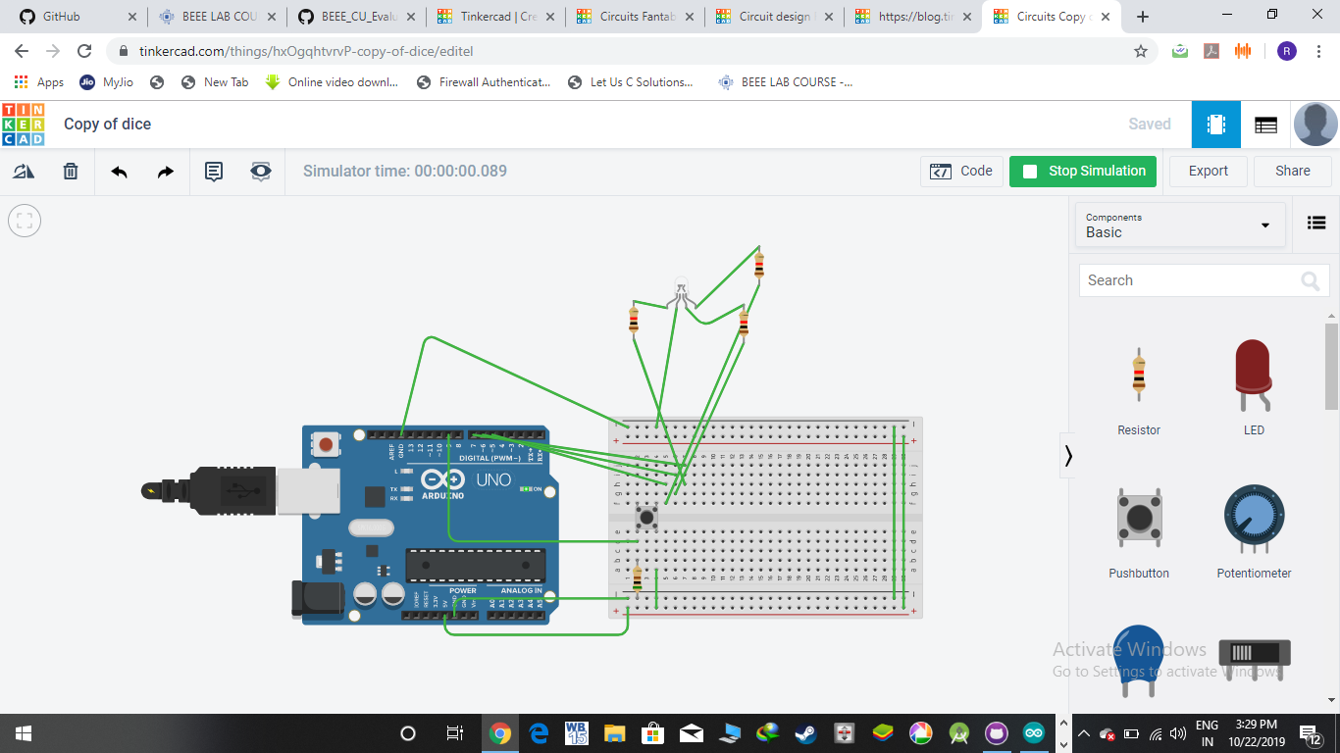

***CODE***

***int button = 0;***

***int x =0;***

***void setup()***

***{***

***pinMode(3, OUTPUT);***

***pinMode(4, OUTPUT);***

***pinMode(5, OUTPUT);***

***pinMode(9, INPUT);***

***}***

***void loop()***

***{***

***button = digitalRead(button);***

***if(button == HIGH)***

***{***

***x=x+2;***

***}***

***if(x==2)***

***{***

***digitalWrite(4 , HIGH);***

***delay(500);***

***}***

***if(x==4)***

***{***

***digitalWrite(5 , HIGH);***

***delay(500);***

***}***

***if(x==6)***

***{***

***digitalWrite(3 , HIGH);***

***delay(500);***

***}***

***}***

***Precautions***

***1. Connections Need to be proper***

***2. Codes and syntax need to be correct***

***THEORY***

***Learning And Observations***

***We learn from this program that the blinking of LEDs at the press of a switch and decide the colour according to the number and observe that the colour blue turns on for the 1st button pressed , which denotes that the dice shows 2 , colour green for 2nd button presss for number on dice 4 , colour red for 3rd button press for number on dice 6 .***

***Concept Used***

***RGB led is triigered by pressing buttons according to outcomes and the looping program gives better working .***

***Circuit Simulation Tool - TinkerCAD***