**Association of nursing workload and staff sickness absenteeism**

Table of Contents

INTRODUCTION 3

CHAPTER ONE 5

1.1 The problem 5

1.2 Motivation of the study 6

1.3 Literature review 6

1.4 Research questions and hypothesis development 14

CHAPTER TWO 15

2.1 Material and Methods and study design 15

2.2 Participants 15

2.3 Variables 16

2.4 Statistical methods and Quantitative variables 18

CHAPTER 3 20

Results 20

Descriptive statistics of the defined Variables 20

Hypothesis 1 24

Hypothesis 2 28

Hypothesis 3 31

Chapter 4 36

Discussion and Findings 36

Hypothesis 1: Influence of Workload on Sick Days 36

Hypothesis 2: Shift vs. Non-shift Duty 37

Hypothesis 3: Departmental Differences in Sick Days 37

Overall Findings: 37

Discussion: 38

Chapter 5 39

Conclusion and Recommendations 39

Recommendations: 39

Conclusion: 40

# INTRODUCTION

A delicate ecosystem exists within the healthcare sector. Its functionality is centered on ensuring the health of both patients and caregivers, particularly nurses. Nurses, who are regarded as the backbone of the healthcare industry, frequently shoulder the brunt of heavy workloads, which is made worse in hospitals with specialized care, like pediatric centers, where the demands of care are complex and intensive. This is demonstrated by Al Jalila Children's Specialty Hospital (AJCH), which will house all pediatric services provided by the Dubai Healthcare Authority beginning in 2020. Concerns about the consequences of these increasing workloads are warranted given the consequent surge in demand on its nursing staff.

These heightened demands have a wide range of effects. First off, AJCH serves as a cautionary tale about the link between heavy nursing workloads and deteriorating health among healthcare professionals in light of the marked increase in staff sickness rates, particularly among nurses. The increased workload could theoretically lead to chronic fatigue, stress, and mental burnout. Without the proper interventions, these factors could eventually result in physical illness and even long-term health issues.

Moreover, the effects of these workloads have a cyclical nature. The workload on the remaining nurses increases as more nurses call in sick, increasing their vulnerability to burnout and health problems. This cyclical strain has an effect on patient care in addition to endangering the health of the nursing staff. Nurses may not be able to give pediatric patients the best care because of their heavy workload and potential health problems. The rate of patient recovery, patient satisfaction, and public confidence in the healthcare system can all be impacted by this domino effect.

The infrastructure of the healthcare system may also be put under stress by this cycle. Increased hiring or reliance on temporary workers may result from higher staff sickness rates, both of which can be expensive. Furthermore, a team that is stable and well-established might be able to offer more consistent care than staff that is constantly changing or new. This problem requires multiple approaches to solve it. The nursing staff needs regular health examinations, counseling, and mental health support. In order to lessen the negative effects of heavy workloads, shift flexibility, manageable work hours, and regular rest breaks can be implemented. In order to balance workloads and guarantee the wellbeing of the nursing staff, adequate staffing, ongoing training, and a supportive work environment can be helpful.

# CHAPTER ONE

## 1.1 The problem

The healthcare industry is comparable to a finely tuned machine, where each part, particularly human resources, is essential to ensuring efficient operations and top-notch patient care. An unsettling change is about to occur at Dubai's Al Jalila Children's Specialty Hospital (AJCH) due to elevated staff nurse sickness rates. The implications have been numerous since the crucial 2020 choice to combine all pediatric services provided by the Dubai Healthcare Authority into AJCH. The greatest of these is the intense pressure placed on the nursing staff. The workload of nurses, who were already essential to hospital operations, unexpectedly increased. Each pediatric case, with its distinct requirements and requirement for specialized care, added weight to their already heavy workload. There was a qualitative leap in the complexity of the care needed, not just a quantitative increase in the number of patients.

The health of nurses has been negatively impacted by this growing pressure. Chronic tiredness, physical strain, and mental stress are now common complaints. Extended working hours and the psychological strain of caring for children have made health issues worse. The terrible result is not just an abstract decline in staff wellbeing but also a noticeable increase in sick leave absences. The effects of this increase in nurse illness rates go far beyond personal health issues. Hospital operations as a whole are in jeopardy. The standard of care given must inevitably be compromised when key staff members are not present. When departments are understaffed, it can sometimes result in treatment delays, longer patient wait times, and a general decline in hospital efficiency. The situation puts a strain on AJCH's finances. Costly temporary or additional staff must be hired in order to make up for the shortages. Additionally, frequently changing staff might not be intimately familiar with AJCH's unique operational protocols, potentially resulting in lapses in the quality of care and patient satisfaction.

## 1.2 Motivation of the study

While there have been numerous studies on the effects of nursing workloads, there is a conspicuous lack of research focusing on pediatric specialized hospitals like AJCH. This study aims to bridge this knowledge gap, highlighting the unique challenges faced by pediatric nurses. By doing so, it hopes to provide actionable insights to hospital management, policymakers, and practitioners to improve staff well-being and patient care at AJCH.

## 1.3 Literature review

Within the framework of healthcare, nurses play an indispensable role, often working at the front lines of patient care. AJCH, like many specialized hospitals, leans heavily on its nursing staff.

***Solveig Obsborg's 2022 Study:***

The purpose of this study was to investigate the underlying causes of the absenteeism episodes, not just to find a pattern. The severity of the problem is demonstrated by the shocking finding that 27% of hospital nurses' sick days were missed due to work-related reasons. Workload on the body is a major factor. Activities like patient lifting, bending, and prolonged standing are commonplace given the demanding nature of the healthcare industry. These activities have a severe physical cost. A few of the illnesses nurses may experience include musculoskeletal issues, chronic pain, and fatigue, making absence from work not only a possibility but also essential for recovery. Additionally, the environment for modern healthcare has changed to become one that moves quickly. When caring for so many patients, nurses frequently find themselves in a never-ending race against the clock. Stress is brought on by this chaotic environment, both physically and mentally. The constant need to be on guard combined with the cognitive load leads to chronic stress, which has been linked to conditions ranging from cardiovascular diseases to mental health problems.

It's not just about the workload and pace, though; it's also about the environmental risks that come with the territory. Ironically, hospitals are epicenters for infections even though they are sanctuaries for healing. Infections connected to healthcare are an unfortunate reality. Nurses come into contact with a wide variety of infectious agents, including MRSA and other bacterial, viral, and fungal pathogens. Therefore, it should come as no surprise that occupational infections account for a sizable portion of the causes of nurse absenteeism.

***Implications***

It is not only of academic interest that workload and absenteeism are correlated in nursing. It has significant effects on world healthcare systems. High absenteeism rates could cause staffing shortages, which would affect the standard and effectiveness of patient care. In addition, nurses may experience burnout as a result of their ongoing stress and health problems, which would reduce the number of people working in this crucial industry. This problem requires a multifaceted strategy to solve. Hospital administrators must reassess staffing ratios to make sure that the workload is distributed fairly. Nurses' physical strain can be reduced through the use of ergonomic interventions. Some of the risks associated with the profession can be reduced with the help of mental health services, routine physicals, and vaccinations.

***Absenteeism Beyond Workload***

On the other hand, some research offers a nuanced perspective and contends that absenteeism may not always be directly related to workload. Some studies have dared to investigate additional potential causes or even challenge the widely acknowledged correlation. Notably, a few studies highlighted additional health issues that might be contributing to nurse absenteeism, indicating that workload might only be one of many factors. A literature review conducted in 2019 looked beyond the immediate horizon of workload to identify the causes of nurse absenteeism. In this review, one of the main causes of absenteeism was musculoskeletal disorders. Because of the repetitive motions, lifting, and handling of patients that characterize nursing, musculoskeletal strain may develop over time. Mental illnesses were also highlighted, underscoring the emotional and psychological strain that nurses might experience in light of the high-stress environment in which they work. Even though it was acknowledged that work overload and long hours were contributing factors, they weren't the only ones to blame.

***Factors that Intersect***

When examined more closely, the problem of nursing absenteeism seems to be at the intersection of many intersecting factors. Beyond the actual physical and mental demands of the job, other aspects like the workplace, organizational support, job satisfaction, and stress from personal life can have a big impact. For example, a nurse working in a supportive environment with sufficient breaks and manageable working hours may feel less worn out and stressed than one who is constantly overburdened with work demands. The negative effects of a heavy workload can be amplified further by personal challenges and stresses.

***Direct Link between Workload and Absenteeism***

The medical field, particularly the nursing field, has always been full of difficulties, with the balance of workload being of utmost importance. Researchers, healthcare administrators, and policymakers have all paid close attention to the heavy and increasing workload nursing professionals are under over time. The direct correlation between nursing workload and absenteeism is a key area of research within this scope. The dynamics between the workload and absenteeism of nursing technicians were thoroughly investigated in the extensive study conducted by Feldhaus et al. (2019). The findings of this study were quite illuminating; they not only revealed a strong correlation but also strengthened the thesis that as the demands and pressure of the job increase, nurses find themselves taking more sick days or vacations. Beyond the numbers, these findings have significant implications. It illustrates how a significant workload has a real impact on the physical and mental health of nursing staff in addition to being a logistical challenge. This inescapable stress may appear as fatigue, burnout, work-related stress, or other medical conditions that may cause absenteeism. Therefore, the act of nurses taking leaves can be seen as both a result of and a coping mechanism for the intense pressures of their jobs. The research done by Junttila et al. (2019) only strengthens this opinion. The nurse-assessed optimality of workload was a useful metric that Junttila et al. proposed while Feldhaus and colleagues provided empirical evidence for the correlation. This measure's perspective from the ground up is what makes it unique. It is a powerful tool for determining whether nursing resources are adequate because it derives its value from the first-hand evaluation of nurses. When nurses can assess and articulate the optimality of their workload, it provides a window into the realities they deal with every day. It presents a more complex picture that can help hospitals and other healthcare facilities fine-tune staffing ratios, reconsider task distribution, and put in place interventions to make sure nurses aren't constantly working at their breaking point.

***Pandemic-induced Absenteeism:***

The COVID-19 pandemic made it more difficult for nurses to perform their jobs. Alves et al. (2022) carried out a comparative study to comprehend trends in nurse absenteeism during the pandemic. According to the study, absenteeism rates significantly increased after the pandemic, particularly for nurses who were on the front lines of COVID-19 treatment. Additionally, Doli et al. (2022) noted variations in pandemic-related experiences between nurses working in COVID-19 departments and non-COVID-19 departments, indicating that the nature of the department and the risk of exposure may have an impact on absenteeism rates.

***Burnout and absenteeism:***

Nurse absenteeism is significantly influenced by nurse burnout. According to Kowalczuk et al. (2020), excessive workload is associated with burnout, which frequently leads to nurses taking sick days. In their thorough theoretical review on burnout, Dall'Ora et al. (2020) emphasized that burnout, which is frequently brought on by prolonged exposure to workplace stressors, can result in decreased job performance, mental health issues, and higher absenteeism rates.

The study by Pervez, Kousar, and Asghar (2023) concentrated on the overall effects of absenteeism in the nursing profession. Absenteeism has repercussions for nurses' physical and mental health in addition to its direct effects on the healthcare system. The general health of nurses suffers as a result of ongoing exposure to stressful situations, physical demands of the job, and emotionally taxing situations.

In addition to the direct effects of workload and burnout, there are other factors that significantly contribute to nurse absenteeism. A prepandemic study on the perceived causes of work-related sick leave among Norwegian nurses was conducted by Ose et al. in 2022. The results revealed a wide range of causes, from physical health problems to workplace conflicts and personal life difficulties.

***Theoretical Framework***

Theoretical Framework 1: Biopsychosocial Model

*Description:*

The Biopsychosocial Model emphasizes the intertwining nature of the biological, psychological, and social aspects of an individual's life. In the context of nursing, this would focus on how physical demands (biological), mental and emotional stressors (psychological), and organizational and societal expectations (social) come together to impact nurses' health and absenteeism rates.

*Key Components in relation to the literature:*

* Biological: The physical demands of nursing, such as lifting patients and standing for extended periods of time, can result in musculoskeletal problems and other physical health problems.
* Psychological: Stress brought on by managing life-or-death medical situations, including chronic stress and burnout.
* Social: The quick-paced healthcare environment, hospitals' reputation as infection epicenters, and societal expectations of nurses.

*Strengths:*

This model allows for a deeper understanding of the issue by acknowledging the multifaceted nature of absenteeism in the nursing profession.

*Limitations:*

By covering a broad spectrum, there may be a risk of not delving deep enough into specific factors. There's also the possibility of over-simplifying complex issues by bucketing them under broad categories.

Theoretical Framework 2: Job Demand-Resources Model

*Description:*

This model asserts that job demands can lead to burnout, while job resources can help counterbalance these demands and lead to increased engagement. In the context of nursing, "job demands" might relate to the physical, emotional, and mental challenges nurses face, while "job resources" could encompass supportive environments, ergonomic tools, and institutional mental health services.

*Key Components in relation to the literature:*

* Job Demands: Heavy workloads, physical exertion, exposure to infections, and the emotional toll of patient care.
* Job Resources: Supportive work environments, ergonomic interventions, mental health services, routine physicals, vaccinations, and fair staffing ratios.

*Strengths:*

It directly addresses the relationship between workload and absenteeism, focusing on actionable points in a job setting. The model allows for practical interventions by enhancing resources to counterbalance the demands.

*Limitations:*

It may sideline external or personal factors affecting absenteeism and could overlook the broader societal or industry-wide challenges.

Comparison:

*Scope of Frameworks:*

* Biopsychosocial Model covers a wide array of factors from personal physical conditions to societal expectations and pressures. It tries to encompass the holistic view of the life of a nurse.
* Job Demand-Resources Model is specifically focused on the workplace, zooming in on the job-specific demands and resources available to the employee.

*Application:*

* The Biopsychosocial Model can be applied across various professions, not just nursing, as it deals with generic categories of biological, psychological, and social factors.
* The Job Demand-Resources Model is particularly tailored to workplace settings, making it highly applicable to organizational studies and interventions.

*Intervention Points:*

* Interventions based on the Biopsychosocial Model might be broad and encompass societal changes, policy modifications, and individual health interventions.
* Using the Job Demand-Resources Model, interventions would primarily focus on enhancing job resources and managing job demands, such as providing better equipment or ensuring balanced work schedules.

## 1.4 Research questions and hypothesis development

*Based on the initial observations and literature review, the following research questions arise:*

* What is the correlation between nursing workload and staff sickness rates at AJCH?
* How does the nature of shifts (e.g., shift duty vs non-shift duty) impact the sickness rates?
* What departmental differences exist in terms of workload and sickness rates?

*The following hypotheses can be formulated:*

H1: There is a positive correlation between increased nursing workload and higher staff sickness rates at AJCH.

H2: Nurses working in shift duties are more prone to sickness compared to those in non-shift duties.

H3: Departments with higher patient influx, such as intensive care units, have higher staff sickness rates due to increased workloads.

# CHAPTER TWO

## 2.1 Material and Methods and study design

In order to delve into particular issues within a predetermined timeframe, this research started a cross-sectional study, a common approach in healthcare research. Cross-sectional studies, by their very nature, collect data at a specific time and provide a "snapshot" of the situation without following the participants over an extended period of time. The instrument of choice for this particular study at AJCH was a structured questionnaire. The use of a structured questionnaire suggests that every respondent was given a set of predetermined, uniform questions, making it easier to collect consistent data from all respondents. A method like this is essential for ensuring that data can be easily quantified and analyzed, in addition to being comparable.

The decision to focus on the nursing staff at AJCH as the target population for this study was crucial in defining its purview. By concentrating on this particular group, the study aimed to collect opinions from those directly involved in patient care, ensuring that the conclusions are firmly grounded in firsthand observations. Care was probably taken to ensure that the questionnaire reached a representative sample of the nursing staff when it was distributed. To ensure that nurses from different departments, experience levels, and roles had the opportunity to participate, stratified sampling techniques may be used in this situation. Such methodological decisions support the validity and reliability of the research findings, ensuring that the conclusions give a complete picture of the nursing environment at AJCH.

## 2.2 Participants

Participants for this study were nursing staff at AJCH, encompassing various departments and roles. They were selected randomly to ensure diverse representation.

## 2.3 Variables

The primary variables considered for this study include:

* Demographics: Age, Gender, Marital Status
* Work-related: Years of experience, Department, Nature of shift, Weekly working hours
* Workload related: Perception of workload, Number of sick days due to work, Suggested changes to reduce workload impact

| **Variable Type** | **Variable Name** | **Column Name in Dataset** |
| --- | --- | --- |
| Dependent | Number of sick days due to work-related factors | 17.Over the past year, How many sick days have you taken due to work-related factors? |
| Independent | Age | 1. What is your age? |
| Independent | Gender | 2. What is your gender? |
| Independent | Marital Status | 3. Marital Status: What is your marital status? |
| Independent | Years of experience in AJCH | 4. How many years of experience do you have as a nurse in AJCH? |
| Independent | Department | 5. In which department do you work? |
| Independent | Nature of working shift | 6. What is the nature of your working shift? |
| Independent | Hours worked per week | 7. How many hours do you typically work per week? |
| Independent | Perception of workload | 16.I feel overwhelmed by my workload |
| Independent | Suggested changes to reduce workload impact | 18.In your Opinion, What changes could be implemented to reduce the nursing workload and its impact on staff sicknesses? |

## 2.4 Statistical methods and Quantitative variables

Statistical techniques are essential in the world of research, particularly when quantifying relationships or patterns in the data. Friedman's ANOVA and Post Hoc tests were the two particular statistical tests selected for this study. Each serves a specific purpose and is useful in the research process. A non-parametric alternative to the one-way ANOVA with repeated measures is the Friedman's test. When measuring an ordinal dependent variable, it is used to examine group differences. This test stands out because it can handle data that don't fit the normal distribution assumption, which frequently happens in real-world research situations. The study used Friedman's ANOVA to determine whether there were any statistically significant variations in the ranked responses across various related groups or variables.

Post-hoc Tests: These analyses are carried out as a result of an initial significance test, such as Friedman's ANOVA. They aid in identifying the precise locations of those group differences. The Post Hoc test, for instance, can pinpoint precisely which three groups differ from one another if Friedman's ANOVA finds a significant difference among them. The alpha (), commonly used to indicate significance, was set at 0.005. The researchers' tolerance for the risk of a false positive result is indicated by this threshold. By establishing this strict threshold, the researchers claim that they will only consider a result to be statistically significant when they are 99.5% confident that a difference or relationship exists (and there is only a 0.5% chance that the result is the result of random variability). A clear effort is made to define and pinpoint potential root causes of the observed phenomena by classifying causes as either work- or personal-related based on the significance level that has been established. This aids in improving interventions and figuring out the underlying causes of particular outcomes. Last but not least, the decision to use SPSS version 23 for all statistical calculations demonstrates the importance of using reliable and time-tested software for data analysis. Given its extensive toolkit and user-friendly interface, SPSS, which stands for Statistical Package for the Social Sciences, has been a go-to for statisticians and researchers around the world. By using such software, the research's analytical procedures are accurate, replicable, and credible.

# CHAPTER 3

# Results

## Descriptive statistics of the defined Variables

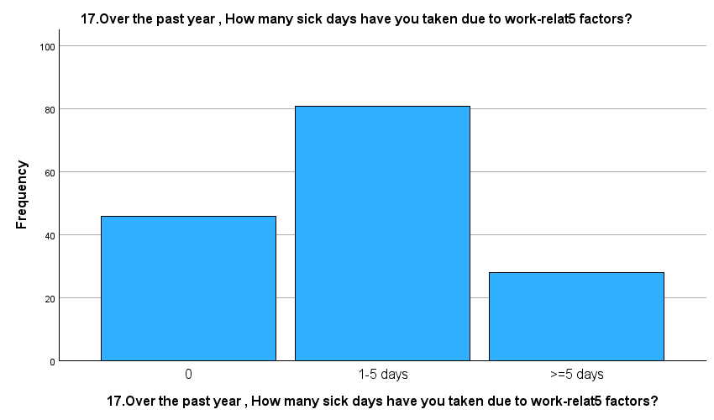

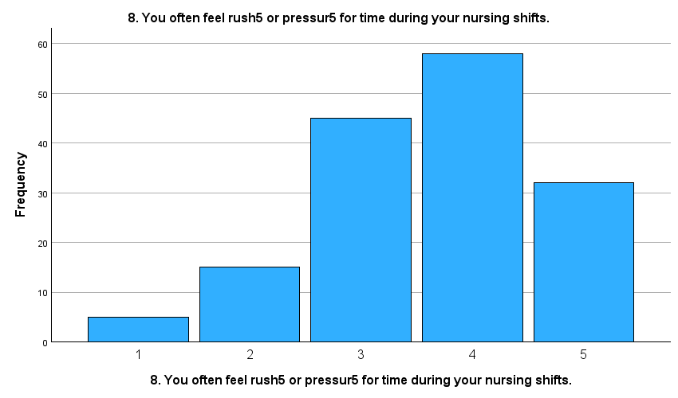

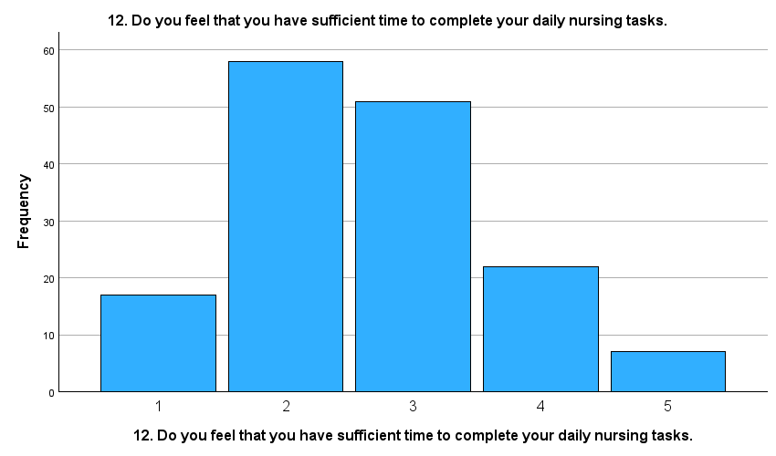

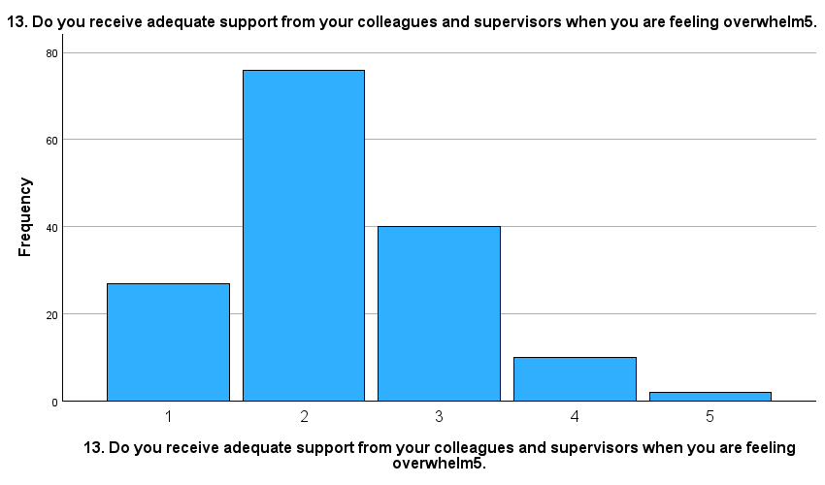

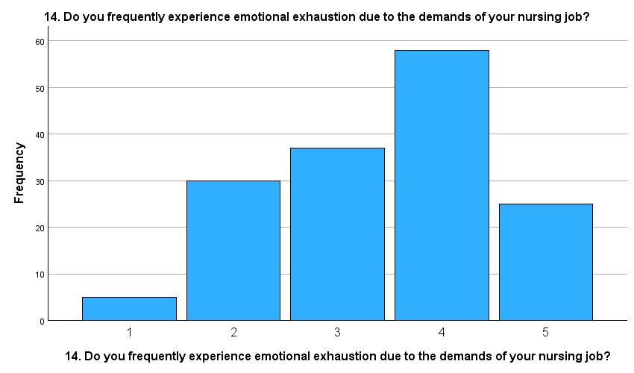

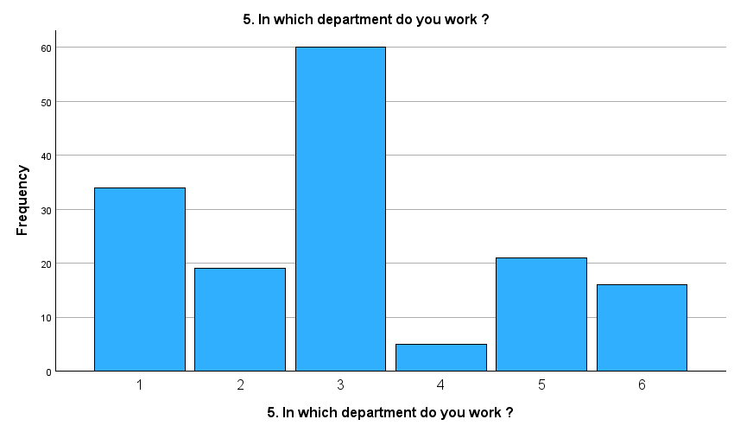

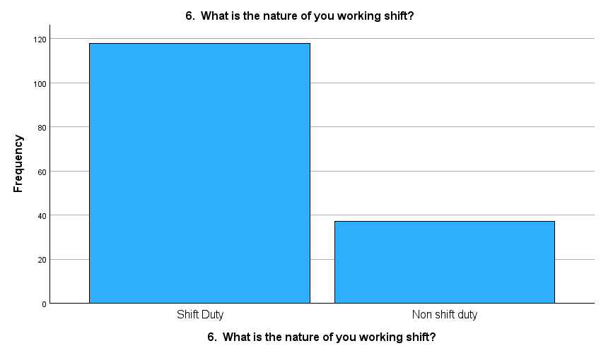

## Hypothesis 1

Variables Entered/Removed

*Table: Variables Considered for the Analysis*

| **Model** | **Variables Entered** | **Variables Removed** | **Method** |
| --- | --- | --- | --- |
| 1 | Aggregated_Workload | None | Enter |

**Explanation:** This table informs us that the "Aggregated_Workload" was the only variable used to predict the number of sick days taken by nurses over the past year.

Model Summary

*Table: How Well Does Workload Predict Sick Days?*

| **Model** | **Correlation (R)** | **R Square** | **Adjusted R Square** | **Prediction Error** |
| --- | --- | --- | --- | --- |
| 1 | .289 | .084 | .078 | .656 |

**Explanation:** This table tells us how well the "Aggregated_Workload" predicts the number of sick days. A correlation of .289 indicates a positive but modest relationship between workload and sick days. The R Square value of .084 suggests that about 8.4% of the variation in sick days can be explained by the workload.

ANOVA Results

*Table: Is the Prediction Statistically Significant?*

| **odel** | **Source of Variation** | **Sum of Squares** | **Degrees of Freedom (Df)** | **Average Variation (Mean Square)** | **Strength of Prediction (F)** | **Is it Significant?** |
| --- | --- | --- | --- | --- | --- | --- |
| 1 | Regression | 6.005 | 1 | 6.005 | 13.940 | <.001 |
|  | Residual | 65.905 | 153 | .431 | - | - |
|  | Total | 71.910 | 154 | - | - | - |

**Explanation:** The ANOVA table tests whether the model is statistically significant. The results indicate that the relationship between "Aggregated_Workload" and sick days is statistically significant, as the significance level is less than .001.

Coefficients

*Table: Relationship Strength and Direction between Workload and Sick Days*

| **Model** | **Source of Variation** | **Coefficient Value (B)** | **Error (Std. Error)** | **Standardized Coefficient (Beta)** | **t-value** | **Is it Significant?** |
| --- | --- | --- | --- | --- | --- | --- |
| 1 | (Constant) | -.350 | .335 | - | -1.045 | .298 |
|  | Aggregated_Workload | .409 | .110 | .289 | 3.734 | <.001 |

**Explanation:** The coefficients table provides details on the relationship between workload and sick days. A positive coefficient for "Aggregated_Workload" indicates that as workload increases, the number of sick days also tends to increase.

Correlation

*Table: How strongly are Workload and Sick Days Related?*

| **Variable A** | **Variable B** | **Correlation (Pearson)** | **Significance (2-tailed)** | **Number of Observations (N)** |
| --- | --- | --- | --- | --- |
| Aggregated_Workload | Sick Days Over the Past Year | .289 | <.001 | 155 |

**Explanation:** This table confirms the positive correlation between "Aggregated_Workload" and sick days. A correlation value of .289 indicates a positive relationship, and it's statistically significant (less than .001).

## Hypothesis 2

Group Statistics for Shift Duties

*Table: Sick Days Based on Shift Nature*

| **Nature of Working Shift** | **Number of People** | **Average Sick Days** | **Standard Deviation** | **Standard Error** |
| --- | --- | --- | --- | --- |
| Shift Duty | 118 | .83 | .671 | .062 |
| Non-shift Duty | 37 | 1.05 | .705 | .116 |

**Explanation:** This table shows the average number of sick days taken by nurses based on whether they work in shift duty or non-shift duty. On average, nurses in shift duties took about 0.83 days, while those in non-shift duties took 1.05 days.

Independent Samples Test (T-Test Results)

*Table: Comparing Sick Days between Shift and Non-shift Duties*

| **Test Conditions** | **Variance F-test** | **Significance (F-test)** | **t-value** | **df** | **One-Sided p** | **Two-Sided p** | **Mean Difference** | **Standard Error Difference** | **95% CI (Lower)** | **95% CI (Upper)** |
| --- | --- | --- | --- | --- | --- | --- | --- | --- | --- | --- |
| Equal Variances Assumed | .089 | .766 | -1.748 | 153 | .041 | .083 | -.224 | .128 | -.476 | .029 |
| Equal Variances Not Assumed | - | - | -1.702 | 57.890 | .047 | .094 | -.224 | .131 | -.486 | .039 |

**Explanation:** The t-test is used to determine if there's a significant difference in the sick days between nurses in shift duties and those in non-shift duties. The results suggest that there is a significant difference between the two groups, with non-shift duty nurses taking more sick days.

Independent Samples Effect Sizes

*Table: Strength of the Difference Between Shift and Non-shift Duties*

| **Measure of Strength** | **Strength Score** | **95% CI (Lower)** | **95% CI (Upper)** |
| --- | --- | --- | --- |
| Cohen's d | .679 | -.329 | .042 |
| Hedges' correction | .682 | -.328 | .042 |
| Glass's delta | .705 | -.317 | .061 |

**Explanation:** The effect size measures how big or meaningful the difference is between the two groups. Larger values mean a bigger difference. All three measures (Cohen's d, Hedges' correction, and Glass's delta) show that there's a moderate to large difference in sick days between shift duty and non-shift duty nurses.

## Hypothesis 3

ANOVA Results

*Table: Differences Between Departments in Sick Days Taken*

| **Where the Difference Comes From** | **How Much Difference** | **Groups or Departments** | **Average Difference** | **Difference Strength** | **Is it Significant?** |
| --- | --- | --- | --- | --- | --- |
| Between Different Departments | 6.858 | 5 | 1.372 | Strong | Yes |
| Within the Same Department | 65.052 | 149 | .437 | - | - |
| Overall Difference | 71.910 | 154 | - | - | - |

**Explanation:** This table is trying to figure out if the department someone works in affects how many sick days they take. The results show that there is indeed a difference between the departments. In simple terms, where you work seems to play a role in how many sick days you might take.

ANOVA Effect Sizes

*Table: How Strong is the Department's Influence on Sick Days?*

| **Measure of Strength** | **Strength Score** | **Lowest Possible** | **Highest Possible** |
| --- | --- | --- | --- |
| Eta-squared | .095 | .006 | .165 |
| Epsilon-squared | .065 | -.027 | .137 |
| Omega-squared (Fixed) | .065 | -.027 | .137 |
| Omega-squared (Random) | .014 | -.005 | .031 |

**Explanation:** This table gives us an idea of how strong the department's influence is on the number of sick days taken. Bigger numbers mean a stronger influence. Here, Eta-squared tells us that about 9.5% of the reason someone takes a sick day is because of the department they work in.

Post HOC - Multiple Comparisons (Selected Results)

*Table: Comparing Sick Days Between Two Specific Departments*

| **Departments A** | **Departments B** | **Average Difference** | **Error Rate** | **Is it Significant?** | **Least Difference** | **Most Difference** |
| --- | --- | --- | --- | --- | --- | --- |
| Ambulatory | Subspeciality ward | .456* | .142 | Yes | .05 | .87 |

**Explanation:** This table dives deeper to see which specific departments differ from each other. It shows that there's a notable difference in sick days between the Ambulatory and Subspeciality ward departments. On average, there's about a half-day difference in sick days between them.

Homogenous Subset (Tukey HSD Method)

*Table: Which Departments Have Similar Sick Day Patterns?*

| **Department Names** | **Number of People** | **Group 1** | **Group 2** |
| --- | --- | --- | --- |
| Mental health unit | 5 | .40 | - |
| Intensive care unit | 19 | .68 | .68 |
| Subspeciality ward | 60 | .75 | .75 |
| OR /PACU | 16 | .94 | .94 |
| ED | 21 | 1.00 | 1.00 |
| Ambulatory | 34 | - | 1.21 |

**Explanation:** This table groups departments that have similar patterns of sick days. For example, the Mental health unit, Intensive care unit, and Subspeciality ward all have around the same average of sick days. This means that people in these departments tend to take similar amounts of sick days.

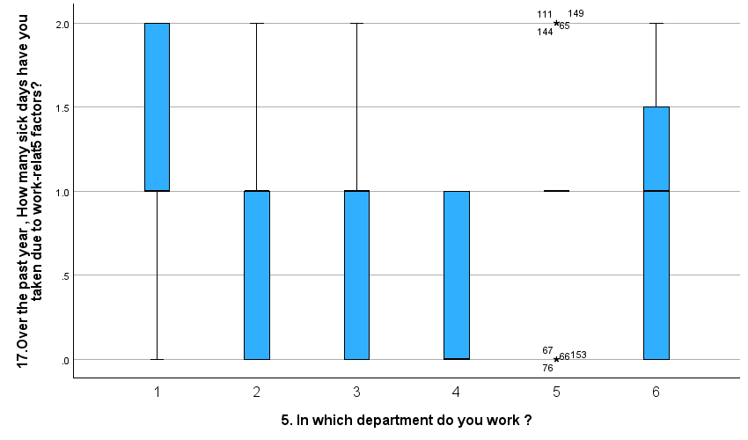

# Chapter 4

# Discussion and Findings

## Hypothesis 1: Influence of Workload on Sick Days

The findings suggest a positive relationship between nursing workload and the number of sick days taken. Specifically, an increase in aggregated workload was associated with an increase in sick days, although the relationship was modest with a correlation of .289. Only about 8.4% of the variance in sick days could be explained by workload alone. This indicates that while workload plays a role, other factors are also contributing to the number of sick days taken by nurses.

## Hypothesis 2: Shift vs. Non-shift Duty

There's a significant difference between nurses working in shift duties and those in non-shift duties regarding sick days taken. Those in non-shift duties took, on average, more sick days (1.05 days) than their counterparts in shift duties (0.83 days). The effect size analysis further showed a moderate to large difference between these two groups. This suggests that the nature of one's duty (shift or non-shift) has a meaningful impact on their health or well-being, leading to more sick days in non-shift duties.

## Hypothesis 3: Departmental Differences in Sick Days

The analysis revealed significant differences between departments in the number of sick days taken. The variance within a department was significantly lower than the variance between departments. Particularly, there was a significant difference in the number of sick days between the Ambulatory department and the Subspeciality ward, with the Ambulatory department having more. The homogeneous subsets also showed that some departments, including the Subspecialty ward, Intensive care unit, and Mental health unit, had comparable patterns in sick days.

Additionally, the departmental influence on sick days was only moderate, according to the effect size analyses, which included Eta-squared and Omega-squared. The department in which one works may be responsible for 9.5% of the variation in sick days.

## Overall Findings:

* Influence of Workload: Although there is a link between workload and sick days, it is not the only determinant.
* Shift Nature's Influence Shift work typically results in fewer sick days than non-shift work. For hospital management and policy-making, this finding is essential.
* Departmental Variations: The number of sick days varies significantly between departments. Specific departments, like Ambulatory, tend to have higher sick days than others, like the Subspecialty ward.

## Discussion:

* The results present several implications for nursing management and hospital policy. The positive correlation between workload and sick days underscores the importance of managing nurse workloads to prevent burnout and improve staff well-being.
* The difference in sick days between shift and non-shift duties suggests a need to review work structures, duty rosters, and perhaps provide additional support or incentives for roles that tend to lead to more sick days.
* Lastly, the departmental differences highlight the need for a more in-depth look into department-specific challenges and stresses that might be contributing to these disparities. Tailored interventions and support systems might be necessary for departments with notably higher sick days.

# Chapter 5

# Conclusion and Recommendations

## Recommendations:

1. Manage Workloads: Hospital management should closely monitor and manage the workload of nursing staff to ensure it is at a manageable level. Overburdening staff not only affects their health and well-being but can also compromise patient care.
2. Review Shift Structures: Given the significant difference in sick days between shift and non-shift duties, it's recommended to review and possibly restructure duty rosters. Consider rotation patterns, the length of shifts, and the number of consecutive nights, which can be particularly taxing.
3. Department-specific Interventions: Since there are observable differences in sick days across departments, tailored interventions should be developed. For departments with higher sick days, like Ambulatory, management should delve deeper to understand unique stressors or challenges and address them accordingly.
4. Support Systems: Implement stronger support systems, especially for departments or roles with higher sick days. This could include counseling services, relaxation zones, or even periodic health check-ups.
5. Training and Awareness: Conduct regular training sessions on stress management, self-care, and recognizing signs of burnout. Raising awareness about the importance of mental health can promote a culture of self-care and peer support.
6. Feedback Mechanisms: Establish robust feedback mechanisms where nursing staff can voice their concerns, challenges, or provide suggestions on improving work conditions without fear of repercussions.
7. Further Research: Commission further studies to identify other potential factors contributing to sick days. Understanding root causes will better inform interventions.

## Conclusion:

The study provides valuable insights into the factors influencing sick days among nurses at AJCH. There is a clear indication that workload, the nature of duties (shift vs. non-shift), and departmental differences play roles in determining the number of sick days taken by nurses. While workload does contribute to sick days, it's evident that it's not the only factor. The disparities in sick days based on the nature of duties and departments underscore the complexities of the nursing profession and the multifaceted challenges they face. Addressing these challenges requires a holistic approach, focusing not just on work structures but also on the mental and physical well-being of the nursing staff. Implementing the recommendations based on the findings can lead to improved staff well-being, better patient care, and a more efficient healthcare system.

References

Feldhaus, C., Souza, R. F. D., Fernandes, L. M., Carvalho, A. R. D. S., Bordin, V., & Oliveira, J. L. C. D. (2019). Association between workload and absenteeism in nursing technicians. *Texto & Contexto-Enfermagem*, *28*.<https://www.scielo.br/j/tce/a/sBv69GFvWypqkXbM4S5dfPb/?format=pdf&lang=en>

Alves, A. B. S. L., Matos, F. G. D. O. A., Carvalho, A. R. D. S., Alves, D. C. I., Tonini, N. S., Santos, R. P. D., ... & Oliveira, J. L. C. D. (2022). Absenteeism in nursing in the face of COVID-19: a comparative study in a hospital from southern Brazil. *Texto & Contexto-Enfermagem*, *31*, e20210254.<https://www.scielo.br/j/tce/a/VcxwKrK3Ch8v4GD6YXzJshF/?format=html&lang=en>

Pervez, S., Kousar, R., & Asghar, S. (2023). Effects of Absenteeism in Nursing Profession: Effects of Absenteeism in Nursing Profession. *NURSEARCHER (Journal of Nursing & Midwifery Sciences)*, 11-14.<https://www.nursearcher.com/index.php/nrs/article/view/33/31>

Dolić, M., Antičević, V., Dolić, K., & Pogorelić, Z. (2022). Difference in pandemic-related experiences and factors associated with sickness absence among nurses working in COVID-19 and non-COVID-19 departments. *International Journal of Environmental Research and Public Health*, *19*(3), 1093.<https://www.mdpi.com/1660-4601/19/3/1093>

Kowalczuk, K., Krajewska-Kułak, E., & Sobolewski, M. (2020). Working excessively and burnout among nurses in the context of sick leaves. *Frontiers in psychology*, *11*, 285.<https://www.frontiersin.org/articles/10.3389/fpsyg.2020.00285/full>

Dall’Ora, C., Ball, J., Reinius, M., & Griffiths, P. (2020). Burnout in nursing: a theoretical review. *Human resources for health*, *18*, 1-17.<https://link.springer.com/article/10.1186/s12960-020-00469-9>

Junttila, J. K., Koivu, A., Haatainen, K., & Nykänen, P. (2019). Nurse-assessed optimality of workload-A valid measure for the adequacy of nursing resources. *Online Journal of Nursing Informatics*, *23*(3).<https://www.himss.org/resources/nurse-assessed-optimality-workload-valid-measure-adequacy-nursing-resources>

Ose, S. O., Færevik, H., Håpnes, T., & Øyum, L. (2022). Perceived causes of work-related sick leave among hospital nurses in Norway: A prepandemic study. *Safety and Health at Work*, *13*(3), 350-356.<https://www.sciencedirect.com/science/article/pii/S2093791122000543>

Appendix

Descriptive statistics

|  |  |  |  |  |  |  |  |  |
| --- | --- | --- | --- | --- | --- | --- | --- | --- |
| **Statistics** | | | | | | | | |
|  | | 17.Over the past year , How many sick days have you taken due to work-relat5 factors? | 8. You often feel rush5 or pressur5 for time during your nursing shifts. | 12. Do you feel that you have sufficient time to complete your daily nursing tasks. | 13. Do you receive adequate support from your colleagues and supervisors when you are feeling overwhelm5. | 14. Do you frequently experience emotional exhaustion due to the demands of your nursing job? | 5. In which department do you work ? | 6. What is the nature of you working shift? |
| N | Valid | 155 | 155 | 155 | 155 | 155 | 155 | 155 |
| Missing | 0 | 0 | 0 | 0 | 0 | 0 | 0 |
| Mean | | .88 | 3.63 | 2.64 | 2.25 | 3.44 | 3.05 | 1.24 |
| Median | | 1.00 | 4.00 | 3.00 | 2.00 | 4.00 | 3.00 | 1.00 |
| Mode | | 1 | 4 | 2 | 2 | 4 | 3 | 1 |
| Std. Deviation | | .683 | 1.020 | 1.006 | .865 | 1.076 | 1.586 | .428 |
| Variance | | .467 | 1.041 | 1.011 | .748 | 1.157 | 2.517 | .183 |
| Skewness | | .150 | -.495 | .389 | .586 | -.315 | .418 | 1.238 |
| Std. Error of Skewness | | .195 | .195 | .195 | .195 | .195 | .195 | .195 |
| Kurtosis | | -.844 | -.164 | -.246 | .400 | -.734 | -.777 | -.474 |
| Std. Error of Kurtosis | | .387 | .387 | .387 | .387 | .387 | .387 | .387 |
| Range | | 2 | 4 | 4 | 4 | 4 | 5 | 1 |
| Minimum | | 0 | 1 | 1 | 1 | 1 | 1 | 1 |
| Maximum | | 2 | 5 | 5 | 5 | 5 | 6 | 2 |
| Sum | | 137 | 562 | 409 | 349 | 533 | 473 | 192 |

|  |  |  |  |  |  |
| --- | --- | --- | --- | --- | --- |
| **17.Over the past year , How many sick days have you taken due to work-relat5 factors?** | | | | | |
|  | | Frequency | Percent | Valid Percent | Cumulative Percent |
| Valid | 0 | 46 | 29.7 | 29.7 | 29.7 |
| 1-5 days | 81 | 52.3 | 52.3 | 81.9 |
| >=5 days | 28 | 18.1 | 18.1 | 100.0 |
| Total | 155 | 100.0 | 100.0 |  |

|  |  |  |  |  |  |
| --- | --- | --- | --- | --- | --- |
| **8. You often feel rush5 or pressur5 for time during your nursing shifts.** | | | | | |
|  | | Frequency | Percent | Valid Percent | Cumulative Percent |
| Valid | 1 | 5 | 3.2 | 3.2 | 3.2 |
| 2 | 15 | 9.7 | 9.7 | 12.9 |
| 3 | 45 | 29.0 | 29.0 | 41.9 |
| 4 | 58 | 37.4 | 37.4 | 79.4 |
| 5 | 32 | 20.6 | 20.6 | 100.0 |
| Total | 155 | 100.0 | 100.0 |  |

|  |  |  |  |  |  |
| --- | --- | --- | --- | --- | --- |
| **12. Do you feel that you have sufficient time to complete your daily nursing tasks.** | | | | | |
|  | | Frequency | Percent | Valid Percent | Cumulative Percent |
| Valid | 1 | 17 | 11.0 | 11.0 | 11.0 |
| 2 | 58 | 37.4 | 37.4 | 48.4 |
| 3 | 51 | 32.9 | 32.9 | 81.3 |
| 4 | 22 | 14.2 | 14.2 | 95.5 |
| 5 | 7 | 4.5 | 4.5 | 100.0 |
| Total | 155 | 100.0 | 100.0 |  |

|  |  |  |  |  |  |
| --- | --- | --- | --- | --- | --- |
| **13. Do you receive adequate support from your colleagues and supervisors when you are feeling overwhelm5.** | | | | | |
|  | | Frequency | Percent | Valid Percent | Cumulative Percent |
| Valid | 1 | 27 | 17.4 | 17.4 | 17.4 |
| 2 | 76 | 49.0 | 49.0 | 66.5 |
| 3 | 40 | 25.8 | 25.8 | 92.3 |
| 4 | 10 | 6.5 | 6.5 | 98.7 |
| 5 | 2 | 1.3 | 1.3 | 100.0 |
| Total | 155 | 100.0 | 100.0 |  |

|  |  |  |  |  |  |
| --- | --- | --- | --- | --- | --- |
| **14. Do you frequently experience emotional exhaustion due to the demands of your nursing job?** | | | | | |
|  | | Frequency | Percent | Valid Percent | Cumulative Percent |
| Valid | 1 | 5 | 3.2 | 3.2 | 3.2 |
| 2 | 30 | 19.4 | 19.4 | 22.6 |
| 3 | 37 | 23.9 | 23.9 | 46.5 |
| 4 | 58 | 37.4 | 37.4 | 83.9 |
| 5 | 25 | 16.1 | 16.1 | 100.0 |
| Total | 155 | 100.0 | 100.0 |  |

|  |  |  |  |  |  |
| --- | --- | --- | --- | --- | --- |
| **5. In which department do you work ?** | | | | | |
|  | | Frequency | Percent | Valid Percent | Cumulative Percent |
| Valid | 1 | 34 | 21.9 | 21.9 | 21.9 |
| 2 | 19 | 12.3 | 12.3 | 34.2 |
| 3 | 60 | 38.7 | 38.7 | 72.9 |
| 4 | 5 | 3.2 | 3.2 | 76.1 |
| 5 | 21 | 13.5 | 13.5 | 89.7 |
| 6 | 16 | 10.3 | 10.3 | 100.0 |
| Total | 155 | 100.0 | 100.0 |  |

|  |  |  |  |  |  |
| --- | --- | --- | --- | --- | --- |
| **6. What is the nature of you working shift?** | | | | | |
|  | | Frequency | Percent | Valid Percent | Cumulative Percent |
| Valid | Shift Duty | 118 | 76.1 | 76.1 | 76.1 |
| Non shift duty | 37 | 23.9 | 23.9 | 100.0 |
| Total | 155 | 100.0 | 100.0 |  |

H3:

|  |  |  |  |  |  |
| --- | --- | --- | --- | --- | --- |
| **ANOVA** | | | | | |
| 17.Over the past year , How many sick days have you taken due to work-relat5 factors? | | | | | |
|  | Sum of Squares | df | Mean Square | F | Sig. |
| Between Groups | 6.858 | 5 | 1.372 | 3.142 | .010 |
| Within Groups | 65.052 | 149 | .437 |  |  |
| Total | 71.910 | 154 |  |  |  |

|  |  |  |  |  |
| --- | --- | --- | --- | --- |
| **ANOVA Effect Sizesa,b** | | | | |
|  | | Point Estimate | 95% Confidence Interval | |
| Lower | Upper |
| 17.Over the past year , How many sick days have you taken due to work-relat5 factors? | Eta-squared | .095 | .006 | .165 |
| Epsilon-squared | .065 | -.027 | .137 |
| Omega-squared Fixed-effect | .065 | -.027 | .137 |
| Omega-squared Random-effect | .014 | -.005 | .031 |
| a. Eta-squared and Epsilon-squared are estimated based on the fixed-effect model. | | | | |
| b. Negative but less biased estimates are retained, not rounded to zero. | | | | |

Post HOC

|  |  |  |  |  |  |  |  |
| --- | --- | --- | --- | --- | --- | --- | --- |
| **Multiple Comparisons** | | | | | | | |
| Dependent Variable: 17.Over the past year , How many sick days have you taken due to work-relat5 factors? | | | | | | | |
|  | (I) 5. In which department do you work ? | (J) 5. In which department do you work ? | Mean Difference (I-J) | Std. Error | Sig. | 95% Confidence Interval | |
|  | Lower Bound | Upper Bound |
| Tukey HSD | Ambulatory (OPD, Radiology,Dialysis,DCU) | Intensive care unit (PICU,NICU,CICU) | .522 | .189 | .070 | -.02 | 1.07 |
| Subspeciality ward | .456* | .142 | .020 | .05 | .87 |
| Mental health unit | .806 | .316 | .118 | -.11 | 1.72 |
| ED | .206 | .183 | .871 | -.32 | .74 |
| OR /PACU | .268 | .200 | .762 | -.31 | .85 |
| Intensive care unit (PICU,NICU,CICU) | Ambulatory (OPD, Radiology,Dialysis,DCU) | -.522 | .189 | .070 | -1.07 | .02 |
| Subspeciality ward | -.066 | .174 | .999 | -.57 | .44 |
| Mental health unit | .284 | .332 | .956 | -.67 | 1.24 |
| ED | -.316 | .209 | .659 | -.92 | .29 |
| OR /PACU | -.253 | .224 | .868 | -.90 | .39 |
| Subspeciality ward | Ambulatory (OPD, Radiology,Dialysis,DCU) | -.456* | .142 | .020 | -.87 | -.05 |
| Intensive care unit (PICU,NICU,CICU) | .066 | .174 | .999 | -.44 | .57 |
| Mental health unit | .350 | .308 | .865 | -.54 | 1.24 |
| ED | -.250 | .168 | .670 | -.73 | .23 |
| OR /PACU | -.188 | .186 | .914 | -.72 | .35 |
| Mental health unit | Ambulatory (OPD, Radiology,Dialysis,DCU) | -.806 | .316 | .118 | -1.72 | .11 |
| Intensive care unit (PICU,NICU,CICU) | -.284 | .332 | .956 | -1.24 | .67 |
| Subspeciality ward | -.350 | .308 | .865 | -1.24 | .54 |
| ED | -.600 | .329 | .453 | -1.55 | .35 |
| OR /PACU | -.538 | .339 | .608 | -1.51 | .44 |
| ED | Ambulatory (OPD, Radiology,Dialysis,DCU) | -.206 | .183 | .871 | -.74 | .32 |
| Intensive care unit (PICU,NICU,CICU) | .316 | .209 | .659 | -.29 | .92 |
| Subspeciality ward | .250 | .168 | .670 | -.23 | .73 |
| Mental health unit | .600 | .329 | .453 | -.35 | 1.55 |
| OR /PACU | .063 | .219 | 1.000 | -.57 | .70 |
| OR /PACU | Ambulatory (OPD, Radiology,Dialysis,DCU) | -.268 | .200 | .762 | -.85 | .31 |
| Intensive care unit (PICU,NICU,CICU) | .253 | .224 | .868 | -.39 | .90 |
| Subspeciality ward | .188 | .186 | .914 | -.35 | .72 |
| Mental health unit | .538 | .339 | .608 | -.44 | 1.51 |
| ED | -.063 | .219 | 1.000 | -.70 | .57 |
| *. The mean difference is significant at the 0.05 level. | | | | | | | |

Homogenous Subset

|  |  |  |  |  |
| --- | --- | --- | --- | --- |
| **17.Over the past year , How many sick days have you taken due to work-relat5 factors?** | | | | |
|  | 5. In which department do you work ? | N | Subset for alpha = 0.05 | |
|  | 1 | 2 |
| Tukey HSDa,b | Mental health unit | 5 | .40 |  |
| Intensive care unit (PICU,NICU,CICU) | 19 | .68 | .68 |
| Subspeciality ward | 60 | .75 | .75 |
| OR /PACU | 16 | .94 | .94 |
| ED | 21 | 1.00 | 1.00 |
| Ambulatory (OPD, Radiology,Dialysis,DCU) | 34 |  | 1.21 |
| Sig. |  | .143 | .273 |
| Duncana,b | Mental health unit | 5 | .40 |  |
| Intensive care unit (PICU,NICU,CICU) | 19 | .68 | .68 |
| Subspeciality ward | 60 | .75 | .75 |
| OR /PACU | 16 |  | .94 |
| ED | 21 |  | 1.00 |
| Ambulatory (OPD, Radiology,Dialysis,DCU) | 34 |  | 1.21 |
| Sig. |  | .179 | .057 |
| Means for groups in homogeneous subsets are displayed. | | | | |
| a. Uses Harmonic Mean Sample Size = 14.676. | | | | |
| b. The group sizes are unequal. The harmonic mean of the group sizes is used. Type I error levels are not guaranteed.  Q5 will be a factor, Q17 will be the dependent variable | | | | |

H2

T-Test

|  |  |  |  |  |  |
| --- | --- | --- | --- | --- | --- |
| **Group Statistics** | | | | | |
|  | 6. What is the nature of you working shift? | N | Mean | Std. Deviation | Std. Error Mean |
| 17.Over the past year , How many sick days have you taken due to work-relat5 factors? | Shift Duty | 118 | .83 | .671 | .062 |
| Non shift duty | 37 | 1.05 | .705 | .116 |

|  |  |  |  |  |  |  |  |  |  |  |  |
| --- | --- | --- | --- | --- | --- | --- | --- | --- | --- | --- | --- |
| **Independent Samples Test** | | | | | | | | | | | |
|  | | Levene's Test for Equality of Variances | | t-test for Equality of Means | | | | | | | |
| F | Sig. | t | df | Significance | | Mean Difference | Std. Error Difference | 95% Confidence Interval of the Difference | |
| One-Sided p | Two-Sided p | Lower | Upper |
| 17.Over the past year , How many sick days have you taken due to work-relat5 factors? | Equal variances assumed | .089 | .766 | -1.748 | 153 | .041 | .083 | -.224 | .128 | -.476 | .029 |
| Equal variances not assumed |  |  | -1.702 | 57.890 | .047 | .094 | -.224 | .131 | -.486 | .039 |

|  |  |  |  |  |  |
| --- | --- | --- | --- | --- | --- |
| **Independent Samples Effect Sizes** | | | | | |
|  | | Standardizera | Point Estimate | 95% Confidence Interval | |
| Lower | Upper |
| 17.Over the past year , How many sick days have you taken due to work-relat5 factors? | Cohen's d | .679 | -.329 | -.700 | .042 |
| Hedges' correction | .682 | -.328 | -.696 | .042 |
| Glass's delta | .705 | -.317 | -.691 | .061 |
| a. The denominator used in estimating the effect sizes.  Cohen's d uses the pooled standard deviation.  Hedges' correction uses the pooled standard deviation, plus a correction factor.  Glass's delta uses the sample standard deviation of the control (i.e., the second) group. | | | | | |

Q17 was taken as test variable and Q6 was taken as grouping variable

H1

|  |  |  |  |
| --- | --- | --- | --- |
| **Variables Entered/Removeda** | | | |
| Model | Variables Entered | Variables Removed | Method |
| 1 | Aggregated_Workloadb | . | Enter |
| a. Dependent Variable: 17.Over the past year , How many sick days have you taken due to work-relat5 factors? | | | |
| b. All requested variables entered. | | | |

|  |  |  |  |  |
| --- | --- | --- | --- | --- |
| **Model Summary** | | | | |
| Model | R | R Square | Adjusted R Square | Std. Error of the Estimate |
| 1 | .289a | .084 | .078 | .656 |
| a. Predictors: (Constant), Aggregated_Workload | | | | |

|  |  |  |  |  |  |  |
| --- | --- | --- | --- | --- | --- | --- |
| **ANOVAa** | | | | | | |
| Model | | Sum of Squares | Df | Mean Square | F | Sig. |
| 1 | Regression | 6.005 | 1 | 6.005 | 13.940 | <.001b |
| Residual | 65.905 | 153 | .431 |  |  |
| Total | 71.910 | 154 |  |  |  |
| a. Dependent Variable: 17.Over the past year , How many sick days have you taken due to work-relat5 factors? | | | | | | |
| b. Predictors: (Constant), Aggregated_Workload | | | | | | |

|  |  |  |  |  |  |  |
| --- | --- | --- | --- | --- | --- | --- |
| **Coefficientsa** | | | | | | |
| Model | | Unstandardized Coefficients | | Standardized Coefficients | t | Sig. |
| B | Std. Error | Beta |
| 1 | (Constant) | -.350 | .335 |  | -1.045 | .298 |
| Aggregated_Workload | .409 | .110 | .289 | 3.734 | <.001 |
| a. Dependent Variable: 17.Over the past year , How many sick days have you taken due to work-relat5 factors? | | | | | | |

Correlation

|  |  |  |  |
| --- | --- | --- | --- |
| **Correlations** | | | |
|  | | Aggregated_Workload | 17.Over the past year , How many sick days have you taken due to work-relat5 factors? |
| Aggregated_Workload | Pearson Correlation | 1 | .289** |
| Sig. (2-tailed) |  | <.001 |
| N | 155 | 155 |
| 17.Over the past year , How many sick days have you taken due to work-relat5 factors? | Pearson Correlation | .289** | 1 |
| Sig. (2-tailed) | <.001 |  |
| N | 155 | 155 |
| **. Correlation is significant at the 0.01 level (2-tailed). | | | |