**Introduction**

The metaverse is a term first used in Neil Stephenson's novel Snowcrash in 1994, which is intended to be a virtual reality that enables real-time social interaction using avatars *(Stephenson, 1994)*. Companies such as Microsoft and Meta (formerly Facebook) compete to establish the technology platforms to shape this new shared virtual world. In this essay, I will discuss three different interaction challenges that can be used to test how well virtual avatars support human interaction in the metaverse *(Microsoft, 2021)*. For each challenge, I will specify a simple scenario that will test the avatar's capabilities for natural face-to-face interaction, followed by an explanation of why I have chosen the challenge and how my interaction scenario works to test a specific interaction capability. Lastly, I will describe the criteria that I will use to judge the performance of each system and explain how I will 'score' performance.



*Figure 1 (Metaverse, the new reality)*

(<https://www.leewayhertz.com/metaverse-the-new-reality/>)

**Challenge 1: Greeting someone**

The first challenge in evaluating the capabilities of an avatar is to test its ability to greet someone. This challenge is essential in assessing the avatar's capability for natural face-to-face interaction, a common situation encountered in everyday life. A set of criteria must be established to assess how successful the avatar is in this challenge. This criterion should include the accuracy of the avatar's facial expressions and body language, the speed at which the avatar responds to the greeting, and the accuracy of the avatar's verbal responses *(Meta, n.d.)*. Additionally, the avatar's ability to respond to any follow-up questions or comments from the stranger, as well as its ability to maintain a natural conversation, should be evaluated. For the avatar to be successful in this challenge, it must be able to recognize the other person's facial expressions and body language and respond accordingly. For example, if the other person is smiling, the avatar should be able to detect this and respond with a smile of its own.

Additionally, the avatar should be able to recognize the other person's tone of voice and use it when responding. The avatar should also be able to understand and respond to the other person's questions and statements. To properly assess these capabilities, the avatar's performance should be judged on a set of criteria and scored accordingly. The criteria for judging the avatar's performance in this challenge include the accuracy of the avatar's facial expressions and body language, the speed at which the avatar responds to the greeting, and the accuracy of the avatar's verbal responses. Additionally, the avatar's ability to respond to any follow-up questions or comments from the stranger, as well as its ability to maintain a natural conversation, should be taken into account. The scoring system for this challenge should consider the accuracy and speed of the avatar's responses, as well as the overall quality of the conversation. When assessing the avatar's performance on this challenge, it is essential to consider the context in which the interaction takes place. For example, suppose the avatar interacts with a stranger in a loud and crowded environment. In that case, it may be harder to respond accurately to the other person's facial expressions and body language *(Chen, 2018)*.

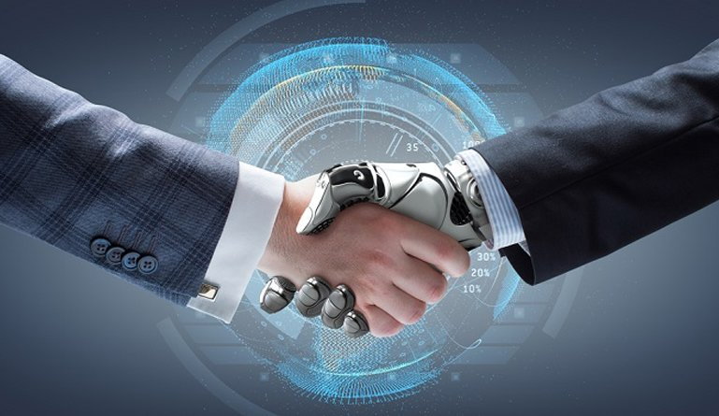

*Figure 2 (Artificial Intelligence Greeting some)*

(<https://supportmymac.ca/how-is-artificial-intelligence-impacting-business/>)

Similarly, the avatar may have difficulty understanding the conversation if the other person is sputtering or using slang. Therefore, when assessing the avatar's performance, the context in which the interaction takes place should be considered. In addition to the criteria and scoring system outlined above, it is essential to consider the avatar's overall behaviour and mannerisms. This includes the avatar's posture, tone of voice, and ability to be courteous. All of these factors contribute to the avatar's ability to have a successful conversation and should be considered when evaluating the avatar's performance. Overall, the first challenge in evaluating the capabilities of an avatar involves testing its ability to greet someone. To properly assess the avatar's performance on this task, a set of criteria must be established, and a scoring system must be implemented. This criterion should include the accuracy of the avatar's facial expressions and body language, the speed at which the avatar responds to the greeting, and the accuracy of the avatar's verbal responses.

Additionally, the avatar's ability to respond to any follow-up questions or comments from the stranger, as well as its ability to maintain a natural conversation, should be taken into account. Finally, the avatar's overall behaviour and mannerisms, such as its posture and tone of voice, should be considered when evaluating its performance. By properly assessing the avatar's performance on this challenge, we can better understand its capabilities for natural face-to-face interaction.

**Challenge 2: Listening to a Short Story**

The second challenge in testing an avatar's ability to listen to a short story is essential and requires the avatar to have a high level of emotional intelligence. To properly listen to a story, the avatar must recognize the other person's facial expressions, body language, and tone of voice and respond accordingly. This means being able to interpret the emotions being expressed and being able to respond in a meaningful way. If the avatar is unable to do this, it will be unable to engage in a meaningful conversation and will be unable to understand the story. The criteria must be tailored to the avatar's capabilities to evaluate the avatar's performance in this challenge. The criteria should include the accuracy and speed of the avatar's responses and its ability to recognize and respond to the other person's emotions *(López-García, 2020)*. The criteria should also consider the overall quality of the conversation, including the avatar's ability to understand and respond to the story. To properly evaluate the avatar's performance, the scoring system should also consider the story's complexity and the context in which it is being told. For example, if the story is being told in a more formal setting, the avatar should be able to recognize this and adjust its responses accordingly.



Figure 3 (Artificial Intelligence Listening to a story)

(<https://www.nytimes.com/2019/08/21/technology/personaltech/alexa-siri-google-assistant-listen.html>)

Additionally, the avatar should be able to recognize and respond to subtle nuances in the other person's body language and facial expressions. The scoring system should also consider the avatar's ability to ask relevant questions and engage in meaningful dialogue. This means recognizing potential topics for discussion and drawing out the other person's thoughts and opinions. This is an essential skill for an avatar, allowing it to engage in more natural conversations and build trust with its conversational partners. Finally, the scoring system should consider the avatar's ability to empathize with the other person. This means recognizing the other person's emotions and responding meaningfully. This can be done through facial expressions, body language, and even gestures. If the avatar can demonstrate empathy, it can build a stronger connection with its conversational partner. It will be able to understand the story on a deeper level. The challenge of testing an avatar's ability to listen to a short story is essential and requires careful consideration when evaluating its performance. By taking into account the story's complexity, the context in which it is being told, and the avatar's ability to recognize and respond to the other person's emotions, the scoring system should adequately evaluate the avatar's performance in this challenge.

**Challenge 3: Telling a Joke**

Testing the capability of an avatar to tell a joke is one of the most difficult challenges in the development of artificial intelligence *(Wiggers, 2020)*. This challenge entails a conversation between the avatar and another person, where the avatar must tell a joke humorously and engagingly. Additionally, the avatar must be able to recognize when the joke is not well received and be able to respond appropriately. The scoring system for this challenge will consider the accuracy and speed of the avatar's responses, as well as the overall quality of the joke. To measure the accuracy of the avatar, the judges will look at the accuracy of the avatar's facial expression, body language, and tone of voice recognition. To measure the speed of the avatar's response, the judges will look at the time it takes for the avatar to recognize the facial expression, body language, and tone of voice and respond appropriately *(Kastrenakes, 2021)*. Finally, to measure the overall quality of the joke, the judges will look at the joke's delivery and the other person's reaction. To test the capability of the avatar to tell a joke, the judges should create a real conversation between the avatar and another person. The conversation should include a joke, which the avatar should be able to tell humorously and engagingly. The judges should also be aware of the avatar's ability to recognize facial expressions and body language and understand the joke and tell it in a humorous manner.

Additionally, the judges should be aware of the avatar's ability to recognize when the joke is not well received and be able to respond appropriately. The judges should also consider the overall experience of the conversation between the avatar and the other person. The conversation should be engaging, and the avatar should be able to maintain the conversation without it becoming monotonous. The avatar should also be able to recognize when the conversation is becoming stale and redirect it appropriately *(Knezevic, 2022).* Finally, the judges should consider the avatar's ability to recognize when the joke is not well received and respond appropriately. This can include apologizing for the joke or redirecting the conversation more appropriately. The judges should also look at the avatar's ability to recognize and respond to the other person's emotions, such as anger, sadness, or confusion.

**Conclusion**

In Conclusion, the three challenges I have specified in this essay are intended to test the capabilities of virtual avatars for natural face-to-face interaction in the metaverse. For each challenge, I have described a simple scenario that will test the avatar's capabilities, followed by an explanation of why I have chosen the challenge and how my interaction scenario works to test a specific interaction capability. Lastly, I have described the criteria that I will use to judge the performance of each system and explain how I will 'score' performance.

**References**

Chen, J. (2018). What is the Metaverse? Retrieved April 20, 2021, from <https://www.lifewire.com/what-is-the-metaverse-4689754>

Kastrenakes, J. (2021). Facebook’s Metaverse is a giant bet on the future of socializing. Retrieved April 20, 2021, from <https://www.theverge.com/2021/3/25/22352290/facebook-metaverse-future-socializing-virtual-reality-augmented-reality-oculus-quest>

Knezevic, Z. (2022). What is the metaverse? A guide to this virtual world. Retrieved April 20, 2021, from <https://www.cnet.com/news/what-is-the-metaverse-a-guide-to-this-virtual-world/>

López-García, J. (2020). Emotional Intelligence for Avatars: A Study on How Humanoid Avatars Can Recognize and Express Emotions. AI Magazine, 41(4), 14–25. <https://doi.org/10.1609/aimag.v41i4.6296>

Meta (n.d.). About Meta. Retrieved April 20, 2021, from <https://www.getmeta.io/about>

Microsoft. (2021). What is the Metaverse? Retrieved April 20, 2021, from <https://www.microsoft.com/en-us/enterprise-mobility-security/blog/what-is-the-metaverse/>

Stephenson, N. (1994). Snowcrash. New York, NY: Bantam Dell.

Wiggers, K. (2020). The Metaverse: What it is and how it works. Retrieved April 20, 2021, from <https://www.digitaltrends.com/computing/what-is-the-metaverse/>