**Welcome to Discover the World Travel Agency’s Cruise Lifestyle Blog!**



*Figure 1 (*[*https://www.dreamstime.com/stock-photo-travel-lifestyle-blogger-desk-laptop-travel-blogs-mixed-objects-personal-blog-website-s-screen-image72663266*](https://www.dreamstime.com/stock-photo-travel-lifestyle-blogger-desk-laptop-travel-blogs-mixed-objects-personal-blog-website-s-screen-image72663266)*)*

Are you looking for a new and exciting way to explore the world? Have you ever considered taking a cruise vacation? If you haven’t, you’re missing out! Cruise vacations offer a unique and luxurious experience for travelers of all ages, budgets, and interests. In this blog, we will discuss everything you need to know about cruise vacations, from why to take one to what types of travelers are most likely to enjoy them.

At Discover the World Travel Agency, we are passionate about helping people plan their dream cruise vacations. We understand that booking a cruise can be intimidating, so we’ve created this blog to help answer any questions you may have and provide you with all of the necessary information to make an informed decision. Our team of experienced professionals are here to guide you every step of the way, from selecting the right cruise line to understanding all the details and options available. We are committed to finding the best value and ensuring your vacation is as stress-free and enjoyable as possible. We offer a wide selection of cruise packages to suit every budget, from luxury cruises to budget-friendly options. Whether you’re looking for a romantic getaway or a family vacation, we have something for everyone. We also offer special group rates and discounts for large parties. We understand that planning a cruise can be a daunting task, so we’ve created useful resources to help make the process easier. From our helpful blog posts and informative articles to our detailed FAQs and helpful customer service team, we’re here to make sure you get the most out of your cruise vacation. At Discover the World Travel Agency, our goal is to ensure that you have an unforgettable cruise experience. We look forward to helping you plan your dream cruise vacation!

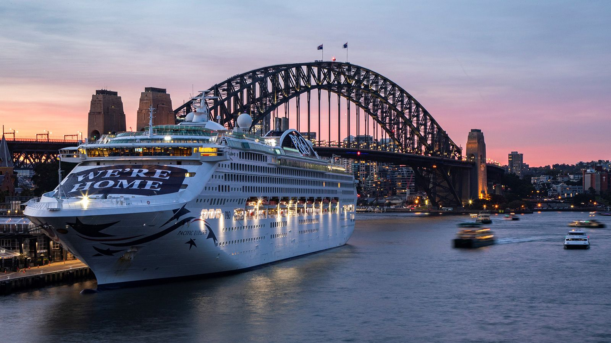

*Figure 2 (*[*https://edition.cnn.com/travel/article/future-of-cruising-cmd/index.html*](https://edition.cnn.com/travel/article/future-of-cruising-cmd/index.html)*)*

Cruising has become an increasingly popular way to travel in recent years, and it’s easy to understand why. A cruise vacation offers a unique and luxurious experience that can’t be found on land, allowing passengers to explore multiple destinations in one trip without the stress of packing and unpacking. On a cruise, travelers can enjoy delicious meals, exciting onboard activities, and the company of other vacationers with similar interests. With so many ships and itineraries to choose from, there's a cruise for everyone. Whether you’re looking for a romantic getaway, an adrenaline-filled adventure, or simply a chance to relax, a cruise vacation can offer it all. Plus, with so many amenities available on board, you’ll never run out of things to do. From swimming pools and spas to casinos and nightclubs, there’s something for everyone. Plus, with experienced staff on board, you can rest assured that your cruise will be a safe and enjoyable experience. So, why not explore the world on a cruise and experience a vacation like no other?  
The price of a cruise vacation can vary significantly depending on the cruise line, the ship, and the destination. There are five main segments of the cruise industry: luxury, premium, contemporary, river, and expedition (Cruise Critic, 2021). Luxury cruises typically offer the most luxurious experience and will often have the highest price tag. Premium cruises offer a slightly less luxurious experience, but they still provide travelers with a comfortable and enjoyable experience. Contemporary cruises are the most popular type of cruise and often offer the best value for money. River cruises are great for travelers who want to explore smaller destinations and experience a more intimate atmosphere. Finally, expedition cruises offer travelers the opportunity to explore remote and rarely visited destinations.

Cruise vacations are a great way to explore a variety of destinations while enjoying the convenience of ocean travel. Cruise lengths can range from a few days to a few weeks, depending on the type of cruise you take. Popular cruise destinations include the Caribbean, Alaska, Europe, and the Mediterranean. In each of these regions, you can find cruises that offer an incredible array of activities and experiences. In the Caribbean, you can enjoy a relaxing vacation with plenty of sun, sand, and sea. You can visit the islands of Jamaica, Barbados, or the Bahamas and enjoy their beautiful beaches, bustling cities, and lively nightlife. On an Alaskan cruise, you can experience the majestic beauty of glaciers, rugged mountains, and wildlife. You may also have the opportunity to visit some of the indigenous villages and observe their culture. A cruise vacation to Europe is a great way to explore a wide variety of cultures, sights, and experiences. You can visit cities like London, Paris, and Rome and wander the historic streets, visit iconic landmarks, and enjoy the local cuisine. A Mediterranean cruise is a great way to explore a variety of countries and cultures, including Spain, Italy, Greece, and Turkey. Here, you can experience the unique customs, cuisine, and architecture of each country. No matter which cruise vacation you choose, you are sure to have an unforgettable experience. With a range of destinations, activities, and experiences, you can create the perfect cruise vacation for your needs.

Cruise vacations are becoming increasingly popular for all types of travelers, not just the elderly. Cruise lines have taken notice, and now offer activities and entertainment for passengers of all ages and interests. Children can join clubs and activities specifically tailored to their age group, while adults can enjoy casinos, live music, comedy shows, and other special events. Of course, there are plenty of opportunities to simply relax and enjoy the scenery. Cruise vacations are a great way to explore the world and make lasting memories with friends and family.  
Cruises are a great way to explore the world while still enjoying the comforts of home. With a wide selection of activities and destinations, it’s no wonder why cruising is becoming more popular (Travel & Leisure, 2018). Onboard, you’ll find a variety of entertainment and leisure activities, from swimming pools and spas to rock-climbing walls and movie theaters. There’s also plenty of dining options, ranging from buffets to fine dining restaurants. On a cruise, you’ll also have the opportunity to explore multiple ports of call without having to worry about unloading your luggage. Each day you’ll be able to take part in guided tours and excursions that will give you an unforgettable experience. For those who want to explore further, most ships offer shore excursions and activities that will allow you to explore the land and sea. It’s also important to note that a cruise can be as relaxing or as active as you’d like. You can choose to stay onboard and enjoy the amenities the ship has to offer, or you can take part in activities like kayaking and snorkeling. No matter what you choose to do, you’ll be sure to have a great time. Although there are still some people who are hesitant to try a cruise, there are so many benefits that make it a great vacation option. With its wide selection of activities, ports of call, and amenities, it’s no wonder why so many people choose to cruise. Not only is it a great way to explore the world, but it’s also a great way to relax and unwind.  
Cruise vacations are marketed to a variety of travelers, from families to couples to solo travelers (Cruise Lines International Association, 2020). No matter what your interests or budget, there’s a cruise for you. Cruise vacations offer a unique combination of luxury, comfort, and adventure. They provide travelers with the opportunity to visit multiple destinations in one trip and experience different cultures.

Cruise vacations offer travelers a unique and luxurious way to explore the world (Lee, 2019). These trips typically provide guests with all-inclusive accommodations, delicious meals, and exciting onboard activities. Moreover, cruise ships provide travelers with the opportunity to explore multiple destinations in one trip and experience different cultures, something that is not possible with a single-destination vacation. Additionally, cruise vacations are often more affordable than other vacation options, making them a great choice for budget-conscious travelers. When booking a cruise vacation, travelers have a wide variety of options to choose from. Depending on the desired experience, travelers can choose from a variety of ships, featuring amenities such as spas, casinos, fitness centers, and luxury suites. Cruise ships also offer a variety of onboard entertainment options, including live music, theatrical performances, and movies. Additionally, many cruise ships offer shore excursions and other activities, allowing travelers to get an in-depth look at the destinations they visit. For those looking for a truly luxurious experience, there are also luxury cruises available. These cruises typically feature more luxurious accommodations and services, such as Butler service, private balconies, and exclusive dining experiences. Luxury cruises also offer more personalized experiences, such as private shore excursions, spa treatments, and personalized amenities. Whether travelers are looking for an affordable way to explore the world or a luxurious experience, cruise vacations offer something for everyone. With the variety of ships and destinations available, there is sure to be the perfect cruise for any traveler.

At Discover the World Travel Agency, we specialize in cruise vacations and we want to help you make the most of your experience. We understand that it can be intimidating to book a cruise, so we’re here to answer any questions that you might have and provide you with all of the information you need to make an informed decision. Contact us today to find out more about our cruise packages and to book your next cruise vacation.

**References**

Cruise Lines International Association (CLIA). (2020). Cruise vacation planning: What you need to know. Retrieved from <https://cruising.org/cruise-vacations/planning/what-you-need-to-know>

Lee, D. (2019). The future of cruising: What does the cruise industry have in store for us? CNN Travel. Retrieved from <https://edition.cnn.com/travel/article/future-of-cruising-cmd/index.html>

Cruise Critic. (2021). Types of cruises: What's the best cruise for you? Retrieved from <https://www.cruisecritic.com/articles.cfm?ID=27>

Cruise Critic. (2023). Cruise ship activities: What to do on a cruise. Retrieved from <https://www.cruisecritic.com/articles.cfm?ID=21>

Travel & Leisure. (2018). Luxury cruises: All you need to know. Retrieved from <https://www.travelandleisure.com/cruises/luxury-cruises-all-you-need-to-know>