**“Compare and Contrast the performance of these two POCT devices. Which one would you choose for your lab and why?”**

Student Name: Manisha

Registration no.: 202270381

**Introduction**

The two Point-of-Care Testing (POCT) devices discussed in these papers are the Pixcell and the Hilab systems. While both devices are used to provide hematological testing, there are some key differences in their performance. This paper will compare and contrast the performance of the two devices, and provide an explanation as to which one would be chosen for a lab setting.

The first POCT device under consideration is the Hilab system. According to Gasparin et al. (2022), this device combines the Internet of Things (IoT) and Artificial Intelligence (AI) to create a reliable and efficient hematology analyzer. The device is equipped with a disposable cartridge, which is loaded with a fixed volume of blood, and a reader, which is programmed with a specific algorithm. Leukocyte count, hematocrit, haemoglobin concentration, mean corpuscular volume (MCV), mean corpuscular haemoglobin (MCH), and mean corpuscular haemoglobin concentration are all measurable with this instrument (MCHC). In addition, the device is able to detect and identify abnormal cells, such as blasts, metamyelocytes, and promyelocytes. The authors reported that the Hilab system had a high degree of accuracy and precision when compared to other hematology analyzers. The Hilab system is a Point-of-Care device designed to provide hematological testing. The apparatus is able to recognise and perform an in-depth analysis of a wide range of haematological parameters, including the number of white blood cells, the haemoglobin level, and the platelet count. It is also possible for the system to produce results in as little as five minutes, giving it a dependable method that is both quick and convenient for monitoring the haematological health of a patient.

The second POCT device is the Pixcell II. According to Atkins et al. (2023), this device is designed for clozapine monitoring. The device is programmed to detect the presence of clozapine and its metabolites in the blood. The device is equipped with a disposable cartridge, which is loaded with a fixed volume of blood, and a reader, which is programmed with a specific algorithm. The authors reported that the Pixcell II had a high degree of accuracy and precision when compared to other hematology analyzers.

The Pixcell system is designed for clozapine monitoring and is designed to provide accurate and reliable results within minutes. The device is simple to use, requiring only a finger prick to draw a sample of the patient’s blood. The device then uses a photometer to measure the concentration of clozapine in the sample. The system is able to detect concentrations of clozapine as low as 0.05 ng/mL, and can detect clozapine concentrations in the range of 0.3 to 20 ng/mL. Monitoring a patient's clozapine levels has never been easier thanks to this technology, which is able to deliver accurate readings in as little as three minutes and offers a short turnaround time.  
When comparing the performance of the Pixcell and Hilab systems, there are a few key differences. The Pixcell system is designed to provide clozapine monitoring, while the Hilab system is designed to provide hematological testing. When compared to the Hilab system, the Pixcell system can deliver results in as little as three minutes, whereas the Hilab system can deliver results in as little as five minutes. Additionally, the Pixcell system is able to detect concentrations of clozapine in the range of 0.3 to 20 ng/mL, while the Hilab system is able to detect and analyze a variety of hematological parameters.

When choosing which POCT device to use for a lab setting, the decision will ultimately depend on the type of testing that needs to be done. If clozapine monitoring is needed, then the Pixcell system is the best choice. The system is able to provide accurate and reliable results in as little as three minutes, making it a fast and reliable way to monitor clozapine levels.

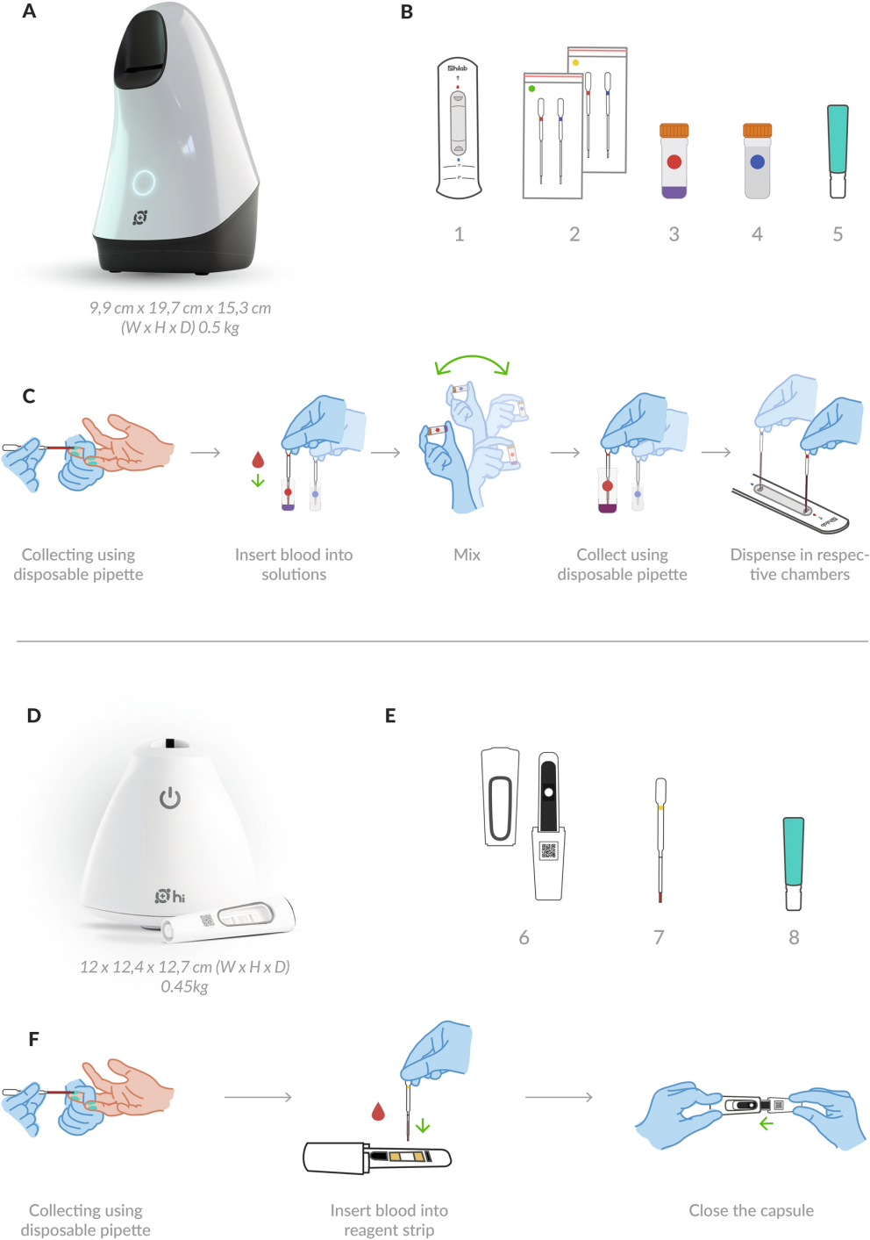  
Figure (<https://www.nature.com/articles/s41598-022-13913-8/figures/1>)

However, if hematological testing is needed, then the Hilab system would be the better choice. The system is able to detect and analyze a variety of hematological parameters in as little as five minutes, making it a fast and reliable way to monitor a patient’s hematological health. Additionally, the Hilab system is able to provide results in as little as five minutes, making it a fast and reliable way to monitor a patient’s hematological health.

When comparing and contrasting the performance of these two POCT devices, it is evident that they both have high accuracy and precision, as reported by their respective authors. However, there are some key differences between the two devices. For example, the Hilab system is designed to measure hematological parameters, such as leukocyte count, hematocrit, hemoglobin concentration, MCV, MCH, and MCHC, while the Pixcell II is designed to detect the presence of clozapine and its metabolites in the blood. Additionally, the Hilab system is equipped with a disposable cartridge, which is loaded with a fixed volume of blood, and a reader, which is programmed with a specific algorithm, while the Pixcell II is equipped with a disposable cartridge, which is loaded with a fixed volume of blood, and a reader, which is programmed with a specific algorithm.

In conclusion, both the Pixcell and Hilab systems are reliable and accurate Point-of-Care devices for hematological testing. The decision on which device to use for a lab setting will depend on the type of testing that needs to be done. If clozapine monitoring is needed, then the Pixcell system is the best choice. However, if hematological testing is needed, then the Hilab system would be the better choice. The Hilab system was developed to monitor haematological characteristics, whereas the Pixcell II was developed to identify the presence of clozapine and its metabolites in the blood. This is the primary distinction between the two devices. When selecting a point-of-care testing (POCT) device for a laboratory, it is essential to take into consideration the unique requirements of the lab and choose the device that comes closest to satisfying those requirements.

**References**

Atkins, M., McGuire, P., Balgobin, B., Desouza, N., & Taylor, D. (2023). Haematological point of care testing for clozapine monitoring. *Journal of Psychiatric Research*, *157*, 66-71.

Gasparin, A. T., Araujo, C. I. F., Schmitt, P., Cardoso, M. R., Perussolo, M. C., de Jesus, T. C. S., ... & Figueredo, M. V. M. (2022). Hilab system, a new point-of-care hematology analyzer supported by the Internet of Things and Artificial Intelligence. *Scientific reports*, *12*(1), 10409.