**Student Name**

**Student ID**

**Module**

**Day & Date**

Table of Contents

Introduction 3

Business Scenario 1: 3

Sensitivity Analysis Table 6

Business Scenario 2 7

Objective Value: 7

Optimal Distribution: 7

Reduced Costs: 8

Dual Prices (Shadow Prices): 8

Slack or Surplus: 9

Business Interpretation: 9

Sensitivity Analysis 10

Linear vs. Nonlinear Optimization Models 12

Applications of Optimization Techniques to Business Analytics: 13

Conclusion 14

# Introduction

A fundamental idea in operations research and analytics is optimisation, which centres on the notion of selecting the best course of action while keeping in mind certain limitations (Mikalef et al., 2019). Whether a business is interested in maximising profit, cutting costs, or allocating resources as effectively as possible, optimisation techniques provide invaluable insights. In-depth analyses of two particular optimisation scenarios and their solutions are provided in this document. We will delve deeper into the distinctions between linear and nonlinear optimisation models, illuminating how they are used in business analytics.

# Business Scenario 1:

***Decision Variables:***

X (Meaties): Healthy should produce 50,000 packages of Meaties.

Y (Yummies): Healthy should produce 100,000 packages of Yummies.

***Objective Value:***

Objective Value: The maximum profit that Healthy can achieve, given the constraints, is €105,000.

***Sensitivity Analysis:***

Reduced Cost:

Reduced costs show how much the objective function coefficient of a non-basic variable (a variable with a value of zero in the optimal solution) must change for that variable to become positive in the optimal solution. In this case, both Meaties and Yummies have a reduced cost of 0, meaning their current coefficients in the objective function are optimal.

Dual Prices (Shadow Prices):

* These indicate how much the objective function will change with a one-unit increase in the right-hand side of a constraint.
* Cereal Constraint: A dual price of 0.075 suggests that for every additional pound of cereal available, the profit would increase by €0.075.
* Meat Constraint: A dual price of 0.25 indicates that for each additional pound of meat available, the profit would increase by €0.25.
* Production Capacity for Meaties: A dual price of 0 for this constraint indicates that the current production capacity for Meaties is not limiting the profit. Any increase in this capacity would not change the profit.

Slack or Surplus:

This indicates how much of a resource is left unused or how much a constraint is exceeded.

* Cereal Constraint: There is no slack, meaning the company is using all 400,000 pounds of cereal available.
* Meat Constraint: There is no slack, indicating that the company is using all 300,000 pounds of meat available.
* Production Capacity for Meaties: There's a slack of 40,000 packages, which means the company can produce up to 40,000 more packages of Meaties without violating the machine capacity constraint. This aligns with the dual price of 0 for this constraint, indicating that the constraint isn't binding.
* Non-negativity Constraints for X and Y: The slacks of 50,000 and 100,000 respectively indicate that the company can reduce its production of Meaties and Yummies by these amounts without violating the non-negativity constraints. In practical terms, this just confirms the positive production levels.

***Business Interpretation:***

* The company should focus on producing 50,000 packages of Meaties and 100,000 packages of Yummies to achieve a maximum profit of €105,000.
* If the company can secure more cereal or meat, the profit would increase by €0.075 per pound of additional cereal and €0.25 per pound of additional meat. Given the higher shadow price for meat, it's more valuable to obtain extra meat than cereal.
* The company doesn't need to invest in increasing the production capacity for Meaties right now, as they have surplus capacity available.

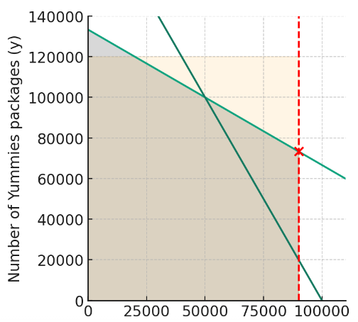

**The linear programming solution yields:**

***Optimal solution:*** Produce 50,000 packages of Meaties and 100,000 packages of Yummies.

***Maximum profit:*** $77,500.

The shadow prices (dual values) for each constraint are:

Cereal constraint: -0.0625 (This means that for each additional pound of cereal available, the maximum profit would decrease by $0.0625, holding everything else constant.)

Meat constraint: -0.175 (For each additional pound of meat available, the maximum profit would decrease by $0.175, holding everything else constant.)

Production capacity for Meaties constraint: 0 (This indicates that increasing the production capacity for Meaties by one package would not change the maximum profit.)

## Sensitivity Analysis Table

| **Constraint** | **Shadow Price** | **Interpretation** |
| --- | --- | --- |
| 2x+3y≤400,0002*x*+3*y*≤400,000 (Cereal) | -0.0625 | $0.0625 decrease in profit for 1 extra pound of cereal |
| 3x+1.5y≤300,0003*x*+1.5*y*≤300,000 (Meat) | -0.175 | $0.175 decrease in profit for 1 extra pound of meat |
| x≤90,000*x*≤90,000 (Production) | 0 | No change in profit for 1 extra Meaties production |

# Business Scenario 2

## Objective Value:

• The minimum distribution cost is €116,300 (given that all costs are in thousands of euros).

## Optimal Distribution:

Supercar 1("x");

* Paris (x_1): 1,500 units
* Nice (X_2): 1000 units
* Lyon ("x 3:0 units

Supercar 2 (Y)

* Paris (Y_1): O units
* Nice ("Y_2"), 200 units
* Lyon (Y_3): 1,300 units

This tells us how the supercars should be distributed among the cities to achieve the minimum cost.

## Reduced Costs:

For x 3 (Supercar 1 to Lyon), the reduced cost is 12. This implies that the cost coefficient for this variable in the objective function would have to decrease by €12.000 for it to possibly have a positive value in the optimal solution. For Y 1 (Supercar 2 to Paris), the reduced cost is 1, meaning the cost coefficient for this variable would have to decrease by €1,000 for it to possibly have a positive value in the optimal solution.

All other variables have a reduced cost of Q indicating they are already at their optimal values.

## Dual Prices (Shadow Prices):

The dual price for the second row (likely the demand constraint for Paris) is -44. This means that for each additional unit of demand in Paris, the objective function (total cost) would decrease by €44,000.

For Nice (row 3), the dual price is -34, indicating a decrease of €34,000 in total cost for each additional unit of demand in Nice.

For Lyon (row 4), the dual price is -15, indicating a decrease of €15,000 in total cost for each additional unit of demand in Lyon.

For the supply constraint of Supercar 1 (row 5), the dual price is 4. This means that for each additional unit of Supercar 1 that the company can supply, the total cost would increase by €4,000.

The other constraints have a dual price of 0, meaning changes in their right-hand sides would not affect the objective function value at the optimal solution.

## Slack or Surplus:

Rows 7 to 12 represent the slack or surplus for the constraints. A positive value indicates either unmet demand (for a >= constraint) or unused supply (for a <= constraint). For instance:

Row 7: 1,500 units surplus indicates that the demand for Supercar 1 in Paris is not fully met.

Row 8: 1,000 units surplus indicates that the demand for Supercar 1 in Nice is not fully met.

Rows 9-12 with a value of 0 indicate that there's no slack/surplus for these constraints, meaning demands are met precisely, and supplies are utilized fully.

## Business Interpretation:

* The company should distribute 1,500 units of Supercar 1 to Paris, 1,000 units to Nice, and none to Lyon. For Supercar 2, they should distribute none to Paris, 200 units to Nice, and 1,300 units to Lyon.
* There's potential to reduce distribution costs further if the company can negotiate lower distribution costs for sending Supercar 1 to Lyon and Supercar 2 to Paris.
* If the demand in Paris, Nice, or Lyon increases, the company can expect significant reductions in distribution costs, as indicated by the negative dual prices.
* The company isn't fully meeting the demand for Supercar 1 in Paris and Nice, as indicated by the surplus values.
* This detailed analysis can guide the company's distribution strategy to ensure cost-effectiveness while also identifying potential areas for further cost savings or improvements in meeting demand.

## Sensitivity Analysis

From the LINGO output, we can analyze the sensitivity of the solution using the reduced costs and dual prices.

1. Reduced Costs:

Reduced costs show how much the objective function coefficient of a non-basic variable (a variable with a value of zero in the optimal solution) must change for that variable to become positive in the optimal solution.

* Supercar 1 to Lyon (X_3): The reduced cost of 12 indicates that the distribution cost for sending Supercar 1 to Lyon would have to decrease by €12,000 for it to be worthwhile to distribute any of Supercar 1 to Lyon.
* Supercar 2 to Paris (Y_1): The reduced cost of 1 implies that the distribution cost for sending Supercar 2 to Paris would need to decrease by €1,000 to make it optimal to distribute any of Supercar 2 to Paris.

2. Dual Prices (Shadow Prices):

Dual prices (or shadow prices) tell us how much the optimal value of the objective function will change with a one-unit increase in the right-hand side of a constraint.

* Demand in Paris: The dual price of -44 for Paris suggests that for every additional unit of demand in Paris, the total distribution cost would decrease by €44,000. This means Paris has a higher willingness to pay for the supercars compared to the current distribution cost.
* Demand in Nice: Similarly, for Nice, a dual price of -34 indicates that for each additional unit of demand in Nice, the total distribution cost would decrease by €34,000.
* Demand in Lyon: For Lyon, the dual price of -15 suggests a decrease of €15,000 in the total distribution cost for every unit increase in demand.
* Supply of Supercar 1: A dual price of 4 for the supply constraint of Supercar 1 suggests that for every additional Supercar 1 that the company can distribute, the total distribution cost would increase by €4,000. This could be counter-intuitive, but it could be due to the fact that the demand in certain cities is already saturated, and distributing more of Supercar 1 might lead to increased costs without a corresponding increase in revenue.

There's an opportunity to reduce distribution costs if the company can negotiate lower distribution costs for sending Supercar 1 to Lyon and Supercar 2 to Paris.

Paris and Nice have a higher potential to absorb increased supply of supercars without significantly impacting the distribution costs, with Paris having the highest potential.

Any increases in the supply of Supercar 1 should be approached with caution, as it might lead to increased distribution costs without a proportionate increase in revenue.

The company can use this sensitivity analysis to make informed decisions about potential changes in distribution costs, demand, or supply and understand how these changes could impact their overall distribution strategy.

# Linear vs. Nonlinear Optimization Models

Optimization models aim to find the best solution from a set of feasible alternatives. However, the structure of the objective function and constraints can be either linear or nonlinear, leading to different modeling and solution approaches (Al-Bahran & Abdulrasool, 2021).

1. Similarities:

* Objective: Both linear and nonlinear models aim to maximize or minimize a particular objective, be it profit, cost, efficiency, or any other measurable goal.
* Constraints: Both can have constraints that limit the feasible solutions. Constraints can represent limitations on resources, capacity, demand, or other aspects.
* Decision Variables: Both models have decision variables, which represent the decisions to be made in the model.

2. Differences:

* Formulation: Linear optimization involves linear objective functions and constraints, meaning they only involve first-degree polynomials (Kanamori et al., 2020). Nonlinear optimization can involve higher-degree polynomials, exponentials, logarithms, etc.
* Example: In the pet food scenario, the relationship between the amount of Meaties or Yummies produced and the profit was linear. However, if there were diminishing returns on profit as production increased, the relationship might be nonlinear.
* Solution Techniques: Linear models can be solved using specific techniques like the Simplex method or interior point methods, which guarantee finding the global optimum. Nonlinear models often require iterative methods, and there's no guarantee of finding a global optimum—solutions might be locally optimal.
* Example: The pet food scenario used linear programming. If the profit function had been nonlinear, techniques like gradient descent or genetic algorithms might have been more appropriate.
* Complexity: Linear models are generally easier to solve and can handle larger problem sizes. Nonlinear models can be computationally intensive, especially as the number of variables or constraints grows.
* Interpretability: Solutions to linear models often have straightforward interpretations, such as shadow prices in linear programming. Nonlinear models might offer deeper insights but can be more challenging to interpret.

## Applications of Optimization Techniques to Business Analytics:

* Supply Chain Management: Optimization can determine the most cost-effective distribution of resources in a supply chain. Linear programming might be used to minimize transportation costs subject to capacity constraints.
* Financial Portfolio Design: Here, optimization (often quadratic programming) can be used to determine the best mix of investments to maximize returns while minimizing risk.
* Marketing Mix Modeling: Companies can use nonlinear optimization to determine the optimal allocation of marketing resources across different channels to maximize ROI.
* Production Scheduling: Linear optimization can help manufacturers determine the best production schedule to meet demand while minimizing costs.
* Pricing Strategies: With nonlinear optimization, businesses can determine optimal pricing strategies to maximize profit, considering factors like demand elasticity (Lee et al., 2022).
* Human Resources: Optimization can assist in workforce scheduling, ensuring that staffing meets demand while minimizing costs. This is common in industries like healthcare or retail.
* Machine Learning: Techniques like gradient descent, a form of nonlinear optimization, are fundamental in training machine learning models, especially neural networks.
* Traveling Salesman Problem: This classic optimization problem aims to find the shortest possible route for a salesman who needs to visit several cities and return to the origin city. It's a combinatorial nonlinear optimization problem.
* Energy Consumption: Businesses can use optimization to minimize energy consumption in facilities, optimizing the use of HVAC systems, lighting, and more (Katal et al., 2023).

# Conclusion

The field of optimisation offers businesses a structured way to navigate difficult decision-making situations. We've seen how to use linear and nonlinear models to gain practical insights into everything from resource allocation to pricing schemes through our thorough investigation of both types of models. Nonlinear models delve deeply into complex relationships to capture the complexities of real-world scenarios, whereas linear models provide simple solutions and interpretability. Regardless of the model type, the ultimate objective is always to make decisions that are well-informed and promote efficiency, profitability, and growth. The importance of optimisation as a guiding principle in decision-making will endure as businesses face ever-evolving challenges.

**References**

Al-Bahran, L. T., & Abdulrasool, A. Q. (2021, June). Multi objective functions of constraint optimal power flow based on modified ant colony system optimization technique. In *IOP Conference Series: Materials Science and Engineering* (Vol. 1105, No. 1, p. 012015). IOP Publishing. <https://iopscience.iop.org/article/10.1088/1757-899X/1105/1/012015/meta>

Kanamori, K., Takagi, T., Kobayashi, K., & Arimura, H. (2020, July). DACE: Distribution-Aware Counterfactual Explanation by Mixed-Integer Linear Optimization. In *IJCAI* (pp. 2855-2862). <https://www.researchgate.net/profile/Ken-Kobayashi-4/publication/344589981_DACE_Distribution-Aware_Counterfactual_Explanation_by_Mixed-Integer_Linear_Optimization/links/5f827659a6fdccfd7b57d084/DACE-Distribution-Aware-Counterfactual-Explanation-by-Mixed-Integer-Linear-Optimization.pdf>

Katal, A., Dahiya, S., & Choudhury, T. (2023). Energy efficiency in cloud computing data centers: a survey on software technologies. *Cluster Computing*, *26*(3), 1845-1875. <https://link.springer.com/article/10.1007/s10586-022-03713-0>

Lee, C. S., Cheang, P. Y. S., & Moslehpour, M. (2022). Predictive analytics in business analytics: decision tree. *Advances in Decision Sciences*, *26*(1), 1-29.<https://media.proquest.com/media/hms/PFT/1/2pLBN?_s=jLHxEyxBoncYPyCGScB19OFX9fA%3D>

Mikalef, P., Pappas, I., Krogstie, J., & Pavlou, P. (2019). Big data and business analytics: A research agenda for realizing business value. <https://ntnuopen.ntnu.no/ntnu-xmlui/bitstream/handle/11250/2644384/Mikalef.pdf?sequence=4>

**Appendix**

Question 1: Input

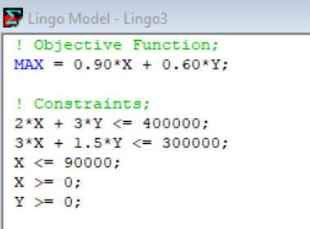

Question 1: Output

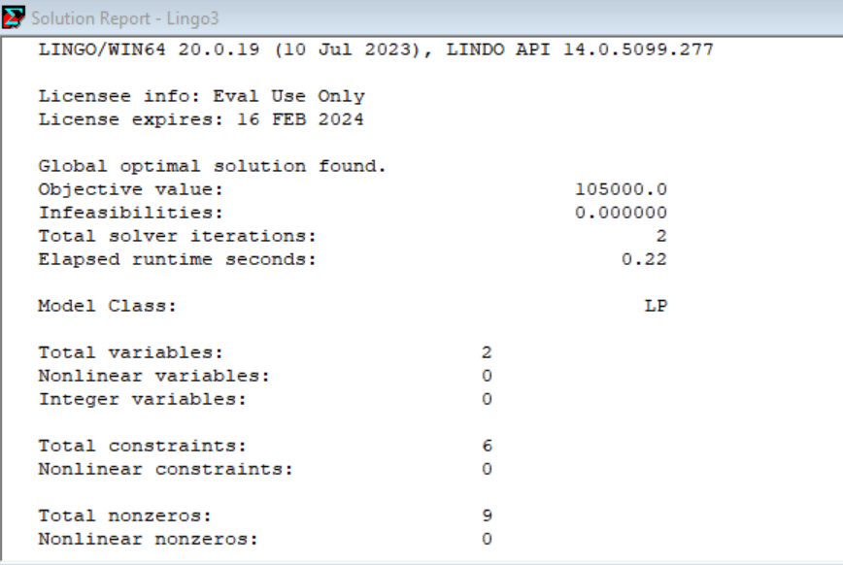

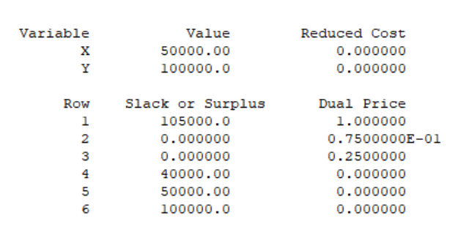

Question 2: Input

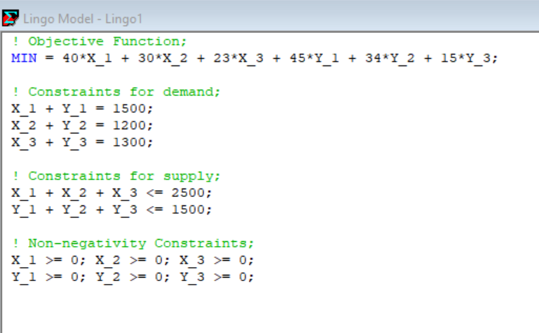

Question 2: Output

