DATA SCIENCE MINOR PROJECT REPORT

CONTENTS OF THE REPORT
- Cover page
- Declaration
- Certificate
- Acknowledgement
- Table of Content

1. Introduction
2. Source of dataset
3. EDA process
4. Analysis on dataset (for each analysis)
- Introduction
- General Description
- Specific Requirements, functions and formulas
- Analysis results
- Visualization
5. Conclusion
6. Future scope
7. References

Other Conventions

- Please note the case of letters in the cover page: The 3rd line is 16 pt bold and other lines are 12 pt. The page is centred. Department and Institute names are bold.
- All the matter contained in the report should be typed in MS word (1.5 spacing) Times New Roman, 12 pt or equivalent with other software.
- Figures and tables may be inserted in the text as they appear or may be appended in order.
- Table of Content shall be in well hyperlinked
- List of figures and tables shall be maintained with captions in MS word.
- List of references shall be appended at the end.
- References shall be in IEEE format
- Total Number of pages with A4 size paper shall be minimum 30 pages and maximum 80 pages.
- Hard copy of report must be available with each student on the day of evaluation.
- In addition to Hard copy of reports e-copy shall also be submitted. An e-copy of the report shall be submitted by the student to respective teacher on their emails.

INTRODUCTION TO DATA MANAGEMENT
PROJECT REPORT
(Project Semester January-April 2025)

REAL TIME AIR QUALITY INDEX ANALYSIS

Submitted by

Anmol Kannaujiya

Registration No: 12314634

Programme and Section: BTech Computer Science and Engineering
Course Code: INT217

Under the Guidance of

Baljinder Kaur (UID: 32130), Assistant Professor

Discipline of CSE/IT

Lovely School of Computer Science and Engineering

Lovely Professional University, Phagwara

CERTIFICATE

This is to certify that Anmol Kannaujiya bearing Registration no. 12314634 has completed INT217 Introduction to Data Management project titled, “Real Time Air Quality Index Analysis” under my guidance and supervision. To the best of my knowledge, the present work is the result of his/her original development, effort and study.

Baljinder Kaur (UID: 32130)
Assistant Professor
School of Computer Science and Engineering
Lovely Professional University
Phagwara, Punjab.

Date: 13/04/2025

DECLARATION

I, Anmol Kannaujiya, student of Bachelor of Technology under CSE/IT Discipline at, Lovely Professional University, Punjab, hereby declare that all the information furnished in this project report is based on my own intensive work and is genuine.

Date: 12/04/2025 Signature
Registration No. 12314634 Anmol Kannaujiya

ACKNOWLEDGEMENT

I would like to express my sincere gratitude to everyone who supported me throughout this project.
This Excel-based project titled, “Real Time Air Quality Index Analysis” focused on analyzing real time air quality index and derive insights such as most and least polluted cities. I would like to express my heartfelt gratitude to my faculty Baljinder Kaur mam for their unwavering guidance and constant support throughout the course of this project. Their insights and encouragement played a crucial role in completing this work successfully. I also extend my sincere thanks to Lovely Professional University for providing me with the opportunity and resources to work on this data-driven project. This project has significantly enhanced my practical understanding of data analysis and Excel-based dashboard creation.

Table of Content

1. Introduction
2. Source of dataset
3. Cleaning Process
4. Dashboard Creation
- Introduction
- General Description
- Specific Requirements, functions and formulas
- Analysis results
- Visualization
5. Attachments
6. Conclusion
7. Future scope
8. References

INTRODUCTION

In recent years, the increasing concern over air pollution and its impact on human health, ecosystems, and climate has brought the importance of monitoring air quality to the forefront of environmental discourse. With growing urbanization and industrial activity, real-time insights into air quality data have become critical for both policymakers and citizens alike. This project focuses on addressing this need through the development of an interactive Excel-based dashboard that visualizes and analyzes real-time air quality data across multiple Indian cities and states.
The primary objective of this project is to transform raw environmental data into meaningful, interactive visual insights that can be used to understand the spatial and temporal distribution of air pollutants. By utilizing Microsoft Excel—a widely accessible and powerful analytical tool—I have designed a comprehensive dashboard that not only displays key air quality metrics but also allows users to filter and explore the data based on cities, states, and specific pollutants.
This dashboard serves as a bridge between raw environmental data and actionable insights. It highlights key aspects such as the most and least polluted cities, average AQI across states, and the relative contribution of different pollutants like PM2.5, PM10, NO2, CO, and more. The user-friendly interface, supported by slicers, maps, and charts, makes it easy for users to navigate the data and draw meaningful conclusions.
The development of this project was also an excellent opportunity to apply and enhance my skills in data cleaning, visualization, and dashboard design—all within Excel. Moreover, it represents a conscious effort to support environmental awareness and data-driven decision-making using publicly available government datasets.
Through this project, I aim to contribute towards the growing need for accessible and transparent environmental data tools, while simultaneously gaining hands-on experience in real-world data analysis and visualization practices.

Source of Data

Website: Data.gov.in
Source of Dataset: The dataset used in this project was obtained from the official Indian government open data portal: 🔗 Real-Time Air Quality Index Dataset – data.gov.in
It provides real-time air quality data across multiple Indian cities and includes various pollutants like CO, NO2, PM2.5, PM10, SO2, NH3, and OZONE, along with AQI values.

Dashboard creation Process

i. Introduction
The core outcome of this project is an interactive and visually engaging Real-Time Air Quality Index (AQI) Dashboard built using Microsoft Excel. The aim of the dashboard is to transform raw AQI data from various cities and states of India into a structured and easily interpretable visual format. This enables stakeholders—including students, researchers, policy-makers, and environmentally conscious individuals—to explore and understand air quality trends, pollutant compositions, and geographical variations in real-time.
This section elaborates on the design and development of the dashboard, which consolidates various analyses and visual elements into one integrated interface for user-friendly exploration.

ii. General Description
The dashboard consists of multiple interactive components that summarize the key findings and patterns in the dataset. It includes:
- Slicers to filter by City, State, and Pollutant
- Key KPIs such as National Average AQI, Maximum AQI (by State), and Minimum AQI (by State)
- Bar Chart for Top 10 Most Polluted Cities
- Map Chart showing AQI levels across Indian states
- Column Chart displaying AQI levels across cities
- Doughnut & Pie Charts to show Pollutant Composition and Overall Pollutant Share
The dashboard acts as the central hub that links all the exploratory data analysis, presenting the processed data through meaningful charts and graphs.

iii. Specific Requirements, Functions and Formulas
To build this dashboard, the following tools, techniques, and formulas were used within Excel:
- Pivot Tables and Pivot Charts: Used to aggregate AQI data by city, state, and pollutant type
- Slicers: Linked to pivot tables for real-time interactive filtering
- Map Chart (Power Map): Used to visually represent state-wise AQI with color gradient based on AQI severity
- Formulas Used:
  - AVERAGE() – To calculate national average AQI
  - MAX() and MIN() – To determine highest and lowest AQI among states
- Chart Types:
  - Clustered Bar Chart for "Top 10 Polluted Cities"
  - Column Chart for "AQI Level by Cities"
  - Doughnut Chart for "Pollutant Composition per City"
  - 3D Pie Chart for "Overall Share of Pollutants"
  - Map Chart for "AQI Level by State"
In addition, custom formatting and color themes were applied to enhance readability and visual aesthetics.

iv. Analysis Results
The dashboard highlighted several important insights:
- Delhi, Dewas, and Gurugram emerged as some of the most polluted cities with very high AQI values.
- States like Punjab and Odisha had higher maximum AQI values compared to others.
- The national average AQI was calculated to be 40.13, indicating relatively good air quality in some regions and high variation in others.
- PM2.5 and PM10 were found to be the dominant pollutants, contributing to 35% and 24%, respectively, of the overall pollution composition.
- Through slicers, users could explore the AQI of any selected city or state and study how specific pollutants varied geographically.

v. Visualization
Visual storytelling is a key strength of this dashboard. Key visual elements include:
- Top 10 Most Polluted Cities: A horizontal bar chart to easily compare cities based on AQI
- State-wise AQI Map: Colored map of India showing pollution distribution by state
- City-wise AQI Levels: A vertical bar chart showing comparative AQI across all cities
- Pollutant Composition per City: A doughnut chart showing percentage contribution of each pollutant in a selected city
- Overall Pollutant Share: A pie chart highlighting dominant pollutants on a national scale
- Interactive Slicers: Allowing real-time filtering of all charts by city, state, and pollutant type
These visuals enable quick interpretation, interactivity, and user-driven exploration, making the dashboard informative and intuitive.

Attachments

Linkedin Screenshot:

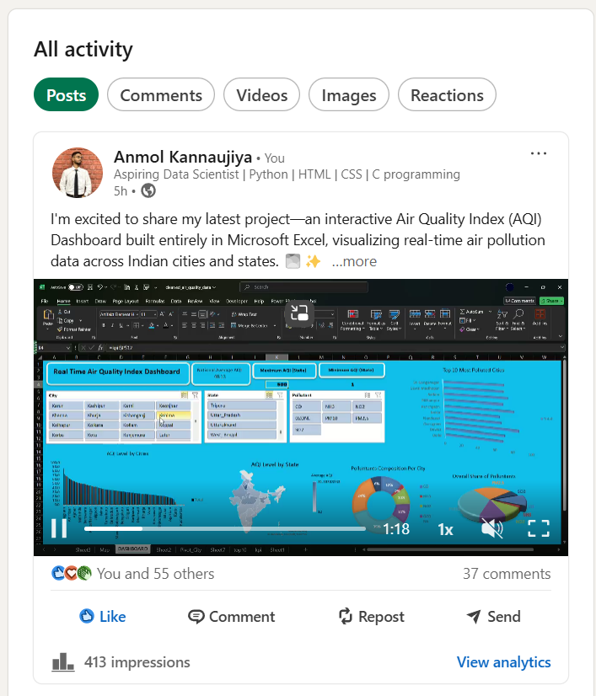
Conclusion

The Real-Time Air Quality Index Dashboard serves as a powerful analytical and visual tool to understand environmental conditions across India. Through comprehensive data cleaning, insightful analysis, and user-friendly visualizations, the project achieves its core objective: to present air quality data in a way that is both meaningful and accessible.
This dashboard not only highlights the pollution levels in major cities and states but also reveals the dominance of specific pollutants such as PM2.5 and PM10. The use of Excel for this project demonstrates its capability beyond traditional spreadsheets—showcasing dynamic data handling, pivoting, mapping, and dashboarding features.
By working on this project, I have gained hands-on experience in:
- Data cleaning and structuring,
- Performing exploratory data analysis (EDA),
- Using pivot tables and charts effectively,
- Creating interactive dashboards with slicers and visuals.
Ultimately, this project underscores the importance of data-driven environmental awareness and promotes transparency in air quality reporting using open government datasets.

Future Scope

While this project successfully delivers a functional and insightful dashboard, there are several directions for enhancement and future work:
- Real-Time Data Integration: Connecting the dashboard with live API feeds to auto-update AQI values.
- Predictive Analytics: Implementing forecasting techniques (e.g., regression or time series models) to predict future AQI trends.
- Automation with Power BI or Python: Migrating the dashboard to Power BI or integrating Python for better automation, performance, and scalability.
- Deeper Pollutant Analysis: Studying health impacts, pollutant sources, and time-of-day variations in AQI.
- Mobile-Friendly Design: Developing responsive dashboards for better accessibility on mobile devices.

References

Government of India Open Data Platform – Real-Time Air Quality Index:
🔗 https://www.data.gov.in/catalog/real-time-air-quality-index
Microsoft Excel Documentation – Pivot Tables and Dashboards:
🔗 https://support.microsoft.com/en-us/excel
Data Visualization Best Practices – Microsoft Learn
🔗 https://learn.microsoft.com/en-us/power-bi/visuals/power-bi-visualization-types
World Health Organization – Ambient (outdoor) air pollution
🔗 https://www.who.int/news-room/fact-sheets/detail/ambient-(outdoor)-air-quality-and-health

