Users Type in the Application
1. Admin
2. User
Admin
Here Admin have the different accessible right who can manage complete application
Modules
1. Login
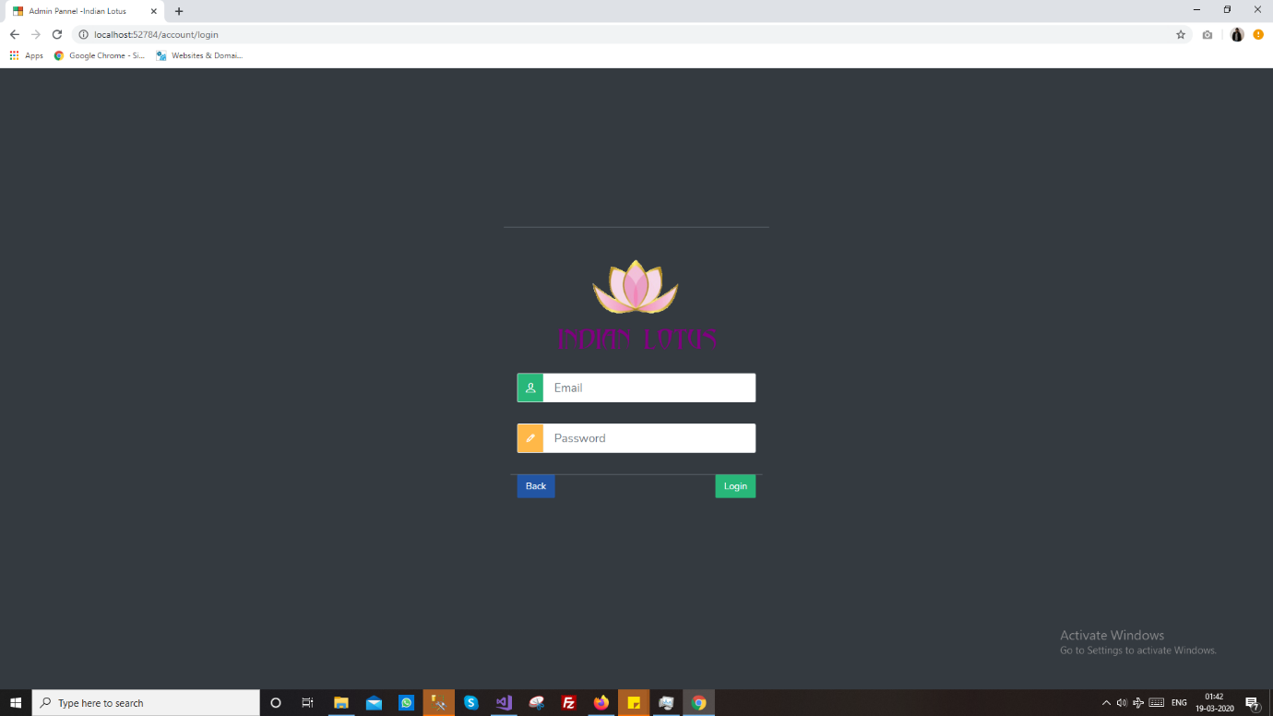
2. Dashboard
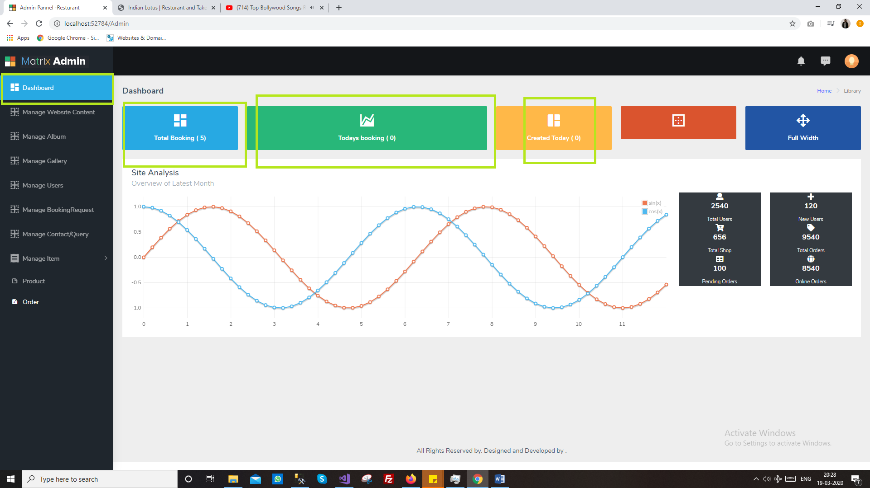
3. User Module
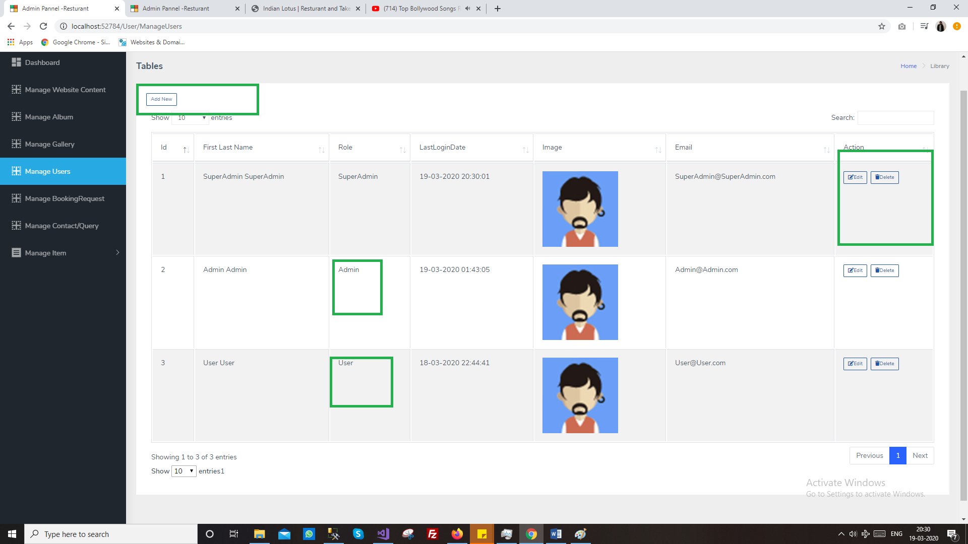
4. Slider Item (Home page image)
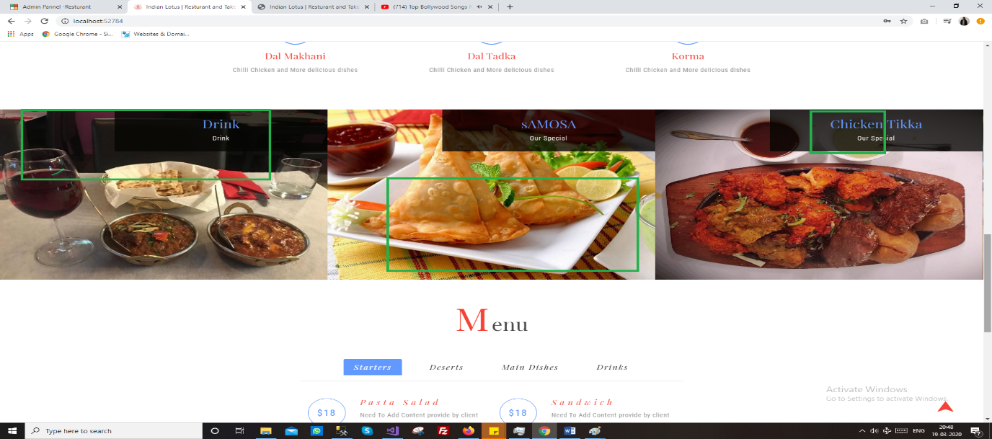
This screen will manage by admin to update from admin
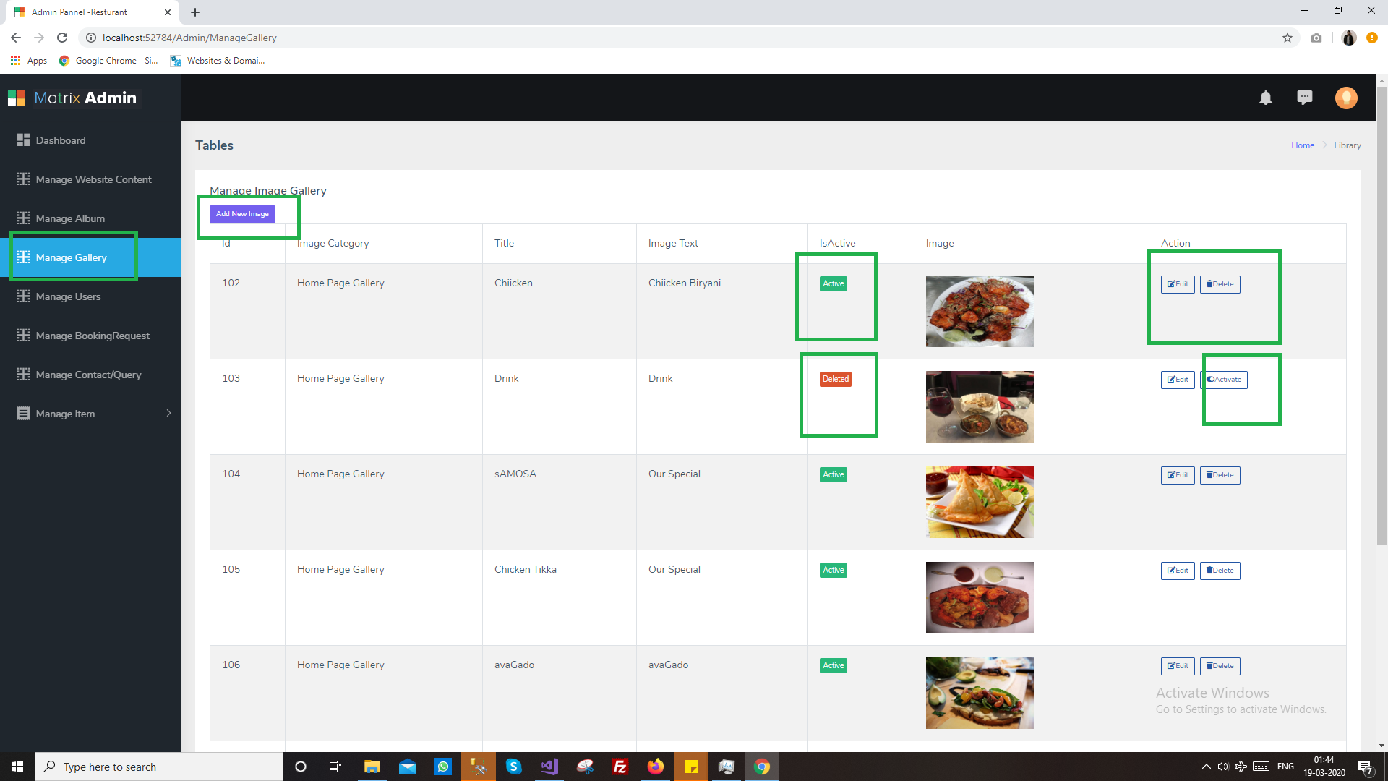
Edit/add screen for same
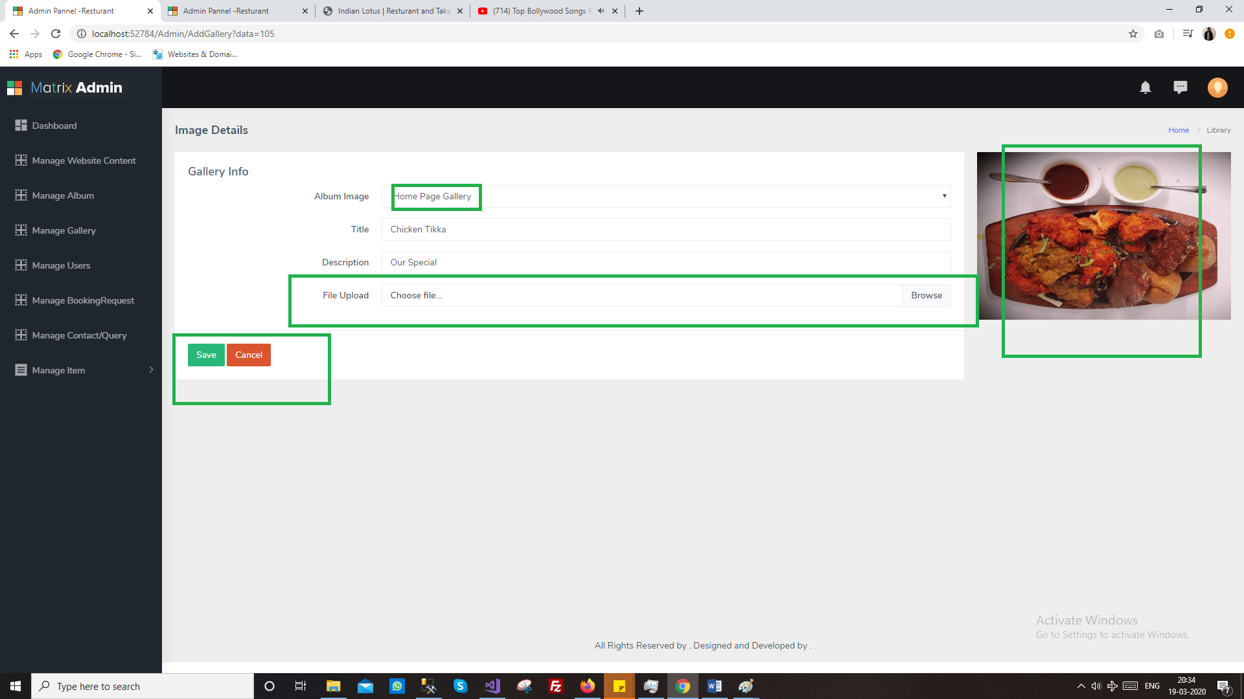
5. Menu Item
Manage item showing menus on home screen 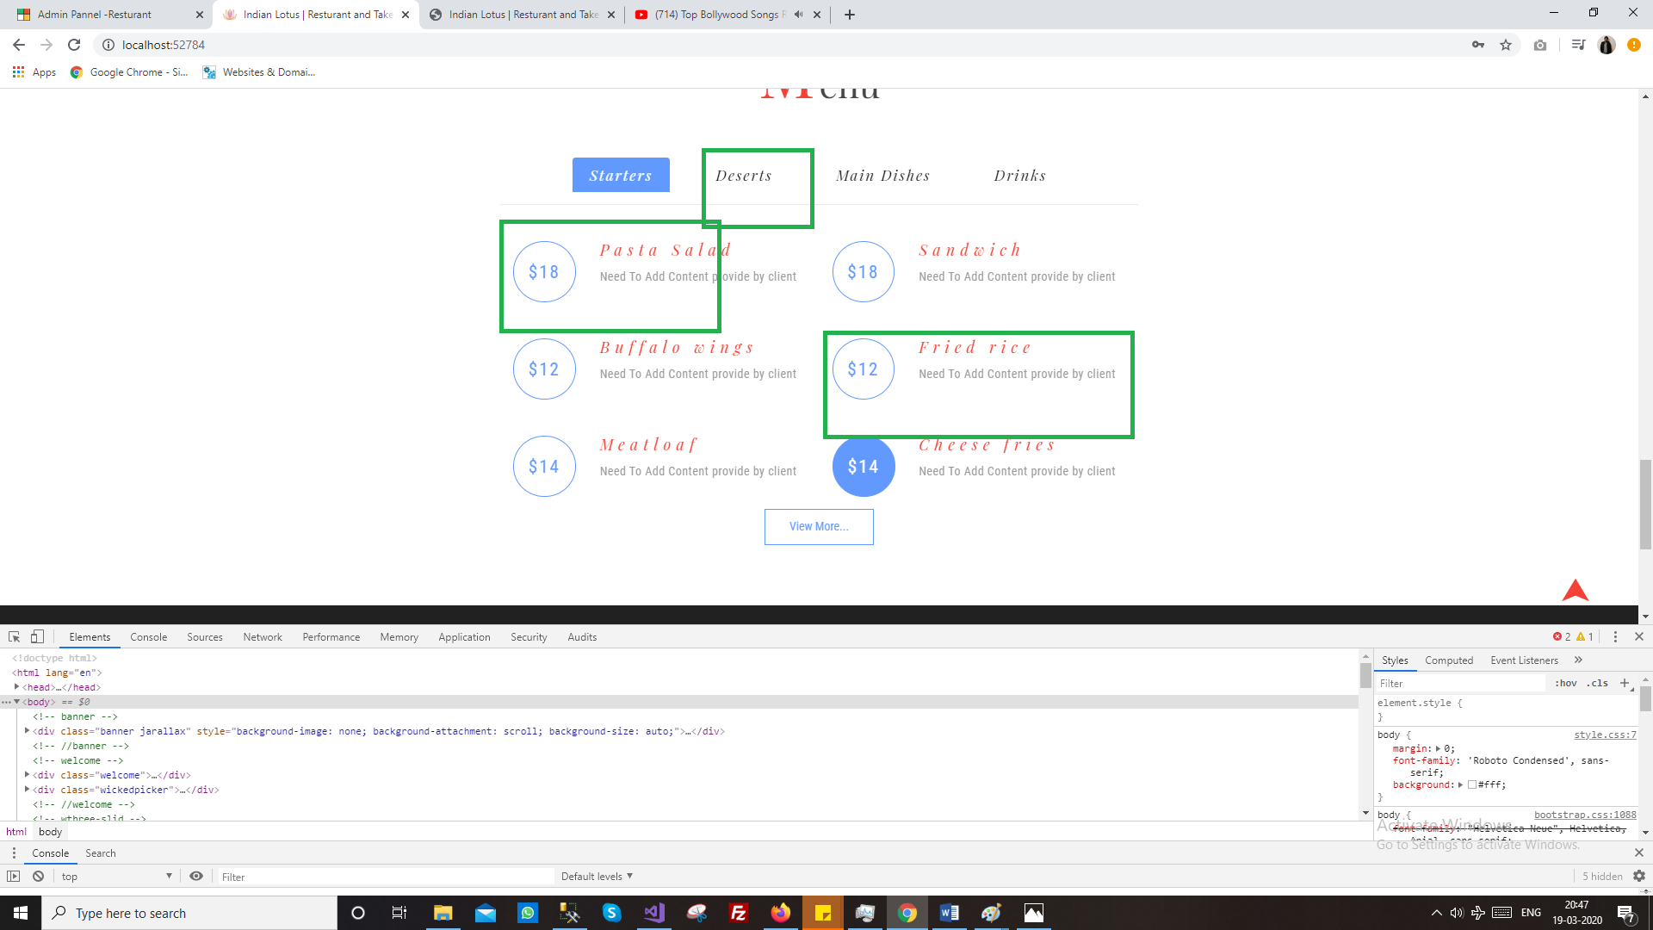

6. Booking Module
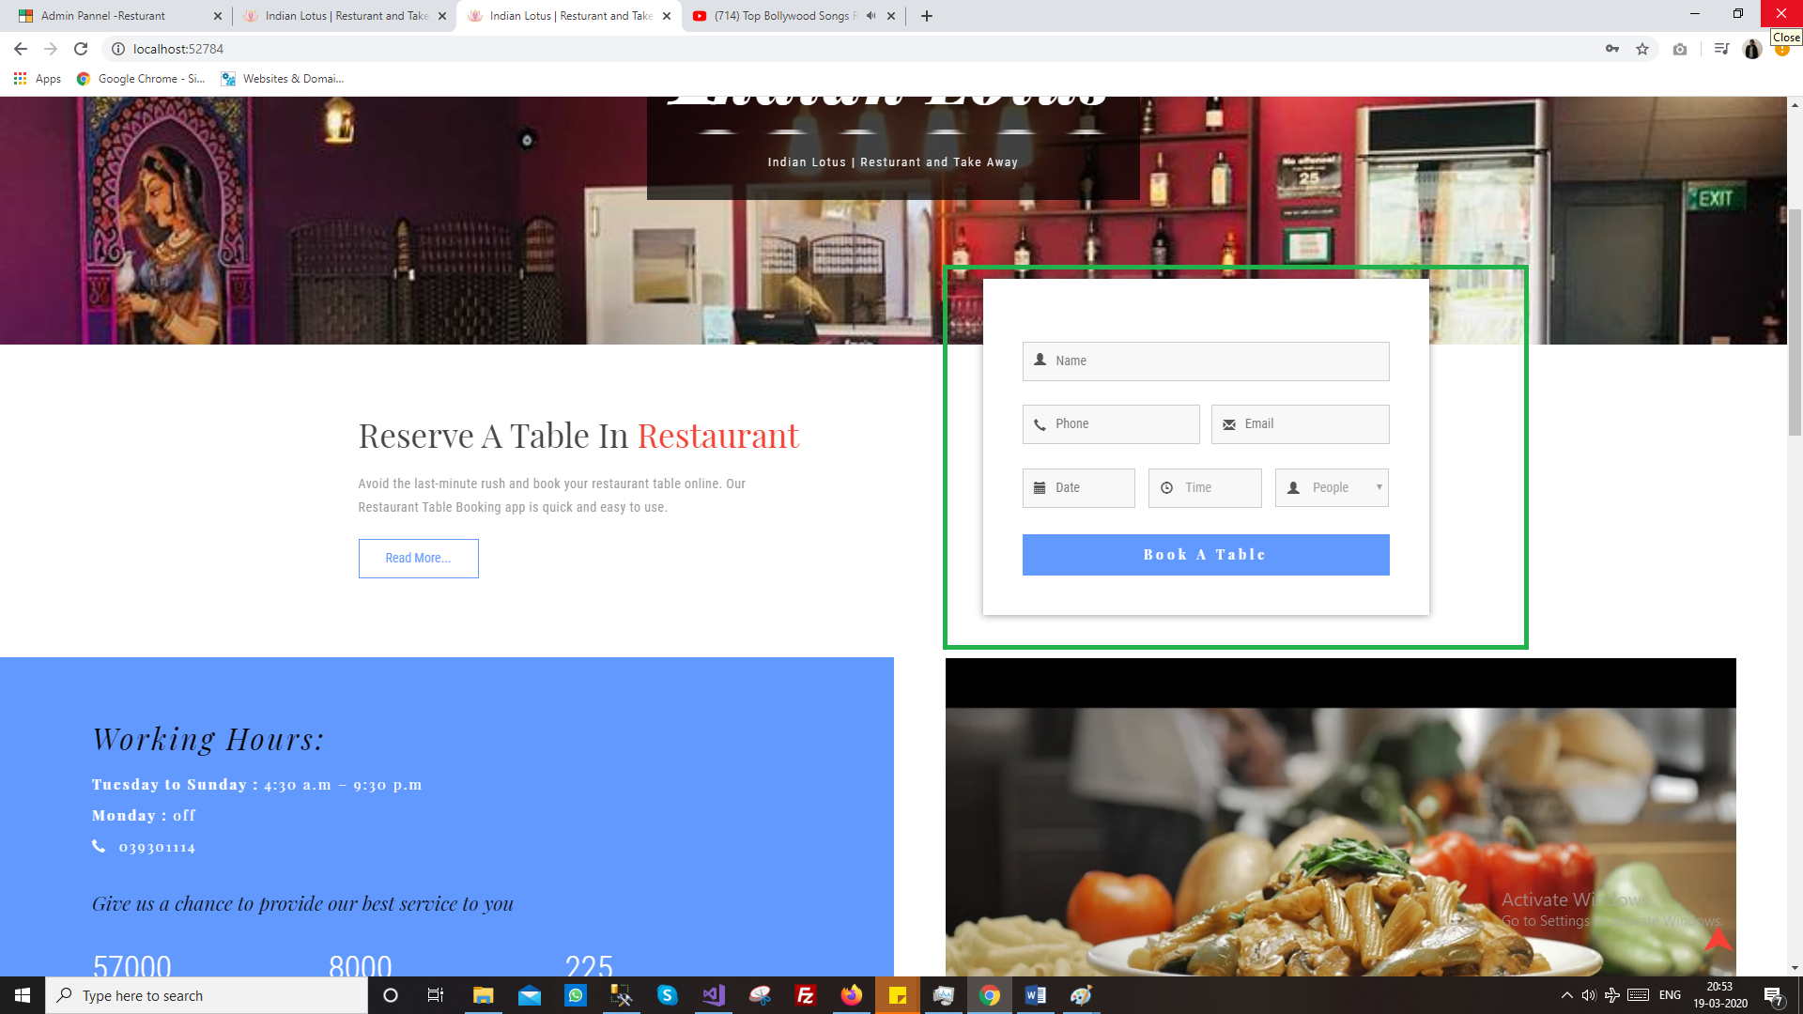
Booking done by user can manage/view by user
Where user will get email on booking with desired template
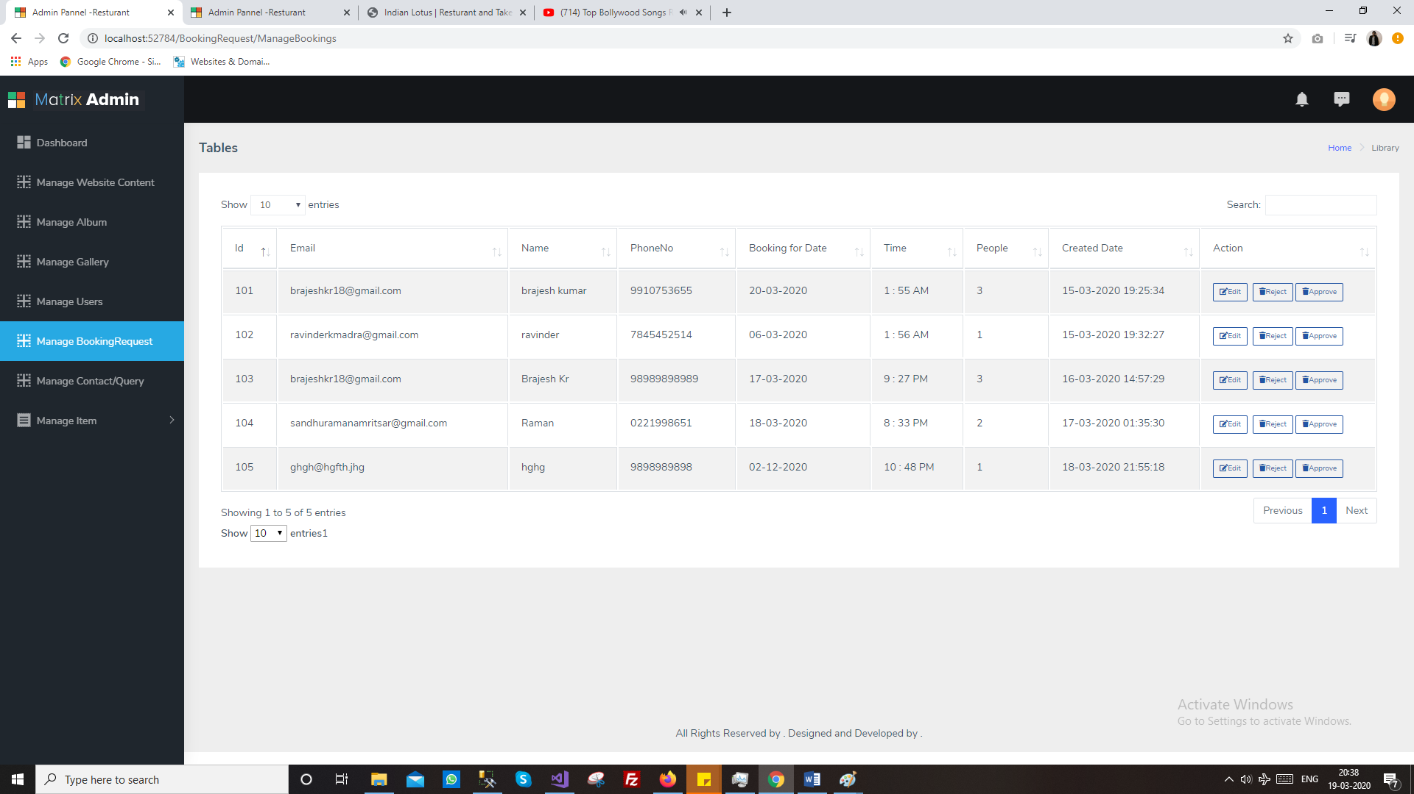

7. Contact Request
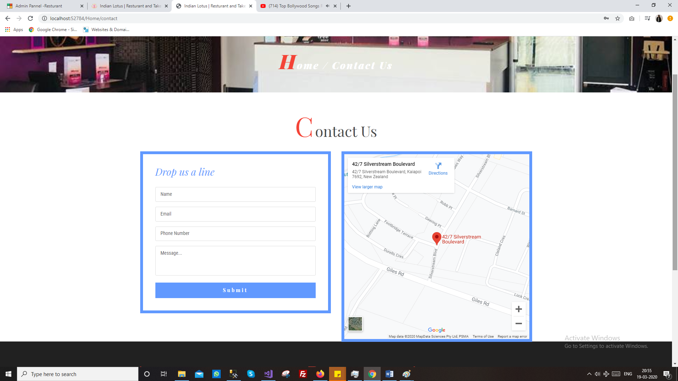
Manage contact requested by user
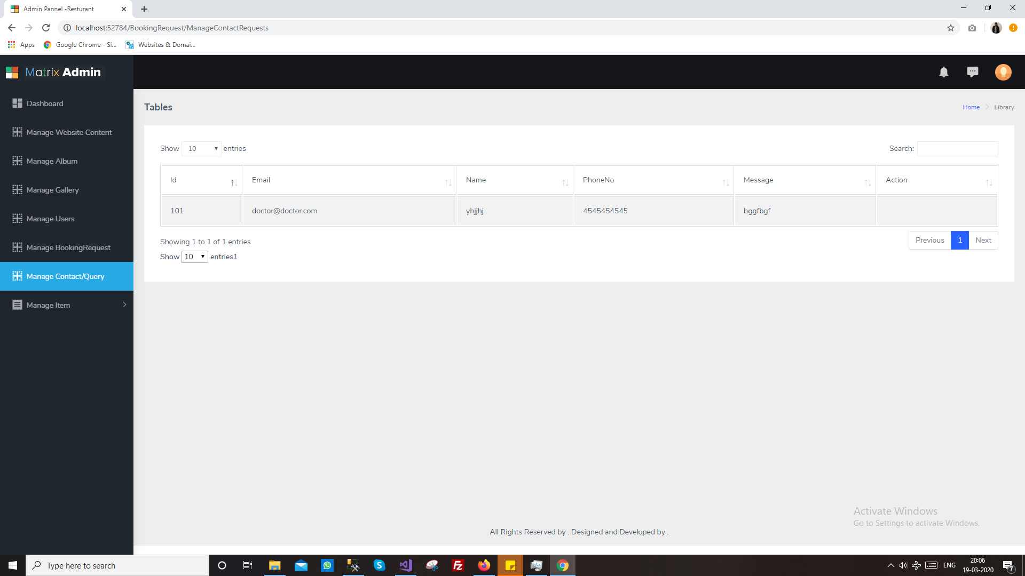
8. Order
Manage order generated by the user
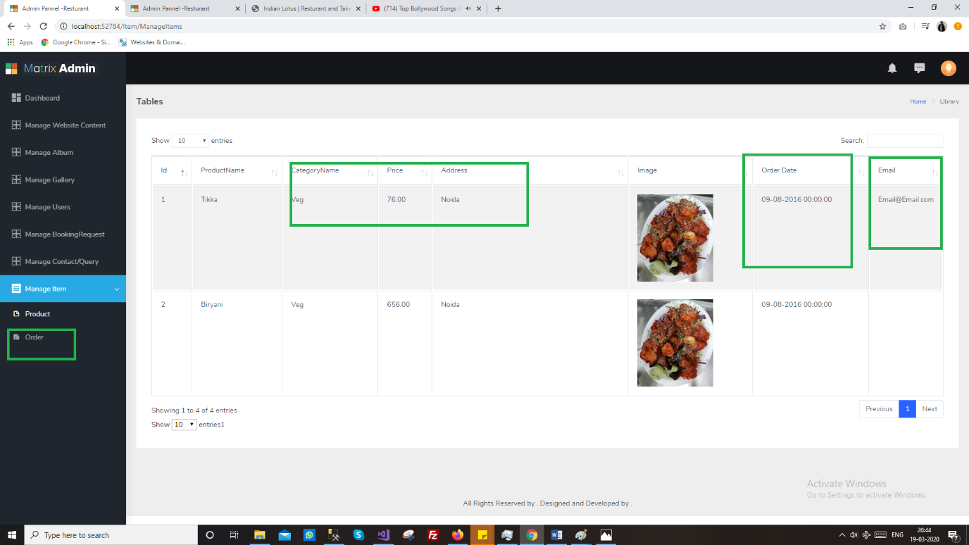
9. Shipping/Delivery
Get processed or in process item for delivery
10. Product
Add item/product with price ,image, and name with description
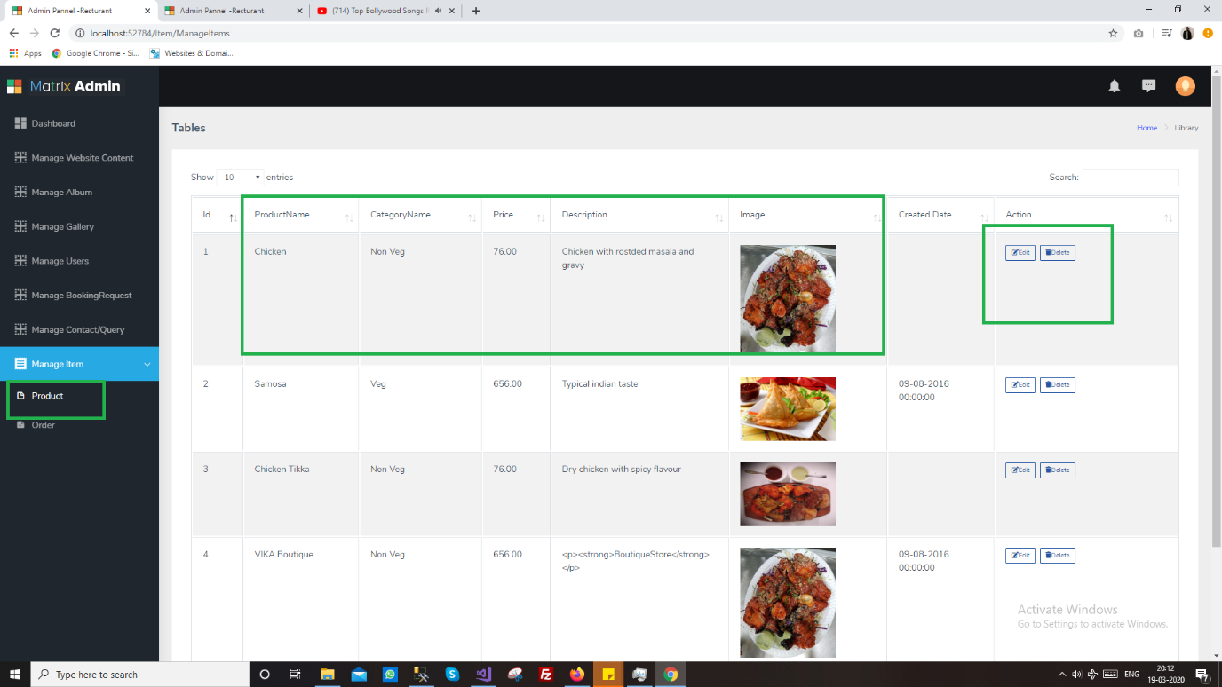

User
User will have access to the following modules
1. Login/ Register
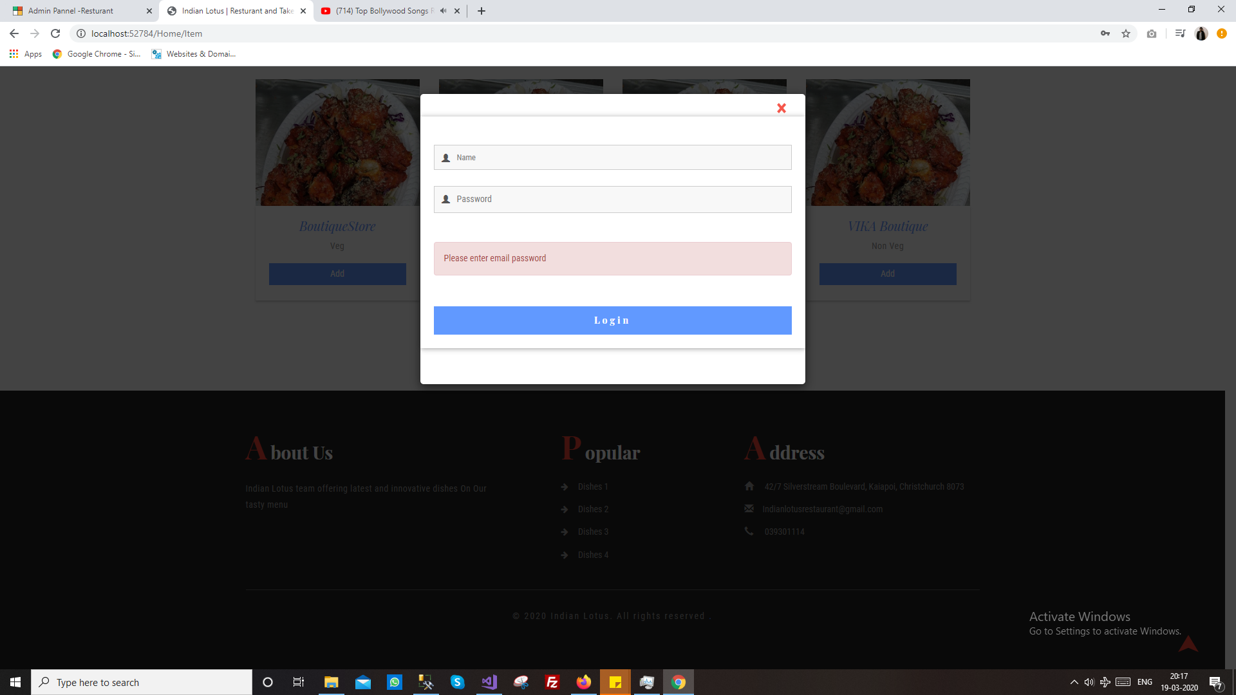
2. My Order
3. Profile
4. Shipping Address
5. Book Table
6. Contact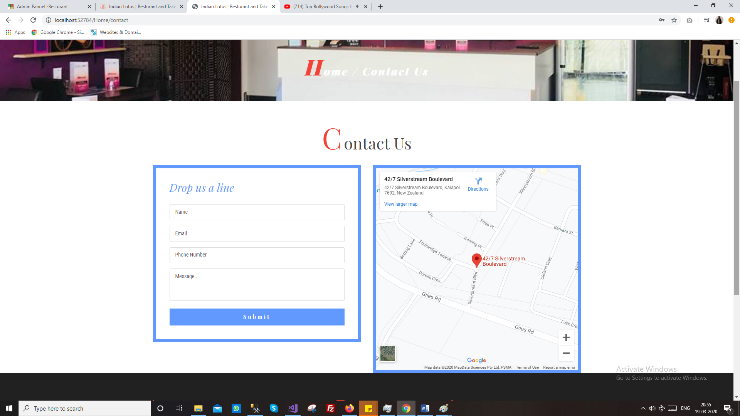
7. Search Items
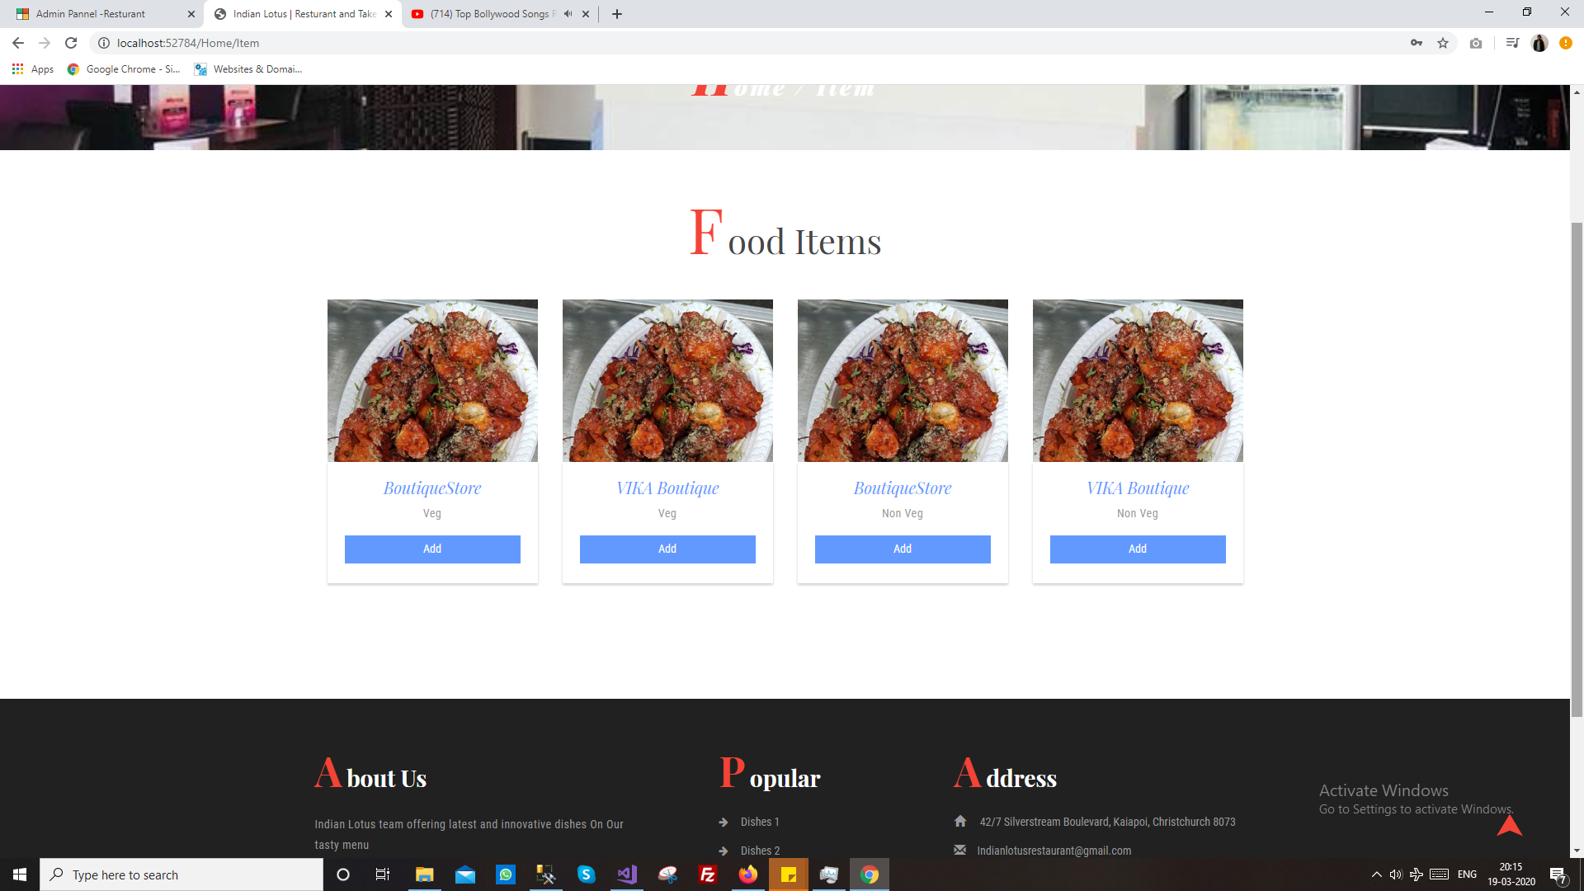
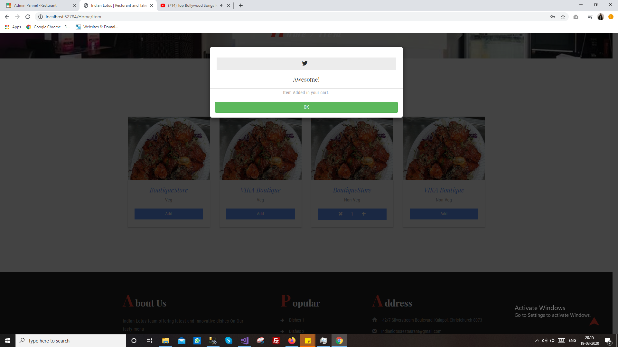
8. Get email and notifications
9. All order will be pay on delivery

