NAME:- VIVEK KUMAR
ROLL NO:- 202501100200366
CSE SECTION -E

- EXPERIMENT 1: Static home page

AIM 1 :- Create Basic HTML page and demonstrate <p>, headings <br>, <hr> tags.

<html lang="en">
<head>
<title>VIVEK KUMAR (202501100200366)</title>
</head>
<body>
<h1 align="center" style="background-color: yellow;">ABOUT GAMES</h1>
<hr><hr><hr>
<P> Games are structured activities, often with rules, goals, and competition, that use mental or physical skill to provide entertainment and can be used for social, educational, or psychological purposes. They are a universal and ancient part of human culture, with origins tracing back to ancient civilizations, and serve to teach, build social connections, and pass on cultural ideas. Modern games include everything from board games and sports to the massive and diverse video game industry. </P>
<BR>
<hr><hr><hr>
</body>
</html>

OUTPUT 1 :- 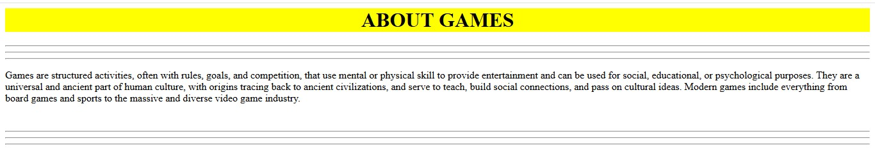

AIM 2 :- Create a Basic HTML page and demonstrate <img>, <ol> <ul>, <a> tags.

<html lang="en">
<head>
<title> VIVEK KUMAR (202501100200366)</title>
</head>
<body>
<ol>
<h3>Outdoor games</h3>
<li>Cricket</li>
<li>Football</li>
<li>Vollyball</li>
<li>Basketball</li>
</ol>
<ul>
<h3>Indoor Games</h3>
<li>Chess</li>
<li>Table Tennis</li>
<li>Carrom</li>
<li>Billiards</li>
</ul>
<img src="sports-tools_53876-138077.jpg" height="200px" width="250px" alt="sports"><br>
<h2><a href="https://takitakigames.com/indoor-and-outdoor-games/">games.in
</a></h2>
</body>
</html>
OUTPUT 2 :- 