Task 1 - GTM Event Schema

Event Name | Trigger Type | Key Parameters | GA4 Report
call_button_click | Click | Page_locations, clinic_name, button_position | Engagement > Events reports
whatsapp_widget_click | Click | Page_location, device_category, time_on_page | Engagement > Events report
clinic_page_view | Page view | Clinic_name, clinic_city, page_location | Engagement > Pages and Screens
blog_scroll_depth | Scroll Depth | Scroll_percentage, article_title, time_on_page | Engagement>Events; Audience: “Engaged Blog Readers”
patient_guide_download | Form Submission | Form_location, page_location, lead_phone_provided | Conversions report; Audience; “Downloaded Guide-Not Booked”
booking_step1_complete | Custom Event | Step_number, clinic_location, speciality | Funnel Exploration-Booking Funnel
booking_step2_complete | Custom Event | Step_number, clinic_location, preferred_date | Funnel exploration- Booking Funnel
booking_confirmed | Custom Event | Step_number, clinic_location, booking_id | Funnel Exploration-Booking Funnel; Conversions report; Google Ads Import

Booking Form Funnel Tracking

The 3-step booking form is a single-page, JavaScript-driven experience — the URL does not change between steps, and no native browser event marks a step transition. GTM cannot detect this automatically. The front-end developer must manually insert a window.dataLayer.push() call at the exact moment each step completes (e.g., inside the "Next" button's click handler), so GTM has something concrete to listen for. explain this in easy words because i am not getting what is written i think its written so technically

I would import booking_confirmed as the Google Ads conversion action. Unlike earlier events like a call button click or step 1 of the form (which only show mild interest and can happen accidentally or without real intent), booking_confirmed means the person has provided their contact details and confirmed an actual appointment. This is the strongest, most reliable signal of a genuine lead. Importing this ensures Google Ads' bidding algorithm optimizes toward people likely to complete real bookings, rather than wasting ad spend on low-intent clicks that never convert.

*booking_step1_complete:
json
{
"event": "booking_step1_complete",
"step_number": 1,
"step_name": "location_specialty_selected",
"clinic_location": "Indiranagar - Bengaluru",
"specialty": "Knee Pain"
}

*booking_step2_complete:
json
{
"event": "booking_step2_complete",
"step_number": 2,
"step_name": "contact_details_entered",
"clinic_location": "Indiranagar - Bengaluru",
"preferred_date": "2026-07-05"
}

*booking_confirmed:
json
{
"event": "booking_confirmed",
"step_number": 3,
"step_name": "booking_confirmed",
"clinic_location": "Indiranagar - Bengaluru",
"booking_id": "ON-2026-08421"
}

TASK 2

Github link to my project for this task
https://anmolsharma-27.github.io/OrthoNow---Landing-Page/
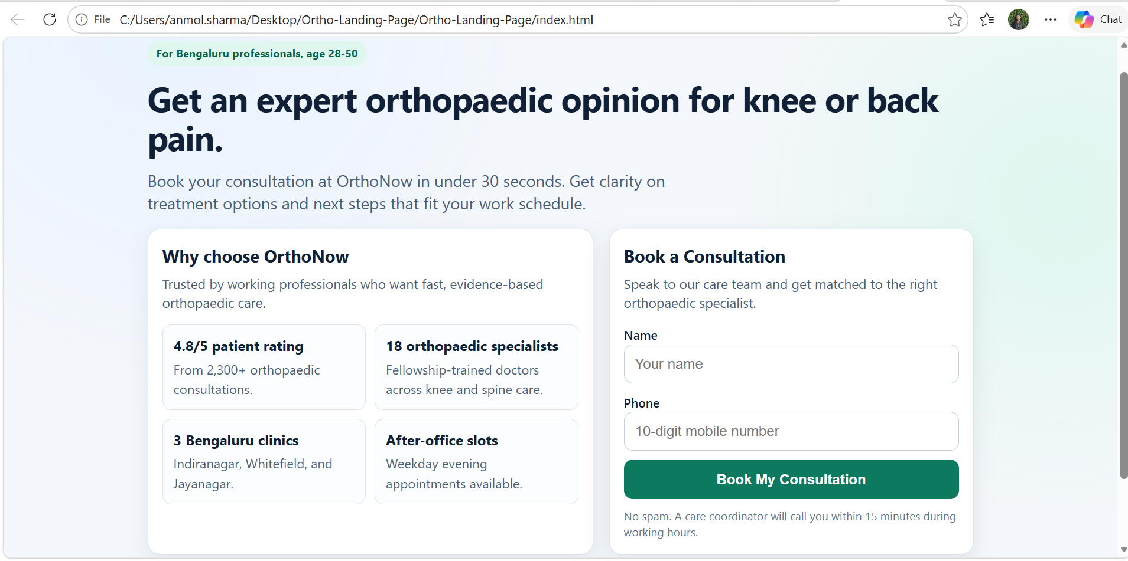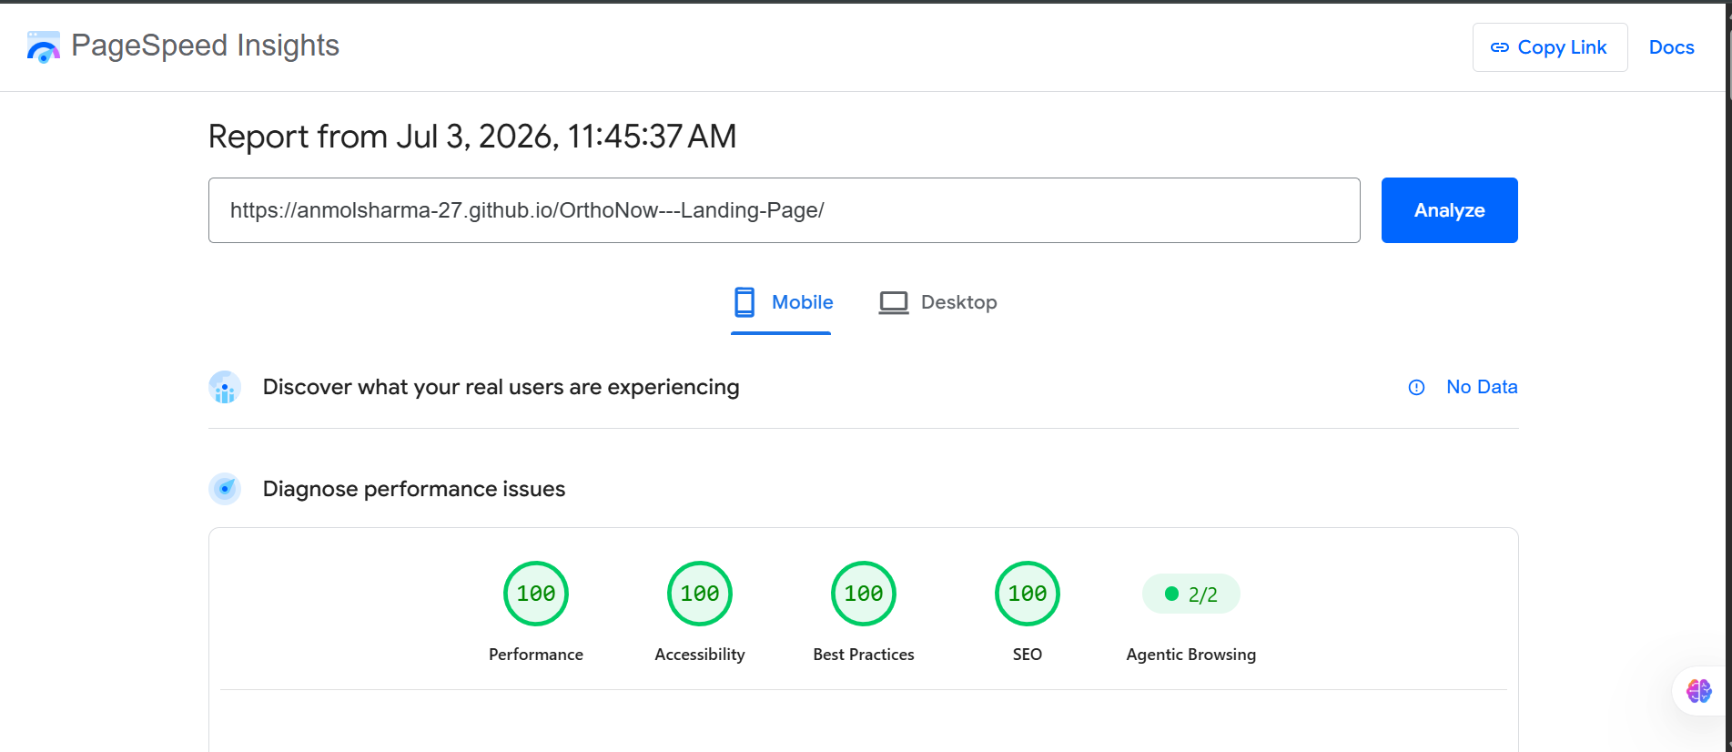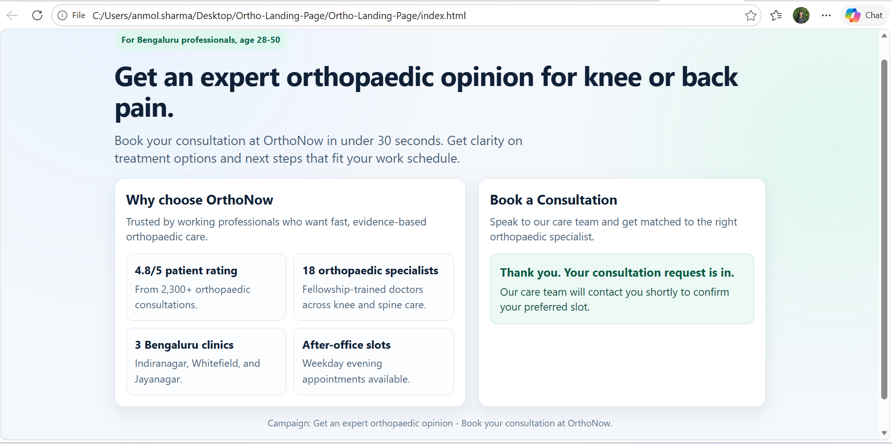

TASK 3

End-to-end architecture
I'd skip Zapier and Make here and go with a direct server-side API call instead. The form already fires a dataLayer.push on submit, so I'd have that same submit handler send the data to a small backend endpoint — a serverless function works fine, nothing fancy needed. From there it fans out to three places at once: HubSpot's Contacts API, Karix for the WhatsApp send, and Google Ads (via server-side Enhanced Conversions or the Conversion API).
Why not the native HubSpot form embed? Because that would mean handing over the form entirely to HubSpot's widget, and we'd lose the custom design and the pain-type chips. Why not Zapier/Make? They're genuinely fine for a v1 or a quick prototype, but every hop through them tacks on a few seconds of trigger delay, and once you're chaining three separate actions off one trigger, that delay stacks up. Given we have a hard 2-minute SLA on the WhatsApp message, I didn't want that extra latency sitting in a black box I can't fully monitor. A direct call gives me control over retries, timing, and logging.
One important thing: none of these three actions (HubSpot, WhatsApp, Ads) should depend on each other succeeding. If the Ads conversion call fails, it shouldn't block the WhatsApp send, and vice versa.
HubSpot deduplicates contacts by email by default. We're not collecting email at all, so out of the box, every submission risks creating a brand new contact even if it's the same patient calling back. I'd get around this by adding a custom property — something like phone_normalized, stored in a consistent format — and explicitly search on that before deciding whether to create or update a contact, rather than trusting HubSpot's default matching.
Now, the tricky edge case: two different patients submitting with the same phone number but different names a shared family phone is a very real scenario in this market. If I just overwrite the name on match, I have silently corrupted the record. So instead, on a name mismatch against an existing phone, I had log it as a new enquiry or note on that existing contact rather than blindly overwriting it, and flag it for someone to manually check.
What could actually break the 2 minute WhatsApp SLA
Karix being slow or rate-limited, a cold-starting serverless function, or the WhatsApp call quietly failing while HubSpot still succeeds. I'd put the WhatsApp send on a queue with retries and a dead-letter queue for anything that keeps failing, and set up an alert if send latency crosses 90 seconds so we catch it before a patient does.

