# Defining the question.

A Kenyan entrepreneur has created an online cryptography course and would want to advertise it on her blog. She currently targets audiences originating from various countries. In the past, she ran ads to advertise a related course on the same blog and collected data in the process. She would now like to employ your services as a Data Science Consultant to help her identify which individuals are most likely to click on her ad.

# Defining the metric for success.

The metric for success in this project will be well plotted visualisations to give insights on the people who are more interested in the cryptography course.

# Understanding the context

In this day and age when most people “live” on the internet, businesses have turned to the internet to search for their customers. This project aims at finding out which netizens are most interested in a cryptography course by checking whether they click on a pop up ad on the internet or not.

# Recording the experimental design.

The main aim of the project is to perform EDA to identify which individuals are most likely to click on a cryptography course ad. Data cleaning and exploratory data analysis will be done and a final documentation.

# Data relevance.

The data contains Information of people who in the past, have interacted with ads that the entreprenuer had ran about a related course. The data will be used to gain insights on who is most likely to click on the ads of the new course. The data contains variables including: Daily Time Spent on Site, Age, Area income, Daily internet usage.The variables are relevant and timely to do the analysis.

# READING THE DATA.

# Setting work directory and loading the dataset.

# 

setwd("C:/Users/Admin/Downloads/R Markdowns/Advertising IP week 11")  
advertising <- read.csv("advertising.csv", header = TRUE)

# CHECKING THE DATA.

# 

head(advertising)

## Daily.Time.Spent.on.Site Age Area.Income Daily.Internet.Usage  
## 1 68.95 35 61833.90 256.09  
## 2 80.23 31 68441.85 193.77  
## 3 69.47 26 59785.94 236.50  
## 4 74.15 29 54806.18 245.89  
## 5 68.37 35 73889.99 225.58  
## 6 59.99 23 59761.56 226.74  
## Ad.Topic.Line City Male Country  
## 1 Cloned 5thgeneration orchestration Wrightburgh 0 Tunisia  
## 2 Monitored national standardization West Jodi 1 Nauru  
## 3 Organic bottom-line service-desk Davidton 0 San Marino  
## 4 Triple-buffered reciprocal time-frame West Terrifurt 1 Italy  
## 5 Robust logistical utilization South Manuel 0 Iceland  
## 6 Sharable client-driven software Jamieberg 1 Norway  
## Timestamp Clicked.on.Ad  
## 1 2016-03-27 00:53:11 0  
## 2 2016-04-04 01:39:02 0  
## 3 2016-03-13 20:35:42 0  
## 4 2016-01-10 02:31:19 0  
## 5 2016-06-03 03:36:18 0  
## 6 2016-05-19 14:30:17 0

tail(advertising)

## Daily.Time.Spent.on.Site Age Area.Income Daily.Internet.Usage  
## 995 43.70 28 63126.96 173.01  
## 996 72.97 30 71384.57 208.58  
## 997 51.30 45 67782.17 134.42  
## 998 51.63 51 42415.72 120.37  
## 999 55.55 19 41920.79 187.95  
## 1000 45.01 26 29875.80 178.35  
## Ad.Topic.Line City Male  
## 995 Front-line bifurcated ability Nicholasland 0  
## 996 Fundamental modular algorithm Duffystad 1  
## 997 Grass-roots cohesive monitoring New Darlene 1  
## 998 Expanded intangible solution South Jessica 1  
## 999 Proactive bandwidth-monitored policy West Steven 0  
## 1000 Virtual 5thgeneration emulation Ronniemouth 0  
## Country Timestamp Clicked.on.Ad  
## 995 Mayotte 2016-04-04 03:57:48 1  
## 996 Lebanon 2016-02-11 21:49:00 1  
## 997 Bosnia and Herzegovina 2016-04-22 02:07:01 1  
## 998 Mongolia 2016-02-01 17:24:57 1  
## 999 Guatemala 2016-03-24 02:35:54 0  
## 1000 Brazil 2016-06-03 21:43:21 1

# Some variables do not have the righ data type.

# Ad.Topic.Line, City and Country should be character string.

# Male and Clicked.on.Ad should be factors, since they are variables,

# with a limited number of different value.

# Timestamp should be a date_time.

# Checking whether each column has an appropriate datatype.

# 

str(advertising)

## 'data.frame': 1000 obs. of 10 variables:  
## $ Daily.Time.Spent.on.Site: num 69 80.2 69.5 74.2 68.4 ...  
## $ Age : int 35 31 26 29 35 23 33 48 30 20 ...  
## $ Area.Income : num 61834 68442 59786 54806 73890 ...  
## $ Daily.Internet.Usage : num 256 194 236 246 226 ...  
## $ Ad.Topic.Line : Factor w/ 1000 levels "Adaptive 24hour Graphic Interface",..: 92 465 567 904 767 806 223 724 108 455 ...  
## $ City : Factor w/ 969 levels "Adamsbury","Adamside",..: 962 904 112 940 806 283 47 672 885 713 ...  
## $ Male : int 0 1 0 1 0 1 0 1 1 1 ...  
## $ Country : Factor w/ 237 levels "Afghanistan",..: 216 148 185 104 97 159 146 13 83 79 ...  
## $ Timestamp : Factor w/ 1000 levels "2016-01-01 02:52:10",..: 440 475 368 57 768 690 131 334 549 942 ...  
## $ Clicked.on.Ad : int 0 0 0 0 0 0 0 1 0 0 ...

# Converting the variables into the correct data types.

# Converting variables into string

# 

a = c('Ad.Topic.Line', 'City', 'Country')  
for (i in a) {  
 advertising[,i] = as.character(advertising[,i])  
}

# Converting variables into factors.

# 

b = c('Male', 'Clicked.on.Ad')  
for (i in b) {  
 advertising[,i] = as.factor(advertising[,i])  
}

# Convering timestamp to appropriate datatype.

# The strptime command is used to take a string and convert it into a time data type.

# 

advertising$Timestamp = strptime(advertising$Timestamp,"%Y-%m-%d %H:%M:%S")

# Confirming that all the variables have correct datatype.

# 

str(advertising)

## 'data.frame': 1000 obs. of 10 variables:  
## $ Daily.Time.Spent.on.Site: num 69 80.2 69.5 74.2 68.4 ...  
## $ Age : int 35 31 26 29 35 23 33 48 30 20 ...  
## $ Area.Income : num 61834 68442 59786 54806 73890 ...  
## $ Daily.Internet.Usage : num 256 194 236 246 226 ...  
## $ Ad.Topic.Line : chr "Cloned 5thgeneration orchestration" "Monitored national standardization" "Organic bottom-line service-desk" "Triple-buffered reciprocal time-frame" ...  
## $ City : chr "Wrightburgh" "West Jodi" "Davidton" "West Terrifurt" ...  
## $ Male : Factor w/ 2 levels "0","1": 1 2 1 2 1 2 1 2 2 2 ...  
## $ Country : chr "Tunisia" "Nauru" "San Marino" "Italy" ...  
## $ Timestamp : POSIXlt, format: "2016-03-27 00:53:11" "2016-04-04 01:39:02" ...  
## $ Clicked.on.Ad : Factor w/ 2 levels "0","1": 1 1 1 1 1 1 1 2 1 1 ...

# TIDYING THE DATASET.

# Checking for missng values.

# 

colSums(is.na(advertising))

## Daily.Time.Spent.on.Site Age Area.Income   
## 0 0 0   
## Daily.Internet.Usage Ad.Topic.Line City   
## 0 0 0   
## Male Country Timestamp   
## 0 0 0   
## Clicked.on.Ad   
## 0

# Data is clean and has no missing values.

# 

# Checking for duplicated values.

# 

dup_advertising = advertising[duplicated(advertising), ]

# There are no duplicated variables.

# The dataframe dup_advertising has 0 observations of 10 variables.

# 

# Checking column names.

# The column ‘Male’ is better represented as gender where 1 is male and 0 female.

# 

names(advertising)[names(advertising) == "Male"] <- "Gender"

# Checking for outliers.

# There are 3 numeric variables.(Age, Area.Income, Daily.Internet.Usage)

# Plotting boxplots to check for outliers.

# Boxplot for age column.

# 

bxplt_Age = boxplot(advertising$Age,  
 main = "Boxplot for Age variable",  
 xlab = "Age",  
   
 col = "pink",  
 border = "brown",  
 horizontal = TRUE,  
 notch = TRUE  
)

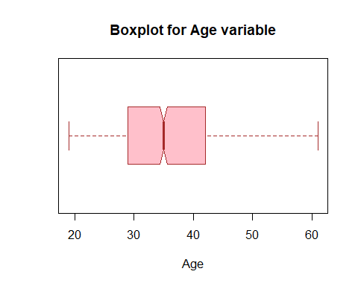

# There are no outliers in the Area.Income.

# 

# Boxplot for age column.

# 

bxplt_Area.Income = boxplot(advertising$Area.Income,  
 main = "Boxplot for Area.Income variable",  
 xlab = "Area Income",  
   
 col = "green",  
 border = "brown",  
 horizontal = TRUE,  
 notch = TRUE  
)

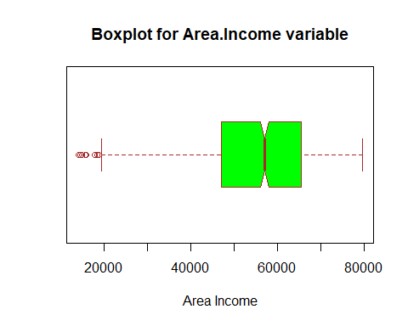

# There are some outliers in the area.income variable

# 

bxplt_Daily.Internet.Usage = boxplot(advertising$Daily.Internet.Usage,  
 main = "Boxplot for Daily.Internet.Usage variable",  
 xlab = "Daily Internet Usage",  
   
 col = "blue",  
 border = "brown",  
 horizontal = TRUE,  
 notch = TRUE  
)

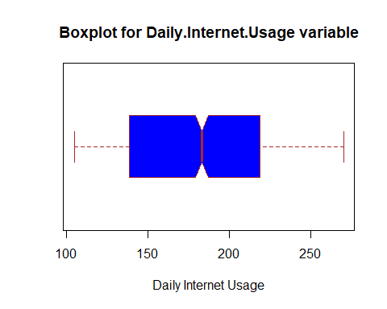

# There are no outliers in the Daily.Internet.Usage variable

# 

# Handling the outliers in the area income variable.

# we store the outliers in a variable outliers.

# 

outliers = bxplt_Area.Income$out

# This vector is to be excluded from our dataset

# The which() function tells us the rows in which the outliers exist,

# These rows will be removed from our data set.

# The dataset advertising will be stored in a new variable so as not to destroy dataset

# 

adv_new = advertising  
adv_new = adv_new[-which(adv_new$Area.Income %in% outliers),]

# Checking if the new data frame has outliers.

# 

bxplt_Income = boxplot(adv_new$Area.Income)

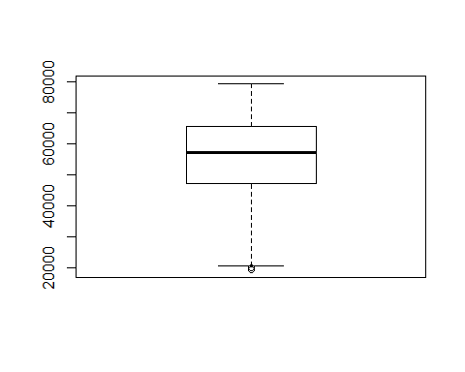

# The outliers have been removed.

# 

# EXPLORATORY DATA ANALYSIS.

# Univariate Analysis.

# Daily time spent on site distribution

# 

x = hist(adv_new$Daily.Time.Spent.on.Site,  
 main = "Daily time Spent on Site",  
 xlab = "Daily time Spent on Site",  
 col = "pink",  
 )

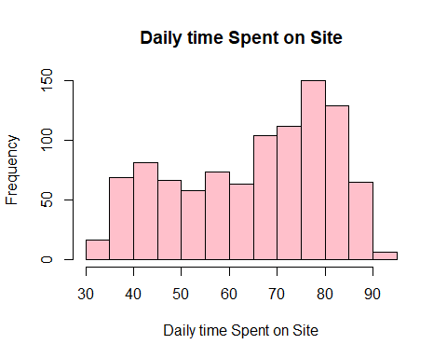

summary(adv_new$Daily.Time.Spent.on.Site)

## Min. 1st Qu. Median Mean 3rd Qu. Max.   
## 32.60 51.28 68.39 65.04 78.58 91.43

# Daily time spent on website is skewed to the left.

# this shows that generaly people spend alot of time on the website.

# from the summary of the variable they spend 65 minutes on the site.

# Age distribution.

# 

y = hist(adv_new$Age,  
 main = "Age distribution",  
 xlab = "Age",  
 col = "gold",  
)

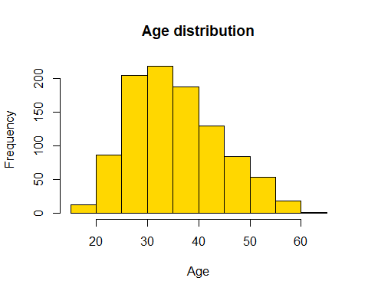

summary(adv_new$Age)

## Min. 1st Qu. Median Mean 3rd Qu. Max.   
## 19.00 29.00 35.00 35.98 42.00 61.00

# Age has a distribution very close to the normal distribution.

# Most people visiting the site are in the (25 - 35) age bracket.

# The average age of the audience is 36.

# 

z = hist(adv_new$Area.Income,  
 main = "Area Income distribution",  
 xlab = "Area",  
 col = "purple",  
)

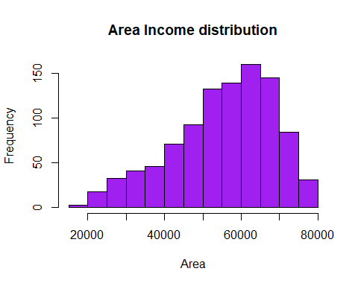

summary(adv_new$Area.Income)

## Min. 1st Qu. Median Mean 3rd Qu. Max.   
## 19345 47333 57228 55313 65519 79485

# The graph is skewed to the left.

# From the graph most people have high incomes.

# On average the audience has an income of 55313.

w = hist(adv_new$Daily.Internet.Usage,  
 main = "Daily internet usage distribution",  
 xlab = "Internet usage",  
 col = "red",  
)

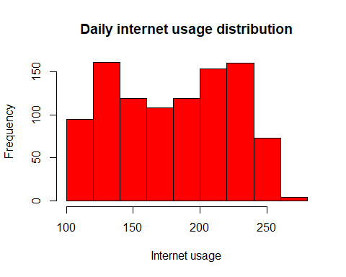

summary(adv_new$Daily.Internet.Usage)

## Min. 1st Qu. Median Mean 3rd Qu. Max.   
## 104.8 138.6 183.4 180.0 218.8 270.0

# Many people have a high daily internet use. Histogram is skewed to the left

# 

# Gender distribution

# 

gender_frequency = table(advertising$Gender)  
gender_frequency

##   
## 0 1   
## 519 481

# Barplot for the frequency.

# 

bar_gen = barplot(gender_frequency,  
 main = 'gender_frequency',  
 xlab = 'gender',  
 ylab = 'count',  
 col = 'yellow')

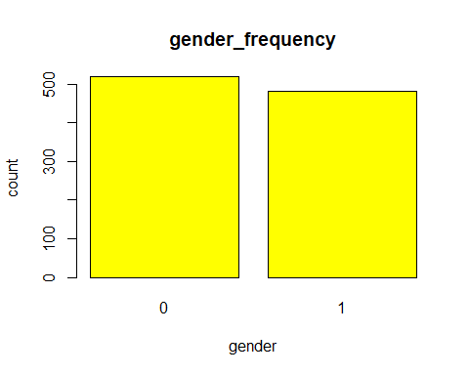

# The females are slightly more than the males.

# This data cannot be considered imbalanced in terms of gender.

# clicked on ad distribution

# 

coad_frequency = table(advertising$Clicked.on.Ad)  
coad_frequency

##   
## 0 1   
## 500 500

# Barplot for clicked on ad variable.

# 

coad_frequency = table(advertising$Clicked.on.Ad)  
coad_frequency

##   
## 0 1   
## 500 500

bar_coad = barplot(coad_frequency,  
 main = 'clicked on ad_frequency',  
 xlab = 'gender',  
 ylab = 'count',  
 col = 'orange')

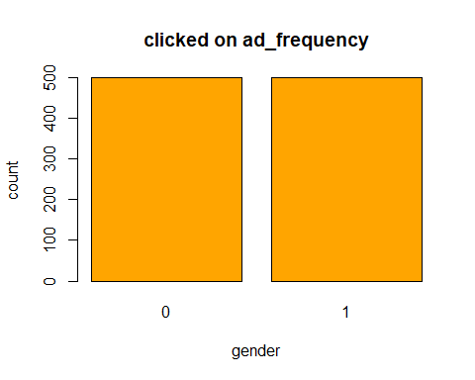

# The clicked on ad variable is the dependent variable.

# The values 0 and 1 in the variable are even.

# This is a perrfectly balanced dataset.

# It is fit to be trained on a machine learning model.

# BIVARIATE ANALYSIS.

# 

# Analysis to see who clicked more on the ads.

# imorting the library ggplot2

# 

library(ggplot2)

## Warning: package 'ggplot2' was built under R version 3.6.2

j = ggplot(data = advertising, aes(x = Clicked.on.Ad, fill = Gender))+   
geom_bar(width = 0.5)  
j

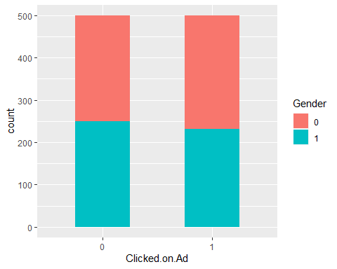

# Slightly more males clicked on the ads compared to the women.

# 

# Area income vs clicked on Ad.

# 

k = ggplot(data = advertising, aes(x = Area.Income, fill = Clicked.on.Ad))+   
geom_histogram(bins = 25)  
k

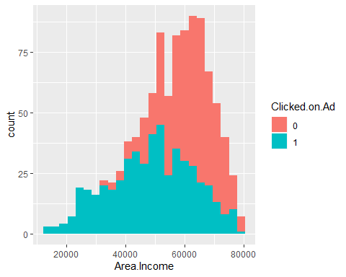

# people in the Lower income areas clicked on the Ads more.

# 

#Subsetting the numerical variables to check correlations. #

num_cols = subset(advertising, select = c("Daily.Time.Spent.on.Site", "Age", "Area.Income", "Daily.Internet.Usage"))  
num_cols

## Daily.Time.Spent.on.Site Age Area.Income Daily.Internet.Usage  
## 1 68.95 35 61833.90 256.09  
## 2 80.23 31 68441.85 193.77  
## 3 69.47 26 59785.94 236.50  
## 4 74.15 29 54806.18 245.89  
## 5 68.37 35 73889.99 225.58  
## 6 59.99 23 59761.56 226.74  
## 7 88.91 33 53852.85 208.36  
## 8 66.00 48 24593.33 131.76  
## 9 74.53 30 68862.00 221.51  
## 10 69.88 20 55642.32 183.82  
## 11 47.64 49 45632.51 122.02  
## 12 83.07 37 62491.01 230.87  
## 13 69.57 48 51636.92 113.12  
## 14 79.52 24 51739.63 214.23  
## 15 42.95 33 30976.00 143.56  
## 16 63.45 23 52182.23 140.64  
## 17 55.39 37 23936.86 129.41  
## 18 82.03 41 71511.08 187.53  
## 19 54.70 36 31087.54 118.39  
## 20 74.58 40 23821.72 135.51  
## 21 77.22 30 64802.33 224.44  
## 22 84.59 35 60015.57 226.54  
## 23 41.49 52 32635.70 164.83  
## 24 87.29 36 61628.72 209.93  
## 25 41.39 41 68962.32 167.22  
## 26 78.74 28 64828.00 204.79  
## 27 48.53 28 38067.08 134.14  
## 28 51.95 52 58295.82 129.23  
## 29 70.20 34 32708.94 119.20  
## 30 76.02 22 46179.97 209.82  
## 31 67.64 35 51473.28 267.01  
## 32 86.41 28 45593.93 207.48  
## 33 59.05 57 25583.29 169.23  
## 34 55.60 23 30227.98 212.58  
## 35 57.64 57 45580.92 133.81  
## 36 84.37 30 61389.50 201.58  
## 37 62.26 53 56770.79 125.45  
## 38 65.82 39 76435.30 221.94  
## 39 50.43 46 57425.87 119.32  
## 40 38.93 39 27508.41 162.08  
## 41 84.98 29 57691.95 202.61  
## 42 64.24 30 59784.18 252.36  
## 43 82.52 32 66572.39 198.11  
## 44 81.38 31 64929.61 212.30  
## 45 80.47 25 57519.64 204.86  
## 46 37.68 52 53575.48 172.83  
## 47 69.62 20 50983.75 202.25  
## 48 85.40 43 67058.72 198.72  
## 49 44.33 37 52723.34 123.72  
## 50 48.01 46 54286.10 119.93  
## 51 73.18 23 61526.25 196.71  
## 52 79.94 28 58526.04 225.29  
## 53 33.33 45 53350.11 193.58  
## 54 50.33 50 62657.53 133.20  
## 55 62.31 47 62722.57 119.30  
## 56 80.60 31 67479.62 177.55  
## 57 65.19 36 75254.88 150.61  
## 58 44.98 49 52336.64 129.31  
## 59 77.63 29 56113.37 239.22  
## 60 41.82 41 24852.90 156.36  
## 61 85.61 27 47708.42 183.43  
## 62 85.84 34 64654.66 192.93  
## 63 72.08 29 71228.44 169.50  
## 64 86.06 32 61601.05 178.92  
## 65 45.96 45 66281.46 141.22  
## 66 62.42 29 73910.90 198.50  
## 67 63.89 40 51317.33 105.22  
## 68 35.33 32 51510.18 200.22  
## 69 75.74 25 61005.87 215.25  
## 70 78.53 34 32536.98 131.72  
## 71 46.13 31 60248.97 139.01  
## 72 69.01 46 74543.81 222.63  
## 73 55.35 39 75509.61 153.17  
## 74 33.21 43 42650.32 167.07  
## 75 38.46 42 58183.04 145.98  
## 76 64.10 22 60465.72 215.93  
## 77 49.81 35 57009.76 120.06  
## 78 82.73 33 54541.56 238.99  
## 79 56.14 38 32689.04 113.53  
## 80 55.13 45 55605.92 111.71  
## 81 78.11 27 63296.87 209.25  
## 82 73.46 28 65653.47 222.75  
## 83 56.64 38 61652.53 115.91  
## 84 68.94 54 30726.26 138.71  
## 85 70.79 31 74535.94 184.10  
## 86 57.76 41 47861.93 105.15  
## 87 77.51 36 73600.28 200.55  
## 88 52.70 34 58543.94 118.60  
## 89 57.70 34 42696.67 109.07  
## 90 56.89 37 37334.78 109.29  
## 91 69.90 43 71392.53 138.35  
## 92 55.79 24 59550.05 149.67  
## 93 70.03 26 64264.25 227.72  
## 94 50.08 40 64147.86 125.85  
## 95 43.67 31 25686.34 166.29  
## 96 72.84 26 52968.22 238.63  
## 97 45.72 36 22473.08 154.02  
## 98 39.94 41 64927.19 156.30  
## 99 35.61 46 51868.85 158.22  
## 100 79.71 34 69456.83 211.65  
## 101 41.49 53 31947.65 169.18  
## 102 63.60 23 51864.77 235.28  
## 103 89.91 40 59593.56 194.23  
## 104 68.18 21 48376.14 218.17  
## 105 66.49 20 56884.74 202.16  
## 106 80.49 40 67186.54 229.12  
## 107 72.23 25 46557.92 241.03  
## 108 42.39 42 66541.05 150.99  
## 109 47.53 30 33258.09 135.18  
## 110 74.02 32 72272.90 210.54  
## 111 66.63 60 60333.38 176.98  
## 112 63.24 53 65229.13 235.78  
## 113 71.00 22 56067.38 211.87  
## 114 46.13 46 37838.72 123.64  
## 115 69.00 32 72683.35 221.21  
## 116 76.99 31 56729.78 244.34  
## 117 72.60 55 66815.54 162.95  
## 118 61.88 42 60223.52 112.19  
## 119 84.45 50 29727.79 207.18  
## 120 88.97 45 49269.98 152.49  
## 121 86.19 31 57669.41 210.26  
## 122 49.58 26 56791.75 231.94  
## 123 77.65 27 63274.88 212.79  
## 124 37.75 36 35466.80 225.24  
## 125 62.33 43 68787.09 127.11  
## 126 79.57 31 61227.59 230.93  
## 127 80.31 44 56366.88 127.07  
## 128 89.05 45 57868.44 206.98  
## 129 70.41 27 66618.21 223.03  
## 130 67.36 37 73104.47 233.56  
## 131 46.98 50 21644.91 175.37  
## 132 41.67 36 53817.02 132.55  
## 133 51.24 36 76368.31 176.73  
## 134 75.70 29 67633.44 215.44  
## 135 43.49 47 50335.46 127.83  
## 136 49.89 39 17709.98 160.03  
## 137 38.37 36 41229.16 140.46  
## 138 38.52 38 42581.23 137.28  
## 139 71.89 23 61617.98 172.81  
## 140 75.80 38 70575.60 146.19  
## 141 83.86 31 64122.36 190.25  
## 142 37.51 30 52097.32 163.00  
## 143 55.60 44 65953.76 124.38  
## 144 83.67 44 60192.72 234.26  
## 145 69.08 41 77460.07 210.60  
## 146 37.47 44 45716.48 141.89  
## 147 56.04 49 65120.86 128.95  
## 148 70.92 41 49995.63 108.16  
## 149 49.78 46 71718.51 152.24  
## 150 68.61 57 61770.34 150.29  
## 151 58.18 25 69112.84 176.28  
## 152 78.54 35 72524.86 172.10  
## 153 37.00 48 36782.38 158.22  
## 154 65.40 33 66699.12 247.31  
## 155 79.52 27 64287.78 183.48  
## 156 87.98 38 56637.59 222.11  
## 157 44.64 36 55787.58 127.01  
## 158 41.73 28 61142.33 202.18  
## 159 80.46 27 61625.87 207.96  
## 160 75.55 36 73234.87 159.24  
## 161 76.32 35 74166.24 195.31  
## 162 82.68 33 62669.59 222.77  
## 163 72.01 31 57756.89 251.00  
## 164 75.83 24 58019.64 162.44  
## 165 41.28 50 50960.08 140.39  
## 166 34.66 32 48246.60 194.83  
## 167 66.18 55 28271.84 143.42  
## 168 86.06 31 53767.12 219.72  
## 169 59.59 42 43662.10 104.78  
## 170 86.69 34 62238.58 198.56  
## 171 43.77 52 49030.03 138.55  
## 172 71.84 47 76003.47 199.79  
## 173 80.23 31 68094.85 196.23  
## 174 74.41 26 64395.85 163.05  
## 175 63.36 48 70053.27 137.43  
## 176 71.74 35 72423.97 227.56  
## 177 60.72 44 42995.80 105.69  
## 178 72.04 22 60309.58 199.43  
## 179 44.57 31 38349.78 133.17  
## 180 85.86 34 63115.34 208.23  
## 181 39.85 38 31343.39 145.96  
## 182 84.53 27 40763.13 168.34  
## 183 62.95 60 36752.24 157.04  
## 184 67.58 41 65044.59 255.61  
## 185 85.56 29 53673.08 210.46  
## 186 46.88 54 43444.86 136.64  
## 187 46.31 57 44248.52 153.98  
## 188 77.95 31 62572.88 233.65  
## 189 84.73 30 39840.55 153.76  
## 190 39.86 36 32593.59 145.85  
## 191 50.08 30 41629.86 123.91  
## 192 60.23 35 43313.73 106.86  
## 193 60.70 49 42993.48 110.57  
## 194 43.67 53 46004.31 143.79  
## 195 77.20 33 49325.48 254.05  
## 196 71.86 32 51633.34 116.53  
## 197 44.78 45 63363.04 137.24  
## 198 78.57 36 64045.93 239.32  
## 199 73.41 31 73049.30 201.26  
## 200 77.05 27 66624.60 191.14  
## 201 66.40 40 77567.85 214.42  
## 202 69.35 29 53431.35 252.77  
## 203 35.65 40 31265.75 172.58  
## 204 70.04 31 74780.74 183.85  
## 205 69.78 29 70410.11 218.79  
## 206 58.22 29 37345.24 120.90  
## 207 76.90 28 66107.84 212.67  
## 208 84.08 30 62336.39 187.36  
## 209 59.51 58 39132.64 140.83  
## 210 40.15 38 38745.29 134.88  
## 211 76.81 28 65172.22 217.85  
## 212 41.89 38 68519.96 163.38  
## 213 76.87 27 54774.77 235.35  
## 214 67.28 43 76246.96 155.80  
## 215 81.98 40 65461.92 229.22  
## 216 66.01 23 34127.21 151.95  
## 217 61.57 53 35253.98 125.94  
## 218 53.30 34 44893.71 111.94  
## 219 34.87 40 59621.02 200.23  
## 220 43.60 38 20856.54 170.49  
## 221 77.88 37 55353.41 254.57  
## 222 75.83 27 67516.07 200.59  
## 223 49.95 39 68737.75 136.59  
## 224 60.94 41 76893.84 154.97  
## 225 89.15 42 59886.58 171.07  
## 226 78.70 30 53441.69 133.99  
## 227 57.35 29 41356.31 119.84  
## 228 34.86 38 49942.66 154.75  
## 229 70.68 31 74430.08 199.08  
## 230 76.06 23 58633.63 201.04  
## 231 66.67 33 72707.87 228.03  
## 232 46.77 32 31092.93 136.40  
## 233 62.42 38 74445.18 143.94  
## 234 78.32 28 49309.14 239.52  
## 235 37.32 50 56735.14 199.25  
## 236 40.42 45 40183.75 133.90  
## 237 76.77 36 58348.41 123.51  
## 238 65.65 30 72209.99 158.05  
## 239 74.32 33 62060.11 128.17  
## 240 73.27 32 67113.46 234.75  
## 241 80.03 44 24030.06 150.84  
## 242 53.68 47 56180.93 115.26  
## 243 85.84 32 62204.93 192.85  
## 244 85.03 30 60372.64 204.52  
## 245 70.44 24 65280.16 178.75  
## 246 81.22 53 34309.24 223.09  
## 247 39.96 45 59610.81 146.13  
## 248 57.05 41 50278.89 269.96  
## 249 42.44 56 43450.11 168.27  
## 250 62.20 25 25408.21 161.16  
## 251 76.70 36 71136.49 222.25  
## 252 61.22 45 63883.81 119.03  
## 253 84.54 33 64902.47 204.02  
## 254 46.08 30 66784.81 164.63  
## 255 56.70 48 62784.85 123.13  
## 256 81.03 28 63727.50 201.15  
## 257 80.91 32 61608.23 231.42  
## 258 40.06 38 56782.18 138.68  
## 259 83.47 39 64447.77 226.11  
## 260 73.84 31 42042.95 121.05  
## 261 74.65 28 67669.06 212.56  
## 262 60.25 35 54875.95 109.77  
## 263 59.21 35 73347.67 144.62  
## 264 43.02 44 50199.77 125.22  
## 265 84.04 38 50723.67 244.55  
## 266 70.66 43 63450.96 120.95  
## 267 70.58 26 56694.12 136.94  
## 268 72.44 34 70547.16 230.14  
## 269 40.17 26 47391.95 171.31  
## 270 79.15 26 62312.23 203.23  
## 271 44.49 53 63100.13 168.00  
## 272 73.04 37 73687.50 221.79  
## 273 76.28 33 52686.47 254.34  
## 274 68.88 37 78119.50 179.58  
## 275 73.10 28 57014.84 242.37  
## 276 47.66 29 27086.40 156.54  
## 277 87.30 35 58337.18 216.87  
## 278 89.34 32 50216.01 177.78  
## 279 81.37 26 53049.44 156.48  
## 280 81.67 28 62927.96 196.76  
## 281 46.37 52 32847.53 144.27  
## 282 54.88 24 32006.82 148.61  
## 283 40.67 35 48913.07 133.18  
## 284 71.76 35 69285.69 237.39  
## 285 47.51 51 53700.57 130.41  
## 286 75.15 22 52011.00 212.87  
## 287 56.01 26 46339.25 127.26  
## 288 82.87 37 67938.77 213.36  
## 289 45.05 42 66348.95 141.36  
## 290 60.53 24 66873.90 167.22  
## 291 50.52 31 72270.88 171.62  
## 292 84.71 32 61610.05 210.23  
## 293 55.20 39 76560.59 159.46  
## 294 81.61 33 62667.51 228.76  
## 295 71.55 36 75687.46 163.99  
## 296 82.40 36 66744.65 218.97  
## 297 73.95 35 67714.82 238.58  
## 298 72.07 31 69710.51 226.45  
## 299 80.39 31 66269.49 214.74  
## 300 65.80 25 60843.32 231.49  
## 301 69.97 28 55041.60 250.00  
## 302 52.62 50 73863.25 176.52  
## 303 39.25 39 62378.05 152.36  
## 304 77.56 38 63336.85 130.83  
## 305 33.52 43 42191.61 165.56  
## 306 79.81 24 56194.56 178.85  
## 307 84.79 33 61771.90 214.53  
## 308 82.70 35 61383.79 231.07  
## 309 84.88 32 63924.82 186.48  
## 310 54.92 54 23975.35 161.16  
## 311 76.56 34 70179.11 221.53  
## 312 69.74 49 66524.80 243.37  
## 313 75.55 22 41851.38 169.40  
## 314 72.19 33 61275.18 250.35  
## 315 84.29 41 60638.38 232.54  
## 316 73.89 39 47160.53 110.68  
## 317 75.84 21 48537.18 186.98  
## 318 73.38 25 53058.91 236.19  
## 319 80.72 31 68614.98 186.37  
## 320 62.06 44 44174.25 105.00  
## 321 51.50 34 67050.16 135.31  
## 322 90.97 37 54520.14 180.77  
## 323 86.78 30 54952.42 170.13  
## 324 66.18 35 69476.42 243.61  
## 325 84.33 41 54989.93 240.95  
## 326 36.87 36 29398.61 195.91  
## 327 34.78 48 42861.42 208.21  
## 328 76.84 32 65883.39 231.59  
## 329 67.05 25 65421.39 220.92  
## 330 41.47 31 60953.93 219.79  
## 331 80.71 26 58476.57 200.58  
## 332 80.09 31 66636.84 214.08  
## 333 56.30 49 67430.96 135.24  
## 334 79.36 34 57260.41 245.78  
## 335 86.38 40 66359.32 188.27  
## 336 38.94 41 57587.00 142.67  
## 337 87.26 35 63060.55 184.03  
## 338 75.32 28 59998.50 233.60  
## 339 74.38 40 74024.61 220.05  
## 340 65.90 22 60550.66 211.39  
## 341 36.31 47 57983.30 168.92  
## 342 72.23 48 52736.33 115.35  
## 343 88.12 38 46653.75 230.91  
## 344 83.97 28 56986.73 205.50  
## 345 61.09 26 55336.18 131.68  
## 346 65.77 21 42162.90 218.61  
## 347 81.58 25 39699.13 199.39  
## 348 37.87 52 56394.82 188.56  
## 349 76.20 37 75044.35 178.51  
## 350 60.91 19 53309.61 184.94  
## 351 74.49 28 58996.12 237.34  
## 352 73.71 23 56605.12 211.38  
## 353 78.19 30 62475.99 228.81  
## 354 79.54 44 70492.60 217.68  
## 355 74.87 52 43698.53 126.97  
## 356 87.09 36 57737.51 221.98  
## 357 37.45 47 31281.01 167.86  
## 358 49.84 39 45800.48 111.59  
## 359 51.38 59 42362.49 158.56  
## 360 83.40 34 66691.23 207.87  
## 361 38.91 33 56369.74 150.80  
## 362 62.14 41 59397.89 110.93  
## 363 79.72 28 66025.11 193.80  
## 364 73.30 36 68211.35 135.72  
## 365 69.11 42 73608.99 231.48  
## 366 71.90 54 61228.96 140.15  
## 367 72.45 29 72325.91 195.36  
## 368 77.07 40 44559.43 261.02  
## 369 74.62 36 73207.15 217.79  
## 370 82.07 25 46722.07 205.38  
## 371 58.60 50 45400.50 113.70  
## 372 36.08 45 41417.27 151.47  
## 373 79.44 26 60845.55 206.79  
## 374 41.73 47 60812.77 144.71  
## 375 73.19 25 64267.88 203.74  
## 376 77.60 24 58151.87 197.33  
## 377 89.00 37 52079.18 222.26  
## 378 69.20 42 26023.99 123.80  
## 379 67.56 31 62318.38 125.45  
## 380 81.11 39 56216.57 248.19  
## 381 80.22 30 61806.31 224.58  
## 382 43.63 41 51662.24 123.25  
## 383 77.66 29 67080.94 168.15  
## 384 74.63 26 51975.41 235.99  
## 385 49.67 27 28019.09 153.69  
## 386 80.59 37 67744.56 224.23  
## 387 83.49 33 66574.00 190.75  
## 388 44.46 42 30487.48 132.66  
## 389 68.10 40 74903.41 227.73  
## 390 63.88 38 19991.72 136.85  
## 391 78.83 36 66050.63 234.64  
## 392 79.97 44 70449.04 216.00  
## 393 80.51 28 64008.55 200.28  
## 394 62.26 26 70203.74 202.77  
## 395 66.99 47 27262.51 124.44  
## 396 71.05 20 49544.41 204.22  
## 397 42.05 51 28357.27 174.55  
## 398 50.52 28 66929.03 219.69  
## 399 76.24 40 75524.78 198.32  
## 400 77.29 27 66265.34 201.24  
## 401 35.98 47 55993.68 165.52  
## 402 84.95 34 56379.30 230.36  
## 403 39.34 43 31215.88 148.93  
## 404 87.23 29 51015.11 202.12  
## 405 57.24 52 46473.14 117.35  
## 406 81.58 41 55479.62 248.16  
## 407 56.34 50 68713.70 139.02  
## 408 48.73 27 34191.23 142.04  
## 409 51.68 49 51067.54 258.62  
## 410 35.34 45 46693.76 152.86  
## 411 48.09 33 19345.36 180.42  
## 412 78.68 29 66225.72 208.05  
## 413 68.82 20 38609.20 205.64  
## 414 56.99 40 37713.23 108.15  
## 415 86.63 39 63764.28 209.64  
## 416 41.18 43 41866.55 129.25  
## 417 71.03 32 57846.68 120.85  
## 418 72.92 29 69428.73 217.10  
## 419 77.14 24 60283.98 184.88  
## 420 60.70 43 79332.33 192.60  
## 421 34.30 41 53167.68 160.74  
## 422 83.71 45 64564.07 220.48  
## 423 53.38 35 60803.37 120.06  
## 424 58.03 31 28387.42 129.33  
## 425 43.59 36 58849.77 132.31  
## 426 60.07 42 65963.37 120.75  
## 427 54.43 37 75180.20 154.74  
## 428 81.99 33 61270.14 230.90  
## 429 60.53 29 56759.48 123.28  
## 430 84.69 31 46160.63 231.85  
## 431 88.72 32 43870.51 211.87  
## 432 88.89 35 50439.49 218.80  
## 433 69.58 43 28028.74 255.07  
## 434 85.23 36 64238.71 212.92  
## 435 83.55 39 65816.38 221.18  
## 436 56.66 42 72684.44 139.42  
## 437 56.39 27 38817.40 248.12  
## 438 76.24 27 63976.44 214.42  
## 439 57.64 36 37212.54 110.25  
## 440 78.18 23 52691.79 167.67  
## 441 46.04 32 65499.93 147.92  
## 442 79.40 35 63966.72 236.87  
## 443 36.44 39 52400.88 147.64  
## 444 53.14 38 49111.47 109.00  
## 445 32.84 40 41232.89 171.72  
## 446 73.72 32 52140.04 256.40  
## 447 38.10 34 60641.09 214.38  
## 448 73.93 44 74180.05 218.22  
## 449 51.87 50 51869.87 119.65  
## 450 77.69 22 48852.58 169.88  
## 451 43.41 28 59144.02 160.73  
## 452 55.92 24 33951.63 145.08  
## 453 80.67 34 58909.36 239.76  
## 454 83.42 25 49850.52 183.42  
## 455 82.12 52 28679.93 201.15  
## 456 66.17 33 69869.66 238.45  
## 457 43.01 35 48347.64 127.37  
## 458 80.05 25 45959.86 219.94  
## 459 64.88 42 70005.51 129.80  
## 460 79.82 26 51512.66 223.28  
## 461 48.03 40 25598.75 134.60  
## 462 32.99 45 49282.87 177.46  
## 463 74.88 27 67240.25 175.17  
## 464 36.49 52 42136.33 196.61  
## 465 88.04 45 62589.84 191.17  
## 466 45.70 33 67384.31 151.12  
## 467 82.38 35 25603.93 159.60  
## 468 52.68 23 39616.00 149.20  
## 469 65.59 47 28265.81 121.81  
## 470 65.65 25 63879.72 224.92  
## 471 43.84 36 70592.81 167.42  
## 472 67.69 37 76408.19 216.57  
## 473 78.37 24 55015.08 207.27  
## 474 81.46 29 51636.12 231.54  
## 475 47.48 31 29359.20 141.34  
## 476 75.15 33 71296.67 219.49  
## 477 78.76 24 46422.76 219.98  
## 478 44.96 50 52802.00 132.71  
## 479 39.56 41 59243.46 143.13  
## 480 39.76 28 35350.55 196.83  
## 481 57.11 22 59677.64 207.17  
## 482 83.26 40 70225.60 187.76  
## 483 69.42 25 65791.17 213.38  
## 484 50.60 30 34191.13 129.88  
## 485 46.20 37 51315.38 119.30  
## 486 66.88 35 62790.96 119.47  
## 487 83.97 40 66291.67 158.42  
## 488 76.56 30 68030.18 213.75  
## 489 35.49 48 43974.49 159.77  
## 490 80.29 31 49457.48 244.87  
## 491 50.19 40 33987.27 117.30  
## 492 59.12 33 28210.03 124.54  
## 493 59.88 30 75535.14 193.63  
## 494 59.70 28 49158.50 120.25  
## 495 67.80 30 39809.69 117.75  
## 496 81.59 35 65826.53 223.16  
## 497 81.10 29 61172.07 216.49  
## 498 41.70 39 42898.21 126.95  
## 499 73.94 27 68333.01 173.49  
## 500 58.35 37 70232.95 132.63  
## 501 51.56 46 63102.19 124.85  
## 502 79.81 37 51847.26 253.17  
## 503 66.17 26 63580.22 228.70  
## 504 58.21 37 47575.44 105.94  
## 505 66.12 49 39031.89 113.80  
## 506 80.47 42 70505.06 215.18  
## 507 77.05 31 62161.26 236.64  
## 508 49.99 41 61068.26 121.07  
## 509 80.30 58 49090.51 173.43  
## 510 79.36 33 62330.75 234.72  
## 511 57.86 30 18819.34 166.86  
## 512 70.29 26 62053.37 231.37  
## 513 84.53 33 61922.06 215.18  
## 514 59.13 44 49525.37 106.04  
## 515 81.51 41 53412.32 250.03  
## 516 42.94 37 56681.65 130.40  
## 517 84.81 32 43299.63 233.93  
## 518 82.79 34 47997.75 132.08  
## 519 59.22 55 39131.53 126.39  
## 520 35.00 40 46033.73 151.25  
## 521 46.61 42 65856.74 136.18  
## 522 63.26 29 54787.37 120.46  
## 523 79.16 32 69562.46 202.90  
## 524 67.94 43 68447.17 128.16  
## 525 79.91 32 62772.42 230.18  
## 526 66.14 41 78092.95 165.27  
## 527 43.65 39 63649.04 138.87  
## 528 59.61 21 60637.62 198.45  
## 529 46.61 52 27241.11 156.99  
## 530 89.37 34 42760.22 162.03  
## 531 65.10 49 59457.52 118.10  
## 532 53.44 42 42907.89 108.17  
## 533 79.53 51 46132.18 244.91  
## 534 91.43 39 46964.11 209.91  
## 535 73.57 30 70377.23 212.38  
## 536 78.76 32 70012.83 208.02  
## 537 76.49 23 56457.01 181.11  
## 538 61.72 26 67279.06 218.49  
## 539 84.53 35 54773.99 236.29  
## 540 72.03 34 70783.94 230.95  
## 541 77.47 36 70510.59 222.91  
## 542 75.65 39 64021.55 247.90  
## 543 78.15 33 72042.85 194.37  
## 544 63.80 38 36037.33 108.70  
## 545 76.59 29 67526.92 211.64  
## 546 42.60 55 55121.65 168.29  
## 547 78.77 28 63497.62 211.83  
## 548 83.40 39 60879.48 235.01  
## 549 79.53 33 61467.33 236.72  
## 550 73.89 35 70495.64 229.99  
## 551 75.80 36 71222.40 224.90  
## 552 81.95 31 64698.58 208.76  
## 553 56.39 58 32252.38 154.23  
## 554 44.73 35 55316.97 127.56  
## 555 38.35 33 47447.89 145.48  
## 556 72.53 37 73474.82 223.93  
## 557 56.20 49 53549.94 114.85  
## 558 79.67 28 58576.12 226.79  
## 559 75.42 26 63373.70 164.25  
## 560 78.64 31 60283.47 235.28  
## 561 67.69 44 37345.34 109.22  
## 562 38.35 41 34886.01 144.69  
## 563 59.52 44 67511.86 251.08  
## 564 62.26 37 77988.71 166.19  
## 565 64.75 36 63001.03 117.66  
## 566 79.97 26 61747.98 185.45  
## 567 47.90 42 48467.68 114.53  
## 568 80.38 30 55130.96 238.06  
## 569 64.51 42 79484.80 190.71  
## 570 71.28 37 67307.43 246.72  
## 571 50.32 40 27964.60 125.65  
## 572 72.76 33 66431.87 240.63  
## 573 72.80 35 63551.67 249.54  
## 574 74.59 23 40135.06 158.35  
## 575 46.66 45 49101.67 118.16  
## 576 48.86 54 53188.69 134.46  
## 577 37.05 39 49742.83 142.81  
## 578 81.21 36 63394.41 233.04  
## 579 66.89 23 64433.99 208.24  
## 580 68.11 38 73884.48 231.21  
## 581 69.15 46 36424.94 112.72  
## 582 65.72 36 28275.48 120.12  
## 583 40.04 27 48098.86 161.58  
## 584 68.60 33 68448.94 135.08  
## 585 56.16 25 66429.84 164.25  
## 586 78.60 46 41768.13 254.59  
## 587 78.29 38 57844.96 252.07  
## 588 43.83 45 35684.82 129.01  
## 589 77.31 32 62792.43 238.10  
## 590 39.86 28 51171.23 161.24  
## 591 66.77 25 58847.07 141.13  
## 592 57.20 42 57739.03 110.66  
## 593 73.15 25 64631.22 211.12  
## 594 82.07 24 50337.93 193.97  
## 595 49.84 38 67781.31 135.24  
## 596 43.97 36 68863.95 156.97  
## 597 77.25 27 55901.12 231.38  
## 598 74.84 37 64775.10 246.44  
## 599 83.53 36 67686.16 204.56  
## 600 38.63 48 57777.11 222.11  
## 601 84.00 48 46868.53 136.21  
## 602 52.13 50 40926.93 118.27  
## 603 71.83 40 22205.74 135.48  
## 604 78.36 24 58920.44 196.77  
## 605 50.18 35 63006.14 127.82  
## 606 64.67 51 24316.61 138.35  
## 607 69.50 26 68348.99 203.84  
## 608 65.22 30 66263.37 240.09  
## 609 62.06 40 63493.60 116.27  
## 610 84.29 30 56984.09 160.33  
## 611 32.91 37 51691.55 181.02  
## 612 39.50 31 49911.25 148.19  
## 613 75.19 31 33502.57 245.76  
## 614 76.21 31 65834.97 228.94  
## 615 67.76 31 66176.97 242.59  
## 616 40.01 53 51463.17 161.77  
## 617 52.70 41 41059.64 109.34  
## 618 68.41 38 61428.18 259.76  
## 619 35.55 39 51593.46 151.18  
## 620 74.54 24 57518.73 219.75  
## 621 81.75 24 52656.13 190.08  
## 622 87.85 31 52178.98 210.27  
## 623 60.23 60 46239.14 151.54  
## 624 87.97 35 48918.55 149.25  
## 625 78.17 27 65227.79 192.27  
## 626 67.91 23 55002.05 146.80  
## 627 85.77 27 52261.73 191.78  
## 628 41.16 49 59448.44 150.83  
## 629 53.54 39 47314.45 108.03  
## 630 73.94 26 55411.06 236.15  
## 631 63.43 29 66504.16 236.75  
## 632 84.59 36 47169.14 241.80  
## 633 70.13 31 70889.68 224.98  
## 634 40.19 37 55358.88 136.99  
## 635 58.95 55 56242.70 131.29  
## 636 35.76 51 45522.44 195.07  
## 637 59.36 49 46931.03 110.84  
## 638 91.10 40 55499.69 198.13  
## 639 61.04 41 75805.12 149.21  
## 640 74.06 23 40345.49 225.99  
## 641 64.63 45 15598.29 158.80  
## 642 81.29 28 33239.20 219.72  
## 643 76.07 36 68033.54 235.56  
## 644 75.92 22 38427.66 182.65  
## 645 78.35 46 53185.34 253.48  
## 646 46.14 28 39723.97 137.97  
## 647 44.33 41 43386.07 120.63  
## 648 46.43 28 53922.43 137.20  
## 649 66.04 27 71881.84 199.76  
## 650 84.31 29 47139.21 225.87  
## 651 83.66 38 68877.02 175.14  
## 652 81.25 33 65186.58 222.35  
## 653 85.26 32 55424.24 224.07  
## 654 86.53 46 46500.11 233.36  
## 655 76.44 26 58820.16 224.20  
## 656 52.84 43 28495.21 122.31  
## 657 85.24 31 61840.26 182.84  
## 658 74.71 46 37908.29 258.06  
## 659 82.95 39 69805.70 201.29  
## 660 76.42 26 60315.19 223.16  
## 661 42.04 49 67323.00 182.11  
## 662 46.28 26 50055.33 228.78  
## 663 48.26 50 43573.66 122.45  
## 664 71.03 55 28186.65 150.77  
## 665 81.37 33 66412.04 215.04  
## 666 58.05 32 15879.10 195.54  
## 667 75.00 29 63965.16 230.36  
## 668 79.61 31 58342.63 235.97  
## 669 52.56 31 33147.19 250.36  
## 670 62.18 33 65899.68 126.44  
## 671 77.89 26 64188.50 201.54  
## 672 66.08 61 58966.22 184.23  
## 673 89.21 33 44078.24 210.53  
## 674 49.96 55 60968.62 151.94  
## 675 77.44 28 65620.25 210.39  
## 676 82.58 38 65496.78 225.23  
## 677 39.36 29 52462.04 161.79  
## 678 47.23 38 70582.55 149.80  
## 679 87.85 34 51816.27 153.01  
## 680 65.57 46 23410.75 130.86  
## 681 78.01 26 62729.40 200.71  
## 682 44.15 28 48867.67 141.96  
## 683 43.57 36 50971.73 125.20  
## 684 76.83 28 67990.84 192.81  
## 685 42.06 34 43241.19 131.55  
## 686 76.27 27 60082.66 226.69  
## 687 74.27 37 65180.97 247.05  
## 688 73.27 28 67301.39 216.24  
## 689 74.58 36 70701.31 230.52  
## 690 77.50 28 60997.84 225.34  
## 691 87.16 33 60805.93 197.15  
## 692 87.16 37 50711.68 231.95  
## 693 66.26 47 14548.06 179.04  
## 694 65.15 29 41335.84 117.30  
## 695 68.25 33 76480.16 198.86  
## 696 73.49 38 67132.46 244.23  
## 697 39.19 54 52581.16 173.05  
## 698 80.15 25 55195.61 214.49  
## 699 86.76 28 48679.54 189.91  
## 700 73.88 29 63109.74 233.61  
## 701 58.60 19 44490.09 197.93  
## 702 69.77 54 57667.99 132.27  
## 703 87.27 30 51824.01 204.27  
## 704 77.65 28 66198.66 208.01  
## 705 76.02 40 73174.19 219.55  
## 706 78.84 26 56593.80 217.66  
## 707 71.33 23 31072.44 169.40  
## 708 81.90 41 66773.83 225.47  
## 709 46.89 48 72553.94 176.78  
## 710 77.80 57 43708.88 152.94  
## 711 45.44 43 48453.55 119.27  
## 712 69.96 31 73413.87 214.06  
## 713 87.35 35 58114.30 158.29  
## 714 49.42 53 45465.25 128.00  
## 715 71.27 21 50147.72 216.03  
## 716 49.19 38 61004.51 123.08  
## 717 39.96 35 53898.89 138.52  
## 718 85.01 29 59797.64 192.50  
## 719 68.95 51 74623.27 185.85  
## 720 67.59 45 58677.69 113.69  
## 721 75.71 34 62109.80 246.06  
## 722 43.07 36 60583.02 137.63  
## 723 39.47 43 65576.05 163.48  
## 724 48.22 40 73882.91 214.33  
## 725 76.76 25 50468.36 230.77  
## 726 78.74 27 51409.45 234.75  
## 727 67.47 24 60514.05 225.05  
## 728 81.17 30 57195.96 231.91  
## 729 89.66 34 52802.58 171.23  
## 730 79.60 28 56570.06 227.37  
## 731 65.53 19 51049.47 190.17  
## 732 61.87 35 66629.61 250.20  
## 733 83.16 41 70185.06 194.95  
## 734 44.11 41 43111.41 121.24  
## 735 56.57 26 56435.60 131.98  
## 736 83.91 29 53223.58 222.87  
## 737 79.80 28 57179.91 229.88  
## 738 71.23 52 41521.28 122.59  
## 739 47.23 43 73538.09 210.87  
## 740 82.37 30 63664.32 207.44  
## 741 43.63 38 61757.12 135.25  
## 742 70.90 28 71727.51 190.95  
## 743 71.90 29 72203.96 193.29  
## 744 62.12 37 50671.60 105.86  
## 745 67.35 29 47510.42 118.69  
## 746 57.99 50 62466.10 124.58  
## 747 66.80 29 59683.16 248.51  
## 748 49.13 32 41097.17 120.49  
## 749 45.11 58 39799.73 195.69  
## 750 54.35 42 76984.21 164.02  
## 751 61.82 59 57877.15 151.93  
## 752 77.75 31 59047.91 240.64  
## 753 70.61 28 72154.68 190.12  
## 754 82.72 31 65704.79 179.82  
## 755 76.87 36 72948.76 212.59  
## 756 65.07 34 73941.91 227.53  
## 757 56.93 37 57887.64 111.80  
## 758 48.86 35 62463.70 128.37  
## 759 36.56 29 42838.29 195.89  
## 760 85.73 32 43778.88 147.75  
## 761 75.81 40 71157.05 229.19  
## 762 72.94 31 74159.69 190.84  
## 763 53.63 54 50333.72 126.29  
## 764 52.35 25 33293.78 147.61  
## 765 52.84 51 38641.20 121.57  
## 766 51.58 33 49822.78 115.91  
## 767 42.32 29 63891.29 187.09  
## 768 55.04 42 43881.73 106.96  
## 769 68.58 41 13996.50 171.54  
## 770 85.54 27 48761.14 175.43  
## 771 71.14 30 69758.31 224.82  
## 772 64.38 19 52530.10 180.47  
## 773 88.85 40 58363.12 213.96  
## 774 66.79 60 60575.99 198.30  
## 775 32.60 45 48206.04 185.47  
## 776 43.88 54 31523.09 166.85  
## 777 56.46 26 66187.58 151.63  
## 778 72.18 30 69438.04 225.02  
## 779 52.67 44 14775.50 191.26  
## 780 80.55 35 68016.90 219.91  
## 781 67.85 41 78520.99 202.70  
## 782 75.55 36 31998.72 123.71  
## 783 80.46 29 56909.30 230.78  
## 784 82.69 29 61161.29 167.41  
## 785 35.21 39 52340.10 154.00  
## 786 36.37 40 47338.94 144.53  
## 787 74.07 22 50950.24 165.43  
## 788 59.96 33 77143.61 197.66  
## 789 85.62 29 57032.36 195.68  
## 790 40.88 33 48554.45 136.18  
## 791 36.98 31 39552.49 167.87  
## 792 35.49 47 36884.23 170.04  
## 793 56.56 26 68783.45 204.47  
## 794 36.62 32 51119.93 162.44  
## 795 49.35 49 44304.13 119.86  
## 796 75.64 29 69718.19 204.82  
## 797 79.22 27 63429.18 198.79  
## 798 77.05 34 65756.36 236.08  
## 799 66.83 46 77871.75 196.17  
## 800 76.20 24 47258.59 228.81  
## 801 56.64 29 55984.89 123.24  
## 802 53.33 34 44275.13 111.63  
## 803 50.63 50 25767.16 142.23  
## 804 41.84 49 37605.11 139.32  
## 805 53.92 41 25739.09 125.46  
## 806 83.89 28 60188.38 180.88  
## 807 55.32 43 67682.32 127.65  
## 808 53.22 44 44307.18 108.85  
## 809 43.16 35 25371.52 156.11  
## 810 67.51 43 23942.61 127.20  
## 811 43.16 29 50666.50 143.04  
## 812 79.89 30 50356.06 241.38  
## 813 84.25 32 63936.50 170.90  
## 814 74.18 28 69874.18 203.87  
## 815 85.78 34 50038.65 232.78  
## 816 80.96 39 67866.95 225.00  
## 817 36.91 48 54645.20 159.69  
## 818 54.47 23 46780.09 141.52  
## 819 81.98 34 67432.49 212.88  
## 820 79.60 39 73392.28 194.23  
## 821 57.51 38 47682.28 105.71  
## 822 82.30 31 56735.83 232.21  
## 823 73.21 30 51013.37 252.60  
## 824 79.09 32 69481.85 209.72  
## 825 68.47 28 67033.34 226.64  
## 826 83.69 36 68717.00 192.57  
## 827 83.48 31 59340.99 222.72  
## 828 43.49 45 47968.32 124.67  
## 829 66.69 35 48758.92 108.27  
## 830 48.46 49 61230.03 132.38  
## 831 42.51 30 54755.71 144.77  
## 832 42.83 34 54324.73 132.38  
## 833 41.46 42 52177.40 128.98  
## 834 45.99 33 51163.14 124.61  
## 835 68.72 27 66861.67 225.97  
## 836 63.11 34 63107.88 254.94  
## 837 49.21 46 49206.40 115.60  
## 838 55.77 49 55942.04 117.33  
## 839 44.13 40 33601.84 128.48  
## 840 57.82 46 48867.36 107.56  
## 841 72.46 40 56683.32 113.53  
## 842 61.88 45 38260.89 108.18  
## 843 78.24 23 54106.21 199.29  
## 844 74.61 38 71055.22 231.28  
## 845 89.18 37 46403.18 224.01  
## 846 44.16 42 61690.93 133.42  
## 847 55.74 37 26130.93 124.34  
## 848 88.82 36 58638.75 169.10  
## 849 70.39 32 47357.39 261.52  
## 850 59.05 52 50086.17 118.45  
## 851 78.58 33 51772.58 250.11  
## 852 35.11 35 47638.30 158.03  
## 853 60.39 45 38987.42 108.25  
## 854 81.56 26 51363.16 213.70  
## 855 75.03 34 35764.49 255.57  
## 856 50.87 24 62939.50 190.41  
## 857 82.80 30 58776.67 223.20  
## 858 78.51 25 59106.12 205.71  
## 859 37.65 51 50457.01 161.29  
## 860 83.17 43 54251.78 244.40  
## 861 91.37 45 51920.49 182.65  
## 862 68.25 29 70324.80 220.08  
## 863 81.32 25 52416.18 165.65  
## 864 76.64 39 66217.31 241.50  
## 865 74.06 50 60938.73 246.29  
## 866 39.53 33 40243.82 142.21  
## 867 86.58 32 60151.77 195.93  
## 868 90.75 40 45945.88 216.50  
## 869 67.71 25 63430.33 225.76  
## 870 82.41 36 65882.81 222.08  
## 871 45.82 27 64410.80 171.24  
## 872 76.79 27 55677.12 235.94  
## 873 70.05 33 75560.65 203.44  
## 874 72.19 32 61067.58 250.32  
## 875 77.35 34 72330.57 167.26  
## 876 40.34 29 32549.95 173.75  
## 877 67.39 44 51257.26 107.19  
## 878 68.68 34 77220.42 187.03  
## 879 81.75 43 52520.75 249.45  
## 880 66.03 22 59422.47 217.37  
## 881 47.74 33 22456.04 154.93  
## 882 79.18 31 58443.99 236.96  
## 883 86.81 29 50820.74 199.62  
## 884 41.53 42 67575.12 158.81  
## 885 70.92 39 66522.79 249.81  
## 886 46.84 45 34903.67 123.22  
## 887 44.40 53 43073.78 140.95  
## 888 52.17 44 57594.70 115.37  
## 889 81.45 31 66027.31 205.84  
## 890 54.08 36 53012.94 111.02  
## 891 76.65 31 61117.50 238.43  
## 892 54.39 20 52563.22 171.90  
## 893 37.74 40 65773.49 190.95  
## 894 69.86 25 50506.44 241.36  
## 895 85.37 36 66262.59 194.56  
## 896 80.99 26 35521.88 207.53  
## 897 78.84 32 62430.55 235.29  
## 898 77.36 41 49597.08 115.79  
## 899 55.46 37 42078.89 108.10  
## 900 35.66 45 46197.59 151.72  
## 901 50.78 51 49957.00 122.04  
## 902 40.47 38 24078.93 203.90  
## 903 45.62 43 53647.81 121.28  
## 904 84.76 30 61039.13 178.69  
## 905 80.64 26 46974.15 221.59  
## 906 75.94 27 53042.51 236.96  
## 907 37.01 50 48826.14 216.01  
## 908 87.18 31 58287.86 193.60  
## 909 56.91 50 21773.22 146.44  
## 910 75.24 24 52252.91 226.49  
## 911 42.84 52 27073.27 182.20  
## 912 67.56 47 50628.31 109.98  
## 913 34.96 42 36913.51 160.49  
## 914 87.46 37 61009.10 211.56  
## 915 41.86 39 53041.77 128.62  
## 916 34.04 34 40182.84 174.88  
## 917 54.96 42 59419.78 113.75  
## 918 87.14 31 58235.21 199.40  
## 919 78.79 32 68324.48 215.29  
## 920 65.56 25 69646.35 181.25  
## 921 81.05 34 54045.39 245.50  
## 922 55.71 37 57806.03 112.52  
## 923 45.48 49 53336.76 129.16  
## 924 47.00 56 50491.45 149.53  
## 925 59.64 51 71455.62 153.12  
## 926 35.98 45 43241.88 150.79  
## 927 72.55 22 58953.01 202.34  
## 928 91.15 38 36834.04 184.98  
## 929 80.53 29 66345.10 187.64  
## 930 82.49 45 38645.40 130.84  
## 931 80.94 36 60803.00 239.94  
## 932 61.76 34 33553.90 114.69  
## 933 63.30 38 63071.34 116.19  
## 934 36.73 34 46737.34 149.79  
## 935 78.41 33 55368.67 248.23  
## 936 83.98 36 68305.91 194.62  
## 937 63.18 45 39211.49 107.92  
## 938 50.60 48 65956.71 135.67  
## 939 32.60 38 40159.20 190.05  
## 940 60.83 19 40478.83 185.46  
## 941 44.72 46 40468.53 123.86  
## 942 78.76 51 66980.27 162.05  
## 943 79.51 39 34942.26 125.11  
## 944 39.30 32 48335.20 145.73  
## 945 64.79 30 42251.59 116.07  
## 946 89.80 36 57330.43 198.24  
## 947 72.82 34 75769.82 191.82  
## 948 38.65 31 51812.71 154.77  
## 949 59.01 30 75265.96 178.75  
## 950 78.96 50 69868.48 193.15  
## 951 63.99 43 72802.42 138.46  
## 952 41.35 27 39193.45 162.46  
## 953 62.79 36 18368.57 231.87  
## 954 45.53 29 56129.89 141.58  
## 955 51.65 31 58996.56 249.99  
## 956 54.55 44 41547.62 109.04  
## 957 35.66 36 59240.24 172.57  
## 958 69.95 28 56725.47 247.01  
## 959 79.83 29 55764.43 234.23  
## 960 85.35 37 64235.51 161.42  
## 961 56.78 28 39939.39 124.32  
## 962 78.67 26 63319.99 195.56  
## 963 70.09 21 54725.87 211.17  
## 964 60.75 42 69775.75 247.05  
## 965 65.07 24 57545.56 233.85  
## 966 35.25 50 47051.02 194.44  
## 967 37.58 52 51600.47 176.70  
## 968 68.01 25 68357.96 188.32  
## 969 45.08 38 35349.26 125.27  
## 970 63.04 27 69784.85 159.05  
## 971 40.18 29 50760.23 151.96  
## 972 45.17 48 34418.09 132.07  
## 973 50.48 50 20592.99 162.43  
## 974 80.87 28 63528.80 203.30  
## 975 41.88 40 44217.68 126.11  
## 976 39.87 48 47929.83 139.34  
## 977 61.84 45 46024.29 105.63  
## 978 54.97 31 51900.03 116.38  
## 979 71.40 30 72188.90 166.31  
## 980 70.29 31 56974.51 254.65  
## 981 67.26 57 25682.65 168.41  
## 982 76.58 46 41884.64 258.26  
## 983 54.37 38 72196.29 140.77  
## 984 82.79 32 54429.17 234.81  
## 985 66.47 31 58037.66 256.39  
## 986 72.88 44 64011.26 125.12  
## 987 76.44 28 59967.19 232.68  
## 988 63.37 43 43155.19 105.04  
## 989 89.71 48 51501.38 204.40  
## 990 70.96 31 55187.85 256.40  
## 991 35.79 44 33813.08 165.62  
## 992 38.96 38 36497.22 140.67  
## 993 69.17 40 66193.81 123.62  
## 994 64.20 27 66200.96 227.63  
## 995 43.70 28 63126.96 173.01  
## 996 72.97 30 71384.57 208.58  
## 997 51.30 45 67782.17 134.42  
## 998 51.63 51 42415.72 120.37  
## 999 55.55 19 41920.79 187.95  
## 1000 45.01 26 29875.80 178.35

cor(num_cols)

## Daily.Time.Spent.on.Site Age Area.Income  
## Daily.Time.Spent.on.Site 1.0000000 -0.3315133 0.3109544  
## Age -0.3315133 1.0000000 -0.1826050  
## Area.Income 0.3109544 -0.1826050 1.0000000  
## Daily.Internet.Usage 0.5186585 -0.3672086 0.3374955  
## Daily.Internet.Usage  
## Daily.Time.Spent.on.Site 0.5186585  
## Age -0.3672086  
## Area.Income 0.3374955  
## Daily.Internet.Usage 1.0000000

# Plotting a heatmap for the correlations.

heatmap(cor(num_cols))

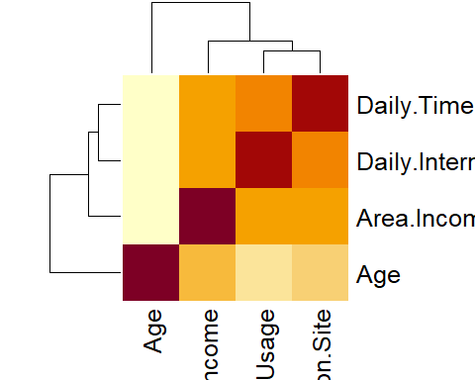

# pairplots to check correlation of variables.

# 

pairs(num_cols)

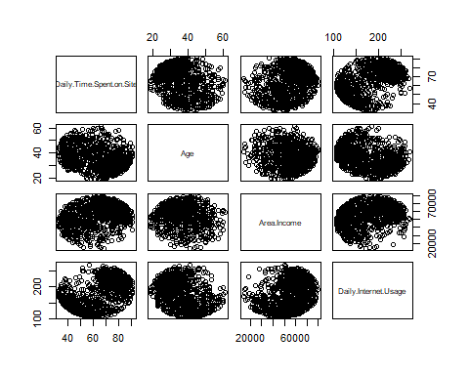

# Recommendation.

From the analysis the entrepreneur should focus on the low income areas.