

ExposureIQ — Stack and Architecture
GraphRAG over SEC filings for the AI SIFI Monitor · github.com/Ann100182/ai-sifi-monitor

1. Summary
ExposureIQ answers natural-language questions about hidden exposures in the AI compute buildout. It reads 147 SEC filings from 12 cloud and AI-infrastructure companies, uses Claude to extract structured facts (off-balance-sheet vehicles, investments, capex commitments, risk factors and hidden-risk signals) into a knowledge graph, and pairs that graph with a vector index of the filing text. A LangGraph state machine routes each question to graph search, vector search or both, then writes an answer in which every claim cites a specific filing.
The thesis it serves: the AI buildout carries interlocking obligations (SPV debt, investor ⇄ customer ⇄ supplier loops, equity that returns as revenue) that no single balance sheet shows. Those signals live in the notes, risk factors and MD&A, which is exactly where ExposureIQ looks.

2. Architecture
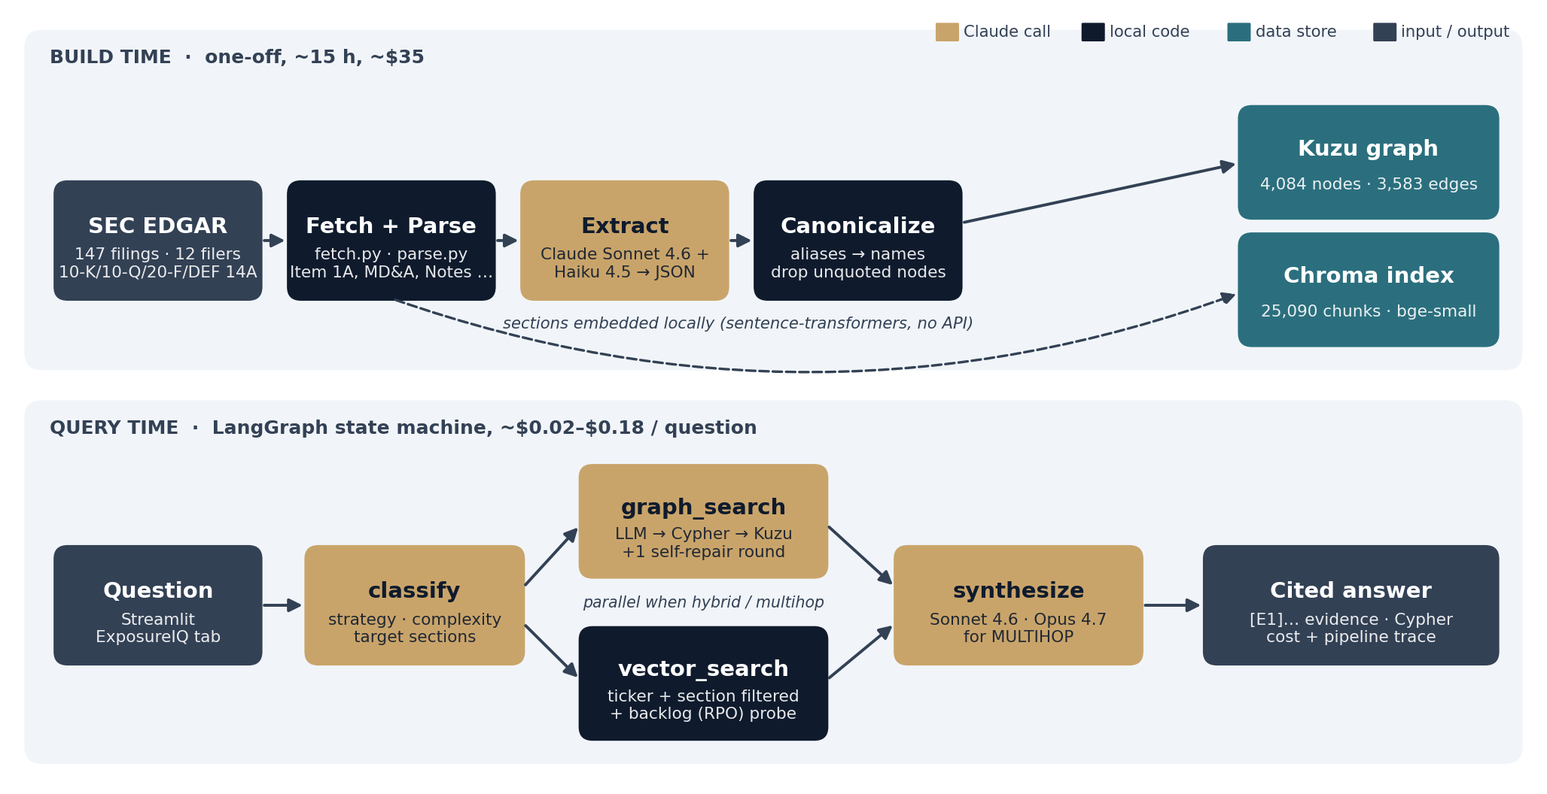
Figure 1. Build-time pipeline (top) and query-time LangGraph flow (bottom).
The system has two halves. The build-time pipeline runs once (about 15 hours and $35 of Claude calls) and produces two local stores: a Kuzu property graph and a Chroma vector index. The query-time engine is a four-node LangGraph state machine that reads those stores and calls Claude two to four times per question.

3. Technology stack
Layer | Technology | Why this choice
Source data | SEC EDGAR (10-K, 10-Q, 20-F, DEF 14A, ARS) | Audited, public and citable; notes and risk factors hold the off-balance-sheet detail
Ingestion | requests, BeautifulSoup, lxml | Rate-limited EDGAR fetch (<10 req/s); section-aware HTML parsing
Extraction | Claude Sonnet 4.6 + Claude Haiku 4.5, Pydantic schemas | Sonnet for risk-critical sections (~65%), Haiku for the rest; JSON validated against the schema
Graph store | Kuzu 0.11 (embedded, Cypher) | pip-installable, no Docker or Java; replaced Neo4j for a zero-footprint laptop setup
Vector store | Chroma 1.5 (persistent, cosine) | Local, metadata filters by ticker and form
Embeddings | BAAI/bge-small-en-v1.5 via sentence-transformers (Apple MPS) | Runs locally; no second API key; ~15 min to embed 25k chunks
Orchestration | LangGraph 0.6 | Explicit state machine, parallel fan-out, reducer-merged state
Reasoning | Claude Sonnet 4.6 (default), Claude Opus 4.7 (multi-hop) | Quality-first query path; Opus only where multi-entity reasoning needs it
UI | Streamlit (tab 5 of the AI SIFI Monitor) | Same app as the market dashboards; no new service
Runtime | Python 3, local laptop | Only secret: ANTHROPIC_API_KEY

4. Input data
Dimension | Scope
Companies (12) | Microsoft, Amazon, Alphabet, Oracle, Meta, IBM, Salesforce, Adobe, NVIDIA, ASML, CoreWeave, Broadcom
Roles | Hyperscalers, a neocloud (CoreWeave), SaaS consumers, the GPU supplier, custom silicon, lithography (foreign filer)
Forms | 10-K, 10-Q, 20-F, DEF 14A, ARS (8-K / 6-K / S-1 deferred)
Period | Fiscal 2024 – 2026
Volume | 147 filings, ~10M raw tokens, ~650 MB of HTML
Sections used | Item 1A risk factors, Item 7 MD&A, financial statements and notes, related-party transactions, compensation discussion

5. Build pipeline
Stage | Module | What it does | Output
1. Fetch | fetch.py | Pulls filing indexes and primary documents from EDGAR | cache/raw (HTML)
2. Parse | parse.py | Splits each filing into named sections with offsets | cache/parsed (sections.jsonl)
3. Extract | extract.py, prompts.py, schemas.py | Claude reads each section and returns typed nodes, edges and hidden-risk signals with verbatim quotes | cache/extracted (JSON)
4. Canonicalize | canonicalize.py | Maps aliases (AWS → Amazon, Facebook → Meta) | —
5. Graph load | graph_load.py | Dedupes nodes, drops nodes without a real quote, writes 7 node tables and 13 edge tables | cache/kuzu
6. Vector load | vector_load.py | Chunks sections and embeds them locally | cache/chroma

The repo ships the parsed sections and the extracted JSON (51 MB), so anyone who clones it runs only stages 5 and 6: about 15 minutes, no API cost.

6. Knowledge graph schema
Element | Values
Node types (7) | Company, AILab (OpenAI, Anthropic, xAI, Mistral, Cohere, Perplexity, Databricks), CapexCommitment, OffBalanceEntity, Investment, RiskFactor, HiddenRiskSignal
Edge types (13) | SELLS_COMPUTE_TO, BUYS_COMPUTE_FROM, INVESTED_IN, COMMITTED_CAPEX, SPONSORS, BENEFITS, CITES_RISK, HAS_RISK_SIGNAL, CIRCULAR_WITH, ROUND_TRIPS_WITH, NAMES_COUNTERPARTY, SUPPLIES, DEPENDS_ON
Hidden-risk types (8) | HIDDEN_LEVERAGE, CIRCULARITY, REVENUE_ROUNDTRIP, CAPEX_ROI_GAP, EXECUTION_RISK, COST_OPACITY, CUSTOMER_CONCENTRATION, SUPPLIER_CONCENTRATION; severity 1–5 (5 = could trigger a cascade)
Provenance | Every node keeps a list of cik:accession references and a verbatim quote
Size | 4,084 nodes, 3,583 edges, 1,631 unique hidden-risk signals

7. Query engine
graphrag/query.py compiles a LangGraph StateGraph with four nodes:
Node | Role | Model
classify | Chooses GRAPH, VECTOR or HYBRID retrieval, rates the question SIMPLE or MULTIHOP, and names the filing sections likely to hold the answer (MD&A, risk factors, notes, business, governance) | Sonnet 4.6
graph_search | Writes 1–3 Cypher queries against the schema and runs them on Kuzu. Failed queries go back to the model once with the Kuzu error. Each row resolves to a ticker, form and filing date. | Sonnet 4.6
vector_search | Embeds the question and searches Chroma filtered to the companies it names. Half the budget is restricted to the chosen sections, mapped across forms (MD&A = item_7 in a 10-K, part1_item2 in a 10-Q, item_5 in a 20-F). Multi-hop questions also get each company's latest backlog (RPO) figures via exact-text match | Local
synthesize | Writes a cited answer from the evidence only; flags hidden-risk patterns; says "insufficient evidence" rather than guessing; labels inferred links as inference | Sonnet 4.6, or Opus 4.7 if MULTIHOP

- Parallel retrieval. Hybrid and multi-hop questions fan out to both retrievers in the same LangGraph superstep; synthesize runs once when both finish.
- Cost tracking. Every Claude call is recorded with model, tokens, cost and latency and shown in the UI.
- Read-only graph. Kuzu opens read-only, so the app and the CLI can query at the same time.

8. Design decisions
Decision | Rationale
Graph + vector, not either alone | Vector search finds similar text; the graph answers structural questions (who sponsors which SPV, who invests in whom) and traverses counterparty webs.
Grounding filter at load | Nodes without a real verbatim quote are dropped. This removed a hallucinated Salesforce "Hyperion" that had overwritten Meta's real $27B Hyperion JV with Blue Owl.
Inference is labelled, never asserted | Filers often omit counterparty names. Oracle never names OpenAI; its backlog rising from $138B to $638B in FY26 is cited as consistent with the reported deal, marked as inference.
Model routing by complexity | Sonnet handles routing and simple answers; Opus is reserved for multi-hop synthesis, where it earns its cost.
Local embeddings and an embedded graph | No Docker, Java or second API key; the whole system runs on a laptop.

9. Cost and performance
Item | Figure
One-off extraction | $35.21 (Haiku $10.80, Sonnet $24.41), ~14 hours, 147 filings
Index build | ~17 minutes locally, $0
Simple question | ~$0.02, ~15 seconds
Multi-hop question | ~$0.06–$0.18, 25–40 seconds

10. Evaluation
A 26-question set (8 graph, 11 text, 6 multi-hop, 1 out-of-scope) is graded by Claude Opus 4.7. Faithfulness splits each answer into factual claims and checks each against the retrieved evidence; relevance rates 1–5 whether the answer addresses the question.
Configuration | Faithfulness (strict) | Faithfulness (lenient) | Relevance (≥4/5) | Mean relevance
Original | 93.2% | 95.7% | 100% | 4.73
+ Grounding-only answer prompt | 97.1% | 98.1% | 92% | 4.65
+ Section-aware retrieval (current) | 96.9% | 98.0% | 100% | 4.81

Forbidding outside knowledge lifted faithfulness but exposed retrieval gaps; section-aware retrieval closed them (e.g. Meta's capex outlook now comes from MD&A, not proxy tables). The grader was audited by hand and leans slightly strict. One run per configuration on 26 questions, with a same-family judge: indicative, not a benchmark.

11. Limitations and roadmap
- Extraction errors. Graph facts come from an LLM; answers still need a human read.
- Filings only. Undisclosed relationships appear only as labelled inference. Next: news as a separate, clearly labelled evidence tier.
- Dropped edges. About 700 extracted edges fall outside the schema's allowed type pairs; widening the schema would recover them.
- Snapshot corpus. Re-run the pipeline to add new filings; 8-K, 6-K and S-1 are next.
- Evaluation. Grow the 26-question set, add a judge from a different model family, and run each configuration several times.

