
SWP391 – Software development project

ARTIX
Version: 1.0
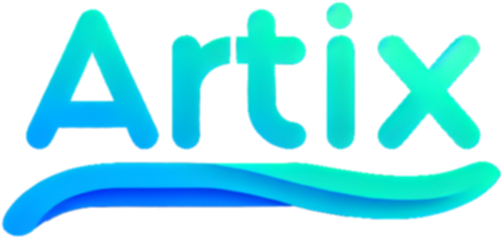
ARTWORK SHARING PLATFORM

– Ho Chi Minh, January 2024 –

STT | Fullname | MSSV
1 | Nguyễn Dương Gia Bảo | SE171697
2 | Huỳnh Thiện Nhân | SE171117
3 | Trần Ánh Tuyết | SE170234
4 | Nguyễn Minh Thức | SE170592
5 | Phạm Minh Triều | SE172937

III. User Manual

1. Overview

Artwork Sharing Platform, a vibrant online community where artists from around the globe come together to showcase their creativity, discover inspiration, and connect with art enthusiasts. Our platform serves as a dynamic hub for the exchange of diverse artistic expressions, fostering a supportive environment for both established and emerging talents.

2. Workflow
2.1 If you be a Guess
If you're a guest, you can only perform low-level functions like viewing photos, viewing artist, and changing background modes.
Higher is register a new Account.
2.1.1 View image, artist
If you want to view:
First way you just need to click a image or avatar of artist.
Second way is search name of artist or artwork you want to view

2.1.2 Change background modes
Step 1: Click on avatar icon
Step 2: Click on Light/Dark to change modes
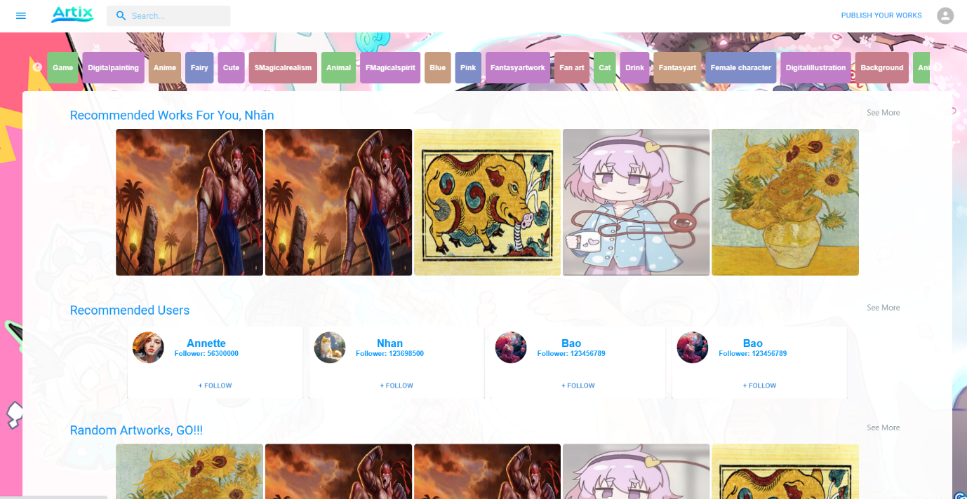

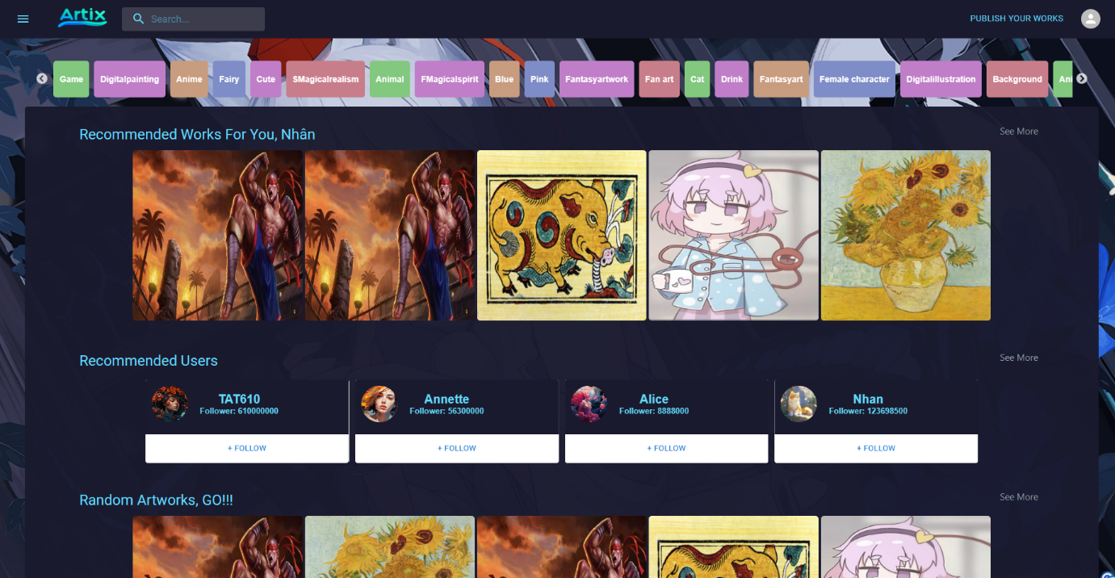
2.1.3 Register Account
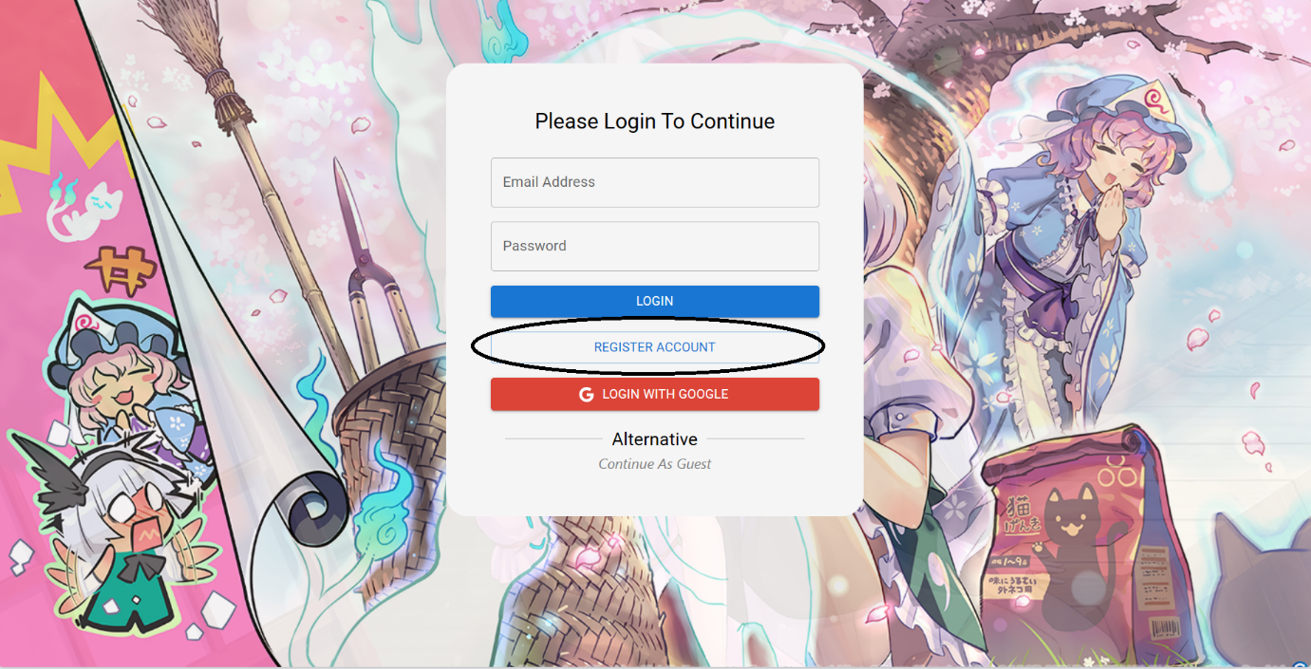
Step 1: Access to Website and click on Register button
Step2: Fill Infomation to Register Form
Step3: Submit the Form

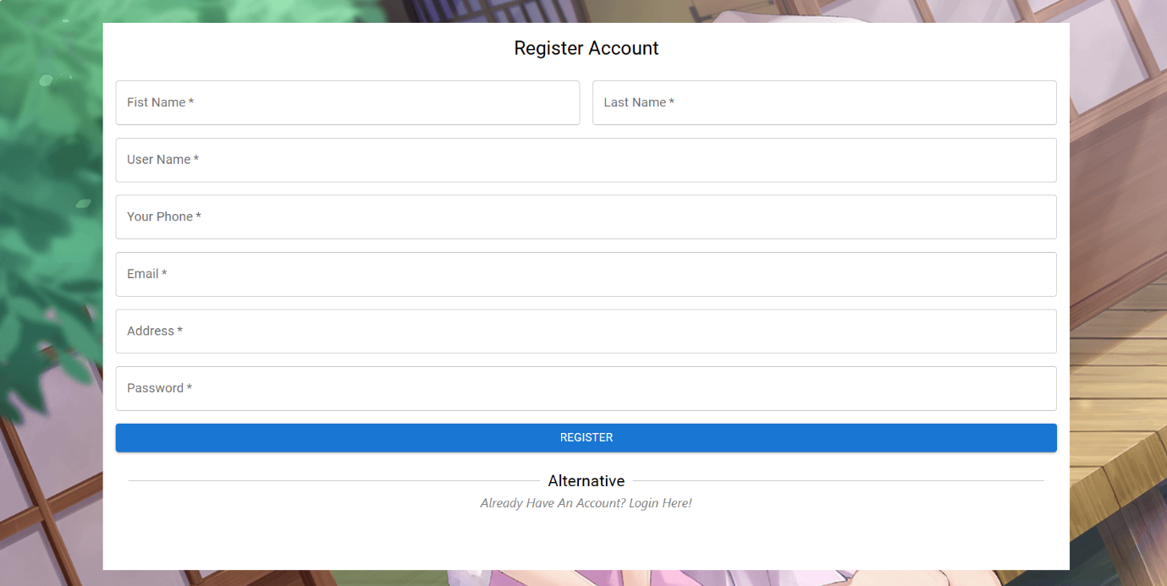

2.2 If you be a User
2.2.1 Upload Image
Step 1: Click “ Publish Your Works”

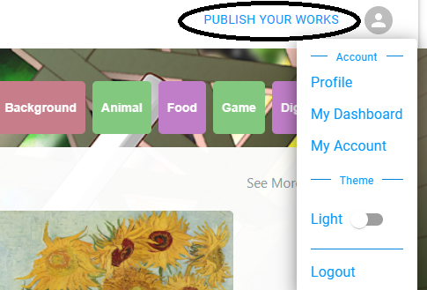
Step 2: Upload Image, Choose Tag, Is This Image Purchasable
Step 3: Click UpLoad Artwork
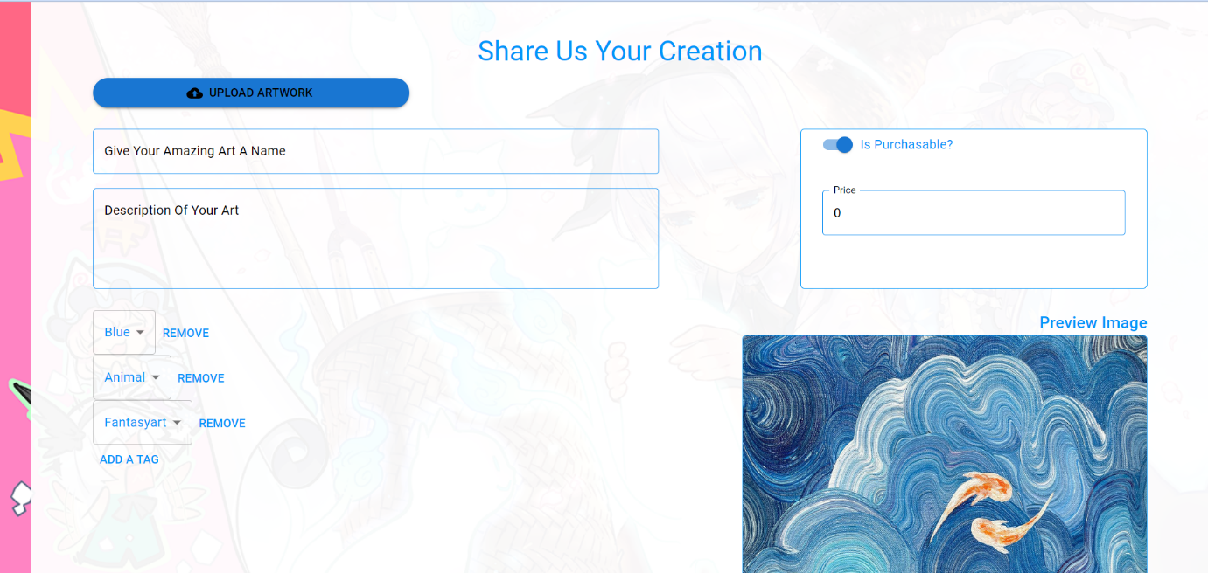

Step 4: If you want to see your Artwork, you click on your avatar and click “Profile”
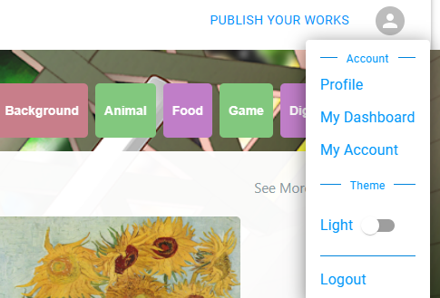

2.2.2 How to open your Commissions receive
Step 1: In Artist profile, click “Open for Commission”
Step 2: You can accept or denine Commission
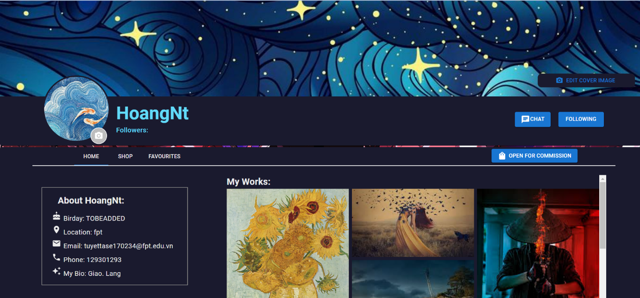

2.2.3 View Dashboard
Step 1: Click on your Avatar, then click “My DashBoard”
Step 2: Wait web sumary the like of your top 10 Newest Works
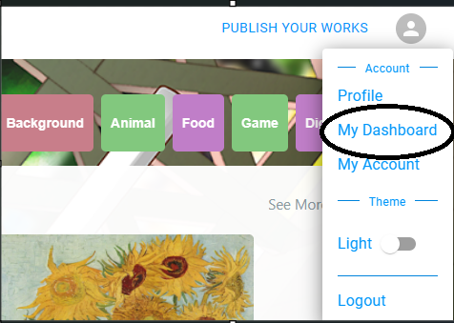
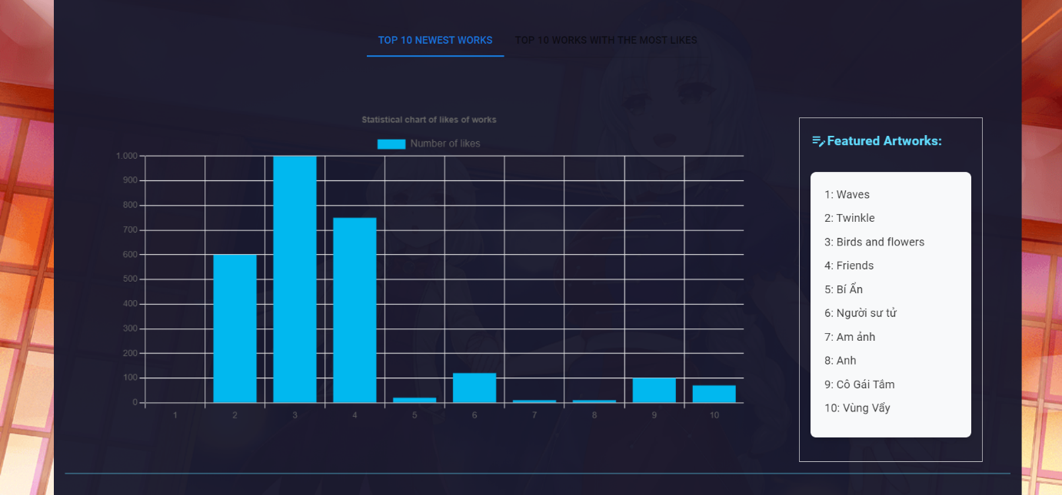

2.2.4 How to post your Artwork
2.2.5 How to buy Artwork

