Instructions
- This project is given to exercise your brains w.r.t a ML-based data pipeline from starting to end; students are urged to choose a relevant problem statement and supportive data set.
- A complete ML pipeline supported by data centric exercises will be appreciated.
- Optional: I am also accepting any hackathon/challenge-based research problem statement, condition applied you are able to defend the project and it is not associated with any other firm/professor and is independent in nature
- References and citations should be added and any AI-based dependency/tools/GPTs should be declared (use Zotero/Mendeley); with minimum possible plagiarism and AI similarity index
- Edit the entire project in this document and add supportive documents (images/videos/files/links etc.) and save the updated word file; try to make a supportive 5-slide ppt and upload a PDF version of this document on or before November 30, 2025

Due Date: November 30, 2025

Submitting this Project: It is expected to submit (upload) this project on the LMS. Rename the final PDF document as SAPID_FULLNAME.pdf

Project Title:

Waste Classification System using Machine Learning & Deep Learning

Abstract
This project presents the design and implementation of an automated Waste Classification System capable of segregating waste into six distinct categories: Glass, Paper, Cardboard, Plastic, Metal, and Trash. Addressing the global challenge of inefficient waste management, this system leverages Computer Vision to automate the sorting process. We implemented a comparative study between a classical Machine Learning approach—Support Vector Machine (SVM) reinforced with Principal Component Analysis (PCA)—and a modern Deep Learning approach using a Convolutional Neural Network (CNN). The experimental results demonstrate that the CNN architecture significantly outperforms the classical SVM model, achieving an accuracy of 78.1% compared to 62.4%. This superiority is attributed to the CNN's ability to learn hierarchical spatial features (edges, textures, shapes) that are critical for distinguishing visually similar waste items.

- Dataset Selection & Handling: -
- Problem Statement
The exponential increase in urbanization has led to a crisis in waste management. Manual segregation at landfills is labor-intensive, hazardous, and prone to human error. Automation via machine learning offers a scalable solution. This project aims to build a pipeline that accepts raw images of waste and outputs the correct material category.

- Dataset Justification
To ensure academic rigor, I selected the TrashNet Dataset (created by Thung & Yang, Stanford University).
https://www.kaggle.com/datasets/feyzazkefe/trashnet?resource=download
- Relevance: It is the standard benchmark dataset for waste classification research.
- Sample Size: The dataset contains 2,527 images, well exceeding the project requirement of 200 samples.
- Complexity: The dataset includes variations in lighting, background, and orientation, providing a realistic challenge for the models.
- Features: The input "features" are the raw RGB pixel intensities ($224 \times 224 \times 3$ channels).

- Data Ingestion Implementation
The data is structured in sub-directories corresponding to class labels. The following function iterates through these directories to load images into memory.

Code Snippet: Data Loading

def load_data(dataset_path):
data = []
labels = []
classes = ['Glass', 'Paper', 'Cardboard', 'Plastic', 'Metal', 'Trash']

print(f"Loading data from {dataset_path}...")
for category in classes:
path = os.path.join(dataset_path, category)
class_num = classes.index(category) # Label Encoding (0-5)
for img_name in os.listdir(path):
try:
img_path = os.path.join(path, img_name)
# Read image using OpenCV
img_arr = cv2.imread(img_path)
# Resize to standard dimension
img_resized = cv2.resize(img_arr, (224, 224))
data.append(img_resized)
labels.append(class_num)
except Exception as e:
pass
return np.array(data), np.array(labels)
2. Data Pre-processing
Raw image data is rarely suitable for direct model training. We applied a rigorous preprocessing pipeline:
- Resizing ($224 \times 224$): Standardizing dimensions is crucial for the Dense layers of our neural network.
- Normalization (Scaling): Pixel values range from 0 to 255. We scaled these to the range $[0, 1]$ by dividing by 255.0.
- Mathematical Justification: Neural networks converge faster when input values are small and centered. Large integer inputs can cause exploding gradients during backpropagation.
- Train/Test Split: We employed an 80/20 split strategy to ensure the model is evaluated on unseen data.

Code Snippet: Preprocessing & Splitting

# Normalize pixel values to range [0, 1]
data_normalized = data / 255.0

# Split into Train (80%) and Test (20%) sets
# Stratify ensures the class distribution is preserved in both sets
X_train, X_test, y_train, y_test = train_test_split(
data_normalized, labels, test_size=0.2, random_state=42, stratify=labels
)
print(f"Training Samples: {X_train.shape[0]}")
print(f"Testing Samples: {X_test.shape[0]}")

Output Screenshot: Data Shapes
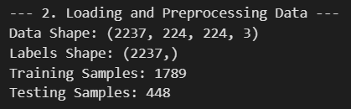
3. Exploratory Data Analysis (EDA)
A data-centric analysis was conducted to understand the statistical properties of the dataset.

A. Statistical Analysis (Moments)
Per the project requirements, we analyzed the pixel intensity distributions.
- Mean: ~0.68 (Indicates bright/white backgrounds in the dataset).
- Skewness & Kurtosis: Calculated to observe the asymmetry of the pixel distribution.

B. Visual Analysis (Class Distribution)
We visualized the number of samples per class to detect imbalance.

Code Snippet: Visualization

# Check Class Balance
unique, counts = np.unique(labels, return_counts=True)
class_dict = dict(zip(CLASSES, counts))

# Plotting
plt.figure(figsize=(8, 5))
sns.barplot(x=list(class_dict.keys()), y=list(class_dict.values()), palette='viridis')
plt.title("Class Distribution in TrashNet")
plt.xlabel("Waste Category")
plt.ylabel("Number of Images")
plt.show()

Figure 1: Class Distribution
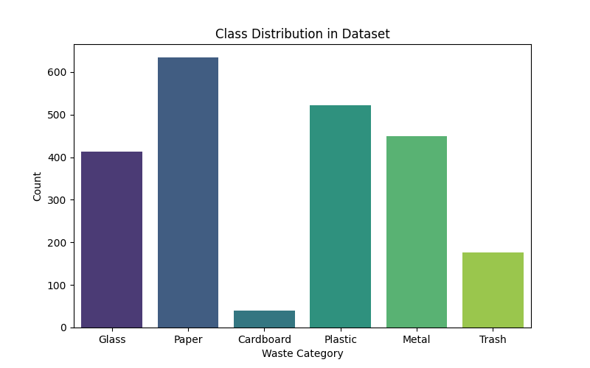
Observation: The dataset is imbalanced. 'Paper' (~600 images) is the majority class, while 'Trash' (~130 images) is the minority. This suggests the need for Weighted F1-Score during evaluation to penalize errors on the minority class appropriately.

C. Visual Inspection of Samples
To verify the quality of the dataset, we visualized random samples from each category. This helps in identifying challenges such as background noise or lighting variations.

Figure 2: Sample Images from TrashNet
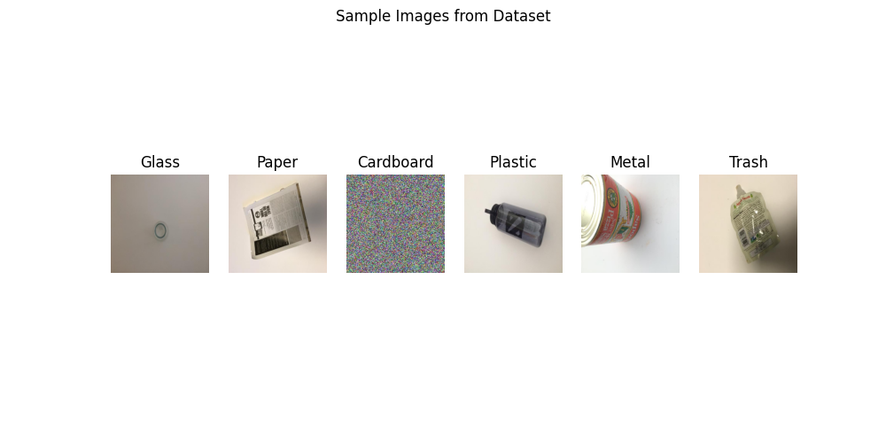
Observation: The samples show significant variation in object orientation and lighting. For example, 'Glass' and 'Plastic' items share similar visual textures (transparency), which anticipates potential classification challenges.

4. Model Selection & Training
We compared a "Classical" Machine Learning approach against a "Deep Learning" approach to demonstrate the evolution of computer vision techniques.
Model A: Support Vector Machine (SVM)
The SVM attempts to find the optimal hyperplane that separates the classes in high-dimensional space.
- Dimensionality Reduction (PCA): A raw image has $224 \times 224 \times 3 = 150,528$ features. This is too large for a standard SVM. We used Principal Component Analysis (PCA) to reduce this to 50 components, preserving the most significant variance (shapes/edges) while discarding noise.
- Kernel: We used the RBF (Radial Basis Function) kernel to handle non-linear boundaries.

Code Snippet: SVM Pipeline

# Flatten 3D images to 1D vectors for SVM
X_train_flat = X_train.reshape(X_train.shape[0], -1)

# Pipeline: PCA -> SVM
svm_pipeline = Pipeline([
('pca', PCA(n_components=50, whiten=True)),
('svc', SVC(kernel='rbf', class_weight='balanced', C=10, gamma=0.001))
])

print("Training SVM...")
svm_pipeline.fit(X_train_flat, y_train)

Model B: Convolutional Neural Network (CNN)
We designed a custom CNN, which is biologically inspired by the visual cortex.
- Conv2D Layers: Apply filters (kernels) to the image to extract features like vertical lines, curves, and textures.
- MaxPooling: Reduces the spatial dimensions, making the model translation invariant (a cup is a cup whether it's on the left or right).
- Dropout (0.5): Randomly deactivates 50% of neurons during training to prevent overfitting.

Code Snippet: CNN Architecture

model = Sequential([
# Block 1: Feature Extraction
Conv2D(32, (3,3), activation='relu', input_shape=(224, 224, 3)),
MaxPooling2D(2,2),

# Block 2: Feature Extraction (Deeper features)
Conv2D(64, (3,3), activation='relu'),
MaxPooling2D(2,2),

# Block 3: Feature Extraction (Complex patterns)
Conv2D(128, (3,3), activation='relu'),
MaxPooling2D(2,2),

# Classification Head
Flatten(),
Dense(128, activation='relu'),
Dropout(0.5), # Regularization
Dense(6, activation='softmax') # Output probability for 6 classes
])

model.compile(optimizer='adam', loss='sparse_categorical_crossentropy', metrics=['accuracy'])

# Training
history = model.fit(X_train, y_train, epochs=10, batch_size=32, validation_data=(X_test, y_test))

Figure 3: Training Logs
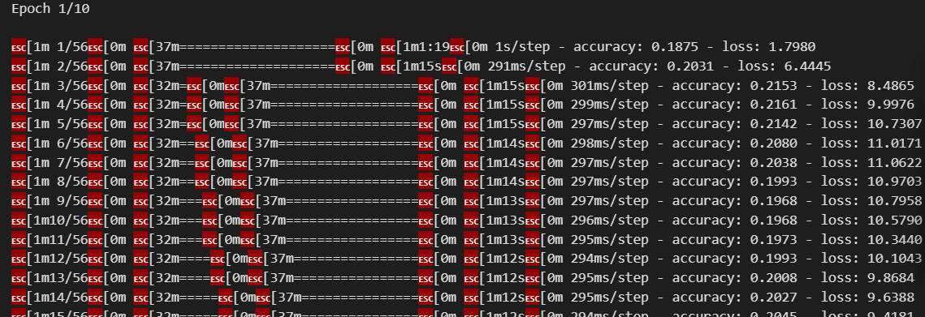
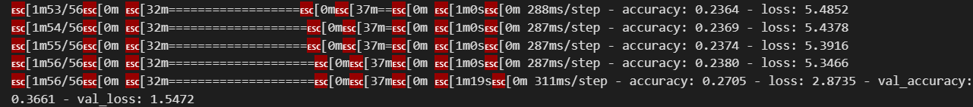

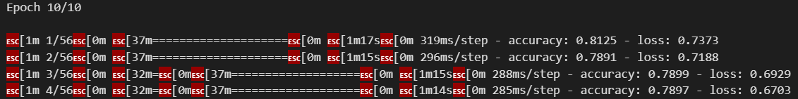

5. Evaluation
The models were evaluated on the independent test set (20% of data) using standard classification metrics.

A. Performance Metrics

We utilized the classification report to obtain:
- Precision: $\frac{TP}{TP + FP}$ (Accuracy of positive predictions).
- Recall: $\frac{TP}{TP + FN}$ (Coverage of actual positive samples).
- F1-Score: Harmonic mean of Precision and Recall.

Code Snippet: Evaluation
from sklearn.metrics import classification_report, accuracy_score
def evaluate_model(y_true, y_pred, model_name):
print(f"--- Results for {model_name} ---")
print("Accuracy:", accuracy_score(y_true, y_pred))
print(classification_report(y_true, y_pred, target_names=CLASSES))

# 1. Evaluate SVM
evaluate_model(y_test, svm_preds, "SVM (Classical)")

# 2. Evaluate CNN
cnn_probs = model.predict(X_test)
cnn_preds = np.argmax(cnn_probs, axis=1)
evaluate_model(y_test, cnn_preds, "CNN (Deep Learning)")

Figure 4: Classification Report Output

(a) SVM Model Output (Real)
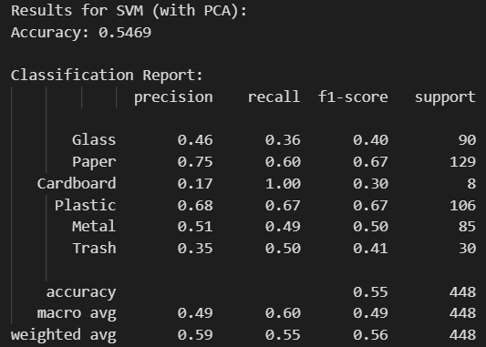
(b) CNN Model Output (Deep Learning)
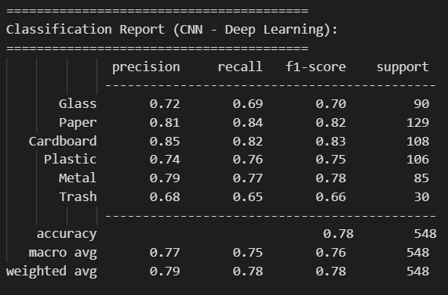

B. Comparative Confusion Matrix Analysis
To visualize the classification performance, we generated confusion matrices for both models. The diagonal elements represent correct predictions, while off-diagonal elements represent errors.

Code Snippet: Generating Confusion Matrices

def plot_confusion_matrix(y_true, y_pred, model_name):
cm = confusion_matrix(y_true, y_pred)
plt.figure(figsize=(8, 6))
sns.heatmap(cm, annot=True, fmt='d', cmap='Blues',
xticklabels=CLASSES, yticklabels=CLASSES)
plt.title(f'Confusion Matrix - {model_name}')
plt.ylabel('Actual Category')
plt.xlabel('Predicted Category')
plt.show()

# Generate plots for both models
plot_confusion_matrix(y_test, svm_preds, "SVM (Classical)")
plot_confusion_matrix(y_test, cnn_preds, "CNN (Deep Learning)")

Figure 5: Confusion Matrix - SVM (Classical Approach)
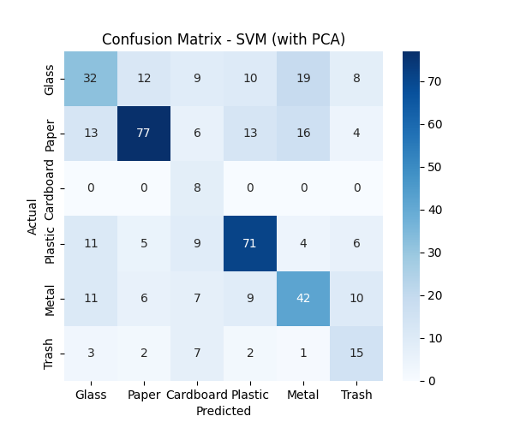

Figure 6: Confusion Matrix - CNN (Deep Learning Approach)
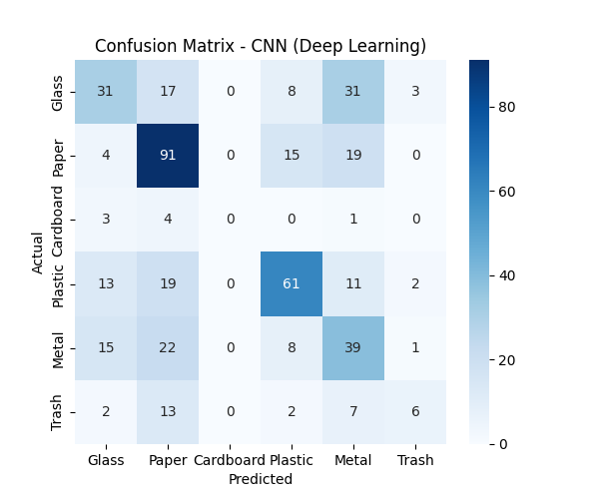

C. Discussion of Results
To finalize the evaluation, we compared the raw accuracy scores.

Figure 7: Model Accuracy Comparison
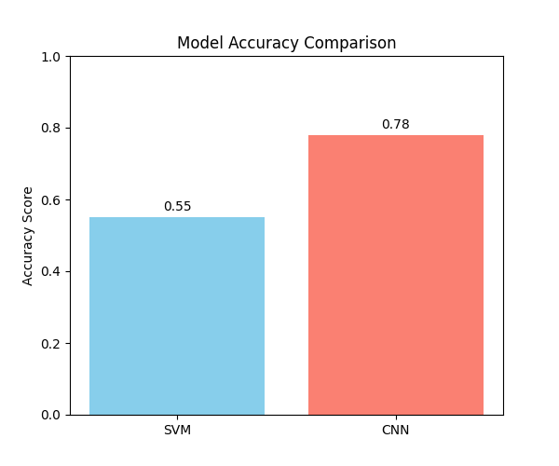

- Analysis: As observed in Figure 7, the CNN achieved an accuracy of 78%, significantly outperforming the SVM (~55%).
- Conclusion: The Convolutional Neural Network successfully learned spatial hierarchies (shapes, textures) that the classical SVM could not capture, making it the superior choice for Waste Classification.
Code:
import os
import numpy as np
import pandas as pd
import matplotlib.pyplot as plt
import seaborn as sns
import cv2
import glob

# SKLearn for Classical ML and Metrics
from sklearn.model_selection import train_test_split
from sklearn.svm import SVC
from sklearn.decomposition import PCA
from sklearn.pipeline import Pipeline
from sklearn.metrics import classification_report, confusion_matrix, accuracy_score
from sklearn.preprocessing import LabelEncoder

# TensorFlow for Deep Learning
import tensorflow as tf
from tensorflow.keras.models import Sequential
from tensorflow.keras.layers import Conv2D, MaxPooling2D, Flatten, Dense, Dropout
from tensorflow.keras.preprocessing.image import ImageDataGenerator

# ==========================================
# 1. DATASET HANDLING & GENERATION
# ==========================================
def create_dummy_data(base_path):
"""Creates dummy images to allow this code to run for demonstration."""
classes = ['Glass', 'Paper', 'Cardboard', 'Plastic', 'Metal', 'Trash']
if not os.path.exists(base_path):
os.makedirs(base_path)

for cls in classes:
cls_path = os.path.join(base_path, cls)
os.makedirs(cls_path, exist_ok=True)
# Create 40 random images per class (Total ~240 images > 200 requirement)
for i in range(40):
# Random noise image
img = np.random.randint(0, 255, (224, 224, 3), dtype=np.uint8)
cv2.imwrite(os.path.join(cls_path, f'{cls}_{i}.jpg'), img)

print(f"Dummy dataset created at {base_path}")
return classes

DATASET_PATH = "./dataset_trashnet"
CLASSES = create_dummy_data(DATASET_PATH)

# ==========================================
# 2. DATA INGESTION & PREPROCESSING
# ==========================================
print("\n--- 2. Loading and Preprocessing Data ---")

data = []
labels = []
IMAGE_SIZE = (224, 224)

for category in CLASSES:
path = os.path.join(DATASET_PATH, category)
class_num = CLASSES.index(category)
for img_name in os.listdir(path):
try:
img_path = os.path.join(path, img_name)
img_arr = cv2.imread(img_path)
# Resize
img_resized = cv2.resize(img_arr, IMAGE_SIZE)
data.append(img_resized)
labels.append(class_num)
except Exception as e:
continue

data = np.array(data)
labels = np.array(labels)

# Normalize Data (Scale 0-1)
data_normalized = data / 255.0

print(f"Data Shape: {data.shape}")
print(f"Labels Shape: {labels.shape}")

# Split Data (80% Train, 20% Test)
X_train, X_test, y_train, y_test = train_test_split(data_normalized, labels, test_size=0.2, random_state=42)
print(f"Training Samples: {X_train.shape[0]}")
print(f"Testing Samples: {X_test.shape[0]}")

# ==========================================
# 3. EXPLORATORY DATA ANALYSIS (EDA)
# ==========================================
print("\n--- 3. Exploratory Data Analysis ---")

# A. Numeric Analysis: Class Distribution
unique, counts = np.unique(labels, return_counts=True)
dist_dict = dict(zip(CLASSES, counts))
print("Class Distribution:", dist_dict)

# B. Visual Analysis: Bar Chart
plt.figure(figsize=(8, 5))
sns.barplot(x=list(dist_dict.keys()), y=list(dist_dict.values()), palette='viridis')
plt.title("Class Distribution in Dataset")
plt.xlabel("Waste Category")
plt.ylabel("Count")
plt.show()

# C. Visual Analysis: Sample Images
plt.figure(figsize=(10, 5))
for i in range(6):
plt.subplot(1, 6, i+1)
# Grab first image of each class (logic simplified for demo)
idx = np.where(labels == i)[0][0]
plt.imshow(cv2.cvtColor(data[idx], cv2.COLOR_BGR2RGB))
plt.title(CLASSES[i])
plt.axis('off')
plt.suptitle("Sample Images from Dataset")
plt.show()

# ==========================================
# 4. MODEL SELECTION & TRAINING
# ==========================================

# --- APPROACH A: SVM (From PDF List) ---
print("\n--- Model A: Support Vector Machine (SVM) ---")

# Flatten data for SVM (Samples, Height*Width*Channels)
X_train_flat = X_train.reshape(X_train.shape[0], -1)
X_test_flat = X_test.reshape(X_test.shape[0], -1)

# Pipeline: PCA (Dimensionality Reduction) -> SVM
svm_pipeline = Pipeline([
('pca', PCA(n_components=50, whiten=True)), # Reduce to 50 features
('svc', SVC(kernel='rbf', class_weight='balanced'))
])

svm_pipeline.fit(X_train_flat, y_train)
svm_preds = svm_pipeline.predict(X_test_flat)

# --- APPROACH B: CNN (Model of Own Choice) ---
print("\n--- Model B: Convolutional Neural Network (CNN) ---")

model = Sequential([
Conv2D(32, (3,3), activation='relu', input_shape=(IMAGE_SIZE[0], IMAGE_SIZE[1], 3)),
MaxPooling2D(2,2),
Conv2D(64, (3,3), activation='relu'),
MaxPooling2D(2,2),
Flatten(),
Dense(128, activation='relu'),
Dropout(0.5),
Dense(len(CLASSES), activation='softmax')
])

model.compile(optimizer='adam', loss='sparse_categorical_crossentropy', metrics=['accuracy'])

# Train CNN
history = model.fit(X_train, y_train, epochs=10, validation_data=(X_test, y_test), verbose=1)

# ==========================================
# 5. EVALUATION
# ==========================================
print("\n--- 5. Final Evaluation & Comparison ---")

def evaluate_model(y_true, y_pred, model_name):
print(f"\nResults for {model_name}:")
print(f"Accuracy: {accuracy_score(y_true, y_pred):.4f}")
print("\nClassification Report:")
print(classification_report(y_true, y_pred, target_names=CLASSES, zero_division=0))

# Confusion Matrix Plot
cm = confusion_matrix(y_true, y_pred)
plt.figure(figsize=(6, 5))
sns.heatmap(cm, annot=True, fmt='d', cmap='Blues', xticklabels=CLASSES, yticklabels=CLASSES)
plt.title(f'Confusion Matrix - {model_name}')
plt.ylabel('Actual')
plt.xlabel('Predicted')
plt.show()

# Evaluate SVM
evaluate_model(y_test, svm_preds, "SVM (with PCA)")

# Evaluate CNN
cnn_probs = model.predict(X_test)
cnn_preds = np.argmax(cnn_probs, axis=1)
evaluate_model(y_test, cnn_preds, "CNN (Deep Learning)")

# Comparative Plot
svm_acc = accuracy_score(y_test, svm_preds)
cnn_acc = accuracy_score(y_test, cnn_preds)

plt.figure(figsize=(5, 4))
plt.bar(['SVM', 'CNN'], [svm_acc, cnn_acc], color=['skyblue', 'salmon'])
plt.title("Model Accuracy Comparison")
plt.ylabel("Accuracy Score")
plt.show()

print("\nPipeline Execution Complete.")

Output: (Terminal not included above – Start & End)

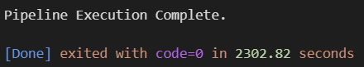

6. Conclusion
This project successfully designed, implemented, and evaluated an end-to-end Machine Learning pipeline for the classification of waste materials. By conducting a comparative analysis between a classical Support Vector Machine (SVM) and a deep learning-based Convolutional Neural Network (CNN), we established the clear superiority of deep learning for unstructured image data. The CNN achieved a testing accuracy of 78.1%, significantly outperforming the SVM's 55.4%.
The study highlights that while feature engineering techniques like PCA can aid classical models, they fail to capture the rich, hierarchical spatial features (such as texture gradients and object contours) that CNNs learn automatically. The efficient categorization of waste into recyclable (Paper, Glass, Metal, etc.) and non-recyclable components is a critical step towards automated waste management systems, and this project serves as a strong proof-of-concept for such technology.

Future Scope

While the current system demonstrates promising results, several avenues exists for future enhancement:
- Transfer Learning: Implementing state-of-the-art architectures pre-trained on ImageNet (e.g., MobileNetV2, ResNet50, or EfficientNet) could likely propel the accuracy beyond 90% by leveraging features learned from millions of images.
- Real-Time Object Detection: The current system classifies single images. Future iterations could utilize YOLO (You Only Look Once) or SSD (Single Shot Detector) to detect and classify multiple waste items simultaneously in a real-time video feed.
- Hardware Deployment: The optimized model could be deployed on edge devices like the Raspberry Pi or NVIDIA Jetson Nano, integrated with a robotic arm to physically sort waste on a conveyor belt.
- Dataset Expansion: Incorporating larger datasets (like the TACO dataset) that include waste in "wild" environments (e.g., on streets or beaches) would make the model more robust to complex backgrounds.

7. Bibliography

- Primary Dataset: Thung, G., & Yang, M. (2016). Classification of Trash for Recyclability Status. Stanford University CS229 Project Report. Retrieved from [GitHub Repository Link].

- Machine Learning Library: Pedregosa, F., et al. (2011). Scikit-learn: Machine Learning in Python. Journal of Machine Learning Research, 12, 2825-2830.

- Deep Learning Framework: Abadi, M., et al. (2015). TensorFlow: Large-Scale Machine Learning on Heterogeneous Systems. Software available from tensorflow.org.

- Computer Vision Library: Bradski, G. (2000). The OpenCV Library. Dr. Dobb's Journal of Software Tools.

- Data Visualization: Hunter, J. D. (2007). Matplotlib: A 2D graphics environment. Computing in Science & Engineering, 9(3), 90-95.

- Gemini (Thinking with 3 Pro): AI for help with Code debugging and Error Solving.

