**INSTRUCTION**

DOWNLOAD INSTRUCTION

1. Clone this project to your local computer.
2. git clone <https://github.com/AnnBonador/puptaaas.git>
3. Rename .env.example to **.env** and edit database credentials there.
4. composer install
5. Generate app key
6. php artisan key:generate
7. php artisan migrate
8. Run npm install && npm run dev
9. If nahirapan I-clone punta kayo sa Code na button at idownload ang zip then proceed to step 3
10. If di gumana ang php artisan migrate gamitin na lang yung sql file.

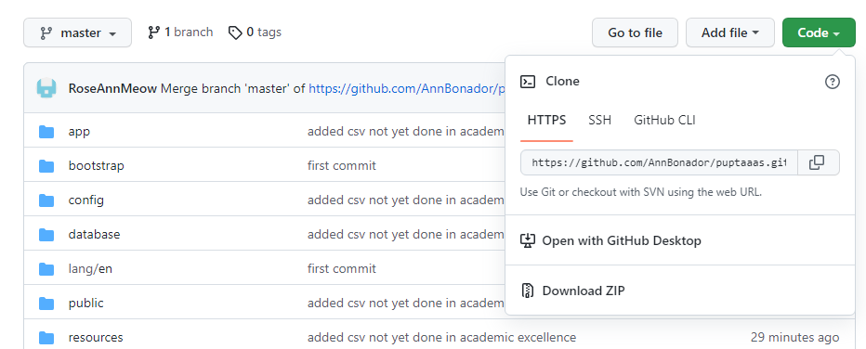

CREDENTIALS

**ADMIN –** admin:11111111

WORKING AS OF SEPT 16

* -Register
* -Login

**Super Admin(admin for now)**

* Student /View/Edit/Delete
* User /Add/Edit/Delete
* Activity Log (button show is not yet functional)
* Academic Awards /Approve/Reject/Select All
* Achiever’s Award
  + List of All Courses (No reporting yet for general)
  + View Application form, printable
  + Delete button no function yet
* Dean’s List Award
  + List of All Courses (No reporting yet for general)
  + View Application form, printable
  + Delete button no function yet
* President’s List Award
  + List of All Courses (No reporting yet for general)
  + View Application form, printable
  + Delete button no function yet
* Academic Excellence List Award
  + List of All Courses (No reporting yet for general)
  + Hindi pa tapos
* Import CSV gumagana na pero di pana didisplay ung imported na file

**User**

* Working na except sa academic excellence di pa po tapos
* Application status

Wala pa sa Officials at Admin kasi di pa po complete lahat ung super admin. Copy paste na lang po kasi gagawin dun para mas madali.