**E-Track: A Document Tracking System**

Submitted By:

BSIT - 4B

December 2024

**TABLE OF CONTENTS**

**I.** **Overview** 1

**II.** **Business Requirements** 1

**Table 2.1 Functional and Non-functional Requirements** 1

**III.** **Major Interface Wireframes** 2

**Table 3.1 Dashboard Page** 2

**Table 3.1 Upload Document Page** 3

**Table 3.1 My Documents Page** 3

**Table 3.1 Notifications Page** 3

**Table 3.1 Profile Page** 3

**IV.** **User Manual** 2

# **Overview**

The E-Track: Document Tracking System (DTS) is a web-based tool that helps organizations manage their documents more efficiently. Instead of relying on paper files or scattered emails, DTS allows users to upload, send, track, and retrieve documents all in one secure online space. This makes it easier to stay organized and ensures that important files don’t get lost or forgotten.

One of the biggest problems with manual tracking is that it’s easy for documents to go missing or get stuck waiting for approval. E-Track solves this by keeping a detailed record of every action taken—who opened the file, what they did, and when they did it. This creates transparency and accountability, so everyone knows what’s happening and nothing slips through the cracks.

E-Track is especially useful for places like government offices, schools, and private companies where many people handle sensitive documents. When timing and accuracy matter, having a system that keeps everything in order can save time, reduce stress, and improve productivity. In short, E-Track help teams work smarter, not harder.

# **Business Requirements**

Table 2.1 shows the identified functional and non-functional requirements of the web-based system.

## **Table 2.1 Functional and Non-functional Requirements**

## 

|  |  |
| --- | --- |
| **Functional Requirements** | **Non-functional Requirements** |
| The system must allow users to register and log in securely. | The system shall load within 3 seconds for standard operations. |
| Users must be able to upload new documents with metadata (title, reference number, description). | User data and documents shall be stored securely with encryption. |
| The system must allow authorized staff to update the status of documents (e.g., “Received,” “In Review,” “Approved,” “Released”). | The interface shall be simple, intuitive, and responsive on multiple devices. |
| The system must generate tracking codes for uploaded documents. | The system shall allow role-based access control (e.g., Admin, Clerk, User). |
| Users must be able to search and filter documents by keywords, status, or date. | The system shall support up to [???] concurrent users without performance degradation. |
| The system must provide audit logs for every transaction. | The system shall ensure minimal data loss by implementing backup and recovery features. |
| Reports must be generated showing document flow, pending documents, and turnaround times. | The system shall load within 3 seconds for standard operations. |
| The system must allow users to register and log in securely. | User data and documents shall be stored securely with encryption. |

# **Major Interface Wireframes**

* **User Area Page**

**Figure 3.1 Dashboard Page**

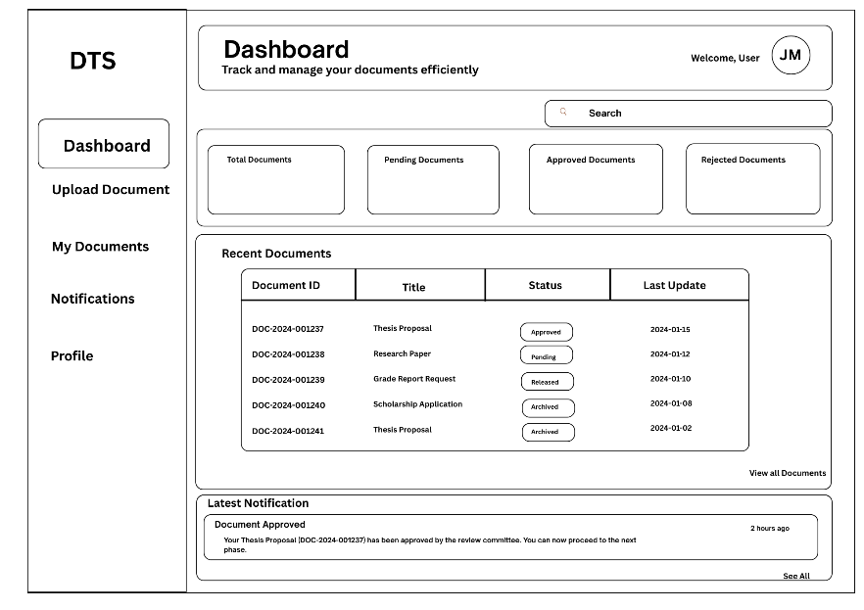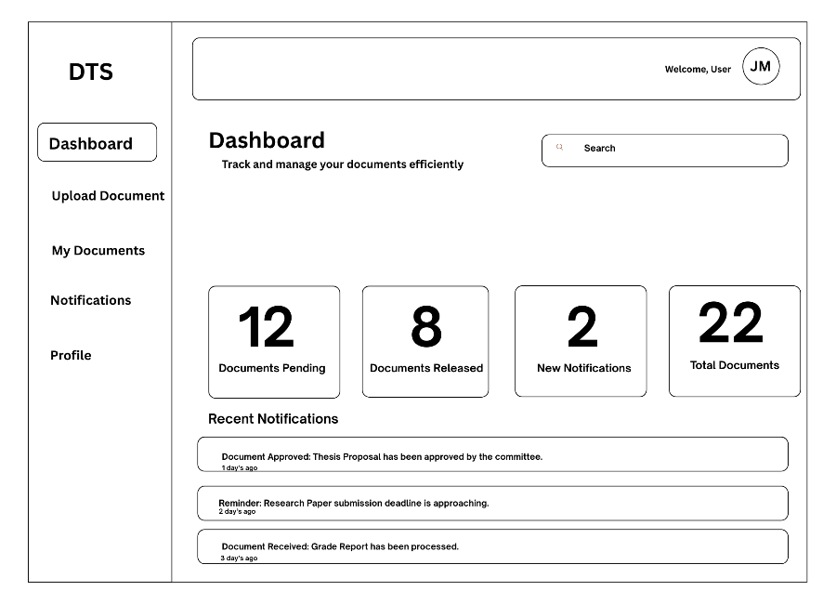

**Figure 3.2 Upload Documents Page**

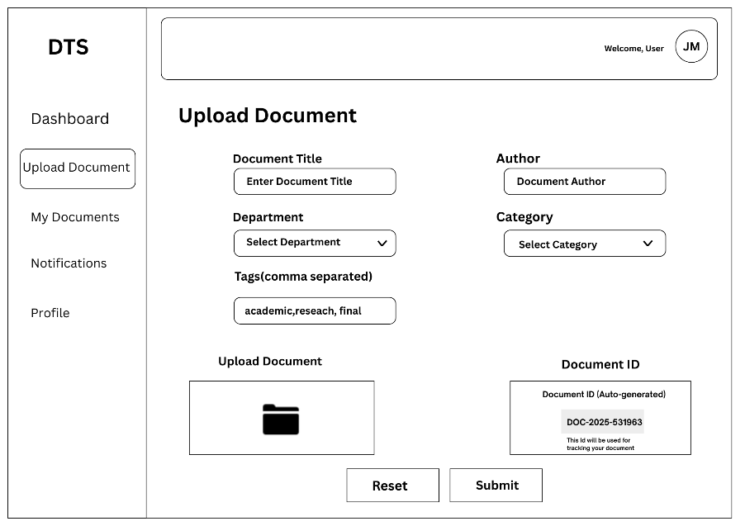

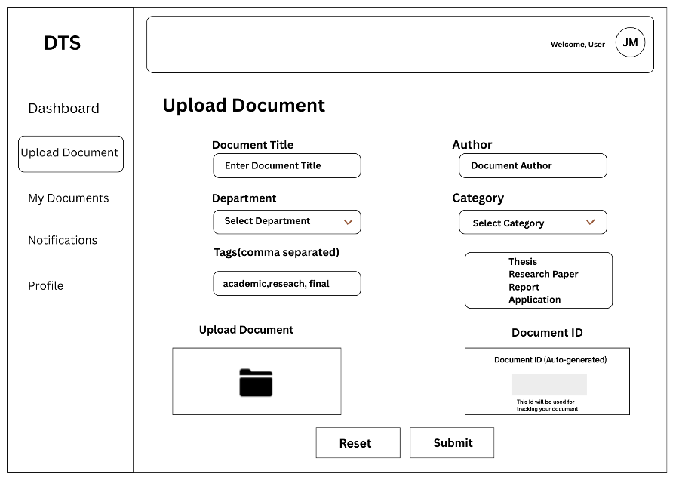

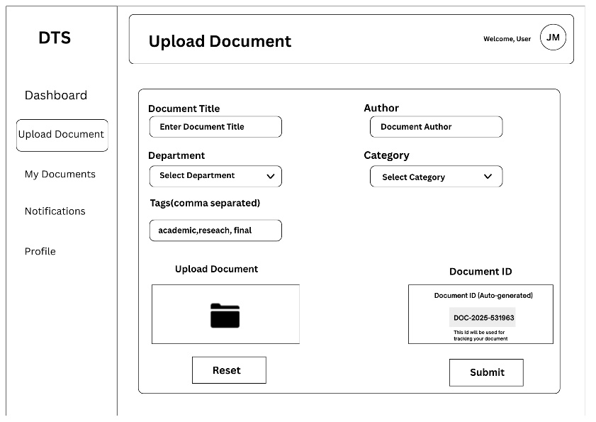

**Figure 3.3 My Documents Page**

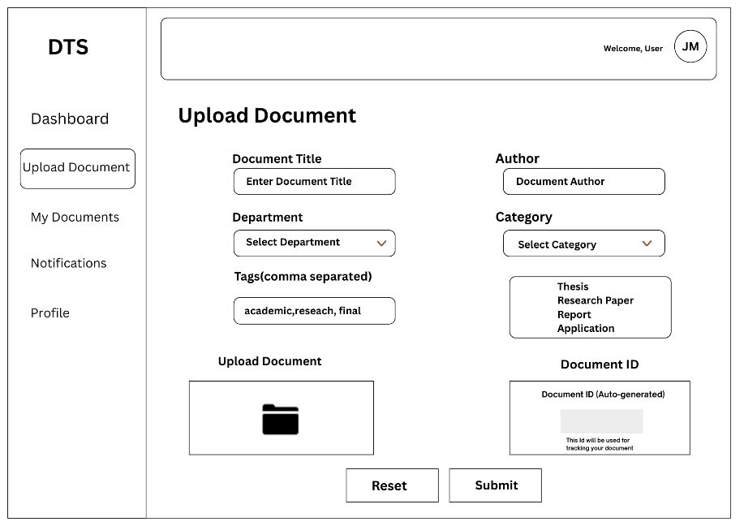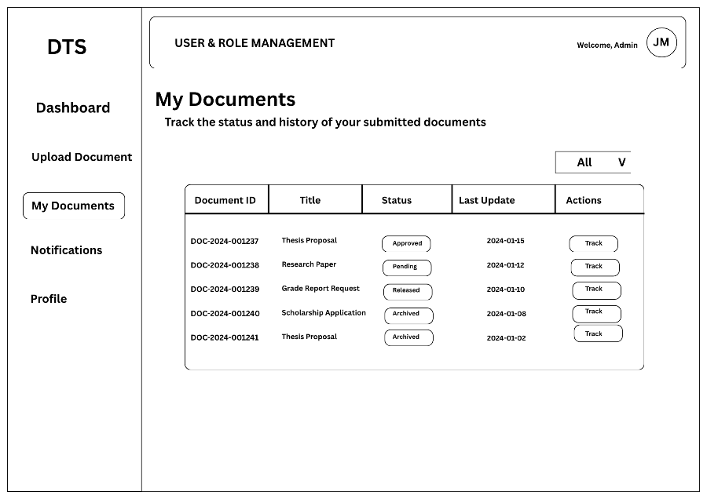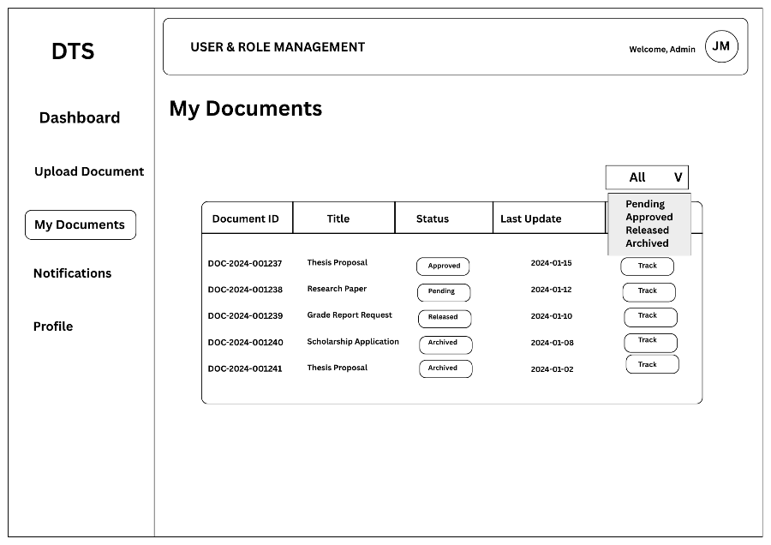

**Figure 3.4 Notifications Page**

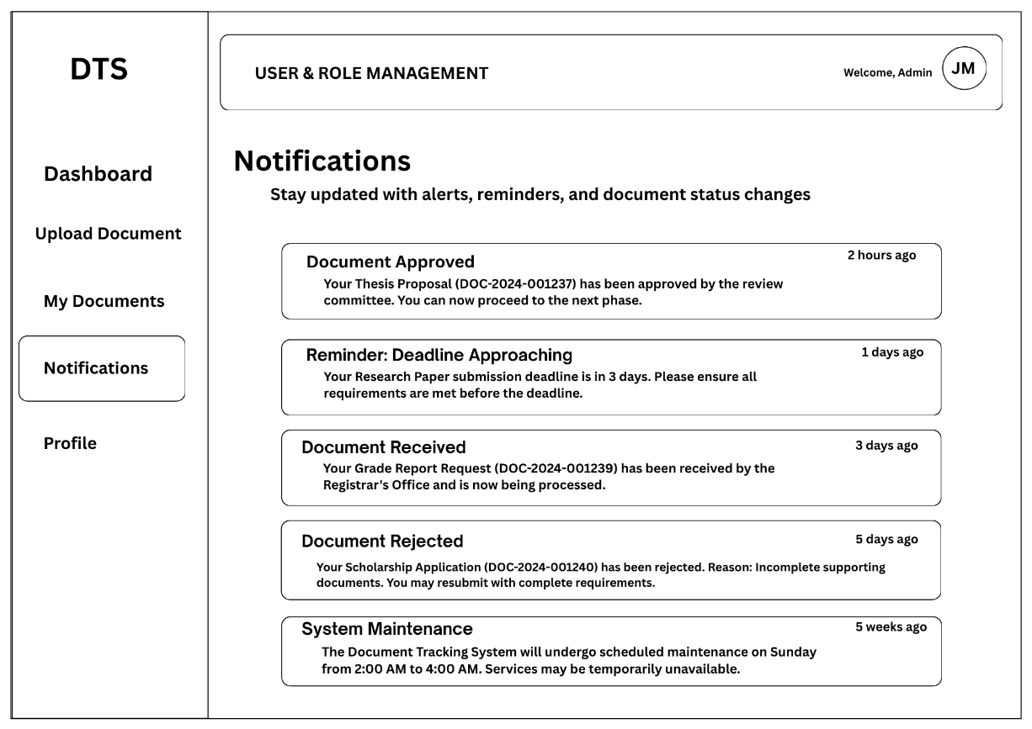

**Figure 3.5 Profile Page**



* **Admin Area Page**

[insert screenshots and descriptions]

# **User Manual**

[insert screenshots and descriptions]