**CSS Basics**

**DEADLINE:**5/08/2018

## FOLDER STRUCTURE

FE_9_2_homework_css-basics/

├─task/

     └─ FE_9_2_homework_css-basics.docx

   └─homework/

        └─css/

            └─styles…

        └─img/

└─ images...

    └─index.html

## TASK

You need to create a print version of the web-page. In the following pictures, you will see mock-ups which represent almost finished site (this is what you need to achieve). In case, you don’t know how to open print version of the page, you should follow the next steps:

* Open index.html file in a browser
* press ctrl+p(or cmd+p for Mac)

Now you should see something like this (see Figure 1):

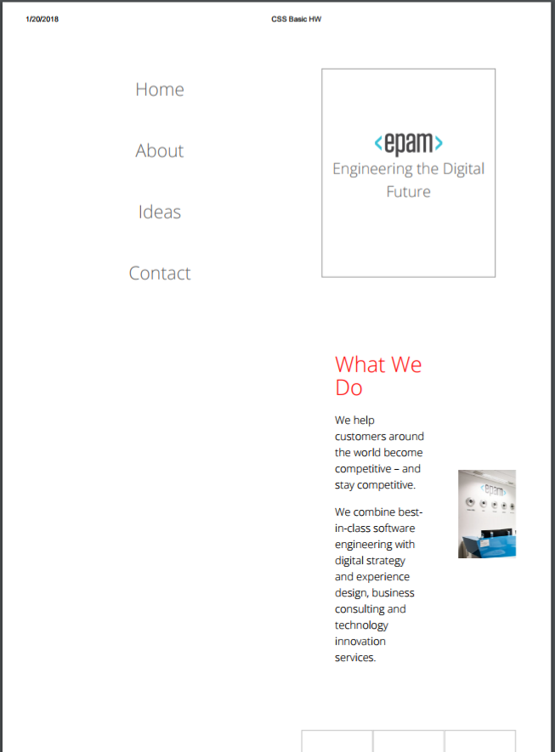

**Figure 1 — Print version**

As you can see, the preview looks not so good and we should improve it. The result should look close (not pixel perfect) to the provided example in Figure 1.

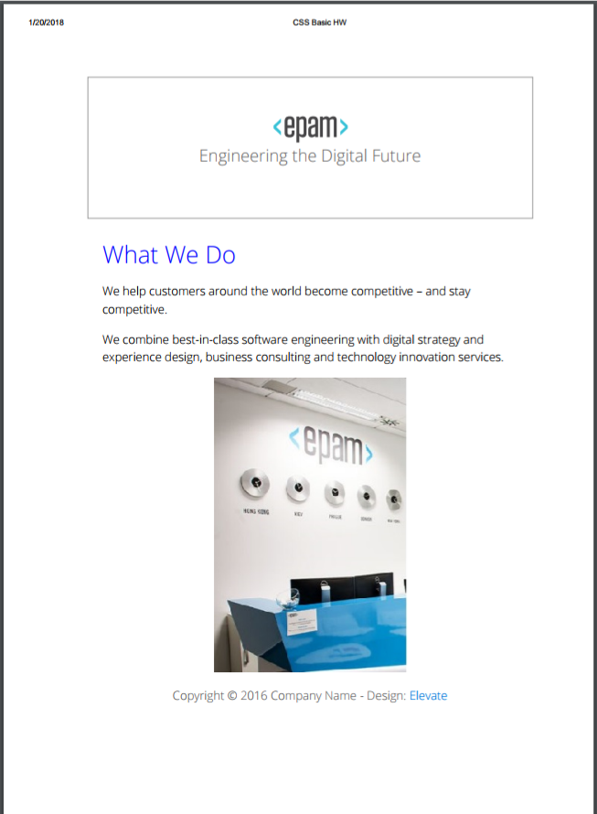

##### **Figure 2 — Print version (mockup)**

1) Lets look closer at this part of site. Images within tiles should be rounded and tiles with text should have hover effect (see Figure 3).

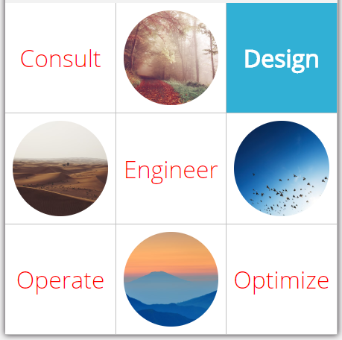

##### **Figure 3 — Gallery block (mockup)**

3) Change color of first letter in each paragraphs to #76cdd7 and font size to 30px.

4) Add box shadow to sidebar and each content block.

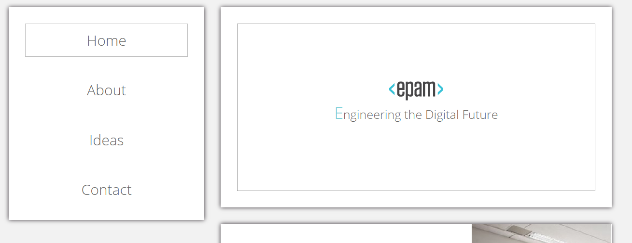

##### **Figure 4 — Blocks shadow (mockup)**

5) Add triangle to each section on the page using pseudo elements. (see left top corner in Figure 5)

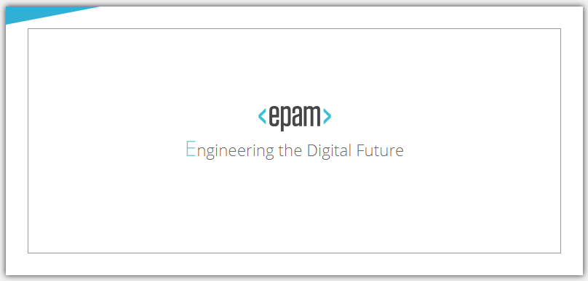

##### **Figure 5 —Triangle (mockup)**

6) Change color of ‘How We Do It’ to gainsboro and add letter spacing 5px.

7) Each first paragraph whichplaced after h2 tag should have italic font style.

8) Text in the paragraph should look like in Figure 6. (vertical space between lines is increased, there is some free space at the start of the first line).



##### **Figure 6 —Text alignment (mockup)**

Pay attentions, that the text in first banner block should not have such styles (see Figure 7):



##### **Figure 7 —Text alignment on first banner (mockup)**

9)In this block apply the following styles:

* already visited links should become silver color
* thehovered links should look like “6. Architects” item
* add‘new’ label to the end of words. It should be applied only for ‘Designers’ and ‘Strategists’ items.

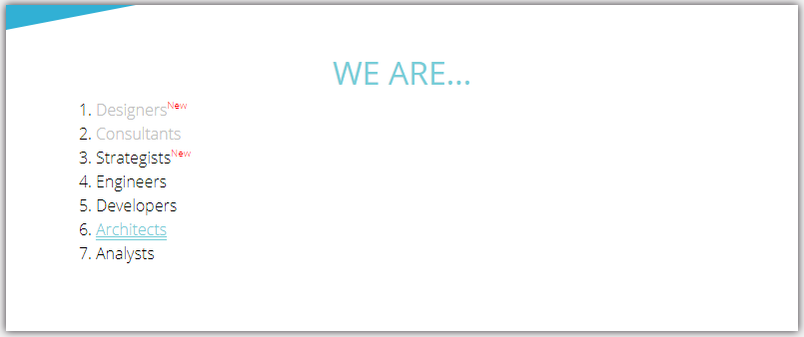**Figure 8 —List styling(mockup)**

10) Add layout and styles for following block.

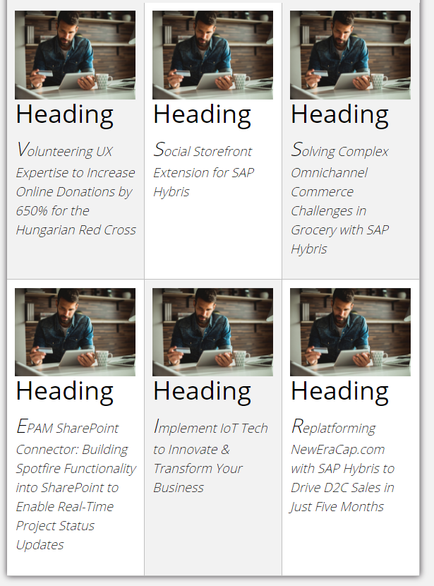

**Figure 9 —Block styling (mockup)**

11) Take a look to sidebar in Figure 10.You need to add the silver border to the bottom of each item, except the last one.

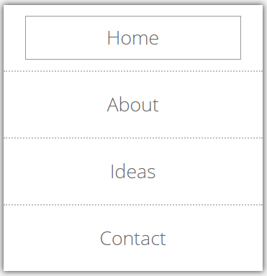

**Figure 10 —Sidebar (mockup)**

12) Change the text color of text inputs and submit button to red. Add asterisk to email field as shown in Figure 11.

Tip: Use attribute type selector.

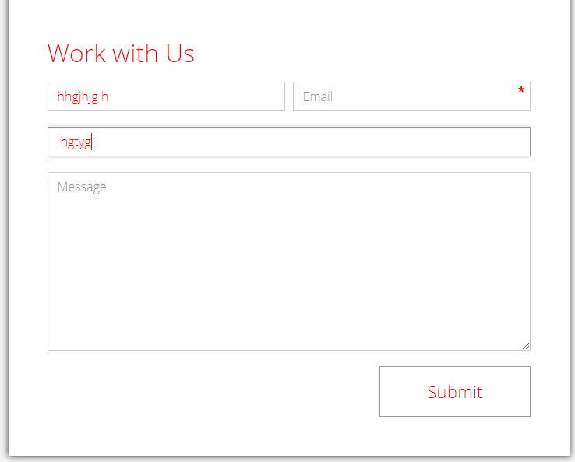

**Figure 11 —Work with Us form (mockup)**

The submit button should have a hover effect like on figure 11:



**Figure 11 —Submit button in hover state (mockup)**

## RESTRICTIONS

* Adding/editing styles in the **general.css**file is forbidden

## BEFORE SUBMIT

* Read requirements and compare to your homework result
* Format the code (remove unnecessary lines of code)
* Remove all unnecessary files that you might have included bymistake

## SUBMIT

* The folder should be uploaded to github repository ‘**fl-9**’into **master** branch