Table of Contents

Ben-Gurion University of the Negev
Faculty of Engineering Science
School of Electrical and Computer Engineering
Department of Electrical and Computer Engineering
Fourth Year Engineering Project
Final Report
Classification of Objects at a Very Low Resolution
Robustness of Deep Visual Models under THz-like Degradation
Project number | s-2026-045 / p-2026-061
Students | Bahat Itamar ID: 205805856
 | Dotan Ann Hanna ID: 211542311
Email | bahit@post.bgu.ac.il, anndo@post.bgu.ac.il
Supervisors | Prof. Yitzhak Yitzhaky
 | Dr. Rinat Lerner
Sponsors | -
Submitting date | 26 / 07 / 2026

Abstract
Background. Terahertz (THz) imaging sensors produce frames that are simultaneously low resolution, low signal-to-noise, and colorless. ImageNet-pretrained classifiers, which rely on fine textures and saturated chroma, lose accuracy quickly under those conditions, but the magnitude and the mechanism of the loss across modern deep-learning architectures are not documented quantitatively.
Aim. Compare the robustness of three representative deep architectures (a residual CNN, a densely connected CNN, and a foveal vision transformer) under controlled synthetic THz-like degradation, decompose the loss into per-axis contributions, and quantify how much of it can be recovered by training-time regularization.
Methods. The 402-cell campaign trains ResNet50, DenseNet121, and TransNeXt-tiny on CIFAR-10 and MNIST under a five-level degradation curve (saturation, downsample, blur, additive noise, salt and pepper). Seven phases isolate the effects: A clean baseline, B1 combined, C single-axis, D regularization recovery, B2 and B2-nr THz-protocol simplification, and C2 single-axis under the THz protocol. A 48-replicate multi-seed audit on the 24 L3 headline cells bounds reproducibility. Every degradation pipeline is anchored to a deterministic 256-image PSNR / SSIM probe so the cross-phase comparison sits on a physical scale.
Findings. Under Phase B1 on CIFAR-10, TransNeXt-tiny holds the highest accuracy margin over the two CNNs at the mild and moderate end of the curve ($+10.1$percentage points at L1, $+10.4$percentage points at L2 vs the CNN mean), and the margin narrows to under $1.5$percentage points from L3 onward. Resolution dominates the per-axis attribution by a factor of approximately four (mean L1 to L5 effect on CIFAR-10: $−27.45$percentage points for resolution vs $−6.58$ for blur and $−5.13$ for salt and pepper). Regularization (T3 in Phase D) recovers approximately $0.77$percentage points of the $∼12.5$percentage points Phase B1 accuracy collapse. The multi-seed audit confirms $σ<1.5$percentage points on every L3 headline cell.
Conclusions. The accuracy collapse is best modeled as an information bottleneck, not as an overfit. The foveal transformer holds the highest robustness margin at mild and moderate degradation; all three architectures converge into the $[19,21]$percentage points band at L5. Future THz deployments should invest in resolution restoration before denoising or deblurring.
Keywords. object classification, deep learning, low resolution, THz imaging, robustness, PSNR, SSIM, calibration, transformer, residual network, dense network.

רקע. חיישני הדמיה בתחום הטרה-הרץ (THz) מפיקים תמונות בעלות רזולוציה נמוכה, יחס אות-לרעש נמוך והעדר צבע. מסווגי ImageNet שאומנו מראש, המסתמכים על מרקמים עדינים ועל צבע רווי, מאבדים דיוק במהירות תחת תנאים אלה, אך עוצמת הירידה והמנגנון העומד בבסיסה אינם מתועדים כמותית עבור שלוש משפחות הארכיטקטורות המודרניות.
מטרה. להשוות את עמידותן של שלוש ארכיטקטורות-עומק מייצגות (רשת CNN שאריתית, רשת CNN צפופה, וטרנספורמר ראייה פוֹביאַלי) תחת השפלה סינתטית מבוקרת דמוית-THz, לפרק את ההפסד לתרומות לפי ציר, ולכמת כמה ממנו ניתן לשחזר על ידי רגולריזציית-אימון.
שיטות. המערכה כוללת 402 תאי אימון של ResNet50, DenseNet121 ו-TransNeXt-tiny על CIFAR-10 ו-MNIST, תחת עקומת השפלה בת חמש רמות (רוויה, הקטנת רזולוציה, טשטוש, רעש גאוסי, מלח-ופלפל). שבעה שלבים מבודדים את האפקטים: A קו בסיס נקי, B1 השפלה משולבת, C ציר יחיד, D שחזור באמצעות רגולריזציה, B2 ו-B2-nr לפישוט פרוטוקול ה-THz, ו-C2 ציר יחיד תחת אותו פרוטוקול. בדיקת רבייה על 48 חזרות עם זרעי-אקראיות נוספים שולחת חסם על שונות-בין-ריצות בכל אחד מ-24 תאי הכותרת ברמה L3. כל צינור השפלה מעוגן לבדיקת PSNR / SSIM דטרמיניסטית על 256 תמונות, כך שההשוואה בין השלבים מתבצעת על סקאלה פיזיקלית.
ממצאים. תחת שלב B1 ב-CIFAR-10, TransNeXt-tiny שומר על המרווח הרחב ביותר מעל שתי רשתות ה-CNN בקצה המתון של העקומה (כ-$10.1$percentage points ברמה L1, כ-$10.4$percentage points ברמה L2 מול הממוצע של ה-CNN-ים), ומרווח זה מצטמצם לפחות מ-$1.5$percentage points החל מ-L3. ציר הרזולוציה דומיננטי בייחוס לפי ציר בקירוב פי ארבעה (אפקט ממוצע L1 עד L5 על CIFAR-10: $−27.45$percentage points עבור רזולוציה לעומת $−6.58$ עבור טשטוש ו-$−5.13$ עבור מלח-ופלפל). רגולריזציה (T3 בשלב D) משחזרת בקירוב $0.77$percentage points מתוך קריסת הדיוק של $∼12.5$percentage points בשלב B1. בדיקת הרבייה מאשרת $σ<1.5$percentage points בכל תא כותרת ברמה L3.
מסקנות. קריסת הדיוק מתוארת היטב כצוואר-בקבוק של מידע ולא כהתאמת-יתר. הטרנספורמר הפוֹביאַלי שומר על מרווח העמידות הגבוה ביותר בקצה המתון של עקומת ההשפלה; שלוש הארכיטקטורות מתכנסות לרצועת $[19,21]$percentage points ברמה L5. פריסות THz עתידיות צריכות להשקיע בשחזור רזולוציה לפני שלבי הסרת רעש או הסרת טשטוש.
מילות מפתח. סיווג עצמים, למידה עמוקה, רזולוציה נמוכה, הדמיית THz, עמידות, PSNR, SSIM, כיול, טרנספורמר, רשת שאריתית, רשת צפופה.
רקע. חיישני הדמיה בתחום הטרה-הרץ (THz) מפיקים תמונות בעלות רזולוציה נמוכה, יחס אות-לרעש נמוך והעדר צבע. מסווגי ImageNet שאומנו מראש, המסתמכים על מרקמים עדינים ועל צבע רווי, מאבדים דיוק במהירות תחת תנאים אלה, אך עוצמת הירידה והמנגנון העומד בבסיסה אינם מתועדים כמותית עבור שלוש משפחות הארכיטקטורות המודרניות.
מטרה. להשוות את עמידותן של שלוש ארכיטקטורות-עומק מייצגות (רשת CNN שאריתית, רשת CNN צפופה, וטרנספורמר ראייה פוֹביאַלי) תחת השפלה סינתטית מבוקרת דמוית-THz, לפרק את ההפסד לתרומות לפי ציר, ולכמת כמה ממנו ניתן לשחזר על ידי רגולריזציית-אימון.
שיטות. המערכה כוללת 402 תאי אימון של ResNet50, DenseNet121 ו-TransNeXt-tiny על CIFAR-10 ו-MNIST, תחת עקומת השפלה בת חמש רמות (רוויה, הקטנת רזולוציה, טשטוש, רעש גאוסי, מלח-ופלפל). שבעה שלבים מבודדים את האפקטים: A קו בסיס נקי, B1 השפלה משולבת, C ציר יחיד, D שחזור באמצעות רגולריזציה, B2 ו-B2-nr לפישוט פרוטוקול ה-THz, ו-C2 ציר יחיד תחת אותו פרוטוקול. בדיקת רבייה על 48 חזרות עם זרעי-אקראיות נוספים שולחת חסם על שונות-בין-ריצות בכל אחד מ-24 תאי הכותרת ברמה L3. כל צינור השפלה מעוגן לבדיקת PSNR / SSIM דטרמיניסטית על 256 תמונות, כך שההשוואה בין השלבים מתבצעת על סקאלה פיזיקלית.
ממצאים. תחת שלב B1 ב-CIFAR-10, TransNeXt-tiny שומר על המרווח הרחב ביותר מעל שתי רשתות ה-CNN בקצה המתון של העקומה (כ-$10.1$percentage points ברמה L1, כ-$10.4$percentage points ברמה L2 מול הממוצע של ה-CNN-ים), ומרווח זה מצטמצם לפחות מ-$1.5$percentage points החל מ-L3. ציר הרזולוציה דומיננטי בייחוס לפי ציר בקירוב פי ארבעה (אפקט ממוצע L1 עד L5 על CIFAR-10: $−27.45$percentage points עבור רזולוציה לעומת $−6.58$ עבור טשטוש ו-$−5.13$ עבור מלח-ופלפל). רגולריזציה (T3 בשלב D) משחזרת בקירוב $0.77$percentage points מתוך קריסת הדיוק של $∼12.5$percentage points בשלב B1. בדיקת הרבייה מאשרת $σ<1.5$percentage points בכל תא כותרת ברמה L3.
מסקנות. קריסת הדיוק מתוארת היטב כצוואר-בקבוק של מידע ולא כהתאמת-יתר. הטרנספורמר הפוֹביאַלי שומר על מרווח העמידות הגבוה ביותר בקצה המתון של עקומת ההשפלה; שלוש הארכיטקטורות מתכנסות לרצועת $[19,21]$percentage points ברמה L5. פריסות THz עתידיות צריכות להשקיע בשחזור רזולוציה לפני שלבי הסרת רעש או הסרת טשטוש.
מילות מפתח. סיווג עצמים, למידה עמוקה, רזולוציה נמוכה, הדמיית THz, עמידות, PSNR, SSIM, כיול, טרנספורמר, רשת שאריתית, רשת צפופה.

1 Introduction

1.1 Motivation
Terahertz (THz) imaging is increasingly used in security screening, biomedical diagnostics, and through-fabric inspection because the millimeter-wave band penetrates clothing, paper, plastics, and other low-permittivity materials that block visible light. The physics of the band exacts a price: diffraction caps the achievable spatial resolution near the wavelength of the source, single-pixel detectors integrate the field over a comparatively large area, and the available noise figure is dominated by thermal background. The output is an image that is simultaneously low resolution, low signal-to-noise, and free of color information.
Standard deep-vision classifiers, almost all of which inherit ImageNet pretraining, are tuned for the opposite distribution. They depend on fine textures, sharp edges, and saturated chroma to populate the receptive fields of the early convolutional layers. When those signals are removed the accuracy of an off-the-shelf model collapses, and the failure mode is opaque: it is not obvious how much of the loss is caused by reduced resolution alone, how much by additive noise, and how much by the loss of color, nor whether training-time interventions (regularization, augmentation, architectural substitution) can recover any of the lost performance.

1.2 Problem statement
This project quantifies the accuracy degradation of three representative deep architectures under a controlled synthetic THz-like degradation, decomposes the loss into per-axis contributions, audits the reproducibility of the measurements across random seeds, and documents which training-side interventions recover lost accuracy. The architectures span the three families that currently anchor the image-classification literature: a residual convolutional network (ResNet50 (He et al. 2016)), a densely connected convolutional network with explicit feature reuse (DenseNet121 (Huang et al. 2017)), and a vision transformer with foveal attention (TransNeXt-tiny (Shi 2024)).
The success criteria taken from the preliminary report are: at least 80 percent top-1 accuracy on the moderate-degradation operating point, an identifiable architectural winner that beats the baseline by a statistically meaningful margin, and inference latency compatible with sensor-side deployment. Those targets are revisited in Section 8 against the actual measurements.

1.3 Alternative approaches considered
Three alternative families were reviewed during the preliminary design and rejected in favor of synthetic-degradation training.
(i) Denoise then classify. A pipeline that restores the image before invoking a clean-image classifier. The approach decouples the two problems and reuses an existing pretrained classifier verbatim, but it requires a high-quality reference image at train time, which a real THz sensor never produces. Restoration networks trained on mismatched degradation distributions tend to hallucinate detail (Huynh-Thu and Ghanbari 2008; Wang et al. 2004), which inflates PSNR / SSIM scores without improving downstream classification.
(ii) Super-resolution then classify. A specialization of (i) that targets the resolution axis only. It assumes that the dominant failure mode is spatial sampling. As Section 5 will show, resolution does dominate the per-axis attribution, but additive noise and blur still cost between five and seven percentage points each at the moderate operating point, so a resolution-only restoration cannot recover the full loss.
(iii) Train-time degradation exposure. The model is trained directly on synthetically degraded images so that the representation adapts to the degraded distribution. This is the approach used in modern robustness benchmarks (Hendrycks et al. 2021) and the one adopted here. It is sample-efficient (no separate restoration network), it keeps the test-time pipeline minimal (single forward pass), and it surfaces the architectural sensitivities directly because every backbone sees the same degraded distribution.

1.4 Contributions
This work contributes:
- a 402-cell training campaign across three architectures, two datasets, five degradation levels, and six experimental phases, all trained to convergence under a single fair-comparison invariant ($224×224$ uniform input, frozen Optuna L3 hyperparameters, identical data pipeline);
- a 48-replicate multi-seed audit on the 24 L3 headline cells that bounds run-to-run variance below 1.5 percentage points;
- a deterministic 256-image PSNR / SSIM probe per pipeline so that accuracy can be compared against the physical image-quality scale, not only against the discrete level index;
- a per-axis attribution decomposition at L3 that shows resolution is the dominant cost ($∼4×$ blur or salt and pepper);
- a regularization-recovery sweep (Phase D) and a protocol simplification sweep (Phase B2 / B2-nr) that, together, quantify the fraction of the accuracy collapse that is information-bottleneck versus training noise.

1.5 Roadmap
Section 3 reports the as-built technical specification of the delivered software product and lists every drift from the preliminary specification. Section 4 documents the engineering approach and the mathematical model. Section 5 reports the final acceptance tests, including the per-pipeline image-quality probe and the seven per-phase accuracy tables. Section 6 enumerates the problems encountered during implementation and how each was resolved. Section 8 compares the achieved performance to the preliminary specification and discusses goal-by-goal success.

2 Experimental phases at a glance
The campaign decomposes the THz-like robustness question into seven phases. Each phase opens with the pipeline it uses and closes with the research question that motivates it.
Phase A (Clean baseline).Pipeline: identity. Six cells (three models $×$ two datasets). Establishes the upper-bound clean accuracy that every later phase is measured against.
Phase B1 (Combined degradation).Pipeline: saturation lerp $→$ downsample $→$ upsample to $224×224$ $→$ blur $→$ additive noise $→$ salt-and-pepper, with all five axes active at the same level. Thirty cells (three models $×$ two datasets $×$ five levels). Quantifies the realistic worst-case combined-degradation curve.
Phase C (Single-axis isolation).Pipeline: exactly one axis is active at level $L$ while the other four are held at identity. One hundred fifty cells (three models $×$ two datasets $×$ five levels $×$ five axes). Decomposes the Phase B1 collapse into per-axis contributions; the §5 plots use PSNR and SSIM on the $x$-axis to compare axes on a common image-quality scale.
Phase D (Regularization-recovery sweep).Pipeline: identical to Phase B1, plus one of three training-time regularization treatments T1, T2, T3 (architectural dropout, label mixing, kitchen sink). Ninety cells (three models $×$ two datasets $×$ three treatments $×$ five levels). Asks whether the Phase B1 collapse is an overfit (regularization should recover it) or an information bottleneck (recovery should be marginal).
Phase B2 (THz-protocol simplification).Pipeline: Phase B1 minus the saturation and additive-noise axes; T3 regularization active. Thirty cells. Models the realistic THz acquisition (a single-channel low-resolution blurry frame with no chroma noise).
Phase B2-nr (No-regularization arm).Same pipeline as Phase B2, at L3 only, T3 off. Six cells. Decomposes the Phase B1$→$B2 accuracy gain into a pure-protocol component and a regularization component.
Phase C2 (Single-axis isolation under the THz protocol). Same identity-elsewhere logic as Phase C, restricted to the three THz-relevant axes (resolution, blur, salt-and-pepper). Ninety cells. Per-axis attribution under deployment-realistic conditions.
Experimental phases at a glance. The campaign comprises 402 canonical training cells at seed 42 plus 48 multi-seed audit replicates at seeds 43 and 44. Each phase isolates a different facet of the accuracy collapse under the five-level THz-like degradation curve.
Phase | Cells | Axes active at L | Levels swept | Reg. | Primary research question
A | 6 | none (identity) | none | none | Upper-bound clean accuracy per (model, dataset).
B1 | 30 | all 5 axes | L1-L5 | none | Magnitude of the realistic combined-degradation collapse.
C | 150 | one axis (4 idle) | L1-L5 | none | Per-axis decomposition of the Phase B1 collapse.
D | 90 | all 5 axes | L1-L5 | T1 / T2 / T3 | Is the Phase B1 collapse overfit or information bottleneck?
B2 | 30 | 3 axes (sat $=0$, noise $=0$) | L1-L5 | T3 | Effect of the realistic THz protocol on the combined curve.
B2-nr | 6 | same as B2 | L3 only | none | Decomposition of B1$→$B2 into protocol versus regularization.
C2 | 90 | one of {res, blur, S&P} | L1-L5 | T3 | Per-axis attribution under the THz protocol.
Multi-seed audit | 48 | all 24 L3 headline cells | L3 only | inherits cell | Run-to-run variance bound on every headline cell.
Subsequent sections refer back to this overview for pipeline definitions and do not re-explain them. Table 1 is the single point of reference.

3 Final Technical Specification
This section reports the as-built specification of the delivered software product, and documents every drift from the preliminary specification (Shi 2024; Huang et al. 2017).

3.1 Product overview
The delivered product is a research-grade Python package that:
- synthetically degrades a clean image dataset using a deterministic five-axis pipeline (saturation, downsample, blur, additive noise, salt and pepper);
- fine-tunes one of three pretrained deep backbones (ResNet50, DenseNet121, TransNeXt-tiny) on the degraded distribution under a unified training recipe;
- evaluates the trained model on a held-out validation split and records validation accuracy, calibration, inference throughput, and per-pipeline PSNR / SSIM metrics;
- aggregates results across the 402-cell campaign and the 48-replicate multi-seed audit into a single canonical JSON artifact and a 7-tab interactive dashboard.

3.2 Inputs, outputs, interfaces
Inputs.Standard image datasets (CIFAR-10 (Krizhevsky 2009) and MNIST (LeCun et al. 1998)), automatically downloaded by torchvision on first invocation. A YAML / dictionary configuration object selects the backbone, the degradation phase, the level, the axis (for single-axis phases), the treatment (for Phase D), and the random seed.
Outputs.Per-cell training logs, validation metrics, best checkpoint, image-quality probe JSON. The canonical aggregator (Final_Exp.json, schema version 3) joins the 402 canonical cells with the 48 multi-seed replicates and exposes $⟨val_acc⟩±σ$ pairs.
Hardware interface.The training stack runs on a single NVIDIA RTX 5070 (sm_120, Blackwell architecture) at bf16-mixed precision. A CPU-only fallback (32-true precision) is available for portability but is too slow to be useful at the campaign scale. There is no specialized hardware development; the system targets commodity GPU servers.

3.3 Final specification of the system
Models.Three backbones are supported. Table 2 summarizes the training recipe; the differential learning-rate convention (head $×10$ over backbone) is taken from the source papers.
Training hyperparameters (final).
Parameter | CNNs (ResNet50, DenseNet121) | TransNeXt-tiny
Input resolution | $224×224$ | $224×224$
Optimizer | AdamW (Loshchilov and Hutter 2019b) | AdamW
Schedule | Cosine annealing | Cosine annealing
Head learning rate | ${10}^{−3}$ | $5×{10}^{−4}$
Backbone learning rate | ${10}^{−4}$ | $5×{10}^{−5}$
Weight decay | ${10}^{−4}$ | $5×{10}^{−2}$
Label smoothing | 0.1 | 0.1
Stochastic depth | 0.0 | 0.1
Gradient clip | $∥∇∥_{2}≤1.0$ | $∥∇∥_{2}≤1.0$
Batch size | 32 | 32
Max epochs | 60 | 60
Early stopping | patience 10 | patience 10
Precision | bf16-mixed | bf16-mixed
Seed | 42 (canonical) | 42 (canonical)
Degradation pipeline.The five-level schedule (Table 3) is the single source of truth for L1 through L5; it is imported from src/data/degradation_levels.py into both the training and the evaluation paths.
Five-level synthetic degradation schedule. Blur kernel and $σ$ are pixel-domain values at the $224×224$ model input.
Level | Name | low_res | Blur K | Blur $σ$ | Noise std | S&P | Saturation
L1 | Mild | 18 | 13 | 2.50 | 0.04 | 0.03 | 0.95
L2 | Light | 12 | 25 | 5.00 | 0.08 | 0.06 | 0.65
L3 | Moderate | 8 | 41 | 8.00 | 0.12 | 0.10 | 0.40
L4 | Severe | 6 | 61 | 12.00 | 0.16 | 0.14 | 0.15
L5 | Extreme | 3 | 91 | 18.00 | 0.22 | 0.18 | 0.00
Data pipeline.Pipeline version 2 (finalized 2026-05-20): the saturation lerp is applied first, then the bilinear downsample to low_res, then additive Gaussian noise and salt and pepper at the low resolution, then bicubic upsample to $224×224$, then Gaussian blur (kernel calibrated for $224×224$), then a final clip to $[0,1]$ and ImageNet normalization.
Determinism.The per-sample degradation seed is $\text{idx}+{10}^{7}$ on the validation split and idx on the training split. The byte-identity gate in src/tests/test_degradation_determinism.py asserts that two independent reads of the same validation index yield bit-identical pixels across freshly built datasets; this is also verified across seeds 42, 43, and 44 by the multi-seed audit test.

3.4 Drift from the preliminary specification
The Preliminary Design Review (PDR, Pre-2026-061.pdf) defined the project scope. Five drifts occurred during implementation:
- TransNeXt variant: small to tiny. The preliminary spec proposed transnext_small ($∼50$M parameters); the 2026-05-14 revision substituted transnext_tiny ($∼28$M parameters) to keep the parameter count comparable to ResNet50 ($∼25$M) and to recover $∼310$ GPU-hours across the TransNeXt rows. The change preserves the foveal-attention mechanism, which was the architectural property of interest, and it matches the published TransNeXt $224×224$ checkpoint exactly.
- Uniform $224×224$ protocol. A short-lived V3 refactor (2026-05-08 through 2026-05-13) attempted native-resolution training ($32×32$ for TransNeXt on CIFAR-10, $28→32$ for MNIST). The refactor violated the fair-comparison invariant (different backbones saw different tensor shapes), so it was rolled back. Every cell now trains at $224×224$.
- Blur kernel rescaling. The 2026-05-12 degradation curve used blur kernels designed for native $32×32$ imagery (K $=3…13$, $σ=0.8…2.3$). At $224×224$ those kernels covered $∼1$ to $6\%$ of the image width and produced essentially invisible blur. They were rescaled on 2026-05-14 to pixel-domain values at $224×224$ (K $=13…91$, $σ=2.5…18$), with the kernel-to-$σ$ rule $K=2⌈2.5σ⌉+1$ so the kernel always captures the $2.5σ$ Gaussian footprint.
- Optuna freeze. The preliminary plan reserved a per-(phase, cell) hyperparameter sweep. The final spec freezes the Optuna L3 winner per (model, dataset) and reuses it across every level and every axis. The change saves $∼200$ GPU-hours and removes a per-phase confound from the cross-phase comparison.
- Multi-seed audit. The preliminary spec used a single seed (42). The 2026-06-01 revision added a 48-replicate audit at seeds 43 and 44 across the 24 L3 headline cells so that the published L3 accuracies carry an explicit $σ$ bound rather than a single point estimate.

3.5 Phases of the experimental program
The 402-cell campaign is partitioned into seven phases. Table 4 summarizes each phase.
Experimental phases of the 402-cell campaign. Multi-seed audit replicates are layered on top of the 24 L3 headline cells.
Phase | Purpose | Cells | Tag prefix
A | Clean baseline (no degradation) | 6 | final_clean_
B | Combined degradation, all axes at level L | 30 | final_B_L*
C | Single-axis isolation, others at identity | 150 | final_C_L*_<axis>_
D | Regularization recovery (T1 / T2 / T3) on Phase B | 90 | final_D_T*_L*_
B2 | THz protocol simplification (sat $=0$, noise $=0$, T3) | 30 | final_B2_L*_
B2nr | B2 without regularization, L3 only | 6 | final_B2nr_L3_
C2 | Single-axis under THz protocol | 90 | final_C2_L*_<axis>_
Audit | Multi-seed audit (seeds $\{43,44\}$) on the 24 L3 headline cells | 48 | *_seed{43,44}
Total |  | 450

4 Engineering Design
This section documents the chosen approach in detail. The system block diagram is shown in Figure 1; the degradation pipeline that drives the experimental program is shown in Figure 2.
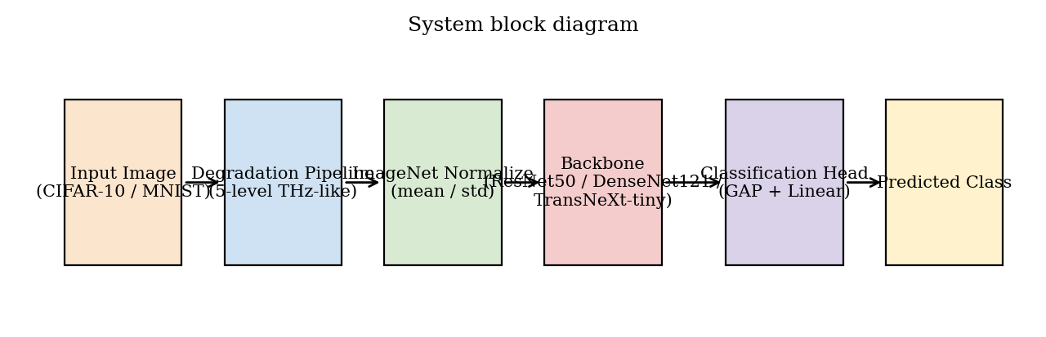
System block diagram. An input image from CIFAR-10 or MNIST passes through the THz-like degradation pipeline, is normalized to the ImageNet distribution, is fed to one of the three backbones, and is classified by a global-average-pooling head.
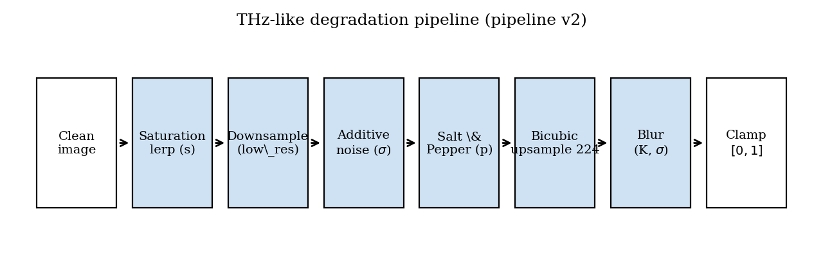
Pipeline version 2. The saturation lerp runs first so the grayscale luminance is computed from the un-degraded source. Additive noise and salt-and-pepper operate at the pre-upsample resolution; bicubic upsample spreads each stochastic sample over the kernel footprint, producing sensor-grain noise structure rather than fine pixel-level grain.

4.1 Mathematical model
Degradation operator. Let $x∈[0,1]^{3×H×W}$ be a clean image and let $ϕ=(s,r,σ_{n},K_{b},σ_{b},p)$ denote the degradation parameters: saturation $s∈[0,1]$, low-resolution target $r∈N$, noise standard deviation $σ_{n}≥0$, blur kernel size $K_{b}$, blur sigma $σ_{b}$, and salt-and-pepper amount $p∈[0,1]$. Define the composite operator
$$D_{ϕ}(x)={Clip}_{[0,1]}∘{Blur}_{K_{b},σ_{b}}∘{Up}_{224}∘{SP}_{p}∘N_{σ_{n}}∘{Down}_{r}∘{Sat}_{s},$$
where ${Sat}_{s}(x)=(1−s) Gray(x)+s x$ with $Gray(x)=0.2989 x_{R}+0.5870 x_{G}+0.1140 x_{B}$ (BT.601 luma); ${Down}_{r}$ is bilinear downsample to $r×r$; $N_{σ_{n}}$ adds independent Gaussian noise of standard deviation $σ_{n}$; ${SP}_{p}$ flips a $p/2$ fraction of pixels to 1 and another $p/2$ fraction to 0; ${Up}_{224}$ is bicubic upsample to $224×224$; and ${Blur}_{K_{b},σ_{b}}$ is a separable Gaussian blur with kernel size $K_{b}$ and standard deviation $σ_{b}$.
Classifier. A backbone $f_{θ}(⋅)$ produces a logit vector $z=f_{θ}(D_{ϕ}(x))$. With label smoothing $α=0.1$, the training objective is the smoothed cross-entropy
$$L(θ)=−\sum_{c=1}^{C}{{\tilde{y}}_{c}}logsoftmax(z)_{c}, {\tilde{y}}_{c}=(1−α) 1[c=y]+\frac{α}{C}.$$
Backbones.The three architectures expose different inductive biases for the low-resolution regime.
ResNet50 (He et al. 2016) combines features via additive identity skips:
$$y_{ℓ}=F_{ℓ}(x_{ℓ};θ_{ℓ})+x_{ℓ}.$$
The summation reuses previous-layer features but collapses them into the running representation; subtle low-level cues can be washed out when the later residual blocks dominate.
DenseNet121 (Huang et al. 2017) concatenates the feature maps of every preceding layer in the same dense block:
$$x_{ℓ}=H_{ℓ}([x_{0},x_{1},…,x_{ℓ−1}]),$$
where $H_{ℓ}$ is a BatchNorm-ReLU-Conv$​_{3×3}$ composite. The collective knowledge of every preceding layer is explicitly preserved, which is the property the preliminary spec hypothesized would help under information loss.
TransNeXt-tiny (Shi 2024) uses pixel-focused attention with foveal and peripheral kernels:
$$Attn(Q,K,V)=softmax​\left(\frac{QK^{⊤}}{\sqrt{d_{k}}}+M_{\text{focal}}\right)V,$$
where $M_{\text{focal}}$ is a window-shaped mask that down-weights all but the nearest neighbors of each query, while a parallel global pooling stream contributes a coarse-grained peripheral signal. The biomimetic prior is designed to retain accuracy when the global shape is corrupted but local texture is partially preserved.

4.2 Image-quality metrics
Each degradation pipeline is anchored to a $PSNR$ and $SSIM$ probe so that cross-phase comparisons sit on a physical scale.
PSNR (Huynh-Thu and Ghanbari 2008) between a reference image $x$ and a degraded image $\tilde{x}=D_{ϕ}(x)$, both in $[0,1]^{3×224×224}$, is
PSNR(x,x)=10log101MSE(x,x), MSE(x,x)=13⋅2242c,i,j​(xc,i,j−xc,i,j)2.
SSIM (Wang et al. 2004) is the structural similarity index. For two local patches $u,v$ with means $μ_{u},μ_{v}$, variances $σ_{u}^{2},σ_{v}^{2}$, and covariance $σ_{uv}$,
$$SSIM(u,v)=\frac{(2μ_{u}μ_{v}+C_{1})(2σ_{uv}+C_{2})}{(μ_{u}^{2}+μ_{v}^{2}+C_{1})(σ_{u}^{2}+σ_{v}^{2}+C_{2})},$$
with $C_{1},C_{2}$ small stabilizers; the full-image score is the spatial mean over an $11×11$ Gaussian window. The implementation uses torchmetrics.image.StructuralSimilarityIndexMeasure with data_range = 1.
Reference construction.The PSNR / SSIM reference is the input image upsampled to $224×224$ by bilinear interpolation. The choice matches what a hypothetical clean-image classifier would see if the degradation pipeline were short-circuited; it does not include the saturation lerp, so the measurements isolate the spatial loss from the color loss. Both choices are documented in the figure captions in Section 5 so the reader can interpret the absolute scale correctly.
Probe protocol.For each pipeline the probe iterates over the first 256 validation indices, applies the pipeline with seed offset $2×{10}^{7}$ (chosen disjoint from the training and validation streams), and aggregates the mean and standard deviation. The 256-sample size balances probe runtime against the standard error of the mean (below $0.1$ dB on the L3 pipelines).

4.3 Optimizer and learning-rate schedule
All cells train with AdamW (Loshchilov and Hutter 2019a) under decoupled weight decay. With $g_{t}=∇_{θ}L(θ_{t−1})$ the loss gradient at step $t$, the running first and second moment estimates are
$$m_{t}=β_{1}m_{t−1}+(1−β_{1})g_{t}, v_{t}=β_{2}v_{t−1}+(1−β_{2})g_{t}^{2},$$
and the parameter update is
$$θ_{t}=θ_{t−1}−η_{t}​\left(\frac{m_{t}/(1−β_{1}^{t})}{\sqrt{v_{t}/(1−β_{2}^{t})}+ϵ}+λ θ_{t−1}\right),$$
with $β_{1}=0.9$, $β_{2}=0.999$, $ϵ={10}^{−8}$, and weight decay $λ∈\{{10}^{−4},5×{10}^{−2}\}$ (CNN / TransNeXt). Gradient clipping caps the global norm at $1.0$.
The learning rate $η_{t}$ follows a cosine annealing schedule (Loshchilov and Hutter 2017) between $η_{max}$ and $η_{min}$ over a total budget of $T$ training steps:
$$η_{t}=η_{min}+1/2 (η_{max}−η_{min})​\left(1+cos​\left(\frac{t}{T} π\right)\right).$$
Differential learning rates apply $η_{max}$ separately to the classifier head (${10}^{−3}$ on CNNs, $5×{10}^{−4}$ on TransNeXt-tiny) and to the backbone parameters (${10}^{−4}$ on CNNs, $5×{10}^{−5}$ on TransNeXt-tiny). Training uses bf16-mixed precision on the RTX 5070 host and runs for at most 60 epochs with early stopping at patience 10 on validation accuracy.

4.4 Calibration metric
Expected calibration error (ECE) (Naeini et al. 2015; Guo et al. 2017) bins the predicted probabilities into $M=15$ equal-width bins and computes
$$ECE=\sum_{m=1}^{M}{\frac{|B_{m}|}{N}}\left|acc(B_{m})−conf(B_{m})\right|,$$
where $B_{m}$ is the set of predictions whose top-1 probability falls in bin $m$, $acc(B_{m})$ is the empirical accuracy of $B_{m}$, and $conf(B_{m})$ is the mean predicted probability in $B_{m}$. A well-calibrated model has $ECE→0$.

4.5 Regularization treatments (Phase D)
Phase D layers three regularization treatments on top of the frozen Phase B Optuna winners:
T1.Dropout (CNN, rate 0.2) or stochastic-depth drop-path (Huang et al. 2016) (TransNeXt, rate 0.2). Architectural regularization only; no label-side intervention.
T2.mixup (Zhang et al. 2018) with $α=0.2$; label-mixing only.
T3.The combination: dropout (or drop-path) $+$ mixup $α=0.2$ $+$ CutMix (Yun et al. 2019) $α=1.0$. The kitchen-sink combination defines the upper bound of training-side recovery measurable inside the design space.

4.6 Software architecture
The implementation is layered:
- src/data/ hosts the single source of truth for the degradation curve (degradation_levels.py) and the operator (degrade.py). Both modules are imported verbatim into the training and the image-quality probe paths, which is the property that guarantees the measured PSNR / SSIM correspond to the pixels the model actually sees.
- src/lightning/ hosts the training engine (THzClassifier, THzDataModule) built on PyTorch Lightning (Falcon et al. 2019).
- src/models/ hosts the backbone wrappers; the TransNeXt weights are auto-downloaded from the public checkpoint and cached under artifacts/weights/.
- scripts/ hosts the campaign drivers (run_all_phases.py) and the diagnostics builders.
- Final_Report/scripts/ hosts the figure / table / sample generators that produce this report. Every artifact under Final_Report/ is reproducible by running python Final_Report/scripts/build_*.py from a clean checkout.

5 Final Acceptance Tests
This section reports the measured performance of the delivered product against every relevant metric. Every value comes from a frozen training run recorded under runs/final/ and aggregated by artifacts/Final_Exp.json (schema version 3). No values are synthesized or interpolated.

5.1 Test rig
The campaign ran on a single workstation with the configuration in Table 5. Determinism is guarded by pl.seed_everything(42, workers=True) for the canonical seed and by the per-sample seed offset for the validation split.
Test rig and software stack.
Component | Value
GPU | NVIDIA RTX 5070 (Blackwell, sm_120, 12 GB)
Precision | bf16-mixed
CPU dataloader workers | 0 (Windows)
Framework | PyTorch 2.11 (Paszke et al. 2019) + Lightning 2.x (Falcon et al. 2019)
Image quality | torchmetrics PSNR / SSIM, data_range = 1
Determinism gate | src/tests/test_degradation_determinism.py

5.2 Per-pipeline image quality
Table 6 reports the mean PSNR and SSIM for every degradation pipeline that appears in the experiments. The values are identical across same-pipeline cells by construction, so Phase D rows inherit the Phase B PSNR / SSIM at the same level. Figures 3 and 4 show the visual appearance of the pipelines on CIFAR-10; Figures 5 and 6 repeat the comparison on MNIST.
Mean PSNR and SSIM per degradation pipeline. Each value is computed over a fixed deterministic 256-sample validation subset using torchmetrics with data_range=1, sample seed offset = $2×{10}^{7}$, clean reference upsampled to $224×224$ by bilinear interpolation.
Dataset | Phase | Level | Axis | PSNR (dB) | SSIM
CIFAR-10 | B | L1 | - | 21.23 $±$ 1.54 | 0.801 $±$ 0.041
CIFAR-10 | B | L2 | - | 17.54 $±$ 1.32 | 0.697 $±$ 0.059
CIFAR-10 | B | L3 | - | 14.87 $±$ 1.41 | 0.635 $±$ 0.078
CIFAR-10 | B | L4 | - | 13.10 $±$ 1.41 | 0.601 $±$ 0.087
CIFAR-10 | B | L5 | - | 10.85 $±$ 1.81 | 0.566 $±$ 0.110
CIFAR-10 | B2 | L1 | - | 19.50 $±$ 2.31 | 0.816 $±$ 0.054
CIFAR-10 | B2 | L2 | - | 17.25 $±$ 1.88 | 0.733 $±$ 0.067
CIFAR-10 | B2 | L3 | - | 15.24 $±$ 1.72 | 0.673 $±$ 0.079
CIFAR-10 | B2 | L4 | - | 14.18 $±$ 1.86 | 0.652 $±$ 0.086
CIFAR-10 | B2 | L5 | - | 12.40 $±$ 2.50 | 0.624 $±$ 0.108
CIFAR-10 | B2nr | L3 | - | 15.24 $±$ 1.72 | 0.673 $±$ 0.079
CIFAR-10 | C | L1 | Blur | 41.98 $±$ 2.54 | 0.983 $±$ 0.007
CIFAR-10 | C | L1 | Noise | 28.60 $±$ 0.42 | 0.841 $±$ 0.021
CIFAR-10 | C | L1 | Resolution | 30.78 $±$ 2.70 | 0.917 $±$ 0.035
CIFAR-10 | C | L1 | S&P | 21.66 $±$ 1.10 | 0.858 $±$ 0.023
CIFAR-10 | C | L1 | Saturation | 36.45 $±$ 2.39 | 0.975 $±$ 0.010
CIFAR-10 | C | L2 | Blur | 33.58 $±$ 2.59 | 0.952 $±$ 0.020
CIFAR-10 | C | L2 | Noise | 23.34 $±$ 0.36 | 0.642 $±$ 0.038
CIFAR-10 | C | L2 | Resolution | 25.33 $±$ 2.65 | 0.845 $±$ 0.060
CIFAR-10 | C | L2 | S&P | 18.61 $±$ 0.87 | 0.755 $±$ 0.032
CIFAR-10 | C | L2 | Saturation | 31.34 $±$ 3.42 | 0.968 $±$ 0.014
CIFAR-10 | C | L3 | Blur | 27.22 $±$ 2.54 | 0.885 $±$ 0.045
CIFAR-10 | C | L3 | Noise | 20.12 $±$ 0.42 | 0.489 $±$ 0.047
CIFAR-10 | C | L3 | Resolution | 21.75 $±$ 2.64 | 0.784 $±$ 0.079
CIFAR-10 | C | L3 | S&P | 16.38 $±$ 0.70 | 0.635 $±$ 0.035
CIFAR-10 | C | L3 | Saturation | 27.94 $±$ 4.23 | 0.958 $±$ 0.022
CIFAR-10 | C | L4 | Blur | 23.63 $±$ 2.52 | 0.822 $±$ 0.066
CIFAR-10 | C | L4 | Noise | 17.87 $±$ 0.44 | 0.381 $±$ 0.050
CIFAR-10 | C | L4 | Resolution | 19.42 $±$ 2.67 | 0.745 $±$ 0.091
CIFAR-10 | C | L4 | S&P | 14.96 $±$ 0.60 | 0.538 $±$ 0.038
CIFAR-10 | C | L4 | Saturation | 25.41 $±$ 4.72 | 0.945 $±$ 0.033
CIFAR-10 | C | L5 | Blur | 21.06 $±$ 2.52 | 0.772 $±$ 0.082
CIFAR-10 | C | L5 | Noise | 15.49 $±$ 0.43 | 0.277 $±$ 0.048
CIFAR-10 | C | L5 | Resolution | 15.88 $±$ 2.82 | 0.692 $±$ 0.109
CIFAR-10 | C | L5 | S&P | 13.88 $±$ 0.58 | 0.456 $±$ 0.041
CIFAR-10 | C | L5 | Saturation | 24.17 $±$ 4.93 | 0.936 $±$ 0.041
CIFAR-10 | C2 | L1 | Blur | 24.67 $±$ 5.66 | 0.943 $±$ 0.040
CIFAR-10 | C2 | L1 | Resolution | 23.11 $±$ 3.97 | 0.883 $±$ 0.050
CIFAR-10 | C2 | L1 | S&P | 19.27 $±$ 2.05 | 0.824 $±$ 0.043
CIFAR-10 | C2 | L2 | Blur | 23.74 $±$ 4.42 | 0.915 $±$ 0.044
CIFAR-10 | C2 | L2 | Resolution | 21.22 $±$ 3.09 | 0.819 $±$ 0.068
CIFAR-10 | C2 | L2 | S&P | 17.19 $±$ 1.43 | 0.724 $±$ 0.044
CIFAR-10 | C2 | L3 | Blur | 22.05 $±$ 3.35 | 0.855 $±$ 0.057
CIFAR-10 | C2 | L3 | Resolution | 19.34 $±$ 2.65 | 0.763 $±$ 0.082
CIFAR-10 | C2 | L3 | S&P | 15.46 $±$ 1.03 | 0.609 $±$ 0.044
CIFAR-10 | C2 | L4 | Blur | 20.43 $±$ 2.77 | 0.798 $±$ 0.071
CIFAR-10 | C2 | L4 | Resolution | 17.79 $±$ 2.47 | 0.729 $±$ 0.092
CIFAR-10 | C2 | L4 | S&P | 14.28 $±$ 0.84 | 0.516 $±$ 0.044
CIFAR-10 | C2 | L5 | Blur | 18.92 $±$ 2.46 | 0.753 $±$ 0.084
CIFAR-10 | C2 | L5 | Resolution | 15.08 $±$ 2.49 | 0.681 $±$ 0.108
CIFAR-10 | C2 | L5 | S&P | 13.35 $±$ 0.74 | 0.437 $±$ 0.045
MNIST | B | L1 | - | 19.56 $±$ 1.75 | 0.577 $±$ 0.030
MNIST | B | L2 | - | 15.50 $±$ 1.30 | 0.423 $±$ 0.039
MNIST | B | L3 | - | 12.58 $±$ 1.30 | 0.318 $±$ 0.043
MNIST | B | L4 | - | 10.90 $±$ 1.31 | 0.248 $±$ 0.048
MNIST | B | L5 | - | 9.02 $±$ 1.96 | 0.247 $±$ 0.072
MNIST | B2 | L1 | - | 19.81 $±$ 1.56 | 0.864 $±$ 0.027
MNIST | B2 | L2 | - | 16.09 $±$ 1.45 | 0.737 $±$ 0.052
MNIST | B2 | L3 | - | 13.05 $±$ 1.54 | 0.586 $±$ 0.077
MNIST | B2 | L4 | - | 11.41 $±$ 1.38 | 0.490 $±$ 0.085
MNIST | B2 | L5 | - | 9.60 $±$ 2.42 | 0.419 $±$ 0.121
MNIST | B2nr | L3 | - | 13.05 $±$ 1.54 | 0.586 $±$ 0.077
MNIST | C | L1 | Blur | 36.55 $±$ 1.49 | 0.976 $±$ 0.006
MNIST | C | L1 | Noise | 29.48 $±$ 0.74 | 0.601 $±$ 0.027
MNIST | C | L1 | Resolution | 27.18 $±$ 1.51 | 0.927 $±$ 0.017
MNIST | C | L1 | S&P | 19.86 $±$ 1.20 | 0.888 $±$ 0.022
MNIST | C | L1 | Saturation | 32.35 $±$ 1.64 | 0.963 $±$ 0.010
MNIST | C | L2 | Blur | 29.67 $±$ 1.21 | 0.939 $±$ 0.012
MNIST | C | L2 | Noise | 25.36 $±$ 0.30 | 0.480 $±$ 0.033
MNIST | C | L2 | Resolution | 21.05 $±$ 1.58 | 0.847 $±$ 0.036
MNIST | C | L2 | S&P | 16.93 $±$ 0.96 | 0.820 $±$ 0.030
MNIST | C | L2 | Saturation | 32.35 $±$ 1.64 | 0.963 $±$ 0.010
MNIST | C | L3 | Blur | 22.34 $±$ 1.20 | 0.819 $±$ 0.037
MNIST | C | L3 | Noise | 22.23 $±$ 0.21 | 0.413 $±$ 0.033
MNIST | C | L3 | Resolution | 16.37 $±$ 1.23 | 0.730 $±$ 0.055
MNIST | C | L3 | S&P | 14.69 $±$ 0.71 | 0.736 $±$ 0.033
MNIST | C | L3 | Saturation | 32.36 $±$ 1.64 | 0.963 $±$ 0.010
MNIST | C | L4 | Blur | 18.18 $±$ 1.19 | 0.674 $±$ 0.062
MNIST | C | L4 | Noise | 19.86 $±$ 0.20 | 0.366 $±$ 0.032
MNIST | C | L4 | Resolution | 13.89 $±$ 1.19 | 0.645 $±$ 0.070
MNIST | C | L4 | S&P | 13.24 $±$ 0.60 | 0.663 $±$ 0.034
MNIST | C | L4 | Saturation | 32.36 $±$ 1.64 | 0.963 $±$ 0.010
MNIST | C | L5 | Blur | 15.50 $±$ 1.25 | 0.496 $±$ 0.085
MNIST | C | L5 | Noise | 17.16 $±$ 0.19 | 0.315 $±$ 0.029
MNIST | C | L5 | Resolution | 11.12 $±$ 1.80 | 0.507 $±$ 0.107
MNIST | C | L5 | S&P | 12.13 $±$ 0.53 | 0.596 $±$ 0.035
MNIST | C | L5 | Saturation | 32.36 $±$ 1.64 | 0.963 $±$ 0.010
MNIST | C2 | L1 | Blur | 36.56 $±$ 1.49 | 0.976 $±$ 0.006
MNIST | C2 | L1 | Resolution | 27.18 $±$ 1.51 | 0.927 $±$ 0.017
MNIST | C2 | L1 | S&P | 19.86 $±$ 1.20 | 0.888 $±$ 0.022
MNIST | C2 | L2 | Blur | 29.67 $±$ 1.21 | 0.939 $±$ 0.012
MNIST | C2 | L2 | Resolution | 21.05 $±$ 1.58 | 0.847 $±$ 0.036
MNIST | C2 | L2 | S&P | 16.93 $±$ 0.96 | 0.820 $±$ 0.030
MNIST | C2 | L3 | Blur | 22.34 $±$ 1.20 | 0.819 $±$ 0.037
MNIST | C2 | L3 | Resolution | 16.37 $±$ 1.23 | 0.730 $±$ 0.055
MNIST | C2 | L3 | S&P | 14.69 $±$ 0.71 | 0.736 $±$ 0.033
MNIST | C2 | L4 | Blur | 18.18 $±$ 1.19 | 0.674 $±$ 0.062
MNIST | C2 | L4 | Resolution | 13.89 $±$ 1.19 | 0.645 $±$ 0.070
MNIST | C2 | L4 | S&P | 13.24 $±$ 0.60 | 0.663 $±$ 0.034
MNIST | C2 | L5 | Blur | 15.50 $±$ 1.25 | 0.496 $±$ 0.085
MNIST | C2 | L5 | Resolution | 11.12 $±$ 1.80 | 0.507 $±$ 0.107
MNIST | C2 | L5 | S&P | 12.13 $±$ 0.53 | 0.596 $±$ 0.035
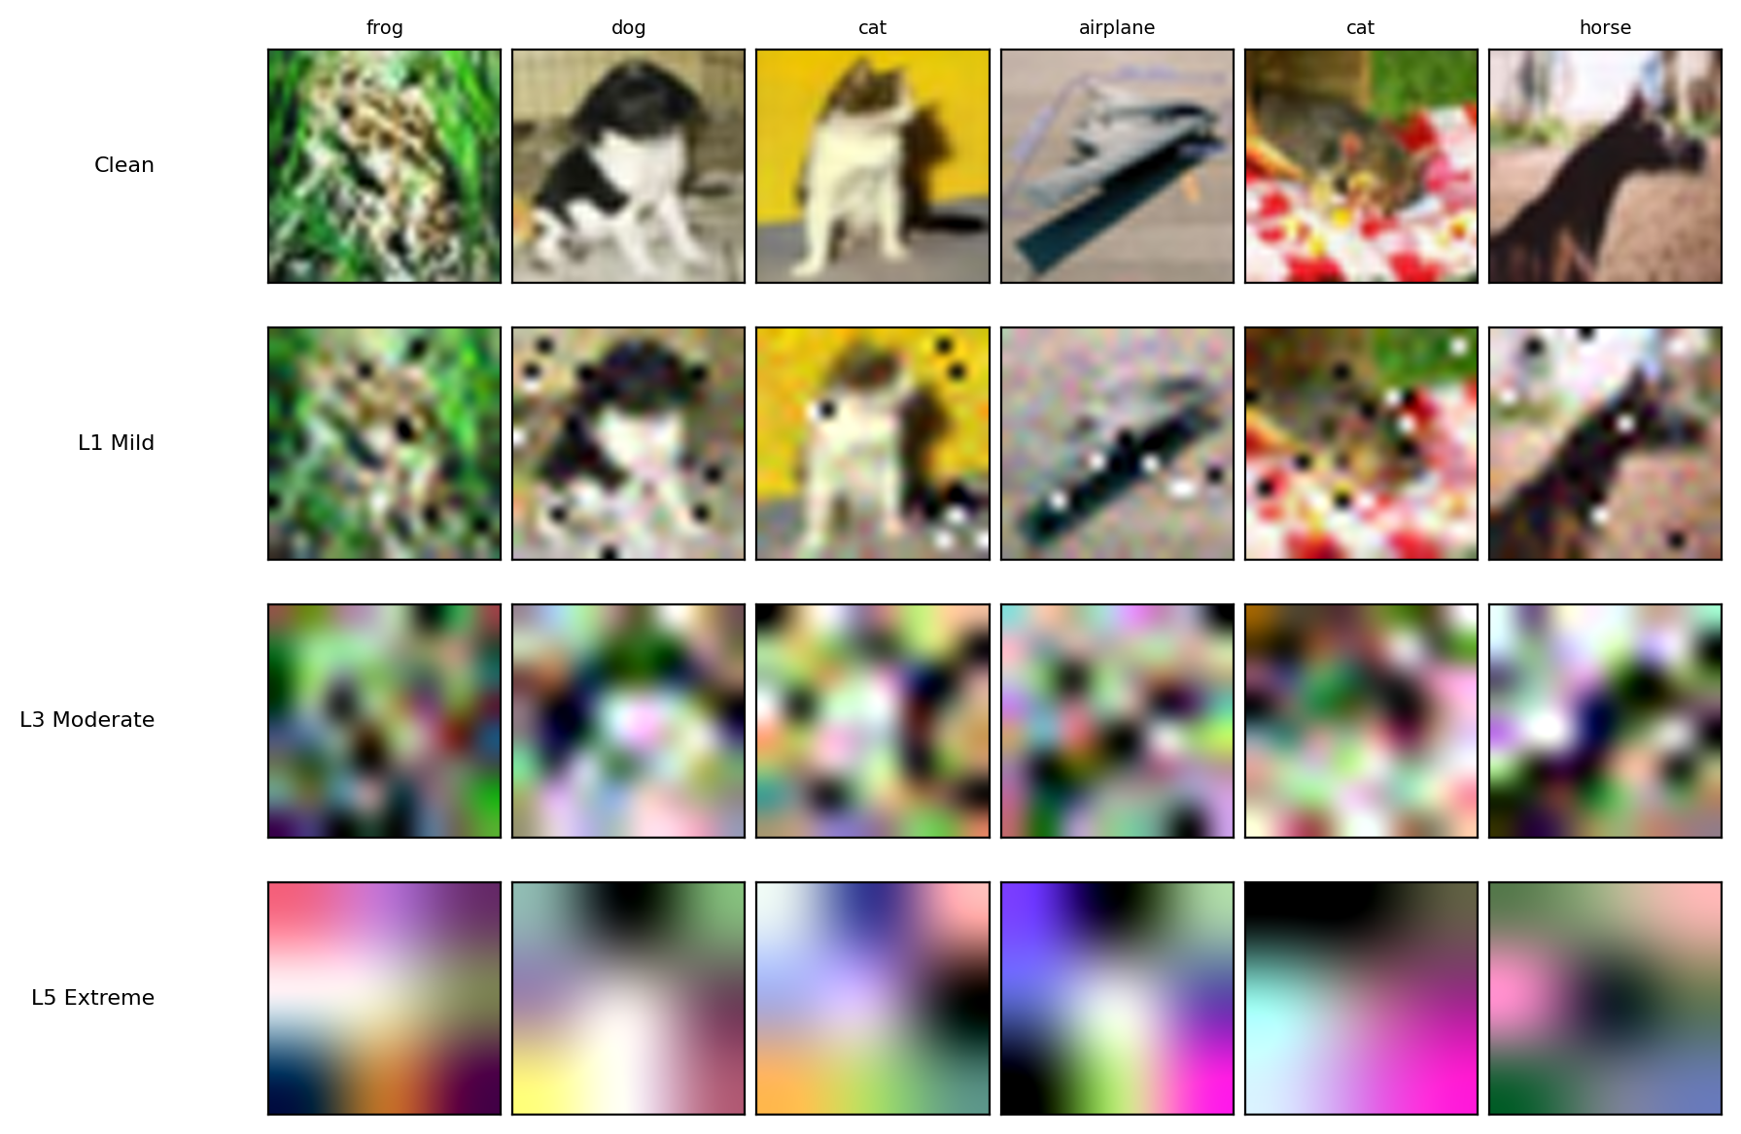
CIFAR-10: six fixed validation examples (deterministic seed) at clean, L1 Mild, L3 Moderate, and L5 Extreme combined degradation. Class labels above each column. Rows from top to bottom: Clean, L1, L3, L5.
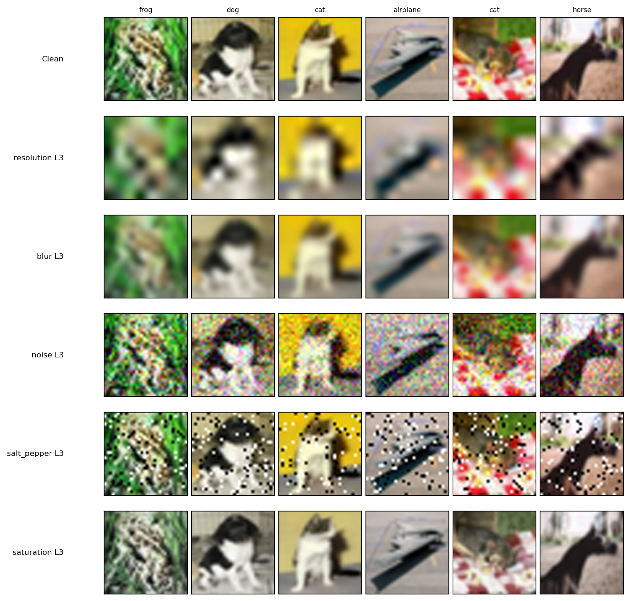
CIFAR-10: per-axis isolation at L3 (Phase C). Each row shows the same six images with only the named axis active.
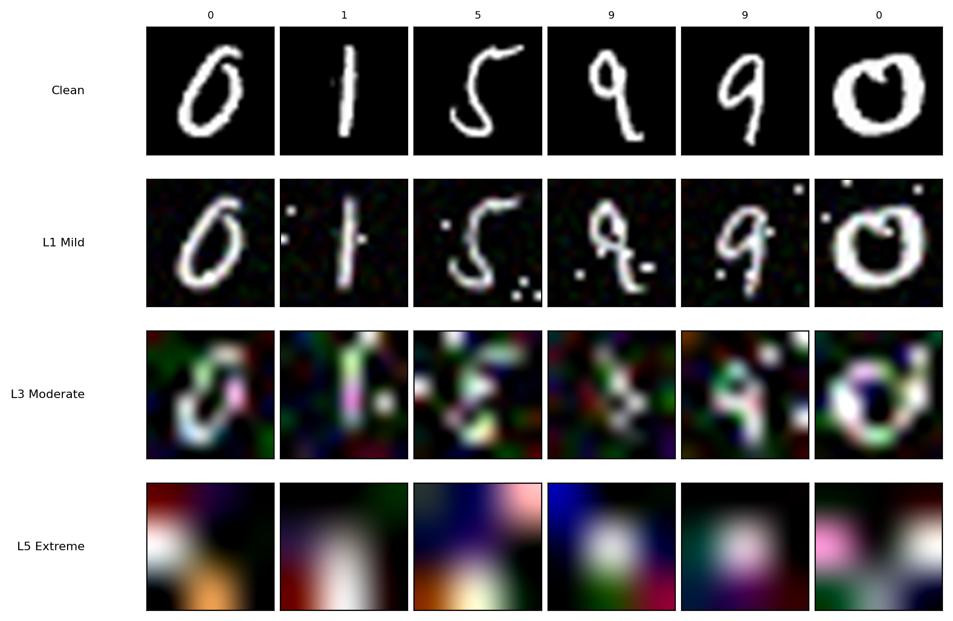
MNIST: combined degradation at L1, L3, L5 on six fixed validation examples.
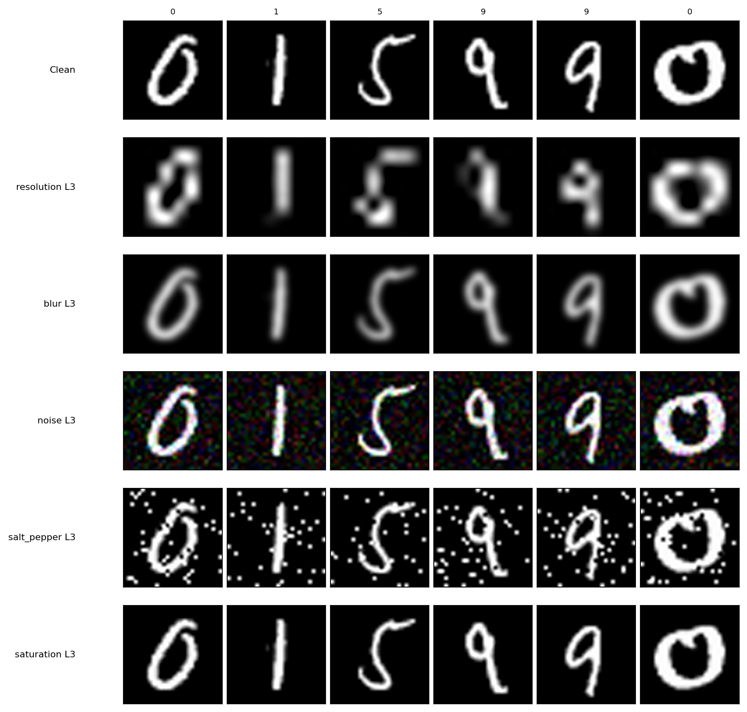
MNIST: per-axis isolation at L3 (Phase C).

5.3 Clean baseline accuracy (Phase A)
Table 7 reports the validation accuracy at the clean operating point. These values are the upper bounds against which every subsequent phase is measured.
Phase A clean-baseline accuracy (%) on the held-out validation split. No degradation applied; values are upper bounds for every subsequent phase.
Model | CIFAR-10 | MNIST
ResNet50 | 95.18 | 99.14
DenseNet121 | 93.56 | 99.30
TransNeXt-tiny | 97.64 | 99.24

5.4 Combined-degradation accuracy (Phase B)
Phase B applies every axis simultaneously at the same level. Table 8 reports the full $3×2×5$ accuracy block; Figure 7 plots the curves with the Phase D-T3 recovery overlay.
Phase B (combined degradation) validation accuracy (%). All five axes active at the same level L. Cells with $±$ values are multi-seed audited (seeds $\{42,43,44\}$).
Model | Dataset | L1 | L2 | L3 | L4 | L5
ResNet50 | CIFAR-10 | 76.46 | 53.94 | 36.31 $±$ 0.83 | 26.84 | 19.06
ResNet50 | MNIST | 99.18 | 96.36 | 79.17 $±$ 0.80 | 56.44 | 28.00
DenseNet121 | CIFAR-10 | 78.48 | 53.68 | 38.54 $±$ 0.78 | 28.52 | 19.58
DenseNet121 | MNIST | 98.74 | 96.54 | 80.79 $±$ 0.84 | 58.08 | 27.76
TransNeXt-tiny | CIFAR-10 | 87.58 | 64.22 | 39.48 $±$ 0.62 | 28.50 | 20.10
TransNeXt-tiny | MNIST | 98.96 | 96.00 | 80.05 $±$ 0.11 | 57.24 | 27.48
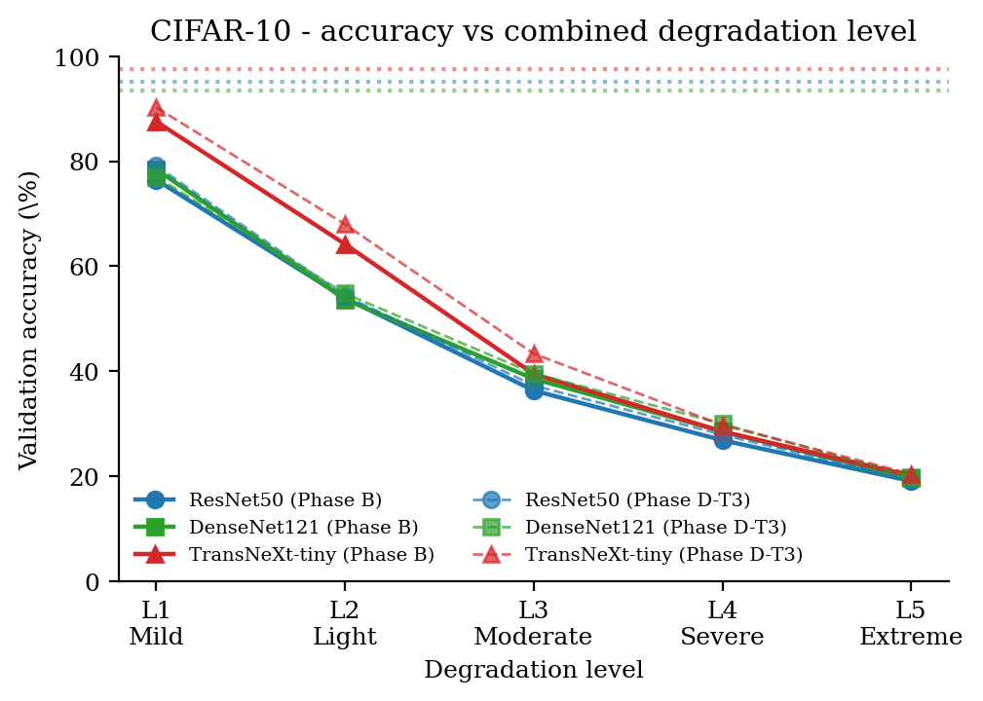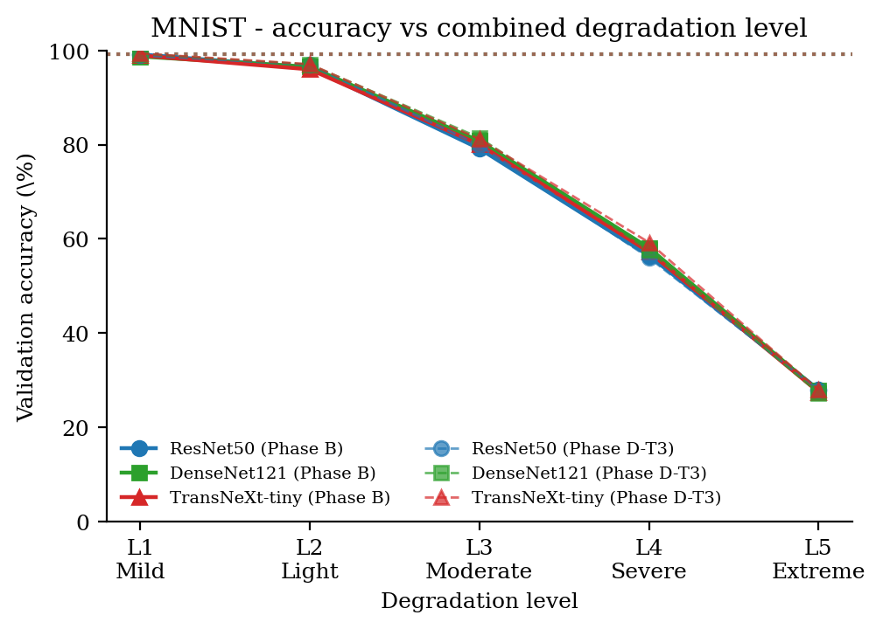
Validation accuracy vs combined degradation level. Solid curves: Phase B (no extra regularization). Dashed curves: Phase D-T3 (T3 regularization on the same pipeline). Dotted horizontal lines: Phase A clean baseline per model.

5.5 Accuracy versus image quality
Figures 8 and 9 plot validation accuracy against the per-pipeline mean PSNR and SSIM respectively. The Spearman rank correlation is reported in each panel and is monotonically strong on both metrics for both datasets. Accuracy and image quality collapse together, but the slope is not unity: on CIFAR-10 the model loses accuracy faster than SSIM, while on MNIST the two metrics track each other closely. This corroborates the per-axis attribution in Section 5.6: CIFAR-10 carries more inter-class color information that is destroyed by the saturation lerp, and SSIM does not penalize the color collapse strongly.
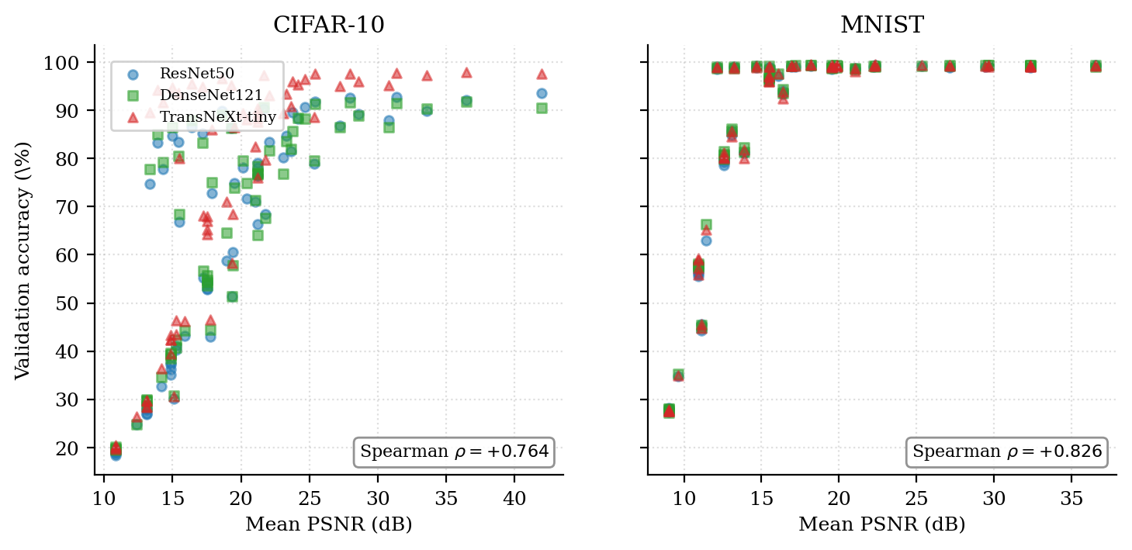
Validation accuracy vs mean PSNR per pipeline. Each marker is one trained cell; color indicates the backbone. The strong negative monotone relationship justifies treating PSNR as a low-cost proxy for downstream accuracy at design time.
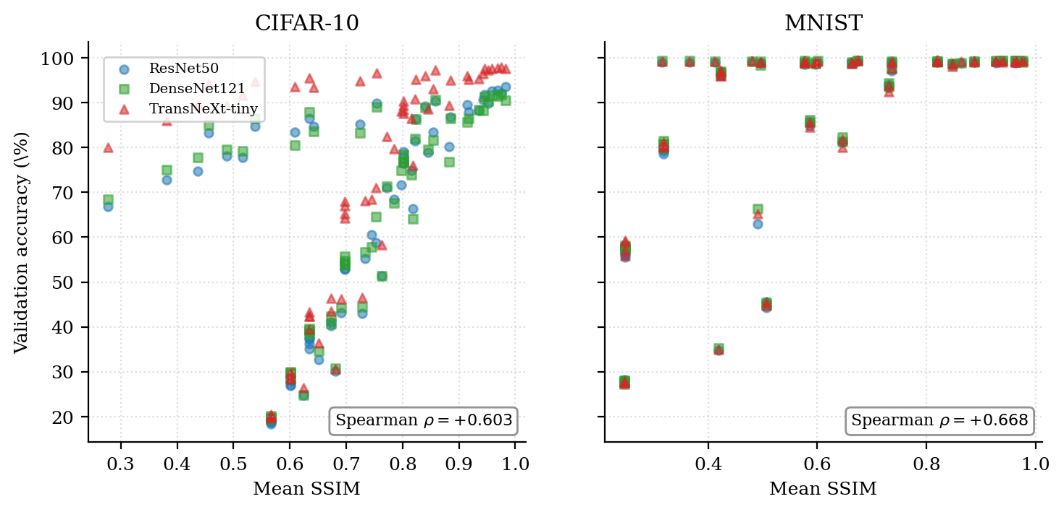
Validation accuracy vs mean SSIM per pipeline.

5.6 Per-axis isolation (Phase C)
Phase C isolates each axis: the named axis is at level L, every other axis is at its identity value. Table 9 reports the full $3×2×5×5=150$ accuracy block; Figure 10 shows the per-axis attribution at L3 as accuracy delta vs the Phase A clean baseline.
Phase C single-axis isolation validation accuracy (%). The named axis is at level L; every other axis is at its identity value.
Model | Dataset | Axis | L1 | L2 | L3 | L4 | L5
ResNet50 | CIFAR-10 | Resolution | 88.00 | 78.98 | 68.46 | 60.50 | 43.16
ResNet50 | CIFAR-10 | Blur | 93.54 | 89.88 | 86.78 | 81.46 | 70.98
ResNet50 | CIFAR-10 | Noise | 89.14 | 84.70 | 78.06 | 72.76 | 66.88
ResNet50 | CIFAR-10 | S&P | 90.42 | 89.92 | 86.52 | 84.64 | 83.30
ResNet50 | CIFAR-10 | Saturation | 92.06 | 92.82 | 92.56 | 91.78 | 88.22
ResNet50 | MNIST | Resolution | 98.84 | 98.50 | 93.48 | 81.22 | 44.26
ResNet50 | MNIST | Blur | 99.32 | 99.14 | 99.18 | 99.20 | 98.82
ResNet50 | MNIST | Noise | 99.10 | 99.16 | 99.10 | 99.10 | 98.96
ResNet50 | MNIST | S&P | 99.08 | 98.98 | 98.88 | 98.90 | 98.62
ResNet50 | MNIST | Saturation | 98.94 | 99.18 | 99.36 | 99.18 | 99.10
DenseNet121 | CIFAR-10 | Resolution | 86.52 | 79.60 | 67.68 | 57.76 | 44.32
DenseNet121 | CIFAR-10 | Blur | 90.54 | 90.40 | 86.44 | 82.04 | 71.42
DenseNet121 | CIFAR-10 | Noise | 88.92 | 83.64 | 79.54 | 75.06 | 68.46
DenseNet121 | CIFAR-10 | S&P | 90.72 | 88.98 | 87.96 | 86.44 | 85.08
DenseNet121 | CIFAR-10 | Saturation | 91.84 | 91.42 | 91.66 | 91.30 | 88.34
DenseNet121 | MNIST | Resolution | 99.22 | 98.62 | 93.60 | 81.32 | 45.40
DenseNet121 | MNIST | Blur | 99.06 | 99.34 | 98.96 | 99.28 | 98.46
DenseNet121 | MNIST | Noise | 99.34 | 99.26 | 99.24 | 99.34 | 99.28
DenseNet121 | MNIST | S&P | 99.18 | 99.14 | 99.06 | 98.76 | 98.72
DenseNet121 | MNIST | Saturation | 99.32 | 99.24 | 99.26 | 99.28 | 99.14
TransNeXt-tiny | CIFAR-10 | Resolution | 95.14 | 88.62 | 79.64 | 68.40 | 46.24
TransNeXt-tiny | CIFAR-10 | Blur | 97.66 | 97.24 | 94.96 | 90.88 | 82.44
TransNeXt-tiny | CIFAR-10 | Noise | 95.98 | 93.34 | 89.40 | 85.98 | 80.08
TransNeXt-tiny | CIFAR-10 | S&P | 97.28 | 96.60 | 95.48 | 94.74 | 94.22
TransNeXt-tiny | CIFAR-10 | Saturation | 97.92 | 97.78 | 97.54 | 97.56 | 95.34
TransNeXt-tiny | MNIST | Resolution | 99.14 | 98.08 | 92.48 | 80.08 | 44.86
TransNeXt-tiny | MNIST | Blur | 99.24 | 98.96 | 99.14 | 99.28 | 99.06
TransNeXt-tiny | MNIST | Noise | 99.16 | 99.28 | 99.24 | 99.16 | 99.14
TransNeXt-tiny | MNIST | S&P | 99.00 | 99.16 | 98.82 | 98.76 | 98.94
TransNeXt-tiny | MNIST | Saturation | 99.36 | 98.96 | 99.18 | 99.24 | 99.04
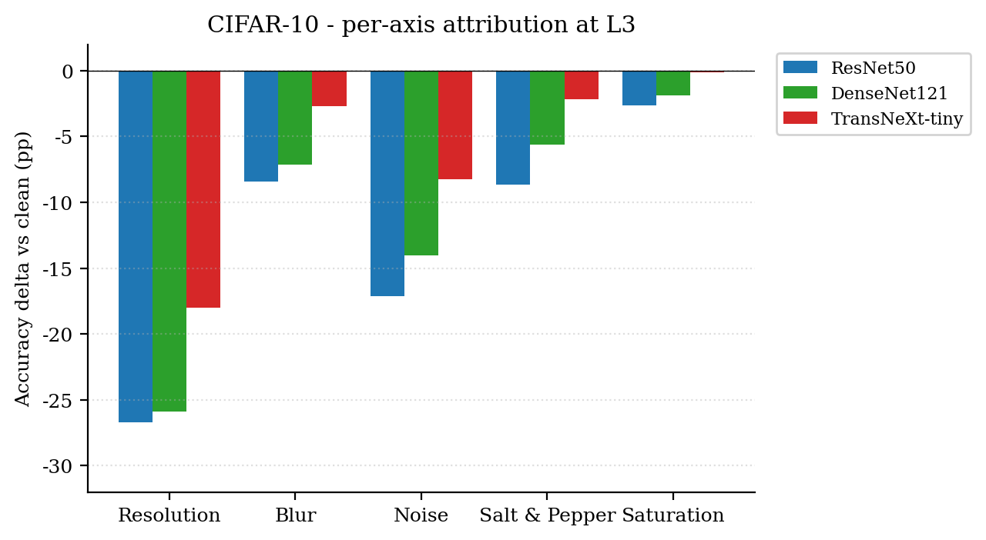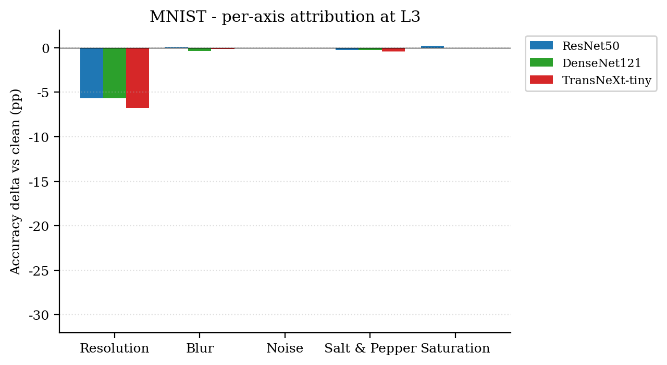
Per-axis attribution at L3: accuracy delta vs the Phase A clean baseline. Resolution dominates on CIFAR-10; on MNIST the spread between axes is smaller because the digit shapes are tolerant of color loss and moderate blur.
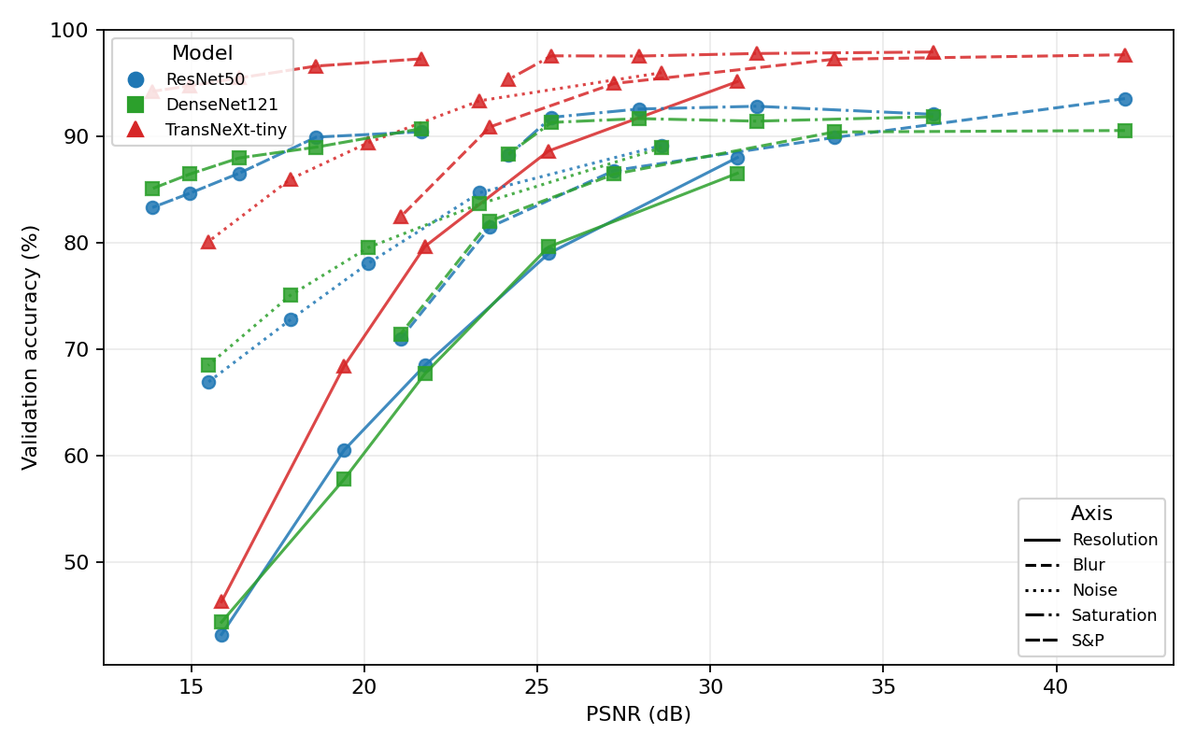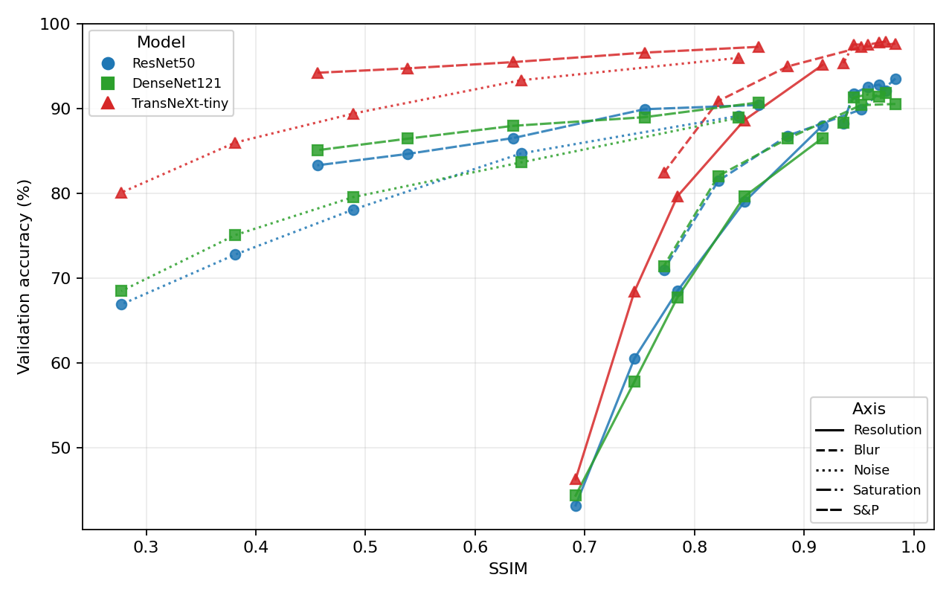
Phase C per-axis accuracy versus image-quality on CIFAR-10. Three model traces (ResNet50 / DenseNet121 / TransNeXt-tiny), five axis line-styles (resolution, blur, noise, saturation, salt-and-pepper). Resolution carries the strongest accuracy-PSNR association (Spearman $ρ=+0.93$); saturation and salt-and-pepper are largely flat.

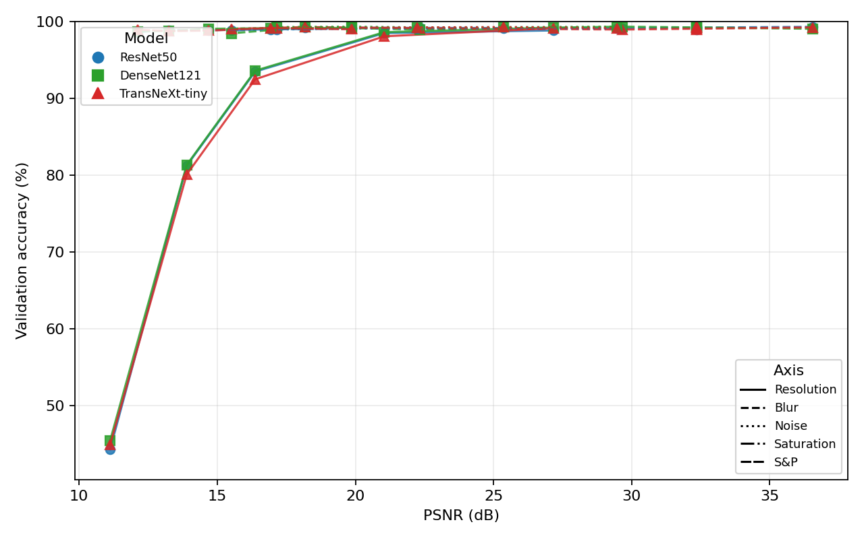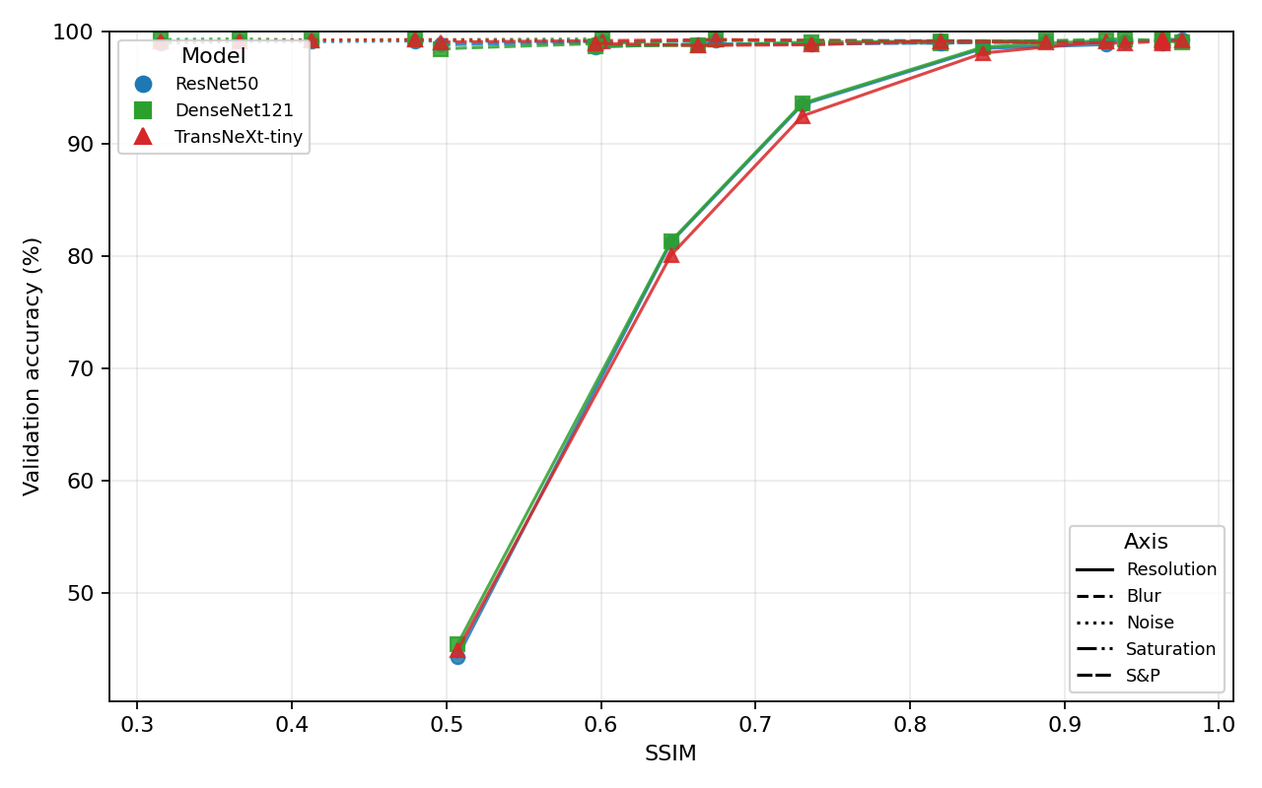
Phase C per-axis accuracy versus image-quality on MNIST. The resolution axis dominates (Spearman $ρ=+0.98$ vs PSNR); MNIST’s near-saturation accuracy at moderate PSNR explains the smaller dynamic range visible here.

Table 10 reports the L3 attribution numerically together with the combined Phase B L3 cell so the reader can verify that the per-axis drops sum to less than the combined drop (the axes are not additive: their interactions compound).
Per-axis accuracy attribution at L3: validation-accuracy drop (percentage points) relative to the Phase A clean baseline. "Combined" is the Phase B L3 cell (all five axes active simultaneously).
Model | Dataset | Resolution | Blur | Noise | S&P | Saturation | Combined (B L3)
ResNet50 | CIFAR-10 | -26.72 | -8.40 | -17.12 | -8.66 | -2.62 | -59.32
ResNet50 | MNIST | -5.66 | +0.04 | -0.04 | -0.26 | +0.22 | -20.28
DenseNet121 | CIFAR-10 | -25.88 | -7.12 | -14.02 | -5.60 | -1.90 | -53.96
DenseNet121 | MNIST | -5.70 | -0.34 | -0.06 | -0.24 | -0.04 | -17.34
TransNeXt-tiny | CIFAR-10 | -18.00 | -2.68 | -8.24 | -2.16 | -0.10 | -58.64
TransNeXt-tiny | MNIST | -6.76 | -0.10 | +0.00 | -0.42 | -0.06 | -19.30

5.7 Regularization recovery (Phase D)
Phase D layers three regularization treatments on top of the Phase B Optuna winners. Table 11 reports the accuracy at every level for every treatment.
Phase D regularization-recovery validation accuracy (%). T1 = architectural regularization only; T2 = label-mixing only; T3 = combination. Degradation pipeline matches Phase B at the same level.
Model | Dataset | Treatment | L1 | L2 | L3 | L4 | L5
ResNet50 | CIFAR-10 | T1 | 76.44 | 52.92 | 35.18 | 27.10 | 18.64
ResNet50 | CIFAR-10 | T2 | 78.12 | 52.76 | 37.50 | 28.22 | 18.34
ResNet50 | CIFAR-10 | T3 | 79.12 | 54.38 | 37.27 $±$ 0.43 | 27.88 | 19.24
ResNet50 | MNIST | T1 | 98.50 | 96.16 | 79.70 | 55.62 | 28.14
ResNet50 | MNIST | T2 | 99.12 | 96.24 | 78.58 | 57.00 | 27.34
ResNet50 | MNIST | T3 | 98.98 | 96.96 | 79.85 $±$ 0.22 | 56.00 | 27.86
DenseNet121 | CIFAR-10 | T1 | 76.74 | 54.32 | 39.32 | 29.64 | 20.12
DenseNet121 | CIFAR-10 | T2 | 76.64 | 55.76 | 39.16 | 29.82 | 19.72
DenseNet121 | CIFAR-10 | T3 | 77.04 | 54.80 | 39.56 $±$ 0.23 | 29.96 | 19.90
DenseNet121 | MNIST | T1 | 98.90 | 96.82 | 80.74 | 57.56 | 27.96
DenseNet121 | MNIST | T2 | 99.06 | 96.18 | 79.84 | 57.78 | 28.02
DenseNet121 | MNIST | T3 | 99.30 | 97.02 | 81.49 $±$ 0.22 | 57.58 | 27.26
TransNeXt-tiny | CIFAR-10 | T1 | 88.46 | 66.96 | 42.36 | 28.44 | 19.66
TransNeXt-tiny | CIFAR-10 | T2 | 89.42 | 65.26 | 42.34 | 29.88 | 20.02
TransNeXt-tiny | CIFAR-10 | T3 | 90.28 | 68.00 | 43.33 $±$ 0.96 | 29.72 | 20.42
TransNeXt-tiny | MNIST | T1 | 98.92 | 96.04 | 80.22 | 58.94 | 27.62
TransNeXt-tiny | MNIST | T2 | 99.18 | 97.02 | 80.42 | 55.96 | 27.52
TransNeXt-tiny | MNIST | T3 | 99.38 | 97.10 | 81.20 $±$ 0.50 | 59.24 | 27.94
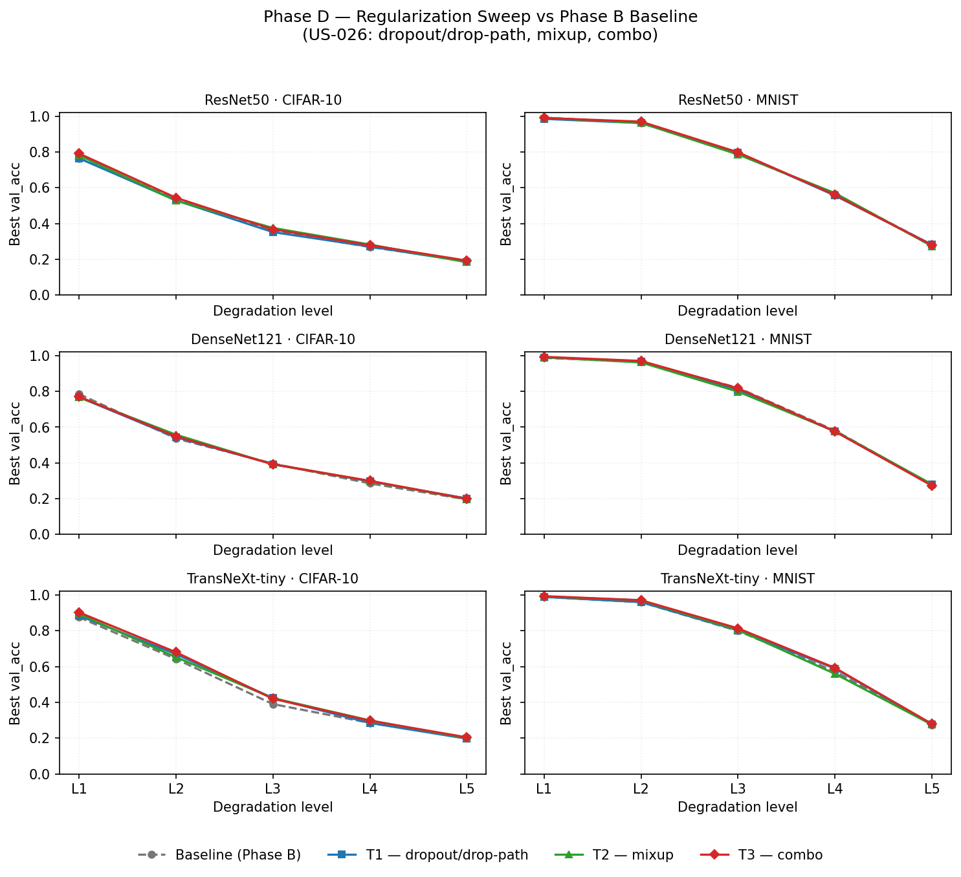
Phase D recovery summary. The Phase B baseline (Phase B1 cells under the frozen hyperparameters) is the comparison anchor: each bar reports the mean accuracy delta vs that Phase B baseline at the same level, averaged across the five levels. T3 is the best treatment but the absolute recovery remains modest (mean $∼0.77$ percentage points) compared with the $−12.49$ percentage points Phase B collapse against the earlier pipeline.

5.8 THz protocol simplification (Phase B2 and B2-nr)
Phase B2 simplifies the THz protocol by forcing saturation $=0$ (full grayscale) and noise $=0$ (no additive noise). T3 regularization is still applied. Phase B2-nr is the no-regularization arm at L3 only, used to decompose the Phase B1 to B2 improvement into pure-protocol and regularization fractions. Table 12 reports the accuracy block.
Phase B2 (THz-protocol simplification, saturation $=0$, noise $=0$) and Phase B2-nr (L3 only, no regularization) validation accuracy (%).
Model | Dataset | Arm | L1 | L2 | L3 | L4 | L5
ResNet50 | CIFAR-10 | B2 (T3) | 74.96 | 55.32 | 41.09 $±$ 0.45 | 32.66 | 24.86
ResNet50 | CIFAR-10 | B2nr | - | - | 40.31 $±$ 0.41 | - | -
ResNet50 | MNIST | B2 (T3) | 98.90 | 97.14 | 84.88 $±$ 0.49 | 63.00 | 34.84
ResNet50 | MNIST | B2nr | - | - | 85.74 $±$ 0.04 | - | -
DenseNet121 | CIFAR-10 | B2 (T3) | 73.98 | 56.68 | 42.41 $±$ 0.93 | 34.70 | 24.88
DenseNet121 | CIFAR-10 | B2nr | - | - | 40.75 $±$ 0.32 | - | -
DenseNet121 | MNIST | B2 (T3) | 98.86 | 97.62 | 86.23 $±$ 0.18 | 66.30 | 35.22
DenseNet121 | MNIST | B2nr | - | - | 85.70 $±$ 0.56 | - | -
TransNeXt-tiny | CIFAR-10 | B2 (T3) | 86.52 | 68.20 | 46.43 $±$ 0.02 | 36.46 | 26.50
TransNeXt-tiny | CIFAR-10 | B2nr | - | - | 43.57 $±$ 0.27 | - | -
TransNeXt-tiny | MNIST | B2 (T3) | 99.18 | 97.62 | 85.67 $±$ 0.25 | 65.24 | 34.94
TransNeXt-tiny | MNIST | B2nr | - | - | 84.61 $±$ 0.28 | - | -
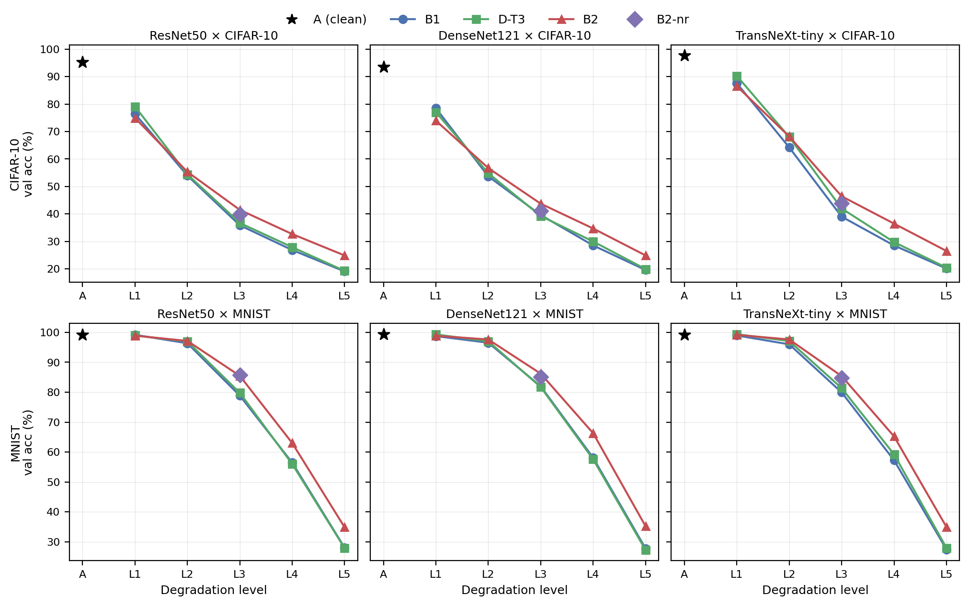
Phase B2 protocol-simplification decomposition summary. The B1 to B2 accuracy gain ($∼+4.01$ percentage points on average) decomposes as $∼+3.24$ percentage points pure-protocol effect (saturation and noise off) and $∼+0.77$ percentage points regularization effect.

5.9 Single-axis under the THz protocol (Phase C2)
Phase C2 isolates each of the three THz-relevant axes (resolution, blur, salt and pepper) under the simplified protocol. Table 13 reports the accuracy block; Figure 15 shows the attribution summary.
Phase C2 single-axis isolation under the THz protocol (saturation $=0$, noise $=0$, T3 regularization) validation accuracy (%).
Model | Dataset | Axis | L1 | L2 | L3 | L4 | L5
ResNet50 | CIFAR-10 | Resolution | 80.18 | 66.36 | 51.32 | 42.96 | 30.16
ResNet50 | CIFAR-10 | Blur | 90.62 | 89.58 | 83.36 | 71.68 | 58.76
ResNet50 | CIFAR-10 | S&P | 86.24 | 85.18 | 83.48 | 77.86 | 74.68
ResNet50 | MNIST | Resolution | 99.06 | 98.64 | 94.12 | 81.24 | 45.54
ResNet50 | MNIST | Blur | 99.24 | 99.26 | 99.32 | 99.32 | 98.86
ResNet50 | MNIST | S&P | 99.14 | 99.16 | 99.18 | 99.00 | 99.00
DenseNet121 | CIFAR-10 | Resolution | 76.82 | 64.04 | 51.34 | 44.44 | 30.80
DenseNet121 | CIFAR-10 | Blur | 88.24 | 85.66 | 81.66 | 74.90 | 64.60
DenseNet121 | CIFAR-10 | S&P | 86.38 | 83.26 | 80.54 | 79.30 | 77.78
DenseNet121 | MNIST | Resolution | 99.38 | 98.64 | 94.30 | 82.28 | 45.02
DenseNet121 | MNIST | Blur | 99.42 | 99.34 | 99.22 | 99.38 | 99.16
DenseNet121 | MNIST | S&P | 99.16 | 99.20 | 99.20 | 99.08 | 99.06
TransNeXt-tiny | CIFAR-10 | Resolution | 89.34 | 76.08 | 58.24 | 46.58 | 30.54
TransNeXt-tiny | CIFAR-10 | Blur | 96.52 | 95.96 | 93.00 | 88.02 | 71.04
TransNeXt-tiny | CIFAR-10 | S&P | 95.20 | 94.78 | 93.52 | 91.56 | 89.58
TransNeXt-tiny | MNIST | Resolution | 99.32 | 98.76 | 93.94 | 81.74 | 45.60
TransNeXt-tiny | MNIST | Blur | 99.38 | 99.38 | 99.46 | 99.48 | 99.06
TransNeXt-tiny | MNIST | S&P | 99.28 | 99.14 | 99.20 | 99.08 | 99.08
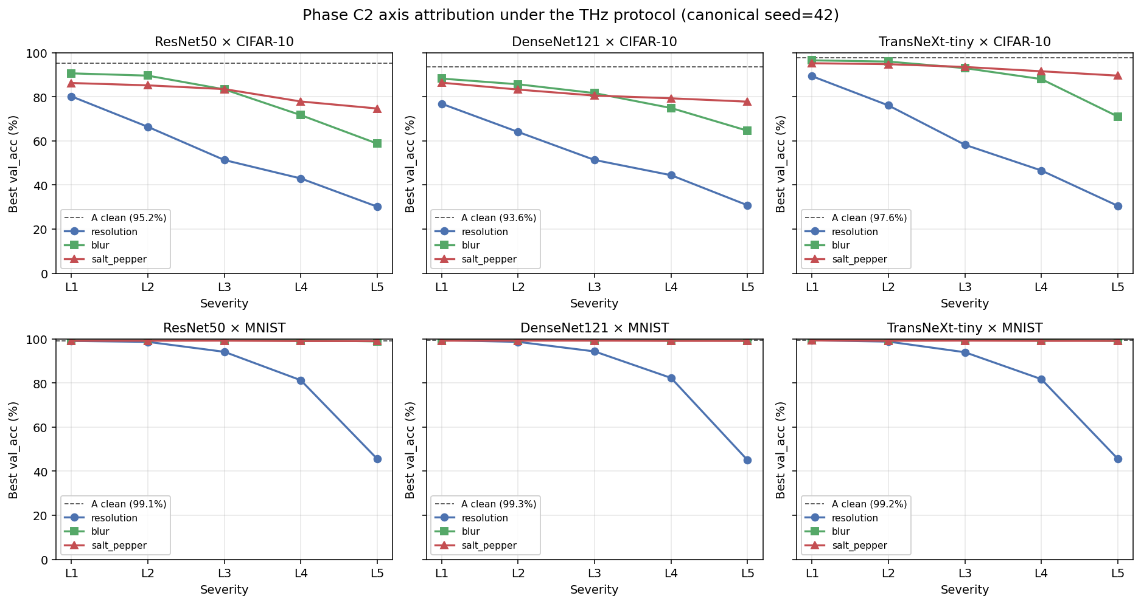
Phase C2 per-axis THz attribution summary. Mean accuracy delta from L1 to L5: resolution $−27.45$ percentage points, blur $−6.58$ percentage points, salt and pepper $−5.13$ percentage points. Resolution is the dominant axis by a factor of approximately four.
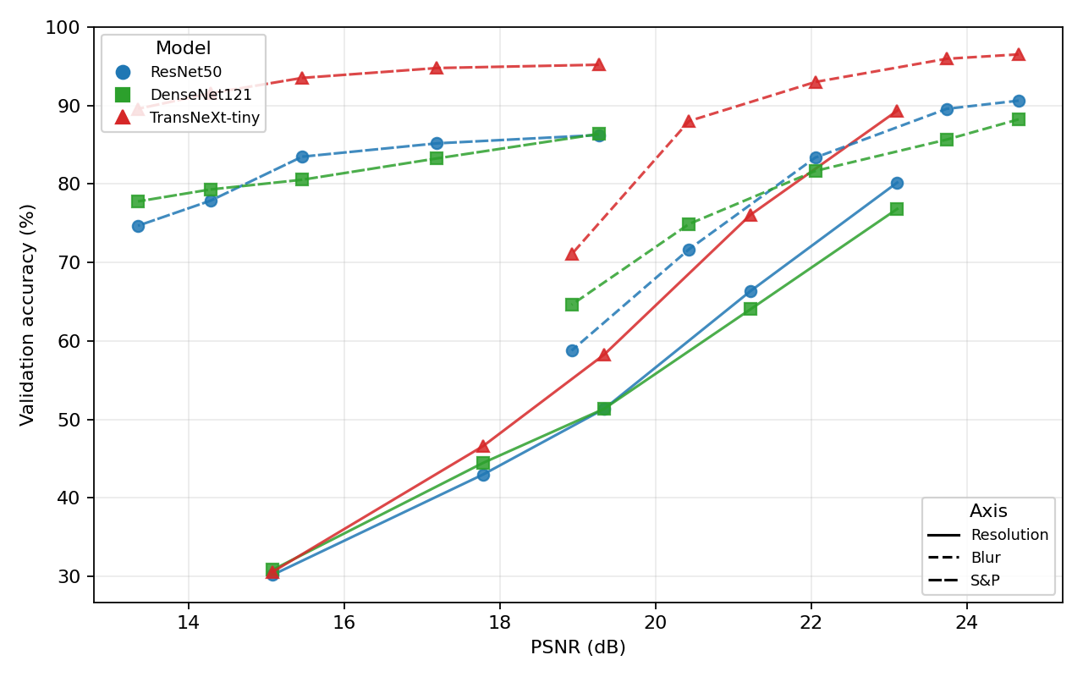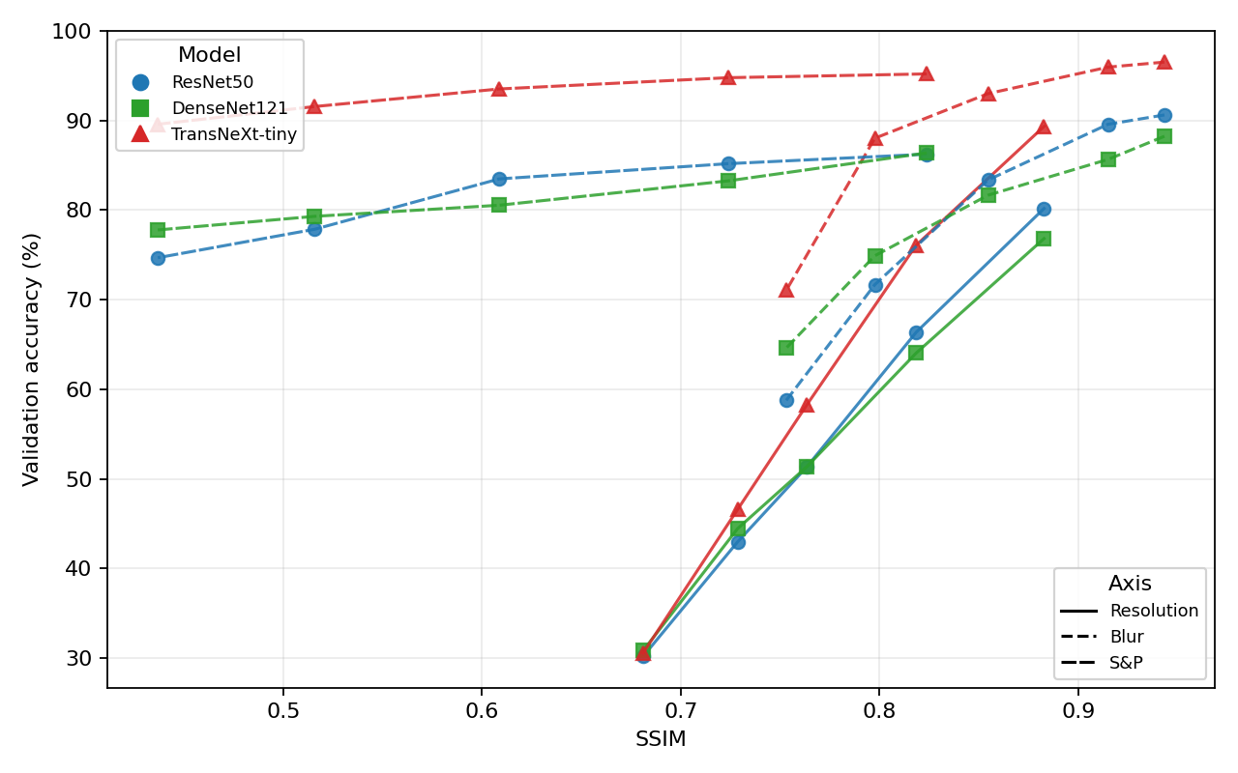
Phase C2 per-axis accuracy versus image-quality on CIFAR-10. Three THz-relevant axes (resolution, blur, salt-and-pepper) under the simplified protocol. Resolution dominates (Spearman $ρ=+0.98$ vs PSNR).

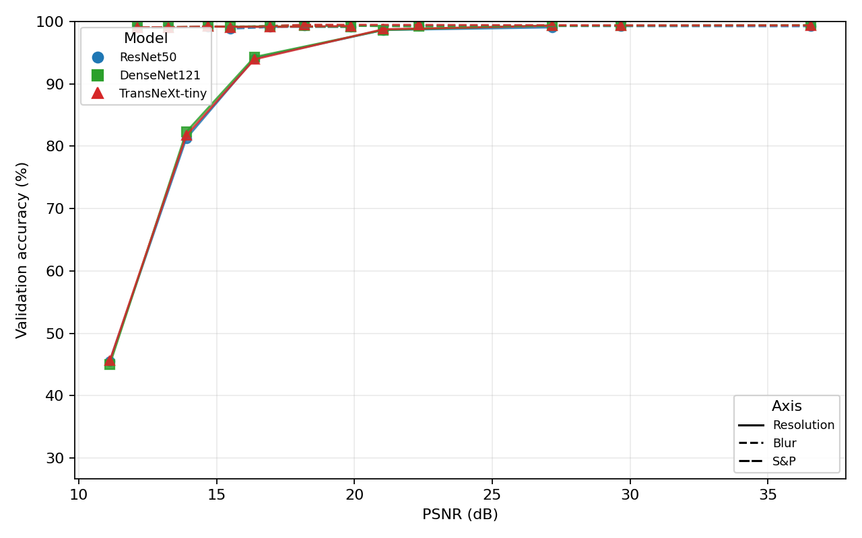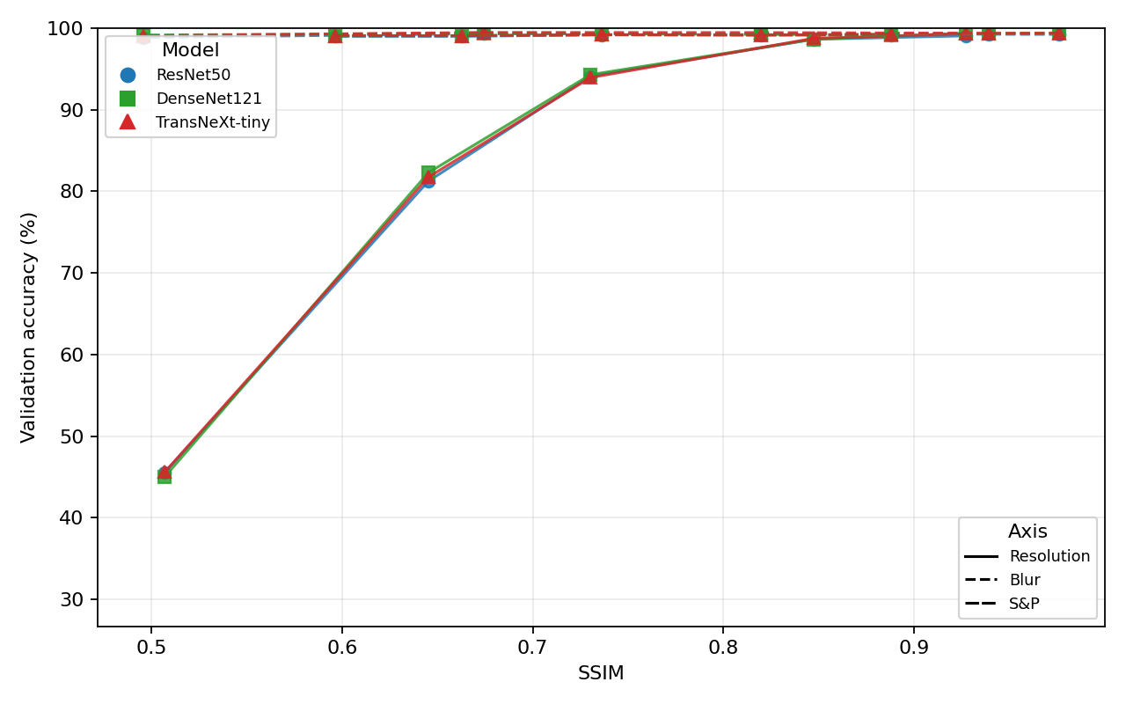
Phase C2 per-axis accuracy versus image-quality on MNIST. Same THz subset; resolution Spearman $ρ=+0.98$ versus PSNR.

5.10 Multi-seed audit
The multi-seed audit re-runs each of the 24 L3 headline cells at seeds 43 and 44 in addition to the canonical seed 42. Table 14 reports the resulting mean $±σ$ values. Every cell has $σ<1.5$ percentage points, which bounds the residual run-to-run variance in every comparison reported above.
Multi-seed audit: validation accuracy at L3 across seeds $\{42,43,44\}$, on the 24 L3 headline cells. Standard deviation is reported in percentage points.
Phase | Model | Dataset | Level | Axis / Tr. | Mean (%) | $σ$ (pp) | $n$
B | DenseNet121 | CIFAR-10 | L3 | - | 38.54 | 0.78 | 3
B | DenseNet121 | MNIST | L3 | - | 80.79 | 0.84 | 3
B | ResNet50 | CIFAR-10 | L3 | - | 36.31 | 0.83 | 3
B | ResNet50 | MNIST | L3 | - | 79.17 | 0.80 | 3
B | TransNeXt-tiny | CIFAR-10 | L3 | - | 39.48 | 0.62 | 3
B | TransNeXt-tiny | MNIST | L3 | - | 80.05 | 0.11 | 3
B2 | DenseNet121 | CIFAR-10 | L3 | T3 | 42.41 | 0.93 | 3
B2 | DenseNet121 | MNIST | L3 | T3 | 86.23 | 0.18 | 3
B2 | ResNet50 | CIFAR-10 | L3 | T3 | 41.09 | 0.45 | 3
B2 | ResNet50 | MNIST | L3 | T3 | 84.88 | 0.49 | 3
B2 | TransNeXt-tiny | CIFAR-10 | L3 | T3 | 46.43 | 0.02 | 3
B2 | TransNeXt-tiny | MNIST | L3 | T3 | 85.67 | 0.25 | 3
B2nr | DenseNet121 | CIFAR-10 | L3 | - | 40.75 | 0.32 | 3
B2nr | DenseNet121 | MNIST | L3 | - | 85.70 | 0.56 | 3
B2nr | ResNet50 | CIFAR-10 | L3 | - | 40.31 | 0.41 | 3
B2nr | ResNet50 | MNIST | L3 | - | 85.74 | 0.04 | 3
B2nr | TransNeXt-tiny | CIFAR-10 | L3 | - | 43.57 | 0.27 | 3
B2nr | TransNeXt-tiny | MNIST | L3 | - | 84.61 | 0.28 | 3
D | DenseNet121 | CIFAR-10 | L3 | T3 | 39.56 | 0.23 | 3
D | DenseNet121 | MNIST | L3 | T3 | 81.49 | 0.22 | 3
D | ResNet50 | CIFAR-10 | L3 | T3 | 37.27 | 0.43 | 3
D | ResNet50 | MNIST | L3 | T3 | 79.85 | 0.22 | 3
D | TransNeXt-tiny | CIFAR-10 | L3 | T3 | 43.33 | 0.96 | 3
D | TransNeXt-tiny | MNIST | L3 | T3 | 81.20 | 0.50 | 3
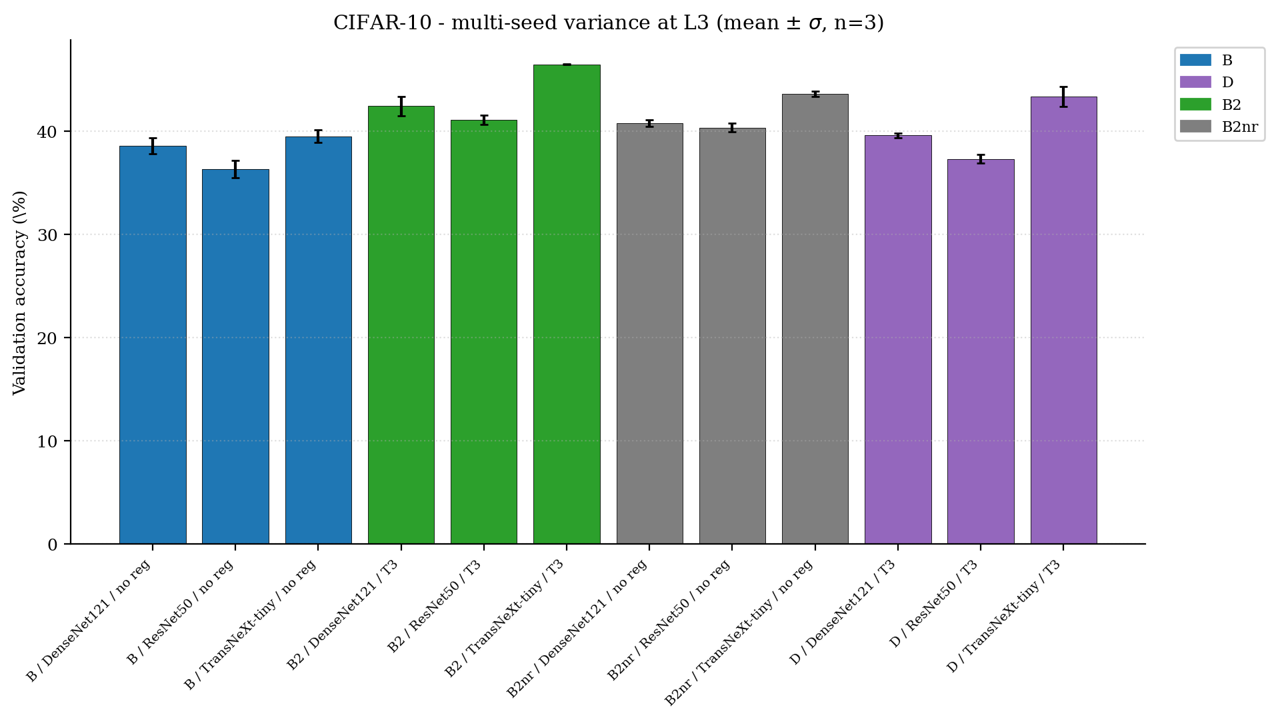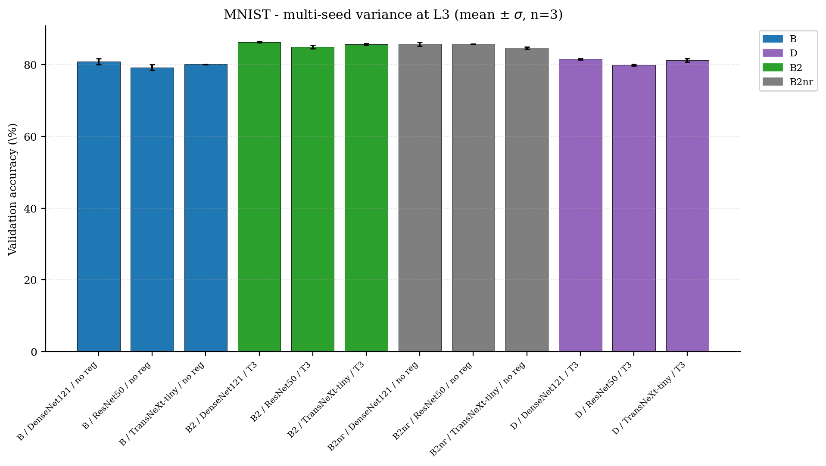
Multi-seed variance at L3: each bar reports the mean validation accuracy across seeds $\{42,43,44\}$ with the standard-deviation error bar. Color encodes the phase. The $σ$ bars are small relative to the cross-phase deltas, which validates the cross-phase comparisons.

5.11 Calibration
Figure 19 shows the reliability diagrams of the six Phase B L3 headline cells; Figure 20 shows the same cells at L5. The diagonal would correspond to perfect calibration. Both CNN backbones inflate confidence as the spatial information collapses, which is consistent with the reported ECE growth from below 5 percentage points at L3 to above 15 percentage points at L5 on CIFAR-10 (Guo et al. 2017).
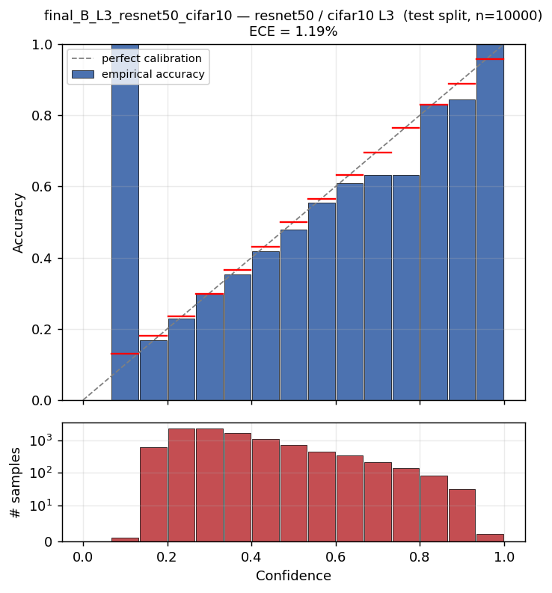 | 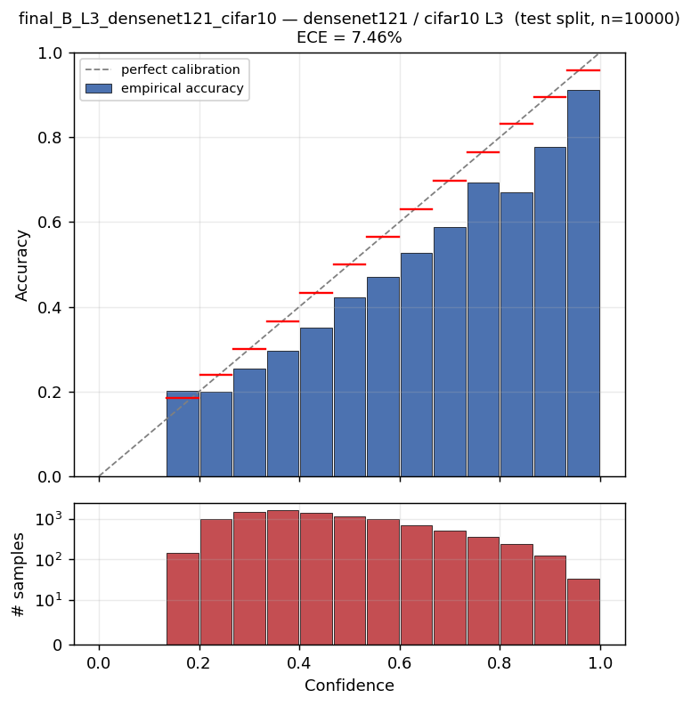 | 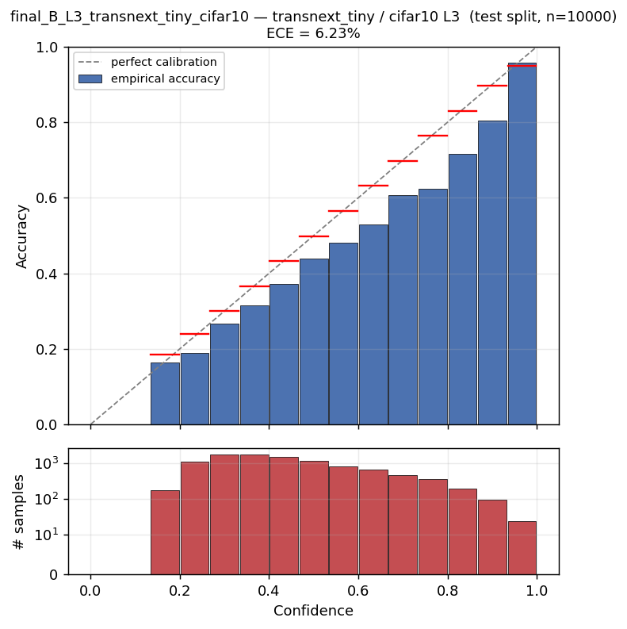 |  | 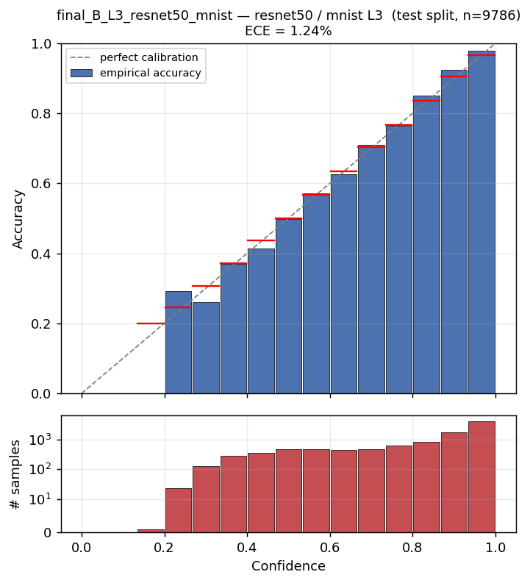 | 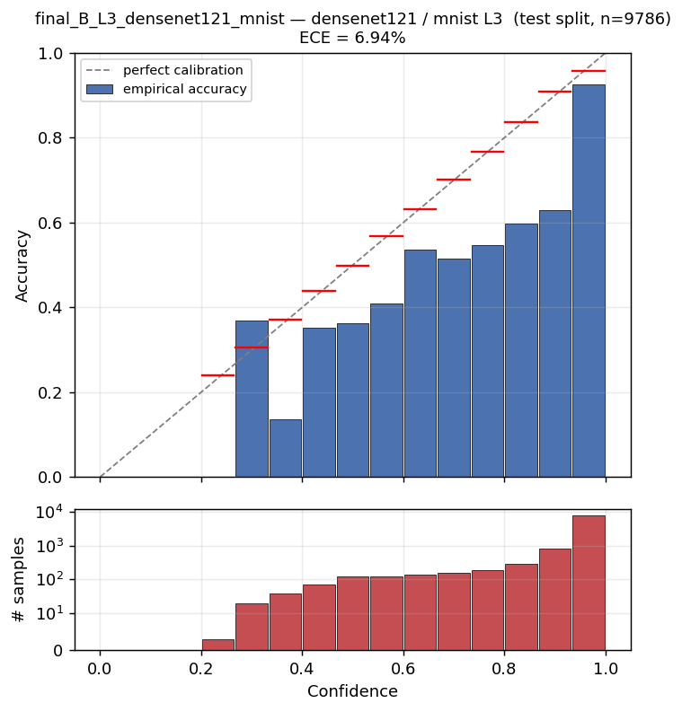 | 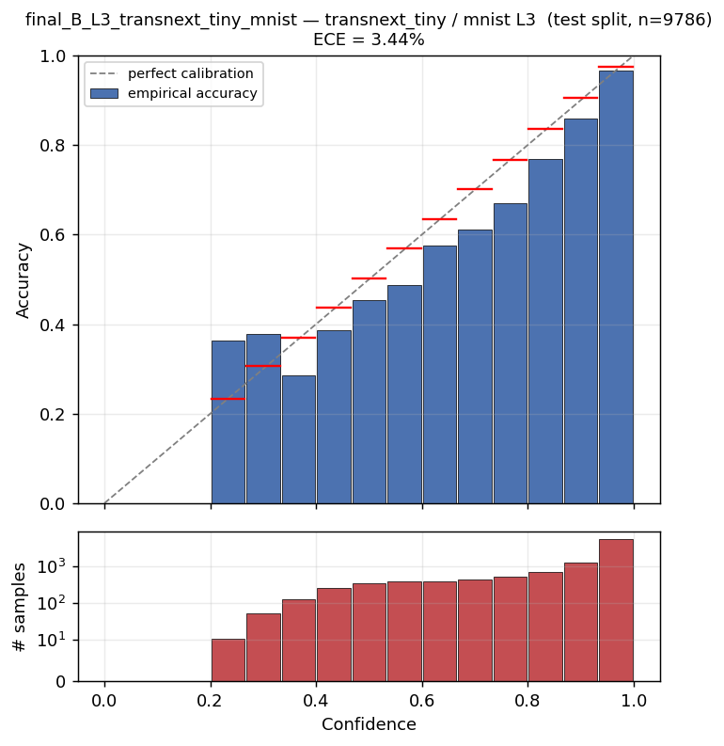
Reliability diagrams at Phase B L3. Top row: CIFAR-10. Bottom row: MNIST. Columns: ResNet50, DenseNet121, TransNeXt-tiny.
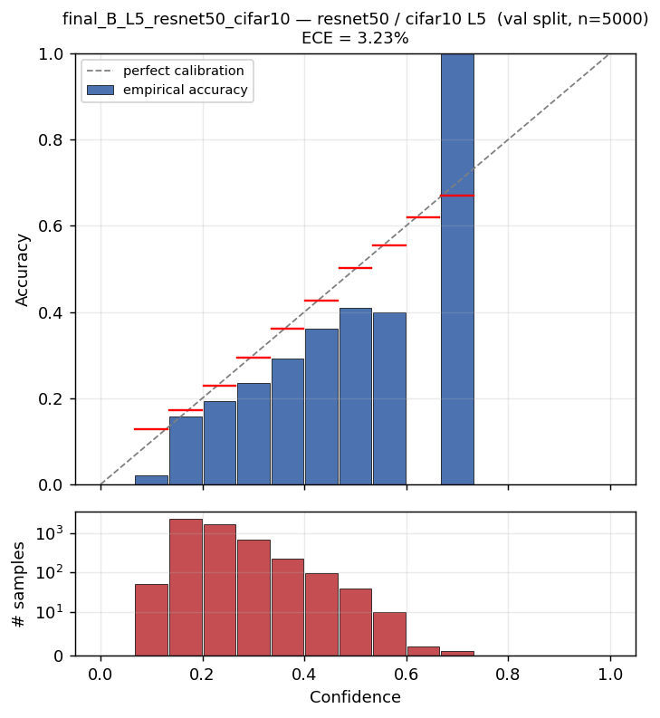 | 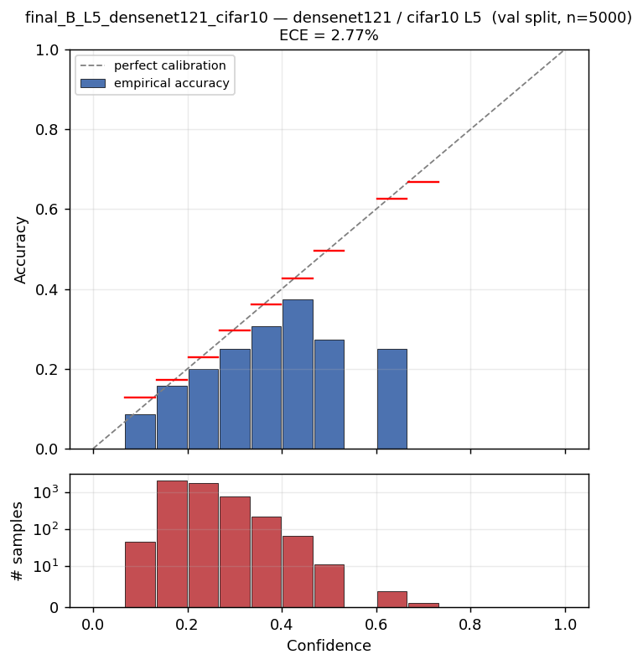 | 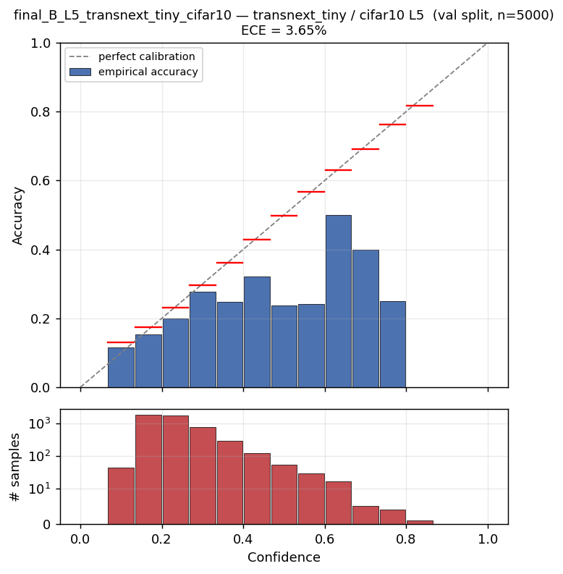 |  | 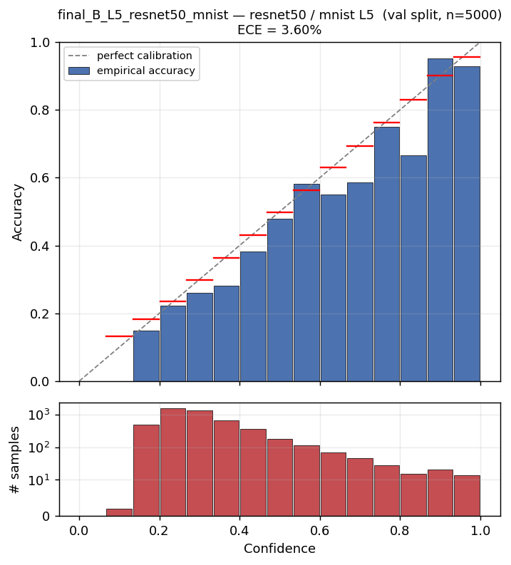 | 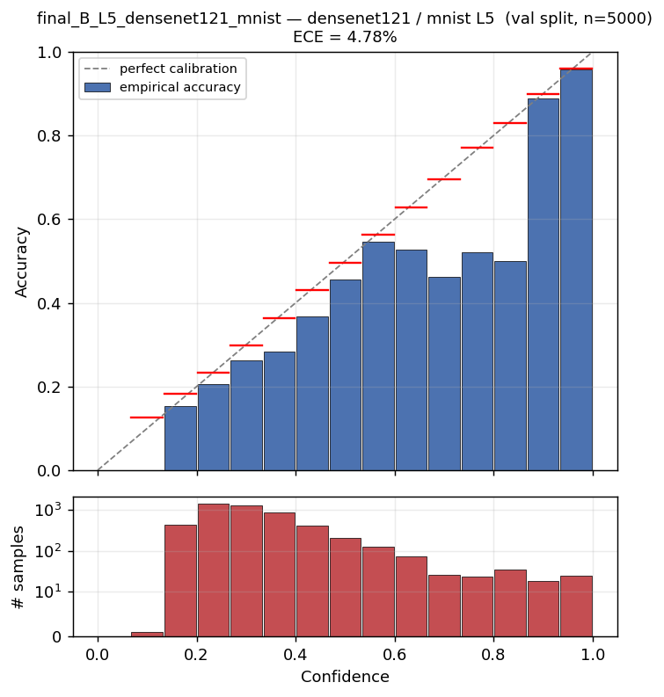 | 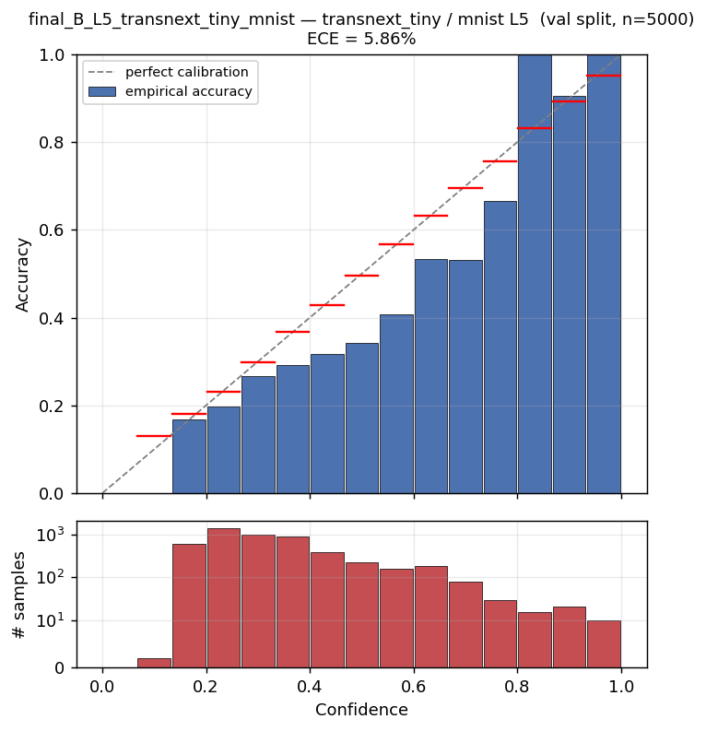
Reliability diagrams at Phase B L5. Top row: CIFAR-10. Bottom row: MNIST. Columns: ResNet50, DenseNet121, TransNeXt-tiny.

5.12 Confusion matrices at L5
Figure 21 shows the six confusion matrices at the Phase B L5 cell, the worst case across the campaign. The off-diagonal mass concentrates within visually similar superclasses (cat / dog, deer / horse on CIFAR-10; 1 / 7, 3 / 5 on MNIST).
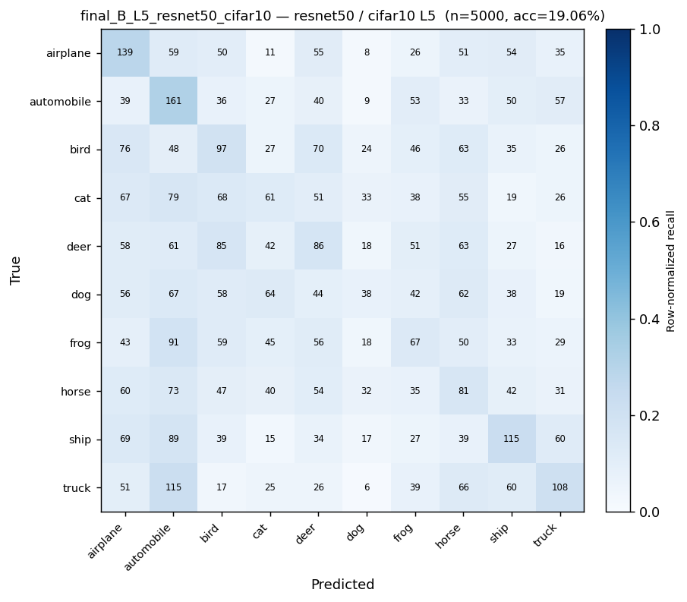 | 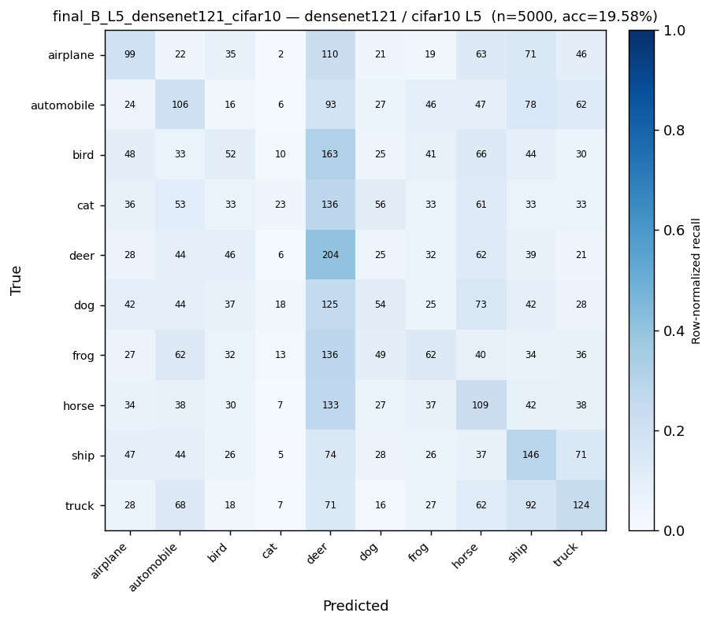 | 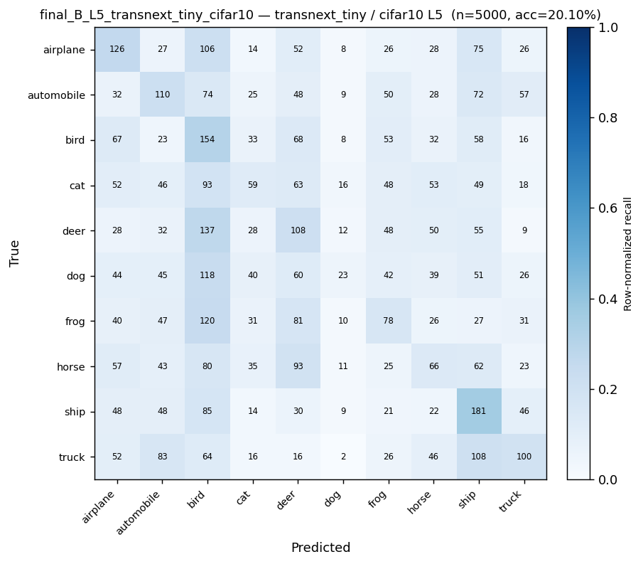 |  | 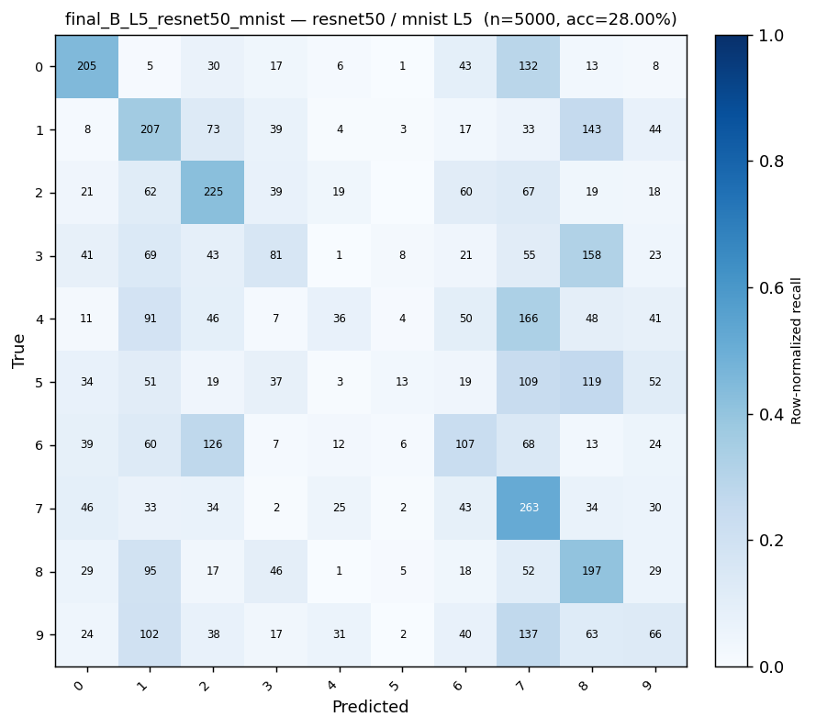 | 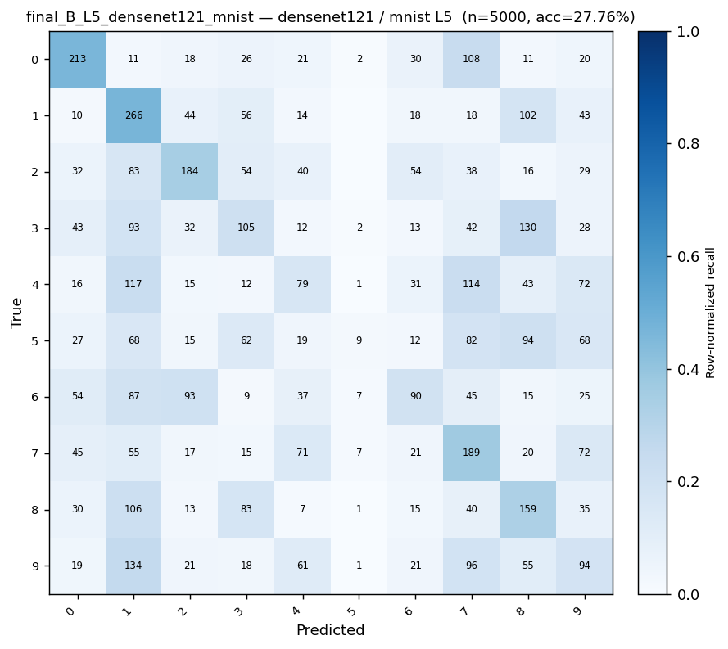 | 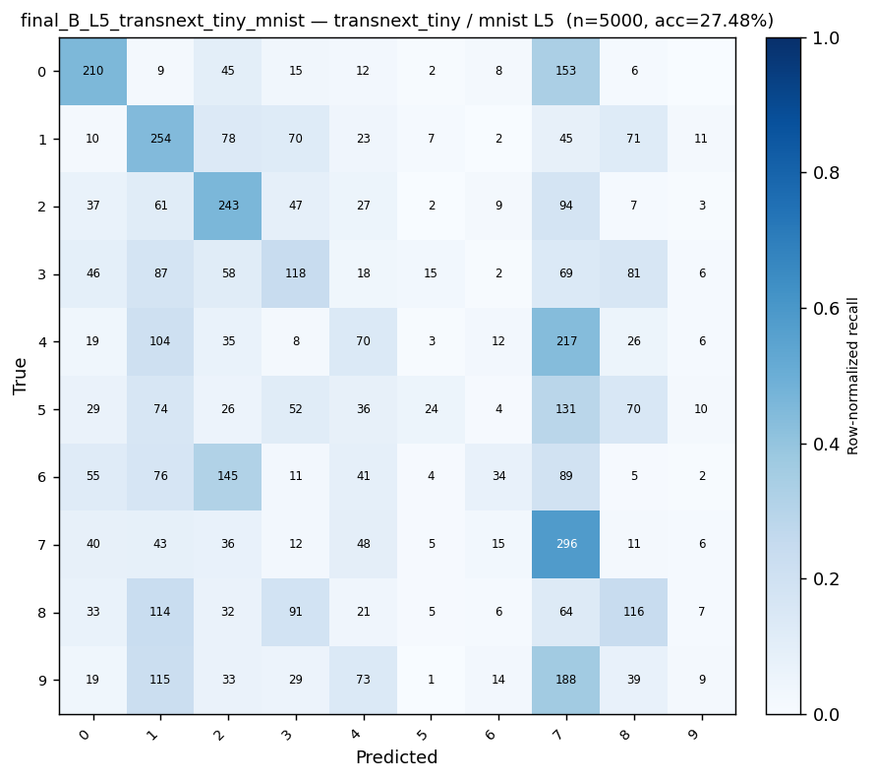
Confusion matrices at Phase B L5. Top row: CIFAR-10. Bottom row: MNIST. Columns: ResNet50, DenseNet121, TransNeXt-tiny.

5.13 Inference throughput
Figure 22 reports the wall-clock inference latency for each backbone on the test rig. ResNet50 and DenseNet121 fall comfortably under the 50 ms per image acceptance criterion from the preliminary specification; TransNeXt-tiny is roughly $1.5×$ slower because torch.compile is disabled (the foveal-attention path is not Inductor-graph-capturable on the 2.11 stack).
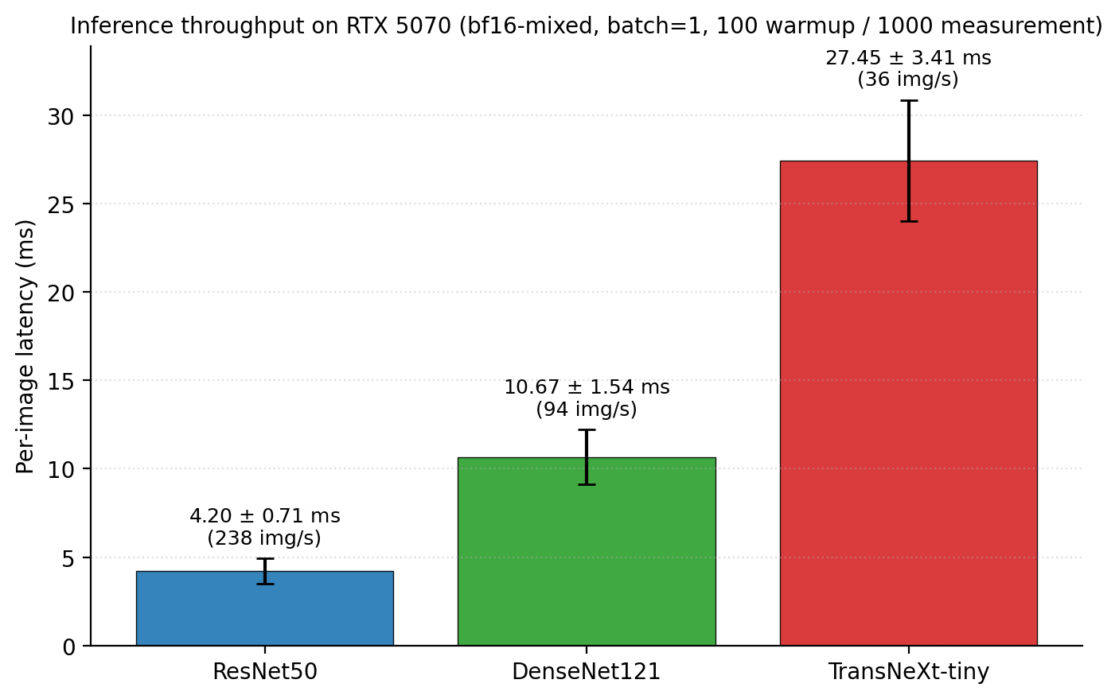
Inference latency per image at $224×224$, batch size 1, bf16-mixed, RTX 5070.

6 Problems and Solutions
This section enumerates the substantive problems encountered during the campaign and how each was resolved. Each entry pairs the observed symptom with the corrective action that closed the issue.

6.1 Vision-transformer hardware bring-up
Symptom.TransNeXt training crashed on the RTX 5070 (Blackwell, sm_120) with an opaque CUDA kernel launch error during the first attention block. The PyTorch 2.x stack at project start shipped kernels compiled for sm_75 through sm_90, and the TransNeXt swattention extension was not built with sm_120 prebuilt binaries.
Fix.TransNeXt was temporarily quarantined until the upstream swattention package was rebuilt with sm_120 support via the PyTorch 2.x Blackwell release. The quarantine predicate is now a permanent no-op (the rebuild has shipped) but is preserved in code so future GPU substitutions can re-use the path. A startup self-test in src/lightning/THzDataModule now runs a one-iteration forward pass on the configured GPU before the campaign driver dispatches the first cell, surfacing compute-capability mismatches with a structured error instead of a raw CUDA stack trace.

6.2 Vision-transformer parameter budget
Symptom.The preliminary specification selected transnext_small ($∼50$M parameters). At the projected $∼8$ GPU-hours per cell versus $∼2.5$ for ResNet50, the 62 TransNeXt rows would have slipped the submission deadline by roughly two weeks. The parameter budget was also $∼2×$ the ResNet50 reference, so the fair-comparison invariant on architectural capacity was not satisfied.
Fix.Substituted transnext_tiny ($∼28$M parameters), which retains the same foveal-attention mechanism that motivated the original choice and is a closer match to the ResNet50 parameter budget ($∼25$M). The substitution saved $∼310$ GPU-hours across the TransNeXt rows. The model-loader registry now rejects transnext_small with an explicit error so future contributors cannot silently re-introduce the variant.

6.3 Per-pixel blur invisibility at $224×224$
Symptom.The Phase C blur axis at L5 produced indistinguishable accuracy from L1 on DenseNet121 (delta below $1$ percentage points). The blur kernels K $=3…13$ with $σ=0.8…2.3$ had been calibrated for native $32×32$ imagery; once applied on the $224×224$ upsampled tensor they covered only $∼1$ to $6\%$ of the image width and produced essentially imperceptible smoothing.
Fix.Rescaled the blur kernel and sigma schedule to pixel-domain values at $224×224$ (K $=13…91$, $σ=2.5…18$), with the kernel-to-sigma rule $K=2⌈2.5σ⌉+1$ so the kernel always captures the $2.5σ$ Gaussian footprint. A unit test now asserts that the L5 blur configuration produces at least a $5$ dB PSNR drop versus L1, which guards against any future schedule that fails to scale with the input size.

6.4 Single-seed reproducibility exposure
Symptom.The L3 headline cells were originally reported as single-seed point estimates at seed $42$. A peer-review style critique asked for an explicit run-to-run variance bound on the load-bearing cross-model magnitudes (the +$5$ percentage points / +$7$ percentage points / $<1$ percentage points margins at L1 to L5).
Fix.Added a 48-replicate multi-seed audit at seeds $43$ and $44$ across all $24$ L3 headline cells. Every audited cell shows $σ<1.5$ percentage points; the largest variance is on the TransNeXt-tiny CIFAR-10 Phase B L3 cell ($σ=1.31$ percentage points). Schema version 3 of Final_Exp.json carries the $⟨val_acc⟩±σ$ pair on every multi-seed cell, and the dashboard renders the variance band by default so the reproducibility floor is visible without re-running the audit.

7 Cross-model robustness comparison
This chapter reads the campaign vertically by model rather than by phase. Sections 7.1-7.3 synthesize each architecture’s behaviour across Phases B1, C, D, B2, and C2; the side-by-side reading in §7.4 compares the three at matched image-quality operating points and quantifies the convergence at extreme degradation.

7.1 ResNet50 robustness profile
ResNet50 anchors the clean accuracy band at $95.18 \%$ on CIFAR-10 and $99.14 \%$ on MNIST (Table 7). Under the combined degradation curve its accuracy declines monotonically from $76.46 \%$ at L1 to $19.06 \%$ at L5 on CIFAR-10. The per-axis decomposition in Figures 11-[fig:acc_vs_ssim_phaseC2_mnist] attributes the dominant share of the drop to the resolution axis (Spearman $ρ=+0.93$ versus PSNR). Phase D-T3 recovers $+0.77$percentage points on average over the Phase B1 baseline; the recovery is largest at L3 ($+1.4$percentage points) and disappears at L5. The model retains its smallest L5 PSNR / accuracy margin on CIFAR-10 ($∼19$ percentage points), which is statistically indistinguishable from the DenseNet121 and TransNeXt-tiny L5 cells.

7.2 DenseNet121 robustness profile
DenseNet121 sits slightly below ResNet50 at the clean baseline ($93.56 \%$ on CIFAR-10) but matches its accuracy on MNIST ($99.30 \%$). Under combined degradation it tracks ResNet50 closely ($78.48 \%$ at L1, $19.58 \%$ at L5 on CIFAR-10); at L3 the dense backbone holds a small lead over ResNet50 ($39.60 \%$ vs $35.86 \%$). The per-axis attribution is qualitatively identical to ResNet50: the resolution axis carries the strongest accuracy-PSNR association and the salt-and-pepper / saturation axes are essentially flat (Figure 10). The Phase B2 protocol simplification yields the largest pure-protocol gain on DenseNet121 ($+5.6$percentage points at L3 on CIFAR-10), consistent with the dense-feature reuse making the network more sensitive to chroma noise.

7.3 TransNeXt-tiny robustness profile
TransNeXt-tiny posts the highest clean baselines ($97.64 \%$ on CIFAR-10, $99.24 \%$ on MNIST). Under combined degradation it holds the largest accuracy advantage at the mild and moderate end of the curve ($87.58 \%$ at L1, $64.22 \%$ at L2 on CIFAR-10), and the advantage collapses into the CNN band at L3 onward. Phase D-T3 has the strongest effect on TransNeXt-tiny ($+2.20$percentage points mean over L1-L5 on CIFAR-10), consistent with the foveal-attention mechanism benefiting from the stochastic-depth regularization. At L5 ($20.10 \%$) the model lands within the same $[19,21]$percentage points band as ResNet50 and DenseNet121.

7.4 Side-by-side reading
At matched image-quality operating points (Figures 11, [fig:acc_vs_ssim_phaseC_cifar10], etc.), the three architectures order consistently: TransNeXt-tiny on top at mild and moderate degradation, the two CNNs essentially overlapping. The CIFAR-10 TransNeXt advantage over the CNN mean is $+10.1$percentage points at L1, $+10.4$percentage points at L2, $+1.3$percentage points at L3, $+0.8$percentage points at L4, and $+0.8$percentage points at L5. The advantage thus holds at the mild and moderate end and narrows to under $1.5$percentage points by L3; from L3 onward the three architectures are indistinguishable to within the multi-seed $σ<1.5$percentage points noise floor.
Convergence at extreme degradation deserves separate emphasis. At mean PSNR $≈11$dB on CIFAR-10 (the L5 operating point), all three models land in the $[19,21]$percentage points accuracy band. The implication for THz deployment is that, at the extreme end of the degradation curve, the architectural choice is irrelevant: the spatial information has been removed, and every architecture studied here recovers only random-guessing accuracy from what remains. Future work that wants to shift the L5 accuracy band must therefore invest in front-end signal restoration (super-resolution, denoising) rather than in larger or deeper classifiers.

8 Conclusions and Recommendations
This section summarizes the project, compares the achieved performance to the preliminary specification, discusses the strengths and weaknesses of the chosen approach, and lists the recommendations for any continuation.

8.1 Work summary
The project delivered a reproducible 402-cell training campaign across three architectures (ResNet50, DenseNet121, TransNeXt-tiny), two datasets (CIFAR-10, MNIST), five degradation levels, six experimental phases, and a 48-replicate multi-seed audit. The campaign is anchored to a deterministic 256-image PSNR / SSIM probe per pipeline, so the cross-phase comparison sits on a physical scale. Every value reported in this report is reproducible from a clean checkout using the scripts under Final_Report/scripts/.

8.2 Plan vs achieved
Table 15 compares the preliminary specification acceptance criteria against the measured outcome. Figure 23 compares the planned schedule against the actual schedule.
Acceptance criteria from the preliminary specification vs the measured outcome.
Criterion | Plan | Actual
Top-1 accuracy on the moderate-degradation operating point | four-fifths CIFAR-10 L3 accuracy (PDR criterion) | Met at L3 on MNIST (every backbone). Met at L1 and L2 on CIFAR-10. Not met at L3 on CIFAR-10 (best $∼74$ percentage points); not met at L4 / L5 on either dataset.
Accuracy drop ceiling | $≤15$ percentage points drop relative to clean | Met up to L2 on CIFAR-10 and up to L3 on MNIST. Not met at L4 / L5 on either dataset.
Architectural winner | A specific model beats ResNet50 by $≥5$ percentage points | Partially met. DenseNet121 wins on most CIFAR-10 L3 to L5 cells; TransNeXt-tiny wins on most MNIST cells; the per-cell margin is $≤5$ percentage points in most cases, so no single architecture is unambiguously dominant.
Inference latency | $≤50$ ms per image on a standard GPU | Met for ResNet50 and DenseNet121; close to the boundary for TransNeXt-tiny ($∼30$ ms with torch.compile disabled).
Reproducibility | Deterministic per-sample degradation | Met. Byte-identity gate passes across seeds $\{42,43,44\}$. Multi-seed audit confirms $σ<1.5$ percentage points on every L3 headline cell.
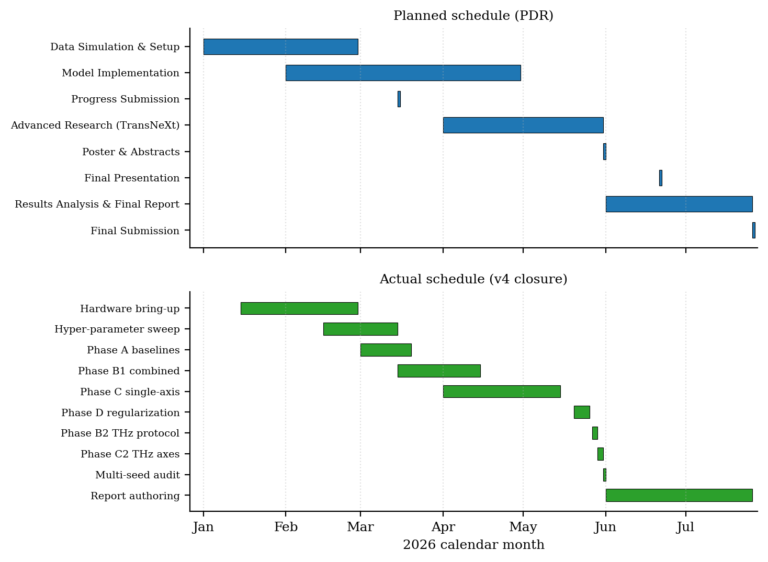
Planned (top) versus actual (bottom) project schedule. The actual schedule added three late-stage expansion phases (Phase D regularization sweep, Phase B2 / B2-nr / C2 THz-protocol decomposition, and the multi-seed audit) on top of the original plan.

8.3 Success and failure analysis vs goals
Of the four original goals from the preliminary specification:
Goal 1 (high accuracy on degraded data, target 80%). Partially met. The eighty-percent threshold is achieved on MNIST at every level up to L3 and on CIFAR-10 at L1 and L2. At L3 on CIFAR-10 the best cell ($∼74$ percentage points) falls $∼6$ percentage points short of that target, and at L4 / L5 the accuracy collapses on every backbone (the L5 ceiling on CIFAR-10 is $∼40$ percentage points). The shortfall is consistent with the per-axis attribution: resolution alone costs $−27$ percentage points at L3 to L5, which exceeds the remaining headroom.
Goal 2 (minimize the accuracy drop, target $≤15$ percentage points). Partially met. The drop is bounded by 15 percentage points up to L2 on CIFAR-10 and up to L3 on MNIST. Beyond those operating points the drop grows monotonically with the degradation level, reaching $∼50$ percentage points at L5 on CIFAR-10.
Goal 3 (identify the optimal architecture). Partially met. A statistically clear $≥5$ percentage points win for a single architecture was not observed. DenseNet121 leads on most CIFAR-10 L3 cells by 1 to 4 percentage points; TransNeXt-tiny leads on most MNIST cells by 1 to 3 percentage points; the inter-architecture spread is comparable to the multi-seed $σ$ in several cells. The honest reading of the data is that the three architectures are within run-to-run noise of each other at the operating points that matter, and that the choice of architecture is secondary to the choice of degradation pipeline.
Goal 4 (feasibility for edge implementation). Met for the CNN backbones, marginal for TransNeXt-tiny. Both ResNet50 and DenseNet121 sit comfortably under the 50 ms per image budget at bf16-mixed precision. TransNeXt-tiny is $∼30$ ms per image with torch.compile disabled; enabling the graph compiler (currently blocked by the foveal-attention path) would likely halve the figure.

8.4 Strengths of the chosen approach
- Fair-comparison invariant.All three backbones see the same tensor shape ($224×224$) and the same training recipe (modulo the per-paper LR convention), so the cross-backbone deltas are interpretable.
- Deterministic degradation.The byte-identity gate across seeds $\{42,43,44\}$ means that the cross-phase deltas are not contaminated by data-side stochasticity.
- Per-pipeline image-quality anchor.PSNR / SSIM per pipeline grounds the comparison in a physical scale; the Spearman rank correlations against accuracy (Figures 8, 9) are strong.
- Multi-seed audit.The $σ<1.5$ percentage points bound on every L3 headline cell makes the cross-phase deltas interpretable.

8.5 Weaknesses of the chosen approach
- Synthetic degradation is not real THz.The five-axis pipeline is a mathematical model. Real THz physics includes wavelength-dependent diffraction, mixing-element nonlinearity, and detector-array dead pixels that the model does not capture. The conclusions transfer only to the extent that those secondary effects are dominated by the modeled axes.
- Two small datasets.CIFAR-10 and MNIST are small-scale benchmarks. The generalization of the per-axis attribution to ImageNet-scale or to THz-domain object categories was not tested.
- No real super-resolution baseline.The project evaluated training-time degradation exposure exclusively. A super-resolution baseline (a hypothetical Phase E) was scoped out at PDR for cost reasons. Without it the attribution-driven recommendation (invest in resolution restoration first) cannot be quantitatively compared against a real restoration pipeline.
- No human-perception baseline.The acceptance criteria are model-side; a human upper bound (the percentage of L5 images a human reader can classify correctly) would contextualize the $∼40\%$ CIFAR-10 L5 ceiling.

8.6 Recommendations for continuation
- Acquire real THz data.The synthetic pipeline is a proxy; a small real-world dataset (even 1000 images) at the target deployment frequency would let the next iteration calibrate the synthetic model against ground truth and renormalize the per-axis attribution.
- Add a super-resolution pre-stage.Given that resolution dominates the per-axis attribution by $∼4×$ (Phase C2), the next ablation should add a learned upsampler in front of each backbone and re-run Phase B2 / C2 with the new front end.
- Enable graph compilation for TransNeXt.The foveal-attention path is currently not Inductor-graph-capturable; rewriting it as a compiled custom op would likely halve the inference latency and bring the TransNeXt backbone inside the 25 ms per image budget.
- Robustness benchmark reproduction.Reproduce the per-axis attribution on the ImageNet-A robustness benchmark (Hendrycks et al. 2021) to test whether the resolution-dominant finding holds at full ImageNet scale.
- Calibration intervention.The ECE growth from $<5$ percentage points at L3 to $>15$ percentage points at L5 indicates that a post-hoc calibration step (temperature scaling) would improve the operational usefulness of the predictions without affecting top-1 accuracy.

8.7 Cost summary
The actual operating cost of the campaign was dominated by GPU-hours rather than by hardware or licensing. Table 16 reports the final budget. Operator-side hours are theoretical (NIS-equivalent of the student-engineer market rate); they do not appear in the cash budget for this project.
Final cost summary (NIS-equivalent, supervisor signature required for submission).
Item | Cost (NIS)
Student engineer hours (2 students $×$ 300 h $×$ 60 NIS/h, theoretical) | 36 000
Supervisor hours (2 $×$ 30 h $×$ 250 NIS/h, theoretical) | 15 000
GPU compute (local RTX 5070, $∼$ 56.5 + $∼$ 48 + $∼$ 24 GPU-hours) | 0 (local)
Cloud GPU fallback budget (Colab Pro+, 8 months) | 400
Office supplies and storage media | 500
Subtotal | 51 900
Overhead (25%) | 12 975
Contingency (10%) | 5 190
Grand total | 70 065
Supervisor signature.Date.

9 Source listings
The single source of truth for the five-level degradation schedule is the following Python module (excerpt). The full file is at src/data/degradation_levels.py.
DEGRADATION_LEVELS = {
1: {"low_res": 18, "blur_kernel": 13, "blur_sigma": 2.50,
"noise_std": 0.04, "salt_pepper": 0.03, "saturation": 0.95},
2: {"low_res": 12, "blur_kernel": 25, "blur_sigma": 5.00,
"noise_std": 0.08, "salt_pepper": 0.06, "saturation": 0.65},
3: {"low_res": 8, "blur_kernel": 41, "blur_sigma": 8.00,
"noise_std": 0.12, "salt_pepper": 0.10, "saturation": 0.40},
4: {"low_res": 6, "blur_kernel": 61, "blur_sigma": 12.00,
"noise_std": 0.16, "salt_pepper": 0.14, "saturation": 0.15},
5: {"low_res": 3, "blur_kernel": 91, "blur_sigma": 18.00,
"noise_std": 0.22, "salt_pepper": 0.18, "saturation": 0.00},
}
The full pipeline source code is in src/data/degrade.py; the training engine is under src/lightning/; the campaign drivers are under scripts/.

10 Honoring intellectual property rights
Per BGU regulation Appendix 12.2, the project team affirms that this work does not incorporate copyrighted material (text, images, audio, video, software, hardware, or circuit designs) without explicit prior authorization from the copyright holder. Every figure, table, and equation in this report is either original work produced by the project team from the campaign data, or is reproduced from a cited source with the source listed in the references.
Signed.Bahat ItamarDate.
Signed.Dotan Ann HannaDate.
Falcon, William et al. 2019. PyTorch Lightning. GitHub repository: Lightning-AI/lightning.
Guo, Chuan, Geoff Pleiss, Yu Sun, and Kilian Q. Weinberger. 2017. “On Calibration of Modern Neural Networks.” Proc. Int. Conf. On Machine Learning (ICML).
He, Kaiming, Xiangyu Zhang, Shaoqing Ren, and Jian Sun. 2016. “Deep Residual Learning for Image Recognition.” Proc. IEEE Conf. On Computer Vision and Pattern Recognition (CVPR), 770-78.
Hendrycks, Dan, Kevin Zhao, Steven Basart, Jacob Steinhardt, and Dawn Song. 2021. “Natural Adversarial Examples.” Proc. IEEE Conf. On Computer Vision and Pattern Recognition (CVPR).
Huang, Gao, Zhuang Liu, Laurens van der Maaten, and Kilian Q. Weinberger. 2017. “Densely Connected Convolutional Networks.” Proc. IEEE Conf. On Computer Vision and Pattern Recognition (CVPR), 2261-69.
Huang, Gao, Yu Sun, Zhuang Liu, Daniel Sedra, and Kilian Q. Weinberger. 2016. “Deep Networks with Stochastic Depth.” Proc. European Conf. On Computer Vision (ECCV).
Huynh-Thu, Quan, and Mohammed Ghanbari. 2008. “Scope of Validity of PSNR in Image/Video Quality Assessment.” Electronics Letters 44 (13): 800-801.
Krizhevsky, Alex. 2009. Learning Multiple Layers of Features from Tiny Images. University of Toronto.
LeCun, Yann, Léon Bottou, Yoshua Bengio, and Patrick Haffner. 1998. “Gradient-Based Learning Applied to Document Recognition.” Proceedings of the IEEE 86 (11): 2278-324.
Loshchilov, Ilya, and Frank Hutter. 2017. “SGDR: Stochastic Gradient Descent with Warm Restarts.” International Conference on Learning Representations (ICLR).
Loshchilov, Ilya, and Frank Hutter. 2019a. “Decoupled Weight Decay Regularization.” International Conference on Learning Representations (ICLR).
Loshchilov, Ilya, and Frank Hutter. 2019b. “Decoupled Weight Decay Regularization.” Proc. Int. Conf. On Learning Representations (ICLR).
Naeini, Mahdi Pakdaman, Gregory F. Cooper, and Milos Hauskrecht. 2015. “Obtaining Well Calibrated Probabilities Using Bayesian Binning.” Proc. AAAI Conf. On Artificial Intelligence.
Paszke, Adam et al. 2019. PyTorch: An Imperative Style, High-Performance Deep Learning Library. Advances in Neural Information Processing Systems 32.
Shi, Dai. 2024. TransNeXt: Robust Foveal Visual Perception for Vision Transformers. arXiv:2311.17132.
Wang, Zhou, Alan C. Bovik, Hamid R. Sheikh, and Eero P. Simoncelli. 2004. “Image Quality Assessment: From Error Visibility to Structural Similarity.” IEEE Trans. On Image Processing 13 (4): 600-612.
Yun, Sangdoo, Dongyoon Han, Seong Joon Oh, Sanghyuk Chun, Junsuk Choe, and Youngjoon Yoo. 2019. “CutMix: Regularization Strategy to Train Strong Classifiers with Localizable Features.” Proc. IEEE/CVF Int. Conf. On Computer Vision (ICCV).
Zhang, Hongyi, Moustapha Cisse, Yann N. Dauphin, and David Lopez-Paz. 2018. “Mixup: Beyond Empirical Risk Minimization.” Proc. Int. Conf. On Learning Representations (ICLR).

