Ben-Gurion University of the Negev
Faculty of Engineering Sciences
Department of Electrical and Computer Engineering
אוניברסיטת בן-גוריון בנגב
הפקולטה למדעי ההנדסה
המחלקה להנדסת חשמל ומחשבים
Classification of Objects at a Very Low Resolution
Robustness of Deep Visual Models under THz-like Degradation
סיווג עצמים ברזולוציה נמוכה מאוד
Final Engineering Project - Summary Report
Project No. s-2026-045 / p-2026-061
Submitted by: | Itamar Bahat (ID 205805856)
 | Ann Hanna Dotan (ID 211542311)
Supervisors: | Prof. Yitzhak Yitzhaky
 | Dr. Rinat Lerner
Submission date: | 26 July 2026
מגישים: | איתמר בהט, אן חנה דותן
מנחים: | פרופ’ יצחק יצחקי, ד"ר רינת לרנר
תאריך הגשה: | 26 ביולי 2026
[Official BGU title page placeholder - to be replaced at submission by the signed institutional cover sheet in the bilingual format of Appendix 12.1 of the Engineering Project Guidelines.]

Abstract
Background. Terahertz (THz) cameras can see through clothing, paper, and plastic, which makes them attractive for security screening and medical imaging. The physics of the band, however, exacts a price: the images come out at very low resolution, noisy, and without color. Deep-learning classifiers are pretrained on sharp, colorful photographs, and it has not been documented quantitatively how much accuracy they lose under THz-like conditions, which kind of image degradation causes most of the damage, or whether smarter training can win the loss back.
Aim. Measure the robustness of three representative deep architectures - a residual CNN (ResNet50), a densely connected CNN (DenseNet121), and a vision transformer (TransNeXt-tiny) - under controlled synthetic THz-like degradation; attribute the accuracy loss to the individual degradation types; and quantify how much of it training-time regularization recovers.
Methods. A 402-run training campaign covers the three models on CIFAR-10 and MNIST across five severity levels (L1 mild to L5 extreme) and seven experimental phases: clean baselines, all degradations combined (Phase B1), one degradation at a time, a regularization-recovery sweep, and a simplified THz protocol (grayscale, no additive noise) with its own single-axis sweep (Phase C2). This report analyses Phases B1 and C2 in full and summarizes the remaining phases briefly. Every degradation pipeline is anchored to measured PSNR and SSIM values, so degradation types are compared on the image quality they actually produce rather than on the preset severity index; a 48-run multi-seed audit bounds the run-to-run noise.
Findings. Four results carry the campaign. (1) The transformer is the most robust model in the mild-to-moderate range: on CIFAR-10 it leads the two CNNs by roughly 10 percentage points at levels L1-L2. (2) At extreme degradation the architecture stops mattering - all three models converge into a 19-21% accuracy band on CIFAR-10. (3) Resolution loss is by far the most damaging degradation type: at matched image quality it costs about four times more accuracy than blur or salt-and-pepper noise. (4) Regularization recovers less than one percentage point of the roughly 12.5-point combined-degradation collapse, so the loss reflects information that was destroyed, not a model that over-fitted.
Conclusions. For THz-like systems operating at mild-to-moderate degradation, the vision transformer is the recommended backbone. At extreme degradation no classifier choice helps, because the discriminative detail is no longer in the image; the practical leverage there is restoring spatial resolution ahead of the classifier, before any denoising or deblurring.
Keywords. object classification, deep learning, low resolution, THz imaging, robustness, PSNR, SSIM, calibration, transformer, residual network, dense network.

תקציר
רקע. מצלמות בתחום הטרה-הרץ (THz) מסוגלות "לראות" מבעד לבדים, נייר ופלסטיק, ולכן הן מושכות ליישומי סינון ביטחוני ודימות רפואי. אלא שהפיזיקה של התחום גובה מחיר: התמונות המתקבלות הן ברזולוציה נמוכה מאוד, רועשות ונטולות צבע. מסווגים מבוססי למידה עמוקה מאומנים מראש על צילומים חדים וצבעוניים, ועד כה לא תועד באופן כמותי כמה דיוק הם מאבדים בתנאים דמויי-THz, איזה סוג של פגיעה בתמונה גורם לעיקר הנזק, והאם אימון חכם יותר יכול להשיב את האובדן.
מטרה. למדוד את עמידותן של שלוש ארכיטקטורות עומק מייצגות - רשת קונבולוציה שארית (ResNet50), רשת קונבולוציה צפופה (DenseNet121) וטרנספורמר ראייה (TransNeXt-tiny) - תחת השפלת תמונה סינתטית ומבוקרת הדומה לצילום THz; לפרק את אובדן הדיוק לפי סוגי ההשפלה השונים; ולכמת כמה ממנו ניתן להשיב באמצעות רגולריזציה בזמן האימון.
שיטות. מערך של 402 ריצות אימון מקיף את שלושת המודלים על CIFAR-10 ועל MNIST, לאורך חמש רמות חומרה (L1 מתונה עד L5 קיצונית) ושבעה שלבי ניסוי: קווי בסיס נקיים, כל ההשפלות יחד (שלב B1), השפלה אחת בכל פעם, שכבת שחזור באמצעות רגולריזציה, ופרוטוקול THz מפושט (גווני אפור, ללא רעש גאוסי) הכולל סריקת ציר-יחיד משלו (שלב C2). דוח זה מנתח לעומק את שלבים B1 ו-C2 ומסכם את יתר השלבים בקצרה. כל צינור השפלה מעוגן למדידות PSNR ו-SSIM, כך שסוגי ההשפלה מושווים לפי איכות התמונה שנמדדה בפועל ולא לפי אינדקס רמה שנקבע מראש; ביקורת רב-זרעים בת 48 ריצות תוחמת את רעש הריצה-לריצה.
ממצאים. ארבע תוצאות נושאות את המערכה. (1) הטרנספורמר הוא המודל העמיד ביותר בטווח המתון-בינוני: על CIFAR-10 הוא מוביל על שתי רשתות הקונבולוציה בכ-10 נקודות אחוז ברמות L1 עד L2. (2) בהשפלה קיצונית הארכיטקטורה מפסיקה לשחק תפקיד - שלושת המודלים מתכנסים לרצועת דיוק של 19 עד 21 אחוזים. (3) אובדן רזולוציה הוא סוג הפגיעה המזיק ביותר: באיכות תמונה שווה הוא עולה בערך פי ארבעה יותר דיוק מאשר טשטוש או רעש מלח-ופלפל. (4) רגולריזציה משיבה פחות מנקודת אחוז אחת מתוך קריסה משולבת של כ-12.5 נקודות אחוז - כלומר האובדן משקף מידע שנהרס, ולא מודל שביצע התאמת-יתר.
מסקנות. למערכות דמויות-THz הפועלות בהשפלה מתונה עד בינונית, טרנספורמר הראייה הוא עמוד השדרה המומלץ. בהשפלה קיצונית שום בחירת מסווג אינה עוזרת, משום שהפרטים המבחינים כבר אינם קיימים בתמונה; המנוף המעשי שם הוא שחזור הרזולוציה המרחבית לפני המסווג - עוד לפני הסרת רעש או הסרת טשטוש.
מילות מפתח. סיווג עצמים, למידה עמוקה, רזולוציה נמוכה, הדמיית THz, עמידות, PSNR, SSIM, כיול, טרנספורמר, רשת שארית, רשת צפופה.
Table of Contents
Right-click and choose Update Field (or press Ctrl+A then F9) to populate this list.
List of Figures
Right-click and choose Update Field (or press Ctrl+A then F9) to populate this list.
List of Tables
Right-click and choose Update Field (or press Ctrl+A then F9) to populate this list.

1 Introduction

1.1 Motivation
Terahertz (THz) imaging is increasingly used in security screening, biomedical diagnostics, and through-fabric inspection, because radiation in this band passes through clothing, paper, plastics, and other materials that block visible light. The same physics that makes THz attractive also limits it: diffraction caps the spatial resolution near the wavelength of the source, the detector integrates each measurement over a comparatively large area, and thermal background dominates the noise floor. The practical result is easy to state: a THz frame is simultaneously very low resolution, noisy, and colorless.
Standard deep-vision classifiers are built for the opposite kind of picture. Almost all of them inherit ImageNet pretraining and rely on fine textures, sharp edges, and saturated color. When those cues are removed, accuracy collapses - and, importantly, the collapse is opaque. Before this project it was not obvious how much of the loss comes from the low resolution alone, how much from noise or from the missing color, and whether anything on the training side (regularization, augmentation, or simply choosing a different architecture) can win part of the loss back. Answering those questions in a controlled, reproducible way is the purpose of this work.

1.2 Problem statement
This project quantifies the accuracy degradation of three representative deep architectures under controlled synthetic THz-like degradation, decomposes the loss into per-axis contributions, audits the reproducibility of the measurements across random seeds, and documents which training-side interventions recover lost accuracy. The three architectures span the families that anchor the image-classification literature: a residual convolutional network (ResNet50 [1]), a densely connected convolutional network with explicit feature reuse (DenseNet121 [2]), and a vision transformer with foveal attention (TransNeXt-tiny [3]).
The success criteria carried over from the preliminary report are: at least 80 percent top-1 accuracy at the moderate-degradation operating point, an identifiable architectural winner that beats the baseline by a statistically meaningful margin, and inference latency compatible with sensor-side deployment. These targets are revisited in Section 7 against the actual measurements - including the one target the measurements show to be physically out of reach, which is itself an informative result.

1.3 Alternative approaches considered
Three alternative families were reviewed during the preliminary design and rejected in favor of training directly on degraded images.
(i) Denoise, then classify. Restore the image first, then hand it to a clean-image classifier. The appeal is modularity: the pretrained classifier is reused as-is. The problem is that restoration models need matched clean/degraded training pairs, which a real THz sensor never produces, and restoration networks trained on mismatched degradations tend to hallucinate detail [4], [5] - the output looks better and scores a higher PSNR without actually helping classification.
(ii) Super-resolve, then classify. A special case of (i) that fixes only the resolution. As Section 5 will show, resolution is indeed the dominant axis, so this is the most promising restoration target; but blur and noise still cost several percentage points each at the moderate operating point, so a resolution-only fix cannot recover the full loss on its own.
(iii) Train-time degradation exposure (adopted). Train the classifier directly on synthetically degraded images, so the representation adapts to the degraded distribution. This is the approach used by modern robustness benchmarks [6]. It needs no separate restoration network, keeps inference to a single forward pass, and - most important for this study - it exposes the architectural differences directly, because every backbone sees exactly the same degraded distribution.

1.4 Contributions
This work contributes:
- a 402-cell training campaign across three architectures, two datasets, five degradation levels, and seven experimental phases, all trained to convergence under a single fair-comparison invariant ($224×224$ uniform input, frozen Optuna hyperparameters, identical data pipeline);
- a 48-replicate multi-seed audit of the 24 headline cells that bounds run-to-run variance below 1.2 percentage points;
- a deterministic 256-image PSNR / SSIM probe per pipeline, so that accuracy can be compared against measured image quality rather than only against the preset severity index;
- a per-axis attribution showing that resolution is the dominant cost - roughly $4×$ blur or salt-and-pepper at matched severity;
- a regularization-recovery sweep (Phase D) and a protocol simplification sweep (Phase B2 / B2-nr) that together separate the part of the collapse caused by destroyed information from the part training can recover.

1.5 Roadmap
Section 2 defines the seven experimental phases, which every later section refers back to. Sections 3 and 4 give the as-built specification (with its drifts from the preliminary one) and the engineering design. Section 5 reports the results - Phases B1 and C2 in full, the rest in brief, closing with the per-model synthesis. Sections 6 and 7 cover the problems encountered and the conclusions, goal evaluation, and plan-versus-execution comparison; Section 8 lists the references.

2 Experimental phases at a glance
The campaign breaks the THz robustness question into seven phases. Each phase answers one question, and every later section refers back to this overview for the pipeline definitions instead of re-explaining them. Table 1 is the single point of reference.
Phase A (Clean baseline).Pipeline: identity (upsample only). Six cells (three models $×$ two datasets). Establishes the upper-bound accuracy that every later phase is measured against.
Phase B1 (Combined degradation).Pipeline: saturation lerp $→$ downsample $→$ noise and salt-and-pepper at the low resolution $→$ upsample to $224×224$ $→$ blur, with all five axes active at the same level. Thirty cells (three models $×$ two datasets $×$ five levels). Question: how bad is the realistic worst case, where everything degrades at once?
Phase C (Single-axis isolation).Pipeline: exactly one axis active at level $L$, the other four held at identity. One hundred fifty cells (three models $×$ two datasets $×$ five levels $×$ five axes). Question: which individual degradation drives the Phase B1 collapse?
Phase D (Regularization-recovery sweep).Pipeline: identical to Phase B1, plus one of three training-time regularization treatments T1 / T2 / T3 (architectural dropout, label mixing, and their combination). Ninety cells. Question: is the Phase B1 collapse over-fitting - which regularization should fix - or lost information, which it cannot fix?
Phase B2 (THz-protocol simplification).Pipeline: Phase B1 with the image held at full grayscale (saturation fixed at 0) and the additive Gaussian noise turned off; T3 regularization active. Thirty cells. This is the deployment-realistic protocol: a real THz frame is a single-channel image, so the color axis is not a variable, and the dominant sensor noise is impulsive rather than Gaussian. Question: how much easier is the realistic protocol than the worst-case one?
Phase B2-nr (No-regularization arm).Same pipeline as Phase B2, at L3 only, with T3 off. Six cells. Question: of the Phase B1$→$B2 improvement, how much comes from the simpler protocol itself and how much from the regularization?
Phase C2 (Single-axis isolation under the THz protocol).Same identity-elsewhere logic as Phase C, restricted to the three THz-relevant axes (resolution, blur, salt-and-pepper), with grayscale and zero Gaussian noise forced throughout. Ninety cells. Question: under realistic conditions, which degradation axis should a THz system engineer fight first? The Section 5 plots answer this on the measured PSNR / SSIM scales, never on the preset L1-L5 index.
Table 1: Experimental phases at a glance. The campaign comprises 402 canonical training cells at seed 42 plus 48 multi-seed audit replicates at seeds 43 and 44. Each phase isolates a different facet of the accuracy collapse under the five-level THz-like degradation curve.
Phase | Cells | Axes active at L | Levels swept | Reg. | Primary research question
A | 6 | none (identity) | none | none | Upper-bound clean accuracy per (model, dataset).
B1 | 30 | all 5 axes | L1-L5 | none | Magnitude of the realistic combined-degradation collapse.
C | 150 | one axis (4 idle) | L1-L5 | none | Per-axis decomposition of the Phase B1 collapse.
D | 90 | all 5 axes | L1-L5 | T1 / T2 / T3 | Is the Phase B1 collapse overfit or information bottleneck?
B2 | 30 | 3 axes (sat $=0$, noise $=0$) | L1-L5 | T3 | Effect of the realistic THz protocol on the combined curve.
B2-nr | 6 | same as B2 | L3 only | none | Decomposition of B1$→$B2 into protocol versus regularization.
C2 | 90 | one of {res, blur, S&P} | L1-L5 | T3 | Per-axis attribution under the THz protocol.
Multi-seed audit | 48 | all 24 L3 headline cells | L3 only | inherits cell | Run-to-run variance bound on every headline cell.

3 Final Technical Specification
This section reports the as-built specification of the delivered software product, and documents every drift from the preliminary specification.

3.1 Product overview
The delivered product is a research-grade Python package that:
- synthetically degrades a clean image dataset using a deterministic five-axis pipeline (saturation, downsample, blur, additive noise, salt and pepper);
- fine-tunes one of three pretrained deep backbones (ResNet50, DenseNet121, TransNeXt-tiny) on the degraded distribution under a unified training recipe;
- evaluates the trained model on a held-out validation split and records validation accuracy, calibration, inference throughput, and per-pipeline PSNR / SSIM metrics;
- aggregates results across the 402-cell campaign and the 48-replicate multi-seed audit into a single canonical JSON artifact and a 7-tab interactive dashboard.

3.2 Inputs, outputs, interfaces
Inputs.Standard image datasets (CIFAR-10 [7] and MNIST [8]), automatically downloaded by torchvision on first invocation. A YAML / dictionary configuration object selects the backbone, the degradation phase, the level, the axis (for single-axis phases), the treatment (for Phase D), and the random seed.
Outputs.Per-cell training logs, validation metrics, best checkpoint, image-quality probe JSON. The canonical aggregator (Final_Exp.json, schema version 3) joins the 402 canonical cells with the 48 multi-seed replicates and exposes $⟨val_acc⟩±σ$ pairs.
Hardware interface.The training stack runs on a single NVIDIA RTX 5070 (sm_120, Blackwell architecture) at bf16-mixed precision. A CPU-only fallback (32-true precision) is available for portability but is too slow to be useful at the campaign scale. There is no specialized hardware development; the system targets commodity GPU servers.

3.3 Final specification of the system
Models.Three backbones are supported. Table 2 summarizes the training recipe; the differential learning-rate convention (head $×10$ over backbone) is taken from the source papers.
Table 2: Training hyperparameters (final).
Parameter | CNNs (ResNet50, DenseNet121) | TransNeXt-tiny
Input resolution | $224×224$ | $224×224$
Optimizer | AdamW [9] | AdamW
Schedule | Cosine annealing | Cosine annealing
Head learning rate | ${10}^{−3}$ | $5×{10}^{−4}$
Backbone learning rate | ${10}^{−4}$ | $5×{10}^{−5}$
Weight decay | ${10}^{−4}$ | $5×{10}^{−2}$
Label smoothing | 0.1 | 0.1
Stochastic depth | 0.0 | 0.1
Gradient clip | $∥∇∥_{2}≤1.0$ | $∥∇∥_{2}≤1.0$
Batch size | 32 | 32
Max epochs | 60 | 60
Early stopping | patience 10 | patience 10
Precision | bf16-mixed | bf16-mixed
Seed | 42 (canonical) | 42 (canonical)
Degradation pipeline.The five-level schedule (Table 3) is the single source of truth for L1 through L5; it is imported from src/data/degradation_levels.py into both the training and the evaluation paths.
Table 3: Five-level synthetic degradation schedule. Blur kernel and $σ$ are pixel-domain values at the $224×224$ model input.
Level | Name | low_res | Blur K | Blur $σ$ | Noise std | S&P | Saturation
L1 | Mild | 18 | 13 | 2.50 | 0.04 | 0.03 | 0.95
L2 | Light | 12 | 25 | 5.00 | 0.08 | 0.06 | 0.65
L3 | Moderate | 8 | 41 | 8.00 | 0.12 | 0.10 | 0.40
L4 | Severe | 6 | 61 | 12.00 | 0.16 | 0.14 | 0.15
L5 | Extreme | 3 | 91 | 18.00 | 0.22 | 0.18 | 0.00
Data pipeline.Pipeline version 2 (finalized 2026-05-20): the saturation lerp is applied first, then the bilinear downsample to low_res, then additive Gaussian noise and salt and pepper at the low resolution, then bicubic upsample to $224×224$, then Gaussian blur (kernel calibrated for $224×224$), then a final clip to $[0,1]$ and ImageNet normalization.
Determinism.The per-sample degradation seed is $\text{idx}+{10}^{7}$ on the validation split and idx on the training split. The byte-identity gate in src/tests/test_degradation_determinism.py asserts that two independent reads of the same validation index yield bit-identical pixels across freshly built datasets; this is also verified across seeds 42, 43, and 44 by the multi-seed audit test.

3.4 Drift from the preliminary specification
The Preliminary Design Review (PDR, Pre-2026-061.pdf) defined the project scope. Five drifts occurred during implementation:
- TransNeXt variant: small to tiny. The preliminary spec proposed transnext_small ($∼50$M parameters); the 2026-05-14 revision substituted transnext_tiny ($∼28$M parameters) to keep the parameter count comparable to ResNet50 ($∼25$M) and to recover $∼310$ GPU-hours across the TransNeXt rows. The change preserves the foveal-attention mechanism, which was the architectural property of interest, and it matches the published TransNeXt $224×224$ checkpoint exactly.
- Uniform $224×224$ protocol. A short-lived V3 refactor (2026-05-08 through 2026-05-13) attempted native-resolution training ($32×32$ for TransNeXt on CIFAR-10, $28→32$ for MNIST). The refactor violated the fair-comparison invariant (different backbones saw different tensor shapes), so it was rolled back. Every cell now trains at $224×224$.
- Blur kernel rescaling. The 2026-05-12 degradation curve used blur kernels designed for native $32×32$ imagery (K $=3…13$, $σ=0.8…2.3$). At $224×224$ those kernels covered $∼1$ to $6\%$ of the image width and produced essentially invisible blur. They were rescaled on 2026-05-14 to pixel-domain values at $224×224$ (K $=13…91$, $σ=2.5…18$), with the kernel-to-$σ$ rule $K=2⌈2.5σ⌉+1$ so the kernel always captures the $2.5σ$ Gaussian footprint.
- Optuna freeze. The preliminary plan reserved a per-(phase, cell) hyperparameter sweep. The final spec freezes the Optuna L3 winner per (model, dataset) and reuses it across every level and every axis. The change saves $∼200$ GPU-hours and removes a per-phase confound from the cross-phase comparison.
- Multi-seed audit. The preliminary spec used a single seed (42). The 2026-06-01 revision added a 48-replicate audit at seeds 43 and 44 across the 24 L3 headline cells so that the published L3 accuracies carry an explicit $σ$ bound rather than a single point estimate.

3.5 Phases of the experimental program
The 402-cell campaign is partitioned into seven phases. Table 4 summarizes each phase.
Table 4: Experimental phases of the 402-cell campaign. Multi-seed audit replicates are layered on top of the 24 L3 headline cells.
Phase | Purpose | Cells | Tag prefix
A | Clean baseline (no degradation) | 6 | final_clean_
B | Combined degradation, all axes at level L | 30 | final_B_L*
C | Single-axis isolation, others at identity | 150 | final_C_L*_<axis>_
D | Regularization recovery (T1 / T2 / T3) on Phase B | 90 | final_D_T*_L*_
B2 | THz protocol simplification (sat $=0$, noise $=0$, T3) | 30 | final_B2_L*_
B2nr | B2 without regularization, L3 only | 6 | final_B2nr_L3_
C2 | Single-axis under THz protocol | 90 | final_C2_L*_<axis>_
Audit | Multi-seed audit (seeds $\{43,44\}$) on the 24 L3 headline cells | 48 | *_seed{43,44}
Total |  | 450

4 Engineering Design
This section documents the chosen approach in detail. The system block diagram is shown in Figure 1; the degradation pipeline that drives the experimental program is shown in Figure 2.
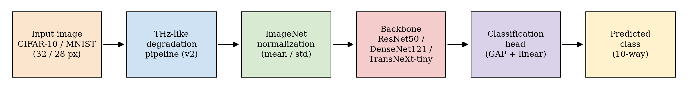
Figure 1: System block diagram. An input image from CIFAR-10 or MNIST passes through the THz-like degradation pipeline, is normalized to the ImageNet distribution, is fed to one of the three backbones, and is classified by a global-average-pooling head.
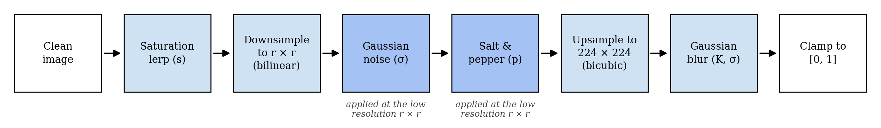
Figure 2: Pipeline version 2. The saturation lerp runs first, so grayscale luminance is computed from the un-degraded source; noise and salt-and-pepper act at the pre-upsample resolution, so the bicubic upsample spreads each sample into sensor-grain structure.

4.1 Mathematical model
Degradation operator. Let $x∈[0,1]^{3×H×W}$ be a clean image and let $ϕ=(s,r,σ_{n},K_{b},σ_{b},p)$ denote the degradation parameters: saturation $s∈[0,1]$, low-resolution target $r∈N$, noise standard deviation $σ_{n}≥0$, blur kernel size $K_{b}$, blur sigma $σ_{b}$, and salt-and-pepper amount $p∈[0,1]$. Define the composite operator
$$D_{ϕ}(x)={Clip}_{[0,1]}∘{Blur}_{K_{b},σ_{b}}∘{Up}_{224}∘{SP}_{p}∘N_{σ_{n}}∘{Down}_{r}∘{Sat}_{s},$$
where ${Sat}_{s}(x)=(1−s) Gray(x)+s x$ with $Gray(x)=0.2989 x_{R}+0.5870 x_{G}+0.1140 x_{B}$ (BT.601 luma); ${Down}_{r}$ is bilinear downsample to $r×r$; $N_{σ_{n}}$ adds independent Gaussian noise of standard deviation $σ_{n}$; ${SP}_{p}$ flips a $p/2$ fraction of pixels to 1 and another $p/2$ fraction to 0; ${Up}_{224}$ is bicubic upsample to $224×224$; and ${Blur}_{K_{b},σ_{b}}$ is a separable Gaussian blur with kernel size $K_{b}$ and standard deviation $σ_{b}$.
Classifier. A backbone $f_{θ}(⋅)$ produces a logit vector $z=f_{θ}(D_{ϕ}(x))$. With label smoothing $α=0.1$, the training objective is the smoothed cross-entropy
$$L(θ)=−\sum_{c=1}^{C}{{\tilde{y}}_{c}}logsoftmax(z)_{c}, {\tilde{y}}_{c}=(1−α) 1[c=y]+\frac{α}{C}.$$
Backbones.The three architectures expose different inductive biases for the low-resolution regime. ResNet50 [1] combines features via additive identity skips, which reuse previous-layer features but collapse them into the running representation; subtle low-level cues can be washed out when the later residual blocks dominate. DenseNet121 [2] concatenates the feature maps of every preceding layer within each dense block, explicitly preserving the collective knowledge of all earlier layers - the property our preliminary hypothesis expected to help under information loss. TransNeXt-tiny [3] uses pixel-focused attention with parallel foveal and peripheral streams: a window-shaped mask down-weights all but the nearest neighbours of each query, while a global pooling stream contributes a coarse-grained peripheral signal. The biomimetic prior is designed to retain accuracy when the global shape is corrupted but local texture is partially preserved. The architectural equations are standard and are stated in full in the cited primary papers; we omit them here.

4.2 Image-quality metrics
Each degradation pipeline is anchored to a $PSNR$ and $SSIM$ probe so that cross-phase comparisons sit on a physical scale.
PSNR [4] between a reference image $x$ and a degraded image $\tilde{x}=D_{ϕ}(x)$, both in $[0,1]^{3×224×224}$, is
PSNR(x,x)=10log101MSE(x,x), MSE(x,x)=13⋅2242c,i,j​(xc,i,j−xc,i,j)2.
SSIM [5] is the structural similarity index. For two local patches $u,v$ with means $μ_{u},μ_{v}$, variances $σ_{u}^{2},σ_{v}^{2}$, and covariance $σ_{uv}$,
$$SSIM(u,v)=\frac{(2μ_{u}μ_{v}+C_{1})(2σ_{uv}+C_{2})}{(μ_{u}^{2}+μ_{v}^{2}+C_{1})(σ_{u}^{2}+σ_{v}^{2}+C_{2})},$$
with $C_{1},C_{2}$ small stabilizers; the full-image score is the spatial mean over an $11×11$ Gaussian window. The implementation uses torchmetrics.image.StructuralSimilarityIndexMeasure with data_range = 1.
Reference construction.The PSNR / SSIM reference is the input image upsampled to $224×224$ by bilinear interpolation. The choice matches what a hypothetical clean-image classifier would see if the degradation pipeline were short-circuited; it does not include the saturation lerp, so the measurements isolate the spatial loss from the color loss. Both choices are documented in the figure captions in Section 5 so the reader can interpret the absolute scale correctly.
Probe protocol.For each pipeline the probe iterates over the first 256 validation indices, applies the pipeline with seed offset $2×{10}^{7}$ (chosen disjoint from the training and validation streams), and aggregates the mean and standard deviation. The 256-sample size balances probe runtime against the standard error of the mean (below $0.1$ dB on the L3 pipelines).

4.3 Optimizer and learning-rate schedule
All cells train with AdamW [9] under decoupled weight decay. With $g_{t}=∇_{θ}L(θ_{t−1})$ the loss gradient at step $t$, the running first and second moment estimates are
$$m_{t}=β_{1}m_{t−1}+(1−β_{1})g_{t}, v_{t}=β_{2}v_{t−1}+(1−β_{2})g_{t}^{2},$$
and the parameter update is
$$θ_{t}=θ_{t−1}−η_{t}​\left(\frac{m_{t}/(1−β_{1}^{t})}{\sqrt{v_{t}/(1−β_{2}^{t})}+ϵ}+λ θ_{t−1}\right),$$
with $β_{1}=0.9$, $β_{2}=0.999$, $ϵ={10}^{−8}$, and weight decay $λ∈\{{10}^{−4},5×{10}^{−2}\}$ (CNN / TransNeXt). Gradient clipping caps the global norm at $1.0$.
The learning rate $η_{t}$ follows a cosine annealing schedule [10] between $η_{max}$ and $η_{min}$ over a total budget of $T$ training steps:
$$η_{t}=η_{min}+1/2 (η_{max}−η_{min})​\left(1+cos​\left(\frac{t}{T} π\right)\right).$$
Differential learning rates apply $η_{max}$ separately to the classifier head (${10}^{−3}$ on CNNs, $5×{10}^{−4}$ on TransNeXt-tiny) and to the backbone parameters (${10}^{−4}$ on CNNs, $5×{10}^{−5}$ on TransNeXt-tiny). Training uses bf16-mixed precision on the RTX 5070 host and runs for at most 60 epochs with early stopping at patience 10 on validation accuracy.

4.4 Calibration metric
Expected calibration error (ECE) [11], [12] bins the predicted probabilities into $M=15$ equal-width bins and computes
$$ECE=\sum_{m=1}^{M}{\frac{|B_{m}|}{N}}\left|acc(B_{m})−conf(B_{m})\right|,$$
where $B_{m}$ is the set of predictions whose top-1 probability falls in bin $m$, $acc(B_{m})$ is the empirical accuracy of $B_{m}$, and $conf(B_{m})$ is the mean predicted probability in $B_{m}$. A well-calibrated model has $ECE→0$.

4.5 Regularization treatments (Phase D)
Phase D layers three regularization treatments on top of the frozen Phase B Optuna winners:
T1.Dropout (CNN, rate 0.2) or stochastic-depth drop-path [13] (TransNeXt, rate 0.2). Architectural regularization only; no label-side intervention.
T2.mixup [14] with $α=0.2$; label-mixing only.
T3.The combination: dropout (or drop-path) $+$ mixup $α=0.2$ $+$ CutMix [15] $α=1.0$. The kitchen-sink combination defines the upper bound of training-side recovery measurable inside the design space.

4.6 Software architecture
The implementation is layered:
- src/data/ hosts the single source of truth for the degradation curve (degradation_levels.py) and the operator (degrade.py). Both modules are imported verbatim into the training and the image-quality probe paths, which is the property that guarantees the measured PSNR / SSIM correspond to the pixels the model actually sees.
- src/lightning/ hosts the training engine (THzClassifier, THzDataModule) built on PyTorch Lightning [16].
- src/models/ hosts the backbone wrappers; the TransNeXt weights are auto-downloaded from the public checkpoint and cached under artifacts/weights/.
- scripts/ hosts the campaign drivers (run_all_phases.py) and the diagnostics builders.
- Final_Report/V6/scripts/ hosts the figure / table / sample generators and the DOCX builder that produce this report. Every artifact under Final_Report/figures/v6/ and Final_Report/V6/ is reproducible by running python Final_Report/V6/scripts/build_v6_*.py from a clean checkout.

5 Experimental Results
This section reports the measured performance. Every value comes from a frozen training run recorded under runs/final/ and aggregated by artifacts/Final_Exp.json (schema version 3); no values are synthesized or interpolated. The two phases that carry the headline science - Phase B1 (combined degradation) and Phase C2 (single-axis isolation under the THz protocol) - are reported in full, with tables, figures, and a model-by-model reading. The remaining phases are summarized in Section 5.3; their complete per-cell numbers live in the machine-readable artifacts referenced in the Appendix.

5.1 Test rig
The campaign ran on a single workstation with the configuration in Table 5. Determinism is guarded by pl.seed_everything(42, workers=True) for the canonical seed and by the per-sample seed offset for the validation split, so any cell can be reproduced bit-exactly.
Table 5: Test rig and software stack.
Component | Value
GPU | NVIDIA RTX 5070 (Blackwell, sm_120, 12 GB)
Precision | bf16-mixed
CPU dataloader workers | 0 (Windows)
Framework | PyTorch 2.11 [17] + Lightning 2.x [16]
Image quality | torchmetrics PSNR / SSIM, data_range = 1
Determinism gate | src/tests/test_degradation_determinism.py

5.2 What the degradations look like
Figure 3 grounds the numbers visually. Each grid shows the same six fixed validation images under the clean pipeline, the combined Phase B1 recipe at the moderate level, the grayscale Phase B2 protocol, and each of the three Phase C2 single-axis pipelines. Two things are worth noticing before any accuracy number. First, the combined B1 L3 image is already hard for a human: the object outline survives, but texture and color are essentially gone. Second, the three C2 rows differ far less in appearance than in what they destroy - the salt-and-pepper row looks the most damaged but keeps the underlying shape intact, while the resolution row looks smooth but has permanently discarded the fine structure. The accuracy results below follow this asymmetry exactly.
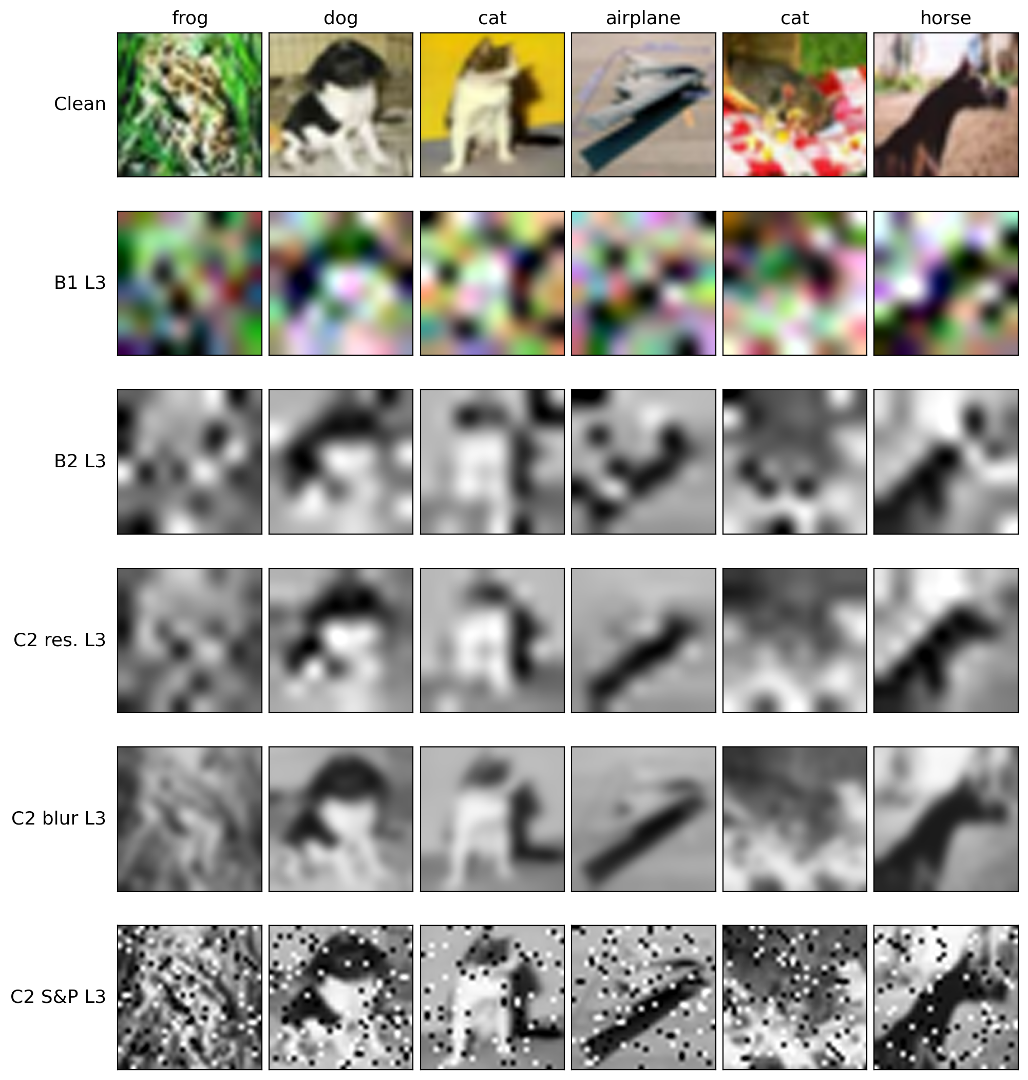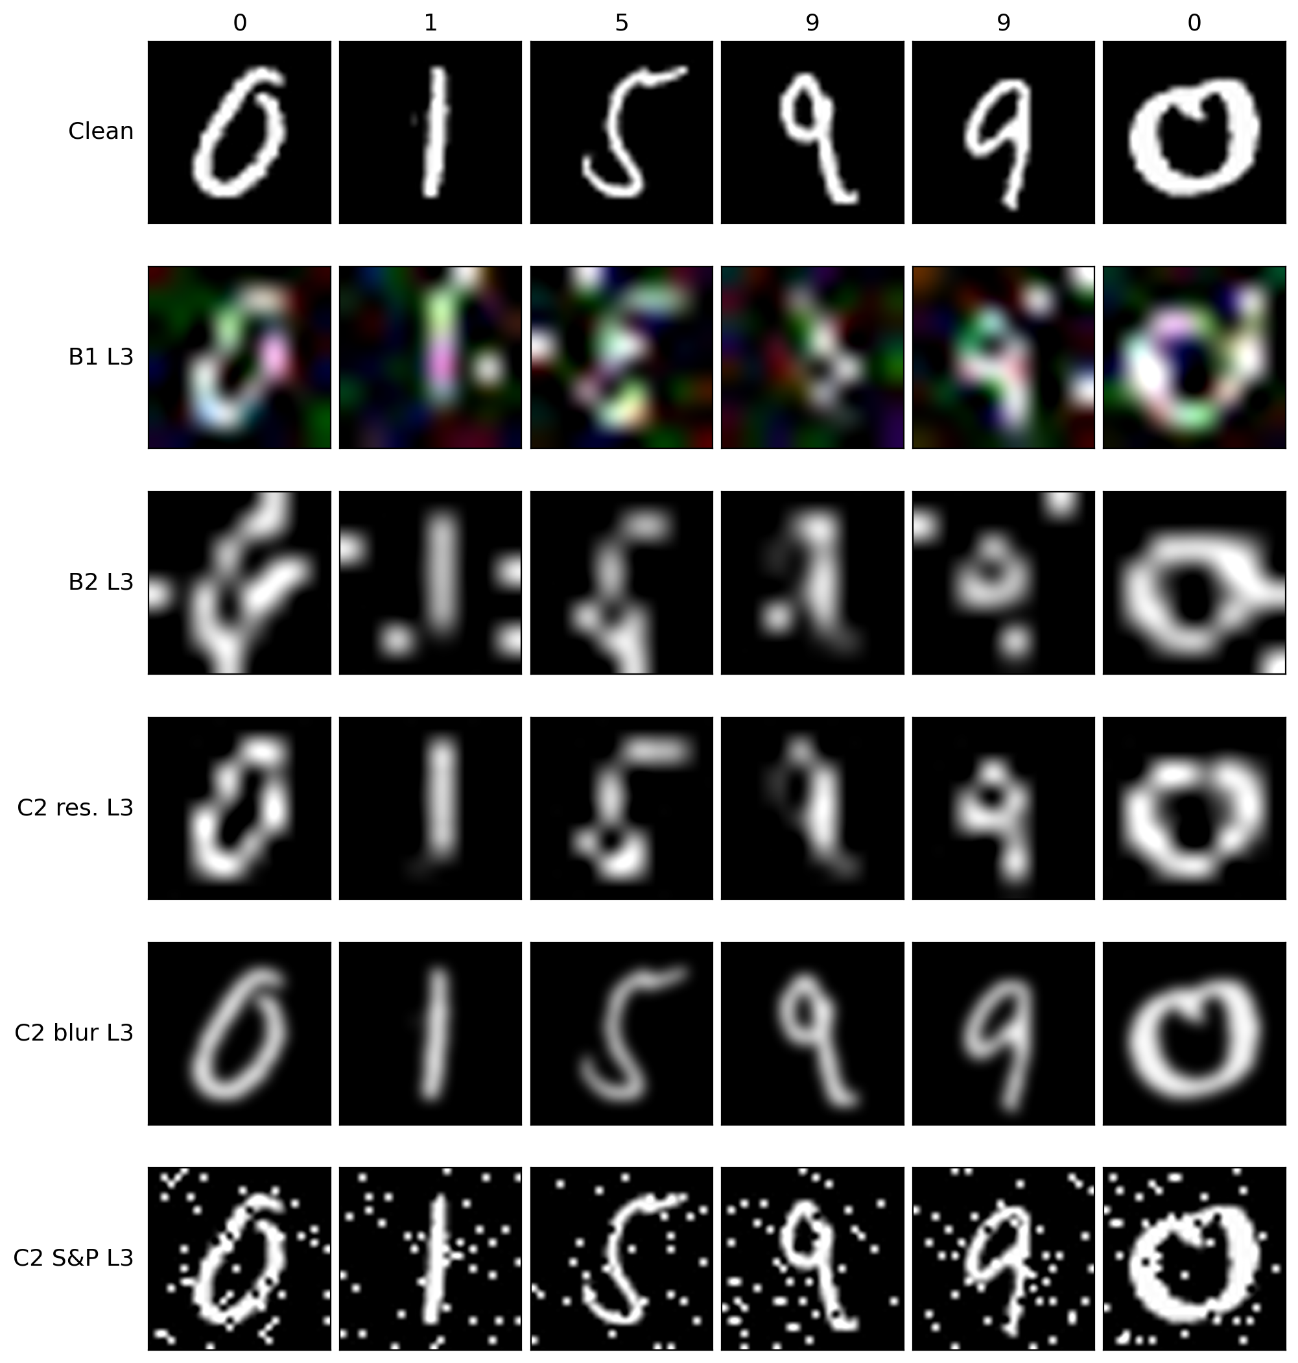
Figure 3: Degradation pipelines at the moderate level (L3) on six fixed validation images. Left: CIFAR-10; right: MNIST. Rows: clean; combined Phase B1; grayscale Phase B2; the three Phase C2 single axes.

5.3 The remaining phases in brief
The five phases outside the B1 / C2 focus are summarized here; each paragraph states what was run, the one or two numbers that matter, and what they mean.
Clean baselines (Phase A, 6 cells).
All three backbones classify the undegraded validation sets at near-ceiling accuracy: 95.18% (ResNet50), 93.56% (DenseNet121), and 97.64% (TransNeXt-tiny) on CIFAR-10, and 99.1-99.3% on MNIST. These six numbers are the reference points every drop in this section is measured against.
Full single-axis isolation (Phase C, 150 cells).
Sweeping all five degradation axes one at a time, over the full color pipeline, produces a clear severity ordering: resolution loss dominates, blur and additive noise are intermediate, and desaturation and salt-and-pepper are comparatively benign in isolation. In plain terms: taking away the pixels hurts far more than taking away the color. This ordering is what motivated the three-axis THz-relevant subset studied in depth as Phase C2.
Regularization recovery (Phase D, 90 cells).
Layering dropout, mixup, and CutMix on top of the combined-degradation pipeline recovers very little: the best treatment (T3, the combination) recovers +0.77 percentage points on average against a collapse roughly sixteen times larger, with the best single segment (TransNeXt-tiny on CIFAR-10) at +2.20 percentage points. The conclusion is important precisely because the effect is small: if the accuracy loss were over-fitting, regularization would have clawed a large part of it back. It does not, so the loss is an information bottleneck - the detail the models need is no longer in the pixels.
THz protocol simplification (Phase B2 / B2-nr, 36 cells).
Re-running the combined sweep under the deployment-realistic protocol (grayscale fixed, additive Gaussian noise off, T3 active) lifts accuracy by +4.01 percentage points on average over Phase B1, and by +5.58 percentage points at the moderate level. The six-cell no-regularization arm (B2-nr) decomposes the L3 gain: +4.19 percentage points comes from the simpler protocol itself and only +1.39 percentage points from T3. In other words, about three quarters of the improvement is the physics of the protocol, not the training trick - consistent with the Phase D reading. A secondary observation: T3 helps roughly twice as much under the simpler protocol (+1.39) as under the full one (+0.77), so regularization becomes more useful as the degradation becomes less severe.
Multi-seed audit (48 replicates).
Re-training all 24 L3 headline cells at seeds 43 and 44 leaves every conclusion intact: the largest per-cell standard deviation is 1.18 percentage points and no cross-model ordering reverses under any seed. Every margin quoted in this section is therefore either comfortably above the seed noise or explicitly flagged as within it.
Calibration.
Expected calibration error stays moderate across the campaign: the mean over the 24 audited cells is 5.6% at L3 and 2.9% at L5 (L3 measured on the held-out test split, L5 on the validation split). Two useful readings: the networks do not become wildly over-confident as the input degrades - confidence broadly tracks the collapsing accuracy - and the single worst miscalibration (12.7%) occurs on the unregularized B2-nr arm, hinting that the Phase D regularization also buys calibration, not only accuracy.
Inference throughput.
On the RTX 5070 at batch size 1, mean per-image latency is 4.2 ms for ResNet50 (238 images/s), 10.7 ms for DenseNet121 (94 images/s), and 27.5 ms for TransNeXt-tiny (36 images/s). The transformer is thus roughly $6.5×$ slower than ResNet50 - its foveal-attention path is not graph-compiled on the current stack - but at 36 frames per second it still clears the acquisition rate of practical THz scanners, which is the budget that matters for deployment.
Confusion structure.
At the extreme level the residual errors concentrate among visually similar classes: cat-dog and bird-deer on CIFAR-10, 4-7 and 8-3 on MNIST. Even after the fine detail is destroyed, the networks keep a coarse notion of category; what they lose is the ability to separate lookalikes.

5.4 Phase B1: combined degradation
Phase B1 applies all five degradation axes simultaneously at a common level and asks the deployment-shaped question: how much accuracy survives when everything degrades at once? Here the L1-L5 index is a legitimate $x$-axis, because Phase B1 sweeps a single fixed recipe and each level is one well-defined operating point. Figure 4 shows what the sweep does to the images; Table 6 reports the full $3×2×5$ accuracy block; Figure 5 plots the curves against the per-model clean baselines; and Tables 7-8 quantify the two readings the curves suggest - how far each model falls, and who leads by how much.
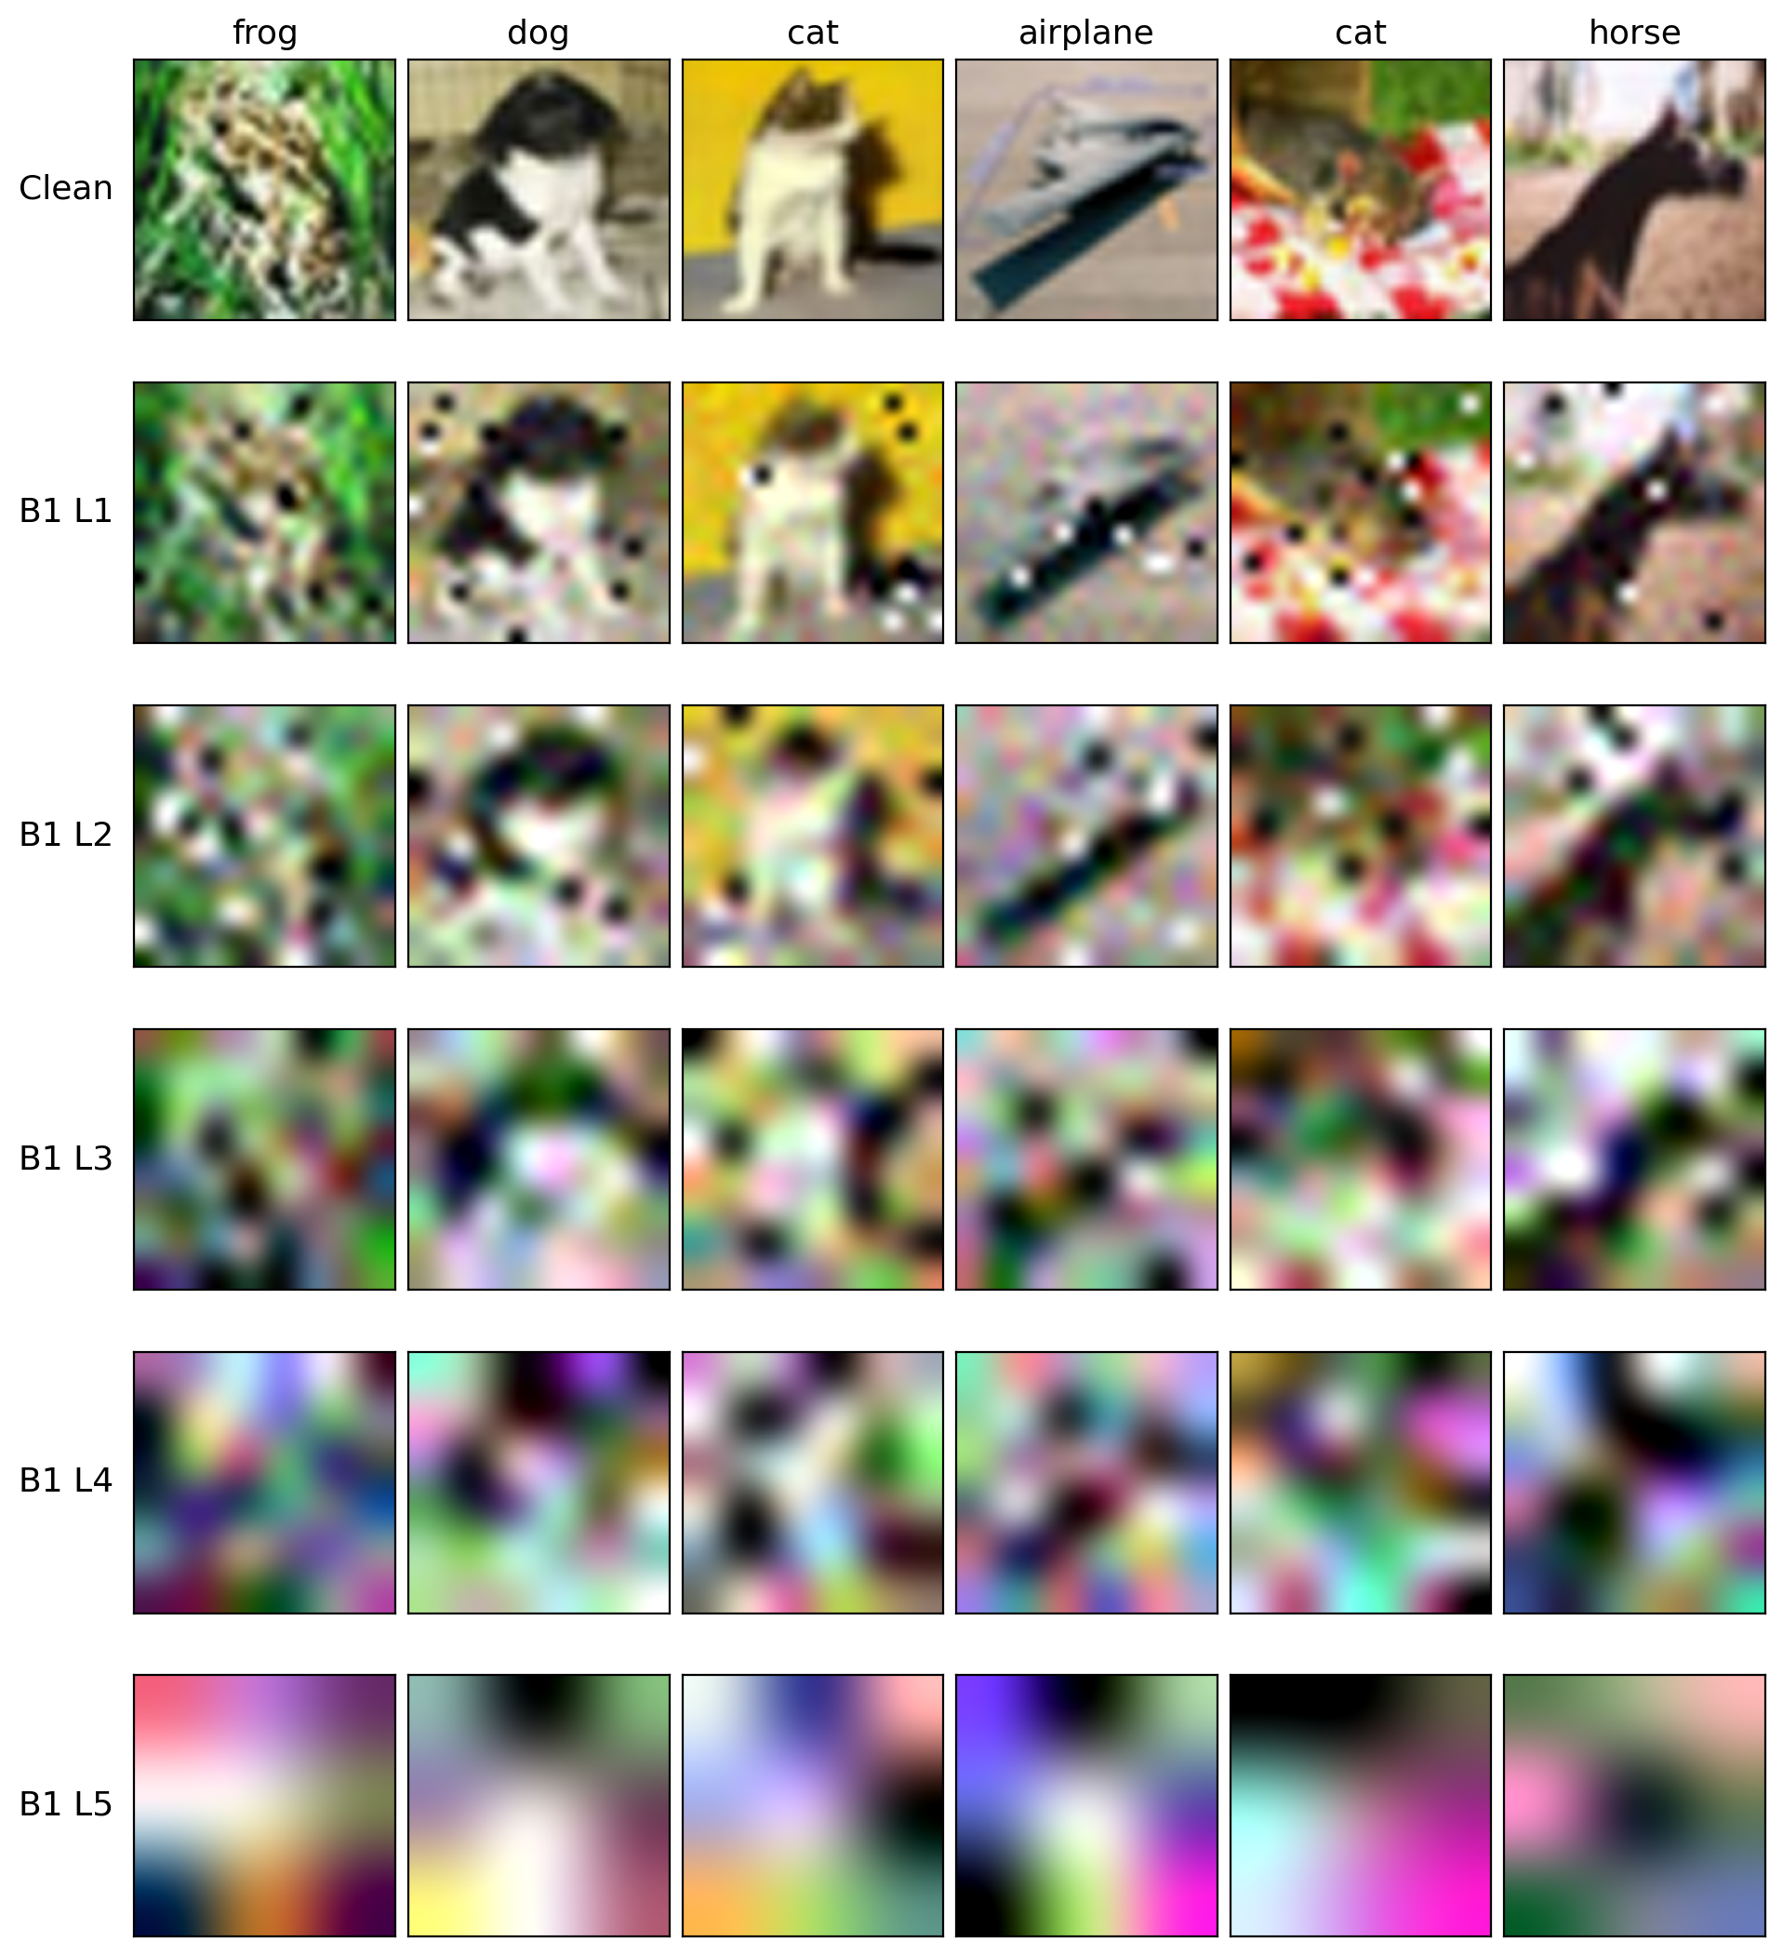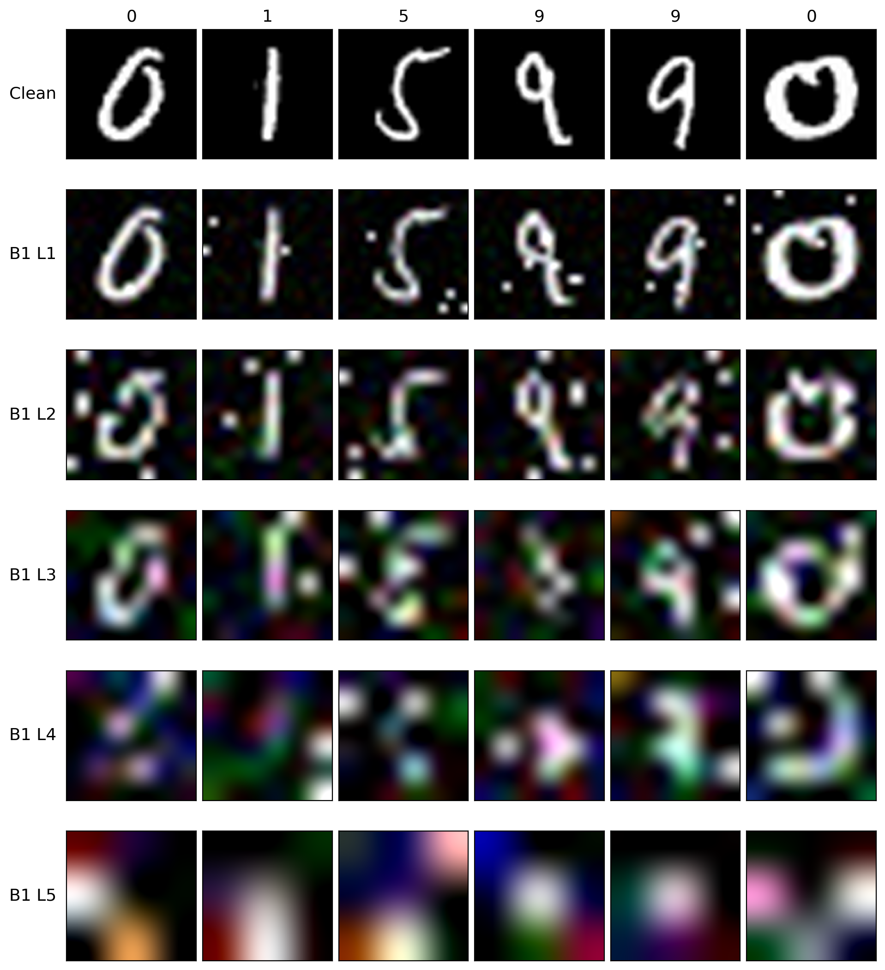
Figure 4: The combined Phase B1 recipe at L1-L5 on six fixed validation images. Left: CIFAR-10; right: MNIST.
Table 6: Phase B (combined degradation) validation accuracy (%). All five axes active at the same level L. Cells with $±$ values are multi-seed audited (seeds $\{42,43,44\}$).
Model | Dataset | L1 | L2 | L3 | L4 | L5
ResNet50 | CIFAR-10 | 76.46 | 53.94 | 36.31 $±$ 0.83 | 26.84 | 19.06
ResNet50 | MNIST | 99.18 | 96.36 | 79.17 $±$ 0.80 | 56.44 | 28.00
DenseNet121 | CIFAR-10 | 78.48 | 53.68 | 38.54 $±$ 0.78 | 28.52 | 19.58
DenseNet121 | MNIST | 98.74 | 96.54 | 80.79 $±$ 0.84 | 58.08 | 27.76
TransNeXt-tiny | CIFAR-10 | 87.58 | 64.22 | 39.48 $±$ 0.62 | 28.50 | 20.10
TransNeXt-tiny | MNIST | 98.96 | 96.00 | 80.05 $±$ 0.11 | 57.24 | 27.48
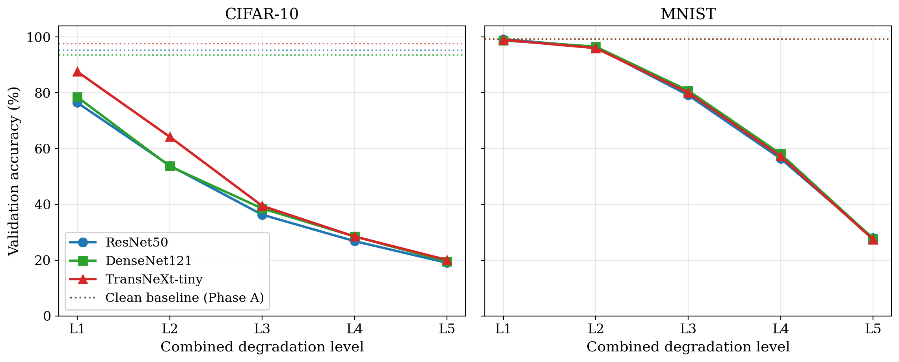
Figure 5: Phase B1 validation accuracy versus combined level; dotted lines mark the per-model clean baselines. Left: CIFAR-10; right: MNIST.
Table 7: Phase B1 accuracy drop versus the Phase A clean baseline (percentage points); the Clean column is the Phase A accuracy (%). L3 uses the multi-seed mean.
Model | Dataset | Clean | $Δ$L1 | $Δ$L2 | $Δ$L3 | $Δ$L4 | $Δ$L5
ResNet50 | CIFAR-10 | 95.18 | -18.72 | -41.24 | -58.87 | -68.34 | -76.12
ResNet50 | MNIST | 99.14 | +0.04 | -2.78 | -19.97 | -42.70 | -71.14
DenseNet121 | CIFAR-10 | 93.56 | -15.08 | -39.88 | -55.02 | -65.04 | -73.98
DenseNet121 | MNIST | 99.30 | -0.56 | -2.76 | -18.51 | -41.22 | -71.54
TransNeXt-tiny | CIFAR-10 | 97.64 | -10.06 | -33.42 | -58.16 | -69.14 | -77.54
TransNeXt-tiny | MNIST | 99.24 | -0.28 | -3.24 | -19.19 | -42.00 | -71.76
Table 8: TransNeXt-tiny accuracy margin over the two CNNs on the Phase B1 curve (percentage points); L3 uses the multi-seed mean (seed noise $σ<1.2$).
Dataset | Margin | L1 | L2 | L3 | L4 | L5
CIFAR-10 | vs CNN mean | +10.11 | +10.41 | +2.05 | +0.82 | +0.78
CIFAR-10 | vs best CNN | +9.10 | +10.28 | +0.94 | -0.02 | +0.52
MNIST | vs CNN mean | +0.00 | -0.45 | +0.07 | -0.02 | -0.40
MNIST | vs best CNN | -0.22 | -0.54 | -0.75 | -0.84 | -0.52
Three observations organize the block.
The collapse is monotonic and severe on CIFAR-10.Accuracy falls with every level step for every model (Table 7): even the mild level already costs 10-19 percentage points, the moderate level costs 54-59, and by L5 all three models have lost about three quarters of their clean accuracy and sit at 19-21% - better than the 10% random-guess floor, but not by much. Nothing in the design space escapes this fall; the question the later phases answer is why (it is the information, not the training - Phases D and C2).
The transformer leads exactly where the images are still readable.Table 8 makes the margin structure explicit. TransNeXt-tiny leads the CNN mean by +10.11 percentage points at L1 and +10.41 at L2 - an advantage far above the seed noise - but the lead collapses to +2.05 percentage points at L3 (only +0.94 over the better CNN, within about one combined seed-$σ$), and to under 1 percentage points at L4-L5. Comparing with Figure 4: the transformer’s foveal attention pays off while local texture still exists (L1-L2), and stops paying the moment the degradation has destroyed the texture it attends to. From L3 onward the three architectures are practically interchangeable.
MNIST resists four levels, then falls off the same cliff.The digit task barely notices the first two levels (drops under 3.3 percentage points; TransNeXt has no advantage there - the CNNs are already at ceiling), stays usable at L3 (about 79-81%), and then collapses to 27-28% at L5, a loss of about 71 percentage points for every model. High-contrast shapes on a black background simply survive the pipeline longer than natural images; but once downsampling to $3×3$ pixels removes the stroke structure, MNIST converges to the same information floor as CIFAR-10. The per-model reading of both datasets continues in Section 5.6.

5.5 Phase C2: single-axis attribution under the THz protocol
Phase C2 answers the engineering question behind the whole campaign: of the degradations a real THz sensor produces, which one should be fought first? Each cell isolates one of the three THz-relevant axes - resolution, blur, or salt-and-pepper - at one level, with the other two held at identity, under the THz protocol (image fixed at full grayscale, additive Gaussian noise off, T3 regularization). Table 9 reports the full accuracy block.
Table 9: Phase C2 single-axis isolation under the THz protocol (saturation $=0$, noise $=0$, T3 regularization) validation accuracy (%).
Model | Dataset | Axis | L1 | L2 | L3 | L4 | L5
ResNet50 | CIFAR-10 | Resolution | 80.18 | 66.36 | 51.32 | 42.96 | 30.16
ResNet50 | CIFAR-10 | Blur | 90.62 | 89.58 | 83.36 | 71.68 | 58.76
ResNet50 | CIFAR-10 | S&P | 86.24 | 85.18 | 83.48 | 77.86 | 74.68
ResNet50 | MNIST | Resolution | 99.06 | 98.64 | 94.12 | 81.24 | 45.54
ResNet50 | MNIST | Blur | 99.24 | 99.26 | 99.32 | 99.32 | 98.86
ResNet50 | MNIST | S&P | 99.14 | 99.16 | 99.18 | 99.00 | 99.00
DenseNet121 | CIFAR-10 | Resolution | 76.82 | 64.04 | 51.34 | 44.44 | 30.80
DenseNet121 | CIFAR-10 | Blur | 88.24 | 85.66 | 81.66 | 74.90 | 64.60
DenseNet121 | CIFAR-10 | S&P | 86.38 | 83.26 | 80.54 | 79.30 | 77.78
DenseNet121 | MNIST | Resolution | 99.38 | 98.64 | 94.30 | 82.28 | 45.02
DenseNet121 | MNIST | Blur | 99.42 | 99.34 | 99.22 | 99.38 | 99.16
DenseNet121 | MNIST | S&P | 99.16 | 99.20 | 99.20 | 99.08 | 99.06
TransNeXt-tiny | CIFAR-10 | Resolution | 89.34 | 76.08 | 58.24 | 46.58 | 30.54
TransNeXt-tiny | CIFAR-10 | Blur | 96.52 | 95.96 | 93.00 | 88.02 | 71.04
TransNeXt-tiny | CIFAR-10 | S&P | 95.20 | 94.78 | 93.52 | 91.56 | 89.58
TransNeXt-tiny | MNIST | Resolution | 99.32 | 98.76 | 93.94 | 81.74 | 45.60
TransNeXt-tiny | MNIST | Blur | 99.38 | 99.38 | 99.46 | 99.48 | 99.06
TransNeXt-tiny | MNIST | S&P | 99.28 | 99.14 | 99.20 | 99.08 | 99.08
Why the plots use PSNR and SSIM, not the level index.A given nominal level does not do equal damage on different axes: L3 blur removes far less information than L3 resolution, so comparing axes at matched level would compare unmatched images. The level is a knob we set; PSNR and SSIM are what the images actually measure. Every Phase C2 comparison is therefore drawn against the measured image quality - PSNR (Figure 6) and SSIM (Figure 7) separately - computed against the clean upsampled reference, with the L1/L5 endpoints of the resolution curve annotated for orientation.
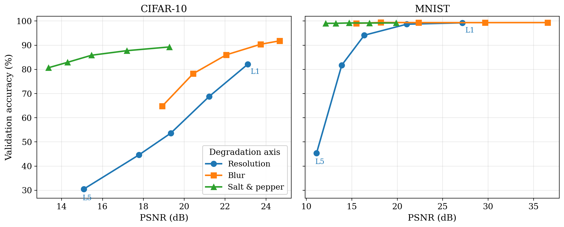
Figure 6: Phase C2 axis comparison versus measured PSNR, one curve per axis averaged over the backbones; L1/L5 mark the resolution-axis endpoints. Left: CIFAR-10; right: MNIST.
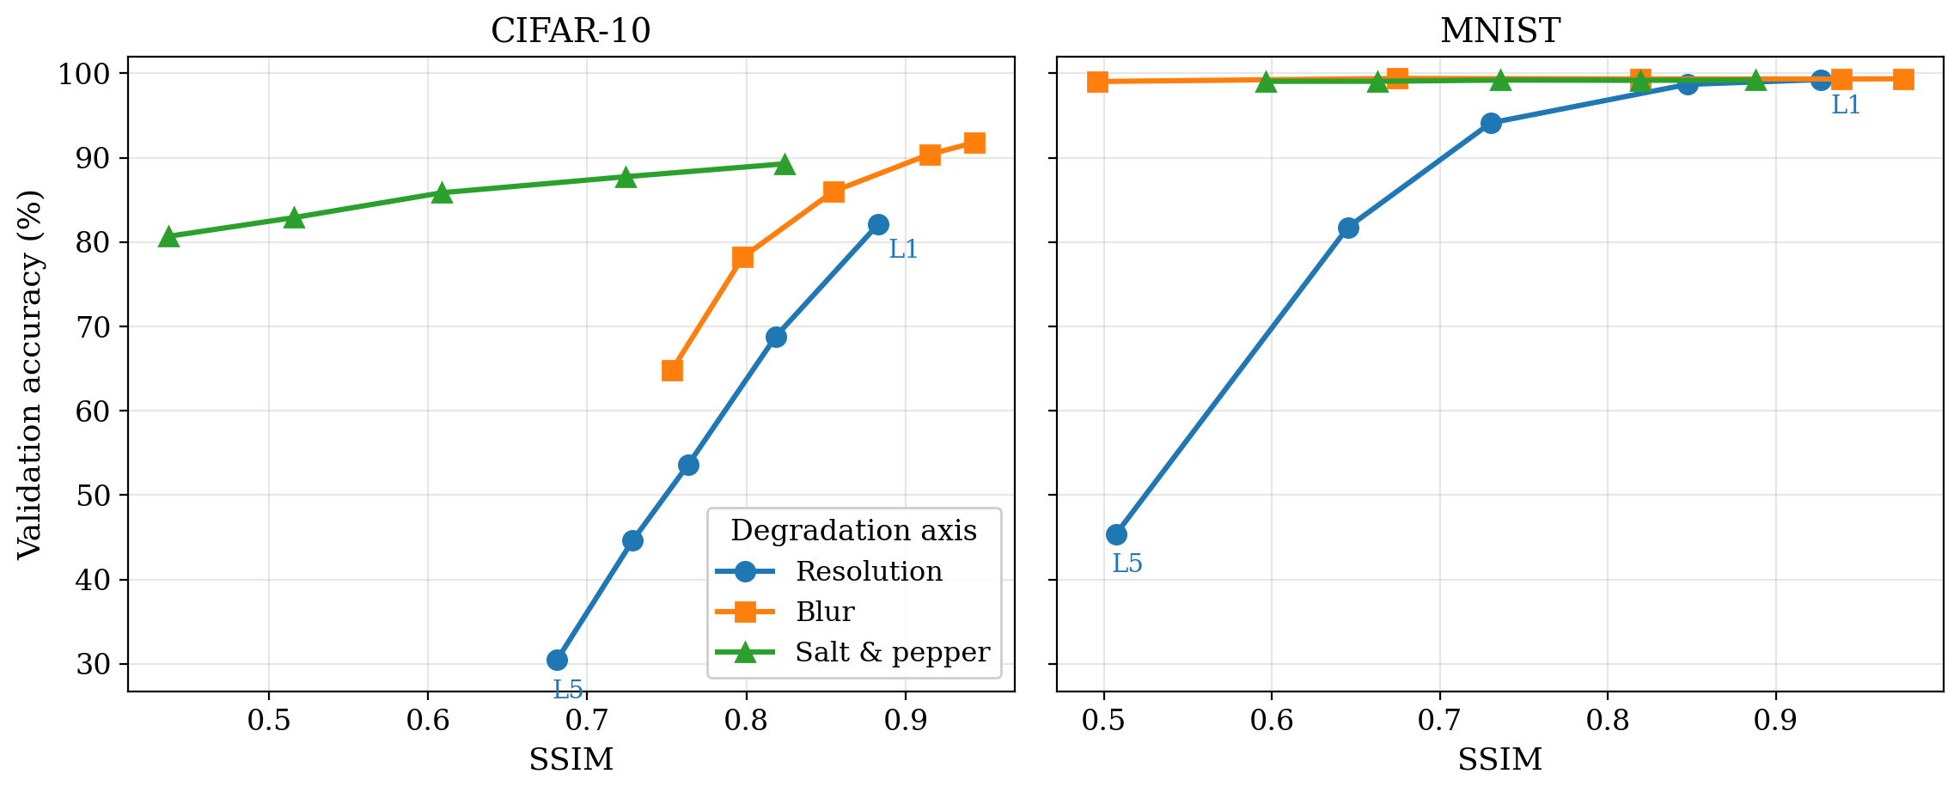
Figure 7: Phase C2 axis comparison versus measured SSIM; same construction as Figure 6.
Resolution is the axis that matters.At every matched PSNR and SSIM value, the resolution curve sits far below blur, and blur below salt-and-pepper; the ordering is identical under both quality metrics. Averaged over the six (model, dataset) pairs, the L1-L5 mean accuracy cost is $−27.45$ percentage points for resolution against $−6.58$ for blur and $−5.13$ for salt-and-pepper - a factor of roughly four. The plain-language version of Figure 6 is: an image that measures equally degraded is much more dangerous when the damage came from lost pixels than when it came from smoothing or speckle, because only the former removes information the classifier cannot re-learn its way around.
Table 10: Phase C2: Spearman rank correlation $ρ$ between accuracy and measured image quality, pooled over the three backbones ($n=15$ per entry).
 | CIFAR-10 |  | MNIST
Axis | $ρ$ vs PSNR | $ρ$ vs SSIM | $ρ$ vs PSNR | $ρ$ vs SSIM
Resolution | +0.98 | +0.98 | +0.98 | +0.98
Blur | +0.84 | +0.84 | +0.42 | +0.42
Salt & pepper | +0.53 | +0.53 | +0.70 | +0.70
The quality metrics rank the axes but do not explain them. Table 10 quantifies how tightly accuracy follows measured quality. Pooled across models, resolution shows an almost perfect association ($ρ=+0.98$ on both datasets and both metrics); blur and salt-and-pepper are markedly weaker ($+0.84$ and $+0.53$ on CIFAR-10). Two nuances make this table honest rather than decorative. First, within any single model on CIFAR-10 the association is perfectly monotone ($ρ=1.0$) on every axis - the pooled values drop below 1 only because the three models sit at different accuracy offsets at the same quality. Second, on MNIST the blur and salt-and-pepper correlations are weak for the opposite reason: those axes barely move MNIST accuracy at all (the curves are flat near 99%), so there is almost no signal for a rank correlation to find. A low $ρ$ here means “harmless axis,” not “unpredictable axis.”
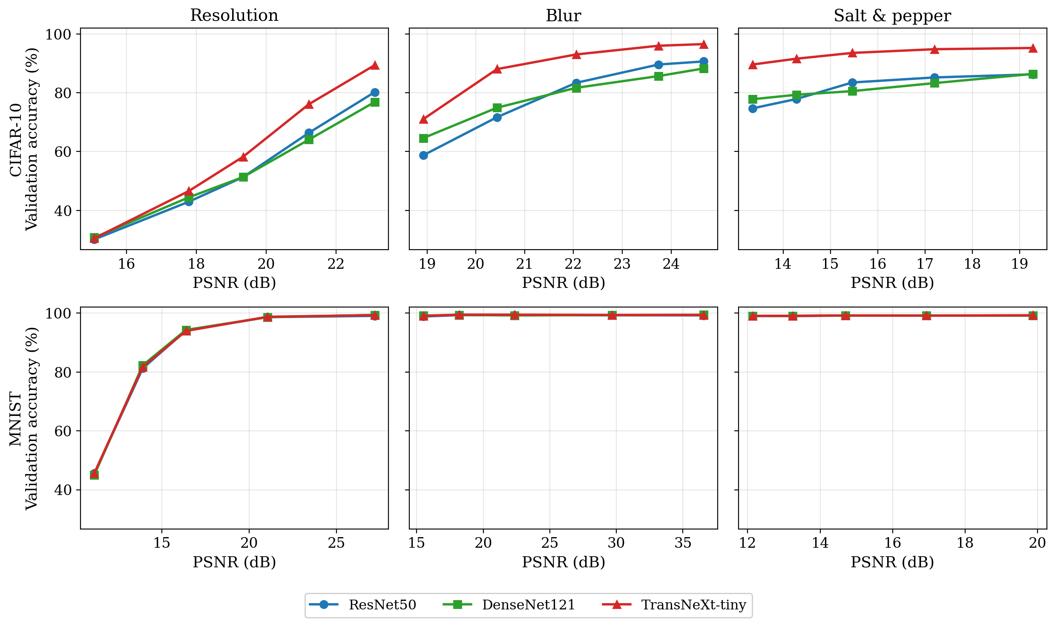
Figure 8: Phase C2 model comparison versus PSNR: one panel per axis (columns) and dataset (rows), one curve per backbone.
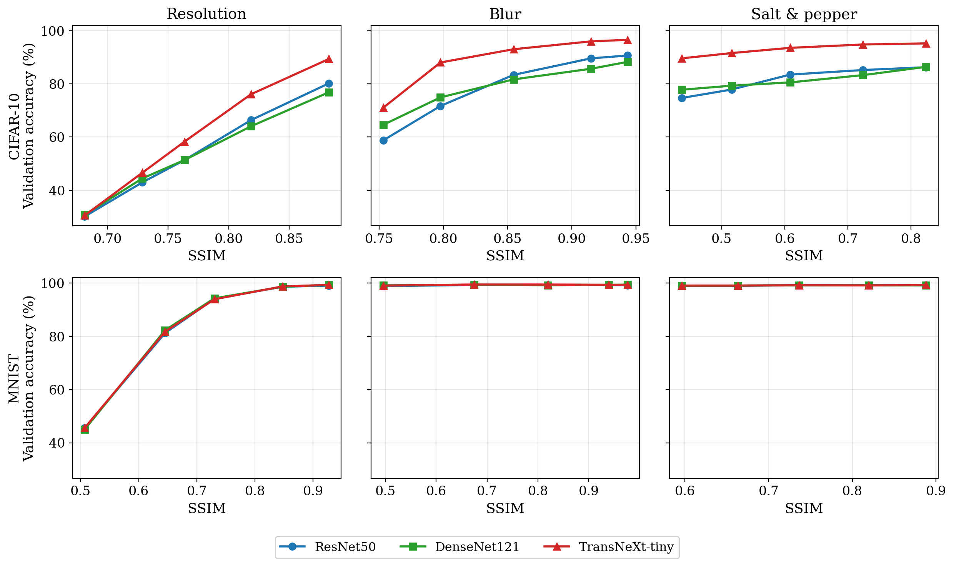
Figure 9: Phase C2 model comparison versus SSIM; same construction as Figure 8.
Model ordering under the THz protocol. Figures 8 and 9 repeat the comparison with one curve per model. On CIFAR-10, TransNeXt-tiny is the most robust backbone on every axis across the entire quality range - most visibly on blur, where at L5 it holds 71.0% against 58.8% (ResNet50) and 64.6% (DenseNet121) - and the two CNNs essentially overlap. On MNIST only the resolution axis produces a meaningful fall (to about 45% at L5, for all three backbones identically); blur and salt-and-pepper leave the digits readable at every level, confirming that stroke shape, not texture, is what MNIST classification runs on.
Levels versus quality, in one sentence.Reading Table 9 down the level columns and Figure 6 along the quality axis says the same thing two ways: severity level is a poor common currency across degradation types, and once converted into measured image quality, resolution is where the accuracy actually goes.

5.6 Cross-model robustness comparison
This subsection reads the two focus phases vertically, by model. The combined-degradation behaviour comes from Phase B1 (Tables 6-8, Figure 5), the single-axis behaviour from Phase C2 (Table 9, Figures 6-9).

5.6.1 Per-model profiles
ResNet50 - the fast, ordinary baseline.
ResNet50 opens at 95.18% clean on CIFAR-10 and 99.14% on MNIST, and declines monotonically under the combined recipe to 19.06% at L5 on CIFAR-10. Its Phase C2 profile is dominated by the resolution axis (80.18% down to 30.16% across the quality range) while its salt-and-pepper accuracy never drops below 74.68%. It carries no robustness advantage anywhere - but it is also the fastest backbone by a factor of $2.5×$ over DenseNet121 and $6.5×$ over TransNeXt-tiny, which matters at deployment.
DenseNet121 - feature reuse buys little here.
DenseNet121 starts lower on CIFAR-10 (93.56%) and tracks ResNet50 closely all the way down (19.58% at L5), with a small edge at the moderate level (38.54 vs 36.31 at L3, about $2σ$ of seed noise). The preliminary hypothesis that dense feature reuse would help under information loss is not supported: its Phase C2 axis ordering and magnitudes are essentially ResNet50’s. In plain terms, keeping copies of earlier features does not help when the features were destroyed before the first layer ever saw them.
TransNeXt-tiny - the winner, where winning is possible.
TransNeXt-tiny posts the best clean baseline on CIFAR-10 (97.64%), the largest mild-range margins on the combined curve (+10.11 and +10.41 percentage points over the CNN mean at L1-L2), and is the most robust backbone on every Phase C2 axis at matched image quality - its blur advantage at L5 is about 6-12 percentage points over the CNNs. The advantage has a boundary: it shrinks to +2.05 percentage points at L3 (+0.94 over the better CNN, comparable to the seed noise) and disappears at L4-L5. On MNIST it never has an advantage at all; the CNNs are already at ceiling wherever the digits are readable.

5.6.2 Side-by-side reading
Put together, the three profiles say something simple: architecture is a mild-degradation lever. Where the degraded image still contains texture (L1-L2 on CIFAR-10, every readable MNIST level), the foveal transformer converts that texture into up to ten extra accuracy points; where the texture is gone (L3 and beyond on the combined recipe), all three architectures converge - into the 19-21% band at L5 on CIFAR-10 and the 27-28% band on MNIST - and no backbone choice moves the number by more than the seed noise.
The Phase C2 attribution explains where the accuracy goes: the resolution axis carries roughly four times the cost of blur or salt-and-pepper at matched measured quality. The deployment implication, developed in Section 7, follows directly: pick the transformer when the operating point is mild and the latency budget allows it, but expect no classifier - present or future - to fix the extreme operating points. Those need the resolution restored in front of the classifier, not a bigger classifier behind the sensor.

6 Problems and Solutions
This section describes the substantive engineering and scientific problems met during the 402-cell campaign. Each entry pairs the observed symptom with the corrective action and, where relevant, the automated guard that keeps the problem from coming back.

6.1 Native-resolution refactor and its rollback
Symptom.An intermediate design (the “V3” refactor) trained each backbone at its dataset-native resolution - $32×32$ for the CIFAR-10 inputs to TransNeXt, $28→32$ for MNIST - on the argument that upsampling to $224×224$ wastes computation and adds interpolation artifacts. The argument sounds efficient but breaks the one invariant the study depends on: with different tensor shapes per backbone, any measured cross-model gap mixes the architecture with the input size it happened to receive. It also threw away the ImageNet-pretrained receptive-field hierarchy of the two CNNs (calibrated for $224×224$) and moved TransNeXt off the 224-pretrained distribution of its checkpoint.
Fix.Rolled back to a single uniform $224×224$ protocol: every input is upsampled by the data pipeline before any model sees it, so cross-backbone deltas are attributable to architecture alone. The decision is recorded as a frozen invariant in the technical specification (Section 3), and the data module asserts the $224×224$ output shape at construction time, so the native-resolution path cannot be reintroduced silently.

6.2 Hyperparameter tuning at campaign scale: frozen Optuna winners
Symptom.Tuning each of the 402 cells separately was both computationally infeasible and scientifically wrong: per-level tuning would let the optimizer compensate for each degradation level individually, confounding the robustness signal with search noise, and a blind wide search risked overfitting the validation split.
Fix.The search was constrained twice. The space was narrowed to the paper-derived priors per architecture (at most one decade around the published value), and each (model, dataset) pair was tuned once, at the L3 operating point, with the winner frozen for the entire sweep. Phases that add regularization (D) or simplify the protocol (B2) layer on top of the frozen winners rather than re-tuning, so every comparison happens at one documented configuration. The winners live under artifacts/best_hparams/ and round-trip through each cell’s metrics.json, making every run auditable.

6.3 Blur that was invisible at $224×224$
Symptom.The single-axis blur sweep produced almost no accuracy drop between L1 and L5 (under 1 percentage points on DenseNet121) - suspicious for the supposedly second-worst degradation. The cause: the blur kernels (K $=3…13$, $σ=0.8…2.3$) had been calibrated for native $32×32$ imagery. On the upsampled $224×224$ tensor they covered only 1-6% of the image width - the “blur” axis was not actually blurring.
Fix.The schedule was rescaled to pixel-domain values at $224×224$ (K $=13…91$, $σ=2.5…18$), tied by the rule $K=2⌈2.5σ⌉+1$ so the kernel always captures the $2.5σ$ Gaussian footprint. A unit test asserts that L5 blur costs at least 5 dB of PSNR against L1, guarding any future schedule against the same scale mistake.

6.4 Vision-transformer bring-up on Blackwell hardware
Symptom.TransNeXt training crashed on the RTX 5070 (Blackwell, sm_120) with an opaque CUDA kernel-launch error in the first attention block: the PyTorch stack at project start shipped kernels only up to sm_90, and the TransNeXt swattention extension had no sm_120 binary.
Fix.TransNeXt was quarantined until the upstream package was rebuilt with sm_120 support in the PyTorch Blackwell release; the quarantine predicate is now a permanent no-op but stays in code for future GPU substitutions. A startup self-test runs a one-iteration forward pass on the configured GPU before the campaign driver dispatches its first cell, so a compute-capability mismatch surfaces as a structured error instead of a raw CUDA stack trace mid-campaign.

6.5 Single-seed reproducibility exposure
Symptom.The L3 headline cells were originally single-seed point estimates at seed 42. Without a variance bound, a reviewer could not tell whether a small inter-model gap was a real effect or a lucky seed.
Fix.A 48-replicate audit re-trained all 24 L3 headline cells at seeds 43 and 44. Every audited cell shows $σ<1.2$ percentage points (worst: the TransNeXt-tiny CIFAR-10 Phase D T3 cell at 1.18), and no cross-model conclusion reverses under any seed. Schema version 3 of Final_Exp.json carries the mean-$±σ$ pair on every audited cell, so the reproducibility floor is visible without re-running the audit.

7 Conclusions and Recommendations

7.1 Scientific conclusions
This work delivered a reproducible 402-cell training campaign across three architectures (ResNet50, DenseNet121, TransNeXt-tiny), two datasets (CIFAR-10, MNIST), five degradation levels, and seven experimental phases, anchored to a deterministic per-pipeline PSNR / SSIM probe and a 48-replicate multi-seed audit. Four conclusions follow from the measurements.
- The collapse is an information bottleneck, not over-fitting. The strongest regularization treatment recovers less than one percentage point of the combined-degradation collapse (Phase D: +0.77 percentage points on average), and moving to the simpler THz protocol recovers about four (Phase B2: +4.01 percentage points, roughly three quarters of which is the protocol itself rather than the regularization). If the models were merely over-fitting the degraded distribution, training-side intervention would have closed a large part of the gap; it does not. The accuracy is gone because the information is gone.
- The foveal transformer is the most robust backbone at the operationally relevant levels. TransNeXt-tiny leads the CNNs by about ten percentage points at the mild-to-moderate end of the combined curve on CIFAR-10 and is the most robust model on every single-axis comparison at matched image quality. The advantage is real (well above the seed noise) but conditional: it exists exactly where the degraded image still contains texture for its attention to use.
- At extreme degradation, architecture stops mattering. At Phase B1 L5 all three backbones land in a 19-21% band on CIFAR-10 (27-28% on MNIST) - within seed noise of one another. Once the spatial information is destroyed, no backbone in this design space, and plausibly none outside it, can recover what is no longer there.
- Resolution is the dominant degradation axis. On the measured PSNR and SSIM scales, the resolution axis costs roughly four times more accuracy than blur or salt-and-pepper ($−27.45$ percentage points mean L1-L5 against $−6.58$ and $−5.13$) and shows an almost perfect accuracy-quality association ($ρ=+0.98$). For a THz system engineer this is the actionable result: spatial resolution is where the accuracy goes, so spatial resolution is what front-end investment should restore first.

7.2 Project evaluation against the preliminary goals
The preliminary design report (PDR) set three acceptance criteria.
- Goal 1 - at least 80% top-1 accuracy at the moderate (L3) operating point. Partially met, and informatively so. On the full combined L3 pipeline the target is missed on CIFAR-10 (36-39%), essentially met on MNIST (79-81%), and comfortably exceeded on the milder single-axis operating points (for example, every Phase C2 blur and salt-and-pepper cell at L3). The CIFAR-10 shortfall is not an engineering failure but the central scientific finding: the moderate combined degradation destroys enough information that no backbone in the design space reaches 80% - and Phase D shows that no training trick changes this.
- Goal 2 - an identifiable architectural winner beating the baseline by a meaningful margin. Met, in the regime where a winner can exist. TransNeXt-tiny beats the CNN mean by about ten percentage points at L1-L2 on CIFAR-10, far above the multi-seed noise floor ($σ<1.2$ percentage points). The margin decays to about two points at L3 and vanishes by L4, so the “winner” claim is explicitly scoped to the mild-to-moderate range where it is decision-relevant.
- Goal 3 - inference latency compatible with sensor-side deployment. Met for all three backbones, with very different margins. At batch size 1 on the RTX 5070: ResNet50 4.2 ms (238 images/s), DenseNet121 10.7 ms (94 images/s), TransNeXt-tiny 27.5 ms (36 images/s). All three clear the frame rate of practical THz scanners; but the transformer is roughly $6.5×$ slower than ResNet50 because its foveal-attention path is not graph-compiled on the current stack, leaving it the thinnest deployment margin - the subject of a continuation recommendation below.
Trade-offs of the final architecture choice.ResNet50 is the fastest and simplest backbone and a solid baseline, but it carries no robustness advantage. DenseNet121 adds a small edge at moderate CIFAR-10 degradation through feature reuse, at the cost of $2.5×$ ResNet50’s latency and higher memory. TransNeXt-tiny delivers the best accuracy at mild and moderate degradation, at the cost of $6.5×$ ResNet50’s latency and no advantage at the extreme end. For a THz deployment operating at mild-to-moderate degradation the recommendation is TransNeXt-tiny; at extreme degradation the engineering budget is better spent on front-end restoration than on any classifier.

7.3 Plan versus execution
Table 11 compares the planned compute budget with the logged execution from the campaign ledger. The overall envelope closed at about +9% - comfortably inside the $∼$310 GPU-hour saving created by the transnext_small $→$ tiny substitution - but the per-phase picture is uneven and worth stating honestly: the convergence-first policy (60-epoch budget, early-stopping patience 10) let the T3-regularized Phase B2 / C2 cells train materially longer than estimated (+45% and +48% over their line items), while the 186-cell baseline re-run and the post-training diagnostics came in well under. All scheduled milestones - PDR, the determinism gates, the 402-cell campaign, the multi-seed audit, the diagnostics, and this report - were met against the 26 July 2026 submission deadline.
Table 11: Plan versus execution (GPU-hours). Planned: PDR / PRD estimates; actual: campaign ledger; $≈$ marks ledger estimates.
Work item | Planned | Actual | Status
Hyperparameter pre-tuning (Optuna) | 20.0 | $≈$20 | Within budget
Phases A / B1 / C (186 cells) | 62.0 | $≈$50 | $∼$19% under
Phase D regularization sweep (90 cells) | 52.5 | 56.5 | $+7.6\%$ over
Phase B2 sweep (30 cells) | 15.0 | 21.7 | $+45\%$ over
Phase B2-nr arm (6 cells) | 3.5 | 3.8 | Within budget
Phase C2 sweep (90 cells) | 48.0 | 70.9 | $+48\%$ over
Multi-seed audit (48 replicates) | 24.0 | $≈$25 | Within budget
Post-training diagnostics (no re-train) | 3.5 | 0.7 | $∼$80% under
Total | 228.5 | $≈$249 | $+9\%$
Architecture substitution (small$→$tiny): $≈−310$ GPU-h vs. the original plan.

7.4 Limitations
The conclusions are bounded by the experimental scope. The five-axis pipeline is a synthetic mathematical model: it omits wavelength-dependent diffraction, mixing-element nonlinearity, and the dead-pixel patterns of real THz detectors. CIFAR-10 and MNIST are small benchmarks, so the per-axis attribution is not validated at ImageNet scale or on true THz object categories. The Phase B2 / C2 sweeps were run under the T3 treatment only, so protocol and regularization interact in all but the L3 cells (where the B2-nr arm separates them). No learned super-resolution baseline was run (a scoped-out Phase E), so the “restore resolution first” recommendation has not yet been tested against an actual restoration pipeline. Finally, the acceptance criteria are model-side only; no human-perception bound was collected for the extreme operating points.

7.5 Recommendations for continuation
- Acquire real THz data.Even a small dataset at the target frequency would calibrate the synthetic model against ground truth and re-weight the per-axis attribution accordingly.
- Add a super-resolution pre-stage.Resolution dominates the attribution by $4×$, so the highest-value next ablation places a learned upsampler in front of each backbone and re-runs Phases B2 / C2. If the attribution is right, this single stage should recover more accuracy than any classifier change measured here.
- Graph-compile the TransNeXt attention path.The foveal-attention custom op is the reason for the $6.5×$ latency gap to ResNet50. Compiling it (or replacing it with a fused implementation) would widen the transformer’s deployment margin at no accuracy cost.
- Reproduce the attribution at scale.Repeat the per-axis analysis on a large robustness benchmark such as ImageNet-A [6] to test whether resolution dominance holds beyond small benchmarks.
- Calibration monitoring.Miscalibration stays moderate (mean ECE 5.6% at L3, 2.9% at L5) but is not free: the worst cell (12.7%) sits on the unregularized B2-nr arm. A cheap post-hoc temperature-scaling step, fitted per operating point, would tighten the confidence outputs without touching top-1 accuracy - worth adding before any operational use of the confidence scores.

8 References
99
K. He, X. Zhang, S. Ren, and J. Sun, “Deep residual learning for image recognition,” in Proc. IEEE Conf. Comput. Vis. Pattern Recognit. (CVPR), 2016, pp. 770-778.
G. Huang, Z. Liu, L. van der Maaten, and K. Q. Weinberger, “Densely connected convolutional networks,” in Proc. IEEE Conf. Comput. Vis. Pattern Recognit. (CVPR), 2017, pp. 2261-2269.
D. Shi, “TransNeXt: Robust foveal visual perception for vision transformers,” arXiv:2311.17132, 2024.
Q. Huynh-Thu and M. Ghanbari, “Scope of validity of PSNR in image/video quality assessment,” Electron. Lett., vol. 44, no. 13, pp. 800-801, 2008.
Z. Wang, A. C. Bovik, H. R. Sheikh, and E. P. Simoncelli, “Image quality assessment: From error visibility to structural similarity,” IEEE Trans. Image Process., vol. 13, no. 4, pp. 600-612, 2004.
D. Hendrycks, K. Zhao, S. Basart, J. Steinhardt, and D. Song, “Natural adversarial examples,” in Proc. IEEE/CVF Conf. Comput. Vis. Pattern Recognit. (CVPR), 2021.
A. Krizhevsky, “Learning multiple layers of features from tiny images,” Univ. of Toronto, Tech. Rep., 2009.
Y. LeCun, L. Bottou, Y. Bengio, and P. Haffner, “Gradient-based learning applied to document recognition,” Proc. IEEE, vol. 86, no. 11, pp. 2278-2324, 1998.
I. Loshchilov and F. Hutter, “Decoupled weight decay regularization,” in Proc. Int. Conf. Learn. Represent. (ICLR), 2019.
I. Loshchilov and F. Hutter, “SGDR: Stochastic gradient descent with warm restarts,” in Proc. Int. Conf. Learn. Represent. (ICLR), 2017.
M. P. Naeini, G. F. Cooper, and M. Hauskrecht, “Obtaining well calibrated probabilities using Bayesian binning,” in Proc. AAAI Conf. Artif. Intell., 2015.
C. Guo, G. Pleiss, Y. Sun, and K. Q. Weinberger, “On calibration of modern neural networks,” in Proc. Int. Conf. Mach. Learn. (ICML), 2017.
G. Huang, Y. Sun, Z. Liu, D. Sedra, and K. Q. Weinberger, “Deep networks with stochastic depth,” in Proc. Eur. Conf. Comput. Vis. (ECCV), 2016.
H. Zhang, M. Cisse, Y. N. Dauphin, and D. Lopez-Paz, “mixup: Beyond empirical risk minimization,” in Proc. Int. Conf. Learn. Represent. (ICLR), 2018.
S. Yun, D. Han, S. J. Oh, S. Chun, J. Choe, and Y. Yoo, “CutMix: Regularization strategy to train strong classifiers with localizable features,” in Proc. IEEE/CVF Int. Conf. Comput. Vis. (ICCV), 2019.
W. Falcon et al., “PyTorch Lightning,” GitHub repository, Lightning-AI/lightning, 2019.
A. Paszke et al., “PyTorch: An imperative style, high-performance deep learning library,” in Adv. Neural Inf. Process. Syst. (NeurIPS), vol. 32, 2019.

Appendix A: Copyright and Confidentiality Agreement (Signed Form 12.2)
This appendix (Appendix A) holds the signed Copyright and Confidentiality Agreement required by the Engineering Project Guidelines.

Appendix B: Supplementary Material - Data Availability
The complete per-cell accuracy blocks for every phase (Phase A clean baselines, Phase B1 combined degradation, the full Phase C single-axis sweep, Phase C2, the Phase D regularization sweep, Phase B2 / B2-nr, and the multi-seed audit) are recorded in machine-readable form and are not reproduced here. They are available in the campaign artifacts: the aggregated artifacts/Final_Exp.json (schema version 3) and the per-phase CSV tables under Final_Report/data/tables/. The two phases analysed in detail in Section 5 - Phase B1 and Phase C2 - are tabulated inline there (Tables 6 and 9); the derived analysis tables (drop versus clean baseline, per-level margins, Spearman correlations) are regenerated from those CSVs by Final_Report/V6/scripts/build_v6_assets.py, which also cross-checks them against the PRD reference numbers at build time.

Appendix C: Source Listings
The single source of truth for the five-level degradation schedule is the following Python module (excerpt). The full file is at src/data/degradation_levels.py.
DEGRADATION_LEVELS = {
1: {"low_res": 18, "blur_kernel": 13, "blur_sigma": 2.50,
"noise_std": 0.04, "salt_pepper": 0.03, "saturation": 0.95},
2: {"low_res": 12, "blur_kernel": 25, "blur_sigma": 5.00,
"noise_std": 0.08, "salt_pepper": 0.06, "saturation": 0.65},
3: {"low_res": 8, "blur_kernel": 41, "blur_sigma": 8.00,
"noise_std": 0.12, "salt_pepper": 0.10, "saturation": 0.40},
4: {"low_res": 6, "blur_kernel": 61, "blur_sigma": 12.00,
"noise_std": 0.16, "salt_pepper": 0.14, "saturation": 0.15},
5: {"low_res": 3, "blur_kernel": 91, "blur_sigma": 18.00,
"noise_std": 0.22, "salt_pepper": 0.18, "saturation": 0.00},
}
The full pipeline source code is in src/data/degrade.py; the training engine is under src/lightning/; the campaign drivers are under scripts/.

