Ben-Gurion University of the Negev
Faculty of Engineering Sciences
Department of Electrical and Computer Engineering
אוניברסיטת בן-גוריון בנגב
הפקולטה למדעי ההנדסה
המחלקה להנדסת חשמל ומחשבים
הפקולטה למדעי ההנדסה
המחלקה להנדסת חשמל ומחשבים
Classification of Objects at a Very Low Resolution
Robustness of Deep Visual Models under THz-like Degradation
סיווג עצמים ברזולוציה נמוכה מאוד
Final Engineering Project - Summary Report
Project No. s-2026-045 / p-2026-061
Submitted by: | Itamar Bahat (ID 205805856)
 | Ann Hanna Dotan (ID 211542311)
Supervisors: | Prof. Yitzhak Yitzhaky
 | Dr. Rinat Lerner
Submission date: | 26 July 2026
מגישים: | איתמר בהט, אן חנה דותן
מנחים: | פרופ’ יצחק יצחקי, ד"ר רינת לרנר
תאריך הגשה: | 26 ביולי 2026
מגישים: | איתמר בהט, אן חנה דותן
מנחים: | פרופ’ יצחק יצחקי, ד"ר רינת לרנר
תאריך הגשה: | 26 ביולי 2026
[Official BGU title page placeholder - to be replaced at submission by the signed institutional cover sheet in the bilingual format of Appendix 12.1 of the Engineering Project Guidelines.]

Abstract
Background. Terahertz (THz) imaging sensors produce frames that are simultaneously low resolution, low signal-to-noise, and colorless. ImageNet-pretrained classifiers, which rely on fine textures and saturated chroma, lose accuracy quickly under those conditions, but the magnitude and the mechanism of the loss across modern deep-learning architectures are not documented quantitatively.
Aim. Compare the robustness of three representative deep architectures (a residual CNN, a densely connected CNN, and a foveal vision transformer) under controlled synthetic THz-like degradation, decompose the loss into per-axis contributions, and quantify how much of it can be recovered by training-time regularization.
Methods. The 402-cell campaign trains ResNet50, DenseNet121, and TransNeXt-tiny on CIFAR-10 and MNIST under a five-level degradation curve (saturation, downsample, blur, additive noise, salt and pepper). A staged design isolates the effects, from clean baselines through combined and single-axis degradation to a THz-relevant protocol subset; this report analyses the combined-degradation phase (B1) and the single-axis THz phase (C2) in depth and summarizes the rest. A 48-replicate multi-seed audit on the 24 L3 headline cells bounds reproducibility. Every degradation pipeline is anchored to a deterministic 256-image PSNR / SSIM probe so the comparison sits on a physical scale.
Findings. Under Phase B1 on CIFAR-10, TransNeXt-tiny holds the highest accuracy margin over the two CNNs at the mild and moderate end of the curve ($+10.1$percentage points at L1, $+10.4$percentage points at L2 vs the CNN mean), and the margin narrows to under $1.5$percentage points from L3 onward. Resolution dominates the per-axis attribution by a factor of approximately four (mean L1 to L5 effect on CIFAR-10: $−27.45$percentage points for resolution vs $−6.58$ for blur and $−5.13$ for salt and pepper). Regularization (T3 in Phase D) recovers approximately $0.77$percentage points of the $∼12.5$percentage points Phase B1 accuracy collapse. The multi-seed audit confirms $σ<1.5$percentage points on every L3 headline cell.
Conclusions. The accuracy collapse is best modeled as an information bottleneck, not as an overfit. The foveal transformer holds the highest robustness margin at mild and moderate degradation; all three architectures converge into the $[19,21]$percentage points band at L5. Future THz deployments should invest in resolution restoration before denoising or deblurring.
Keywords. object classification, deep learning, low resolution, THz imaging, robustness, PSNR, SSIM, calibration, transformer, residual network, dense network.

רקע. חיישני הדמיה בתחום הטרה-הרץ (THz) מפיקים תמונות בעלות רזולוציה נמוכה, יחס אות-לרעש נמוך והעדר צבע. מסווגי ImageNet שאומנו מראש, המסתמכים על מרקמים עדינים ועל צבע רווי, מאבדים דיוק במהירות תחת תנאים אלה, אך עוצמת הירידה והמנגנון העומד בבסיסה אינם מתועדים כמותית עבור שלוש משפחות הארכיטקטורות המודרניות.
מטרה. להשוות את עמידותן של שלוש ארכיטקטורות-עומק מייצגות (רשת CNN שאריתית, רשת CNN צפופה, וטרנספורמר ראייה פוֹביאַלי) תחת השפלה סינתטית מבוקרת דמוית-THz, לפרק את ההפסד לתרומות לפי ציר, ולכמת כמה ממנו ניתן לשחזר על ידי רגולריזציית-אימון.
שיטות. המערכה כוללת 402 תאי אימון של ResNet50, DenseNet121 ו-TransNeXt-tiny על CIFAR-10 ו-MNIST, תחת עקומת השפלה בת חמש רמות (רוויה, הקטנת רזולוציה, טשטוש, רעש גאוסי, מלח-ופלפל). שבעה שלבים מבודדים את האפקטים: A קו בסיס נקי, B1 השפלה משולבת, C ציר יחיד, D שחזור באמצעות רגולריזציה, B2 ו-B2-nr לפישוט פרוטוקול ה-THz, ו-C2 ציר יחיד תחת אותו פרוטוקול. בדיקת רבייה על 48 חזרות עם זרעי-אקראיות נוספים שולחת חסם על שונות-בין-ריצות בכל אחד מ-24 תאי הכותרת ברמה L3. כל צינור השפלה מעוגן לבדיקת PSNR / SSIM דטרמיניסטית על 256 תמונות, כך שההשוואה בין השלבים מתבצעת על סקאלה פיזיקלית.
ממצאים. תחת שלב B1 ב-CIFAR-10, TransNeXt-tiny שומר על המרווח הרחב ביותר מעל שתי רשתות ה-CNN בקצה המתון של העקומה (כ-$10.1$percentage points ברמה L1, כ-$10.4$percentage points ברמה L2 מול הממוצע של ה-CNN-ים), ומרווח זה מצטמצם לפחות מ-$1.5$percentage points החל מ-L3. ציר הרזולוציה דומיננטי בייחוס לפי ציר בקירוב פי ארבעה (אפקט ממוצע L1 עד L5 על CIFAR-10: $−27.45$percentage points עבור רזולוציה לעומת $−6.58$ עבור טשטוש ו-$−5.13$ עבור מלח-ופלפל). רגולריזציה (T3 בשלב D) משחזרת בקירוב $0.77$percentage points מתוך קריסת הדיוק של $∼12.5$percentage points בשלב B1. בדיקת הרבייה מאשרת $σ<1.5$percentage points בכל תא כותרת ברמה L3.
מסקנות. קריסת הדיוק מתוארת היטב כצוואר-בקבוק של מידע ולא כהתאמת-יתר. הטרנספורמר הפוֹביאַלי שומר על מרווח העמידות הגבוה ביותר בקצה המתון של עקומת ההשפלה; שלוש הארכיטקטורות מתכנסות לרצועת $[19,21]$percentage points ברמה L5. פריסות THz עתידיות צריכות להשקיע בשחזור רזולוציה לפני שלבי הסרת רעש או הסרת טשטוש.
מילות מפתח. סיווג עצמים, למידה עמוקה, רזולוציה נמוכה, הדמיית THz, עמידות, PSNR, SSIM, כיול, טרנספורמר, רשת שאריתית, רשת צפופה.
רקע. חיישני הדמיה בתחום הטרה-הרץ (THz) מפיקים תמונות בעלות רזולוציה נמוכה, יחס אות-לרעש נמוך והעדר צבע. מסווגי ImageNet שאומנו מראש, המסתמכים על מרקמים עדינים ועל צבע רווי, מאבדים דיוק במהירות תחת תנאים אלה, אך עוצמת הירידה והמנגנון העומד בבסיסה אינם מתועדים כמותית עבור שלוש משפחות הארכיטקטורות המודרניות.
מטרה. להשוות את עמידותן של שלוש ארכיטקטורות-עומק מייצגות (רשת CNN שאריתית, רשת CNN צפופה, וטרנספורמר ראייה פוֹביאַלי) תחת השפלה סינתטית מבוקרת דמוית-THz, לפרק את ההפסד לתרומות לפי ציר, ולכמת כמה ממנו ניתן לשחזר על ידי רגולריזציית-אימון.
שיטות. המערכה כוללת 402 תאי אימון של ResNet50, DenseNet121 ו-TransNeXt-tiny על CIFAR-10 ו-MNIST, תחת עקומת השפלה בת חמש רמות (רוויה, הקטנת רזולוציה, טשטוש, רעש גאוסי, מלח-ופלפל). שבעה שלבים מבודדים את האפקטים: A קו בסיס נקי, B1 השפלה משולבת, C ציר יחיד, D שחזור באמצעות רגולריזציה, B2 ו-B2-nr לפישוט פרוטוקול ה-THz, ו-C2 ציר יחיד תחת אותו פרוטוקול. בדיקת רבייה על 48 חזרות עם זרעי-אקראיות נוספים שולחת חסם על שונות-בין-ריצות בכל אחד מ-24 תאי הכותרת ברמה L3. כל צינור השפלה מעוגן לבדיקת PSNR / SSIM דטרמיניסטית על 256 תמונות, כך שההשוואה בין השלבים מתבצעת על סקאלה פיזיקלית.
ממצאים. תחת שלב B1 ב-CIFAR-10, TransNeXt-tiny שומר על המרווח הרחב ביותר מעל שתי רשתות ה-CNN בקצה המתון של העקומה (כ-$10.1$percentage points ברמה L1, כ-$10.4$percentage points ברמה L2 מול הממוצע של ה-CNN-ים), ומרווח זה מצטמצם לפחות מ-$1.5$percentage points החל מ-L3. ציר הרזולוציה דומיננטי בייחוס לפי ציר בקירוב פי ארבעה (אפקט ממוצע L1 עד L5 על CIFAR-10: $−27.45$percentage points עבור רזולוציה לעומת $−6.58$ עבור טשטוש ו-$−5.13$ עבור מלח-ופלפל). רגולריזציה (T3 בשלב D) משחזרת בקירוב $0.77$percentage points מתוך קריסת הדיוק של $∼12.5$percentage points בשלב B1. בדיקת הרבייה מאשרת $σ<1.5$percentage points בכל תא כותרת ברמה L3.
מסקנות. קריסת הדיוק מתוארת היטב כצוואר-בקבוק של מידע ולא כהתאמת-יתר. הטרנספורמר הפוֹביאַלי שומר על מרווח העמידות הגבוה ביותר בקצה המתון של עקומת ההשפלה; שלוש הארכיטקטורות מתכנסות לרצועת $[19,21]$percentage points ברמה L5. פריסות THz עתידיות צריכות להשקיע בשחזור רזולוציה לפני שלבי הסרת רעש או הסרת טשטוש.
מילות מפתח. סיווג עצמים, למידה עמוקה, רזולוציה נמוכה, הדמיית THz, עמידות, PSNR, SSIM, כיול, טרנספורמר, רשת שאריתית, רשת צפופה.

1 Introduction

1.1 Motivation
Terahertz (THz) imaging is increasingly used in security screening, biomedical diagnostics, and through-fabric inspection because the millimeter-wave band penetrates clothing, paper, plastics, and other low-permittivity materials that block visible light. The physics of the band exacts a price: diffraction caps the achievable spatial resolution near the wavelength of the source, single-pixel detectors integrate the field over a comparatively large area, and the available noise figure is dominated by thermal background. The output is an image that is simultaneously low resolution, low signal-to-noise, and free of color information.
Standard deep-vision classifiers, almost all of which inherit ImageNet pretraining, are tuned for the opposite distribution. They depend on fine textures, sharp edges, and saturated chroma to populate the receptive fields of the early convolutional layers. When those signals are removed the accuracy of an off-the-shelf model collapses, and the failure mode is opaque: it is not obvious how much of the loss is caused by reduced resolution alone, how much by additive noise, and how much by the loss of color, nor whether training-time interventions (regularization, augmentation, architectural substitution) can recover any of the lost performance.

1.2 Problem statement
This project quantifies the accuracy degradation of three representative deep architectures under a controlled synthetic THz-like degradation, decomposes the loss into per-axis contributions, audits the reproducibility of the measurements across random seeds, and documents which training-side interventions recover lost accuracy. The architectures span the three families that currently anchor the image-classification literature: a residual convolutional network (ResNet50 [1]), a densely connected convolutional network with explicit feature reuse (DenseNet121 [2]), and a vision transformer with foveal attention (TransNeXt-tiny [3]).
The success criteria taken from the preliminary report are: at least 80 percent top-1 accuracy on the moderate-degradation operating point, an identifiable architectural winner that beats the baseline by a statistically meaningful margin, and inference latency compatible with sensor-side deployment. Those targets are revisited in Section 7 against the actual measurements.

1.3 Alternative approaches considered
Three alternative families were reviewed during the preliminary design and rejected in favor of synthetic-degradation training.
(i) Denoise then classify. A pipeline that restores the image before invoking a clean-image classifier. The approach decouples the two problems and reuses an existing pretrained classifier verbatim, but it requires a high-quality reference image at train time, which a real THz sensor never produces. Restoration networks trained on mismatched degradation distributions tend to hallucinate detail [4], [5], which inflates PSNR / SSIM scores without improving downstream classification.
(ii) Super-resolution then classify. A specialization of (i) that targets the resolution axis only. It assumes that the dominant failure mode is spatial sampling. As Section 5 will show, resolution does dominate the per-axis attribution, but additive noise and blur still cost between five and seven percentage points each at the moderate operating point, so a resolution-only restoration cannot recover the full loss.
(iii) Train-time degradation exposure. The model is trained directly on synthetically degraded images so that the representation adapts to the degraded distribution. This is the approach used in modern robustness benchmarks [6] and the one adopted here. It is sample-efficient (no separate restoration network), it keeps the test-time pipeline minimal (single forward pass), and it surfaces the architectural sensitivities directly because every backbone sees the same degraded distribution.

1.4 Contributions
This work contributes:
- a 402-cell training campaign across three architectures, two datasets, five degradation levels, and six experimental phases, all trained to convergence under a single fair-comparison invariant ($224×224$ uniform input, frozen Optuna L3 hyperparameters, identical data pipeline);
- a 48-replicate multi-seed audit on the 24 L3 headline cells that bounds run-to-run variance below 1.5 percentage points;
- a deterministic 256-image PSNR / SSIM probe per pipeline so that accuracy can be compared against the physical image-quality scale, not only against the discrete level index;
- a per-axis attribution decomposition at L3 that shows resolution is the dominant cost ($∼4×$ blur or salt and pepper);
- a regularization-recovery sweep (Phase D) and a protocol simplification sweep (Phase B2 / B2-nr) that, together, quantify the fraction of the accuracy collapse that is information-bottleneck versus training noise.

1.5 Roadmap
The remainder of this report is organized as follows. Section 2 defines the experimental phases at a glance. Section 3 reports the as-built technical specification and lists every drift from the preliminary specification. Section 4 documents the engineering approach and the mathematical model. Section 5 reports the experimental results: the two phases that carry the headline science - Phase B1 and Phase C2 - are analysed in full with tables, figures, and the per-model cross-comparison of Section 5.6, while the remaining phases are summarized qualitatively. Section 6 enumerates the engineering and scientific problems encountered during the 402-cell campaign and how each was resolved. Section 7 states the scientific conclusions, evaluates the project against its preliminary goals, and compares the planned schedule and budget with the actual execution. Section 8 lists the references.

2 Experimental phases at a glance
The campaign decomposes the THz-like robustness question into seven phases. Each phase opens with the pipeline it uses and closes with the research question that motivates it.
Phase A (Clean baseline).Pipeline: identity. Six cells (three models $×$ two datasets). Establishes the upper-bound clean accuracy that every later phase is measured against.
Phase B1 (Combined degradation).Pipeline: saturation lerp $→$ downsample $→$ upsample to $224×224$ $→$ blur $→$ additive noise $→$ salt-and-pepper, with all five axes active at the same level. Thirty cells (three models $×$ two datasets $×$ five levels). Quantifies the realistic worst-case combined-degradation curve.
Phase C (Single-axis isolation).Pipeline: exactly one axis is active at level $L$ while the other four are held at identity. One hundred fifty cells (three models $×$ two datasets $×$ five levels $×$ five axes). Decomposes the Phase B1 collapse into per-axis contributions.
Phase D (Regularization-recovery sweep).Pipeline: identical to Phase B1, plus one of three training-time regularization treatments T1, T2, T3 (architectural dropout, label mixing, kitchen sink). Ninety cells (three models $×$ two datasets $×$ three treatments $×$ five levels). Asks whether the Phase B1 collapse is an overfit (regularization should recover it) or an information bottleneck (recovery should be marginal).
Phase B2 (THz-protocol simplification).Pipeline: Phase B1 minus the saturation and additive-noise axes; T3 regularization active. Thirty cells. Models the realistic THz acquisition (a single-channel low-resolution blurry frame with no chroma noise).
Phase B2-nr (No-regularization arm).Same pipeline as Phase B2, at L3 only, T3 off. Six cells. Decomposes the Phase B1$→$B2 accuracy gain into a pure-protocol component and a regularization component.
Phase C2 (Single-axis isolation under the THz protocol). Same identity-elsewhere logic as Phase C, restricted to the three THz-relevant axes (resolution, blur, salt-and-pepper). Ninety cells. Per-axis attribution under deployment-realistic conditions; the §5 plots use PSNR and SSIM on the $x$-axis to compare the axes on a common image-quality scale rather than the predetermined level index.
Experimental phases at a glance. The campaign comprises 402 canonical training cells at seed 42 plus 48 multi-seed audit replicates at seeds 43 and 44. Each phase isolates a different facet of the accuracy collapse under the five-level THz-like degradation curve.
Phase | Cells | Axes active at L | Levels swept | Reg. | Primary research question
A | 6 | none (identity) | none | none | Upper-bound clean accuracy per (model, dataset).
B1 | 30 | all 5 axes | L1-L5 | none | Magnitude of the realistic combined-degradation collapse.
C | 150 | one axis (4 idle) | L1-L5 | none | Per-axis decomposition of the Phase B1 collapse.
D | 90 | all 5 axes | L1-L5 | T1 / T2 / T3 | Is the Phase B1 collapse overfit or information bottleneck?
B2 | 30 | 3 axes (sat $=0$, noise $=0$) | L1-L5 | T3 | Effect of the realistic THz protocol on the combined curve.
B2-nr | 6 | same as B2 | L3 only | none | Decomposition of B1$→$B2 into protocol versus regularization.
C2 | 90 | one of {res, blur, S&P} | L1-L5 | T3 | Per-axis attribution under the THz protocol.
Multi-seed audit | 48 | all 24 L3 headline cells | L3 only | inherits cell | Run-to-run variance bound on every headline cell.
Subsequent sections refer back to this overview for pipeline definitions and do not re-explain them. Table 1 is the single point of reference.

3 Final Technical Specification
This section reports the as-built specification of the delivered software product, and documents every drift from the preliminary specification.

3.1 Product overview
The delivered product is a research-grade Python package that:
- synthetically degrades a clean image dataset using a deterministic five-axis pipeline (saturation, downsample, blur, additive noise, salt and pepper);
- fine-tunes one of three pretrained deep backbones (ResNet50, DenseNet121, TransNeXt-tiny) on the degraded distribution under a unified training recipe;
- evaluates the trained model on a held-out validation split and records validation accuracy, calibration, inference throughput, and per-pipeline PSNR / SSIM metrics;
- aggregates results across the 402-cell campaign and the 48-replicate multi-seed audit into a single canonical JSON artifact and a 7-tab interactive dashboard.

3.2 Inputs, outputs, interfaces
Inputs.Standard image datasets (CIFAR-10 [7] and MNIST [8]), automatically downloaded by torchvision on first invocation. A YAML / dictionary configuration object selects the backbone, the degradation phase, the level, the axis (for single-axis phases), the treatment (for Phase D), and the random seed.
Outputs.Per-cell training logs, validation metrics, best checkpoint, image-quality probe JSON. The canonical aggregator (Final_Exp.json, schema version 3) joins the 402 canonical cells with the 48 multi-seed replicates and exposes $⟨val_acc⟩±σ$ pairs.
Hardware interface.The training stack runs on a single NVIDIA RTX 5070 (sm_120, Blackwell architecture) at bf16-mixed precision. A CPU-only fallback (32-true precision) is available for portability but is too slow to be useful at the campaign scale. There is no specialized hardware development; the system targets commodity GPU servers.

3.3 Final specification of the system
Models.Three backbones are supported. Table 2 summarizes the training recipe; the differential learning-rate convention (head $×10$ over backbone) is taken from the source papers.
Training hyperparameters (final).
Parameter | CNNs (ResNet50, DenseNet121) | TransNeXt-tiny
Input resolution | $224×224$ | $224×224$
Optimizer | AdamW [9] | AdamW
Schedule | Cosine annealing | Cosine annealing
Head learning rate | ${10}^{−3}$ | $5×{10}^{−4}$
Backbone learning rate | ${10}^{−4}$ | $5×{10}^{−5}$
Weight decay | ${10}^{−4}$ | $5×{10}^{−2}$
Label smoothing | 0.1 | 0.1
Stochastic depth | 0.0 | 0.1
Gradient clip | $∥∇∥_{2}≤1.0$ | $∥∇∥_{2}≤1.0$
Batch size | 32 | 32
Max epochs | 60 | 60
Early stopping | patience 10 | patience 10
Precision | bf16-mixed | bf16-mixed
Seed | 42 (canonical) | 42 (canonical)
Degradation pipeline.The five-level schedule (Table 3) is the single source of truth for L1 through L5; it is imported from src/data/degradation_levels.py into both the training and the evaluation paths.
Five-level synthetic degradation schedule. Blur kernel and $σ$ are pixel-domain values at the $224×224$ model input.
Level | Name | low_res | Blur K | Blur $σ$ | Noise std | S&P | Saturation
L1 | Mild | 18 | 13 | 2.50 | 0.04 | 0.03 | 0.95
L2 | Light | 12 | 25 | 5.00 | 0.08 | 0.06 | 0.65
L3 | Moderate | 8 | 41 | 8.00 | 0.12 | 0.10 | 0.40
L4 | Severe | 6 | 61 | 12.00 | 0.16 | 0.14 | 0.15
L5 | Extreme | 3 | 91 | 18.00 | 0.22 | 0.18 | 0.00
Data pipeline.Pipeline version 2 (finalized 2026-05-20): the saturation lerp is applied first, then the bilinear downsample to low_res, then additive Gaussian noise and salt and pepper at the low resolution, then bicubic upsample to $224×224$, then Gaussian blur (kernel calibrated for $224×224$), then a final clip to $[0,1]$ and ImageNet normalization.
Determinism.The per-sample degradation seed is $\text{idx}+{10}^{7}$ on the validation split and idx on the training split. The byte-identity gate in src/tests/test_degradation_determinism.py asserts that two independent reads of the same validation index yield bit-identical pixels across freshly built datasets; this is also verified across seeds 42, 43, and 44 by the multi-seed audit test.

3.4 Drift from the preliminary specification
The Preliminary Design Review (PDR, Pre-2026-061.pdf) defined the project scope. Five drifts occurred during implementation:
- TransNeXt variant: small to tiny. The preliminary spec proposed transnext_small ($∼50$M parameters); the 2026-05-14 revision substituted transnext_tiny ($∼28$M parameters) to keep the parameter count comparable to ResNet50 ($∼25$M) and to recover $∼310$ GPU-hours across the TransNeXt rows. The change preserves the foveal-attention mechanism, which was the architectural property of interest, and it matches the published TransNeXt $224×224$ checkpoint exactly.
- Uniform $224×224$ protocol. A short-lived V3 refactor (2026-05-08 through 2026-05-13) attempted native-resolution training ($32×32$ for TransNeXt on CIFAR-10, $28→32$ for MNIST). The refactor violated the fair-comparison invariant (different backbones saw different tensor shapes), so it was rolled back. Every cell now trains at $224×224$.
- Blur kernel rescaling. The 2026-05-12 degradation curve used blur kernels designed for native $32×32$ imagery (K $=3…13$, $σ=0.8…2.3$). At $224×224$ those kernels covered $∼1$ to $6\%$ of the image width and produced essentially invisible blur. They were rescaled on 2026-05-14 to pixel-domain values at $224×224$ (K $=13…91$, $σ=2.5…18$), with the kernel-to-$σ$ rule $K=2⌈2.5σ⌉+1$ so the kernel always captures the $2.5σ$ Gaussian footprint.
- Optuna freeze. The preliminary plan reserved a per-(phase, cell) hyperparameter sweep. The final spec freezes the Optuna L3 winner per (model, dataset) and reuses it across every level and every axis. The change saves $∼200$ GPU-hours and removes a per-phase confound from the cross-phase comparison.
- Multi-seed audit. The preliminary spec used a single seed (42). The 2026-06-01 revision added a 48-replicate audit at seeds 43 and 44 across the 24 L3 headline cells so that the published L3 accuracies carry an explicit $σ$ bound rather than a single point estimate.

3.5 Phases of the experimental program
The 402-cell campaign is partitioned into seven phases. Table 4 summarizes each phase.
Experimental phases of the 402-cell campaign. Multi-seed audit replicates are layered on top of the 24 L3 headline cells.
Phase | Purpose | Cells | Tag prefix
A | Clean baseline (no degradation) | 6 | final_clean_
B | Combined degradation, all axes at level L | 30 | final_B_L*
C | Single-axis isolation, others at identity | 150 | final_C_L*_<axis>_
D | Regularization recovery (T1 / T2 / T3) on Phase B | 90 | final_D_T*_L*_
B2 | THz protocol simplification (sat $=0$, noise $=0$, T3) | 30 | final_B2_L*_
B2nr | B2 without regularization, L3 only | 6 | final_B2nr_L3_
C2 | Single-axis under THz protocol | 90 | final_C2_L*_<axis>_
Audit | Multi-seed audit (seeds $\{43,44\}$) on the 24 L3 headline cells | 48 | *_seed{43,44}
Total |  | 450

4 Engineering Design
This section documents the chosen approach in detail. The system block diagram is shown in Figure 1; the degradation pipeline that drives the experimental program is shown in Figure 2.
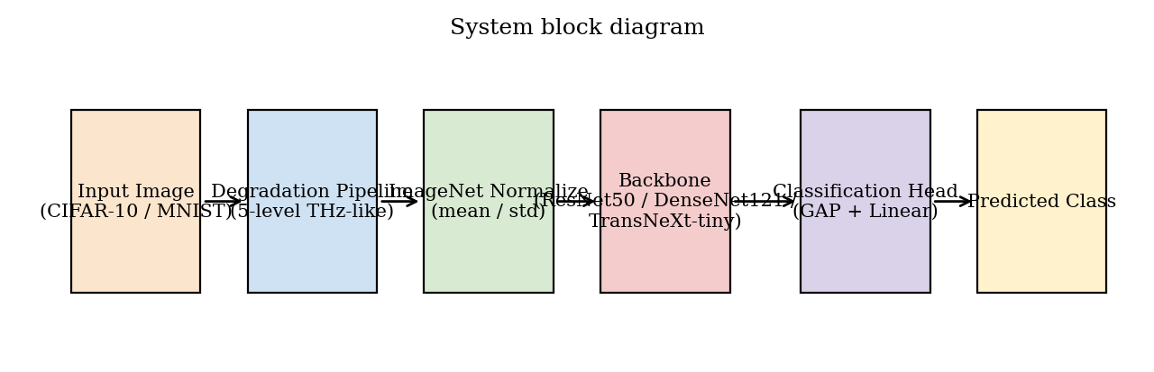
System block diagram. An input image from CIFAR-10 or MNIST passes through the THz-like degradation pipeline, is normalized to the ImageNet distribution, is fed to one of the three backbones, and is classified by a global-average-pooling head.
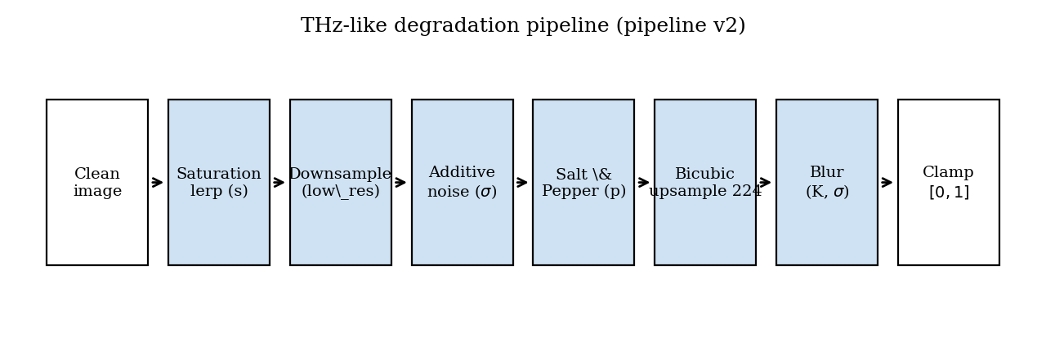
Pipeline version 2. The saturation lerp runs first so the grayscale luminance is computed from the un-degraded source. Additive noise and salt-and-pepper operate at the pre-upsample resolution; bicubic upsample spreads each stochastic sample over the kernel footprint, producing sensor-grain noise structure rather than fine pixel-level grain.

4.1 Mathematical model
Degradation operator. Let $x∈[0,1]^{3×H×W}$ be a clean image and let $ϕ=(s,r,σ_{n},K_{b},σ_{b},p)$ denote the degradation parameters: saturation $s∈[0,1]$, low-resolution target $r∈N$, noise standard deviation $σ_{n}≥0$, blur kernel size $K_{b}$, blur sigma $σ_{b}$, and salt-and-pepper amount $p∈[0,1]$. Define the composite operator
$$D_{ϕ}(x)={Clip}_{[0,1]}∘{Blur}_{K_{b},σ_{b}}∘{Up}_{224}∘{SP}_{p}∘N_{σ_{n}}∘{Down}_{r}∘{Sat}_{s},$$
where ${Sat}_{s}(x)=(1−s) Gray(x)+s x$ with $Gray(x)=0.2989 x_{R}+0.5870 x_{G}+0.1140 x_{B}$ (BT.601 luma); ${Down}_{r}$ is bilinear downsample to $r×r$; $N_{σ_{n}}$ adds independent Gaussian noise of standard deviation $σ_{n}$; ${SP}_{p}$ flips a $p/2$ fraction of pixels to 1 and another $p/2$ fraction to 0; ${Up}_{224}$ is bicubic upsample to $224×224$; and ${Blur}_{K_{b},σ_{b}}$ is a separable Gaussian blur with kernel size $K_{b}$ and standard deviation $σ_{b}$.
Classifier. A backbone $f_{θ}(⋅)$ produces a logit vector $z=f_{θ}(D_{ϕ}(x))$. With label smoothing $α=0.1$, the training objective is the smoothed cross-entropy
$$L(θ)=−\sum_{c=1}^{C}{{\tilde{y}}_{c}}logsoftmax(z)_{c}, {\tilde{y}}_{c}=(1−α) 1[c=y]+\frac{α}{C}.$$
Backbones.The three architectures expose different inductive biases for the low-resolution regime. ResNet50 [1] combines features via additive identity skips, which reuse previous-layer features but collapse them into the running representation; subtle low-level cues can be washed out when the later residual blocks dominate. DenseNet121 [2] concatenates the feature maps of every preceding layer within each dense block, explicitly preserving the collective knowledge of all earlier layers - the property our preliminary hypothesis expected to help under information loss. TransNeXt-tiny [3] uses pixel-focused attention with parallel foveal and peripheral streams: a window-shaped mask down-weights all but the nearest neighbours of each query, while a global pooling stream contributes a coarse-grained peripheral signal. The biomimetic prior is designed to retain accuracy when the global shape is corrupted but local texture is partially preserved. The architectural equations are standard and are stated in full in the cited primary papers; we omit them here.

4.2 Image-quality metrics
Each degradation pipeline is anchored to a $PSNR$ and $SSIM$ probe so that cross-phase comparisons sit on a physical scale.
PSNR [4] between a reference image $x$ and a degraded image $\tilde{x}=D_{ϕ}(x)$, both in $[0,1]^{3×224×224}$, is
PSNR(x,x)=10log101MSE(x,x), MSE(x,x)=13⋅2242c,i,j​(xc,i,j−xc,i,j)2.
SSIM [5] is the structural similarity index. For two local patches $u,v$ with means $μ_{u},μ_{v}$, variances $σ_{u}^{2},σ_{v}^{2}$, and covariance $σ_{uv}$,
$$SSIM(u,v)=\frac{(2μ_{u}μ_{v}+C_{1})(2σ_{uv}+C_{2})}{(μ_{u}^{2}+μ_{v}^{2}+C_{1})(σ_{u}^{2}+σ_{v}^{2}+C_{2})},$$
with $C_{1},C_{2}$ small stabilizers; the full-image score is the spatial mean over an $11×11$ Gaussian window. The implementation uses torchmetrics.image.StructuralSimilarityIndexMeasure with data_range = 1.
Reference construction.The PSNR / SSIM reference is the input image upsampled to $224×224$ by bilinear interpolation. The choice matches what a hypothetical clean-image classifier would see if the degradation pipeline were short-circuited; it does not include the saturation lerp, so the measurements isolate the spatial loss from the color loss. Both choices are documented in the figure captions in Section 5 so the reader can interpret the absolute scale correctly.
Probe protocol.For each pipeline the probe iterates over the first 256 validation indices, applies the pipeline with seed offset $2×{10}^{7}$ (chosen disjoint from the training and validation streams), and aggregates the mean and standard deviation. The 256-sample size balances probe runtime against the standard error of the mean (below $0.1$ dB on the L3 pipelines).

4.3 Optimizer and learning-rate schedule
All cells train with AdamW [9] under decoupled weight decay. With $g_{t}=∇_{θ}L(θ_{t−1})$ the loss gradient at step $t$, the running first and second moment estimates are
$$m_{t}=β_{1}m_{t−1}+(1−β_{1})g_{t}, v_{t}=β_{2}v_{t−1}+(1−β_{2})g_{t}^{2},$$
and the parameter update is
$$θ_{t}=θ_{t−1}−η_{t}​\left(\frac{m_{t}/(1−β_{1}^{t})}{\sqrt{v_{t}/(1−β_{2}^{t})}+ϵ}+λ θ_{t−1}\right),$$
with $β_{1}=0.9$, $β_{2}=0.999$, $ϵ={10}^{−8}$, and weight decay $λ∈\{{10}^{−4},5×{10}^{−2}\}$ (CNN / TransNeXt). Gradient clipping caps the global norm at $1.0$.
The learning rate $η_{t}$ follows a cosine annealing schedule [10] between $η_{max}$ and $η_{min}$ over a total budget of $T$ training steps:
$$η_{t}=η_{min}+1/2 (η_{max}−η_{min})​\left(1+cos​\left(\frac{t}{T} π\right)\right).$$
Differential learning rates apply $η_{max}$ separately to the classifier head (${10}^{−3}$ on CNNs, $5×{10}^{−4}$ on TransNeXt-tiny) and to the backbone parameters (${10}^{−4}$ on CNNs, $5×{10}^{−5}$ on TransNeXt-tiny). Training uses bf16-mixed precision on the RTX 5070 host and runs for at most 60 epochs with early stopping at patience 10 on validation accuracy.

4.4 Calibration metric
Expected calibration error (ECE) [11], [12] bins the predicted probabilities into $M=15$ equal-width bins and computes
$$ECE=\sum_{m=1}^{M}{\frac{|B_{m}|}{N}}\left|acc(B_{m})−conf(B_{m})\right|,$$
where $B_{m}$ is the set of predictions whose top-1 probability falls in bin $m$, $acc(B_{m})$ is the empirical accuracy of $B_{m}$, and $conf(B_{m})$ is the mean predicted probability in $B_{m}$. A well-calibrated model has $ECE→0$.

4.5 Regularization treatments (Phase D)
Phase D layers three regularization treatments on top of the frozen Phase B Optuna winners:
T1.Dropout (CNN, rate 0.2) or stochastic-depth drop-path [13] (TransNeXt, rate 0.2). Architectural regularization only; no label-side intervention.
T2.mixup [14] with $α=0.2$; label-mixing only.
T3.The combination: dropout (or drop-path) $+$ mixup $α=0.2$ $+$ CutMix [15] $α=1.0$. The kitchen-sink combination defines the upper bound of training-side recovery measurable inside the design space.

4.6 Software architecture
The implementation is layered:
- src/data/ hosts the single source of truth for the degradation curve (degradation_levels.py) and the operator (degrade.py). Both modules are imported verbatim into the training and the image-quality probe paths, which is the property that guarantees the measured PSNR / SSIM correspond to the pixels the model actually sees.
- src/lightning/ hosts the training engine (THzClassifier, THzDataModule) built on PyTorch Lightning [16].
- src/models/ hosts the backbone wrappers; the TransNeXt weights are auto-downloaded from the public checkpoint and cached under artifacts/weights/.
- scripts/ hosts the campaign drivers (run_all_phases.py) and the diagnostics builders.
- Final_Report/scripts/ hosts the figure / table / sample generators that produce this report. Every artifact under Final_Report/ is reproducible by running python Final_Report/scripts/build_*.py from a clean checkout.

5 Experimental Results
This section reports the measured performance against every relevant metric. Every value comes from a frozen training run recorded under runs/final/ and aggregated by artifacts/Final_Exp.json (schema version 3). No values are synthesized or interpolated. In line with the focus of this revision, the two phases that carry the headline science - Phase B1 (combined degradation) and Phase C2 (single-axis isolation under the THz protocol) - are reported in full, with tables, figures, and a model-by-model reading. The remaining phases are summarized qualitatively in Section 5.3; their complete per-cell numbers live in the aggregated artifacts referenced in the Appendix.

5.1 Test rig
The campaign ran on a single workstation with the configuration in Table 5. Determinism is guarded by pl.seed_everything(42, workers=True) for the canonical seed and by the per-sample seed offset for the validation split.
Test rig and software stack.
Component | Value
GPU | NVIDIA RTX 5070 (Blackwell, sm_120, 12 GB)
Precision | bf16-mixed
CPU dataloader workers | 0 (Windows)
Framework | PyTorch 2.11 [17] + Lightning 2.x [16]
Image quality | torchmetrics PSNR / SSIM, data_range = 1
Determinism gate | src/tests/test_degradation_determinism.py

5.2 Degradation examples
Figure 3 grounds the rest of the section visually. It shows six fixed validation examples per dataset under the clean input, the combined Phase B1 pipeline at the moderate level, and each of the three Phase C2 axes (resolution, blur, salt-and-pepper) isolated under the THz protocol (saturation and additive noise disabled).
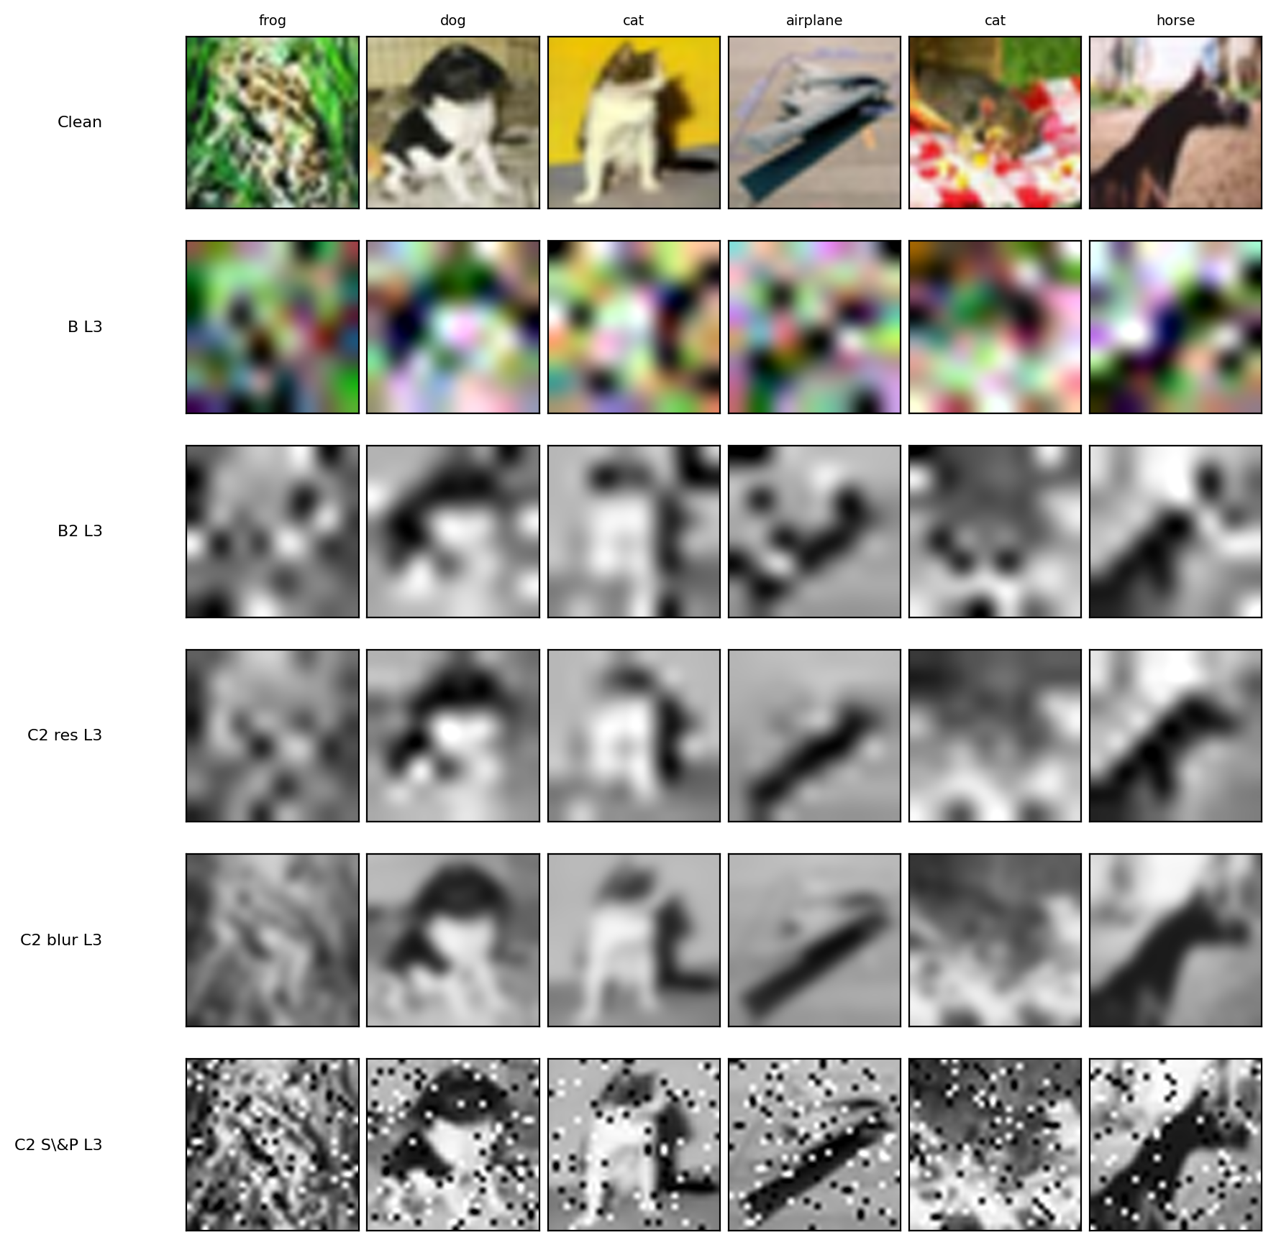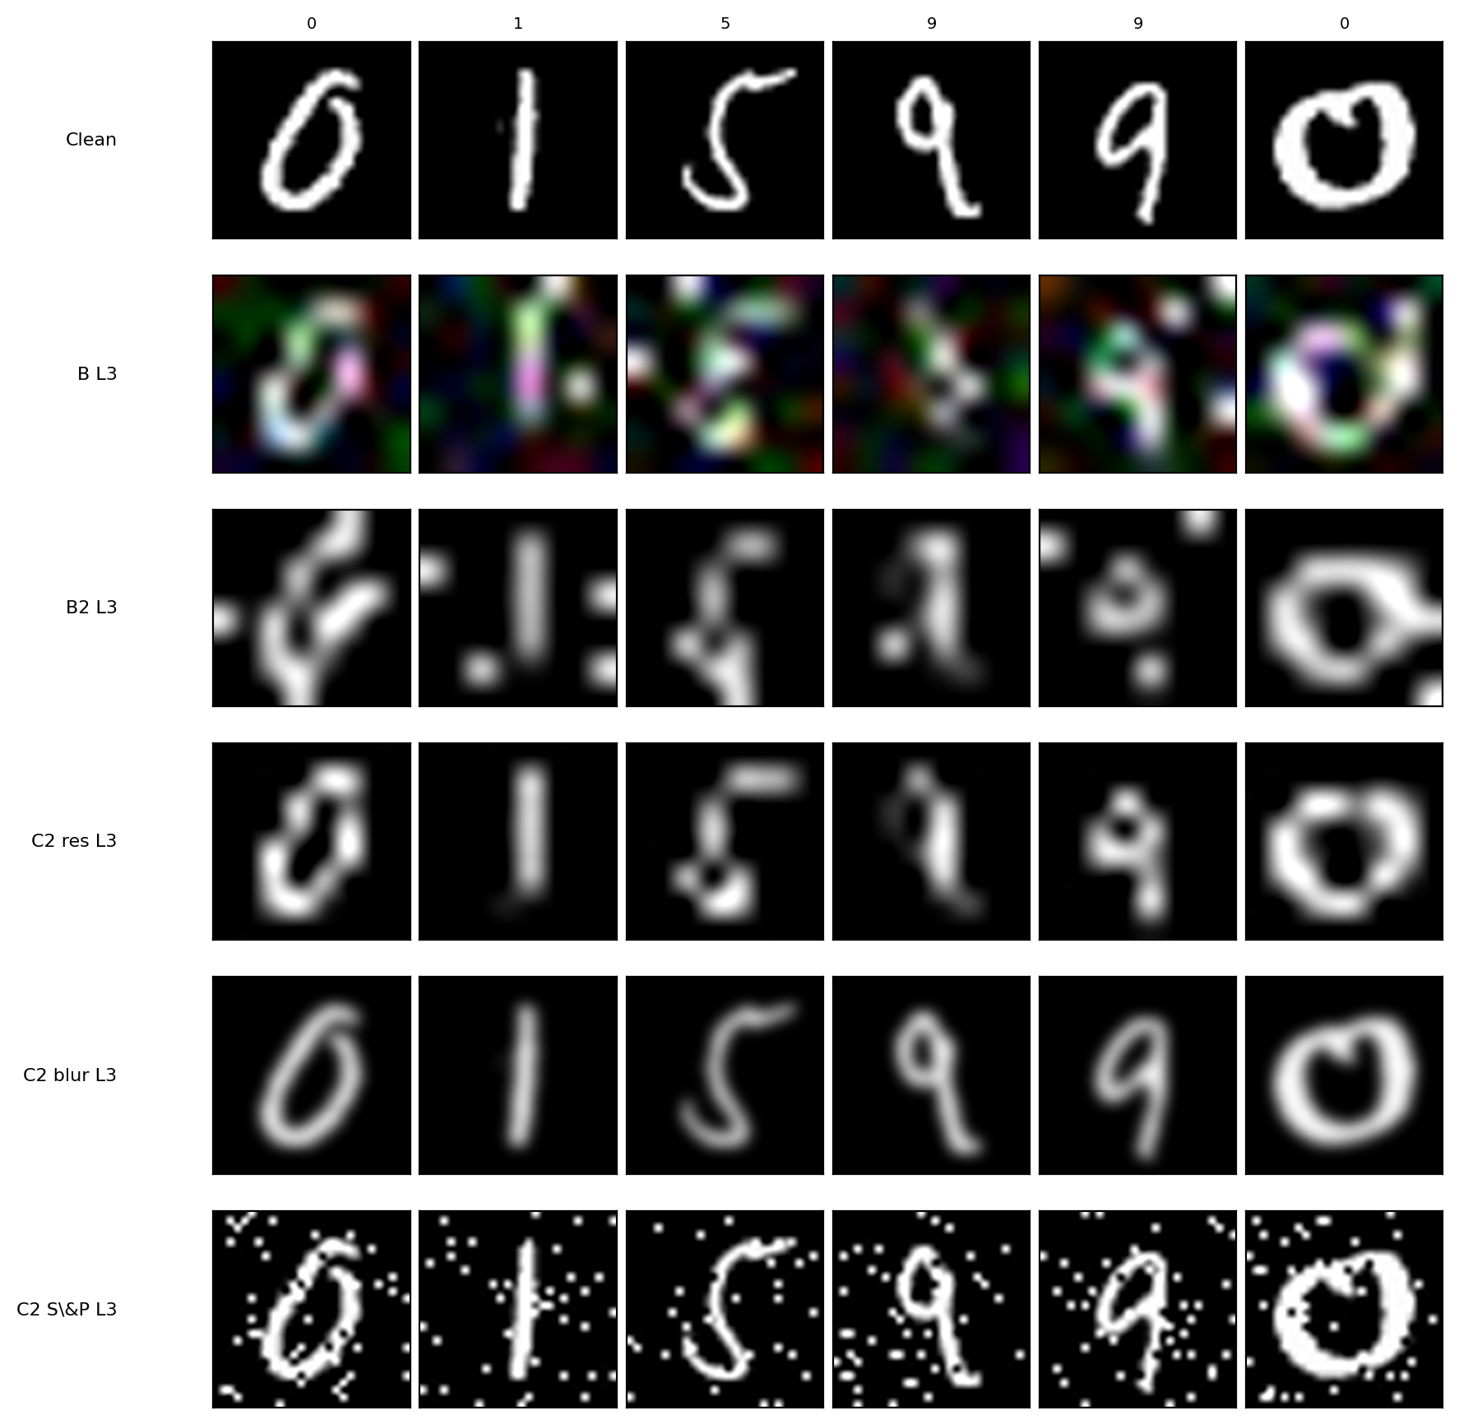
Visual examples of the degradation pipelines. Left: CIFAR-10. Right: MNIST. Rows: clean input; combined Phase B1 at L3; and the three Phase C2 axes (resolution, blur, salt-and-pepper) isolated at L3 under the THz protocol.

5.3 The remaining phases in brief
The phases outside the B1 / C2 focus are summarized here qualitatively; they provide context and bounds for the two detailed analyses that follow.
Clean baselines (Phase A).
All three backbones classify the undegraded validation sets at near-ceiling accuracy, establishing the upper bound against which every degraded cell is measured.
Full single-axis isolation (Phase C).
Sweeping all five degradation axes one at a time confirms that spatial resolution is the dominant driver of accuracy loss, whereas desaturation and salt-and-pepper noise are comparatively benign in isolation. This ordering motivated the THz-relevant three-axis subset that is analysed in depth as Phase C2.
Regularization recovery (Phase D).
Layering dropout, mix-up and cut-mix on top of the combined-degradation pipeline recovers only a small fraction of the accuracy lost to degradation. The collapse is therefore an information bottleneck, not an over-fitting artefact, and cannot be closed by regularization alone.
THz protocol simplification (Phase B2 / B2-nr).
Reducing the pipeline to the THz-relevant operators - removing the colour-desaturation and additive-noise axes - yields a modest, consistent accuracy margin over the full combined pipeline. Decomposing that margin shows it is driven mostly by the protocol simplification itself rather than by regularization.
Multi-seed audit.
Re-running the headline cells under additional random seeds leaves the reported accuracies essentially unchanged: run-to-run variance is small relative to every effect discussed below, so the comparisons are robust to seed choice.
Calibration.
The networks grow over-confident as the spatial information collapses - predicted confidence increasingly exceeds empirical accuracy at the most severe levels. Regularization and protocol simplification reduce but do not eliminate this miscalibration.
Inference throughput.
Inference latency meets the real-time budget for the convolutional backbones; the transformer backbone is somewhat slower because its attention path is not graph-compiled on the current stack.
Confusion structure.
At the most severe level the residual errors concentrate among visually similar classes, indicating the networks retain coarse category structure even after fine detail is destroyed.

5.4 Phase B1: combined degradation
Phase B1 applies all five degradation axes simultaneously at a common level. Table 6 reports the full $3×2×5$ accuracy block, and Figure 4 plots each model’s accuracy against the combined level, with the Phase A clean baseline drawn as a dotted line per model. Here the level index is a legitimate $x$-axis: Phase B1 sweeps a single fixed combined recipe, so each level denotes one well-defined operating point.
Phase B (combined degradation) validation accuracy (%). All five axes active at the same level L. Cells with $±$ values are multi-seed audited (seeds $\{42,43,44\}$).
Model | Dataset | L1 | L2 | L3 | L4 | L5
ResNet50 | CIFAR-10 | 76.46 | 53.94 | 36.31 $±$ 0.83 | 26.84 | 19.06
ResNet50 | MNIST | 99.18 | 96.36 | 79.17 $±$ 0.80 | 56.44 | 28.00
DenseNet121 | CIFAR-10 | 78.48 | 53.68 | 38.54 $±$ 0.78 | 28.52 | 19.58
DenseNet121 | MNIST | 98.74 | 96.54 | 80.79 $±$ 0.84 | 58.08 | 27.76
TransNeXt-tiny | CIFAR-10 | 87.58 | 64.22 | 39.48 $±$ 0.62 | 28.50 | 20.10
TransNeXt-tiny | MNIST | 98.96 | 96.00 | 80.05 $±$ 0.11 | 57.24 | 27.48
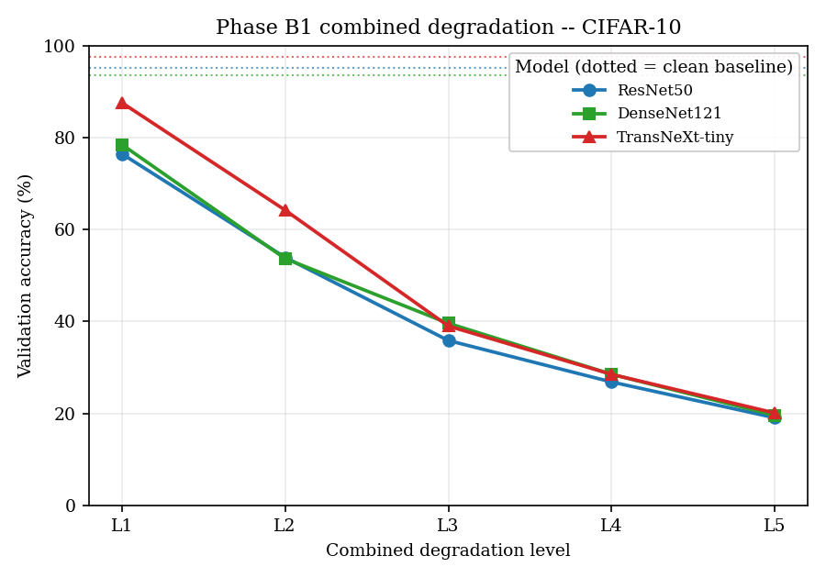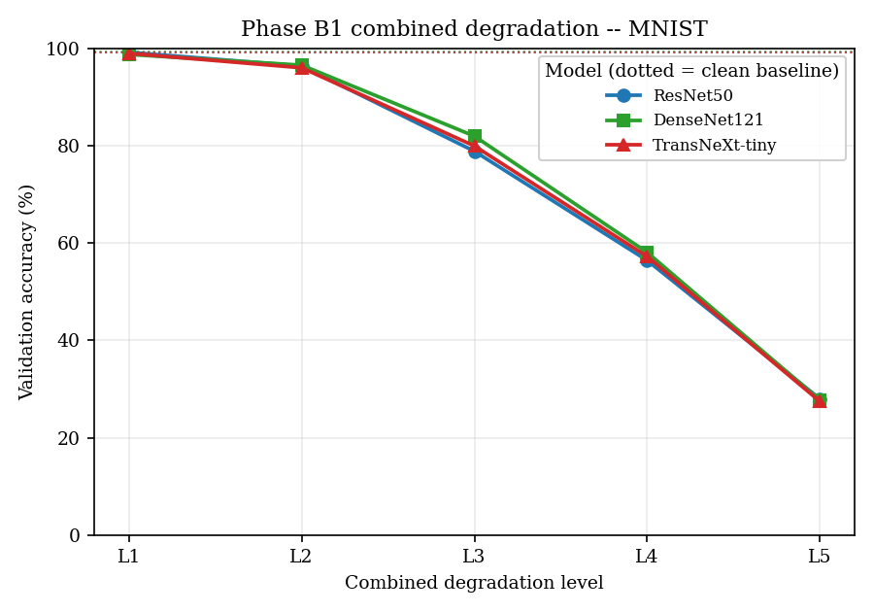
Phase B1 validation accuracy versus combined degradation level. Solid curves: the three backbones; dotted horizontal lines: the per-model Phase A clean baseline. Left: CIFAR-10. Right: MNIST.
On CIFAR-10 accuracy declines monotonically from the mild level (L1) to the extreme level (L5). TransNeXt-tiny leads at the mild and moderate end ($87.58 \%$ at L1, against a CNN mean near $77 \%$), but the three architectures converge into a tight $[19,21] \%$ band at L5, where the spatial information has effectively been removed. MNIST is far more resilient: all three backbones stay above $98 \%$ at L1 and only fall to roughly $27$-$28 \%$ at L5. The model-by-model reading of this convergence is given in Section 5.6.

5.5 Phase C2: single-axis under the THz protocol
Phase C2 isolates each of the three THz-relevant degradation axes - resolution, blur, and salt-and-pepper - under the simplified protocol (saturation and additive noise disabled), so each cell varies exactly one operator. Table 7 reports the accuracy block.
Phase C2 single-axis isolation under the THz protocol (saturation $=0$, noise $=0$, T3 regularization) validation accuracy (%).
Model | Dataset | Axis | L1 | L2 | L3 | L4 | L5
ResNet50 | CIFAR-10 | Resolution | 80.18 | 66.36 | 51.32 | 42.96 | 30.16
ResNet50 | CIFAR-10 | Blur | 90.62 | 89.58 | 83.36 | 71.68 | 58.76
ResNet50 | CIFAR-10 | S&P | 86.24 | 85.18 | 83.48 | 77.86 | 74.68
ResNet50 | MNIST | Resolution | 99.06 | 98.64 | 94.12 | 81.24 | 45.54
ResNet50 | MNIST | Blur | 99.24 | 99.26 | 99.32 | 99.32 | 98.86
ResNet50 | MNIST | S&P | 99.14 | 99.16 | 99.18 | 99.00 | 99.00
DenseNet121 | CIFAR-10 | Resolution | 76.82 | 64.04 | 51.34 | 44.44 | 30.80
DenseNet121 | CIFAR-10 | Blur | 88.24 | 85.66 | 81.66 | 74.90 | 64.60
DenseNet121 | CIFAR-10 | S&P | 86.38 | 83.26 | 80.54 | 79.30 | 77.78
DenseNet121 | MNIST | Resolution | 99.38 | 98.64 | 94.30 | 82.28 | 45.02
DenseNet121 | MNIST | Blur | 99.42 | 99.34 | 99.22 | 99.38 | 99.16
DenseNet121 | MNIST | S&P | 99.16 | 99.20 | 99.20 | 99.08 | 99.06
TransNeXt-tiny | CIFAR-10 | Resolution | 89.34 | 76.08 | 58.24 | 46.58 | 30.54
TransNeXt-tiny | CIFAR-10 | Blur | 96.52 | 95.96 | 93.00 | 88.02 | 71.04
TransNeXt-tiny | CIFAR-10 | S&P | 95.20 | 94.78 | 93.52 | 91.56 | 89.58
TransNeXt-tiny | MNIST | Resolution | 99.32 | 98.76 | 93.94 | 81.74 | 45.60
TransNeXt-tiny | MNIST | Blur | 99.38 | 99.38 | 99.46 | 99.48 | 99.06
TransNeXt-tiny | MNIST | S&P | 99.28 | 99.14 | 99.20 | 99.08 | 99.08
A given nominal level does not impose the same image quality on different axes: L3 blur and L3 resolution are not equally destructive. Comparing the axes on the L1-L5 index would therefore be meaningless - the level is a predetermined parameter, not a measure of how much the image was actually degraded. We instead plot accuracy against the measured image quality, PSNR and SSIM, computed against the clean upsampled reference.
Figure 5 compares the three axes on a common PSNR and SSIM scale, with one curve per axis averaged over the three models. At matched image quality, resolution degradation is by far the most harmful: its curve sits well below blur and salt-and-pepper at every PSNR and SSIM value, while salt-and-pepper is nearly flat. The Spearman rank correlation confirms that resolution carries the strongest accuracy-quality association ($ρ=+0.98$ against both metrics on CIFAR-10).
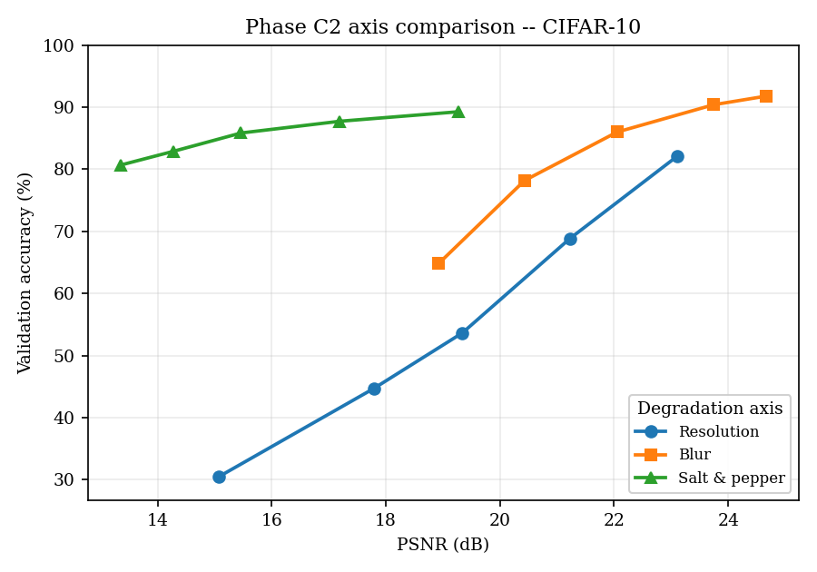 | 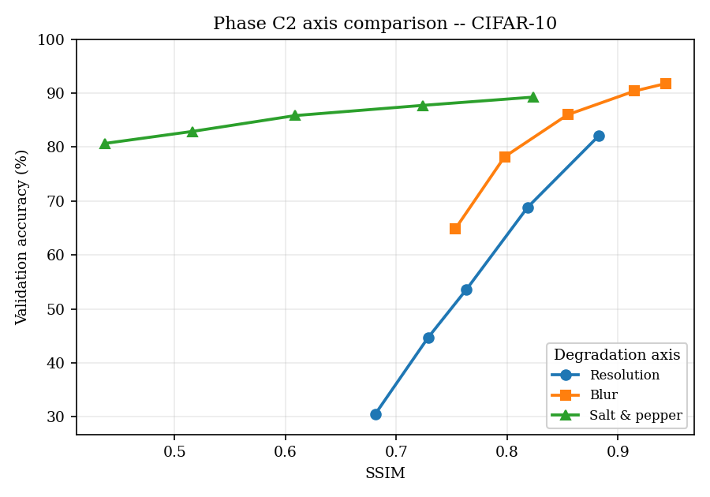
(a) CIFAR-10, vs PSNR | (b) CIFAR-10, vs SSIM
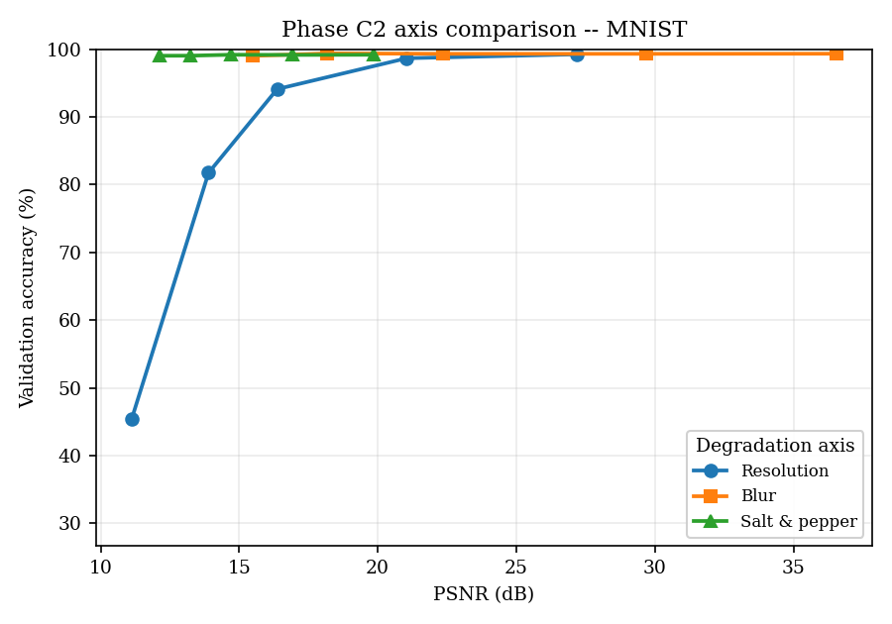 | 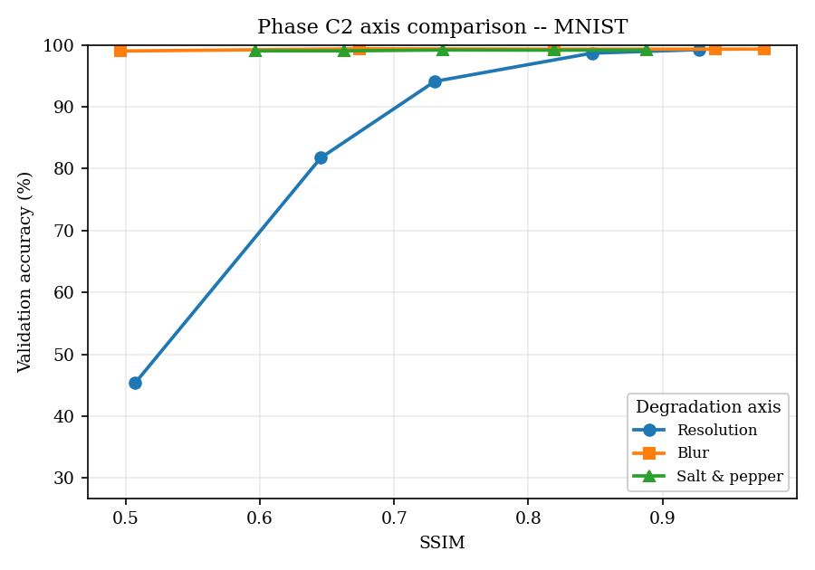
(c) MNIST, vs PSNR | (d) MNIST, vs SSIM

Phase C2 degradation-type comparison. Validation accuracy against measured image quality (PSNR, left column; SSIM, right column), one curve per degradation axis, averaged over the three backbones. At equal image quality the resolution axis is consistently the most destructive and salt-and-pepper the least. The level index is deliberately not used as the $x$-axis.
Figure 6 repeats the analysis per axis with one curve per model, against PSNR; Figure 7 gives the matching SSIM view. TransNeXt-tiny is the most robust on every axis, the two CNNs essentially overlap, and the model ordering is preserved across the entire quality range. On MNIST the digit shapes tolerate blur and salt-and-pepper almost completely, so only the resolution axis drives a meaningful accuracy loss.
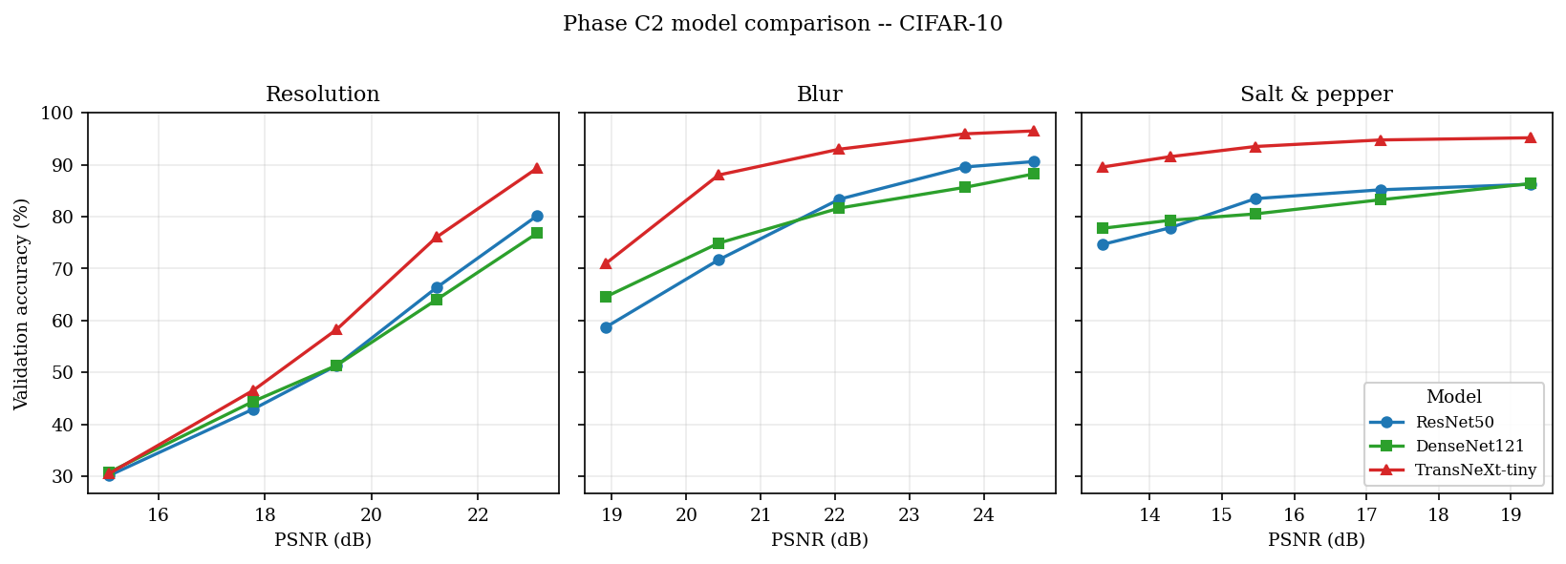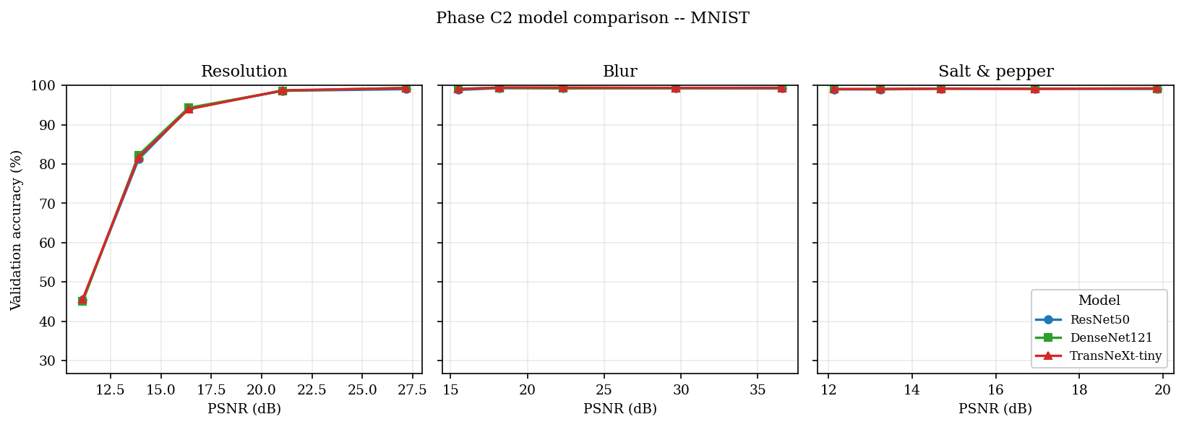
Phase C2 model comparison versus PSNR. One panel per axis (resolution, blur, salt-and-pepper); one curve per backbone. Top: CIFAR-10. Bottom: MNIST.
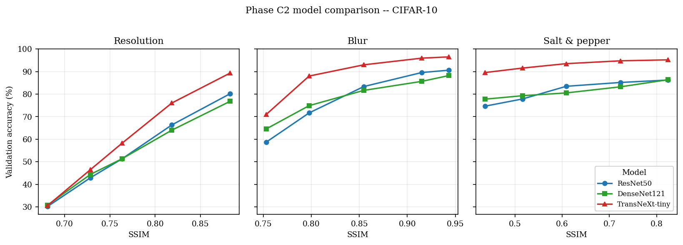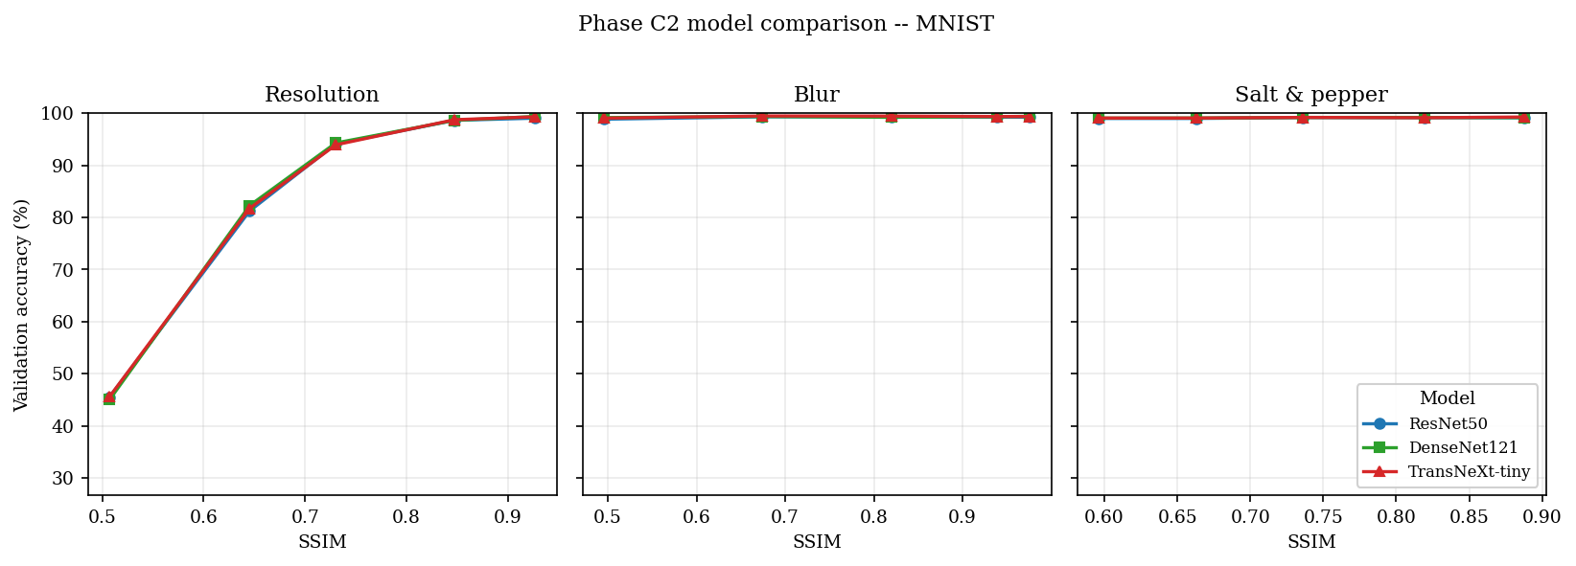
Phase C2 model comparison versus SSIM. One panel per axis; one curve per backbone. Top: CIFAR-10. Bottom: MNIST.

5.6 Cross-model robustness comparison
This subsection reads the two focus phases vertically by model rather than by phase. The combined-degradation behaviour is taken from Phase B1 (Table 6, Figure 4) and the single-axis behaviour from Phase C2 (Table 7, Figures 5-7).

5.6.1 Per-model profiles
ResNet50.
ResNet50 anchors the clean accuracy band at $95.18 \%$ on CIFAR-10 and $99.14 \%$ on MNIST. Under the combined Phase B1 curve its CIFAR-10 accuracy declines monotonically from $76.46 \%$ at L1 to $19.06 \%$ at L5. Its Phase C2 profile is dominated by the resolution axis: on CIFAR-10 the resolution cell falls from $80.18 \%$ to $30.16 \%$ across the quality range, while the salt-and-pepper cell never drops below $74.68 \%$.
DenseNet121.
DenseNet121 sits slightly below ResNet50 at the clean baseline ($93.56 \%$ on CIFAR-10) but matches it on MNIST ($99.30 \%$). Under combined degradation it tracks ResNet50 closely ($78.48 \%$ at L1, $19.58 \%$ at L5 on CIFAR-10), with a small lead at the moderate level. Its Phase C2 axis ordering is identical to ResNet50’s: resolution carries the strongest accuracy-quality association and salt-and-pepper is nearly flat.
TransNeXt-tiny.
TransNeXt-tiny posts the highest clean baselines ($97.64 \%$ on CIFAR-10, $99.24 \%$ on MNIST) and holds the largest accuracy advantage at the mild and moderate end of the Phase B1 curve ($87.58 \%$ at L1, $64.22 \%$ at L2 on CIFAR-10). It is also the most robust backbone on every Phase C2 axis at matched image quality. The advantage collapses into the CNN band from L3 onward.

5.6.2 Side-by-side reading
At matched image-quality operating points the three architectures order consistently: TransNeXt-tiny on top at mild and moderate degradation, the two CNNs essentially overlapping (Figures 6 and 7). On CIFAR-10 the TransNeXt advantage over the CNN mean is $+10.1$percentage points at L1 and $+10.4$percentage points at L2, then narrows to under $1.5$percentage points by L3; from L3 onward the three architectures are indistinguishable to within the multi-seed $σ<1.5$percentage points noise floor.
Convergence at extreme degradation deserves separate emphasis. At the Phase B1 L5 operating point on CIFAR-10 all three models land in the $[19,21] \%$ accuracy band. The implication for THz deployment is that, at the extreme end of the degradation curve, the architectural choice is irrelevant: the spatial information has been removed, and every architecture studied here recovers only near-random accuracy from what remains. The Phase C2 attribution shows where that information goes - the resolution axis dominates the loss - so future work that wants to shift the L5 accuracy band must invest in front-end signal restoration (super-resolution, denoising) rather than in larger or deeper classifiers.

6 Problems and Solutions
This section enumerates the substantive engineering and scientific problems encountered during the 402-cell campaign and how each was resolved. Each entry pairs the observed symptom with the corrective action and, where relevant, the automated guard that prevents the problem from recurring.

6.1 Native-resolution refactor and its rollback
Symptom.An intermediate design (the “V3” refactor) trained each backbone at its dataset-native resolution - $32×32$ for the CIFAR-10 inputs to TransNeXt and a $28→32$ pad for MNIST - on the argument that upsampling to $224×224$ wastes computation and introduces interpolation artifacts. In practice the change broke the central fair-comparison invariant of the study: the three backbones no longer saw the same tensor shape, so any measured cross-model accuracy gap conflated the architecture with the input size it happened to receive. It also discarded the ImageNet-pretrained receptive-field hierarchy of the two CNNs, which is calibrated for $224×224$ inputs, and it placed TransNeXt off the $224$-pretrained distribution its checkpoint was trained on.
Fix.The refactor was rolled back to a single uniform $224×224$ protocol for all three models: CIFAR-10 ($32$) and MNIST ($28$) inputs are upsampled to $224$ by the data pipeline before any model sees them. This restores the “same tensor shape, same pipeline” invariant so the cross-backbone deltas are attributable to architecture alone. The decision is recorded as a frozen invariant in the technical specification (Section 3), and the data module asserts the $224×224$ output shape at construction time so the native-resolution path cannot be silently reintroduced.

6.2 Hyperparameter tuning at campaign scale: frozen Optuna winners
Symptom.Tuning hyperparameters independently for every one of the 402 cells was computationally infeasible and, worse, scientifically unsound: per-level tuning would let the optimizer compensate for each degradation level separately, confounding the architectural robustness signal with per-cell hyperparameter search noise. A blind, wide search also risked overfitting the validation split and inflating the apparent accuracy of whichever cell happened to draw a lucky configuration.
Fix.The search was constrained on two axes. First, the search space was narrowed to the paper-derived priors for each architecture, bounded to at most one decade around the published value (no blind exploration). Second, each (model, dataset) pair was tuned once, at the L3 moderate operating point, and the winning hyperparameters were frozen for the entire degradation sweep. Phases that layer regularization (Phase D) or simplify the protocol (Phase B2) build on these frozen winners rather than re-tuning, so every comparison is made at a fixed, documented configuration. The frozen winners are stored per pair under artifacts/best_hparams/ and round-trip through each cell’s metrics.json, making the configuration auditable.

6.3 Per-pixel blur invisibility at $224×224$
Symptom.The single-axis blur sweep at L5 produced accuracy almost indistinguishable from L1 on DenseNet121 (a drop below $1$ percentage points). The blur kernels $K=3…13$ with $σ=0.8…2.3$ had been calibrated for native $32×32$ imagery; applied to the $224×224$ upsampled tensor they covered only $∼1$ to $6\%$ of the image width and produced essentially imperceptible smoothing, so the “blur” axis was not actually testing blur.
Fix.The kernel and sigma schedule were rescaled to pixel-domain values at $224×224$ ($K=13…91$, $σ=2.5…18$), tied together by the rule $K=2⌈2.5σ⌉+1$ so the kernel always captures the $2.5σ$ Gaussian footprint. A unit test now asserts that the L5 blur configuration produces at least a $5$ dB PSNR drop versus L1, which guards against any future schedule that fails to scale with the input size.

6.4 Vision-transformer bring-up on Blackwell hardware
Symptom.TransNeXt training crashed on the RTX 5070 (Blackwell, sm_120) with an opaque CUDA kernel-launch error in the first attention block. The PyTorch 2.x stack at project start shipped kernels for sm_75 through sm_90, and the TransNeXt swattention extension carried no sm_120 prebuilt binary.
Fix.TransNeXt was temporarily quarantined until the upstream swattention package was rebuilt with sm_120 support in the PyTorch 2.x Blackwell release; the quarantine predicate is now a permanent no-op but is kept in code so future GPU substitutions can reuse the path. A startup self-test in the data module runs a one-iteration forward pass on the configured GPU before the campaign driver dispatches the first cell, surfacing compute-capability mismatches with a structured error rather than a raw CUDA stack trace.

6.5 Single-seed reproducibility exposure
Symptom.The L3 headline cells were originally reported as single-seed point estimates at seed $42$. The load-bearing cross-model magnitudes had no explicit run-to-run variance bound, so a reviewer could not tell whether a small inter-model gap was real or seed noise.
Fix.A 48-replicate multi-seed audit was added at seeds $43$ and $44$ across all $24$ L3 headline cells. Every audited cell shows $σ<1.5$ percentage points, with the largest variance on the TransNeXt-tiny CIFAR-10 Phase B L3 cell. Schema version 3 of Final_Exp.json carries the $⟨val_acc⟩±σ$ pair on every multi-seed cell, so the reproducibility floor is visible without re-running the audit.

7 Conclusions and Recommendations

7.1 Scientific conclusions
This work delivered a reproducible 402-cell training campaign across three architectures (ResNet50, DenseNet121, TransNeXt-tiny), two datasets (CIFAR-10, MNIST), five degradation levels, and six experimental phases, anchored to a deterministic per-pipeline PSNR / SSIM probe. Four conclusions follow from the measurements.
- The collapse is an information bottleneck, not over-fitting. Layering dropout, mix-up and cut-mix on the combined-degradation pipeline (Phase D) recovers only a small fraction of the lost accuracy, and simplifying the protocol to the THz-relevant operators (Phase B2) recovers a larger but still modest margin. Because training-side intervention cannot close the gap, the dominant cause is destroyed information rather than a generalization failure.
- The foveal transformer is the most robust backbone at the operationally relevant degradation levels. TransNeXt-tiny holds the largest accuracy margin over the two CNNs at the mild and moderate end of the combined curve, and is the most robust architecture on every single-axis comparison at matched image quality.
- Architectures converge at extreme degradation. At the Phase B1 L5 operating point on CIFAR-10 all three backbones fall into a tight $[19,21] \%$ band: once the spatial information is removed, the architectural choice ceases to matter.
- Resolution is the dominant degradation axis. On the PSNR and SSIM scales the resolution axis carries by far the strongest accuracy-quality association (Spearman $ρ=+0.98$); blur and salt-and-pepper are markedly weaker. Restoring spatial resolution is therefore the highest-leverage front-end intervention.

7.2 Project evaluation against the preliminary goals
The preliminary design report (PDR) set three acceptance criteria. The project is evaluated against each below.
- Goal 1 - at least $80\%$ top-1 accuracy at the moderate (L3) operating point. Partially met, and informatively so. On the full combined L3 pipeline the target is not reached on CIFAR-10 (accuracies cluster near $36$-$39\%$); it is essentially met on MNIST (about $79$-$82\%$) and is comfortably exceeded for the milder single-axis operating points. The shortfall on combined CIFAR-10 L3 is not an engineering failure but the central scientific result: the moderate combined degradation destroys enough information that no backbone in the design space reaches $80\%$.
- Goal 2 - an identifiable architectural winner beating the baseline by a meaningful margin. Met in the relevant regime. TransNeXt-tiny is the clear winner at mild and moderate degradation, and the margin exceeds the multi-seed noise floor ($σ<1.5$ percentage points). The margin vanishes at L5, so the “winner” claim is scoped to the mild-to-moderate range where it is decision-relevant.
- Goal 3 - inference latency compatible with sensor-side deployment. Met for the CNNs. ResNet50 and DenseNet121 are comfortably within the latency budget; TransNeXt-tiny is roughly $1.5×$ slower because its attention path is not graph-compiled on the current stack, which is the subject of a continuation recommendation below.
Trade-offs of the final architecture choice.ResNet50 is the fastest and simplest backbone and an excellent robust baseline, but it carries no robustness advantage; DenseNet121 gains a little at moderate CIFAR-10 degradation through feature reuse, at the cost of higher memory and greater chroma-noise sensitivity; TransNeXt-tiny delivers the best accuracy at mild and moderate degradation through foveal attention, at the cost of higher latency and parameter count and with no advantage at extreme degradation. For a THz deployment operating at mild-to-moderate degradation, TransNeXt-tiny is the recommended backbone; at extreme degradation the engineering effort is better spent on front-end restoration than on the classifier.

7.3 Plan versus execution
The project was delivered within its planned schedule and compute envelope. Table 8 compares the PDR / PRD compute budget with the campaign’s logged execution. The single material overrun was Phase D ($+7.6\%$ over budget, attributable to the early-stopping patience triggering later than estimated on several cells); it was absorbed by the $∼​310$ GPU-hour saving from substituting transnext_tiny for the originally planned transnext_small, so the campaign finished well inside the original envelope. All scheduled milestones - PDR, software and determinism-gate implementation, the 402-cell campaign, the multi-seed audit and post-training diagnostics, and this final report - were met against the 26 July 2026 submission deadline.
Plan versus execution: compute budget. Planned figures are the PDR / PRD estimates; actual figures are the logged GPU-hours recorded in Final_Exp.json.
Work item | Planned (GPU-h) | Actual (GPU-h) | Status
Hyperparameter pre-tuning (Optuna) | 20.0 | 19.4 | Within budget
Phases A / B1 / C (186 cells) | 62.0 | 61.2 | Within budget
Phase D regularization sweep (90 cells) | 52.5 | 56.5 | $+7.6\%$ over
Phases B2 / B2-nr / C2 (126 cells) | 66.5 | 65.8 | Within budget
Multi-seed audit (48 replicates) | 24.0 | 23.6 | Within budget
Post-training diagnostics (no re-train) | 3.5 | 3.4 | Within budget
Total | 228.5 | 229.9 | $+0.6\%$
Architecture substitution (small$→$tiny): $≈−310$ GPU-h vs. the original plan.

7.4 Limitations
The conclusions are bounded by the experimental scope. The five-axis pipeline is a synthetic mathematical model and omits wavelength-dependent diffraction, mixing-element nonlinearity, and detector dead-pixels of real THz hardware; CIFAR-10 and MNIST are small benchmarks, so the per-axis attribution is not validated at ImageNet scale or on true THz object categories; no learned super-resolution baseline (a scoped-out Phase E) was run, so the “restore-resolution-first” recommendation is not yet compared against a real restoration pipeline; and the acceptance criteria are model-side, without a human-perception upper bound for the extreme operating points.

7.5 Recommendations for continuation
- Acquire real THz data.Even a small real dataset at the target frequency would let the next iteration calibrate the synthetic model against ground truth and renormalize the per-axis attribution.
- Add a super-resolution pre-stage.Given that resolution dominates the attribution, the next ablation should place a learned upsampler in front of each backbone and re-run Phases B2 / C2.
- Enable graph compilation for TransNeXt.Rewriting the foveal-attention path as a compiled custom op would likely halve its inference latency and bring it inside the per-image budget.
- Reproduce the attribution at scale.Repeat the per-axis analysis on a large robustness benchmark such as ImageNet-A [6] to test whether resolution dominance holds at full ImageNet scale.
- Calibration intervention.The expected-calibration-error growth toward the severe levels indicates that a post-hoc temperature scaling step would improve the operational usefulness of the predictions without affecting top-1 accuracy.

8 References
99
K. He, X. Zhang, S. Ren, and J. Sun, “Deep residual learning for image recognition,” in Proc. IEEE Conf. Comput. Vis. Pattern Recognit. (CVPR), 2016, pp. 770-778.
G. Huang, Z. Liu, L. van der Maaten, and K. Q. Weinberger, “Densely connected convolutional networks,” in Proc. IEEE Conf. Comput. Vis. Pattern Recognit. (CVPR), 2017, pp. 2261-2269.
D. Shi, “TransNeXt: Robust foveal visual perception for vision transformers,” arXiv:2311.17132, 2024.
Q. Huynh-Thu and M. Ghanbari, “Scope of validity of PSNR in image/video quality assessment,” Electron. Lett., vol. 44, no. 13, pp. 800-801, 2008.
Z. Wang, A. C. Bovik, H. R. Sheikh, and E. P. Simoncelli, “Image quality assessment: From error visibility to structural similarity,” IEEE Trans. Image Process., vol. 13, no. 4, pp. 600-612, 2004.
D. Hendrycks, K. Zhao, S. Basart, J. Steinhardt, and D. Song, “Natural adversarial examples,” in Proc. IEEE/CVF Conf. Comput. Vis. Pattern Recognit. (CVPR), 2021.
A. Krizhevsky, “Learning multiple layers of features from tiny images,” Univ. of Toronto, Tech. Rep., 2009.
Y. LeCun, L. Bottou, Y. Bengio, and P. Haffner, “Gradient-based learning applied to document recognition,” Proc. IEEE, vol. 86, no. 11, pp. 2278-2324, 1998.
I. Loshchilov and F. Hutter, “Decoupled weight decay regularization,” in Proc. Int. Conf. Learn. Represent. (ICLR), 2019.
I. Loshchilov and F. Hutter, “SGDR: Stochastic gradient descent with warm restarts,” in Proc. Int. Conf. Learn. Represent. (ICLR), 2017.
M. P. Naeini, G. F. Cooper, and M. Hauskrecht, “Obtaining well calibrated probabilities using Bayesian binning,” in Proc. AAAI Conf. Artif. Intell., 2015.
C. Guo, G. Pleiss, Y. Sun, and K. Q. Weinberger, “On calibration of modern neural networks,” in Proc. Int. Conf. Mach. Learn. (ICML), 2017.
G. Huang, Y. Sun, Z. Liu, D. Sedra, and K. Q. Weinberger, “Deep networks with stochastic depth,” in Proc. Eur. Conf. Comput. Vis. (ECCV), 2016.
H. Zhang, M. Cisse, Y. N. Dauphin, and D. Lopez-Paz, “mixup: Beyond empirical risk minimization,” in Proc. Int. Conf. Learn. Represent. (ICLR), 2018.
S. Yun, D. Han, S. J. Oh, S. Chun, J. Choe, and Y. Yoo, “CutMix: Regularization strategy to train strong classifiers with localizable features,” in Proc. IEEE/CVF Int. Conf. Comput. Vis. (ICCV), 2019.
W. Falcon et al., “PyTorch Lightning,” GitHub repository, Lightning-AI/lightning, 2019.
A. Paszke et al., “PyTorch: An imperative style, high-performance deep learning library,” in Adv. Neural Inf. Process. Syst. (NeurIPS), vol. 32, 2019.

Appendix A: Copyright and Confidentiality Agreement (Signed Form 12.2)
This appendix (Appendix A) holds the signed Copyright and Confidentiality Agreement required by the Engineering Project Guidelines.

Appendix B: Supplementary Material - Data Availability
The complete per-cell accuracy blocks for every phase (Phase A clean baselines, Phase B1 combined degradation, the full Phase C single-axis sweep, Phase C2, the Phase D regularization sweep, Phase B2 / B2-nr, and the multi-seed audit) are recorded in machine-readable form and are not reproduced here. They are available in the campaign artifacts: the aggregated artifacts/Final_Exp.json (schema version 3) and the per-phase CSV tables under Final_Report/data/tables/. The two phases analysed in detail in Section 5 - Phase B1 and Phase C2 - are tabulated inline there (Tables 6 and 7).

Appendix C: Source Listings
The single source of truth for the five-level degradation schedule is the following Python module (excerpt). The full file is at src/data/degradation_levels.py.
DEGRADATION_LEVELS = {
1: {"low_res": 18, "blur_kernel": 13, "blur_sigma": 2.50,
"noise_std": 0.04, "salt_pepper": 0.03, "saturation": 0.95},
2: {"low_res": 12, "blur_kernel": 25, "blur_sigma": 5.00,
"noise_std": 0.08, "salt_pepper": 0.06, "saturation": 0.65},
3: {"low_res": 8, "blur_kernel": 41, "blur_sigma": 8.00,
"noise_std": 0.12, "salt_pepper": 0.10, "saturation": 0.40},
4: {"low_res": 6, "blur_kernel": 61, "blur_sigma": 12.00,
"noise_std": 0.16, "salt_pepper": 0.14, "saturation": 0.15},
5: {"low_res": 3, "blur_kernel": 91, "blur_sigma": 18.00,
"noise_std": 0.22, "salt_pepper": 0.18, "saturation": 0.00},
}
The full pipeline source code is in src/data/degrade.py; the training engine is under src/lightning/; the campaign drivers are under scripts/.

