Hi
Current package has been uploaded from Unity 2020.3.6f1 and HD RP 10.x at Ma 2021
Also tested on unity 2021.2.0a and works well
This is the Lit version with some limitations:
Some effects are not availbale in the Lit version:
- Fog and Volumetric Lighting
- Snow effect and shader
- Screen Space Reflections
- Terrain tessellation shader
- Day Night cycle helper prefab

First you must install HD pipeline into your project or use default sample creator.
There are some useful links:
https://unity.com/how-to/getting-started-high-definition-render-pipeline-hdrp-games

HD RP Manual:
https://docs.unity3d.com/Packages/com.unity.render-pipelines.high-definition@6.9/manual/index.html

Also you must enable Screen Space Reflections:
- Go to Edit->Project Settings
- Enable Screen Space Reflections from Lighting Tab
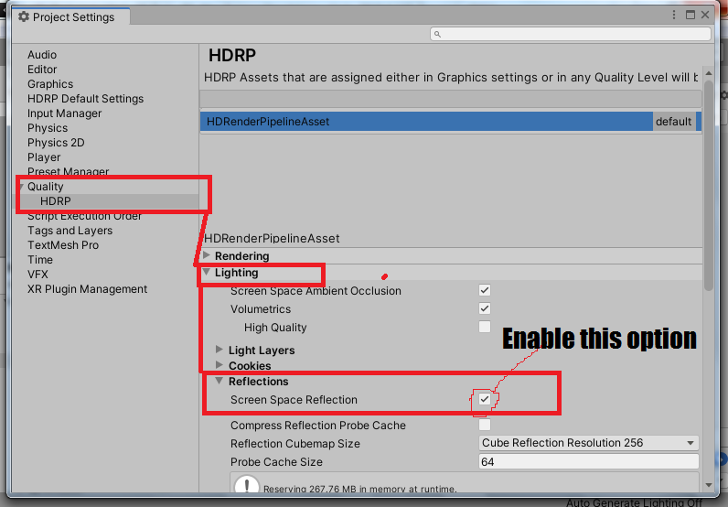
3. Enable Screen Space Global Illumination from Lighting Tab
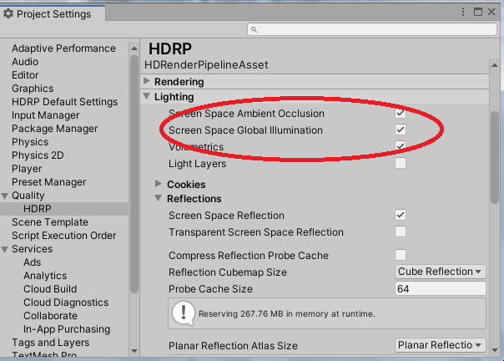

Update 2021 playlist for update 1.6:
https://www.youtube.com/playlist?list=PLVXvfvDWvto3FJHcWEcV1xOPrKDbFEHvQ

My youtube Channel:
https://www.youtube.com/channel/UCKGKwkmZagsc0QKTkWn_w-w

HDRP Tutorials:
https://www.youtube.com/watch?v=nJ5XnjzFkH0&list=PLVXvfvDWvto0B4yUal_H4ea3wcUxB3Z_9

