Hi
First of all, I want to thank you for your purchase.
I have worked hard to make this package and thank you for choosing it
I ask you not share it for free so that I do not lose motivation for future updates.
I also ask you to ask your questions and problems from my email(aliyeredon@gmail.com) and try to not write a negative comment on the Store page. This drastically reduces package sales and reduces my motivation to update the package
Thank you

Video Tutorial Play List On YouTube Channel:
https://www.youtube.com/playlist?list=PLVXvfvDWvto3FJHcWEcV1xOPrKDbFEHvQ
importing HDRP Lighting Box 2 and installing HDRP based on quick start guide, you can open it from Window->HD Lighting Box 2 menu:
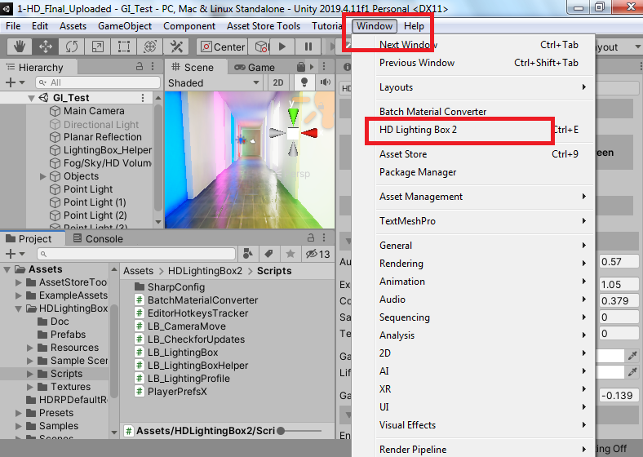

Now you can see HD Lighting Box 2 window inside Inspector:

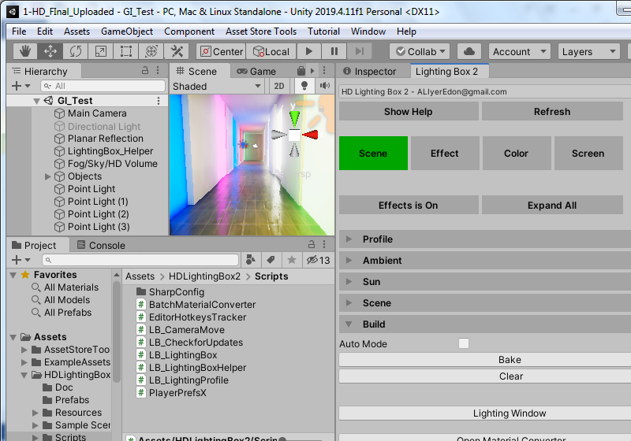
To use HD Lighting Box 2 you must create an separate profile for each scene. It called Lighting Profile.
Note: You must have a camera in your scene to apply effects
To create it, first you must save your scene. After that click on the New button in Profile section of the Lighting Box. Now you must select a path to let Lighting Box to create an Lighting Profile and HDRP Volume profile for your current scene:
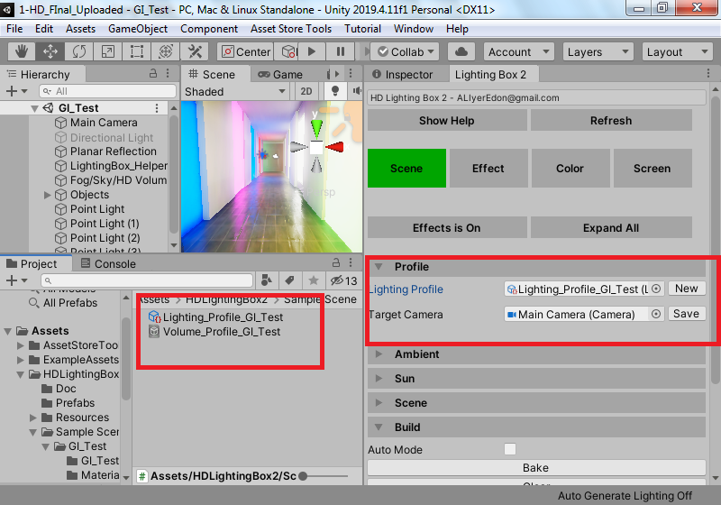
As you can see two game objects has been created in your scene:
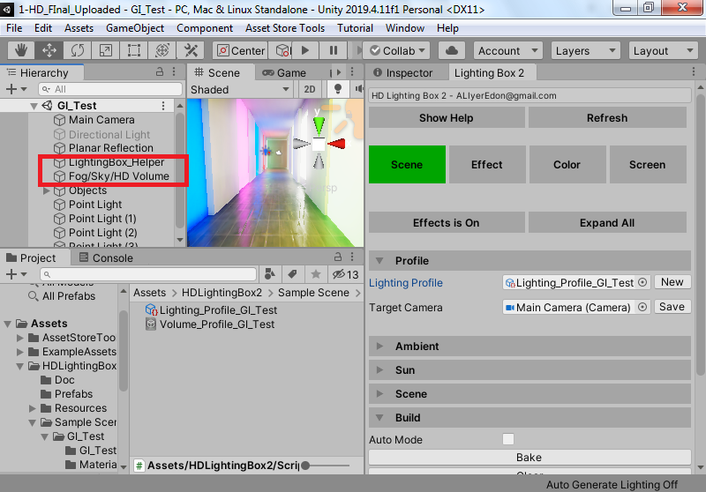
These objects is always available and creating when opening Lighting Box window. You can’t delete them when Lighting Box 2 window is open. You can disable Lighting Box Helper object when you don’t like to use lighting box at the future
Note: Default HDRP volume game object (created by HDRP on an new empty scene) will be deleted when creating Lighting Box objects (name: “Sky and Fog Volume")
Now you are ready to use Lighting Box.

Lighting box consists of four parts,You have to set these 4 parts in order at the beginning.After that, you can change any part to your liking

Note: If your scene is completely white, you can disable reflection probes in your scene, or disable and enable the directional light again.

1.Scene 2.Effect 3.Color 4.Screen

Part 1: Scene
In this section you can adjust the general lighting settings of the scene. For example, Skybox settings, Baked or real-time lighting, and sun or moonlight settings.
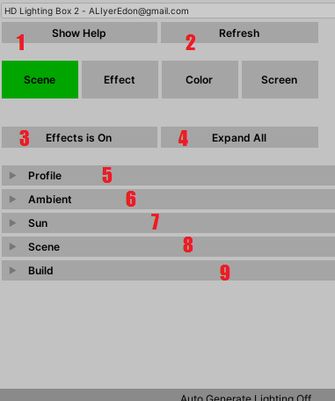
- Show Help
By clicking this button on any part of the lighting box, you will see helpful help
2. Refresh
After making changes during the game and returning to the scene, you can refresh the settings by pressing this button
3. Effects On
By pressing this button, you can turn the effects on or off in the scene
4. Expand All
By pressing this button, you can open or close the settings section of the Lighting box parts generally
5. Profile
In this section, you can create a profile for each of your scenes. You have to do this for each scene
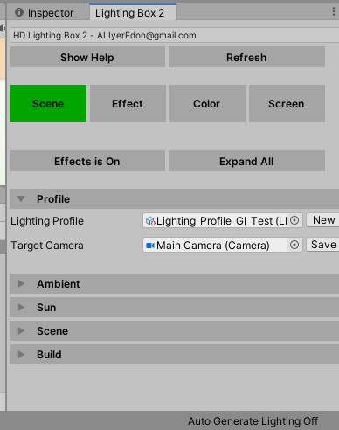
Lighting Profile: View or edit the current scene profile
Target Camera: Which camera is affected by the effects?
6. Ambient
In this section, you can make the Skybox settings
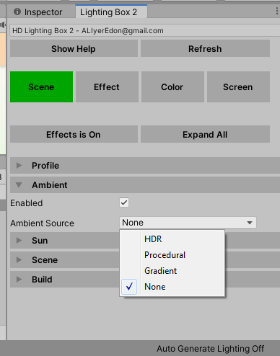
Default is HDRI that has been used a cube map as sky box. Watch the video to learn how to create and set up a cube map as sky box:
https://youtu.be/bta10oJsDiw
Search google for free HDRI sky box download

6. Sun
7. In this section you can assign sun or moon light (an directional light) and adjust its settings. Also you can use my Day / Night Cycle prefab to set up sun settings based on time of the day. It's much better than manually define sun settings
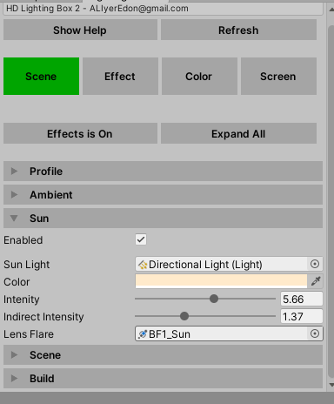
Enabled: By activating this option, sunlight will be applied based on the settings of the lighting box window. Disable this if you want to use personal settings yourself
Sun Light: An directional light as sun light. Will be found automattilly by lighting box
Color: Sun light color
Intensity: Sun light intensity
Indirect Intensity: Indirect intensity for light mapping. Only works on Realtime or baked GI mode.
Lens Flare (:Removed from latest update
Lens flare tutorial: https://youtu.be/kSG1NTS6RxM
8. Scene
In this section you can set the general lighting settings of the scene
By the way, for example, real-time or baked lighting
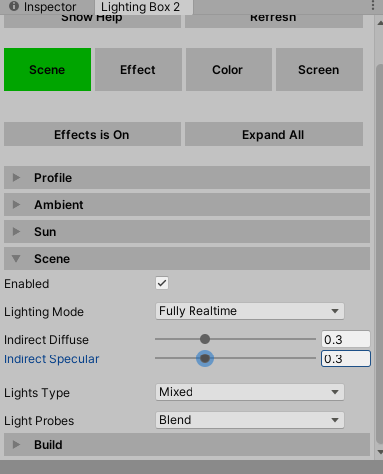

Enabled: By activating this option, your scene lighting settings will be applied based on the settings of the lighting box window. Disable this if you want to use personal settings yourself
Lighting Mode: use this to switch between lighting mode like Realtime GI, Baked GI or Fully realtime or mixed of them
Indirect Diffuse & Indirect Specular: Use HD Pipeline volume component o control indirect lighting intensity after baking the scene. Only works on baked scene
Lights Type: Change all scene light’s type to this option
Lights Probes : Select scene light probes mode automatically
9. Build
In this section, you can use Lighting Box useful actions:
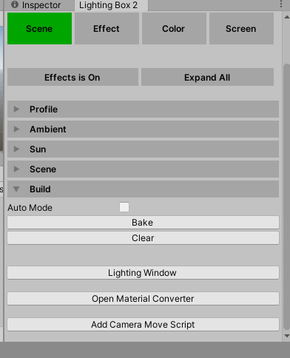
Bake & Clear: Bake or clear light mapping data or Reatime GI data
Lighting Window: An shortcut to open lighting window from Window->Rendering->Lighting Window menu
Material Converter: Open my custom material converter window from Window->Batch Material Converter menu
Camera Move Script: Add an camera movement script to control game view like scene view camera

Part 2: Effect
In this section you can add different effects to the scene. Watch my videos in HD Lighting Box 2 play list to learn how it works for more detail descriptions
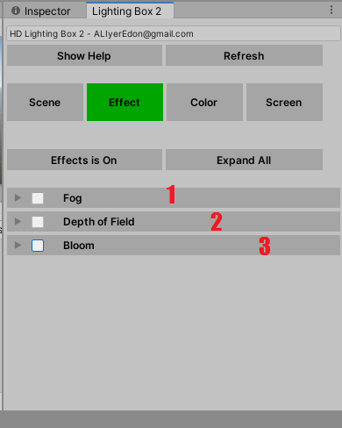
- Fog
Add fog effect into your scene
2. Depth of Field
Add depth of field effect into your scene
3. Bloom
Add bloom effect into your scene

Part 3: Color
In this section you can add color settings such as brightness and shadows to your game. Watch my videos in HD Lighting Box 2 play list to learn how it works for more detail descriptions
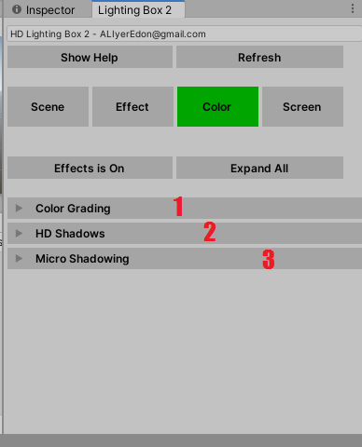
- Color Grading
Customize color grading settings for your scene
2. HD Shadows
Adjust and add HD Shadow from volume component for your scene
3. Micro Shadowing
Add micro shadowing effect from volume profile into your scene

Part 4: Screen
In this section, you can add the final effects to your game. Watch my videos in HD Lighting Box 2 play list to learn how it works for more detail descriptions
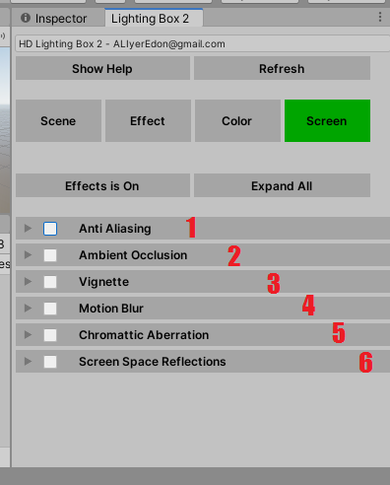
- Anti-Aliasing
Select AA mode from your camera
2. Ambient Occlusion:
Adjust AO settings for your volume component’s profile
3. Vignette:
Add vignette effect for your volume component’s profile
4. Motion Blur:
Add motion blur feature works for Camera and moved objects
5. Chromatic Aberration:
Add chromatic aberration effect for your volume component
6. Screens Space Reflection:
Add SSR effect to your volume component. You must enable it from Edit->Project Settings->Quality->HDRP->Lighting ->Screen Space Reflections before use

I hope you have these explanations
I recommend watching the videos in the YouTube playlist to learn how to use Lightbox in practice:

