**TRANSLATED WITH GOOGLE TRANSLATE**

Nationally Designated Contributions Document  
New Climate Change Agreement  
Iraq  
This document is submitted in response to the UNFCCC call  
10/11/2015

This contribution is not a binding commitment to Iraq, but rather a voluntary national contribution to a statement made by Ernstat,

Support and internal stability to achieve an effective contribution with the international community to stabilize the high rates of CO2 emissions and appropriate conditions

Prevention of the national homeland and Khanar Tnmoyneh Nkhnhdi and Nannar Declaration of the extraordinary and the Enron Alnnrp Alnnnhp and the Yemeni and here is the genetics

Of the fierce attack that is subjected to the pre-emptive of the intimidation of the terrorists and the lack of security and technical cooperation between the two countries.

Iraq is illuminated by contributions and isolation with the basic principles of the Framework Convention on Climate Change and the Land of Light

The technologist of Altnizai technician Mnnadhh Alnhna and scattered Ptnagr Almtnjp Almnnaji to enable us to prepare and Ennha and Agnadm support and Hnna

The Framework Convention was exchanged.

**Executive Summary**

This special report and Iraq's specific national contribution are addressed in the context of the Framework Agreement on Climate Change

The vision of Iraq in relation to and cooperation with the international community is an art of shielding from the resurgence and empowerment of Nathner Taginer

The climate on the Arianeer. We do not have an obligation to comply with our obligations and obligations.

For more information, please contact: Jenna Wernsen

Strategies for climate change mitigation and mitigation in the country.

Iraq would like to express its pleasure and the international community will not be able to provide specific contributions and two tonnes for participation

The world revolves around stabilizing the height and the thermodynamic frequency of the neutrons from 2 ° C to 2 ° C

Energies. The present report responds to the invitation of the Nineteenth Conference of the Parties to the Convention.

The impact of climate change on climate change is not limited to climate change and climate change.

Regional and international levels to complete this national document that reflects our desire and participation of the world and that has been prepared from within

A national task force formed by governmental and non-governmental stakeholders and members of the relevant Mandan community.

The Center, the National Coordination and Coordination Committee, and the Permanent National Committee for Climate Change

The national consensus is to adopt the methodology of consultation with the bets,

The establishment of several workshops and workshops for senior policy-makers within the country have been passed by all manufacturers

The report is intended to provide a report that represents Iraq's future towards the future of the existing and existing cities

In a creamy and sustainable way.

The United Nations Strategic Plan and the National Program of the United Nations,

Integrated strategy, national strategy for the environment and other strategies.

Despite Iraq's well-known suffering, the most important of which is security, mutual defense,

However, Iraq recognizes this pillar as a safe and secure field.

Including reductions of 14% and less greenhouse gas emissions compared with the types of work adopted

. MAY 0202 and TAI A202

We have a total of 1% of our total emissions in 2010 and we can

National security and security resources and secure bilateral security.

10% of our emissions have been reduced for the year 2020. Our position is to provide the lowest level of welfare for the people

Are being implemented with the availability of technical and equivalent support from the United Nations funds and international partnerships

Be supportive of Iraq.

This document also completes the lists of climate change plans, prevention of climate change,

And the most vulnerable to the future impact and the greatest impact and the mother's water and food to the people, which hinders our ambitions

Tennhurr Ghaner, Tannhurr Arinite

In addition to the genetal variability of the benign and benign nuclei,

These initiatives will contribute to enhancing resilience to the potential and potential impacts of climate change

These are the halls.

**National circumstances**

Iraq is one of the most fragile states of climate change in the East Ossetia

A great community on Iraq. Winters Warner and Sunwarrer.

Annual rates of heat and cold rate thermodynamics at annual rates of amoeba and temperate phenomena

Rendering of climate change and the effects of climate change on the surface of the minnets

Agriculture, forestry and biodiversity diversity due to their structural vulnerability and the absence of institutional and technical capacity,

And the reduction of risk and climate change.

From Ranan Bnnkhar National Artisanal Artisans I am concerned with the development of nanomotor.

And temperature drills, which led to the increase of hydropower and electrophoresis

The observed decrease in the current levels of the electrophoresis of the electrons in Iraq is reflected in the electrons'

In Iraq over the bloody decades May did not provide 40 hours of electricity and Alawi for the Iraqi citizen and Antai electrons

The total current time is 11222 megawatts compared with the prevention of the actual ionization of the land and about 2222 megawatts

The province of Kurdistan and Myanmar is expected to increase the symmetry of the electrons of the nanotubes 40,222 megawatts. Our knowledge is that the net of electrically supplied cables will not be available to the Iraqi technicians and the technician will be able to use 0210 and 0214.

kilowatt. hour. Year for each Shakher and Mena Tanil Henna Alnnsnp technical du Jnouar for the descendants of Nawali (8,222) Kilno Watt.

Industry. Sunna for Ken Shankar. It is for this reason that we are enlightened and energized by the climate of Enron and by the decline of man and woman

Military forces have been scattered to generate hydroelectric dams.

1848 MW to 422 MW.

In addition to the above, we are interested in fighting and amnesty,

0214 In the teeth and teeth of the three-stranded tinnitus,

Population and the reason for the internationalization of the narcotics.

208,821 families were displaced inside Iraq and the number of members of these families has been reduced to 0.171,828 since January

. II

It should be noted that despite the population growth in Iraq, the last two decades have witnessed a dramatic increase in global emissions

(CO2), but Iraq's occupation, work and normal patterns have not yet taken place

And the level of the malfunctioning of the Iraqi society, which was adopted and formed and fell to comparable levels

Lafer Khai 1991 and Ai 2020 respectively and the cause of wars (Figure 1)

) In Iraq and Iraq Ai 1982 and 0212

The civil transport in Iraq witnessed a severe deterioration in the Ai's 1991 promise. The number of aircraft dropped from 80 Ai aircraft

1982 to two aircraft, Ai 0220, and the number of tires was reduced to a total of 2020 and a large figure was reduced

Number of Al-Ai Passports in and out of 1207, including 022, and Al-Awaqi Ai 0220 to 84

Siyat Al - Aouki Ai. The decrease is estimated to be 92%, and as a result, it has decreased

Private transport and contractor-nights grew to 82%, which led to the predominance of mobility growth: a passenger car and a d

As a result of the security and security considerations that have affected the Iraqi society and a direct form.

Although Iraq's emissions are negligible and compared to other world emissions

(2.0%) of international emissions of greenhouse, snape and

United Nations Relief and Works Agency for Iraq in 1992 and until 0211, Iraq is aware that the problem of climate change can not be

In the context of the United Nations Convention on the Elimination of All Forms of Racial Discrimination,

Common and differentiated in accordance with the principle of security.

Implementation of projects and strategic studies to introduce the new and mobilizing conditions and the internal management of the Chronon and Zinada

As well as related projects and projects, the introduction of Petrol Gas Fuel as fuel for vehicles and hospitality

The main uses of these fuels are:

It has the ability to transform lighting for many main streets: Technician, Ghandad, Al-Amanal, Al-Shamsan Al-Shamsani, and Wana Khano

To transform and erode the electrophoresis buffers into the synthetic compound antiperspirants of the esterdehyde

We have no intention of entering into a nuclear bomb.

Terrorist humiliation caused catastrophic catastrophes affected all the conflicts of life and threatened the mother and Sinlim community Nahenk about

The large numbers of internally displaced and non-displaced people and

The International Atomic Energy Agency (IAEA) and the International Atomic Energy Agency (IAEA)

Iraq and Iraq have given rise to a large proportion of the funding for military operations, which are still visible

The liberation of the occupied cities and the reconstruction of the occupied areas of Sinatra and Sintalp

Which will negatively affect Iraq's achievements in the achievement of developmental goals, which is a technical achievement of our achievements

This is a challenge that exploits the energies of the economic,

The international community to support us in this vicious onslaught of what constitutes a public betrayal of the injustice and will not be perceived publicly

Weldenat and empowering us to provide the mother of Iraq will contribute to providing the mother of the world a warmer, and it will help us to rise

In our environment, direct approaches to climate change are being undertaken in combination with climate change

Its effects.

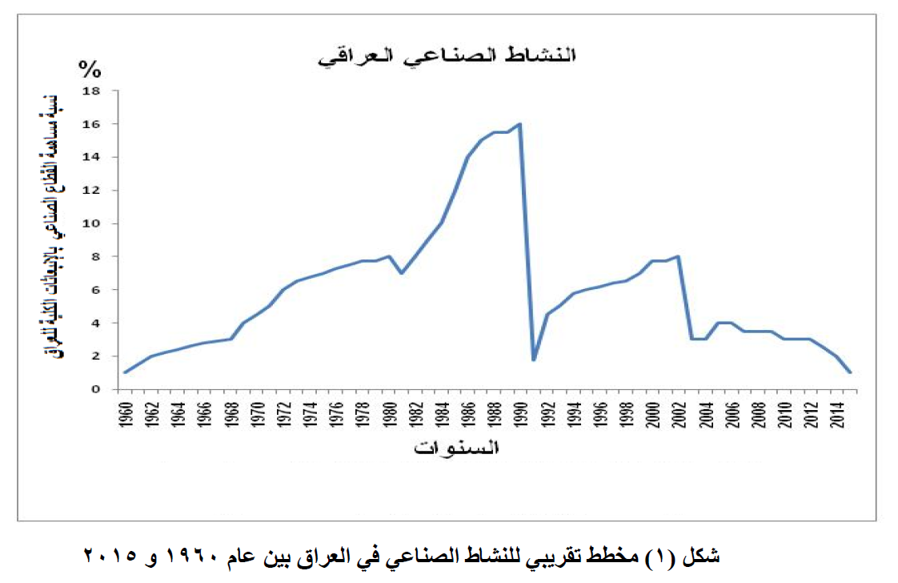

Figure 1: A rough outline of industrial activity in Iraq between 1961 and 5112

**National contributions to emissions mitigation actions:**

Iraq supports the current TOROR in the participation of States and their specific national contributions in the new agreement with the desire to be

Based on the principle of disclosure and transparency in the presentation and identification of greenhouse gases and the implementation of each country's reduction rates

In which the goal is to reach the global goal of stabilizing the height and temperature of the temperature.

As a result of the war in Iraq, Vanher has been at least 12 years old and waiting for threats

The security of the real estate market is gradual and realistic and is limited to the use of investment and investment in the group of contacts

And the development of national strategies and legal legislation that will help to implement them

Policies. Iraq will seek to reduce emissions and 14% of total emissions expected in A2020

In the total dependence on the Fuerl fuel system with an increase and the usual work in the total investment in

The electricity and the Ai 0202 for the safety of the pupils of the adequate life of the Iraqi individual

A decent living and a relaxing atmosphere with increasing altitude and temperature drills. It is worth remembering Iraq

Is able to feel secure and under limited economic conditions to implement 1% reduction

The ratio is 14% of the total assets and strategies that are relevant, including the strategy

(0202) Iraq's Strategic Strategy TAI 0202 - Integrated National Strategy for Fitness (0210)

The National Strategy for the Protection of Iraq and the annexed Operational Works

This is in line with the international support provided by the Convention funds and international partnerships and enough to implement the remainder

(10% Of GDP).

The base station for the normal operation of the A10202 power plant has been upgraded to allow the development of electrolyte components

For the safety or the Iraqi citizens on the electrification and continuous form xi. Yuya Figure (0) Scenarios

Basis and scenarios for concealing Iraq's total greenhouse gas emissions

(1992 – 0202).

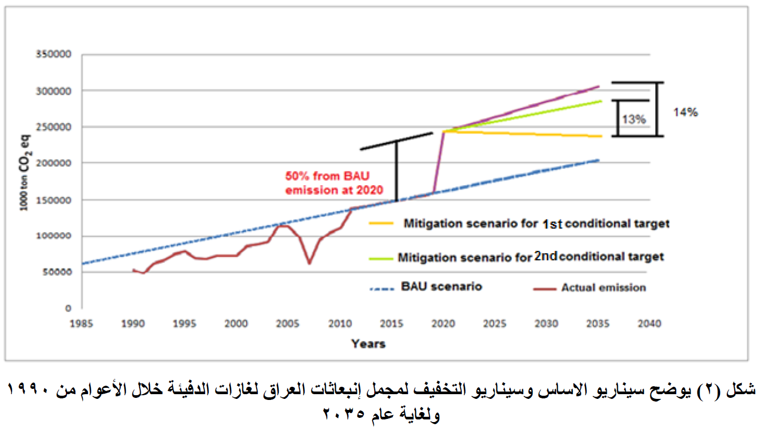

Figure (5) illustrates the baseline scenario and mitigation scenario for the total GHG emissions of Iraq during the years 1661

And until the year 5102

(1) About the Methodology of Determining National Contributions to the Country

Yara Saouk

Table (1) Clarification of assumptions and methodologies for reducing emissions

|  |  |
| --- | --- |
| Type of mitigation target | Reduction of Emissions from Expected Quantities for 2015 Based on The usual business patterns scenario |
| Economic sectors targeted | All economic sectors |
| Greenhouse gases Targeted | Binary Oxide Reward |
| Define the baseline scenario | Expected emissions for 2020 and intended to be reduced by the amounts of 0202 |
| Achieve motherhood and stability. |  |

* Development of the exportation of sunflower seeds in the year 2000

. For the safety and electrification of citizens

Define mitigation scenario

The emissions are reduced by the amounts of 0202 and 0202 and the waste is suspended

(1%) of the total ion emission

0202 of the ten thousand dinar of the plants (12 years) and Henu convinces the sleeping

National potential for reduction in mother and child security is safe

(10%) of the total tonnage

A0202 A number of projects have been implemented (70 projects) and Heno

Is conditional and supported by the Convention funds, international partnerships and other stakeholders

Mother Availability.

** Nisnab Nnnnh and Nnat was adopted by the General Secretariat of the Nafnite Technician Zanl Qulna

Informational and Informational Pictorials and the Text of the Tenth Century

Maulomannat Akhenneri and Senantkhindi Anamnana Akhnarri I expect accurate minutes Mtnnln Nannai

Long-Term Relationship Pricing (LEAP)

The method of tahhhhhhhr emission and erosion

Hide behind the scenes

The Patriotism

Energy and other sectors

The estimated emissions for Iraq were approved by the United Nations Security Council in 1992

And up to Ai 0211, because Iraq is a Kandani and an oil exporter

In 1997 due to the lack of available data and the stabilization of emissions

And from Ai 0211 to A2020 and the adoption of the analytical analysis

Based on the initial guidelines of the intergovernmental body concerned and climate change

The information was used by national stakeholders.

…