Ann Koelzer

**Compatibility Predictor**

As a health information management student, my experience is limited with coding and JSON files. This document will show my thought process through each step.

I was ultimately unable to connect MySQL database to any type of text editor or Visual Studio Code. I accredit this to using my school’s connection host and was unable to create my own MySQL connection. I am hoping this document shows my work and thought process in this assessment. Despite many challenges, I have gained valuable experience and knowledge.

In order to fully understand the assignment, I researched JSON and its syntax:

* Strings: “Eddie”
* Numbers: 1
* Booleans: true false
* Null: essentially stands for nothing
* Arrays: list [1, 2, 3] [“Hello”, “World”]
* Objects: {“key”: “value”} {“age”: 30} Allows to represent values (key/value pairs)
  + Values must be data types: string, number, object, array, Boolean, null

In my Healthcare Data Analytics course, I worked with MySQL Workbench, Tableau Desktop, and Tableau Prep. I was not sure which application would work best with JSON so I had some trial and error. Ultimately, I ended up MySQL Workbench.

After some quick research, I found Visual Studio Code to be the best application to write my JSON code. Since this is my first-time writing code, I started small with only creating the “team” data using three names.

1. 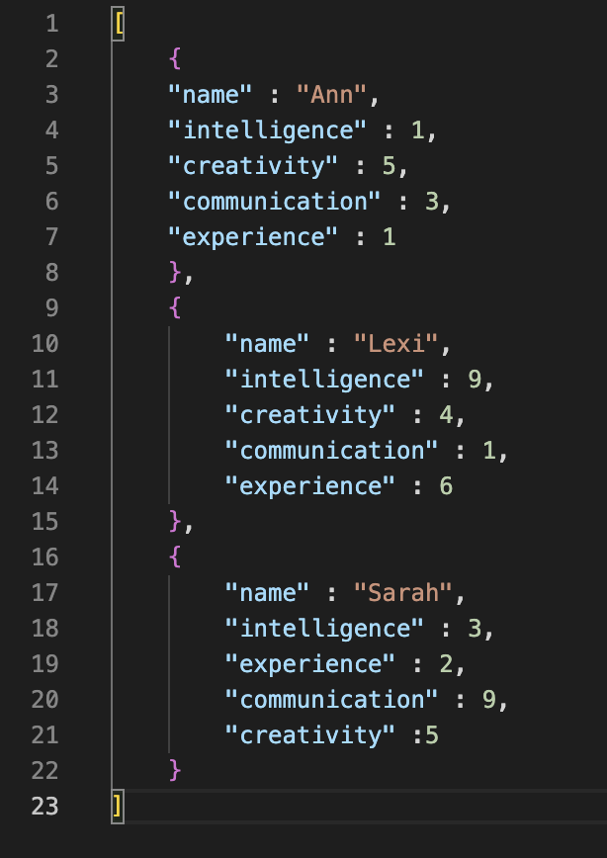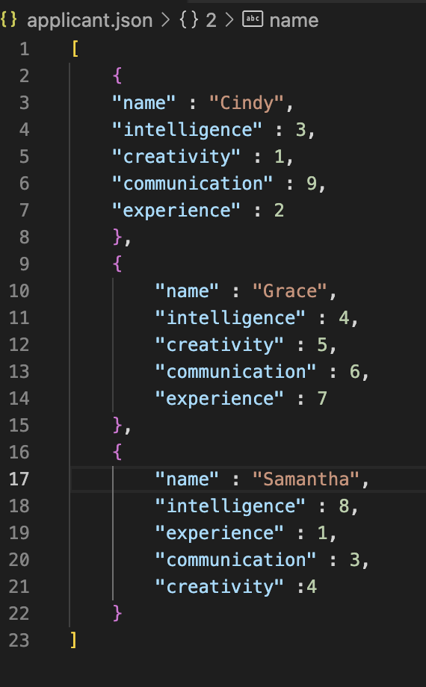Team data: Each person (object) will have the properties:

* the key “name”: and their corresponding name as the value
* the key “attributes”: and values of; “intelligence”, “experience”, “creativity”, and “communication” which are scored on a 1-10 scale.

I chose the above attributes because they are qualities of good team members.

1. Applicant data: I repeated this step (pictured above, right)
2. After trial and error, I was able to import my JSON file into MySQL workbench. Starting with the team data, I named the table team_table.

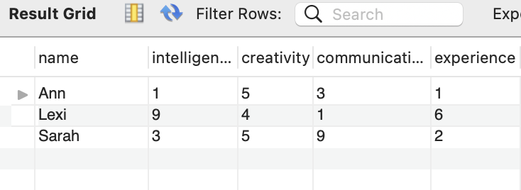

1. I wanted to weigh each attribute differently according to the importance of the qualities. Therefore, I added 5 columns to the table where I would create these calculations.

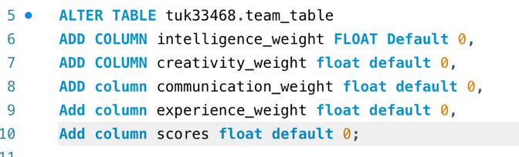

1. Next, I wanted to create a new table where the above columns would be combined with the original table.

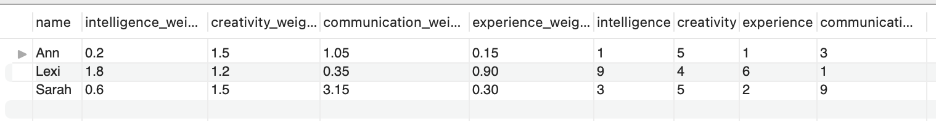 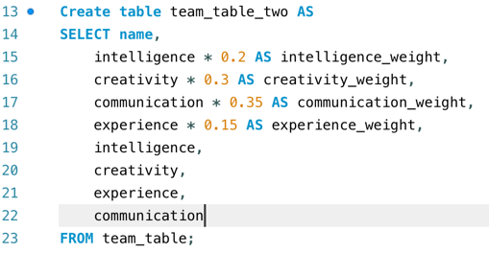

1. I then joined the original table with my new table.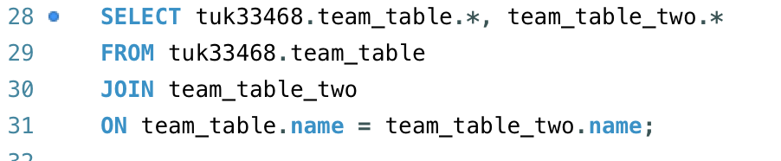
2. 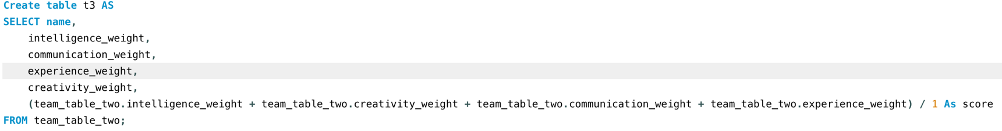I then created another table that would only include the weighted attributes and the score. The score is the average of all the weighted attributes divided by 1.

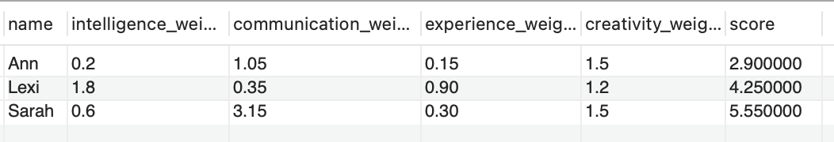

1. I repeated the above steps for the applicant data.

*Applicant Step 1:*

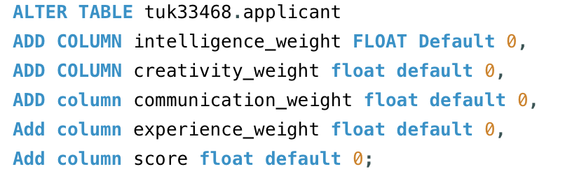

*Applicant Step 2:*

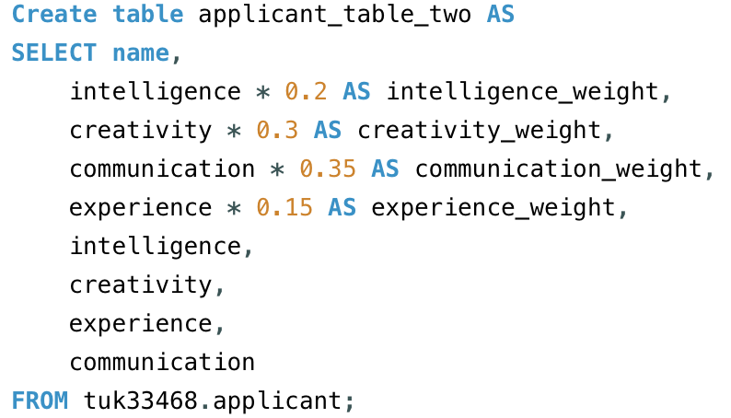

*Returned*:

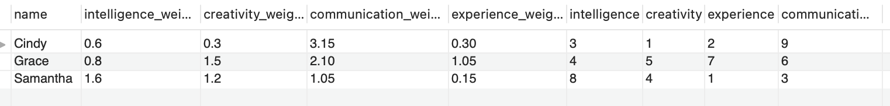

*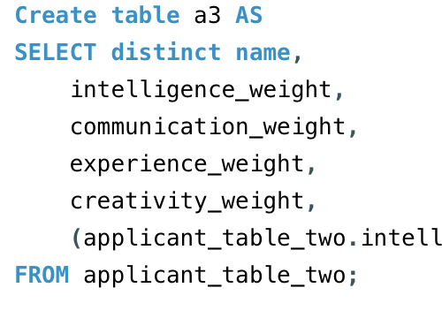Applicant Step 3:*

*Returned:*

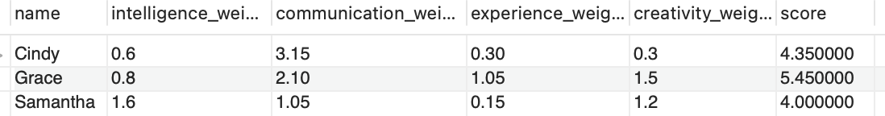

1. 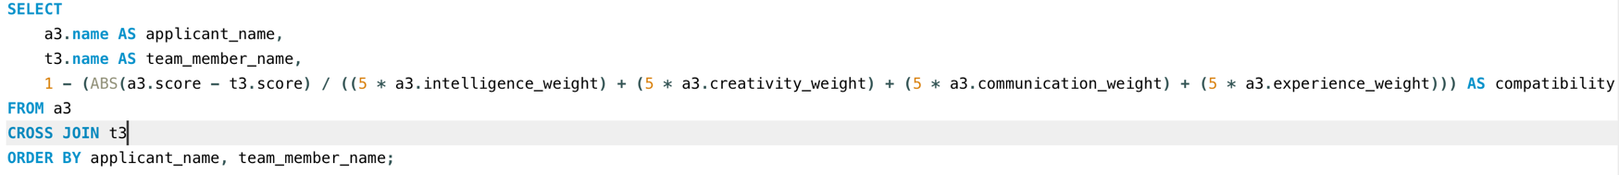To score the applicants, I initially wanted to normalize the weighted averages but after many, **many** tries was unable to come up with a formula in MySQL. Instead, decided to compare the scores of each applicant to each team member:

*Returned*:

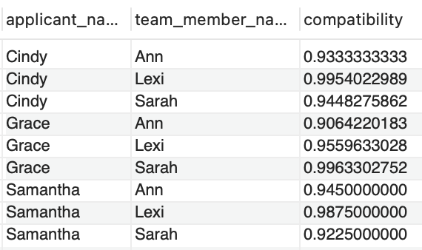

1. Finally, I calculated the final compatibility score from each applicant to the team as a whole by averaging the above compatibility score between applicant and each team member.

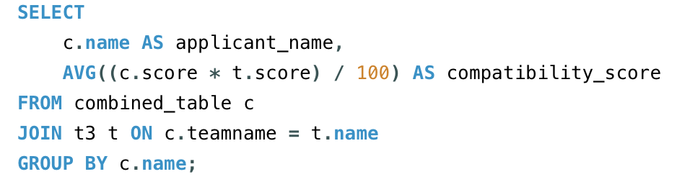

*Returned:*

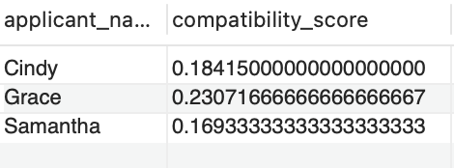

1. I recruited ChatGPT to help me figure out how to convert the MySQL code into a json file to submit. However, since I was working on my school’s connection host I was unable to connect my database into Visual Studio Code.