ER Model of Online Pizza Ordering Database

**GROUP MEMBERS**

K.Nandhini U19CS078

Ann Mary Eldo U19CS086

Badavathu Manasa U19CS098

**PROJECT DESCRIPTION**

**Online Pizza Ordering System** is a website for ordering pizza online. Another website was created for management of prices and offers by admins (employees).

NOTE: This particular pizza shop focuses on the build-your-own-pizza business model.

The customer can manage details of their account and orders, and they can access details of pizza ingredients and offers (One offer applied per order).

The admin has access to summary reports, and can view details of ingredients, customers, orders and offers.

The payment type will be cash on delivery or gpay.

**ENTITIES**

**Cust_Acct (PK = Cust_ID)**

**Admin_Acct (PK = A_Username)**

**Orders (PK = Order_ID) (FK Cust_ID from Cust_Acct.Cust_ID)**

**Bill_Items (PK = Pizza_ID, Order_ID) (FK Cust_ID from Cust_Acct.Cust_ID**

**(FK Order_ID from Orders.Order_ID)**

**Ingredients (PK = Ingredient_ID**

**Offers (PK = Offer_ID)**

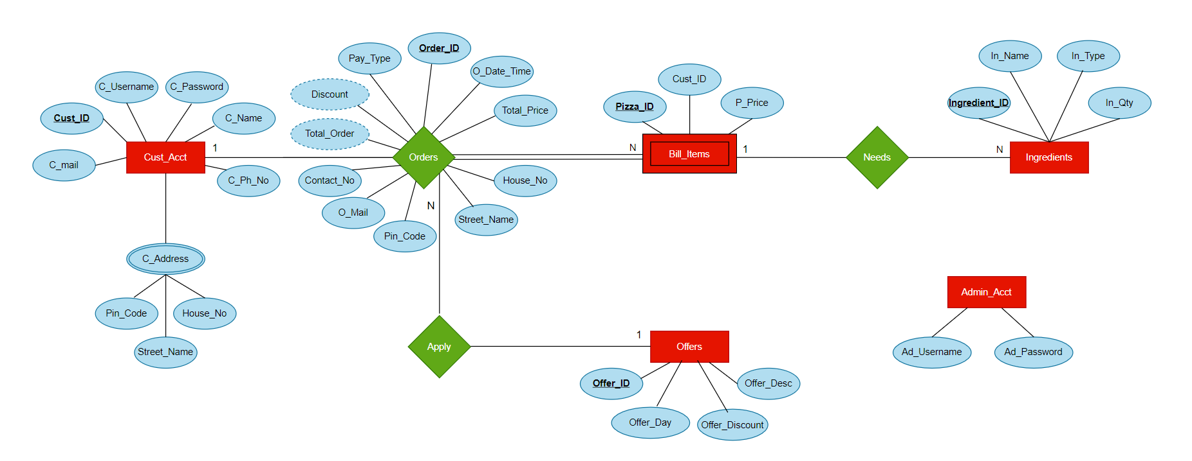**E R DIAGRAM**

**E R MODEL DESCRIPTION**

**Cust_Acct -** Account details of registered customers

**Orders -** Orders of each customer for one checkout. It contains contact and address details, total price, final price after discount and so on.

**Bill_Items -** Each Order is broken up into its constituent items (pizzas ordered in one checkout) and their details are recorded, which include price (calculated from ingredients used) in addition to customer id and order id.

**Ingredients -** Since this is a build-your-own-pizza establishment, pricing is based on ingredients picked by the customer. Price of ingredients is recorded here.

Specialised into **Crusts, sauce, cheese and toppings**

**Offers -** Discounts and deals are recorded with their descriptions, requirements and information

Specialised into **Weekly (day of the week).**

**NORMALIZATION**

* C_Address in Cust table is multivalued, so, applying 1NF, we get the C_Address table.
* The tables are in 2NF as all non-key attributes are dependent on the key(no partial dependencies)
* The tables are in 3NF as there are no transitive functional dependencies.(Customer can give phone numbers that are not linked to their mail id)

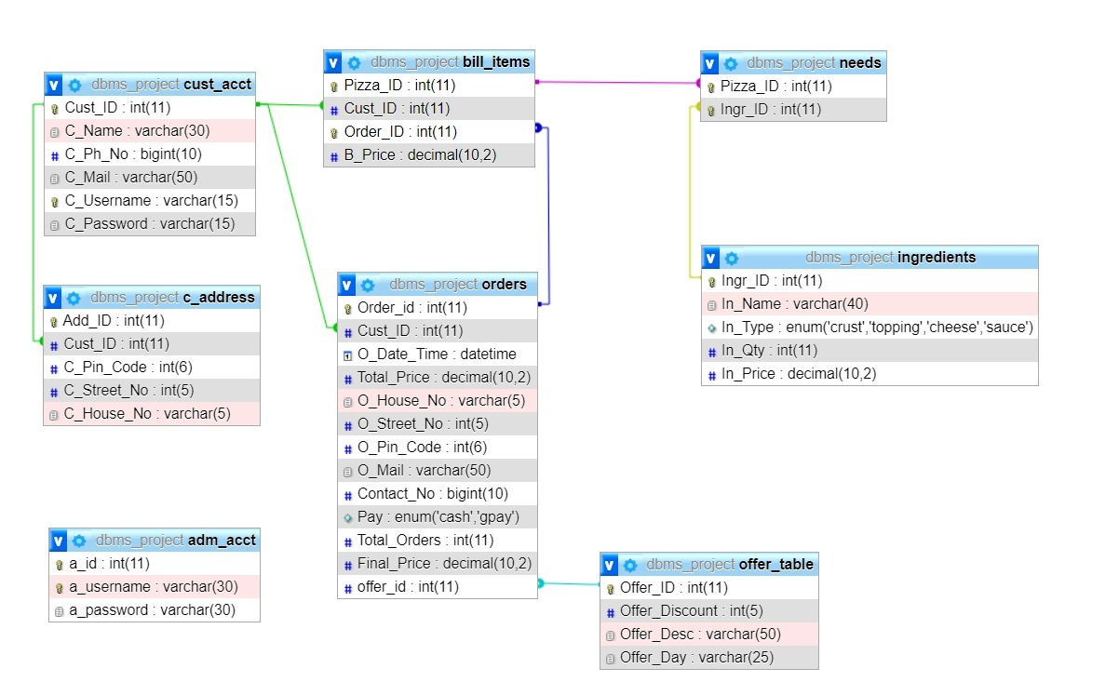

**RELATIONAL SCHEM**

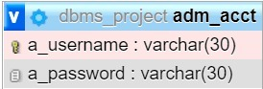

PK

FK

PK

FK

PK

FK

FK

FK

FK

PK

PK

PK

PK

PK

PK

PK

**DATABASE**

VIEWS –

DISP_CUST

PIZZAINGR

PIZZAINGR_DISP

PROCEDURES –

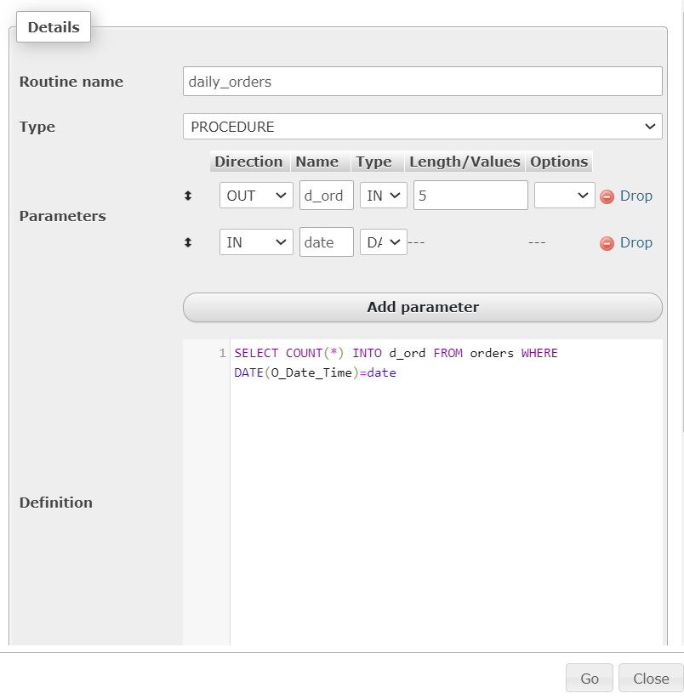

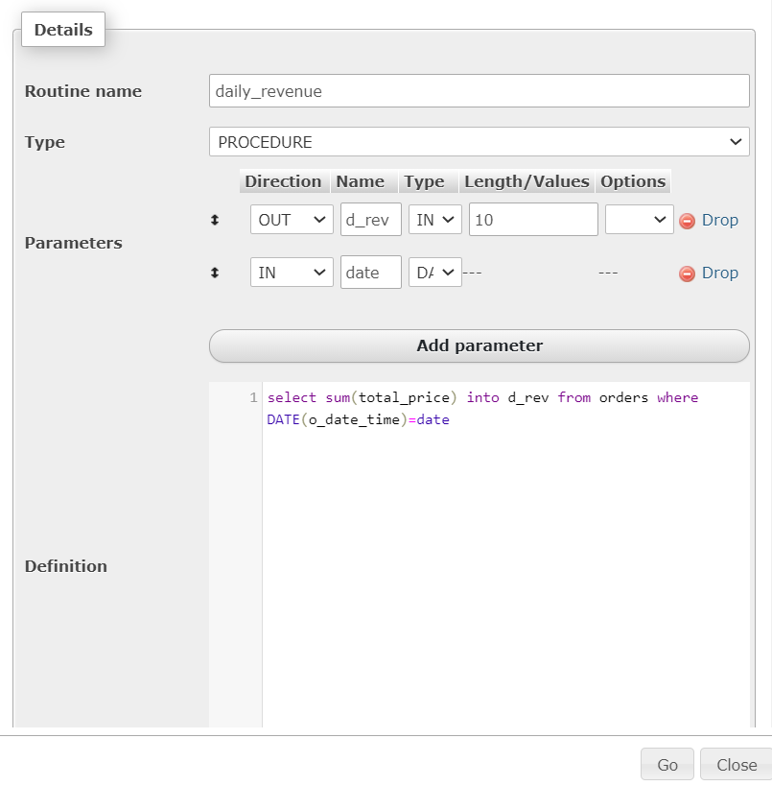

FUNCTION –

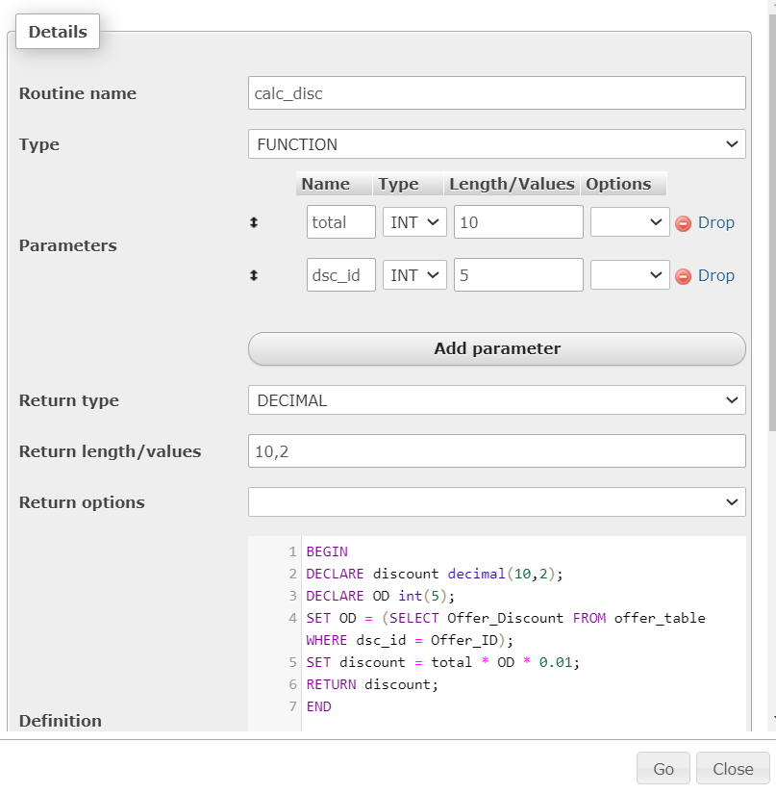

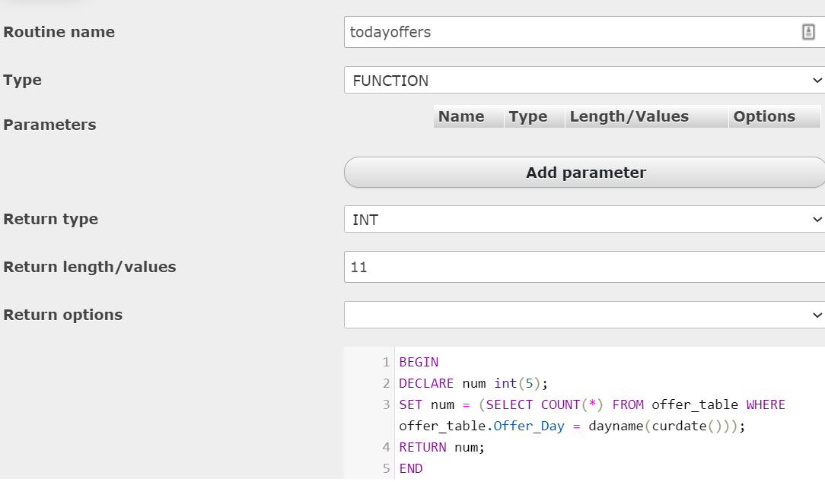

TRIGGERS –

