Bugay-Dagat:
An Online Platform
For Seafood Delivery

A Capstone Project
Presented to the Faculty of the
College of Information Technology Education
PHINMA University of Iloilo

In Partial Fulfillment
of the Requirements for the degree
Bachelor of Science in Information Technology

By:
Ann Nicolie B. Antonino
Ashley Marie G. Gayares
Cherry Mae M. Sardenola

Approval Sheet

In partial fulfillment of the requirements for the Bachelor of Science in Information Technology, this Capstone Project, entitled Bugay-Dagat prepared and submitted by Ann Nicolie Antonino, Ashley Marie Gayares, and Cherry Mae Sardenola, who are hereby recommended for the corresponding final evaluation.

Marlo Kyn Bunda
Adviser

Approved by the Panel of Evaluators with a grade of PASSED

Dr. Arnold M. Fuentes, Ph. D, MPA, MMIT
Chairman

Accepted in partial fulfillment of the requirements of the degree Bachelor of Science in Information Technology

Seth dA. Nono, MSCS
CITE, DEAN OF DEANS

ACKNOWLEDGEMENT

We would like to express our sincere gratitude to everyone who supported us in completing this project. We sincerely appreciate all those who contributed to its success. We extend our heartfelt thanks to our colleagues for their valuable guidance and encouragement.

We are also grateful to our friends and family for their unwavering support and motivation. Your help and belief in us have made this journey smoother and more fulfilling. Our profound gratitude goes out to our instructors and mentors at PHINMA University of Iloilo, whose advice and encouragement have substantially improved our comprehension of the topic.

Finally, we would like to express our sincere gratitude to our classmates, study participants, and everyone else who contributed to making this capstone project a reality, whether directly or indirectly.
Many thanks to all of you.

ABSTRACT

Bugay-dagat is an online platform that delivers fresh and dried seafood directly from local fishermen and vendors to consumers. Bugay-Dagat makes the process faster, more affordable, and more reliable while ensuring customers enjoy the ease of online ordering. At the same time, the platform helps strengthen the livelihoods of fishermen and vendors by giving them fair access to a wider market.

Customers can easily browse the selection of seafood, place orders, and track their deliveries through a simple online platform. They can use their smartphones or laptops to look for the seafood they want, and they can pay online or by cash on delivery.

Residents of the First District of Iloilo can now access our services conveniently from home. With Bugay-Dagat, transparency is ensured by providing clear details on where the seafood comes from and how it is handled. We make sustainable seafood accessible to all—supporting local communities, promoting fair trade, and delivering fresh, clean products right to your doorstep.

TABLE OF CONTENTS

Title page ------------------------------------------------- i

Approval Sheet---------------------------------------------- ii

Acknowledgement-------------------------------------------- iii

Abstract---------------------------------------------------- iv

Table of Contents------------------------------------------ v-vii

List of Figures---------------------------------------------viii

List of Tables------------------------------------------------ x

CHAPTER I

Introduction---------------------------------------------1
Background of the Study---------------------------------2-3
Statement of the Problem--------------------------------4
Objectives of the Study---------------------------------5
Significance of the Study-------------------------------6
Scope and Limitation------------------------------------7-8
Definition of Terms-------------------------------------9-10

CHAPTER II

Literature Review----------------------------------------11-12
Overview---------------------------------------------------13
Traditional VS Modern System-------------------------------13-14
Technology Use---------------------------------------------14
Case Studies----------------------------------------------15

CHAPTER III
Methodology----------------------------------------------16-18
Research Design---------------------------------------------19
Model Use------------------------------------------------19-20
Data Flow Diagram-------------------------------------------29
Entity Relationship Diagram------------------------------31-32

CHAPTER IV

Result and Discussion---------------------------------------40
Screenshots-----------------------------------------------45-49
System’s Features-----------------------------------------49-50
Implementation Challenges------------------------------------
User Feedback------------------------------------------------
Comparison to other systems ---------------------------------

CHAPTER V

Conclusion and Recommendation------------------------------51
Conclusion-------------------------------------------------52 Recommendation---------------------------------------------52
Appendices------------------------------------------------54-55
Curriculum Vitae-------------------------------------------
Grammarian Certificate-------------------------------------
LIST OF FIGURES

Figure Pages
19
1.1 28
1.2 29
1.3 30
1.4 31
1.5
2

LIST OF TABLES
Tables Pages
1.0 42
3.0 43
4.0 44
4.1
4.2
4.3
4.4
4.5
4.6

CHAPTER I

INTRODUCTION

Bugay-Dagat is an innovative online marketplace developed to connect consumers with the dedicated fishermen and vendors of Guimbal. The platform offers a wide selection of fresh and dried seafood products that are guaranteed to be of high quality, sustainably sourced, and conveniently delivered to customers’ doorsteps.
Bugay-Dagat combines new technology with a focus on freshness and easy access to improve how seafood is distributed. Our platform helps restaurants, families, and seafood lovers get high-quality seafood quickly and easily through a simple online system.
Furthermore, Bugay-Dagat values fairness, transparency, and empowering the community. By working directly with local fishermen and vendors in Guimbal, the platform promotes fair trade, supports the local economy's growth, and ensures customers receive seafood they can trust: fresh and responsibly sourced.

Technical Background of the Study
Bugay-Dagat: An Online Platform for Seafood Delivery was developed to modernize the traditional seafood trading system by integrating e-commerce technology into the local seafood industry. The system utilizes a web-based architecture that allows customers to browse, order, and pay for fresh and dried seafood products directly from trusted local suppliers through an intuitive online platform.

The platform is designed using HTML and CSS for the front-end interface, providing a responsive and user-friendly environment accessible through any web browser. The back-end is designed by PHP and JavaScript connected to a MySQL database, which manages user accounts, product listings, orders, and transaction records.

1. Front-end –using HTML and CSS, Bugay-Dagat is an accessible platform for seafood delivery. It involves the design and structure of our website.
2. Back-end – PHP is the server that handles requests from the website, such as fetching information from the database. The backend handles customer orders, processes payments, and communicates with the database.
3. Database – MYSQL for relational data is essential for storing and managing sensitive information.
4. Database Analytics - to track the daily season of the fish and can help businesses make informed decisions on stock levels, sales, monthly income, and prevent stockouts or overstocking.
5. Payment Technologies – To maintain trust and safeguard transactions, Bugay-Dagat uses secure payment systems and data protection protocols.
6. Delivery Tracking - allows both the customer and the administrator to monitor the status and progress of each order from the moment it is confirmed until it reaches its destination.

STATEMENT OF THE PROBLEM
The seafood industry continues to face challenges in establishing fair and direct connections between producers and consumers. This limitation affects accessibility, equity, and trust within the market. The fishermen and vendors of Guimbal often struggle to compete with larger enterprises, resulting in limited income opportunities and a reduced variety of seafood for consumers.

Furthermore, ongoing problems with freshness, traceability, and transparency have reduced consumer trust. To address these issues, there is a need for a digital platform that supports fair, direct, and transparent seafood trading between producers and consumers.

OBJECTIVES OF THE STUDY
This study's main goal is to evaluate and create Bugay-Dagat. This online platform facilitates the direct distribution of seafood from suppliers and fishermen to customers in a sustainable, transparent, and effective manner. The study specifically seeks to:

1. Design and develop an online seafood marketplace that directly connects fishermen and vendors with consumers.
2. Assess the effectiveness of the platform in ensuring the freshness, traceability, and transparency of seafood products.
3. Evaluate the impact of the system on improving income opportunities for fishermen and vendors.
4. Determine the level of consumer trust and satisfaction when using the platform compared to traditional seafood markets.
5. Examine the role of technology in enhancing accessibility, convenience, and fairness in seafood transactions.

By targeting these goals, the project aims to contribute to the development of a fair, sustainable, and customer-friendly delivery system that enhances the seafood industry's accessibility, efficiency, and sustainable production practices.

SIGNIFICANCE OF THE STUDY
Bugay-Dagat is an online platform that provides consumers with fresh and dried seafood sourced directly from local fishermen and vendors in Guimbal. This study aims to examine the impact of Bugay-Dagat in enhancing the seafood supply chain by improving efficiency, maintaining product quality, and strengthening the relationship between producers and consumers.
- Consumers: Bugay-Dagat makes it easier for people to order seafood online and have it delivered to their homes. This improves access and helps people avoid traditional markets, which often lack transparency.
- Fishermen and Local Vendors: The platform helps fishermen and local seafood vendors earn a fair income. This study supports building a model that improves their livelihoods and economic security.
- Seafood Industry: This study demonstrates that digital platforms can enhance the seafood supply chain and enable sellers to increase their revenue. It also explains how technology can improve processes and product quality.
- Future Research: This study opens the door for more research on sustainable food systems, fair supply chains, and digital tools in the seafood industry. It also encourages exploring better ways to connect sellers and buyers in fields like farming and fishing.

Overall, this study helps promote a fair, transparent, and sustainable seafood system that supports both consumers and local communities by using technology responsibly.
SCOPE OF THE STUDY
To enhance the seafood supply chain by creating direct links among fishermen, vendors, and consumers, this project centers on the development and implementation of Bugay-Dagat, an online platform designed for seafood distribution. The scope of the study covers the following main areas:

- Platform Development and Functionality – Examining the features, design, and technical aspects of the Bugay-Dagat platform, including the ordering process, user interface, payment system, and delivery management.
- Target Market – Identifying the platform’s primary users, such as households, restaurants, seafood vendors, and other customers seeking fresh and dried high-quality seafood products with clear sources.
- Fishermen and Vendor Empowerment – Exploring how the platform helps fishermen and vendors receive fair compensation and better market access while maintaining affordable prices for consumers.
- Consumer Experience and Adoption – Evaluating customer satisfaction, trust-building approaches, and user engagement to ensure the platform’s reliability, ease of use, and continued customer support.
- Market Competition and Challenges – Identifying potential competitors in the online seafood market and analyzing the challenges Bugay-Dagat may face in terms of expansion, competition, and regulatory requirements.

LIMITATIONS OF THE STUDY

- This study focuses on local seafood trading and does not include the global seafood supply chain.
- It centers on the digital facilitation of fresh and dried seafood transactions and does not cover the actual handling or processing of seafood.
- The study also does not directly address external factors such as government policies, environmental changes affecting fish availability, or unforeseen operational challenges.

By defining these limits, the study shows how Bugay-Dagat can use technology to make the seafood industry more efficient, fair, and collaborative for both fishermen and vendors.
​

DEFINITION OF TERMS
- Online Platform – A digital system or website that facilitates transactions and communication between users. In this study, it serves as a medium for seafood vendors and customers to interact and complete orders.
- Seafood Delivery – The process of transporting fresh and dried seafood products from local vendors or fishermen directly to consumers through the Bugay-Dagat platform.
- Local Fishermen – Individuals engaged in small-scale fishing activities who supply fresh seafood to vendors or directly to consumers through the platform.
- Vendors – Sellers who list and manage seafood products on the Bugay-Dagat platform and fulfill customer orders for delivery.
- Consumers – End-users or customers who use the Bugay-Dagat platform to browse, order, and purchase seafood products online.
- User Interface (UI) – The visual and interactive components of the Bugay-Dagat platform that allow users to navigate, view products, and place orders easily.
- User Experience (UX) – The overall satisfaction and ease of use experienced by users while interacting with the Bugay-Dagat platform.
- E-Commerce – The buying and selling of goods and services over the internet. Bugay-Dagat utilizes e-commerce features to support online seafood transactions.
- Order Management System – A feature within the Bugay-Dagat platform that handles order placement, tracking, confirmation, and delivery updates.
- Inventory Management – The process of tracking available seafood products, ensuring that stock levels are updated and accurate on the platform.
- Delivery System – The operational process that ensures the ordered seafood products are delivered efficiently and in good condition to customers.
- Traceability – The ability to track the origin and movement of seafood products from fishermen to consumers, ensuring transparency and food safety.
- Sustainability – The practice of maintaining ecological balance and supporting local livelihoods by promoting responsible fishing and fair trade through the Bugay-Dagat platform.
- Transparency – The clear and open sharing of product details, prices, and sourcing information to build trust among consumers and suppliers.
- Feedback System – A feature that allows users to rate and review products or services, providing valuable insights for system improvement and customer satisfaction.
- Data Analytics – The process of collecting and analyzing platform data, such as sales trends, customer behavior, and product demand, to enhance decision-making and system performance.
- System Development – The process of designing, creating, testing, and deploying the Bugay-Dagat platform to meet user and operational requirements.
- Real-world Testing – The evaluation of the Bugay-Dagat platform in an actual business setting with real users to ensure functionality, usability, and performance under realistic conditions.

CHAPTER II

REVIEW OF RELATED LITERATURE

This chapter presents existing studies and literature related to Bugay Dagat: An Online Platform for Fresh Seafood Delivery. It discusses online seafood marketplaces, e-commerce systems for perishable goods, supply chain technologies, and digital platforms that support local fisheries and food distribution. The review supports the development of Bugay Dagat to improve access to fresh seafood, enhance delivery efficiency, promote local fishermen, and strengthen seafood distribution systems.

Rani, P., Sharma, P., Gupta, I. (2024). From Sea to Table: A Blockchain-Enabled Framework for Transparent and Sustainable Seafood Supply Chains. In: Nanda, U., Tripathy, A.K., Sahoo, J.P., Sarkar, M., Li, KC. (eds) Advances in Distributed Computing and Machine Learning. ICADCML 2024. Lecture Notes in Networks and Systems, vol 1015. Springer, Singapore. https://doi.org/10.1007/978-981-97-3523-5_9

Rani, Sharma, and Gupta (2024) introduced the “Sea to Table” framework, which utilizes Ethereum blockchain technology to establish a transparent and secure system for tracking seafood throughout its supply chain. Their study emphasizes how digital systems can improve food safety, traceability, and consumer trust by recording every step from harvesting to distribution on the blockchain. This approach aligns with the objectives of Bugay-Dagat, which seeks to enhance transparency and reliability in the seafood trade through an online platform connecting consumers directly with the fishermen and vendors of Guimbal.

Roheim, C.A., Bush, S.R., Asche, F. et al (2018). Evolution and future of the sustainable seafood market. Nat Sustain 1, 392–398. https://doi.org/10.1038/s41893-018-0115-z
Likewise, Roheim et al. (2018) explored the development of the sustainable seafood industry and emphasized the persistent difficulties in attaining environmental and social progress within fisheries, especially in developing areas. They noted that market-based strategies, such as certification schemes, have not been entirely effective in fostering genuine sustainability and equity. Together, the insights from both studies highlight the necessity of combining technological innovation with sustainability practices in today’s seafood systems. Bugay-Dagat responds to these challenges by offering a digital platform that encourages fair trade, uplifts local fishermen and vendors, and ensures the efficient delivery of fresh and dried seafood in a transparent and eco-friendly manner.

OVERVIEW
Bugay Dagat is a local online seafood delivery platform based in Guimbal, Iloilo, offering fresh fish, shellfish, seaweeds, and dried seafood products directly to consumers. It highlights Guimbal’s rich coastal heritage while making seafood accessible through digital ordering and delivery.

Key Features
- Fresh seafood: Products are sourced directly from local fisherfolk, ensuring freshness and supporting community livelihoods.
- Wide selection: Fish, shellfish, seaweeds, pusit (squid), and dried fish are available.
- Affordable pricing: Example prices include ₱200 for fresh bangus.

TRADITIONAL VS MODERN SYSTEM
Traditional Use
- Community markets: Fisherfolk sold their catch directly in wet markets or by roadside stalls.
- Face-to-face transactions: Negotiation and selection happened in person, with customers inspecting fish and shellfish before purchase.
Modern Use
- Digital ordering: Customers browse seafood products online, place orders via the platform, and pay digitally.
- Home delivery: Fresh seafood is delivered directly to households, saving time and effort.
- Expanded selection: Beyond fresh fish, Bugay Dagat offers dried seafood, seaweeds, and shells

TECHNOLOGY USE
Bugay Dagat uses technology to make seafood delivery easier and more modern. Instead of buying fish only in the market, people can now order through an online platform using their phones. Customers can see the products, check prices, and pay through digital wallets or online banking. The platform also organizes delivery services so seafood arrives fresh at people’s homes. To keep quality, it uses cold storage and packaging during transport.
Bugay Dagat also promotes its products through social media, helping more people discover Guimbal’s seafood and culture. Technology allows fisherfolk to sell directly to buyers, giving them better income and reducing middlemen. In simple terms, Bugay Dagat combines traditional seafood with modern tools like apps, online payments, and delivery systems, making fresh seafood more accessible while supporting the local community.

CASE STUDIES
The case study of Bugay Dagat, an online seafood delivery platform in Guimbal, Iloilo, shows how technology can transform traditional fishing practices into modern business opportunities. In the past, fisherfolk relied on local markets and middlemen to sell their catch, which limited their income and reach. Customers had to visit markets in person, pay in cash, and carry seafood home themselves. Bugay Dagat addressed these challenges by creating an online platform where customers can browse products, check prices, and order seafood through their phones. Payments are made easier with digital wallets and online banking, while a coordinated delivery system ensures seafood arrives fresh, supported by cold chain technology to maintain quality.
The platform also uses social media marketing to promote Guimbal’s seafood and cultural heritage, reaching a wider audience beyond the town. This innovation empowers fisherfolk by allowing them to sell directly to consumers, increasing their earnings and reducing dependence on middlemen. Customers benefit from convenience, while the community gains economic growth and cultural visibility.

CHAPTER III

METHODOLOGY

This study employed a developmental research design to develop Bugay-Dagat, an online platform that directly links consumers with the local fishermen and vendors of Guimbal. The platform is designed to promote fairness, transparency, and sustainability in the seafood delivery process. The research involved several essential phases, including data collection, system design, system development, and data analysis.
A developmental-descriptive research design was used to identify the problems in the seafood supply chain and create a technological solution to solve them. The study focused on developing and implementing an easy-to-use online platform that allows direct transactions between consumers and the local fishermen and vendors of Guimbal. The design of the platform focused on being simple, functional, and community-centered to make sure it is accessible and helpful for its users.
The participants of this study were mainly local fishermen and seafood vendors from selected coastal areas of Guimbal. They were chosen through purposive sampling because of their active role in seafood trading and distribution. Feedback was also gathered from potential consumers to understand their preferences and expectations when buying seafood online. The information from these participants helped shape the system’s features and design to make sure the platform met real needs.
Data was collected through surveys, which helped the researchers gather information about the current situations of local fishermen and vendors, especially in terms of product distribution, pricing transparency, and access to online markets. The results of the survey served as the main basis for designing and developing the system’s features.
The design and development of the Bugay-Dagat platform followed the Software Development Life Cycle (SDLC) process, which includes planning, designing, developing, testing, and evaluating. For the front-end part, HTML and CSS were used to create a simple and responsive design that looks good and works well on different devices and screen sizes. The back-end was built using PHP for server-side functions and MySQL for storing and managing data. These tools allowed the system to perform key tasks such as user registration, login, product listing, order processing, and transaction tracking. When designing the platform, the researchers focused on making it easy to use and accessible so that consumers could navigate it smoothly. The layout and features were improved based on user feedback collected during the survey.
After developing the system, the researchers studied the data collected from the surveys using thematic analysis. This helped them find common ideas and problems shared by the fishermen and vendors, which were then used to improve the platform’s features and functions. The system’s usability and performance were also tested by letting users try it and give feedback about its speed, reliability, and ease of use. The results from these tests helped the researchers make more adjustments to ensure the platform met the needs and expectations of its users. To sum up, the Bugay-Dagat framework brings together community input, user-centered design, and technology to address real challenges in seafood trading. By applying data and web development, the study aims to make digital trading systems better and more supportive for local fishermen and vendors.

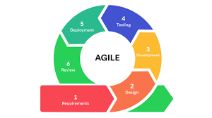
MODEL USE

Research and Development Stage
This study used a developmental-descriptive research design to create Bugay-Dagat, an online platform that connects local fishermen, seafood vendors, and consumers. The main goal of the project is to build an easy-to-use and efficient system where customers can browse, order, and receive fresh and dried seafood delivered straight to their homes. The platform also aims to promote fair trade, transparency, and sustainability in the seafood business.
deployment, ensuring that the system meets the needs of the users and aligns with the insights provided by the respondents. The SDLC will consist of the following stages:
- Plan - To create a user-friendly and efficient online platform for seafood delivery, providing fresh and high-quality seafood to customers while streamlining operations for restaurants and suppliers.
- Design - Design mockups for homepage, seafood catalog (dried and fresh), checkout process, and delivery tracking. We use tools like Figma to create user interface prototypes. And also to review the design with stakeholders for their feedback.
- Develop - In the development stage of Buhay Dagat, our team starts building the actual features of the platform. Our programmers work in short sprints to create both the front end and back end. The front end includes pages for the log-in process, and the back end includes the pages for browsing seafood, placing orders, and tracking deliveries. It also connects the platform to other services like GCash for payments.
- Testing - In the testing stage of Bugay Dagat, our team checks if all the features work correctly. We're testing important parts like ordering, payments, and delivery tracking. Different tests are done to make sure the system runs smoothly and without errors. Some real users also try the platform and give feedback. Our team uses this feedback to identify and address problems and to improve the website before the next update.
- Deployment - In the deployment stage of Bugay Dagat, our team launches the platform so users can start using it. This helps them find any remaining bugs or issues before a full launch. Once everything is stable, the platform is made available to more users. Our team continues to monitor its performance and make updates based on user feedback.
- Review - In the review stage of Bugay Dagat, our team looks back at the work done during the sprint. We check if the goals were met and discuss what went well and what needs improvement. Feedback from users is carefully considered. This helps our team understand how to make the platform better in the next sprint. The review also allows everyone to share ideas and solve any problems together.

SURVEYS

To gather relevant information for the development and evaluation of Bugay-Dagat, various data collection techniques were utilized. These methods aimed to obtain both qualitative and quantitative data to ensure that the platform effectively addresses the needs of local fishermen, vendors, and consumers.

Survey Questionnaire
A structured survey was conducted among local fishermen, seafood vendors, and consumers to collect data on their current challenges, preferences, and expectations in the seafood supply chain. The questionnaire included both closed-ended and open-ended questions to gather measurable and descriptive data regarding ordering processes, pricing, product quality, and delivery satisfaction.

Interviews
Semi-structured interviews were carried out with key stakeholders to gain deeper insights into their experiences, operational challenges, and suggestions for improving the seafood trade. These interviews helped identify specific needs that guided the platform’s design and functionalities.

Observation
The researchers conducted direct observation in local markets and fishing communities to understand the existing seafood selling and delivery processes. This technique provided firsthand information on stock handling, pricing methods, and communication gaps between suppliers and customers.

Document and Literature Review
Relevant documents, studies, and online resources were reviewed to support the system’s conceptual and technical framework. The literature review provided background information on online delivery systems, e-commerce platforms, and digital supply chain management in the fisheries industry.

System Testing and User Feedback
After developing the Bugay-Dagat platform, prototype testing was conducted. Users, including fishermen, vendors, and consumers, were asked to navigate the platform and provide feedback on its usability, design, and functionality. This feedback helped refine and enhance the system for better performance.

Justification for Selecting the Agile Methodology
The decision to adopt Agile over other SDLC models, such as Waterfall, was based on several critical factors:

Aspect | Agile Method | Iterative Method
Focus | working flexibly with customers | Making it better step by step
Feedback Timing | Repeated each sprint | Each time the process is completed
Change Handling | Highly adaptable to changing requirements | Changes are possible but less frequent
Team Involvement | Developer and stakeholder collaboration | Developer-focused
Delivery | Small, usable parts delivered regularly | Final product made after many improvements

System Architecture and Design

3.1 Overview

Bugay-Dagat is an online platform that connects consumers with local fishermen and vendors in Guimbal. It aims to make trade fair, transparent, and sustainable. This study looks at ways to improve how fresh and dried seafood products are delivered.
As technology continues to advance, an increasing number of people are relying on the internet for online transactions. Consumer preferences have increasingly shifted toward the convenience of door-to-door delivery services. This study focuses on the evolution of online seafood delivery, particularly those that emphasize the direct transport of fresh and dried seafood products.
The platform seeks to establish a fair and transparent marketplace where fresh and dried, sustainably sourced seafood is delivered directly from local fishermen and vendors to consumers’ doorsteps.
Overall, the review highlights the evolving dynamics of seafood delivery and its response to modern consumer preferences and environmental considerations.

3.2 System Architecture
The system architecture is divided into three main layers:
- Presentation Layer: Includes user interfaces such as the web application for customers, administrators, and delivery drivers. Customers can browse fresh and dried seafood, place and track orders, and view order status. Administrators can upload seafood products, update stock availability, manage orders, monitor inventory, manage users, and generate reports. Delivery drivers can access their portal to view assigned deliveries and update delivery status.
- Application Layer: This layer contains the backend logic that manages all system operations. It handles product listings, order processing, Cash on Delivery (COD) verification, and delivery coordination. It also manages reporting functions to ensure smooth communication between customers, administrators, and delivery personnel, ensuring efficient order fulfillment and tracking.
- Data Layer: Includes the database where all essential information is stored, such as user accounts, seafood inventory, order details, Cash on Delivery transaction records, and delivery logs. The database ensures that all transactions and updates are securely stored and can be accessed or retrieved by authorized users when needed.

Diagram:
Include a System Architecture Diagram showing components like:
- Bugay Dagat database
- Website application
- API services

3.3 System Components and Modules

The Bugay-Dagat Online Platform is composed of several interconnected modules that work together to ensure a smooth and efficient seafood delivery process. Each module is designed to handle specific system functions, from product management to order processing and reporting.

3.3.1 User Module

It allows customers and administrators to log in, access their dashboards, and perform authorized actions.

3.3.2 Product Management Module
Administrators can upload seafood products, update stock availability, set prices, and categorize items as fresh or dried.

3.3.3 Order Management Module
Processes customer orders from placement to completion. It records order details, verifies product availability, and updates order status.

3.3.4 Payment Module
Manages payment transactions using Cash on Delivery (COD) only. It records payment status upon delivery and ensures that all transactions are properly documented.

3.3.5 Delivery Management Module
Coordinates with the delivery service to ensure timely and accurate delivery of seafood products. It tracks delivery progress, updates status information, and notifies administrators once an order is successfully delivered.

3.3.6 Reporting and Analytics Module
These include monthly order volume, monthly income, top-selling products, and product performance by month. This module helps administrators make informed decisions and monitor platform performance.

Use Case Diagram
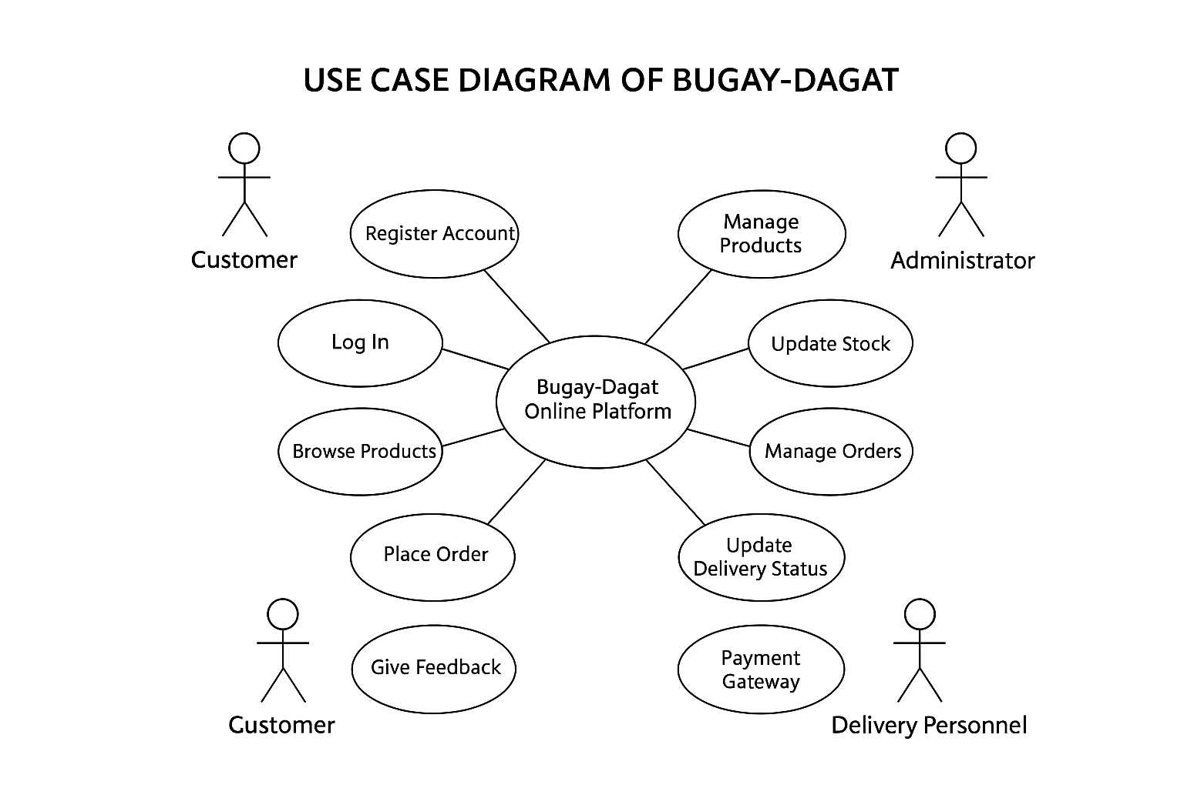

The Use Case Diagram of Bugay-Dagat illustrates the interaction between the system and its external users or actors. It shows how each actor performs specific actions to achieve their goals within the platform. Each use case represents a function or process that the system performs in response to a user’s request.

Data Flow Diagram
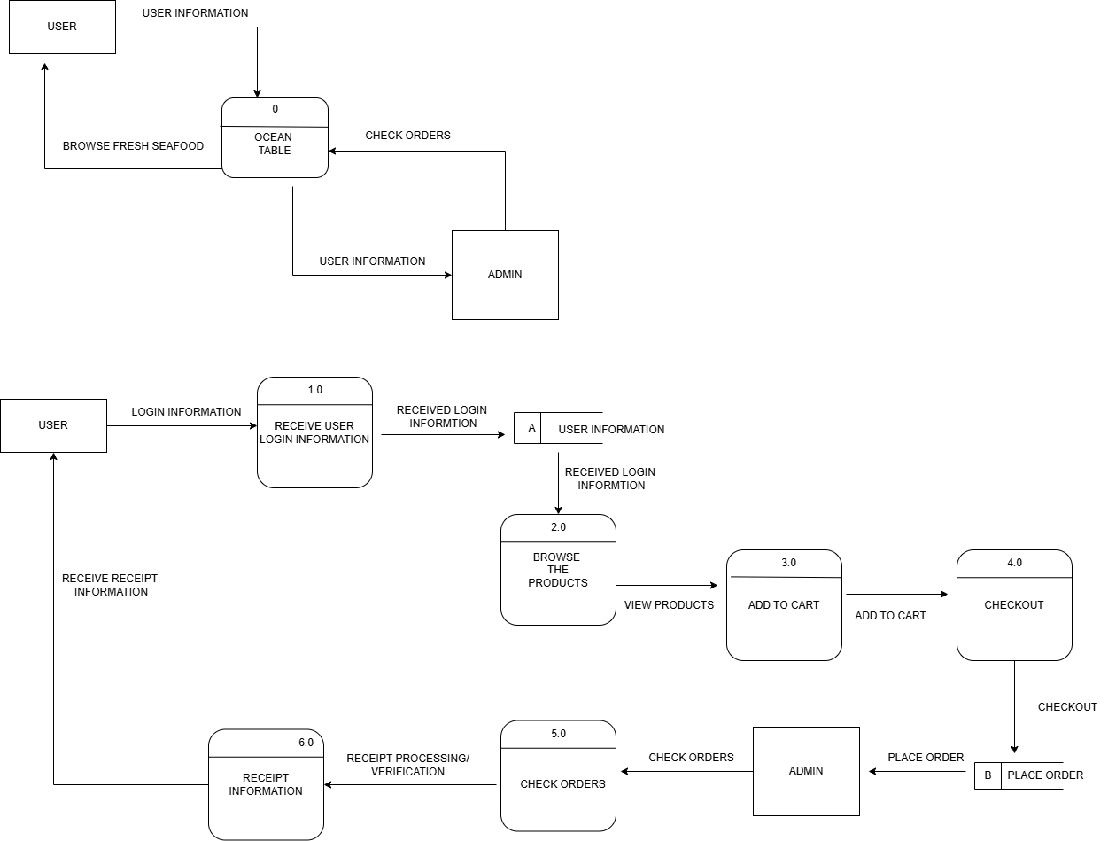

The Data Flow Diagram (DFD) of Bugay-Dagat illustrates how information such as orders, payments, stock updates, and delivery statuses flows between customers, fishermen, or vendors, and the platform’s processes, including order management, inventory management, payment processing, and delivery coordination. Key data stores, such as customer details, vendor/product information, and transaction records, are also represented to show how data is stored and accessed.

The Use Case Diagram highlights the system’s functional requirements by showing how actors—customers, vendors, and administrators—interact with the platform to perform tasks like placing orders, updating products, tracking deliveries, and managing users. Together, these diagrams provide a clear overview of the platform’s operations and user interactions.

ERD

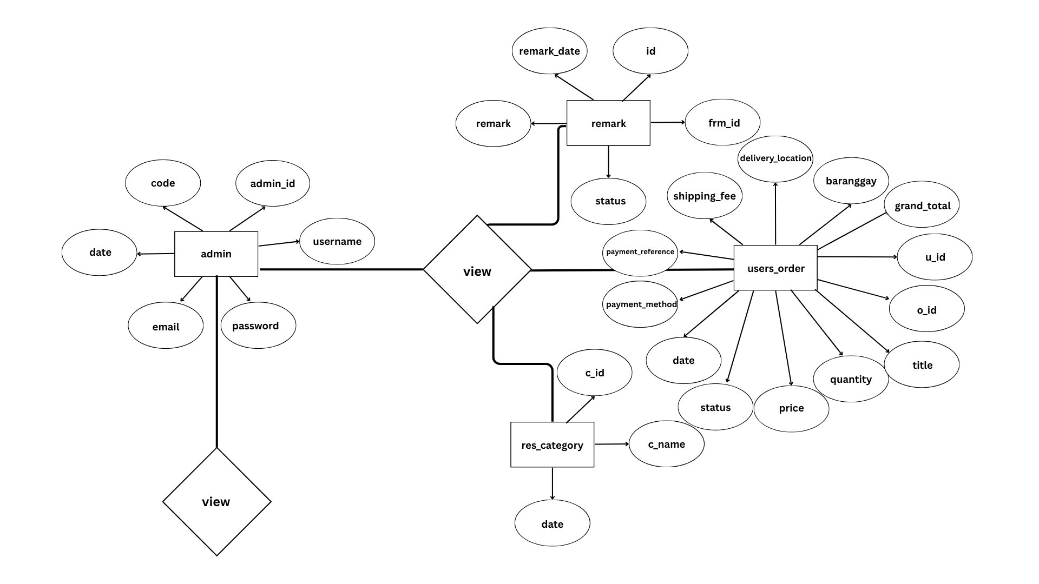

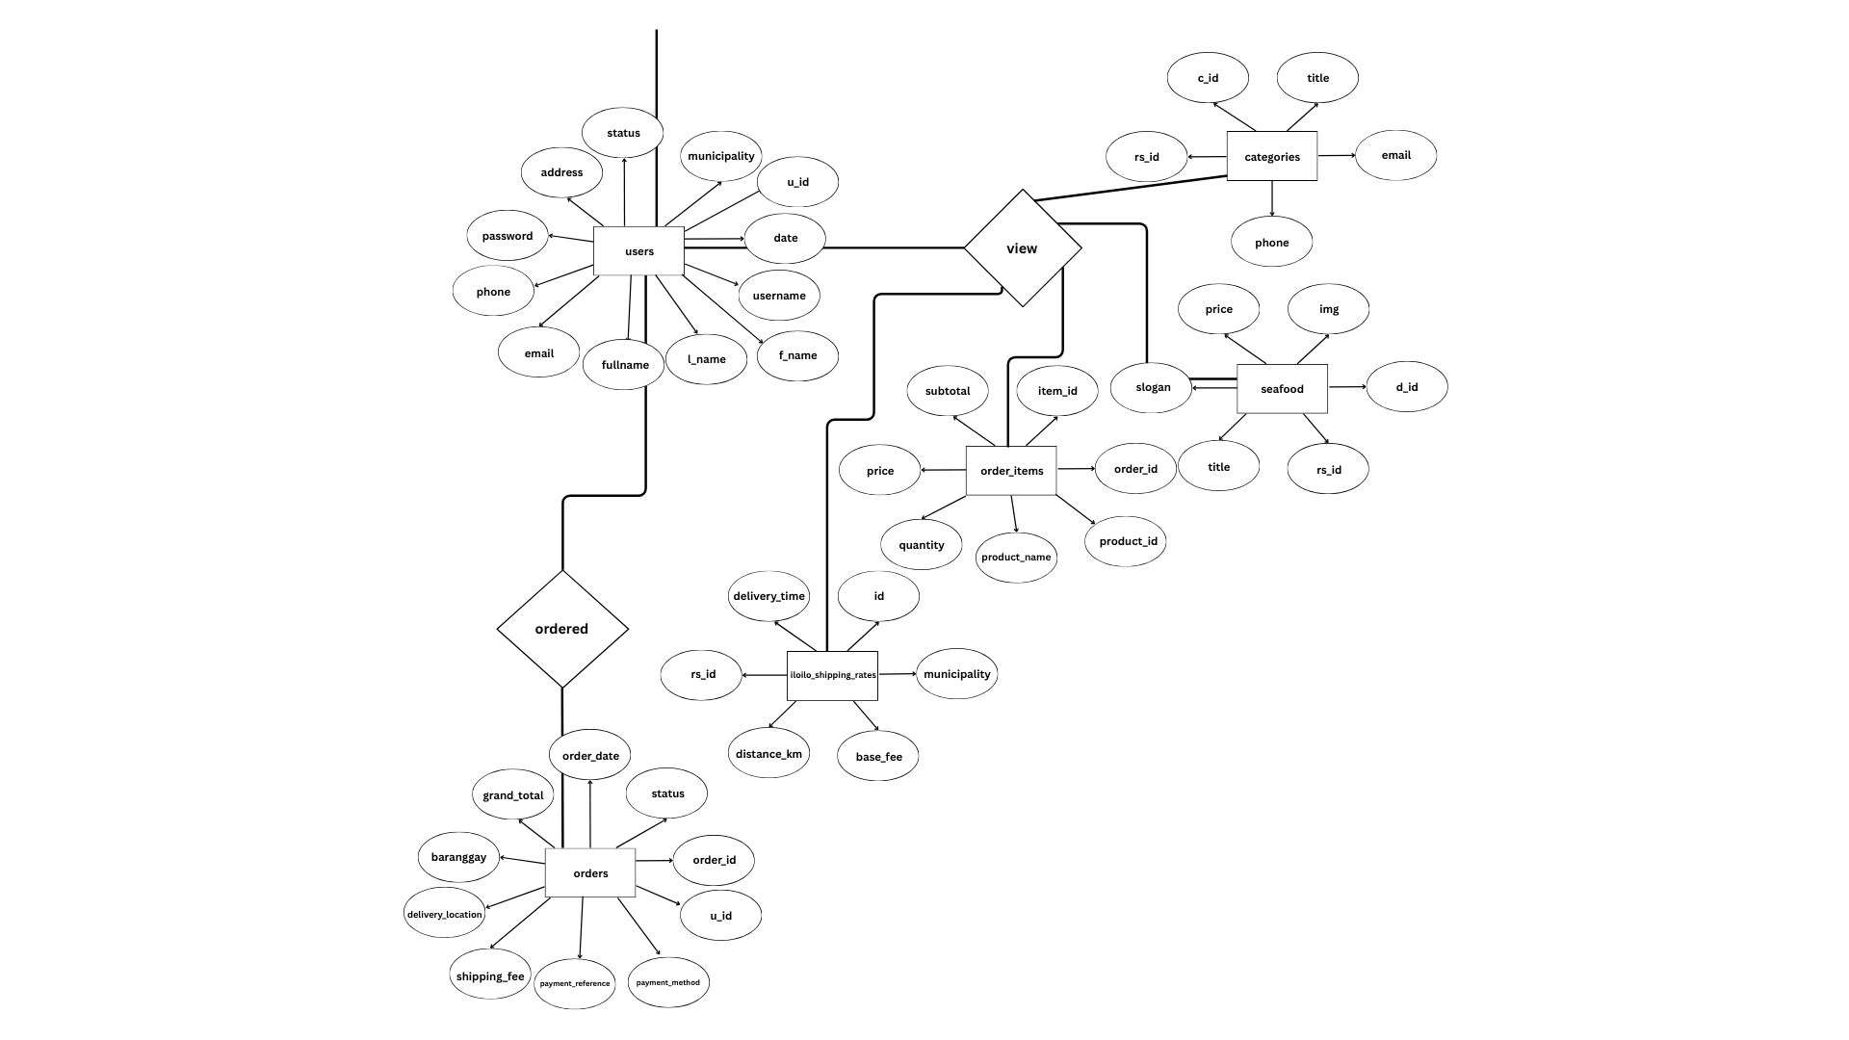

3.4 Database Design
The Bugay-Dagat Database serves as the backbone of the system, storing and managing all essential data related to users, products, orders, payments, and deliveries.
Key tables may include:
- Admin
- Remarks
- User_orders
- Res_category
- Users
- Categories
- Seafood
- Order_items
- Iloilo_shipping_rates
- Orders

3.5 User Interface Design

The User Interface (UI) of Bugay-Dagat is simple and easy to use. Customers can quickly browse seafood products, see prices and pictures, add items to their cart, place orders, and track deliveries. Payments are secure and straightforward. Vendors have a clear dashboard to update product availability, confirm orders, and manage deliveries. The design is clean, responsive, and makes using the platform fast and convenient for everyone.

3.6 Security Considerations
Discuss any security mechanisms implemented, such as:
- User authentication
- Role-based access control
- Data encryption
- Secure API endpoints

3.7 Technology Stack
List all the tools, platforms, and technologies used in the development:
- Frontend: HTML
- Backend: JAVASCRIPT, PHP
- Database: MySQL

DATA GATHERING TECHNIQUES

Survey Questionnaire for System Assessment
The purpose of the surveys in this study is to evaluate the effectiveness, usability, and overall performance of Bugay-Dagat from the users' perspective. Through the survey, feedback is gathered from customers and administrators to assess how well the system meets their needs in terms of accessibility, functionality, reliability, and satisfaction.

- Is the platform easy to navigate and user-friendly?
  - 1- very easy
  - 2- easy
  - 3- neutral
  - 4- hard
  - 5- very hard

- Are the seafood products clearly categorized and easy to find?
  - 1- very easy
  - 2- easy
  - 3- neutral
  - 4- hard
  - 5- very hard

- The website design is attractive and organized.
  - 1- very easy
  - 2- easy
  - 3- neutral
  - 4- hard
  - 5- very hard

- The order process is simple and efficient.
  - 1- very easy
  - 2- easy
  - 3- neutral
  - 4- hard
  - 5- very hard

- Payment methods are convenient and secure.
  - 1- very easy
  - 2- easy
  - 3- neutral
  - 4- hard
  - 5- very hard

- I am satisfied with the variety of seafood available.
  - 1- Very Satisfied
  - 2- Satisfied
  - 3- Neutral
  - 4- Unsatisfied
  - 5- Very Unsatisfied

- I am satisfied with the delivery speed and reliability.
  - 1- Very Satisfied
  - 2- Satisfied
  - 3- Neutral
  - 4- Unsatisfied
  - 5- Very Unsatisfied
8. The products I received met my quality expectations.
  - 1- Very Satisfied
  - 2- Satisfied
  - 3- Neutral
  - 4- Unsatisfied
  - 5- Very Unsatisfied

9. I would recommend Bugay-Dagat to others.
  - 1- Very Satisfied
  - 2- Satisfied
  - 3- Neutral
  - 4- Unsatisfied
  - 5- Very Unsatisfied

10. The information about seafood products is clear and easy to understand.

  - 1- Very Satisfied
  - 2- Satisfied
  - 3- Neutral
  - 4- Unsatisfied
  - 5- Very Unsatisfied

Sampling Methods for Respondents
Respondents​‍​‌‍​‍‌​‍​‌‍​‍‌ of this survey will be chosen via purposive sampling method. It is because these respondents were selectively picked according to their closeness and direct involvement with the Bugay-Dagat platform. The three groups of the chosen participants are those customers who use the platform to order seafood, fishermen or vendors who supply and sell seafood products through the system, and administrators who manage and oversee the platform’s ​‍​‌‍​‍‌​‍​‌‍​‍‌operations.

- Define the Target Respondents: Respondents​‍​‌‍​‍‌​‍​‌‍​‍‌ were the main focus of the research on the Bugay-Dagat platform. The chosen people are customers who use the system to order seafood, fishermen or vendors who supply seafood through the platform, and administrators who oversee and manage system operations. These groups were selected as they can give the most accurate and in-depth feedback regarding the system’s ease of use, its performance, and, in general, its ​‍​‌‍​‍‌​‍​‌‍​‍‌effectiveness.
- Group Respondents by Category: Through​‍​‌‍​‍‌​‍​‌‍​‍‌ purposive sampling, the Bugay-Dagat platform users were categorized based on their roles and relationships to the platform. Customers, fishermen or seafood suppliers, and system administrators became the three main groups into which the respondents were divided. Such a division made it possible for the data obtained to be a fair representation of the views of the whole process of delivering seafood. The respondents' organization in this manner made the study have the voices of different users and get the view of their different experiences with the ​‍​‌‍​‍‌​‍​‌‍​‍‌platform.
- Select Qualified Respondents: From each category, participants were purposely chosen based on their experience and familiarity with the system. Only respondents who have used, managed, or interacted with the Bugay-Dagat platform were included to ensure the accuracy and relevance of the data collected.
- Determine Sample Size: The​‍​‌‍​‍‌​‍​‌‍​‍‌ total number of people surveyed was figured out according to the needs of the project, thus making sure that each group was adequately represented. They aimed to have at least 10 to 15 participants from each category in order to collect balanced feedback and make it possible to draw substantial conclusions concerning the system’s ​‍​‌‍​‍‌​‍​‌‍​‍‌performance.
- Survey Distribution: The survey will be distributed using Google Forms, ensuring easy access for all respondents. It will be shared through social media platforms, direct messages, and personal coordination with local fishermen, seafood suppliers, delivery personnel, and potential customers involved in the Bugay Dagat Online Platform.

Compliance with Data Privacy Laws and Ethical Standards
● All participants were informed about the purpose of the study and how their responses would be used in evaluating the Bugay Dagat Online Platform. Their participation was voluntary, and they were allowed to withdraw at any time without any consequences. Personal details were not collected unless necessary, and all responses were kept confidential and anonymous. The study ensured compliance with the Data Privacy Act of 2012 (Republic Act No. 10173) and followed all relevant ethical guidelines in conducting research.

Protection of Participant Information
● All collected data were securely stored and used strictly for academic purposes only. The researchers ensured that no personal information was shared or disclosed to individuals outside the research group. In presenting the results, only summarized and aggregated data were shown to maintain confidentiality and protect the identity of all respondents.

CHAPTER IV

RESULTS AND DISCUSSION

The implementation of Bugay-Dagat, an online platform for buying and delivering fresh and dried seafood, was successful in connecting the local fishermen and vendors of Guimbal with consumers. The number of registered users continued to grow, showing that many people are interested in easily and reliably getting seafood. Feedback from users showed high satisfaction, especially with the freshness and quality of the seafood they received.
The system helped improve the income of local fishermen and vendors of Guimbal by increasing their sales. Through the platform, they were able to reach more customers and promote their products directly to buyers. This digital connection made pricing fairer and product sourcing clearer, helping build trust between sellers and customers.
However, several operational challenges emerged during implementation. Delivery delays sometimes happened because of weather, logistical issues, and transportation limits in coastal areas. Competition from larger e-commerce and e-grocery platforms also affected market visibility and customer retention. Despite these obstacles, Bugay-Dagat showed the potential of digital platforms to enhance the seafood trade ecosystem by supporting local livelihoods and ensuring customers have access to fresh and dried seafood conveniently.

Summary of the data sources and analysis methods used
The data used in this study were collected from several reliable sources to ensure accuracy and validity. Primary data were obtained from the Bugay-Dagat platform’s backend database, which recorded all essential activities such as user transactions, seafood orders, and delivery records during the system’s testing and implementation phases. Additional data were gathered from system-generated reports that monitored order status, delivery time, and customer engagement.
Quantitative methods were employed to analyze the collected data. Descriptive statistics were used to evaluate key performance metrics such as order completion rates, transaction accuracy, and delivery efficiency. The results from these analyses provided a clear understanding of the system’s operational performance and effectiveness in improving the seafood ordering and delivery process.

Task Manager:
Gantt Chart / Project Timetable – Bugay-Dagat Online Platform For Seafood Delivery

Week | Task | Programmer | UI/UX Designer | Documenter
1 | Project planning & requirements gathering | ✅ | ✅ | ✅
2 | Research & system design planning | ✅ | ✅ | ✅
3 | Use Case & DFD creation |  |  | ✅
4 | Database design & schema creation | ✅ |  | ✅
5 | UI wireframes & mockups |  | ✅
6 | Frontend development begins | ✅ | ✅
7 | Backend development begins | ✅
8 | Integration of frontend and backend | ✅ | ✅
9 | System testing & debugging | ✅ | ✅
10 | User testing & feedback collection | ✅ | ✅ | ✅
11 | Final revisions (code + UI + content) | ✅ | ✅ | ✅
12 | Documentation finalization & formatting | ✅ |  | ✅
 | Final project submission | ✅ | ✅ | ✅

✅ Legend:

● ✅ = Active role/task in that week

Presentation of Results

The results of Bugay-Dagat show that the platform effectively improves the seafood supply chain through technology. Users found it easy to navigate and convenient for ordering, with smooth payment and delivery tracking. The system helped streamline operations, reducing delays and minimizing waste, ensuring fresh seafood reached consumers on time. Local fishermen and vendors benefited from increased sales and wider customer reach, while the platform provided valuable data on consumer preferences and stock levels to guide future decisions. Some challenges, such as occasional delivery delays and the need for digital training for vendors, were also noted. Overall, Bugay-Dagat proved to be a reliable and user-friendly platform that supports both consumers and local suppliers.
To clearly present the collected data, tables and charts were created showing stock accuracy before and after the system was used, transaction speed, and user feedback ratings.

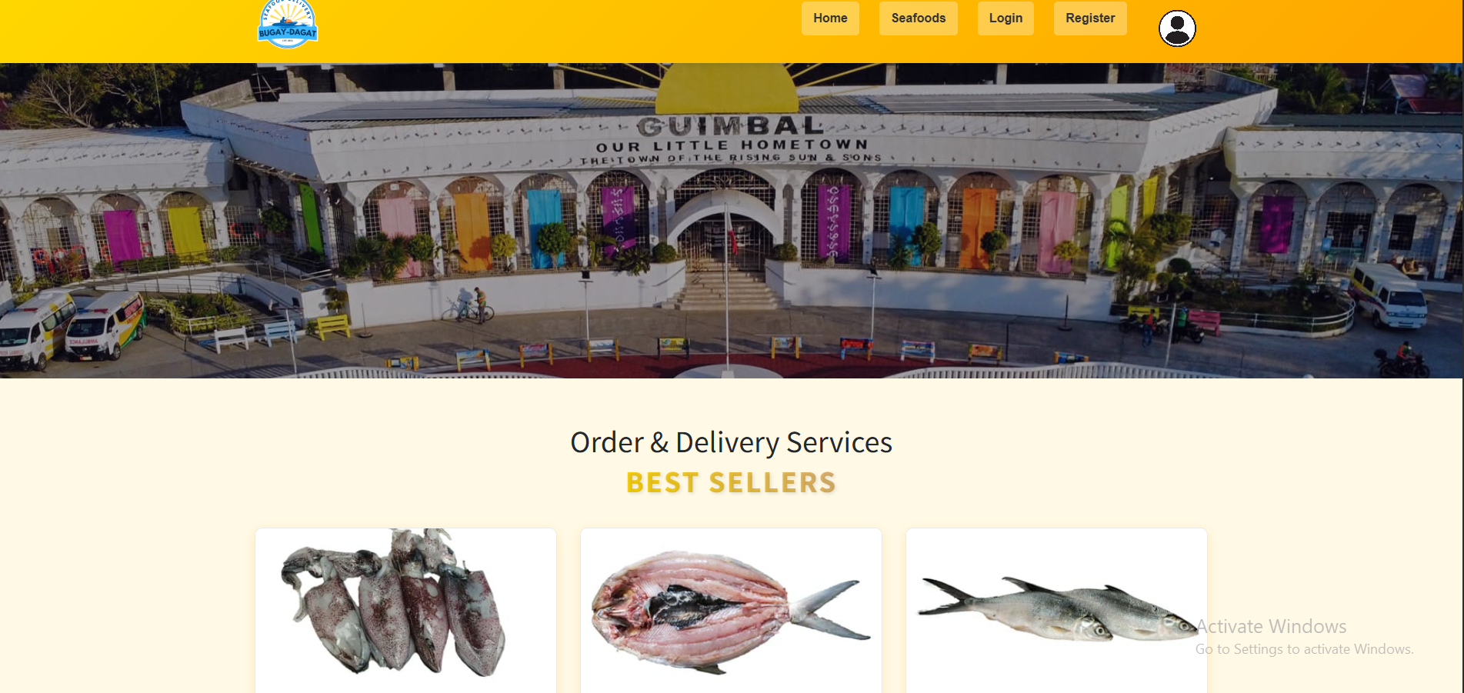
System Screenshots

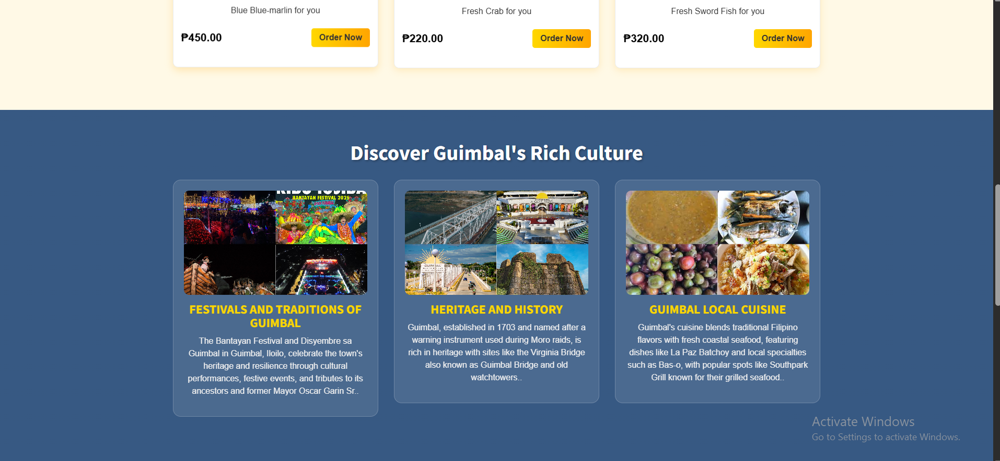

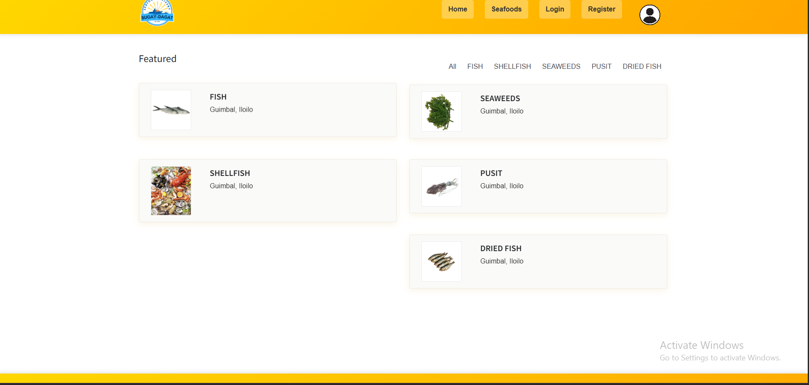

4.2 Data Tables, Graphs, and Figures
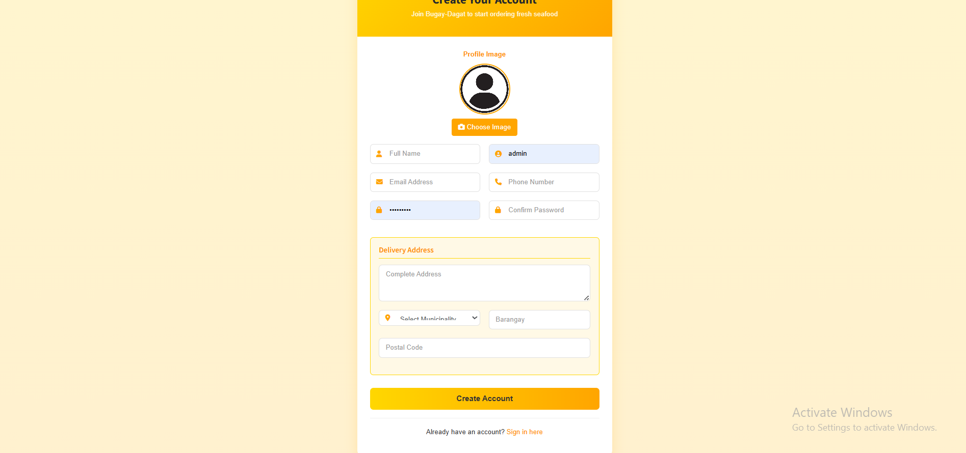
To clea

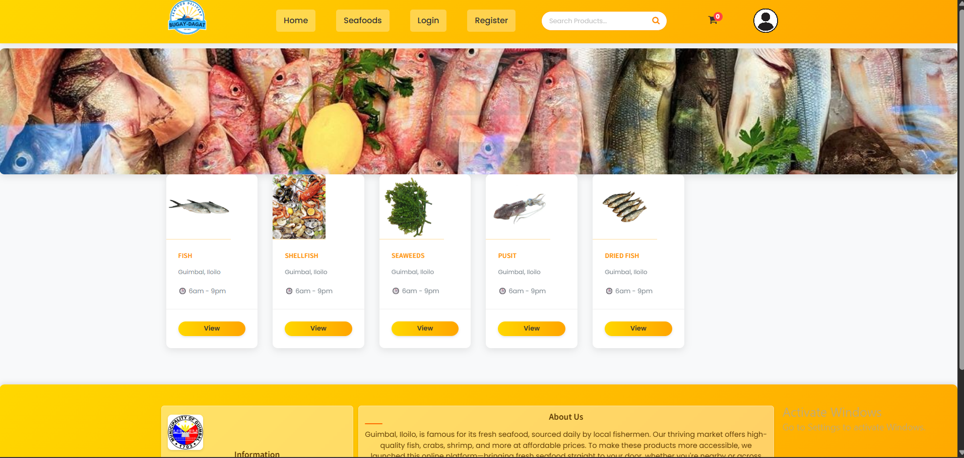

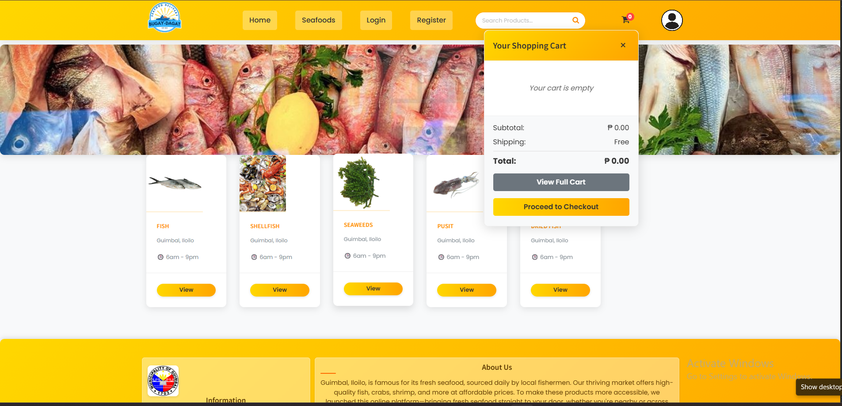

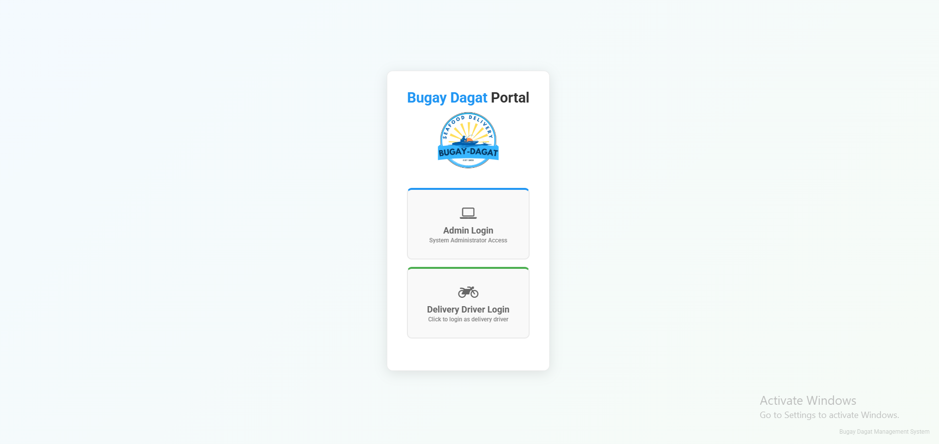
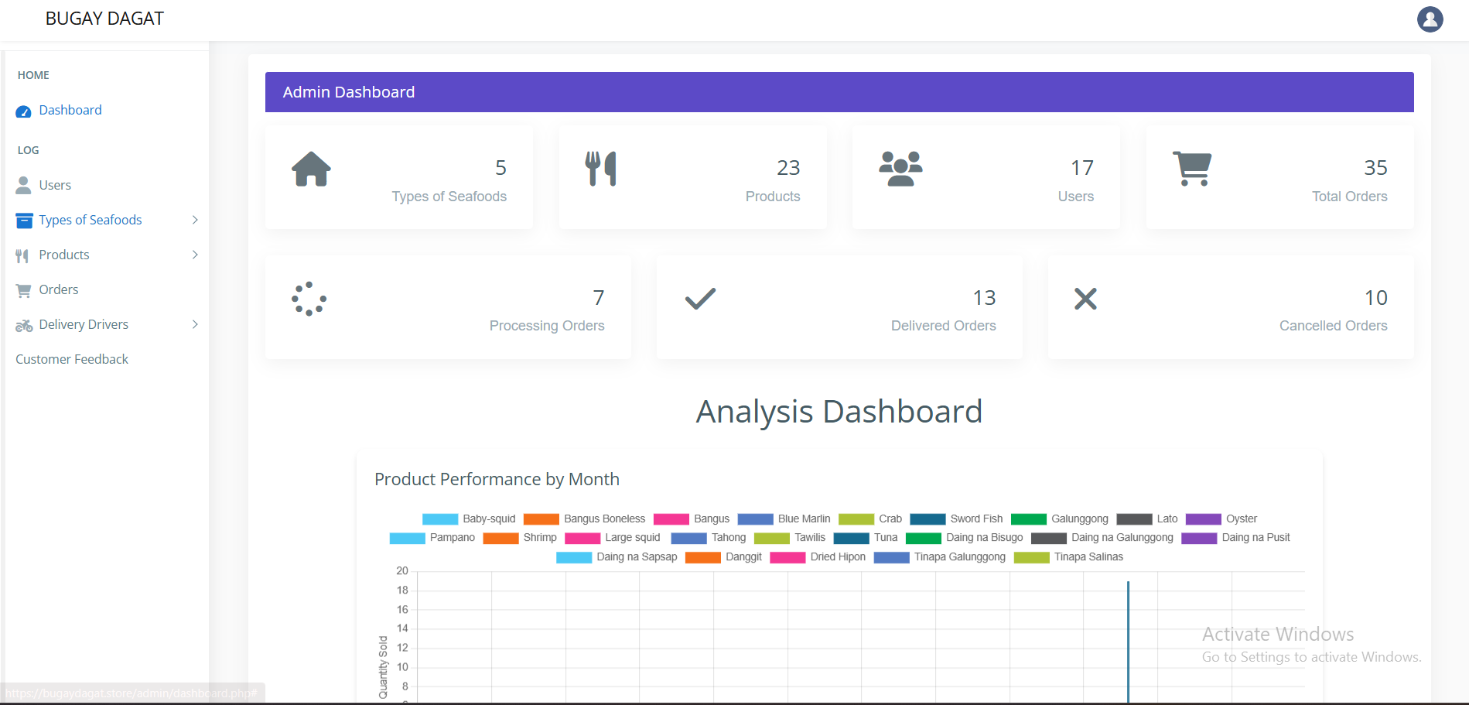
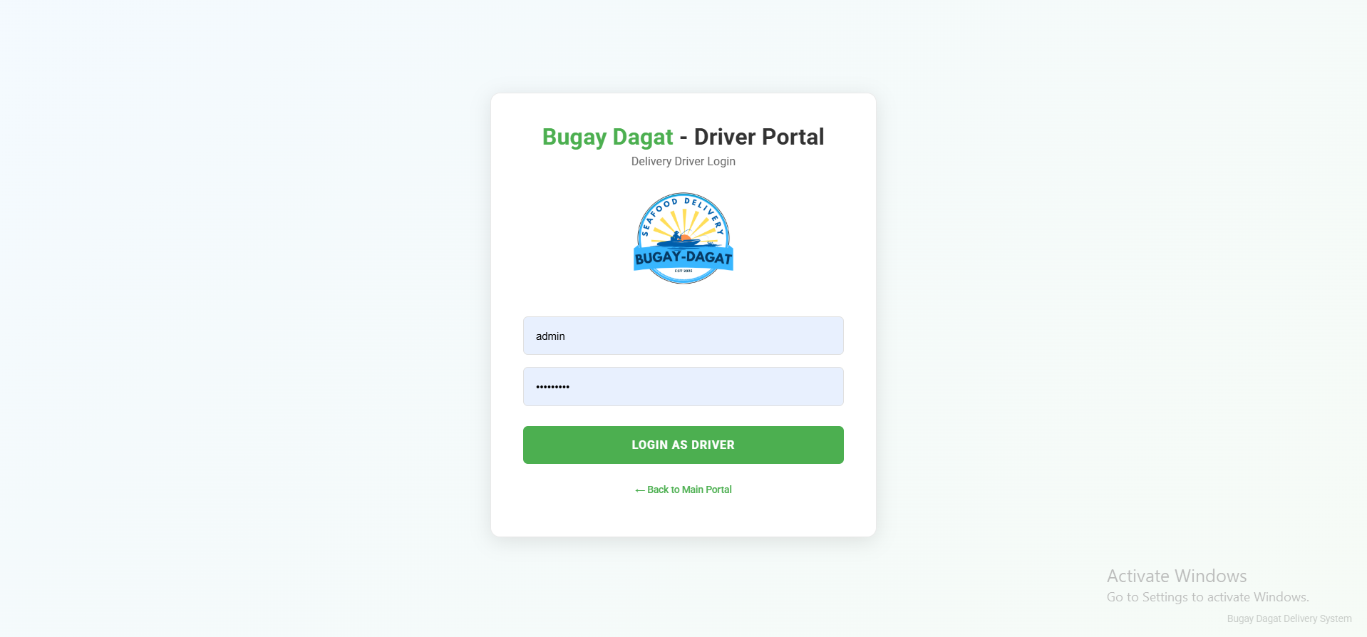

Features of the System

The Bugay Dagat Online Platform was developed to provide an efficient and convenient way of accessing fresh seafood directly from local fishermen and suppliers. Its key features include:
1. Seafood Product Listing – Displays available seafood products such as fresh fish, crabs, shrimps, and dried seafood. Each item includes images, price, stock availability, and product description.
2. User Login and Authentication – Provides secure login for customers, administrators, fishermen/suppliers, and delivery drivers to access their respective accounts and system functions.
3. Order Management System – Allows customers to place orders easily, view order details, and track order status from processing to delivery completion.
4. Cash on Delivery (COD) System – Supports secure transactions where customers pay upon receiving their orders, ensuring trust and convenience.
5. Driver Portal – A dedicated interface for delivery drivers to view assigned orders, manage delivery schedules, update delivery status, and confirm successful delivery transactions.
6. Delivery Tracking System – Provides real-time updates on order status and delivery progress to ensure timely and accurate distribution of seafood products.
7. User Account Management – Allows users such as customers, suppliers, drivers, and administrators to create, update, and manage their profiles securely.
8. Product Search Functionality – Enables users to quickly search for specific seafood products or categories for easier navigation.
9. User-Friendly Interface – Ensures a simple, clean, and easy-to-use design that allows users to browse and order seafood without difficulty.
10. Feedback System – Allows customers to provide feedback on products and delivery service to help improve the overall platform quality.
11. Inventory Management – Helps administrators and suppliers monitor stock levels, update availability, and manage seafood listings in real time.
12. Responsive Web Access – The platform is designed to be accessible on mobile phones and computers, allowing users to order seafood anytime and anywhere with internet access.

CHAPTER V

SUMMARY, CONCLUSION, AND RECOMMENDATION

Summary
Bugay-Dagat is an innovative online platform created to improve the process of buying and selling fresh and dried seafood. It serves as a digital bridge that connects local fishermen, seafood vendors, and consumers in one convenient system. Through its user-friendly interface, customers can browse available products, place orders online, and have their seafood delivered directly to their homes. The system also allows the admin to manage inventory efficiently by tracking stock levels and updating product availability in real time.
In addition, Bugay-Dagat aims to support local livelihoods by providing small-scale fishermen and vendors with a wider market reach through digital technology. It ensures that transactions are smooth and reliable through features like order tracking and cash-on-delivery options. The system gathers data from user activity and transactions, which can be used to improve operations and decision-making.
Overall, Bugay-Dagat demonstrates how technology can modernize traditional seafood trading. It promotes convenience, efficiency, and transparency in the seafood supply chain while strengthening the connection between local producers and consumers. Through this platform, the community benefits from faster transactions, better product accessibility, and a more sustainable approach to seafood distribution.

Conclusion
Bugay-Dagat is a helpful online platform that makes buying fresh and dried seafood easier and more convenient. It connects local fishermen, vendors, and customers in one system, allowing them to trade seafood directly and fairly. The platform helps ensure that products are fresh and of good quality while giving customers a simple way to order online.
Overall, Bugay-Dagat supports local livelihoods and provides a reliable way for people to buy seafood. It shows how technology can improve local businesses and help communities adapt to modern ways of selling and buying products.

5.3 Recommendations
To improve Bugay-Dagat, it is recommended to expand the delivery areas so more customers can access fresh and dried seafood. The system can also be enhanced by adding more product options and making the website or app easier to use. Promoting the platform through social media and local markets can attract more users and increase sales.
It is also suggested to build stronger partnerships with local fishermen and vendors to ensure a steady supply of quality seafood. Regular feedback from customers should be gathered to help improve services and maintain customer satisfaction. By following these recommendations, Bugay-Dagat can continue to grow and better serve both customers and local communities.

References (APA Format)
- Rani, P., Sharma, P., & Gupta, I. (2024). From sea to table: A blockchain-enabled framework for transparent and sustainable seafood supply chains. In U. Nanda, A. K. Tripathy, J. P. Sahoo, M. Sarkar, & K. C. Li (Eds.), Advances in Distributed Computing and Machine Learning: ICADCML 2024 (Lecture Notes in Networks and Systems, Vol. 1015). Springer. https://doi.org/10.1007/978-981-97-3523-5_9

- Roheim, C. A., Bush, S. R., & Asche, F. (2018). Evolution and future of the sustainable seafood market. Nature Sustainability, 1(7), 392–398. https://doi.org/10.1038/s41893-018-0115-z

Appendices:

Appendix A: System Interface Screenshots
● Homepage / Dashboard
● Seafood Product Listing Page
● Product Details Page
● Search / Category Module
● Login Page
● Driver Portal Interface
● Admin Dashboard

Appendix B: Use Case Diagram
● Actors:
○ Customer – Individual users who browse and purchase fresh seafood through the Bugay Dagat Online Platform
○ Administrator – Person responsible for adding, editing, and deleting seafood products, managing orders, users, and reports
○ Delivery Personnel (Driver) – Responsible for viewing assigned deliveries, updating delivery status, and confirming Cash on Delivery (COD) transactions
● Use Cases:
○ User Registration and Login
○ View Seafood Products
○ Search and Filter Products
○ Place Order
○ Track Order Status
○ Manage Product Inventory
○ Manage Orders
○ Assign and Manage Deliveries
○ Update Delivery Status
○ Confirm Cash on Delivery (COD)
○ Generate Report

Appendix C: Data Flow Diagram

(Include Level 0 and Level 1 DFDs with titles and descriptions.)

Appendix D: User Survey Form and Summary

● Survey Questions

Is the platform easy to navigate and user-friendly?

Are the seafood products clearly categorized and easy to find?

The website design is attractive and organized.

The order process is simple and efficient.

Payment methods are convenient and secure.

I am satisfied with the variety of seafood available.

I am satisfied with the delivery speed and reliability.

The products I received met my quality expectations.

I would recommend Bugay-Dagat to others.
- The information about seafood products is clear and easy to understand.

