IST 263

# Lab 13

## This lab covers:

1. Usability
2. Site Testing
3. Favicons
4. Google Fonts
5. Domain Names

## SETUP and Overview

For this lab you don't need to do any setup. You can work on your project files or in the latest version of your portfolio site or on your current project site.

This lab is a potpourri of usability, site testing and your requests.

## Usability

Usability is a big field that studies the effectiveness of user design. You could take a whole class on evaluating user interfaces. For our section on usability we are going to conduct a five second test.

Five second tests are used to determine the first impressions of a design. It's also approximately the amount of time that users will evaluate a home page to decide whether it is what they were looking for. Here's how ours will work.

1. Five Second Test – **IMPORTANT – Read all instructions before doing this**
   1. Pick a partner in class and evaluate their project home page. I will help you find a partner if needed. Don't worry if your home page is not finished. I know that. We are just collecting feedback and suggestions to make your page better.
   2. Examine their home page for approximately 5 seconds
   3. Do not look at their home page again before answering the following questions
      1. What is the purpose of the site?

Showing the World of Adrenaline.

* + 1. What are the main elements you can recall?

The background picture, the title of the page.

* + 1. Who do you think the intended audience is?

The audience who are interested in exploring new activities during leisure time.

When you are done with this part, find out what your partner said about your site. You will be turning in your partner’s answers below.

Note: More about the 5 second test can be found here: <https://fivesecondtest.com/>

## Site Proofing

1. Below is a checklist for site proofing. You will proof your own website. For this section, go through the checklist and either make changes, or make notes about items you need to change in the next round of the project. You will detail your notes on the lab submission.
   1. site text is free of misspellings and well written
   2. navigation works correctly on all pages
   3. all other links work and go to the correct location
   4. images are correct and no images used as placeholders remain
   5. site looks correct on a mobile device
   6. site looks correct on desktop computer in Safari, Firefox, Chrome and Edge  
      if you're on the Mac, don't worry about Edge  
      if you're on Windows don't worry about Safari

## Favicons

Recall that favicons are the tiny images that display on the tabs of our browser. Decide which site you would like to create a favicon for (project or portfolio). If you don't have Photoshop on your machine you can get it on Remote Lab: <https://answers.syr.edu/display/ITHELP/Remote+Desktop+Services+via+RDP+Client>

1. Locate an image – remember to keep your choices simple
2. Open the image in photoshop or alternatively you can create a new document, find a font and use text for your favicon. Here's my image in photoshop.   
     
   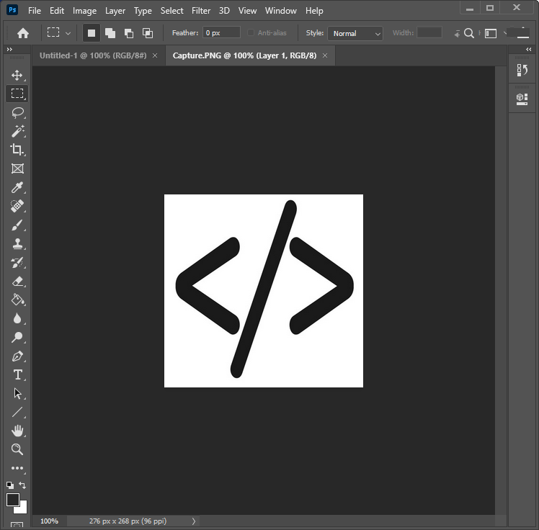
3. Crop off any extra space around the edges with the cropping tool. 
4. Favicons need to be a square so change the canvas size:
   1. Image -> canvas size
   2. Choose the larger of the two sizes (width and height) and make the width and the height match to square up your image
5. Resize the image to 32x32 pixels by going to image -> image size
6. Save as either a .jpg or a .png file – if you've forgotten how to do this consult the photoshop lab
7. Translate to favicon
   1. Go to <https://www.icoconverter.com/>
   2. Press the browse button and locate the image you created in photoshop
   3. Press the convert button and save the resulting favicon.ico file in your github repository
8. Push your favicon.ico file to github.
9. Normally you could put this file in the root directory of your website and every page would automatically pick up the favicon. But github web hosting requires one extra step. For any page you would like to use the favicon add the following element inside the head tags:  
     
   <link rel="shortcut icon" type="image/x-icon" href="favicon.ico">

Make sure that href attribute value relatively paths to your favicon.ico file correctly. The example above is the correct path if the favicon.ico file is in the same folder as the file you are linking from.

1. Check to make sure it worked by loading the page you put it on. You might have to empty the cache to see it.  
     
   Here's mine: 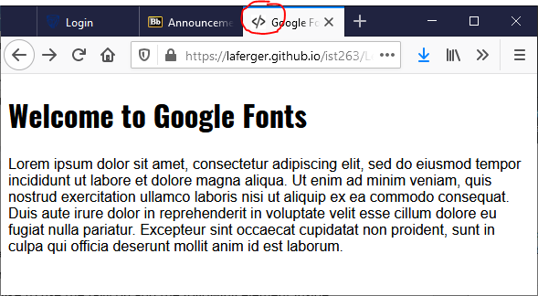

## Google fonts

Over the last few weeks several folks have asked me how to change the "boring web safe fonts". Web safe fonts offer about a dozen different font choices. Google fonts offers 850+ fonts to choose from. For this part we're going to change the font of your portfolio headers.

1. Go to Google Fonts and locate a font you like: <https://fonts.google.com/>
2. Click on the font to go to the details page.
3. Click  next to the font weight you like the best.
4. If you didn't get the embed code window, click the on the top right.
5. Copy the link code provided and put it in between the head tags of all your portfolio pages.
6. Copy the CSS rule provided by Google fonts. Think about what you need to do to change all the header (h1, h2…) tags on your page and right the CSS rule for that. If you are doing it in your embedded stylesheet, make sure you add the rule to all the pages.

## Domain Names

Domain names cost around $15 and I don't want to make you spend money. Instead I'll have you come up with an available name for your project website and I'll give you the info you need to make the domain name work should you ever decide to use one.

1. Think about a good domain name for your project website.
2. Go to <https://www.dotster.com/> which is a registrar and check to see if your domain name is available. If it's not, come up with another domain name until you've found one that is available. If you decide to use a domain that does not have .com at the end, think about making sure the ending makes sense for your project.  
     
   For Example: ist263.com is not available but I could register ist263.biz or .tech. .tech makes more sense in the context of our class.

If you choose to pay money and register a domain name. You can get the instructions on how to point the domain to github here: <https://richpauloo.github.io/2019-11-17-Linking-a-Custom-Domain-to-Github-Pages/>.

## What will You hand IN?

Create a word document, pdf or use the "write submission" option in blackboard to provide the following:

1. Usability –
   1. Who evaluated your site?
   2. What did they say about the purpose of the page?
   3. What are the main elements they recalled?
   4. Who do they think the intended audience was?
2. Site Testing – What changes did you make or what notes did you write about proofing changes?
3. Favicons - Submit the url for a page that shows your favicon.
4. Google Fonts - Submit the url for a page that shows your google font.
5. Domain Names - Submit the available domain name you researched above and tell me why that is a good domain name for your project.
6. Submit answers to the following:
   1. What questions did you have about the lab? What didn't you fully understand?
   2. What was the hardest part of the lab?
   3. Rate your comfort level with this week's topics.  
      1 ==> I can do this on my own and explain how to do it.  
      2 ==> I can do this on my own without any help.  
      3 ==> I can do this with help or guidance from others.   
       If you choose this level, please indicate HOW this person helped you.  
      4 ==> I don't understand this at all yet and need extra help.

• Do not look at their home page again before answering the following questions

1. The site is definitely focusing on the city of Shanghai. I could tell that much easily, but otherwise, I think it had something to do with the development of the city? So maybe it’s a site to check on new projects, developments, and updates about things happening throughout Shanghai?
2. I remember a big hero image of the city that was really striking, and colorful which clearly caught my attention. I also remember the words “Shanghai the city that never sleeps” which told me that the site was something to do with Shanghai. These elements were great, but the other two confused me a bit. There was also large text saying “Introduction” which seemed unnecessary since it’s the home page after all, so I recommend making that smaller and eliminating the fight for visual dominance on the page or deleting it all together. I also remember a graphic that showed an outline of the city of Shanghai with a variety of facts or information coming out but there were too many to read in 5 seconds. I think this might work better further down on the page where the user scrolls to it to find more detailed info or possibly moved to a different page, like an about page or something similar. Take advantage of the beautiful photo and really showcase it, along with a quick description of what the site is. It will look more streamlined and cleaner which will attract more users to stay and learn more.
3. I think the intended audience is citizens of Shanghai, or even tourists or visitors to the city who want to know what is happening around the city.