Node.js + Docker + Amazon ECS (EC2 Launch Type) End-to-End Deployment Demo

Project Overview
This end-to-end demo demonstrates how to containerize a simple Node.js REST API with Docker, push the Docker image to Amazon Elastic Container Registry (ECR), deploy it to an Amazon ECS cluster (EC2 launch type), and successfully access the application through the EC2 instance's public IPV4 URL.

Architecture
Node.js Express Application
│
▼
Docker Container
│
▼
ECR
│
▼
Amazon ECS Cluster
• Task Definition
• Cluster Service
│
▼
EC2 Instance
│
▼
Public IPv4 URL

Part 1 - Local Development

1. Install Prerequisites
Install the following software on the local PC:
- Node.js
- Docker Desktop

Verify the installation.
node -v
npm -v
docker –v (or docker --version)
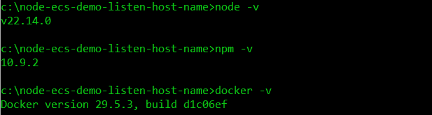
Ensure TCP port 3000 is available before starting the application
netstat –ano | findstr :3000 | findstr LISTENING
taskkill /PID (pid #) /f
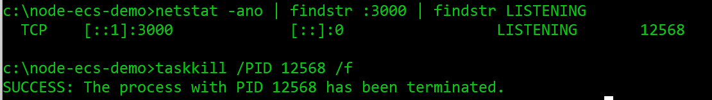

2. Create the Node.js Application
Create the project folder
node-ecs-demo-listen-host-name
Navigate into the folder
cd node-ecs-demo-listen-host-name
Initialize a new Node.js project (auto gen a package.json in the current directory with default values, -y means “yes” to all prompts)
npm init -y
Install Express.
npm install express

Create server.js under c:\node-ecs-demo-listen-host-name
const express = require("express");
const app = express();

const port = 3000;
const hostname = "0.0.0.0";

app.get("/", (req, res) => {
res.send("Hello from ECS EC2 Docker Demo!");
});

app.get("/health", (req, res) => {
res.json({
status: "healthy"
});
});

app.listen(port, hostname, () => {
console.log("Server running");
});

Update package.json

Add: "scripts": {
"start": "node server.js"
}
Start node app
npm start
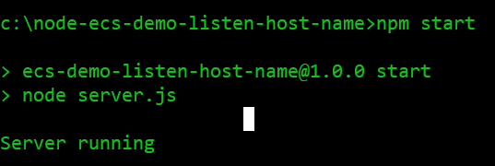

Verify that the app is running
http://localhost:3000
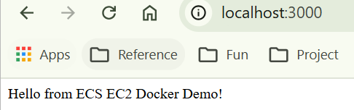
Expected response:
Hello from ECS EC2 Docker Demo!

Run ipconfig, the app should be run on the port 3000 of per public IPV4 url.

3. Containerize the Application
Create a Dockerfile:
FROM node:20-alpine
WORKDIR /node-ecs-demo-listen-host-name
COPY package*.json ./
RUN npm install
COPY . .
EXPOSE 3000
CMD ["npm","start"]
Build the Docker image:
docker build -t node-ecs-demo . (rename Dockerfile.txt Dockerfile in case, using Dockerfile to build docker image and tagged it as node-ecs-demo under current dir )
Verify the image:
docker images 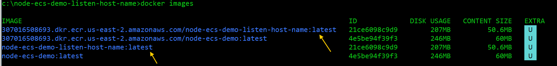

Check Docker Desktop
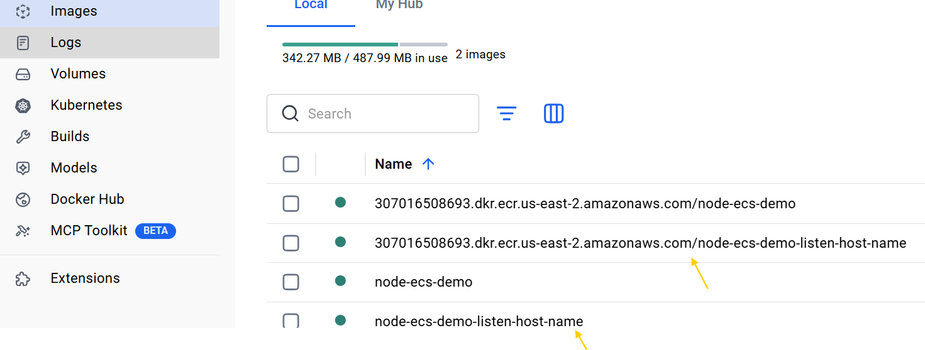
Run the Docker Image (container)
docker run -p 3000:3000 node-ecs-demo-listen-host-name (-p – publish container's port(s) to the host; -P, - Publish all exposed ports to random ports)
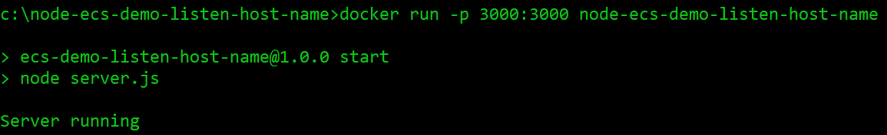
Verify that the containerized app is accessible
Run in CMD: curl http://localhost:3000 Or navigate to browser addr bar: http://localhost:3000
The app was running properly on port 3000 of all above all ipv4 IP address (referred by 0.0.0.0) & localhost or 127.0.0.1
The app listens on 0.0.0.0, allowing Docker to expose port 3000 through the host machine.

Part 2 - Upload Docker Image to Amazon ECR

1. Create an ECR Repository
Open the Amazon ECR Console

Create a repository:
node-ecs-demo-listen-host-name
Configuration:
- Mutable
- Mutable tag exclusions: AES-256 encryption
- Encryption: AES-256
- Leave other settings as default
Example repository URI:
xxxxxxxxxxxx.dkr.ecr.us-east-2.amazonaws.com/node-ecs-demo-listen-host-name

2. Configure AWS CLI
Run aws configure
Access Key (Go IAM -> user -> Security Credential -> either use existed access key or delete the old one and create a new one, download .cvs file including security key)
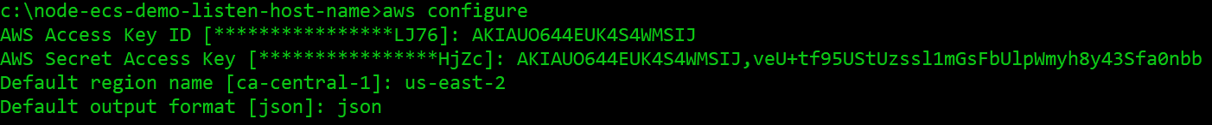

3. Authenticate Docker to Amazon ECR
Run aws ecr get-login-password --region us-east-2 | docker login --username AWS –
password-stdin 307016508693.dkr.ecr.us-east-2.amazonaws.com
Expected result: Login Succeeded
Log Docker to AWS ECR own by AWS account 307016508693 in the region us-east-2 successful

4. Tag the Docker Image
Run docker tag node-ecs-demo-listen-host-name:latest 307016508693.dkr.ecr.us-east-
2.amazonaws.com/node-ecs-demo-listen-host-name:latest

5. Push the Image

Run docker push 307016508693.dkr.ecr.us-east-2.amazonaws.com/node-ecs-demo-listen-
host-name:latest
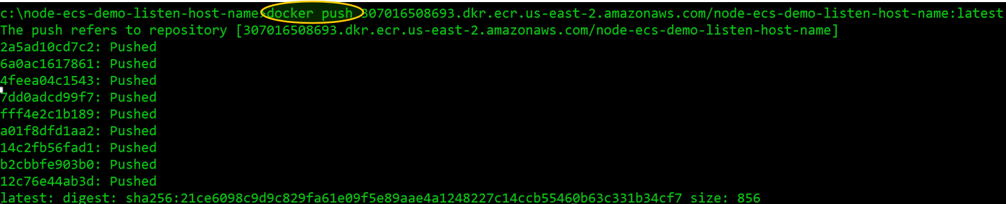 Verify that the image appears in:
- Amazon ECR
- Docker Desktop

Part 3 - Deploy on Amazon ECS (EC2 Launch Type)
Before deployment, remove any previous resources.
Delete:
- Remove Key Pair both on AWS & Local Folder
- Stop EC2 Instance
- Delete ECS Service
- Deregisgter Task Definition
- Wait 30 min, Delete ECS Cluster

1. Create an EC2 Key Pair
Create a new key pair
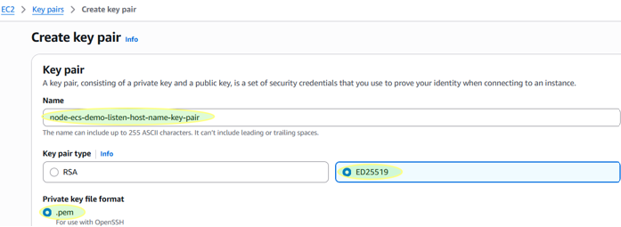
Download the .pem file and store it securely C:\node-ecs-demo-listen-host-name\helpfile

2. Create an ECS Cluster
Create an ECS cluster (EC2 Launch Type)
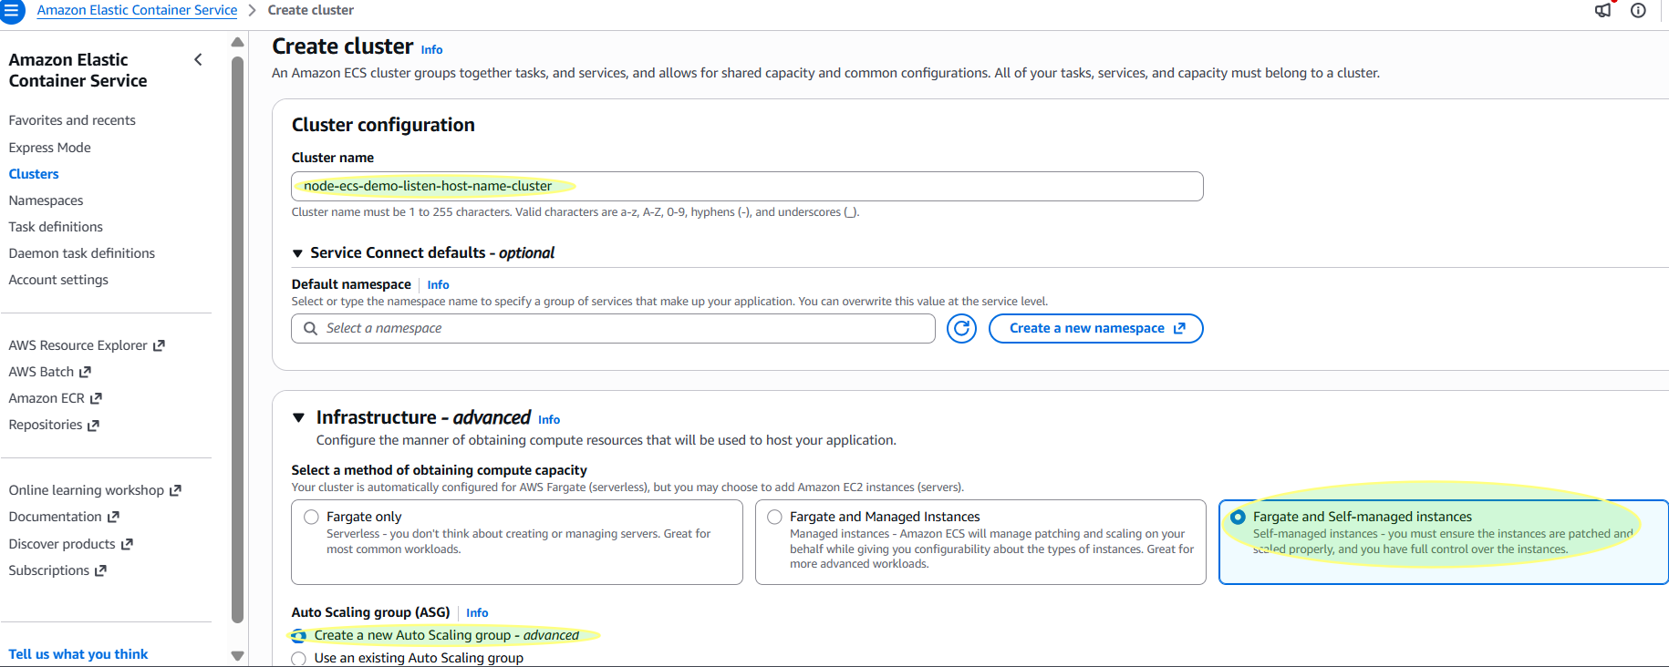
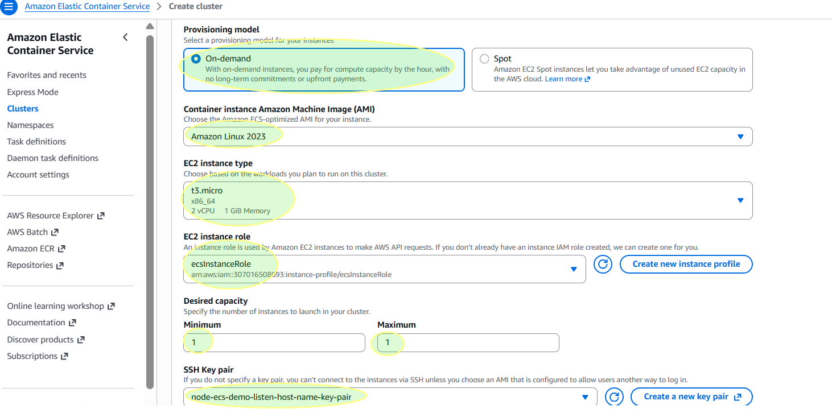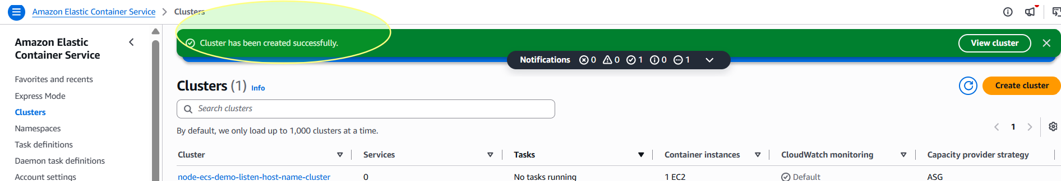 Leave the rest settings as default

3. Verify the EC2 Instance
Confirm that the EC2 instance is running:
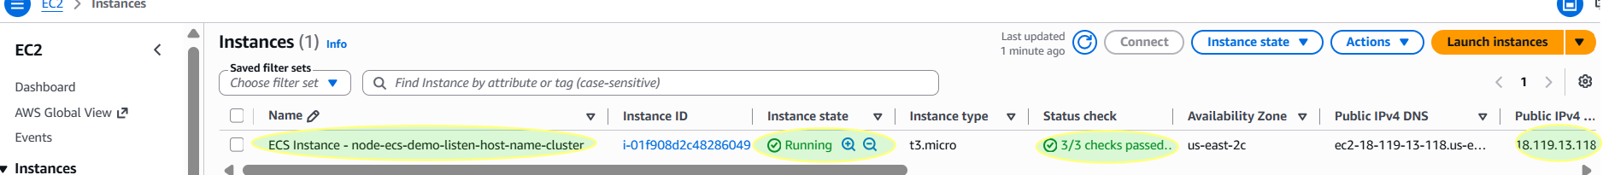

Configure the downloaded PEM file with the correct security permissions:
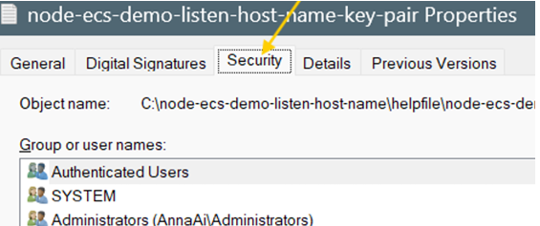
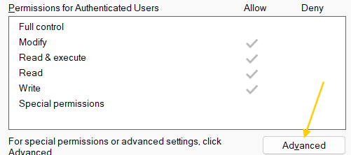
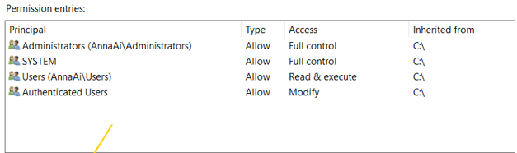
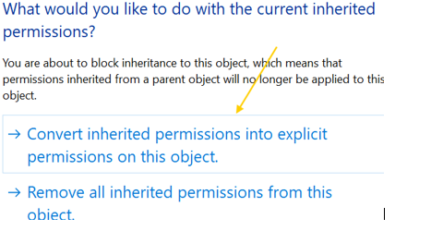
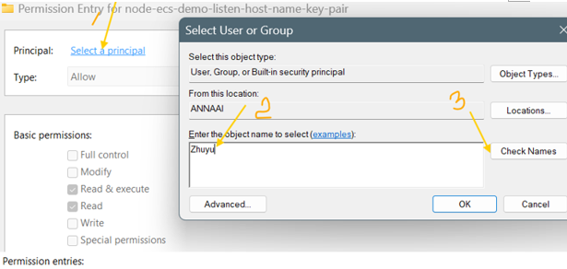
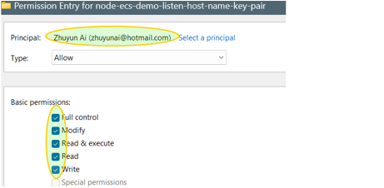
SSH connect to EC2 instance:
Run ssh -i C:\node-ecs-demo-listen-host-name\helpfile\node-ecs-demo-listen-host-name-key-pair.pem ec2-user@18.119.13.118
ssh -i node-ecs-demo-key.pem ec2-user@<EC2-Public-IP>

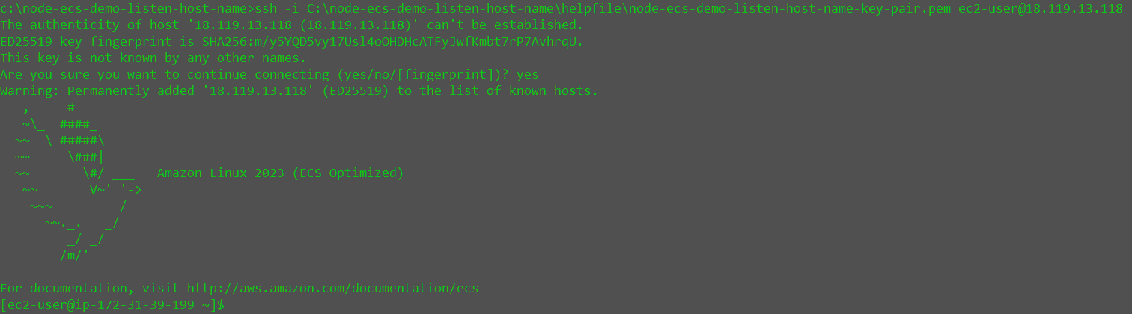Success

4. Create an ECS Task Definition

Create a task definition:

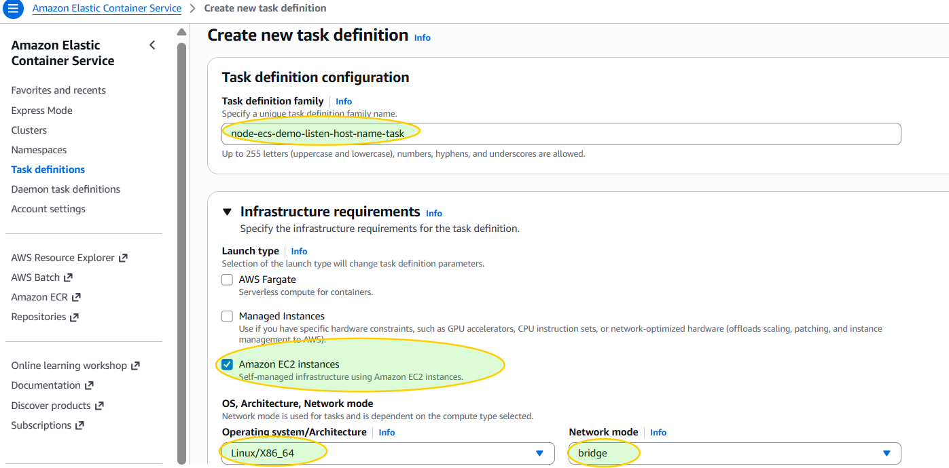

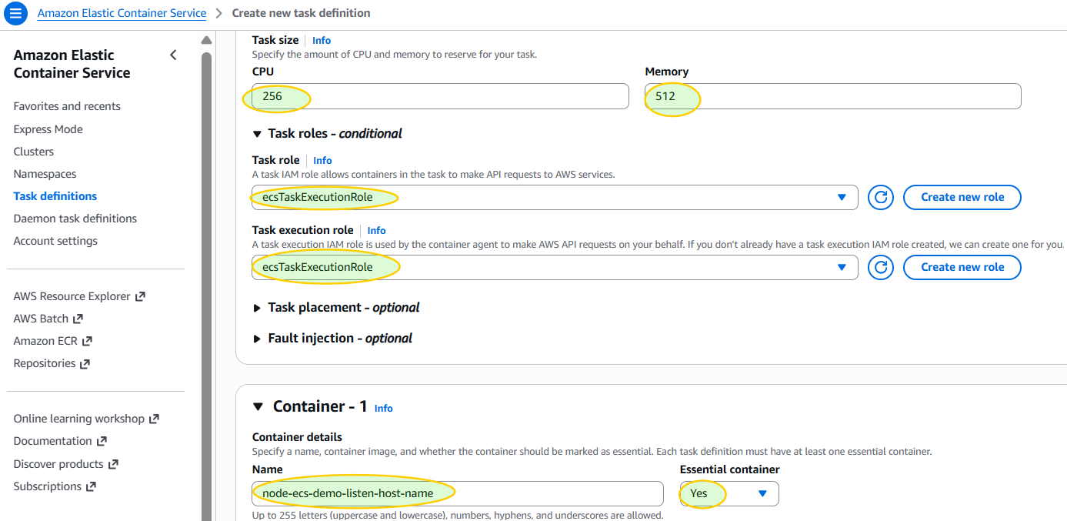

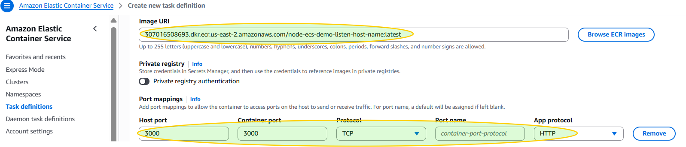

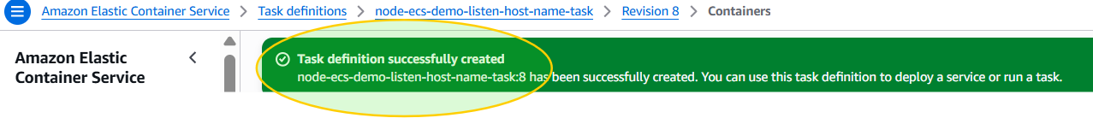
Container settings:
- Image: ECR image
- Container Port: 3000
- Host Port: 3000
Leave the remaining settings as default

5. Create an ECS Cluster Service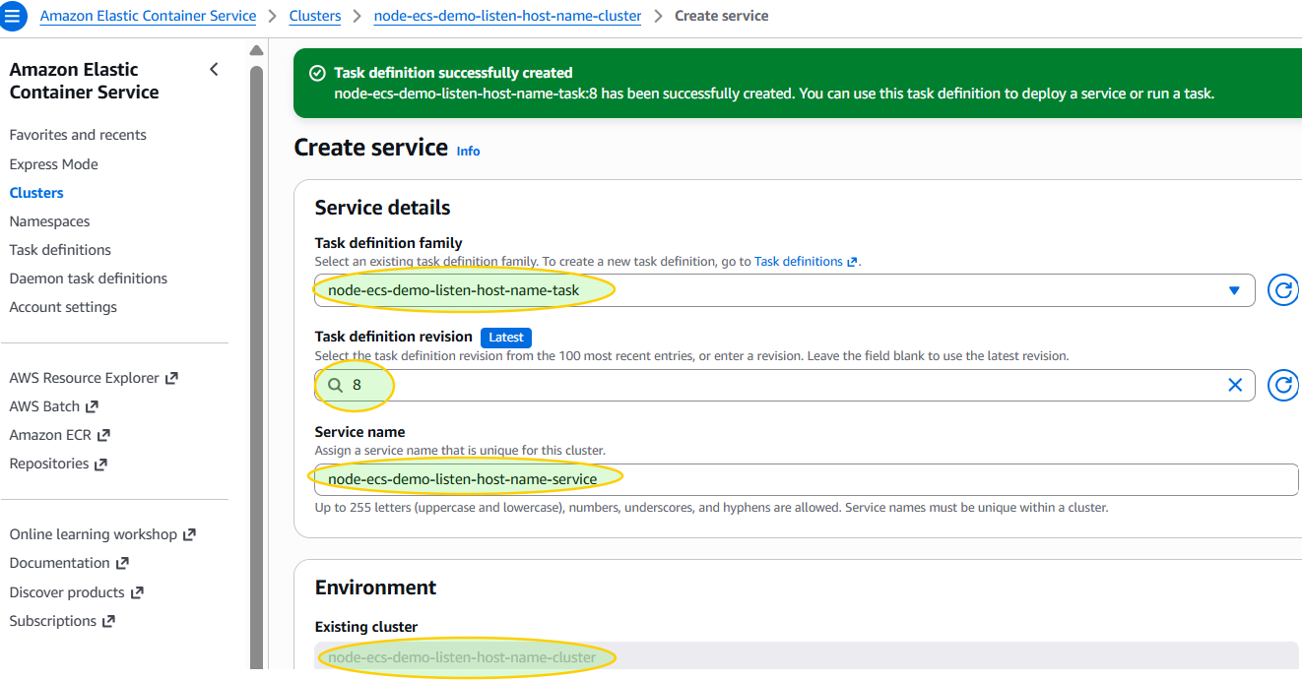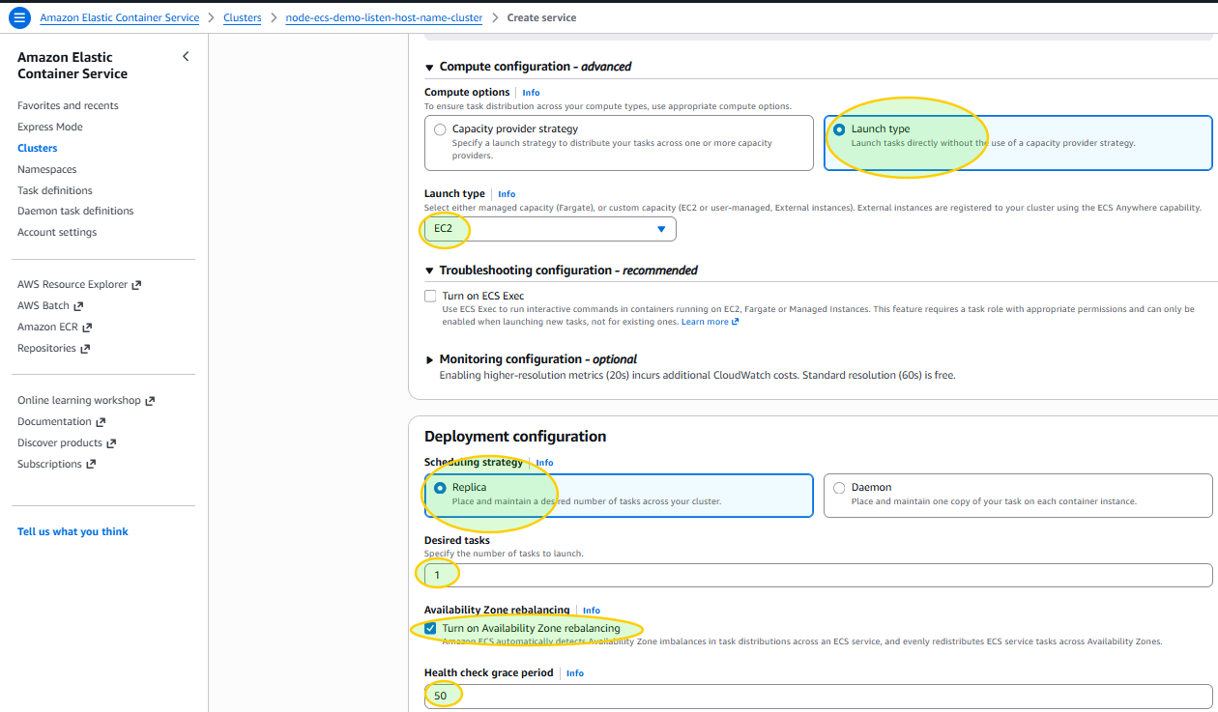
Leave the remaining configuration as default.

6. Verify Deployment
Confirm:
- ECS Service status is Running
- One task is running
- Container port mapping is correct
- EC2 Security Group allows inbound TCP port 3000
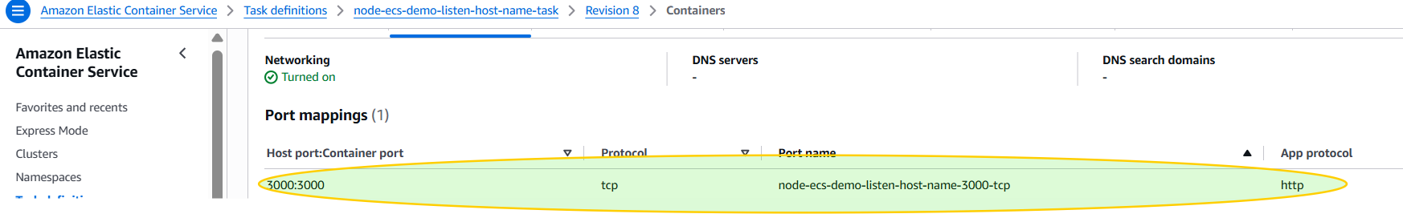
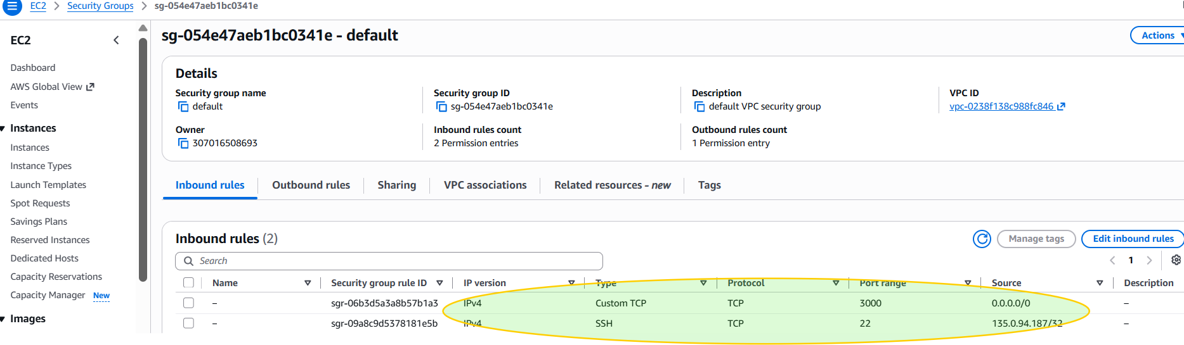

7. Test the Deployment

Make sure the app is running, if not, then:
Run docker run -p 3000:3000 node-ecs-demo-listen-host-name
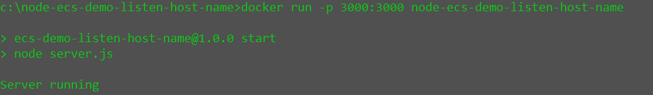
Run curl http://localhost:3000 curl http://18.119.13.118:3000 respectively
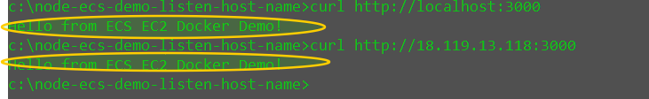
Navigate to browser http://localhost:3000, http://<EC2-Public-IP>:3000 respectively
The responses are as expected, SUCCESS
The successful response confirms that:
- The Node.js application is running correctly.
- Docker successfully containerized the application.
- Amazon ECR stored the Docker image.
- Amazon ECS deployed the container to an EC2 instance.
- The application is publicly accessible through the EC2 instance's public IPv4 address.

Resource Cleanup
To avoid unnecessary AWS charges, delete all resources after completing the demo.
- Stop the EC2 instance.
- Delete the ECS Service (Force Delete if necessary).
- Deregister the ECS Task Definition.
- Delete the ECS Cluster after all tasks have stopped and wait 30 min
- Delete the EC2 Key Pair .pem file from AWS and local folder
- Optionally delete the ECR repository and Docker images.

Technologies Used
- Node.js
- Express.js
- Docker
- Amazon Elastic Container Registry (ECR)
- Amazon Elastic Container Service (ECS Cluster, Task Definition, ECS Cluster Service)
- Amazon EC2
- AWS CLI
- SSH
- Linux

Key Learning Outcomes
- Built a REST API using Node.js and Express.
- Containerized the application with Docker.
- Managed Docker images using Amazon ECR.
- Deployed containers with Amazon ECS (EC2 Launch Type).
- Connected to EC2 using SSH.
- Configured container networking and port mapping.
- Verified deployment using browser and curl.
- Managed AWS resources and performed cleanup to minimize cloud costs.

