# Python

* dir(method_name)
  + function gives all the attributes a module has
* type(varable_name)
  + gives back the type of the variable
* %%time
  + Commutates the wall time, after command insert the function you need the time of
* Help()
* ?variable_name
* Info()
* Seed ()
  + 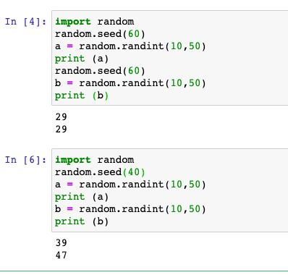
  + If seed is called again it will generate the same random number again
* Skimage library is there for image visualization in python
* Open picture with matplotlib.pyplot
  + Display data as an image
  + imshow()
  + A screenshot of a cell phone

    Description automatically generated
* Matplotlib: visualization with Python