Density Dependent Age-0 Survival of Sablefish (Anoplopoma fimbria): Age-Structured Modeling Assessment of Commercial Harvest Feasibility

Introduction
The sablefish (Anoplopoma fimbria) is a valuable marine groundfish species widely distributed throughout the North Pacific Ocean (Goetz et al., 2020). This long-lived species exhibits a characteristic ontogenetic shift, with juveniles and younger adults inhabiting nearshore habitats and older adults found deeper along the continental slope (Head et al., 2014). As an important component of the deep-water commercial complex, sustainable management of A.fimbria is essential for maintaining viable harvest and supporting aquaculture production (Goetz et al., 2020). In one West Coast population, periods of commercial harvest have substantially reduced abundance of A.fimbria, prompting fishery closure and subsequent monitoring of population dynamics. Critically, uncertainty remains regarding age-0 survival rates and strength of density dependent effects on recruitment success.
To address these key uncertainties, I used an age-structured model to estimate the baseline survival of age-0 individuals (a) and the strength of density dependence (b) on the population. My objectives were to: 1) quantity age-0 survival at low population abundance, and 2) determine how survival declines as total population increases. The outcome of my analysis will inform our understanding of recruitment dynamics of A.fimbria and will support sustainable management strategies of an important and valuable groundfish species.

Methods
For this analysis I used data provided by the fishery, which has closely monitored and studied this population of A.fimbria over a 40-year time series. The fishery collected abundance-at-age data for individuals aged 1 through 4 (Figure 1). These observational data were collected annually after winter mortality but shortly before the spawning period. The dataset also included the average fecundity for ages 1-4 and average survival rates for each age class over the time series. Finally, age-specific harvest rates were recorded across all survey years, with the age-4 group encompassing all individuals four years and older, as slower growth beyond this age makes precise age classification increasingly difficult.
I used an age-structured model to estimate age-0 survival and quantify density dependence. The model tracks annual abundance for all four age classes using a Leslie matrix framework that incorporates age-specific survival and fecundity as well as harvest mortality. I modeled population dynamics using a four-stage Leslie matrix with a plus group for age 4+, where the state vector Nₜ = (N₁,ₜ, N₂,ₜ, N₃,ₜ, N₄₊,ₜ) represents abundance at each age class.
Annual transitions were given by:
$$Nₜ₊₁ = L(Nₜ) · Nₜ,$$

Leslie matrix was defined as:
s₀(Nₜ)·f₁ s₀(Nₜ)·f₂ s₀(Nₜ)·f₃ s₀(Nₜ)·f₄
s₁ 0 0 0
0 s₂ 0 0
0 0 s₃ s₄

The first row represents age-specific fecundity scaled by density-dependent age-0 survival. The sub-diagonal elements represent age-specific survival transitions from ages 1→2, 2→3, and 3→4+, while the terminal age class (4+) is modeled as a plus group, retaining individuals with survival probability s₄.
I modeled age-0 survival as a density dependent function:

$$s_{0}= αe^{-β_{d}N_{t}}$$

Where $α$ is the baseline survival at low population abundance, $β$ is density dependence strength, and $N_{t}$ is total abundance of all age classes in year t. I calculated population trajectories for each year, applying survival, fecundity, and harvest rate. I used maximum likelihood estimation to estimate the model parameters ($α$, $β$, and log-normal standard deviation). Observed abundances were assumed to follow a log-normal error distribution, and the negative log-likelihood was minimized using the SANN algorithm in the mle2 function (Bolker, 2025). I characterized uncertainty in the parameter estimates using likelihood profiles. I evaluated model fit by comparing predicted abundance from the fitted model to observed abundance for each age class of the time series. Finally, I quantified parameter uncertainty by constructing 95% profile likelihood confidence intervals for the estimated parameters α, β, and the log-normal observation error parameter σ.

Results
The maximum likelihood estimation for the age-structured model produced well-defined parameter estimates for the A.fimbria population. The estimated baseline survival of age-0 individuals $α$ was 0.183 (95% CI: 0.163 – 0.211), and the strength of density dependence 𝛽 was 0.000617 (95% CI: 0.000492–0.000775). The log-normal distribution error was estimated at 0.451 (95% CI: 0.401 – 0.499). All parameter estimates were highly significant with a p-value of less than 0.0001, which indicated that the model reliably captures this population.
The predicted abundance from the fitted model generally tracked observed abundance across all four age classes (Figure 3), and most observed abundance-at-age values fell within the 95% prediction intervals derived from the fitted log-normal observation error model. However, patterns in model fit were evident. The model tended to overestimate abundance of age-1 individuals while underestimating abundance of age-2 individuals across much of the time series, indicating age-specific bias in predicted survival or recruitment transitions between early age classes. In contrast, predictions for older age classes were more closely aligned with observations, though variability increased in years with high harvest pressure. These patterns suggest that early-life transitions (age-0 to age-1 and age-1 to age-2) may not be fully captured by the current model structure, which has implications for interpreting recruitment dynamics and projecting future population responses to harvest. The model also demonstrated that harvest strongly influenced population abundance, particularly in older age classes.

Discussion
The results of my analysis reveal that A.fimbria is influenced not only by harvest but also by natural population regulation. The model indicates that density dependence plays a key role, and baseline survival of age-0 individuals is relatively low (α = 0.183). At a low population abundance, age-0 survival is close to the baseline at 0.183(Figure 4). This suggests a bottleneck is limiting recruitment success, likely driven by density-dependent processes. In practice, this means that even a modest increase in juvenile or adult abundance could substantially limit the survival from age-0 to age-1. Although harvest removes older, reproductive individuals from the population, reducing adult abundance in the population may relieve density dependent constraints and improve recruitment success. Collectively, these findings underscore the importance of incorporating both harvest effects and density dependence into managing the fishery.

References
Bolker, B. (2025). bbmle: Tools for General Maximum Likelihood Estimation. R package version
1.0.29. https://CRAN.R-project.org/package=bbmle
Goetz, F. W., Anulacion, B. F., Arkoosh, M. R., Cook, M. A., Dickhoff, W. W., Dietrich, J. P.,
Fairgrieve, W. T., Hayman, E. S., Hicks, M. B. R., Jensen, C., Johnson, R. B., Lee, J. S. F., Luckenbach, J. A., Massee, K. C., & Wade, T. H. (2021). Status of sablefish, Anoplopoma fimbria, aquaculture. Journal of the World Aquaculture Society, 52, 607–646. https://doi.org/10.1111/jwas.12769
Head, M. A., Keller, A. A., & Bradburn, M. (2014). Maturity and growth of sablefish,
Anoplopoma fimbria, along the U.S. West Coast. Fisheries Research, 159, 56–67. https://doi.org/10.1016/j.fishres.2014.05.007
R Core Team (2025). _R: A Language and Environment for Statistical Computing_. R
Foundation for Statistical Computing, Vienna, Austria. <https://www.R-project.org/>.

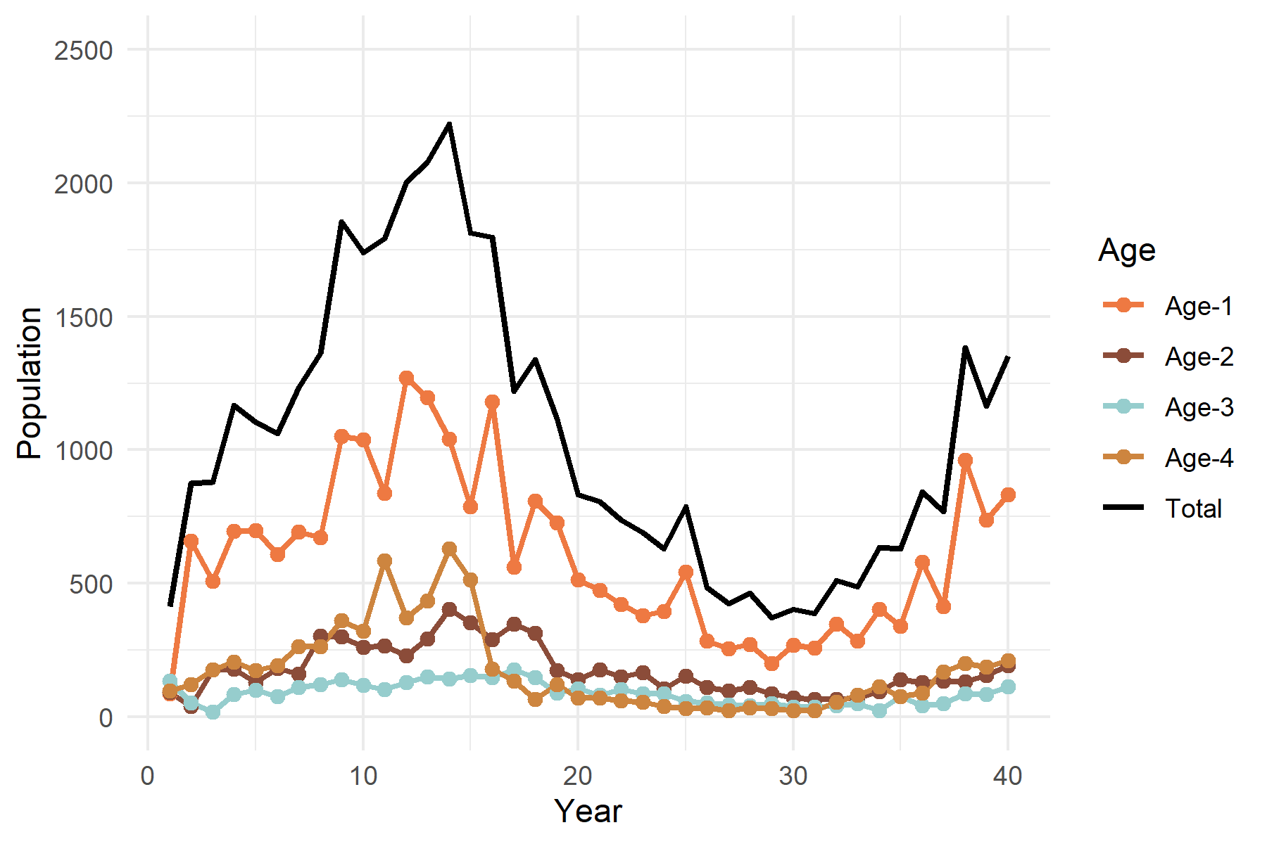
Figure 1. Observed population trends for Anoplopoma fimbria for ages 1, 2, 3, 4, and total population over a 40-year time series.
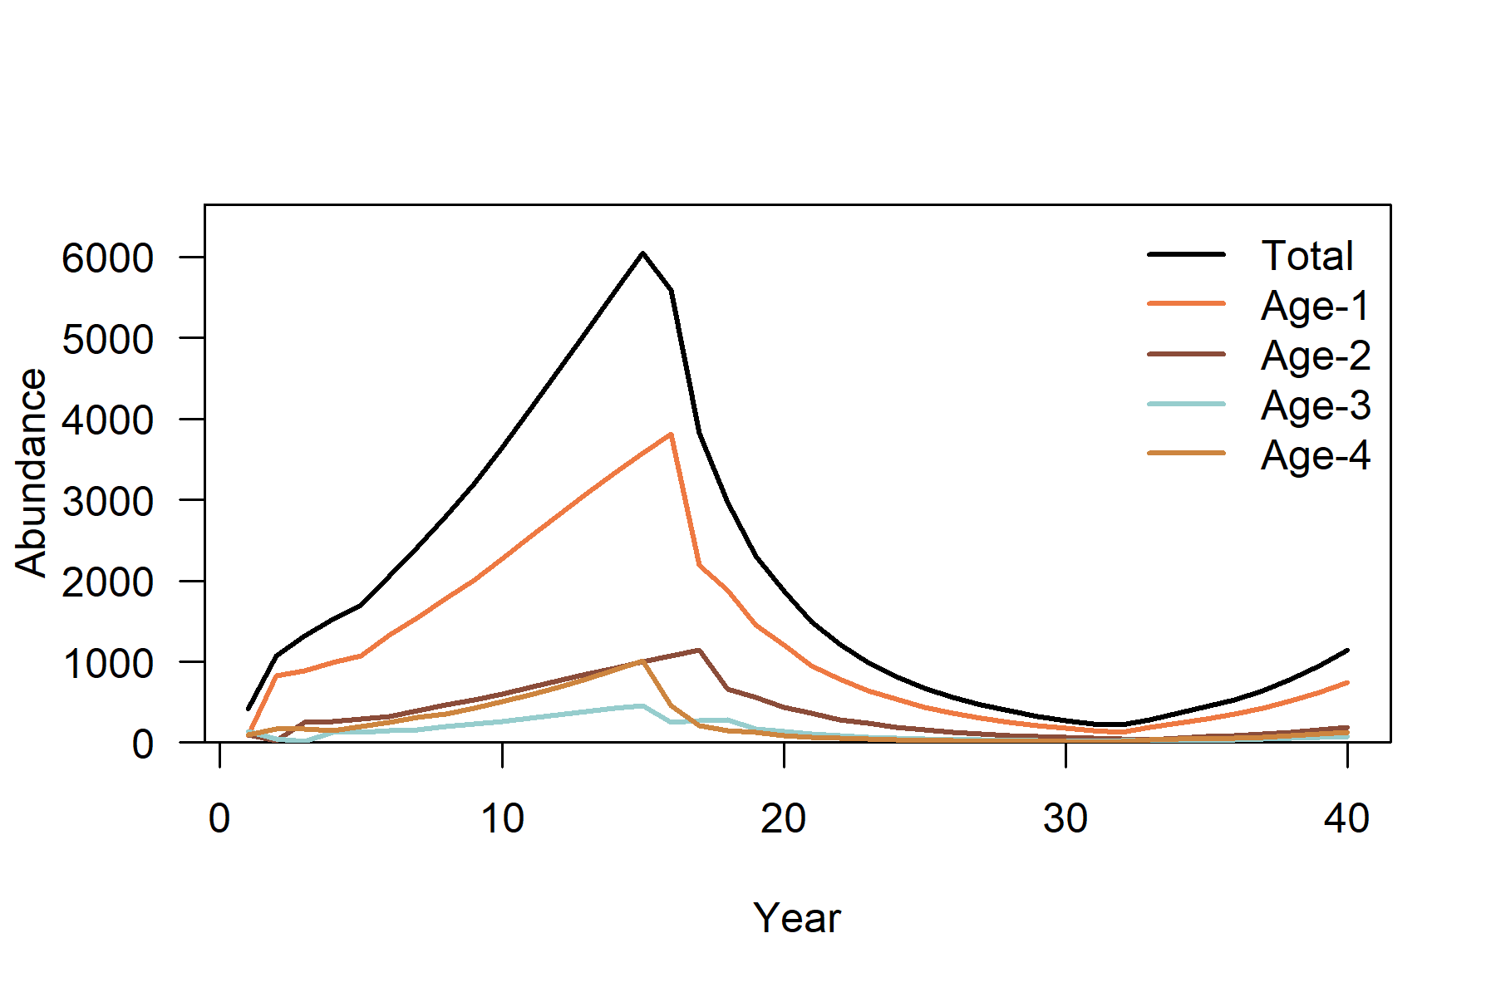
Figure 3. Predictions of harvest impacts by age for Anoplopoma fimbria over the 40- year time series.
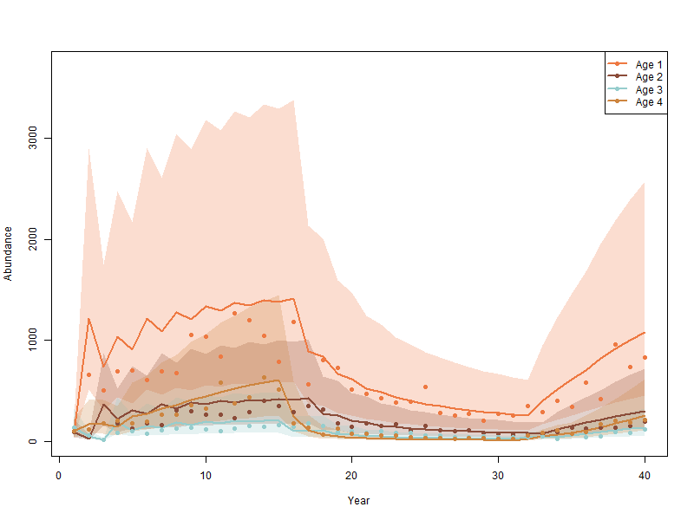
Figure 3. Observed abundance points and predicted abundance lines for all age classes of Anoplopoma fimbria over the 40-year time series, including impacts of harvest. Ninety-five percent confidence intervals for each age class are included in shaded polygons.

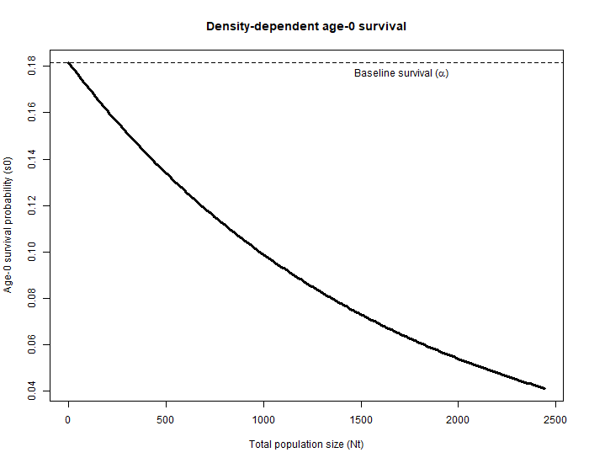
Figure 4. Density-dependent age-0 survival as a function of total population abundance. The fitted relationship demonstrates that, when scaled to the entire population, a density-dependence parameter of β = 0.000617 results in a rapid decline in early-life survival as total abundance increases. This pattern indicates strong density-dependent regulation of recruitment in Sablefish (A. fimbria).

