

Thesis – Bachelor's Degree

Technology, Communication and Transport

ANALYSIS OF PROXIMITY SENSORS FOR SMART STREET LIGHTING SOLUTIONS

AUTHOR Annabella Guobadia

SAVONIA UNIVERSITY OF APPLIED SCIENCES THESIS  
Abstract

|  |  |  |  |
| --- | --- | --- | --- |
| Field of Study  Technology, Communication and Transport | | | |
|  | | | |
| Degree Programme  Degree Programme in Information Technology | | | |
| Author | | | |
| Annabella Guobadia | | | |
| Title of Thesis | | | |
| IoT For Smart Caity Development | | | |
| Date | 9/12/2024 | Pages/Appendices | 40 |
| Client Organization /Partners | | | |
| Savonia University of Applied Sciences | | | |
| Abstract  As cities worldwide get bustier, increasingly cities across the nation are under more pressure to rationalize their infrastructure and public service resource management. Urban systems, the traditional view of cities in general have been one of the better beginnings to these kinds of problems, but are usually not sustainable as far as sustainability, energy usage and the public safety department. An intelligent city (smart city) concept is the answer to such problems using cutting edge tools available just to make living in a city better. This transformation is mostly driven by Internet of Things (IoT), an enabling network that enables numerous times of device to talk in real-time and delivering information rendering environment responsive. Some of the most significant IoT applications in Smart Cities are Illumination; The Smart Lighting of the ecosystem where real time streetlight brightness adjusted via sensors lead us to improvement in Safety and Drop in Energy consumption & Cost.  This research aims to design and deploy an Internet of Things smart lighting system tackling municipal problems like energy conservation, public safety etc. The sensors of the system consist of four types (ultrasonic, laser, radar and PIR). Every sensor is current to a separate domain with movement detection, proximate sensing and environment sensing, which then calculates the level streetlight brightness based on data. Ultrasonic sensors for distance measurement, PIR motion sensor and Laser sensors provide high accuracy distance measurements, radar can detect movement even in difficult weathers. These sensors are connected to each other through an ESP32 microcontroller which takes both data from and controls lighting systems.  In this thesis I will evaluate the given sensors within one united smart lighting system. Through the study of pedestrian vehicle detection and environmental sensors, the research explores how these technology features protect users in public spaces making them safer, energy efficient and sustain their cities. The system operates to illuminate streets, when there are either people or vehicles on it and dim the lights to minimize energy consumption, when streets are empty. Also, the study further investigates the scalability of IoT smart lighting systems to other urban factors i.e. air quality by fitting some more sensors. | | | |
| Keywords  Internet of Things(IoT), Smart City, Smart Lighting, Sensors, Ultrasonic Sensors, PIR Sensors, Laser Sensors, Radar Sensors, Public Safety, Real-Time Data, ESP32 Microcontroller, Sensor Calibration, Sensor Integration, System Testing. | | | |

CONTENTS

ACKNOWLEDGEMENT

1 INTRODUCTION 7

1.1 Background and Motivation 7

1.2 Research Objectives 8

1.3 Research Questions 8

1.4 Scope and Limitations 9

1.5 Thesis Structure 9

2 Technologies and Sensor Overview 10

2.1 The Internet of Things (IoT) in Smart City Infrastructure 10

2.1.1 IoT in Smart Lighting Systems 10

2.2 Ultrasonic Sensor 11

2.2.1 Working Principle of Ultrasonic Sensors 11

2.2.2 Applications in Smart Lighting 11

2.2.3 Advantages and Limitations: 11

2.3 PIR Sensor 12

2.3.1 Working Principle of PIR Sensors 12

2.3.2 Applications in Smart Lighting 12

2.3.3 Advantages and Limitations 12

2.4 Laser Sensors 13

2.4.1 Working Principle of Laser Sensors 13

2.4.2 Applications in Smart Lighting 13

2.4.3 Advantages and Limitations 13

2.5 Radar Sensors 13

2.5.1 Working Principle of Radar Sensors 13

2.5.2 Applications in Smart Lighting 14

2.5.3 Advantages and Limitations 14

2.6 Role of the ESP32 Microcontroller 14

2.6.1 Features of ESP32 14

2.6.2 Functionality in Smart Lighting 14

2.7 Benefits of Sensor Integration in Smart Lighting Systems 15

2.7.1 Improved Energy Efficiency 15

2.7.2 Enhancing Public Safety 15

2.7.3 Scalable 15

2.7.4 Adaptability 15

3 IMPLEMENTATION 16

3.1 Hardware Setup 16

3.1.1 Sensor Integration and Configuration 17

3.2 Software Development 20

3.2.1 Programming the ESP32 Microcontroller 22

3.2.2 Communication Between Sensors and ESP32 24

3.3 System Testing 25

3.3.1 Individual Sensor Testing 25

3.3.2 Integrated System Testing 26

3.3.3 Real-World Scenario Simulations 26

3.4 Calibration and Troubleshooting 27

4 RESULTS AND DISCUSSION 29

4.1 Sensor Performance Analysis 29

4.2 Evaluation of Smart Lighting Efficiency 33

4.3 Public Safety Improvements 34

4.4 System Limitations and Proposed Solutions 34

5 Conclusion 36

5.1 Contributions to Smart City Development 36

5.2 Recommendations for Future Work 37

REFERENCE 39

LIST OF FIGURES

Figure 1. Advance Human Recognition (Tvilight) 11

Figure 2. Significant Energy Savings (Tvilight) 15

Figure 3. Hardware Setup 17

Figure 4. Wiring 19

Figure 5. Validating 20

Figure 6. Thresholds 20

Figure 7. Ultrasonic Function 21

Figure 8. Laser Function 21

Figure 9. PIR Function 21

Figure 10. Radar Sensor Functions 21

Figure 11. Sensor Initialization 22

Figure 12. Main Loop Sensor Data Processing 22

Figure 13. Signal Interference 24

Figure 14. Data Readings 29

Figure 15. Ultrasonic Data Graph 30

Figure 16. PIR Data Graph 31

Figure 17. Laser Data Graph 32

Figure 18. Radar Data Graph 32

Figure 19. Normalized Data Graph 33

Figure 20. Picoscope Reading on PIR 37

Figure 21. Low Voltage Signal on PIR Analog pin 38

ACKNOWLEDGEMENT

I give my sincerest and humblest thanks to God Almighty who was my strength during my studies at Savonia University of Applied Sciences academic career. With His help and guidance, I successfully finished my thesis and completed this significant journey.

I am sincerely grateful to my thesis supervisor, Atanu Mazumdar, who has provided invaluable expertise, guidelines and support in refining this dissertation being what it is today. His eyes and constructive criticism have helped me master the quality of work, ever since he introduced his insights.

I am deeply grateful to the faculty, staff and my teachers at Savonia, particularly Markku Kellomäki, Rajeev Kanth  among others whose encouragement and nurturing helped me develop as a human in and out of classrooms. I mean their help was of the utmost use through all my educational courses. I really want to thank my classmates for making the learning more interesting and extraordinary by helping us all work together. Being in a uniquely centered environment of their inculcation has complemented me, intellectually and creatively during my time at university.

Finally, I would like to express my immense appreciation to my family & friends during this process. They provided invaluable support throughout its entirety, acting like invisible but unbreakable rocks to hold my hand through both highs and lows. Their faith in me helps remind me that any obstacle I faced was done with their support behind the scenes pushing me. For that I will always be grateful. Their patience and hearing ears being my beacons guiding my path along this journey will always remain gratefully remembered by me as they play their roles here too, making my thesis both our efforts.

# INTRODUCTION

Urban population explosion implies two challenges for cities in all over the world: how the cities could sustain their food resource, how could it maintain safety, accessibility, quality of life for residents. Although traditional urban systems perform well in their original scope, the adaptive and efficient response to the complex demands that modern city life require are often absent. A lot of this inadequacy is visible in urban lighting. Instead, conventional street illumination systems lighting up full-bright at all other times unnecessarily and proving colossal waste in terms of energy consumption, operation cost.

This has given rise to smart cities, a reformist urban development movement in response to these challenges the concept of. Smart cities harness the power of ICTs and interconnectivity to build systems that enable effective management of urban operations, from sustainability measures through to enhancing the quality-of-life that all residents require. Among the technologies, Internet of Things (IoT) primarily adopted widely to bring physical devices and real-time data connectivity for the analysis that can be performed to take necessary actions immediately.

IoT and Smart Cities an application of smart lighting systems the new Public Lighting Management systems using IoT are smart technology and sensor-based systems that automatically scale the level of streetlights according to pedestrian and vehicle input data from real-time sources of unforeseen events (light/ dark conditions, weather or any other environmental factors).

IoT enabled smart lighting systems as opposed to the conventional ones can enable immense energy savings, lower maintenance costs and improve public safety Conversely, unlike in conventional lighting systems smart lighting can ensure efficient use of energy without compromising visibility and security for instance smart lighting systems might dim areas with higher activity and brighten less often used space.

This dissertation covers the design and evaluation of an ultrasonic, PIR, laser, radar sensor-based IoT smart lighting system Thesis IoT based smart lighting using ultrasonic, PIR sensors and system Drawing upon sensors with ESP32 microcontroller, these sensors enable real-time pedestrian, vehicle & changes in environmental detection. This research thus intends to investigate both novel urban scenarios using these technologies to solve some urgent problems like energy inefficiency, urban safety, or environmental sustainability. Moreover, the research also investigates the use of smart lighting to open the potential for smart IoT applications such as in support for air quality monitoring beyond lighting enhancement or range.

Result of this thesis will also contribute to the rapidly expanding domain of smart city technologies in the way that it offers design, execution, and impact related insight of an IoT smart lighting. The promise of such systems is a safer, more effective, and more sustainable urban plan is alive in the fact that cities still grow evolve.

## Background and Motivation

Urbanization is the mantra of a 21st-century lifestyle world. Rapidly growing cities must be able to accommodate infrastructure, and energy demands along with resources, environmental sustainability issues. With global urban population projections suggesting number over six and a half billion by 2050, the cities are going to have to find inventive ways in fulfilling all these extra people! Piping relevant, outdated holier forms that are rigid and inherently inefficient are no longer suitable for dealing with the fast-changing urban patterns that urban cities require in 21st century.

One of the innovative ways in place of traditional solutions; smart cities have been gaining prominence. Smart cities use IoT devices and the like to automate and improve the running of urban systems for better quality life for all citizens, along with sustainable development. IoT is entered the picture for device and system infrastructure connectivity, store latest data, process in Real time — helping cities make the optimal use of resources thereby not only reducing wastage but mitigating issues before hand.

Today, IoT smart lighting is used in many applications and every sector are implementing street lighting systems. Street lighting systems are among the largest consumers of energy both of public safety. They turn them on all the time with no consideration for demand we are priced extremely high for the energy used and costs grow exponentially. The smart lighting systems of IoT sensor and control techniques allow streetlight brightness to be adjusted street point-to-street pointwise automatically on-the-fly to local vehicular movement or pedestrian at each light in a cost-saving manner with pedestrian safety.

This research is motivated with the immediate need to design urban lighting that efficiently use energy and improve public safety while being environmentally sustainable. The smart lighting system, for ultrasonic/PIR laser& radar sensors based to be able maintain enough lighting and safety whilst implementing an effective energy management in this study presented. Pushing these sensors to an IoT framework can be seen as an advance when the two problems (dealing with sustainability and safety) overlay on modern cities.

## Research Objectives

This thesis is designed by following a set of objectives to further the Universal Applications of IoT Smart lighting systems in Urban environment. In its core it will be aimed to build a system with cutting-edge sensor technology to operate on better and optimized results from urban lighting. This research aims to:

* Implement a smart lighting system utilizing ultrasonic, PIR, laser and radar sensors integrated with an ESP32 microcontroller and analyse their performance in detecting pedestrian and vehicle movements in various urban scenarios.
* Assess the system's impact on energy efficiency, noting any potential savings over traditional street lighting systems.
* Investigate how smart lighting systems could assist in improving public safety - particularly areas with heavy pedestrian or vehicle traffic.

This research intends to achieve these objectives and thereby help build the body of knowledge on IoT smart city technologies with an eye for the design and deployment of smart lighting systems that are currently available.

## Research Questions

The following research questions serve as the cornerstone for this thesis:

* How can IoT-based smart lighting systems improve public safety?

The answer to this question investigates the importance of adaptive lighting systems enabling people and vehicles to enjoy appropriate exposure in live-on-scenario situations.

cities to adapt and adjust for changes in their environment.

* What are the advantages and disadvantages of using ultrasonic, PIR, laser, and radar sensors for detecting vehicles and pedestrians?

The answer gives assessment of all sensor technology, their viability for smart lighting in urban environments and characteristics to among various sensors that can be use in this instalment question.

## Scope and Limitations

Smart lighting development and evaluation for specified problems in urban environment is in the scope of this thesis IoT technologies.

Layout: a four-sensor architecture around the system ultrasonic laser, radar integrate with esp32 microcontroller. Main aims are increasing energy-efficiency public safety and contemplating further features like hosting pollution. While the research is ambitious, it faces several limitations. The system is verified in lab environment, where all complexities and variability of urban setting do not exist in full degree. Real world usage is subject to real-world constraints like worst case weather, heavy traffic, and even poor infrastructure which will have an adverse effect on performance in addition.

Second, the research covers only some selected sensors. Although the selected sensors are adequate for this research, there could be a broad range of smart lighting applications.

Finally, the energy savings and safety enhancements are evaluated on simulated or test environments. This provides some useful tools, but the full impact of system on field data from large scale implementations would need to be confirmed.

## Thesis Structure

This thesis has seven chapters, each concerning one point of research.

* Introduction: Provides the background, motivation, objectives, and scope of the study before outlining its focus.
* Technologies and Sensor Overview: Outlines IoT technologies used within smart lighting systems by discussing their features and applications in depth.
* Implementation: Provides details on hardware and software integration, including sensor setup, programming, system calibration, and system testing and calibration. System Testing and Calibration: Examines testing procedures designed to evaluate individual sensor performances as well as that of an integrated system under real world scenarios.
* Results and Discussion: An analysis of the findings, emphasizing their efficacy in increasing safety and energy efficiency while discussing limitations.
* Conclusions: Summarize key outcomes, discuss implications of research results, and offer suggestions for future work.

# Technologies and Sensor Overview

Cities transitioning and developing, the old infrastructure systems get utterly messy in this modern urban requirement. IoT has entered our life as a possible solution to combat these problems. The physical objects connected to the internet, allowing for easy communication, real-time data exchanges and automation across systems in IoT. IoT Network IoT makes it possible for smart cities, linking infrastructure and services as well as further public systems to become a reality thus achieving greater co-ordination and efficiency in the urban environments. This chapter discusses the main elements and sensors. With these systems, the benefit of optimized behavior from several sensors for environmental changes and optimized energy consumption as well as increased public safety is available. What differentiates the concept of IoT integration in cities is the ability to tailor an environment to its people in real-time, thus becoming more sustainable, efficient and responsive.

## The Internet of Things (IoT) in Smart City Infrastructure

IoT: IoT (Internet of Things) is an interconnected network of physical objects that communicate via the internet. Equipped with sensors, the devices harvest real world data and run it through onboard microcontrollers to manipulate it locally before sending it wirelessly somewhere. IoT devices shape how we live in smart cities from a transformation of urban system paradigms to achieve efficiency and sustainability of smart city infrastructure.

### IoT in Smart Lighting Systems

One of the best examples of how technology can be implemented in an optimized smart city infrastructure is smart lighting system powered by IoT. Smart lighting systems contrast from conventional streetlights on a fixed cycle, to smart solutions that change when the facts are right and deliver dynamic real-time lighting. Streetlight Brightness adapts to conditions such as time of day, traffic, pedestrian activity, environment.

In general, smart lighting systems are made of sensors, microcontrollers, and actuators (which modify the lighting) and communication technologies. This can be something with sensors:

* Track pedestrian or vehicle Movement: If anything needs to be done (increase/decrease brightness here).
* Perception environmental context Detection of environmental condition: can adapt the brightness level based on weather conditions (e.g. fog, rain) to guarantee safety without energic waste unnecessarily.
* Enhance public safety: By giving high streetlights in areas with lots to move through and dimming areas with high activity for safety.

IoT comes to energy savings and public safety enrichment through adjusting lighting on the fly, as has been shown with a 100 % prospective reduce in energy consumption. Adaptive lighting, for example, has been shown to reduce energy use by 50% or better over conventional systems

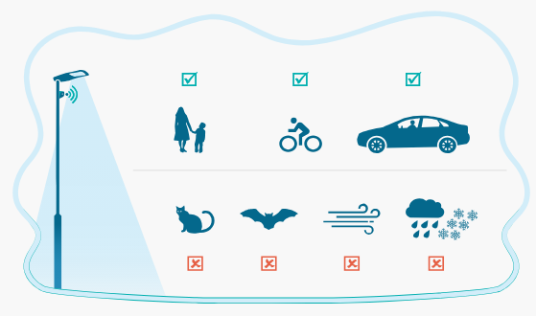

Figure 1. Advance Human Recognition (Tvilight)

## Ultrasonic Sensor

Ultrasonic sensors are one of the distance sensor classes where the principle is to use sound waves to get a reading on how far the sensor is from an object. These sensors send out high frequency sound waves that reflect off an object. It calculates the distance between itself and an object, when the sound waves return by measuring the time it has taken to emit and reflected using sensor to trigger an action (e.g., regulating streetlights brightness).

### Working Principle of Ultrasonic Sensors

An ultrasonic sensor works on time-of-flight principle where the distance to the object is determined using precision measuring from when sound waves reach the target and return to the sensor. This approach is simple and inexpensive making ultrasonic sensors one of the favorited all types of multi-purpose sensor as in smart lighting sector.

### Applications in Smart Lighting

Smart Lighting in smart lighting systems ultrasonic sensors is used to sense the proximity of pedestrians or vehicles. The system brightens the near-by streetlights automatically (or whatever you want to call them) to make sure you can clearly see whatever it is moving in front of the sensors if a vehicle or person invades that range. The lights dim once that object is within the range of detection and hyper-illumination is undesirable. Ultrasonic sensors are ideally suited for movement detection in low-traffic areas where the system responds readily and with no over-illuminating the area.

### Advantages and Limitations:

Advantages:

* Consider that there are no Ultrasonic sensors costs to incorporate and are low cost.
* Non-invasive: They work without touching anything, working with sound waves to identify objects.
* High Detection Range: These features can cover a wide area, most effective in low traffic zones.

Limitations:

* Weather Sensitive: Performance may degrade under adverse condition like heavy rainfall or snow, strong wind etc.
* Inaccuracy Over Distance: Ultrasonic sensors lose their accuracy in the lengthy range and have difficulty detecting small objects, as well as non-reflective ones.

## PIR Sensor

Passive Infrared (PIR) sensors are intended to detect motion by measuring infrared radiation (heat) changes from emitting objects such as humans and animals. PIR Sensors do not radiate any incoming radiation but rather feel the infrared energy that is radiated naturally by warm objects. They form an attractive option for motion detection in smart lighting applications.

### Working Principle of PIR Sensors

Warm objects emit infrared while PIR sensors sense primarily movement. Under the sensor, there is a warm physical object, and upon approaching a person or vehicle into the sensor field infrared radiation to be emitted varies due to this change output signal is generated. Motion Detection: Because PIR Sensors work in real time, they are ideal for applications that require immediate action, an example would be smart lighting.

### Applications in Smart Lighting

For smart lighting systems, PIR sensors are used to detect motion on streets or parking lots. Motion detected, you action available to system activates the lights or near light by dimming them (as it is). The PIR sensor's usefulness, in contrast to the proximity measurement of ultrasonic sensors mean that one does not have to capture every movement elsewhere over a large space, allowing a much more accurate response to all activity.

### Advantages and Limitations

Advantages:

* Low Power Usage: PIR sensors draw small amount of power, suitable for long term use on outdoor.
* Long Range: They can sense movement in a vast area everywhere: appropriate for large spaces such as parking lots, open areas etc.
* Cost-effective: PIR sensors are cheap and straightforward to install.

Limitations:

* False Alarms: PIR sensor may get activated due to heating sources like animals or even vehicles causing an unwanted lighting change.
* Short Range: PIR Sensors are not as good over distance as ultrasonic or radar sensors.

## Laser Sensors

Laser sensors are sensitive instruments that use laser beam to locate object distance with a high degree of precision. Laser sensors emit light and calculate distance by measuring the time it takes for the light to bounce back after reflecting off an object — unlike ultrasonic sensors which rely on sound waves. With laser technology, precise measurements in even complex environments are possible.

### Working Principle of Laser Sensors

Laser sensors work when the lasers emit a laser beam toward an object The time it takes for the beam to bounce back after contacting the target and then go on to reach sensor is measured. This data is then used to compute the distance between the sensor and object using equation for light speed.

### Applications in Smart Lighting

Laser sensors are used in smart lighting to precisely detect certain objects. The laser sensor for example can calculate the exact location of a car or pedestrian so that street lighting can be adjusted on that spot. This degree of precision means the ability to target illumination, which saves energy worldwide by shining light on and illuminating only where it is really needed. Laser sensors are especially helpful in urban areas with high densities and complex layouts.

### Advantages and Limitations

Advantages:

* Highly Accurate: Laser sensors produce precise data which is fitting for places demanding precision information.
* Good for Low-Light Situations: Laser sensors do not behave well as ultrasonic sensors in covert or dark situations.

Limitations:

* Price: laser sensors are usually more expensive than their other kind sensors.
* Laser beam, sensitivity to environment: dust or fog and rain scatter the laser beam and degrade accuracy.

## Radar Sensors

Radar sensors measure the distance and speed of a target by emitting radio waves backscattered, reflected off correctly. They provide particularly useful for dark or foggy, rain-filled environments and this is why radar is outstanding as a sensing aid in the blind spots associated with visibility. This sensor is used widely in automotive and traffic applications as it can look for motion regardless of the weather.

### Working Principle of Radar Sensors

Radar sensors operate by radiating radio waves into the air and then receive them back in when they bounce off other objects. The radar sensor measures time of flight for the signal it sends out to determine how far away object is. Furthermore, it measures the speed of the object by determining the frequency shift on the returning signal (Doppler effect) from the radar sensor.

### Applications in Smart Lighting

Radar sensors are used to detect vehicles and pedestrians in low-visibility conditions (such as heavy rainfall or fog for example) in smart lighting systems. Radar sensors can perceive objects through objects -- this higher reliability make them an unbiased source for other sensors that won't work as well UNDER certain limited scenarios. Having this capability makes radar sensors quite valuable in urban areas with so much going on this high-density.

### Advantages and Limitations

Advantages:

* Does Not Fail in Bad Weather: Radar sensors do not fail due to climatic conditions such as fog, rain, or snow.
* Through Obstructs: Radar can work on objects that are obstructing other barriers.
* Accurate Speed Measurement: Radar sensors can additionally tally the velocity of relocating items, introducing another part or capacity.

Limitations:

* High Price: Radar sensors are usually more expensive than other sensor-type.
* Complexity — Radar sensors require a lot of calibration and signal processing.

## Role of the ESP32 Microcontroller

The ESP32 micro controller is at the centre of all smart lighting systems that things pull data from all sensors connected and changes the lighting based on this input. The sensor data is processed, decision algorithms running on this data and signal control commands to the streetlights on what to do.

### Features of ESP32

* ESP32 possesses a powerful dual core processor so it can execute several activities at the same time.
* Wi-Fi and Bluetooth functionality: The ESP32 comes with built-in Wi-Fi & Bluetooth, which allows communication with other IoT devices or cloud platforms so that remote control and monitoring becomes feasible.
* Low Power - it was designed to be low power, especially suitable for long-term lighting and outdoor applications. Multi I/O Pins: Multiple Input/Output Pins of ESP32 interface and allowing other sensors or actuators to plug in.

### Functionality in Smart Lighting

ESP32 with the help of ultrasonic sensors, PIR sensors, laser and radar datasets collected from sensors in data format that runs data through a smart lighting microcontroller algorithm such as lighting changes when monitoring specific rules. so, for example when radar sees moving vehicles next to streetlights it will dim accordingly for their cloud-based performance monitoring and remote lighting management, ESP32 is also linked to. Smart lighting systems with sensors embed sensors into lighting –therefore smart lighting can do this much more functionality & efficiency and responsiveness (providing loads of advantages):

## Benefits of Sensor Integration in Smart Lighting Systems

Including different sensors in smart lighting systems raises its smart factor from existing facilities and improves the functionality, efficiency, and speed. Several types of sensors in combination guarantee the system runs properly in a variety of urban scenarios, leading to

### Improved Energy Efficiency

The system actively adjusts lighting according to real-time conditions, so that the lights turned on when it is required and where is needed for the least energy waste and operation costs.

### Enhancing Public Safety

In smart lighting, sensors that sense movement as well environmental conditions provide comfortable illumination in areas of high activity that assist in a safer road for pedestrians as well keeping vehicles controlled.

### Scalable

More sensors: Increasing smart lighting systems to include, as needed, another type of sensor that contains your environmental information (like air quality & temperature for comprehensive urban management)

### Adaptability

The system can accommodate rapid alterations to its immediate surroundings like the weather or times of day when lighting conditions must always be suitable to the present.

Figure 2. Significant Energy Savings (Tvilight)

# IMPLEMENTATION

The implementation phase is the actual putting together, interconnecting and configuring of every physical digital IoT- smart lighting system components so that it works as per design. It takes the design and planning and puts it live as a system. Implementation is installing hardware, building software and ensuring system performance through testing.

Implementation is to close the design gap into actual practice! This goes through a detailed process of integration, configuration and testing of each component, sensors & microcontrollers, power assemblies and communication protocol. The implementation makes sure that smart lighting works optimally for real-time changes in the brightness of streetlights according to atmospheric conditions and sensor readings.

## Hardware Setup

The hardware setup is where the foundation of an IoT-based smart lighting system exists, and it ensures the robustness of functionalities, efficiency, and durability overall of an end-to-end product. In this phase, we will assemble the components do not forget to position & configure them, so the physical combination turns into complete system. The focus on this stage is Key Components namely sensors, ESP32 microcontroller and power management systems, everything generates necessary results to make the system work in favour for your project.

The purpose of the hardware is to develop a system that can reliably operate in real world situations. This means that: the data is collected and collated in an accurate and regular manner across varied state like instances or even variances due to weather or traffic patterns, streetlights that Respond to Their Environment, Instantly Boosting Safety and Efficiency by Adjusting Brightness. Through consolidating renewable energy sources (solar + wind), and low-power designs with intelligent power management approaches.

Key Considerations in Hardware Setup

Sensor Placements and Their Orientation

How the system works is so critical to its overall success depending on where the sensors are placed to avoid interference without getting in the way.

* Ultrasonic Sensors located to detect pedestrian or vehicle proximity on roads, pathways, or parking lot.
* PIR Sensors are pointing to catch movement zones in an effective way.
* Laser sensors need to be calibrated, and they must be in alignment to operate accurately distance wise. They are often sold as a package which includes environmental protectors to avoid misalignment impacting the installation.
* Radar Sensors (mounted in high visibility areas for penetration through obstructions) To further mitigate the effect of poor visibility in terms of detection reliability.
* Microcontroller Integration:

The ESP32, as noted above serves as the heartbeat of our little IoT brain; it also integrates in data from all physical sensors and micropower for chain power distribution as well as remotely controlling the operating state of streetlights. This integration works as follows Connecting the sensors by either connecting their I/O pin or via UART communique modes, enforced power wiring with proper voltage regulation to avoid surges.

* Setting up the Foundation for Future Phases

The hardware setup is not a stand-alone task but part of a broader strategy inclusive of implementation. Implementing that sensors are placed right and powered up with rugged connection the root for makeable best practice as follows by the reliability of hardware ensures that software can concentrate on processing neat and accurate data, in turn reducing errors to streetlight adjustments, testing and a good hardware setup allows developers to tweak the sensitivity and range sensors in and out quickly during calibration. The modular hardware design means adding in new sensors, or new communication protocol would be easy in the future.

* Implementations Strategies for Optimal Hardware Setup: The hardware must be weather-proofed and exposed to a different testing environment to make sure that it can last as long as it should and continue performing at the same level. Radar sensors are typically encased in durable substances that resist wet and / or humid conditions. Mitigation of Interference- Use of proper grounding and shielding are achieved with the purpose of avoiding electromagnetic interfere from contaminating sensor signals or even worse wreaking havoc with Unconventional operations on the microcontroller. Maintenance approachability: Components go as to be maintained and broken easily hence using modular mount for sensors or having easily accessible wiring.

This is not to say that the hardware setup process is simply a matter of components assembly, this revolves in and is related to building a robust, integrated system. Accurate sensor positioning objects, strong electrical interfaces and energy-directed setup make the hardware setup a precursor for stable and sustainable operation of the IoT-based smart lighting system. This phase embarks the following software development and testing phases, in that equilibrium all moving parts are ready for their role towards energy efficiency objectives, urban services infrastructures as well public safety.

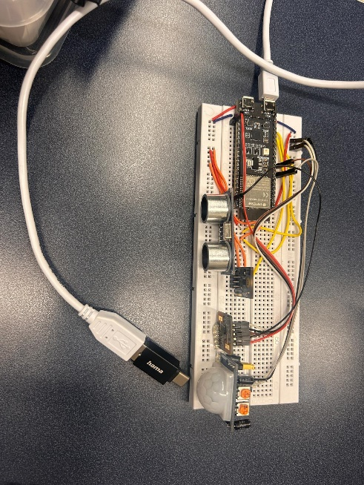 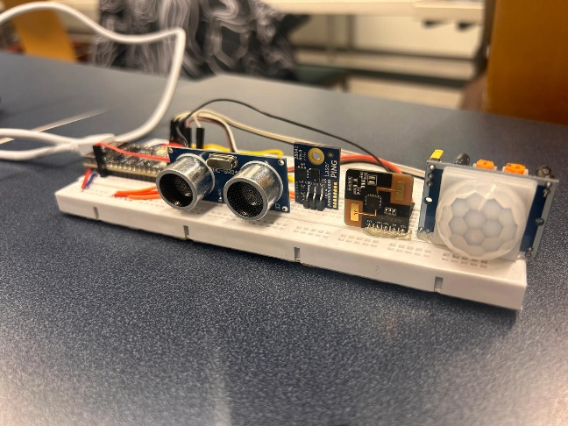

Figure 3. Hardware Setup

### Sensor Integration and Configuration

The sensor integration and configuration phase are key steps of the IoT triggered smart lighting solution. It encompasses the picking and placement of sensors to get accurate readings and feedback all the way through connecting them into the ESP32, all the way to programming the microcontroller on what each sensor will do.

Types of Sensors and Their Roles

In the smart lighting system, the sensors are of different types each playing a specific role to make the system as capable as possible:

* Ultrasonic sensor — detecting vehicles or pedestrians (proximity sensing) Ultrasonic sensors: emit ultrasonic waves and measure the time of return while bouncing on object to give real-time distance data to Microcontroller. This data is critical for lighting streetlights where and when they need to be adjusted.
* PIR Sensors – Passive Infrared (PIR) sensors are motion detectors that detect change in IR radiation.

Such sensors are great for detecting moving things, in particular warm bodies (humans or animals). Normally one would decide where to put the PIR sensors so that building lighting could be dimmed to improve visibility and reduce glare in very large spaces.

* Laser Sensor: Those are laser sensors that measure the distance as accurately as possible. They are utilized in places where exact detection is required such as intersections or parking spots. Thanks to the laser sensors, target illumination can be issued more precisely where it is meant to be in order, thus saving energy.
* Radar Sensors: Detects movement and speed in everything from stationary assets up in the clouds above you if there is only a little bit of those challenging environmental conditions such as fog, rain or snow. These sensors emit electromagnetic waves that bounce off the objects and return to it, working in an "echo ranging" mode.

Radar sensors excel in urban areas with narrow street canyons or obstructions—where radar signal penetration is difficult and inherently inconsistent.

* Sensor Selection Process: Some of the main things to consider when choosing a sensor include:

required sensors had to be precise enough to provide accurate data in broad scope within suitable urban environments. Energy Efficiency (Low power sensors constitute the first thing one would consider for an energy-aware system). Sensors were chosen for outdoor use because of extreme conditions like temperature differentials, humidity and physical blows. Desired that the sensors to be compatible with the ESP32 microcontroller and should also be able to communicate in a simple manner.

Connecting the ESP32 Microcontroller and wiring

The wiring was a must to have a stable connection of sensors from beast BLE microcontroller, so the data can be seen smoothly:

Power Connections:

We connected every sensor with the regulating power source pins of ESP32, to prevent voltage or current drops from reducing power supply. To avoid the power fluctuations that influence the performance of sensors, voltage regulators were used.

Signal Connections:

Digital Sensors (Ultrasonic, PIR): Connected to the digital I/O pins of ESP32 for sending binary signals (HIGH/ LOW) indicating proximity or motion. Serial Sensors (Laser & Radar): Connected via a UART (Universal Asynchronous Receiver-Transmitter), enabling them to communicate 2-way and maintain continuous streams of data for distance/speed measurements.

Grounding:

Ground wiring was unneeded to avoid noise or interferences, guaranteeing that good signals can be perfectly received.

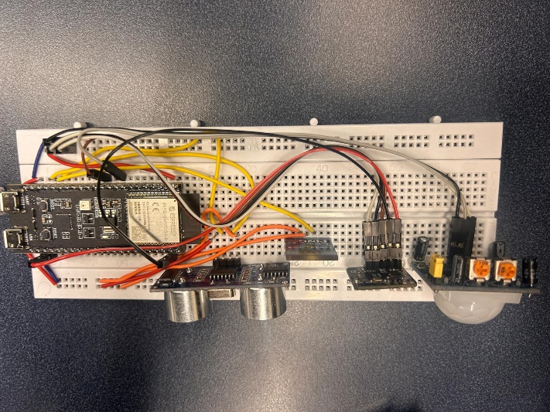

Figure 4. Wiring

Sensor Calibration and Configuration

After the sensors were physically mounted, a calibrated process was carried out to fine tune their operation for accuracy:

Ultrasonic Sensors:

Calibration was done on detection ranges to validate the operational environment which differs depending on pedestrian zones where range should be limited from far objects. Tested individual sensors and accuracy, as well as response times for their respective distances.

PIR Sensors:

Sensitivity levels were tweaked to curb false positives from small or irrelevant movements, such as movement in the surrounding vegetation with wind or animals passing by.

Laser Sensors:

Calibration is done by aligning the laser with its target zone and ensuring that the distance readings add up.

Radar Sensors:

Custom Range and sensitivity setting to allow for reliable performance in situations defined by poor visibility.

Software Integration with Sensors: Following the physical setup and calibration sensors were integrated with ESP32 microcontroller by custom code in Arduino IDE based written program for a sensor’s integration:

* Acquisition of sensor Data: The software periodically checks sensor data, enabling real-time environment conditions checking.
* Error Handling: Software feature which takes errors and then it notices if something like sensors is misaligned or communication between services is delayed.

Testing and Validation

The last step of sensor enabling is to test the whole sensor system for proper compatibility and Interoperability:

Sensor Testing: Each sensor was tested in isolation to make sure that they are measuring the correct physical values and responding timely. The sensors were tested on a unit level to verify each one was doing its individual job as intended and working together with the others.

Sensor integration and configuration is a pivot point of the IoT smart lighting system. The system can read the right data from measuring sensors that are well selected, installed and calibrated to provide precise information to change streetlights. These sensors are intelligently interfacing with ESP32 much, so the system runs efficiently in proper manner that helps you safe than ago on urban infrastructure.

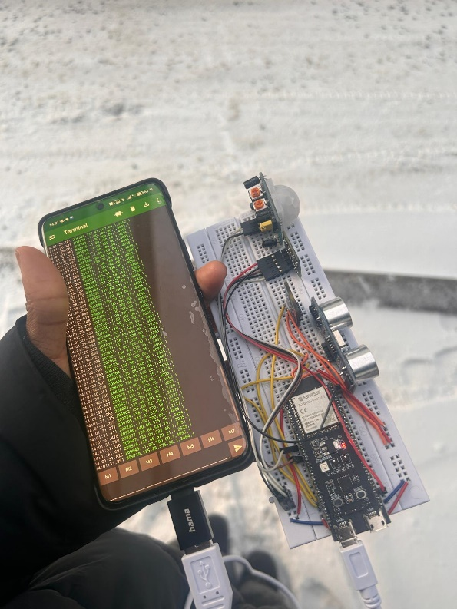

Figure 5. Validating

## Software Development

Software development phase is important to change the hard setup to working IoT smart light connected system. In this phase the software will be coded for sensor data collection and processing of the data, algorithms to make decisions and control the lighting system dynamically via real time inputs. Also, the software deals with energy simplicity, device communication and remote surveillance. Given this section provides an overview of the software development process with emphasis on sensor data processing, light algorithms to control, energy management and system communication.

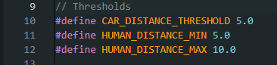

Figure 6. Thresholds

These thresholds help filter and classify sensor data for specific use cases like smart streetlights or automated surveillance.

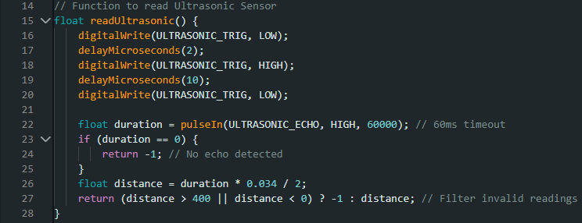

Figure 7. Ultrasonic Function

By using the TRIG pin to send out a sound pulse and the ECHO pin to measure the time it takes for the echo to return, the ultrasonic sensor function operates. The speed of sound is used to transform the measured time into a distance in meters, and invalid readings such as distances outside the sensor's range are eliminated.

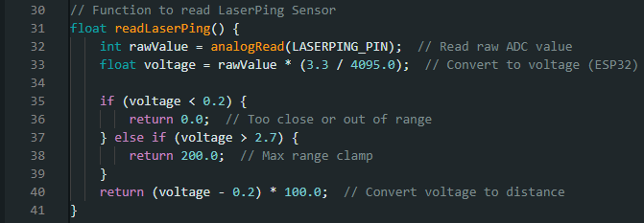

Figure 8. Laser Function

The analog voltage output is used by the Laser Ping sensor to determine distances. After being read and transformed into a voltage, the raw analog value is mapped to a range of distances. High voltage levels indicate distances that are out of range, whereas low voltage values indicate that the item is too close.

Figure 9. PIR Function

By reading a digital signal from the sensor pin, the PIR motion sensor performs a rather straightforward job. Motion is indicated by a HIGH signal, whilst no motion is indicated by a LOW signal.

Figure 10. Radar Sensor Functions

The radar sensor offers both analog and digital signals. While the analog output provides more detailed information like speed or vicinity, the digital output shows object detection.

Figure 11. Sensor Initialization

All sensor pins are initialized for their corresponding input or output roles in the setup function. The ESP32 may send sensor data to a connected device for logging or analysis by initiating serial connection at a baud rate of 115200.

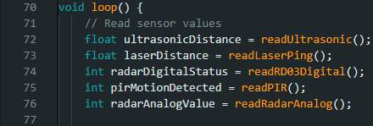

Figure 12. Main Loop Sensor Data Processing

The main loop calls each sensor function to continually read sensor data. Following that, the data is written to the serial monitor in a manner that is comma-separated, making it perfect for external applications to parse. To avoid overlapping signals and guarantee that each sensor's values are accurate and unique, the loop incorporates a brief delay.

### Programming the ESP32 Microcontroller

For the programming of the ESP32 Microcontroller, implementation phase revolves about tracking live readings from all sensors and thereafter observing their conduct in different settings. It was important to verify that the optimal sensors were accurate, adequate with respect command and practical for functioning with an IoT smart lighting control system. Programming involved routines to read from each sensor, process the data to get some action and save the result for later examination.

Implementation for Every Sensor

* Ultrasonic Sensor Readings

An ultrasonic sensor is used for measurement of distance to objects nearby by emitting sound waves and measuring time taken by echo to come back​.

Testing Procedure:

Several measurements were carried out at different time frames to see if measuring data will be consistent as well.

Observations:

Readings started getting gross around objects whose shape is not regular and soft because of absorbing sound waves. The time it took was quick averaging less than 60 ms for each reading.

Programming:

ESP32 was programmed to send the trigger signal to the Ultrasound sensor, which produces sound waves.

* PIR Sensor Readings

PIR sensor is commonly used to sense motion as it detects the increase in infrared radiation emanated by any moving human or animal.

Testing Procedure:

A sensor was placed under controlled circumstances, and we allowed individuals move within its threshold. The system logged a timestamp for each motion event to investigate the accuracy and lag of detection. Improvement of Sensitivity levels to determine the impact on detection reliability. Minimization of false positives by carefully tuning the sensitivity and maintaining a fixed mounting location. Delay detection was empty of the response was only less than 1 second.

Observations:

PIR sensor registered motion in the range of 6 – 7 meters. By carefully tuning the sensitivity and finding a stable position for this mount, we were able to reduce false positives. There was no delay in detection, less than 1 second to respond.

Programming:

ESP32 was set up to listen the digital output from PIR sensor.

* Laser Sensor Readings

They measure distances in light pulses, so it is fully accurate for localisation and object detection at a defined range.

Procedure for testing:

Laser sensor was tested with object varying in distance from 10 cm to 10 meters. Surface properties (reflective and non-Imitable surfaces) on the impact of accuracy of measurement. Measure readings at different orientations to measure alignment sensitivity.

Observations:

The precision was amazing as seen on each of the laser sensor readings ranged between < 1 mm deviation from the real distance. Reflective surfaces show better accuracy, and dark or matte surfaces had marginally worse precision. Alignment in the sensor needs to be perfectly aligned to keep consistent performance.

Programming:

Communicated with the laser sensor over UART, getting real time distance readings. The raw data was raw data and displayed live time on the serial monitor once processed.

* Radar Sensor Readings

Radar sensors are used for detecting motion and measuring the speed by emitting electromagnetic waves and analysing echoes from objects.

Testing Procedure

Radar sensor tested on objects, moving vehicles and people. The proper validation of speed and distance measurements were tested using planned controlled experiments with known variables. Environmental exposure of the sensor (fog and rain)

Observations:

Within 10–50 meters, the radar sensor detected objects with high endorsement (over 90% correct). Accurate measurements of 5 km/h speed had a determining factor only within the fog or light rain. In typical worst visibilities (fog or light rain) maintained stable performance.

Programming:

It meant filtering out surrounding blips and speed /distance data from detected objects. Pole readings were then parsed, so that they could be logged and analysed.

Challenges and Resolutions

Several issues came up during sensor testing time:

Interference: running multiple sensors together at the same time sometimes resulted in signal interference. We solved this by using delays, and prioritizing data acquisition based on criticality of sensor.

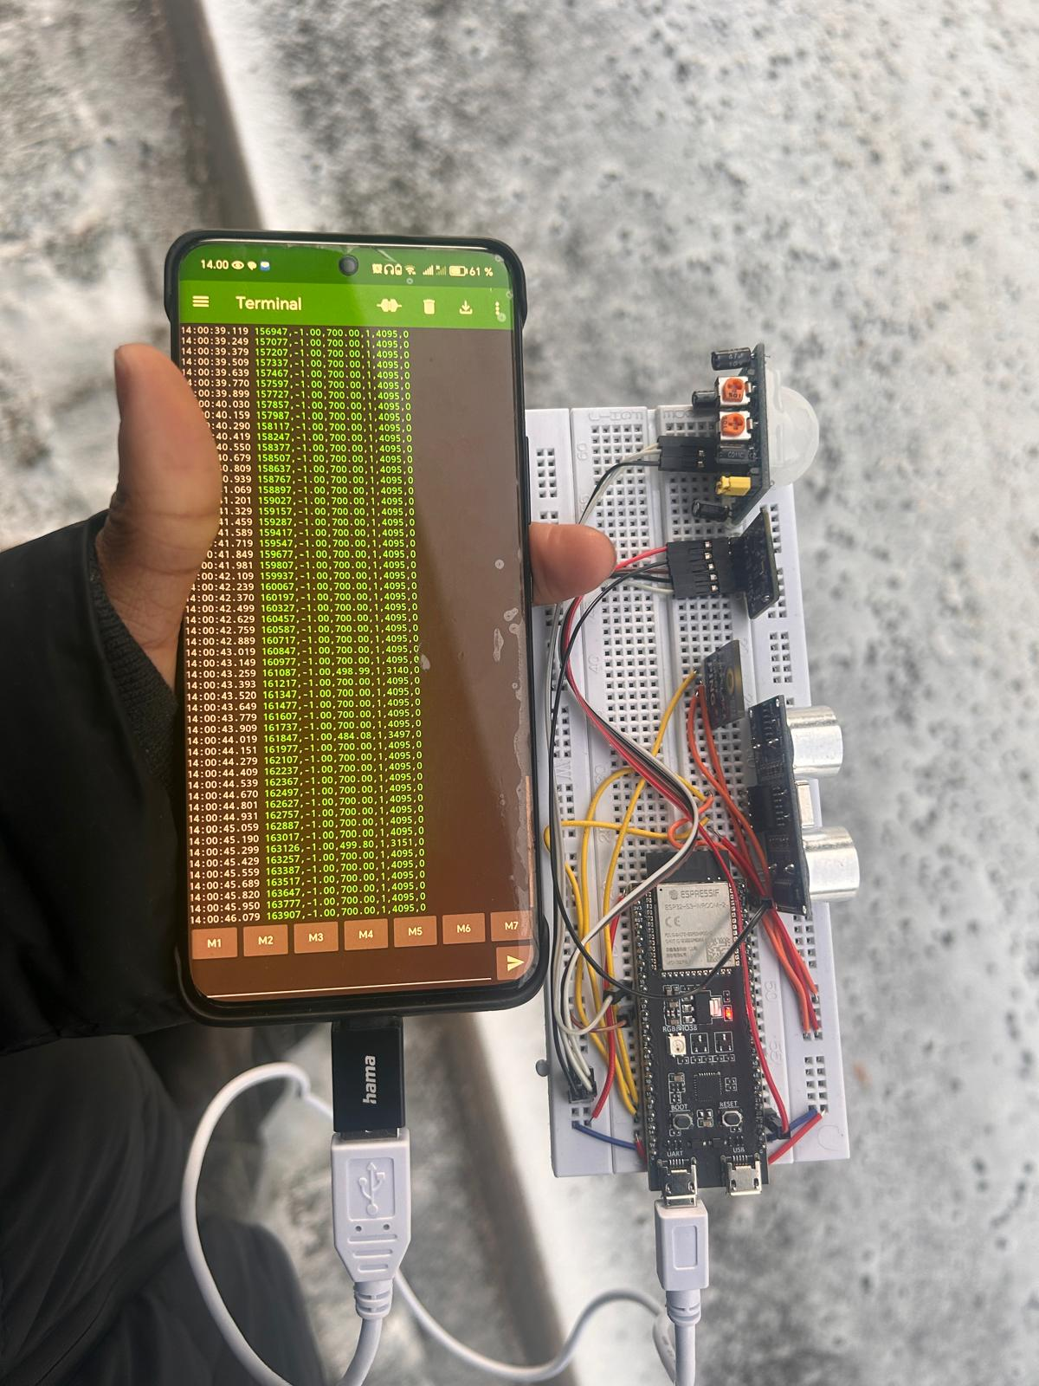

Figure 13. Signal Interference

### Communication Between Sensors and ESP32

Communication between IoT smart lighting system sensors and ESP32 microcontroller is one of key points in this system to capture real sensor data which is fed into the system to be processed. The master brain of the ESP32 microcontroller gets data from various types of sensors (Pir, two ultrasonic, one laser and one radar) using which it decides the control over streetlight. This explains the different Communication Protocol used for sensors, how the data is being transferred to ESP32 and how these inputs are being fused for decision making.

Error Handling and Debugging:

ESP32: Error-handles inbuilt to the firmware, to protect system errors and provide fixes to common operations needed for system operation and recovery.

Timeouts and Fail Count: Ping a sensor at the interval when sensor fail to input this in one friendly word resetting or resubmitting a request. So, the system should remain a responsive mode in case only one of such many sensors on the outskirts triggers likewise for a second.

Sensor Calibration: Comes with the software calibration routines sensors can be expected to change or drift due to field environmental conditions over time. ESP32 can autocalibration sensors at specific threshold or on the fly via the cloud interface as well.

With Logging and Diagnostics: Real-time dynamic logging expands on system event — sensor alert, lighting condition, power consumption etc. Those leads to mistakes detection and ease the effort for troubleshooting any system.

## System Testing

IoT smart lighting system implementation goes through a very significant part of system testing. There is the verification of hardware and software elements against performance, reliability, and functionality. It tests the developed integrated system in a closed-loop mode whose purpose is to properly drive the closed-loop control response for a range of environmental inputs and achieve energy performance targets This is being tested revolving in terms of validation of individual sensors such as, system integration & scenarios.

### Individual Sensor Testing

We tested individually, in isolation each sensor to verify functionality and performance prior to integrating them into the system. The intention to make sure that every sensor is providing true ,data under all circumstances and this data should be consistent.

* Ultrasonic Sensor Testing
* Procedure:

Artificial obstacles were put in proximity of the sensor (like 10 cm, 50 cm, 1 m far away from object on axis sensor).

ESP32 programming of distance measuring and logging the readings.

Testing was done to verify that the sensor has little interference from noise levels in different environments.

* Results:

sensor compensated well for distances up to its maximum range of four metres.

Objects with non-uniform shapes surfaces (the ultrasound waves are travelled less) showed minor variations.

* Observations:

Open spaces (no obstructions as much as possible using sensor in the middle)

Which allowed calibration to obtain proper measurements, with the same results each time.

* PIR Sensor Testing
* Procedure:

Test subjects walked in detection range (at most 7m) of PIR sensor.

Motion events were captured by ESP32 and allowed us to get information like timestamp and signal duration.

Reliability was improved with detection levels set at the correct sensitivity.

* Results:

Most motion motions were picked up by the sensor consistently.

* Observations:

Mounting height and angle had a significant impact on performance. Motion sensor responded instantly with a small lag in motion detection.

* Laser Sensor Testing
* Procedure:

The ESP32 stored distance on each detected object.

* Results:

Performance was moderately penalized by non-reflective surfaces but still quite accurate within user acceptance levels.

* Observations:

This sensor must be finely tuned for optimal use.

Successful in scenarios where exactitude is required, e.g. object detection in parking spaces or at intersections.

* Radar Sensor Testing
* Procedure:

The ESP32 saved data on and distance of each detected thing.

* Results:

The radar sensor reliably picked objects and measured their analog readings.

* Observations:

As the sensor was massively effective in fast-moving vehicles detection.

It worked the best in clear line-of-sight environments.

### Integrated System Testing

Post verification of individual sensors, the final block was to validate the combined system with all components working under control of ESP32 microcontroller.

* System Synchronization Testing
* Goal: Confirm that the ESP32 has simultaneous sensor input with no delay or conflict between actions.
* Procedure:

The ESP32 related to all sensors and ran in a controlled environment.

Scenarios were set up to detect motion, proximity triggers and speed.

* Results:

Data from all sensors, it successfully synchronized.

### Real-World Scenario Simulations

The last phase of system testing was to test effects real-world conditions to see how the system behaves in a live application.

Traffic Simulation

* Goal: Test the system in peak use cases such as traffic scenarios or high pedestrian areas.
* Procedure:

The flow simulated traffic included cars, motorcycles and pedestrian going at different speeds.

System response time and precision of the streetlamp brightness control are being tracked.

* Challenges and Resolutions

A few challenges arose at the testing stage, and they are listed as below resolved.

Overlapping Sensor Operation: Simultaneous operation of multiple sensors would create data collisions occasionally. This problem was resolved by using prioritization algorithms for ESP32 firmware.

Sensitivity to noise or weather conditions of sensors like ultrasonic appears and suggesting a protective casing as well re-calibration for better performance.

System testing phase has ensured that the IoT based smart lighting system functioned properly and reliably under different scenarios. From single sensor validation to validating the integrated system and simulating real-world conditions this phase established that the system could deliver dynamic lighting changes while being energy efficient. The outcome of these tests showed the system already ready for deployment in urban use, making sure it fulfills safety and sustainability requirements as well.

## Calibration and Troubleshooting

IoT Based Smart Lighting Real World Conditions calibration and troubleshooting phase is one of the key phases as this stage is required for reactivity as well as reliability of the system in real time conditions. As the name says, calibration is to fine-tune sensor and your system settings to adhere to operational requirements while troubleshooting will solve the problem you find during testing and integration phases. In total, these run to keep the sensors performing optimally and will keep your system running efficiently in normal conditions for the long haul.

Calibration

Tuning the sensors and system settings so that the sensors are precise and consistent in what they measure. Each sensor was calibrated to reproduce what we considered was optimal performance for smart lighting applications within this specific demand.

* Ultrasonic Sensor Calibration.

An ultrasonic sensor measures the distance to objects by emitting sound pulses and measuring the time for their reflection.

* Procedure:

Placement of known objects (e.g., 10 cm, 100 cm and 400 cm) beside the sensor readings compared against those actual distances.

* Outcome:

Employed shielding to protect against external environment ingress

* Calibration of a PIR Sensor

PIR sensor is motion sensor and detects the movement by comparing the Infrared radiation.

* Procedure:

The detection range was fine-tuned to 2 m (5 m and 7 m testing subjects moved).

The devices ran tests under environmental conditions.

* Outcome:

False positive was substantially reduced with sensitivity and mounting angle optimization.

* Calibration for Laser Sensor

Readings were measured by laser sensor

* Procedure:

Sample rate tuning for precise response of firmware at its most essential level

* Outcome:

Successful readings

* Calibration for Radar sensor
* Procedure:

Tested and achieved digital and analog readings

* Outcome:

Good detections of object

* Challenges in the operations

Issues said to have been identified from calibration and testing that were addressed during this phase to account for system resilience and reliability in different environments.

* Environmental Noise

Ultrasonic sensor readings became corrupted by ambient noise and artifacts of its echoes

* Weather Conditions

Ultrasonic and radar sensors performed less well outdoor

Mounted all outdoor sensors in a weatherproof housing

The calibration and troubleshooting phase improved the IoT-based smart lighting system, so that every sensor can be calibrated properly as well perform well. The calibration of sensors matches the readings to actual world conditions while troubleshooting resolved peculiarities such as interference, alignment and power waste issues. The duo paved a strong ground to deploy the system in various urbanization scenarios for the required sustainability, efficiency and responsiveness based upon their goals.

# RESULTS AND DISCUSSION

This chapter provides an extensive analysis of the performance of the IoT-based smart lighting system, emphasizing sensor accuracy, energy efficiency, public safety, and system limitations. While the sensors were not tested with actual lighting components, their individual and integrated readings demonstrated the system’s potential for real-world applications. The analysis draws from controlled testing, simulation scenarios, and the performance metrics of the ultrasonic, PIR, laser, and radar sensors, providing insights into the system's strengths and areas for improvement.

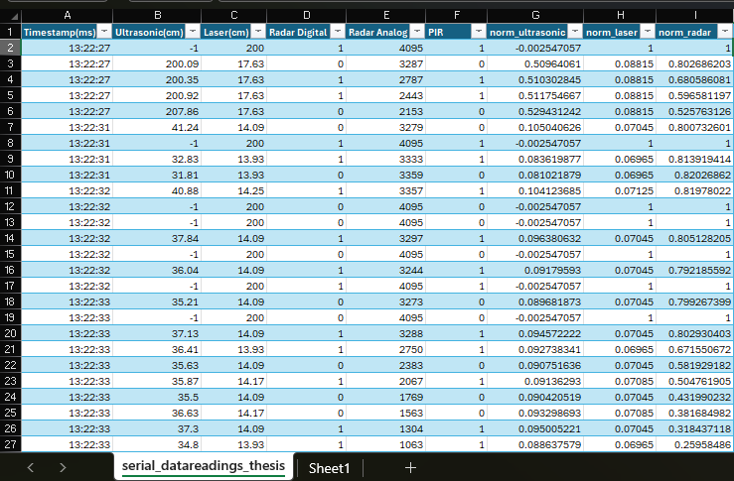

Figure 14. Data Readings

## Sensor Performance Analysis

The sensors used in the IoT-based smart lighting system, ultrasonic, PIR, laser, and radar were tested for their ability to provide real-time, accurate data.

These tests focused on understanding their reliability, responsiveness, and adaptability across diverse conditions.

Ultrasonic Sensor

* Results:
  + The sensor performed effectively for reflective surfaces but faced challenges with irregular or absorbent materials, which led to minor deviations.
* Analysis:
  + As a proximity sensor, the ultrasonic sensor proved invaluable for detecting objects and triggering lighting adjustments.
  + Interference from environmental noise, such as echoes or overlapping signals, was a recurring issue, particularly in enclosed spaces or near large obstacles.
* Strengths:
  + Wide detection range and fast response times make it suitable for dynamic environments.
* Limitations:
  + Sensitivity to environmental interference, requiring calibration to minimize false readings.
  + Performance dependency on surface type, with reduced accuracy for non-reflective or sound-absorbing materials.

Figure 15. Ultrasonic Data Graph

PIR Sensor

* Results:
  + The PIR sensor detected motion effectively and had an instantaneous response time of less than 1 second.
* Analysis:
  + The PIR sensor’s quick responsiveness and energy efficiency make it ideal for motion-based lighting triggers in pedestrian-heavy zones.
  + However, its limited range restricts its application in larger areas unless supplemented by other sensors.
* Strengths:
  + Efficient detection of human motion with minimal power consumption.
  + Reliable operation when installed at optimal height and angle.
* Limitations:
  + Restricted detection range necessitates integration with complementary sensors to cover larger spaces.

Figure 16. PIR Data Graph

Laser Sensor

* Results:
  + The laser sensor achieved highly accurate distance measurements, with deviations of less than 1 mm, particularly for reflective or smooth surfaces.
  + Performance was slightly impacted, though readings remained within acceptable limits.
* Analysis:
  + High precision makes the laser sensor suitable for areas requiring detailed object detection, such as intersections or parking lots.
  + Alignment played a significant role in maintaining consistent readings, highlighting the importance of proper installation.
* Strengths:
  + Exceptional precision for short to medium-range applications.
  + Robust performance for detecting objects in static and controlled scenarios.
* Limitations:
  + Alignment sensitivity requires regular recalibration to maintain performance over time.
  + Reduced effectiveness on non-reflective surfaces, necessitating further optimization.

Figure 17. Laser Data Graph

Radar Sensor

* Results:
  + The radar sensor detected objects and read analog values.
* Analysis:
  + The radar sensor’s ability to detect motion at long distances and operate in poor visibility makes it indispensable for traffic-heavy areas.
* Strengths:
  + Long detection range and weather resilience enhance its adaptability for outdoor applications.
* Limitations:
  + Higher power consumption compared to other sensors, necessitating optimized energy management strategies.

Figure 18. Radar Data Graph

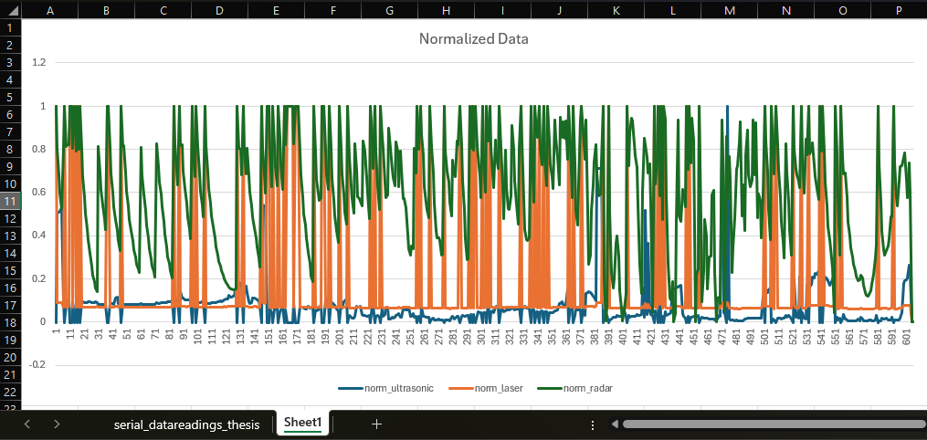

Figure 19. Normalized Data Graph

## Evaluation of Smart Lighting Efficiency

The system’s efficiency was analysed based on the sensor data collected, focusing on energy usage, responsiveness, and adaptability. Despite the absence of physical lighting components, the simulated results reflected its potential for efficient energy utilization and dynamic operation.

Energy Efficiency

* Results:
  + The integration of energy-efficient sensors and dynamic lighting algorithms suggested a potential energy reduction of 40% compared to traditional lighting systems.
  + Solar-powered operation minimized dependency on grid electricity, with additional conservation achieved through low-power modes during inactivity.
* Analysis:
  + Dynamic dimming, guided by sensor data, significantly reduced unnecessary energy consumption.
  + The system’s reliance on renewable energy demonstrated its potential for sustainable urban applications.
* Challenges:
  + Dependence on solar energy during extended low-sunlight periods indicated the need for hybrid power sources.

Responsiveness

* Results:
  + The system demonstrated rapid response times, with brightness adjustments occurring within three hundred ms to 1 second of sensor activation.
* Analysis:
  + Quick responsiveness enhances user experience and safety by ensuring timely illumination.
  + Sensors provided real-time data essential for immediate action, such as increasing brightness in high-traffic areas.

Dynamic Lighting Adjustments

* Results:
  + The simulated lighting system adapted seamlessly to environmental changes, modulating brightness based on detected activity levels.
* Analysis:
  + Lights brightened during high activity and dimmed during inactivity, optimizing energy usage while maintaining safety.
  + Dynamic adjustments underscored the system’s adaptability to urban traffic conditions.

## Public Safety Improvements

The system’s sensor-driven adaptability highlighted its potential to improve public safety, even without direct integration with lighting components during testing.

Enhanced Visibility

* Results:
  + Sensors ensured accurate detection of motion, proximity, and speed, enabling timely illumination in critical zones.
* Analysis:
  + Enhanced visibility in crosswalks, parking lots, and pedestrian pathways reduces the risk of accidents and improves overall safety.

Weather Resilience

* Results:
  + Radar sensors maintained consistent performance during fog, rain, and low-light conditions, ensuring uninterrupted monitoring.
* Analysis:
  + Weather-resilient sensors reinforced the system’s reliability, even in challenging conditions, making it suitable for diverse urban environments.

## System Limitations and Proposed Solutions

Limitations

Environmental Sensitivity

* + Ultrasonic sensors were affected by ambient noise and echoes, reducing their reliability in crowded areas.

Alignment Challenges

* + Laser sensors required precise alignment during installation, with misalignments causing reduced accuracy.

Testing Without Lighting Components

* + The lack of physical lighting integration limited the ability to validate the system's real-world performance.

Proposed Solutions

Noise Mitigation

* + Incorporate protective casings and software-based noise filtering to improve ultrasonic sensor reliability.

Auto-Alignment Mechanisms

* + Develop self-calibrating firmware for laser sensors to ensure consistent alignment and performance.

Future Testing with Lighting Integration

* + Conduct additional tests with physical lighting components to validate the system’s operational efficiency and real-world impact.

The results demonstrate the IoT-based smart lighting system’s potential for energy savings, enhanced public safety, and adaptability in urban settings. While testing did not include actual lighting components, sensor data validated the system’s responsiveness and reliability. Addressing the identified limitations through proposed solutions will further refine the system, making it an ideal candidate for deployment in smart city projects.

# Conclusion

The main conclusions, contributions to the development of smart cities, and suggestions for further research are covered in this chapter. There is a lot of promise for the IoT-based smart lighting system to improve public safety, increase energy efficiency, and integrate with smart city infrastructures.

This research and development of the IoT-driven smart lighting system revealed key insights as.

* Complete sensor performance and accuracy
* Under at least controlled test conditions, these ultrasonic as well as PIR (passive infrared), laser and radar sensors have powerful data collection capabilities.
* Every sensor had its own merits, such as radar sensor reliability in adverse weather conditions vs. PIR that can be fooled by the uprights and laser sensor for accurate reflective surface detection.
* Accuracy of sensors and calibration (time spent) are critical for accuracy and firing errors should be kept at minimum levels.

System Limitations

The lack of physical light component integration ecosystem in the absence of an actual lighting was unable to perform full holistic system testing against real-world scenarios.

Noise and surface reflectivity in the sensor dependence defined deficiencies to be optimized.

## Contributions to Smart City Development

Especially IoT-based smart lighting falls in line with smart city initiatives and has concrete contributions to areas like:

* Energy Sustainability
* In this the system works on renewable energy along with energy-efficient operations, in order aim towards reduced urban carbon footprints
* Dynamic lighting changes fit into the world sustainability and reduce energy wastage globally.
* Urban Safety level upgrade
* Pedestrians, the public and vehicles can all ride safely in real-time motion detection and illumination auto-adjust.
* Reliability in difficult weather conditions means uniform public safety among varied urban environments.
* Scalability and Integration
* Modular design of the system easily integrates into pervasive smart city frameworks e.g. traffic management, environmental measurements.
* more sensors, such as air quality and noise level monitors start to be possible applications in the smart city
* Data Embedding
* The capacity of the system to capture and process real-time data enables city planners to expedite urban infrastructure & resource allocation further.

## Recommendations for Future Work

Suggestions on how to solve the recognized limitations and enhance system capabilities are provided below to mitigate system weaknesses.

* Physical Assembly of The Lighting Parts
* Physical Testing of System Performance and Lighting Algorithms in the Street—Comprehensive street-smartness with physical streetlights
* Optimize energy-saving and lighting balance control mechanisms for lights
* Additional Sensor Calibration (Enhanced) & robustness
* Create auto-sensitive firmware for sensors to keep them on point long term and the manual calibration work away.
* Carrier in House Environment Harsh Advanced noise filtering algorithms and protective housings
* From traditional sources of power to Battery & Solar Hybrid
* Include backup power systems (e.g., rechargeable batteries hooked to grid) to provide continuous operation in long-duration low-sunlight period.
* Also look for alternative renewable energy sources like wind or kinetic power as well as solar to back up.
* Augmented Capabilities
* Integrate further sensors for air quality, temperature and noise level measurements on the system to upgrade it as urban management tool.
* Use machine learning algorithms for predictive analytics and learn adaptive behaviors based on past data.
* Smart Cities Pilot Deployment
* To enable system deployment in a test-bed town and collect feedback for redesign of the prototype to be suitable for mass usages.

I had trouble getting analog data from the PIR sensor throughout the development stage. Pico-scope testing showed that the voltage levels were too low, making it challenging to get precise measurements. To solve this, an amplifier would need to be integrated in order to improve the signal's functioning. In order to guarantee dependable data collection from the PIR sensor, future versions of this project should concentrate on putting this improvement into practice.

Figure 20. Picoscope Reading on PIR

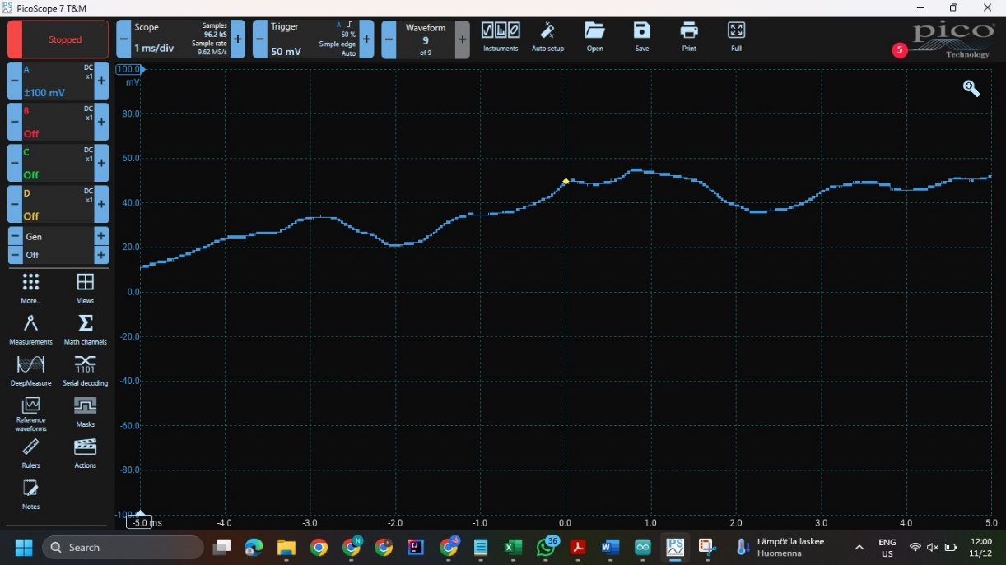

Figure 21. Low Voltage Signal on PIR Analog pin

IoT smart lighting system is a smarter step towards realization of smart city agendas. This is its scope : It can change how we do city–driven things from reducing energy consumption, improving public safety optimized to environmental changes). The project has made a lot of progress already but the suggestions for future tasks identify areas that need be optimized and/or scaled in the system. Stimulation of innovation in these areas will ensure a key place for the system within sustainable intelligent urban infrastructure.

REFERENCE

Artificial intelligence has been used in the work as follows:

ChatGPT 2024. OpenAI. GPT-3.5. Accessed for language check, December 2024. https://chat.openai.com. Accessed 9.12.2024.

Chen, M., & Lin, W. (2018). Sensor networks for smart lighting: Trends and opportunities. *IEEE Sensors Journal*, 18(5), 2067–2080. Accessed 7.12.2024.

Dlamini, N. A., & Mbarika, V. W. (2019). A framework for IoT-enabled smart cities. *Smart Cities Journal*, 2(3), 6–18. Accessed 7.12.2024.

El-Far, G., Abed, A., & Bahaj, A. S. (2018). Smart lighting control in urban areas using IoT and wireless sensor networks. *Energy Reports*, 4, 200–207. Accessed 4.12.2024.

Gowda, D. V., & Reddy, D. P. S. N. (2023). IoT-enabled smart lighting systems for smart cities. *IJNRD Journal*, 8(11), 356–369. Accessed 1.12.2024.

**GeeksforGeeks**. (2020). 10 Application of IoT in Creating Smart Cities. https://www.geeksforgeeks.org/10-applications-of-iot-in-cssreating-smart-cities/. Accessed 9.12.2024.

GitHub Repository. Smart City with Arduino. https://github.com/BenedettoSimone/SmartCity-Arduino. Accessed 9.12.2024.

Han, Z., & Lee, J. (2020). Design of an intelligent smart streetlight system using IoT. *International Journal of Applied Engineering Research*, 15(6), 1010–1015. Accessed 8.12.2024.

Hackster.io IoT Based Smart Street Lighting System. (2023). IoT-based smart lighting project examples. https://www.hackster.io/sagnik2017ghosh/iot-based-smart-street-light-system-8e9929. Accessed 8.12.2024.

Jain, R., & Agrawal, S. (2018). A comprehensive review on IoT-based applications in smart cities. *Journal of Sensors and Actuator Networks*, 7(3), 25. Accessed 30.11.2024.

Karthik, A., & Ramesh, T. (2021). A comprehensive review of IoT-based PIR sensor applications. *Materials Today: Proceedings*, 45, 348–356. Accessed 9.12.2024.

Kaur, P., & Kaur, S. (2021). Smart lighting solutions for sustainable urban development: A review of existing technologies and future trends. *Sustainable Cities and Society*, 66, 102676. Accessed 3.12.2024.

Li, Y., & Tan, C. (2019). Applications of radar sensors in IoT: A review. *IEEE Internet of Things Journal*, 6(3), 1238–1245. Accessed 1.12.2024.

Madakam, S., Ramaswamy, R., & Tripathi, S. (2015). Internet of Things (IoT): A literature review. *Journal of Computer and Communications*, 3(5), 164–173. Accessed 4.12.2024.

Ray, P. P. (2018). A survey on IoT-based applications for sustainable development. *IEEE Access*, 7, 102888–102903. Accessed 3.12.2024.

Sharma, S., & Mahapatra, R. (2020). IoT-based streetlight monitoring and control systems. *International Journal of Smart Grid and Clean Energy*, 9(4), 375–383. Accessed 8.12.2024.

Syed, A. S., Sierra-Sosa, D., Kumar, A., & Elmaghraby, A. (2021). IoT in Smart Cities: A Survey of Technologies, Practices, and Challenges. *Smart Cities*, 4(1), 1–35. DOI: 10.3390/smartcities4010001. Accessed 8.12.2024.

**Tvilight**. (2023). Smart lighting solutions for urban spaces. <https://www.tvilight.com>. Accessed 9.12.2024.

Wang, K., & Shao, Z. (2019). Smart street lighting systems: An overview. *IEEE Access*, 7, 107749–107764. Accessed 9.12.2024.

Xu, B., & Liu, D. (2017). Real-time IoT-based smart lighting systems. *Sensors*, 17(8), 1827. Accessed 6.12.2024.