Министерство науки и высшего образования Российской Федерации

Федеральное государственное автономное образовательное учреждение высшего образования

«НАЦИОНАЛЬНЫЙ ИССЛЕДОВАТЕЛЬСКИЙ УНИВЕРСИТЕТ ИТМО»

Факультет инфокоммуникационных технологий

**ОТЧЕТ**

**О ЛАБОРАТОРНОЙ РАБОТЕ № 3**

по теме: **Создание таблиц базы данных POSTGRESQL. Заполнение таблиц рабочими данными**

по дисциплине: Проектирование и реализация баз данных

Специальность: 09.03.03 Мобильные и сетевые технологии

|  |  |
| --- | --- |
| Проверил:  Говорова М.М. __________  Дата: «02» мая 2021г.  Оценка ______________ | Выполнил:  студент группы К3240  Борисов Матвей |

Санкт-Петербург 2020/2021

Цель работы:

Овладеть практическими навыками создания таблиц базы данных PostgreSQL 1Х, заполнения их рабочими данными, резервного копирования и восстановления БД.

Практическое задание:

1. Создать базу данных с использованием pgAdmin 4 (согласно индивидуальному заданию).
2. Создать схему в составе базы данных.
3. Создать таблицы базы данных.
4. Установить ограничения на данные: *Primary Key, Unique, Check, Foreign Key*.
5. Заполнить таблицы БД рабочими данными.
6. Создать резервную копию БД.

*Указание:*

*Создать две резервные копии:*

* *с расширением CUSTOM для восстановления БД;*
* *с расширением PLAIN для листинга (в отчете);*
* *при создании резервных копий БД настроить параметры Dump options для Type of objects**и**Queries.*

1. Восстановить БД.

Индивидуальное задание:

**Вариант 5. БД «Издательство компьютерной литературы»**

Выполнение:

**Наименование БД:** bookshop.

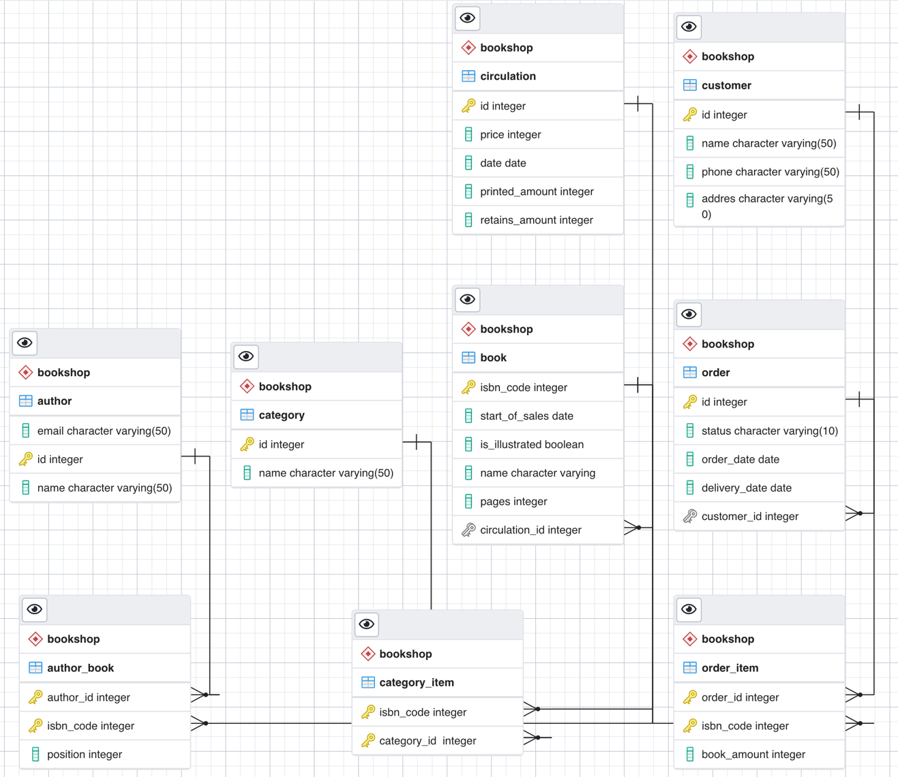

--

-- PostgreSQL database dump

--

-- Dumped from database version 13.2

-- Dumped by pg_dump version 13.2

-- Started on 2021-05-04 13:03:46 MSK

-- Устанавливаем значения по умолчанию

SET statement_timeout = 0;

SET lock_timeout = 0;

SET idle_in_transaction_session_timeout = 0;

SET client_encoding = 'UTF8';

SET standard_conforming_strings = on;

SELECT pg_catalog.set_config('search_path', '', false);

SET check_function_bodies = false;

SET xmloption = content;

SET client_min_messages = warning;

SET row_security = off;

--

-- TOC entry 5 (class 2615 OID 16535)

-- Name: bookshop; Type: SCHEMA; Schema: -; Owner: postgres

--

-- Создаем БД и назначаем владельца

CREATE SCHEMA bookshop;

ALTER SCHEMA bookshop OWNER TO postgres;

--

-- TOC entry 2 (class 3079 OID 16536)

-- Name: adminpack; Type: EXTENSION; Schema: -; Owner: -

--

CREATE EXTENSION IF NOT EXISTS adminpack WITH SCHEMA pg_catalog;

--

-- TOC entry 3333 (class 0 OID 0)

-- Dependencies: 2

-- Name: EXTENSION adminpack; Type: COMMENT; Schema: -; Owner:

--

COMMENT ON EXTENSION adminpack IS 'administrative functions for PostgreSQL';

SET default_tablespace = '';

SET default_table_access_method = heap;

--

-- TOC entry 202 (class 1259 OID 16546)

-- Name: author; Type: TABLE; Schema: bookshop; Owner: postgres

--

-- Создаем автора

CREATE TABLE bookshop.author (

email character varying(50) NOT NULL,

id integer NOT NULL,

name character varying(50) NOT NULL

);

ALTER TABLE bookshop.author OWNER TO postgres;

--

-- TOC entry 203 (class 1259 OID 16549)

-- Name: Author_id_seq; Type: SEQUENCE; Schema: bookshop; Owner: postgres

--

ALTER TABLE bookshop.author ALTER COLUMN id ADD GENERATED ALWAYS AS IDENTITY (

SEQUENCE NAME bookshop."Author_id_seq"

START WITH 1

INCREMENT BY 1

NO MINVALUE

NO MAXVALUE

CACHE 1

);

--

-- TOC entry 204 (class 1259 OID 16551)

-- Name: circulation; Type: TABLE; Schema: bookshop; Owner: postgres

--

-- Создаем тираж

CREATE TABLE bookshop.circulation (

id integer NOT NULL,

price integer NOT NULL,

date date NOT NULL,

printed_amount integer NOT NULL,

retains_amount integer NOT NULL

);

ALTER TABLE bookshop.circulation OWNER TO postgres;

--

-- TOC entry 205 (class 1259 OID 16554)

-- Name: Circulation_id_seq; Type: SEQUENCE; Schema: bookshop; Owner: postgres

--

ALTER TABLE bookshop.circulation ALTER COLUMN id ADD GENERATED ALWAYS AS IDENTITY (

SEQUENCE NAME bookshop."Circulation_id_seq"

START WITH 1

INCREMENT BY 1

NO MINVALUE

NO MAXVALUE

CACHE 1

);

--

-- TOC entry 206 (class 1259 OID 16556)

-- Name: customer; Type: TABLE; Schema: bookshop; Owner: postgres

--

-- Создаём покупателя

CREATE TABLE bookshop.customer (

id integer NOT NULL,

name character varying(50) NOT NULL,

phone character varying(50),

addres character varying(50) NOT NULL

);

ALTER TABLE bookshop.customer OWNER TO postgres;

--

-- TOC entry 207 (class 1259 OID 16559)

-- Name: Customer_id_seq; Type: SEQUENCE; Schema: bookshop; Owner: postgres

--

ALTER TABLE bookshop.customer ALTER COLUMN id ADD GENERATED ALWAYS AS IDENTITY (

SEQUENCE NAME bookshop."Customer_id_seq"

START WITH 1

INCREMENT BY 1

NO MINVALUE

NO MAXVALUE

CACHE 1

);

--

-- TOC entry 208 (class 1259 OID 16561)

-- Name: author_book; Type: TABLE; Schema: bookshop; Owner: postgres

--

CREATE TABLE bookshop.author_book (

author_id integer NOT NULL,

isbn_code integer NOT NULL,

"position" integer NOT NULL

);

ALTER TABLE bookshop.author_book OWNER TO postgres;

--

-- TOC entry 209 (class 1259 OID 16564)

-- Name: book; Type: TABLE; Schema: bookshop; Owner: postgres

--

-- Создаём книгу

CREATE TABLE bookshop.book (

isbn_code integer NOT NULL,

start_of_sales date NOT NULL,

is_illustrated boolean,

name character varying NOT NULL,

pages integer,

circulation_id integer NOT NULL

);

ALTER TABLE bookshop.book OWNER TO postgres;

--

-- TOC entry 210 (class 1259 OID 16570)

-- Name: category; Type: TABLE; Schema: bookshop; Owner: postgres

--

-- Создаём категорию

CREATE TABLE bookshop.category (

id integer NOT NULL,

name character varying(50) NOT NULL

);

ALTER TABLE bookshop.category OWNER TO postgres;

--

-- TOC entry 211 (class 1259 OID 16573)

-- Name: category_item; Type: TABLE; Schema: bookshop; Owner: postgres

--

-- Создаём элемент категории

CREATE TABLE bookshop.category_item (

isbn_code integer NOT NULL,

"category_id " integer NOT NULL

);

ALTER TABLE bookshop.category_item OWNER TO postgres;

--

-- TOC entry 212 (class 1259 OID 16576)

-- Name: order; Type: TABLE; Schema: bookshop; Owner: postgres

--

-- Создаем заказ

CREATE TABLE bookshop."order" (

id integer NOT NULL,

status character varying(10) NOT NULL,

order_date date NOT NULL,

delivery_date date NOT NULL,

customer_id integer NOT NULL

);

ALTER TABLE bookshop."order" OWNER TO postgres;

--

-- TOC entry 213 (class 1259 OID 16579)

-- Name: order_item; Type: TABLE; Schema: bookshop; Owner: postgres

--

-- Создаём элемент заказа

CREATE TABLE bookshop.order_item (

order_id integer NOT NULL,

isbn_code integer NOT NULL,

book_amount integer NOT NULL

);

ALTER TABLE bookshop.order_item OWNER TO postgres;

--

-- TOC entry 3316 (class 0 OID 16546)

-- Dependencies: 202

-- Data for Name: author; Type: TABLE DATA; Schema: bookshop; Owner: postgres

--

COPY bookshop.author (email, id, name) FROM stdin;

\.

--

-- TOC entry 3322 (class 0 OID 16561)

-- Dependencies: 208

-- Data for Name: author_book; Type: TABLE DATA; Schema: bookshop; Owner: postgres

--

COPY bookshop.author_book (author_id, isbn_code, "position") FROM stdin;

\.

--

-- TOC entry 3323 (class 0 OID 16564)

-- Dependencies: 209

-- Data for Name: book; Type: TABLE DATA; Schema: bookshop; Owner: postgres

--

COPY bookshop.book (isbn_code, start_of_sales, is_illustrated, name, pages, circulation_id) FROM stdin;

\.

--

-- TOC entry 3324 (class 0 OID 16570)

-- Dependencies: 210

-- Data for Name: category; Type: TABLE DATA; Schema: bookshop; Owner: postgres

--

COPY bookshop.category (id, name) FROM stdin;

\.

--

-- TOC entry 3325 (class 0 OID 16573)

-- Dependencies: 211

-- Data for Name: category_item; Type: TABLE DATA; Schema: bookshop; Owner: postgres

--

COPY bookshop.category_item (isbn_code, "category_id ") FROM stdin;

\.

--

-- TOC entry 3318 (class 0 OID 16551)

-- Dependencies: 204

-- Data for Name: circulation; Type: TABLE DATA; Schema: bookshop; Owner: postgres

--

COPY bookshop.circulation (id, price, date, printed_amount, retains_amount) FROM stdin;

\.

--

-- TOC entry 3320 (class 0 OID 16556)

-- Dependencies: 206

-- Data for Name: customer; Type: TABLE DATA; Schema: bookshop; Owner: postgres

--

COPY bookshop.customer (id, name, phone, addres) FROM stdin;

\.

--

-- TOC entry 3326 (class 0 OID 16576)

-- Dependencies: 212

-- Data for Name: order; Type: TABLE DATA; Schema: bookshop; Owner: postgres

--

COPY bookshop."order" (id, status, order_date, delivery_date, customer_id) FROM stdin;

\.

--

-- TOC entry 3327 (class 0 OID 16579)

-- Dependencies: 213

-- Data for Name: order_item; Type: TABLE DATA; Schema: bookshop; Owner: postgres

--

COPY bookshop.order_item (order_id, isbn_code, book_amount) FROM stdin;

\.

--

-- TOC entry 3334 (class 0 OID 0)

-- Dependencies: 203

-- Name: Author_id_seq; Type: SEQUENCE SET; Schema: bookshop; Owner: postgres

--

SELECT pg_catalog.setval('bookshop."Author_id_seq"', 1, false);

--

-- TOC entry 3335 (class 0 OID 0)

-- Dependencies: 205

-- Name: Circulation_id_seq; Type: SEQUENCE SET; Schema: bookshop; Owner: postgres

--

SELECT pg_catalog.setval('bookshop."Circulation_id_seq"', 1, false);

--

-- TOC entry 3336 (class 0 OID 0)

-- Dependencies: 207

-- Name: Customer_id_seq; Type: SEQUENCE SET; Schema: bookshop; Owner: postgres

--

SELECT pg_catalog.setval('bookshop."Customer_id_seq"', 1, false);

--

-- TOC entry 3161 (class 2606 OID 16583)

-- Name: author Author_pkey; Type: CONSTRAINT; Schema: bookshop; Owner: postgres

--

ALTER TABLE ONLY bookshop.author

ADD CONSTRAINT "Author_pkey" PRIMARY KEY (id);

--

-- TOC entry 3171 (class 2606 OID 16585)

-- Name: category Category_pkey; Type: CONSTRAINT; Schema: bookshop; Owner: postgres

--

ALTER TABLE ONLY bookshop.category

ADD CONSTRAINT "Category_pkey" PRIMARY KEY (id);

--

-- TOC entry 3163 (class 2606 OID 16587)

-- Name: circulation Circulation_pkey; Type: CONSTRAINT; Schema: bookshop; Owner: postgres

--

ALTER TABLE ONLY bookshop.circulation

ADD CONSTRAINT "Circulation_pkey" PRIMARY KEY (id);

--

-- TOC entry 3165 (class 2606 OID 16589)

-- Name: customer Customer_pkey; Type: CONSTRAINT; Schema: bookshop; Owner: postgres

--

ALTER TABLE ONLY bookshop.customer

ADD CONSTRAINT "Customer_pkey" PRIMARY KEY (id);

--

-- TOC entry 3167 (class 2606 OID 16593)

-- Name: author_book author_book_pkey; Type: CONSTRAINT; Schema: bookshop; Owner: postgres

--

ALTER TABLE ONLY bookshop.author_book

ADD CONSTRAINT author_book_pkey PRIMARY KEY (author_id, isbn_code);

--

-- TOC entry 3169 (class 2606 OID 16595)

-- Name: book book_pkey; Type: CONSTRAINT; Schema: bookshop; Owner: postgres

--

ALTER TABLE ONLY bookshop.book

ADD CONSTRAINT book_pkey PRIMARY KEY (isbn_code);

--

-- TOC entry 3173 (class 2606 OID 16597)

-- Name: category_item category_item_pkey; Type: CONSTRAINT; Schema: bookshop; Owner: postgres

--

ALTER TABLE ONLY bookshop.category_item

ADD CONSTRAINT category_item_pkey PRIMARY KEY (isbn_code, "category_id ");

--

-- TOC entry 3159 (class 2606 OID 16645)

-- Name: order_item chk_book_amount; Type: CHECK CONSTRAINT; Schema: bookshop; Owner: postgres

--

ALTER TABLE bookshop.order_item

-- Устанавливаем ограничение на количество книг в заказе

ADD CONSTRAINT chk_book_amount CHECK ((book_amount > 0)) NOT VALID;

--

-- TOC entry 3157 (class 2606 OID 16641)

-- Name: book chk_pages; Type: CHECK CONSTRAINT; Schema: bookshop; Owner: postgres

--

ALTER TABLE bookshop.book

-- Устанавливаем ограничение на количество страниц в книге

ADD CONSTRAINT chk_pages CHECK ((pages > 0)) NOT VALID;

--

-- TOC entry 3156 (class 2606 OID 16640)

-- Name: author_book chk_position; Type: CHECK CONSTRAINT; Schema: bookshop; Owner: postgres

--

ALTER TABLE bookshop.author_book

-- Устанавливаем ограничение на позиции автора

ADD CONSTRAINT chk_position CHECK (("position" > 0)) NOT VALID;

--

-- TOC entry 3154 (class 2606 OID 16642)

-- Name: circulation chk_price; Type: CHECK CONSTRAINT; Schema: bookshop; Owner: postgres

--

ALTER TABLE bookshop.circulation

-- Устанавливаем ограничение на цену

ADD CONSTRAINT chk_price CHECK ((price > 0)) NOT VALID;

--

-- TOC entry 3155 (class 2606 OID 16643)

-- Name: circulation chk_retains_amount; Type: CHECK CONSTRAINT; Schema: bookshop; Owner: postgres

--

ALTER TABLE bookshop.circulation

-- Устанавливаем ограничения на количество книг в запасе у издательства

ADD CONSTRAINT chk_retains_amount CHECK ((retains_amount <= printed_amount)) NOT VALID;

--

-- TOC entry 3177 (class 2606 OID 16599)

-- Name: order_item order_item_pkey; Type: CONSTRAINT; Schema: bookshop; Owner: postgres

--

ALTER TABLE ONLY bookshop.order_item

ADD CONSTRAINT order_item_pkey PRIMARY KEY (order_id, isbn_code);

--

-- TOC entry 3175 (class 2606 OID 16591)

-- Name: order order_pkey; Type: CONSTRAINT; Schema: bookshop; Owner: postgres

--

ALTER TABLE ONLY bookshop."order"

ADD CONSTRAINT order_pkey PRIMARY KEY (id);

--

-- TOC entry 3158 (class 2606 OID 16644)

-- Name: order order_status_check; Type: CHECK CONSTRAINT; Schema: bookshop; Owner: postgres

--

ALTER TABLE bookshop."order"

-- Устанавливаем ограничения на возможные статусы заказа

ADD CONSTRAINT order_status_check CHECK (((status)::text = ANY ((ARRAY['not_paid'::character varying, 'in_process'::character varying, 'delivered'::character varying])::text[]))) NOT VALID;

--

-- TOC entry 3178 (class 2606 OID 16600)

-- Name: author_book author_id; Type: FK CONSTRAINT; Schema: bookshop; Owner: postgres

--

ALTER TABLE ONLY bookshop.author_book

ADD CONSTRAINT author_id FOREIGN KEY (author_id) REFERENCES bookshop.author(id);

--

-- TOC entry 3181 (class 2606 OID 16605)

-- Name: category_item category_id; Type: FK CONSTRAINT; Schema: bookshop; Owner: postgres

--

ALTER TABLE ONLY bookshop.category_item

ADD CONSTRAINT category_id FOREIGN KEY ("category_id ") REFERENCES bookshop.category(id);

--

-- TOC entry 3180 (class 2606 OID 16610)

-- Name: book circulation_id; Type: FK CONSTRAINT; Schema: bookshop; Owner: postgres

--

ALTER TABLE ONLY bookshop.book

ADD CONSTRAINT circulation_id FOREIGN KEY (circulation_id) REFERENCES bookshop.circulation(id);

--

-- TOC entry 3183 (class 2606 OID 16615)

-- Name: order fr_customer_id; Type: FK CONSTRAINT; Schema: bookshop; Owner: postgres

--

ALTER TABLE ONLY bookshop."order"

ADD CONSTRAINT fr_customer_id FOREIGN KEY (customer_id) REFERENCES bookshop.customer(id);

--

-- TOC entry 3184 (class 2606 OID 16620)

-- Name: order_item isbn_code; Type: FK CONSTRAINT; Schema: bookshop; Owner: postgres

--

ALTER TABLE ONLY bookshop.order_item

ADD CONSTRAINT isbn_code FOREIGN KEY (isbn_code) REFERENCES bookshop.book(isbn_code);

--

-- TOC entry 3182 (class 2606 OID 16625)

-- Name: category_item isbn_code; Type: FK CONSTRAINT; Schema: bookshop; Owner: postgres

--

ALTER TABLE ONLY bookshop.category_item

ADD CONSTRAINT isbn_code FOREIGN KEY (isbn_code) REFERENCES bookshop.book(isbn_code);

--

-- TOC entry 3179 (class 2606 OID 16630)

-- Name: author_book isbn_code; Type: FK CONSTRAINT; Schema: bookshop; Owner: postgres

--

ALTER TABLE ONLY bookshop.author_book

ADD CONSTRAINT isbn_code FOREIGN KEY (isbn_code) REFERENCES bookshop.book(isbn_code);

--

-- TOC entry 3185 (class 2606 OID 16635)

-- Name: order_item order_id; Type: FK CONSTRAINT; Schema: bookshop; Owner: postgres

--

ALTER TABLE ONLY bookshop.order_item

ADD CONSTRAINT order_id FOREIGN KEY (order_id) REFERENCES bookshop."order"(id);

-- Completed on 2021-05-04 13:03:46 MSK

--

-- PostgreSQL database dump complete

--

**Выводы:**

* Создана БД **courses** с использованием pgAdmin 4 (согласно индивидуальному заданию).
* Созданы таблицы **course, recruitment, inclusion, subject, student, class, area, auditorium, teacher, enrollment** и **group**.
* Установлены ограничения на данные: *Primary Key, Unique, Check, Foreign Key*.
* Таблицы БД заполнены рабочими данными.
* Создана резервная копия БД.
* БД восстановлена.