Сначала создала таблицу в консоли: 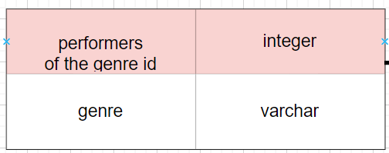

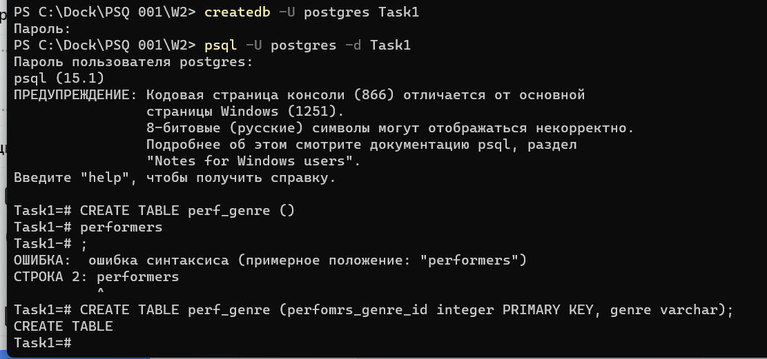

Затем продолжила в Dbeaver.

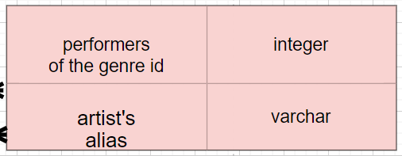

create table if not exists perf_alias

(

perfomrs_genre_id varchar,

artist_alias varchar,

primary key (perfomrs_genre_id, artist_alias)

)

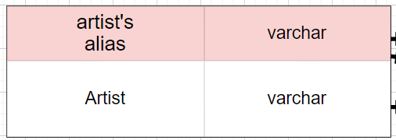

**create** **table** alias_artists(

artist_alias **varchar** **primary** **key**,

artist **varchar** **not** **null**

)

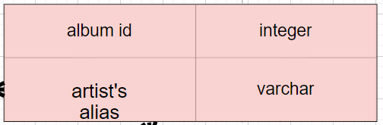

create table if not exists album_id_alias

(

album_id integer,

artist_alias varchar,

primary key (album_id, artist_alias)

)

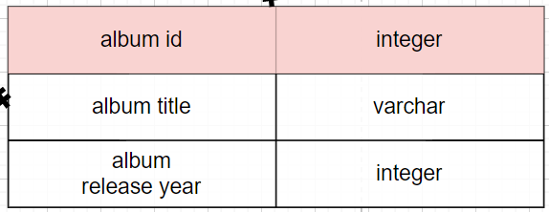

create table album

(

album_id integer primary key,

album_title varchar,

albuum_release_year integer

)

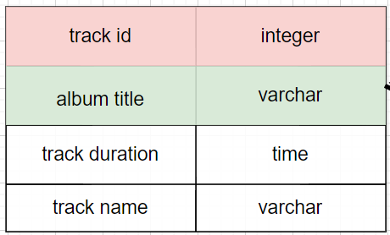

**create** **table** track

(

track_id **integer** **primary** **key** **references** album(album_id),

album_title **varchar**,

track_duration **time**,

track_name **varchar**

)

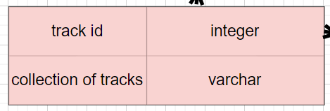

**create** **table** track_collection

(

track_id **integer**,

collection_of_tracks **varchar**,

**primary** **key** (track_id, collection_of_tracks)

)

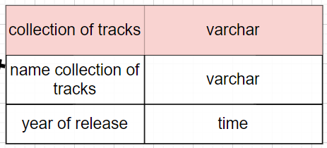

**create** **table** collection

(

collection_of_tracks **varchar** **primary** **key**,

name_collection **varchar**,

year_of_release **time**

)