Instruction for posting products to Database:

1. Run server. In main folder in console -> npm run server OR nodemon server.js



You should get such info in console

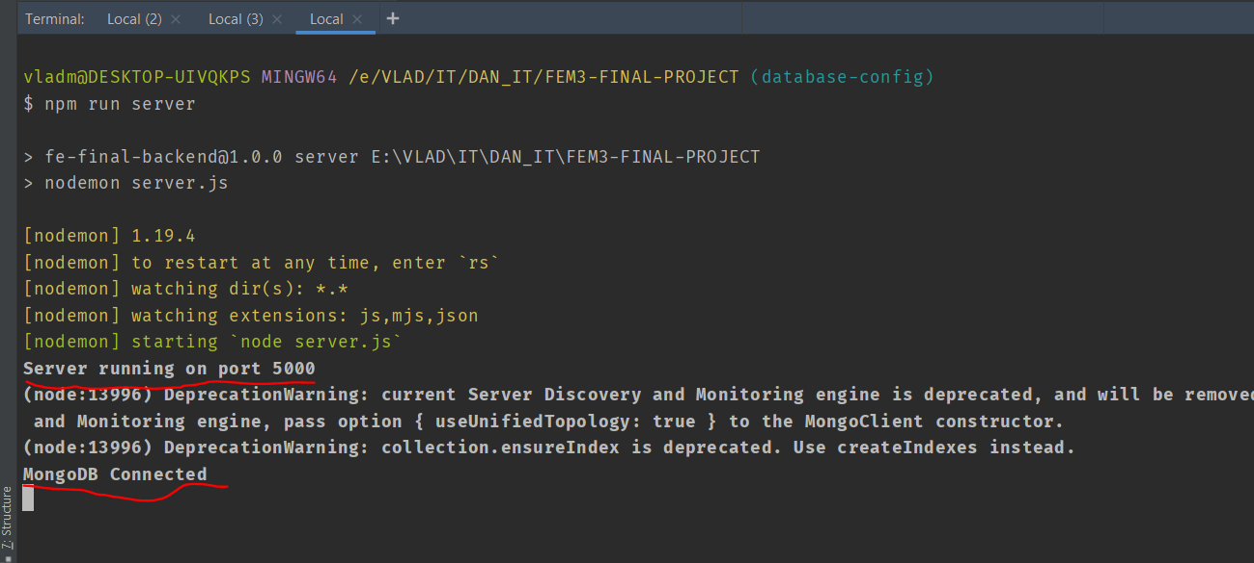

1. Go to Postman and create POST request:

**URL:**



**HEADERS:**

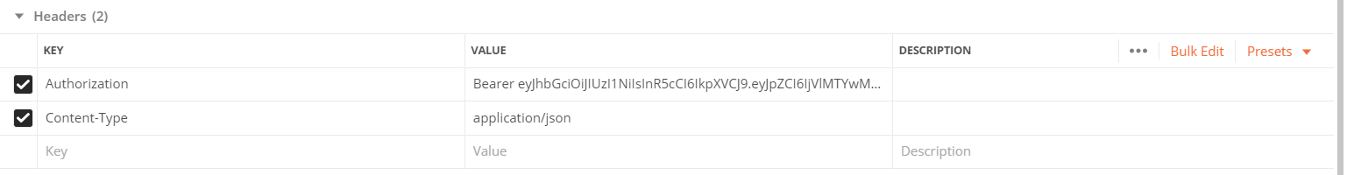

**BODY:**

JSON from Excel

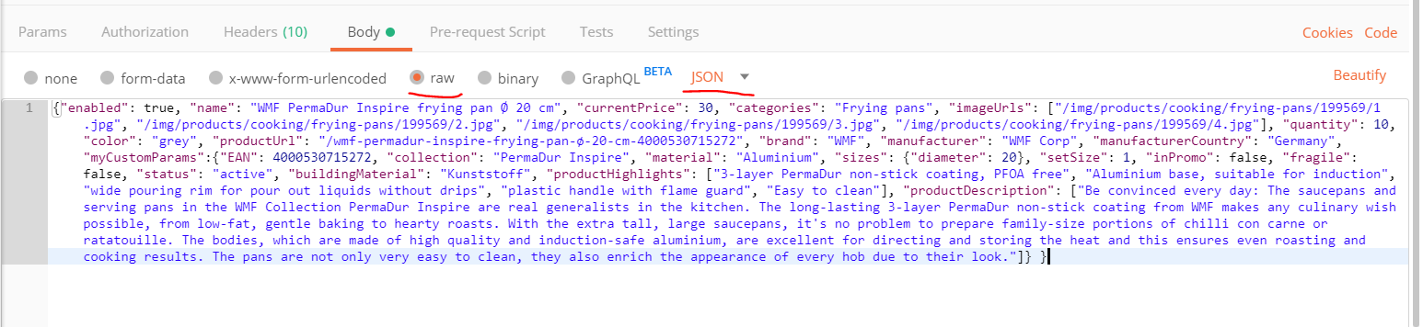

Press “SEND”. If everything goes well – you get as answer Object with product info:

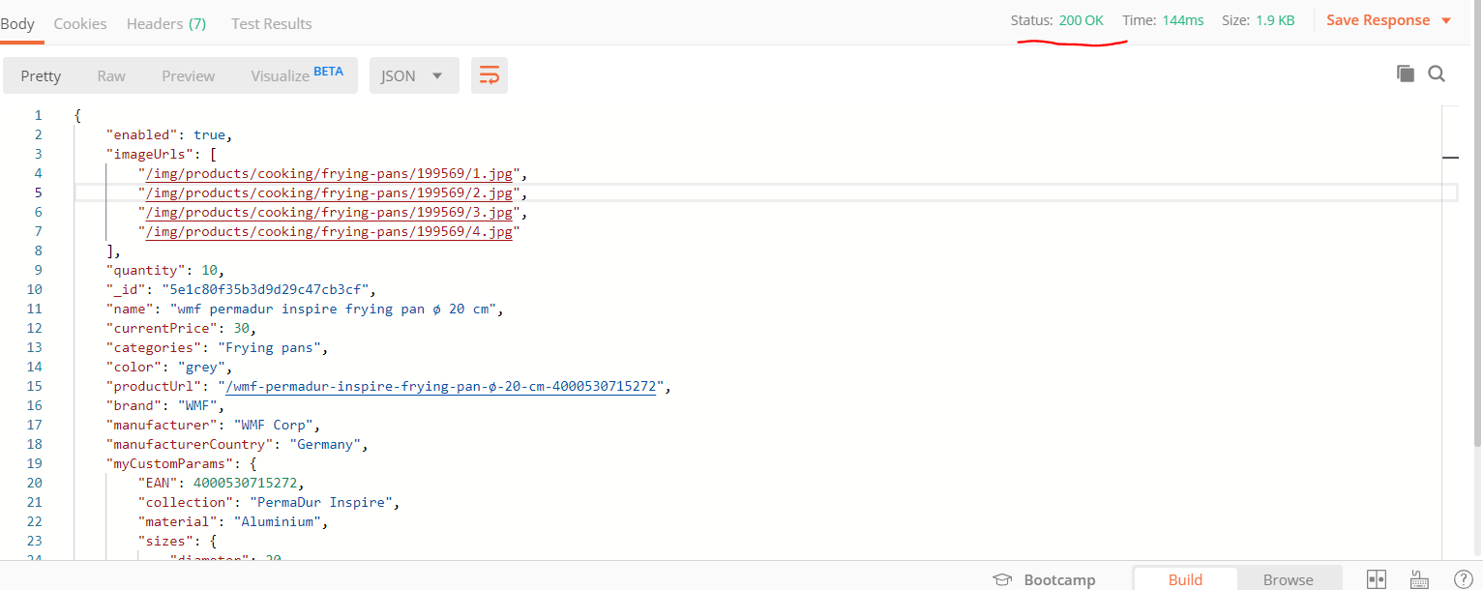

If you got as answer “Unauthorized” – your token is not valid.

If you got as answer -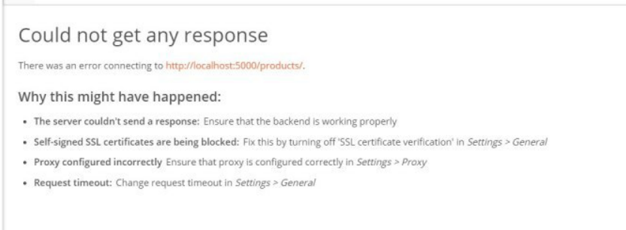

You forgot to start server (see p.1)

1. Pictures:

* We save biggest pictures from site.

From here:

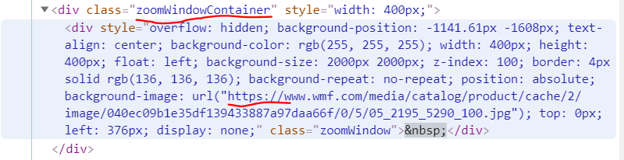

Or from here:

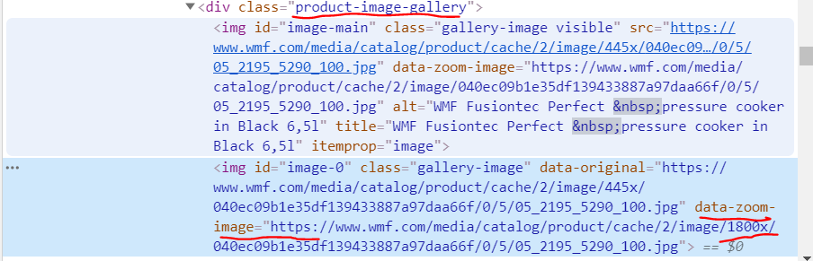

1. For each product we create separate folder. Folder name – EAN. Name of files (pictures inside) – 1, 2, 3 …. (not more than 9)