# Task

Create VIM-like text editor using C++.

Basic requirements:

1. The program must be created using C++ and STL and/or BOOST on any chosen operation system.

2. Program must be created using MVC pattern.

3. Program must have UML diagram.

4. Program must have TUI – Text User Interface. It is allowed to use any open-source libs. If this libs are coded on C, it is necessary to create an interpreter class using Adapter pattern. TUI requirements:

A. TUI must be VIM-like.

B. TUI must maintain cursor and status bar.

C. Status bar must demonstrate:

i. Current operation mode.

ii. File name.

iii. String number / strings at all.

5. Program must maintain one-byte text encoding.

6. To process text own string class must be used as static or dynamic library. It is forbidden to modify source code. If it is necessary, the student must implement a new class based on the original class using Decorator pattern.

7. Program must have the following operating modes:

A. Navigation and editing mode – the main operating mode.

B. Command input mode.

C. Text input mode.

D. Search mode.

# Results

To implement the program I used ncurses. I decided to code it for Windows operation system.

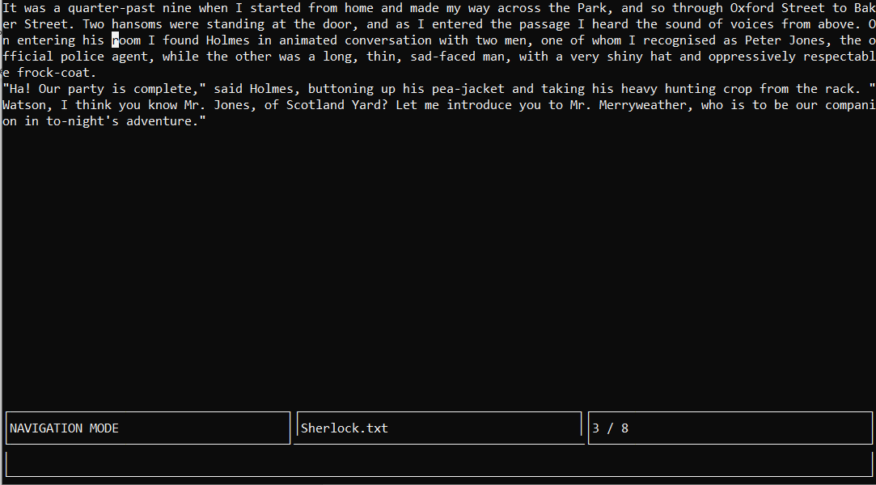The visual window of my program contains five ncurses windows: file window, mode window, filename window, string number window, command window. Look for an example in Picture 1.

Picture 1 – Text editor view.

I created five classes: Observer, Observable, MyEditorModel, MyEditorController, MyEditorView. First to classes are auxiliary and used to communicate with MyEditorView class. Observer is a virtual class and MyEditorView class inherits Observer class. MyEditorModel and MyEditorController classes inherit Observable class. Observable class contains a pointer to an Observer class instance. So MyEditorModel and MyEditorController classes can call MyEditorView class method Update().

MyEditorModel class purpose is to edit the data. It contains a file and a buffer which contain the text from the opened file. The buffer is an instance of my own class - MyString class. MyEditorModel edits the buffer, opens, edits and closes files.

MyEditorController class purpose is to communicate with the user. It contains a pointer to a ncurses command window to scan user’s requests. This class operate switching between modes. It can cause refreshing of all windows.

MyEditorView class purpose is to output actual information on the screen. Other classes call notification for MyEditorView class’ methods to update the information on the screen.

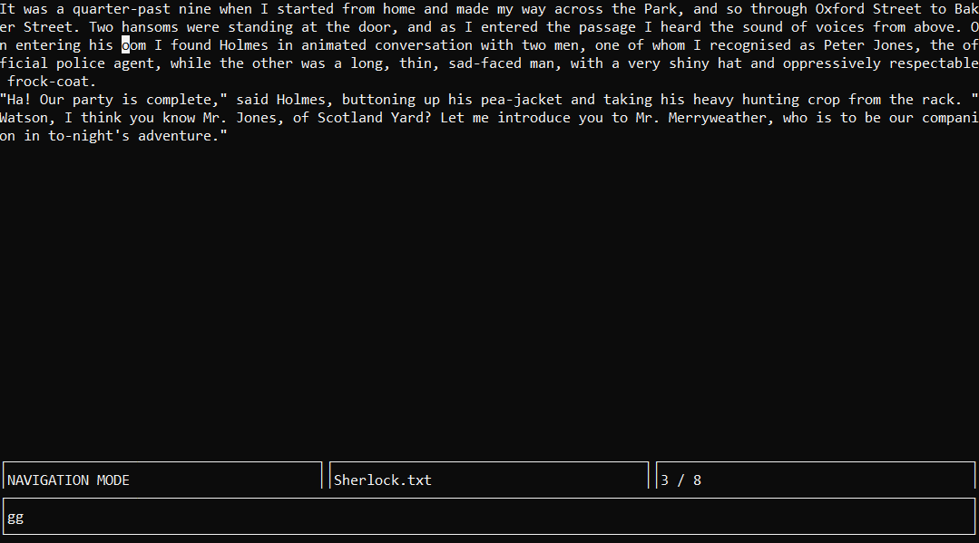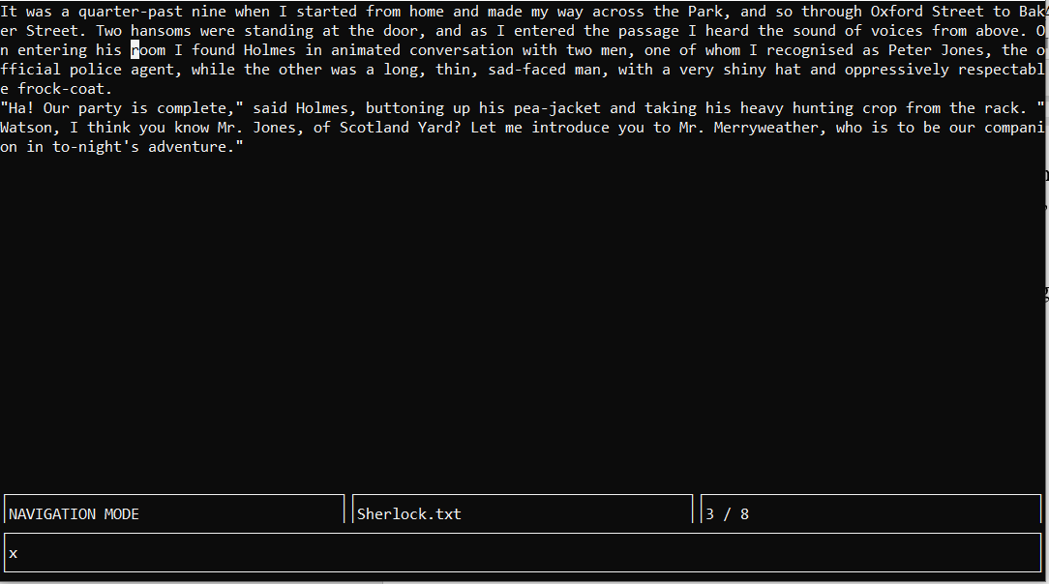There are demonstrations of my program operating on Pictures 2 – 6.

Picture 2 – Using of delete command (deleting letter ‘r’).

Picture 3 – Result of delete command and using jump command

(jumping to the start).

# 

Picture 3 – Result of jump command and using search command.

# 

Picture 4 – Result of search command and using of insert before cursor command (inserting the “FLY “ string).

# Summary

Picture 5 – Result of insert command.

I created VIM-like text editor on Windows using C++. I used my own MyString class to edit the text. I learned MVC pattern and put this knowledge into practice. I created convenient text user interface and status bar. The program can work in four different modes with unique commands.