BIO782P Statistics for Bioinformaticians: Assessment 1

Dataset 1

There was a significant interaction between infection severity and probiotics on mean intestinal AMP levels (ANCOVA, F = 22.036, *p* < 0.001). We found AMP to be positively correlated with infection severity (adjusted R-squared = 0.702; figure 1), and that patients in the probiotic treatment group had higher AMP (intercept = 70.60) than patients in the placebo group (intercept = 65.90). The difference in AMP levels between the two groups increased with infection severity (for probiotic group, slope = 1.49; for placebo group, slope = 0.33).

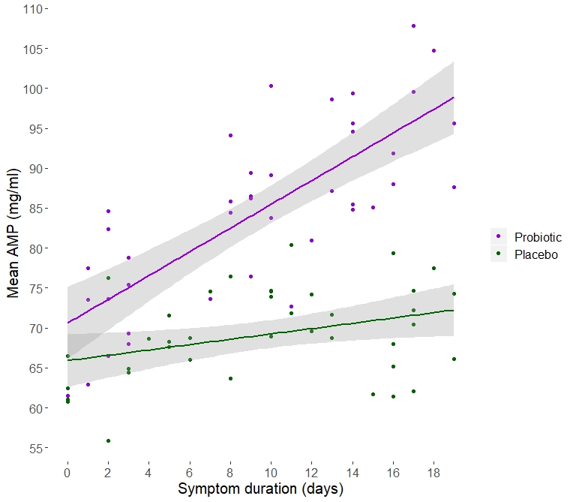

Figure 1. Intestinal microbiota immune function, as measured by mean intestinal AMP level five days post-treatment, is positively correlated with infection severity as measured by pre-treatment symptom duration in days. AMP was higher in patients who were given a multispecies probiotic treatment (purple) than those given a placebo (green). 95% confidence intervals shown in grey.

Dataset 2

There was a significant interaction between probiotics and dietary fibre on the mean Shannon diversity score of stool samples taken after ten days of treatment (two-way ANOVA, F = 15.287, *p* < 0.001). Effects and group means are shown in an interaction plot (figure 2). 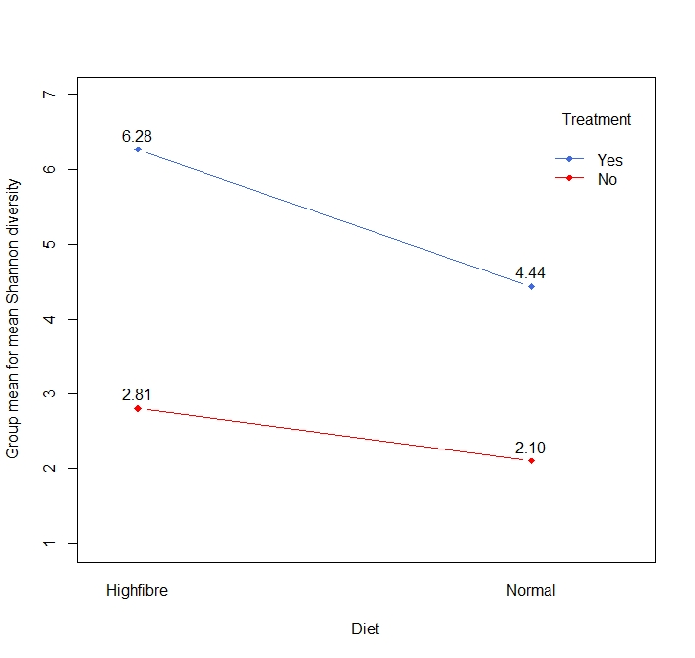

Figure 2. Interaction plot showing the effect of probiotics and high fibre diet on mean Shannon diversity scores. Participants were assigned to four different treatment groups and their mean Shannon diversity scores were measured to indicate microbial population diversity. The high fibre diet groups are plotted on the left, while the normal diet groups are plotted on the right. The groups administered with probiotics are shown in blue, and those without probiotics are shown in red.

The group with the highest mean Shannon diversity was the probiotic, high fibre diet group, followed by the probiotic, normal diet group, followed by the no-probiotic, high fibre diet group. The lowest mean Shannon diversity was seen in the no-probiotic, normal diet group. A Tukey test showed that pairwise differences between all group means were significant (figure 3).

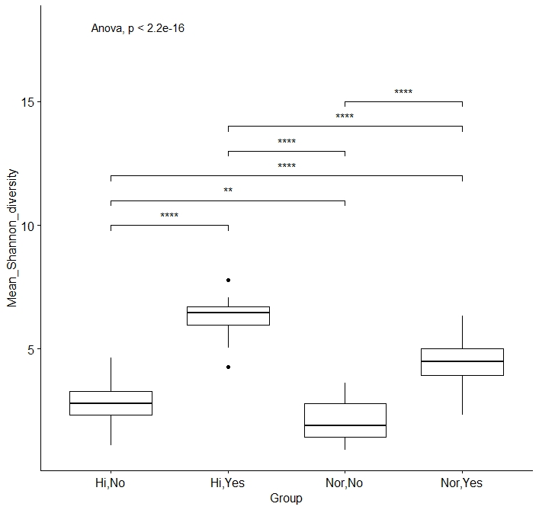

Figure 3. Boxplots showing the positive effect of probiotics and high fibre diet on mean Shannon diversity score. Group differences were significant for every pairwise group comparison. “Hi” = high fibre diet, “Nor” = normal diet; “Yes” = probiotic, “No” = no probiotic. All *p*-values were <0.001 except for the comparison between groups “Hi,No” and “Nor,No”, for which *p* = 0.005).

One result was excluded from the analysis due to recording error.

References:

Kassambara, A. 2019, *ggpubr: ‘ggplot2’ Based Publication Ready* Plots. R package version 0.2.4. CRAN, viewed 21 November 2019, <https://CRAN.R-project.org/package=ggpubr>

Wickham, et al. 2019, *dplyr: A Grammar of Data Manipulation*. R package version 0.8.3. CRAN, viewed 21 November 2019, <https://CRAN.R-project.org/package=dplyr>

Wickham, H. 2016, *ggplot2: Elegant Graphics for Data Analysis,* 2nd edn, Springer-Verlag, New York.