Software Requirement Specification for ACE CTS
ACE CONFIDENTIAL
Field | Value
Submitted To | [Bank Name]
Submitted By | [Vendor Name / ACE Technology]
Reference No | ACECTS-SRS-001
Version | 1.0
Date | 08-06-2026

Review Summary
This document defines the formal requirements for ACE CTS. Screenshots are indicative and subject to change.

Revision History
Release Date DD-MM-YY | Revision Number x.y | Changes Made | Author | Reviewed By | Approved By
08-06-26 | 1.0 | First Draft for ACE CTS | [Author Name] | [Reviewer Name / Role] | [Approver Name / Role]

Table of Contents

1. Introduction
The purpose of this Software Requirement Specification is to define ACE CTS functional, interface, workflow, reporting, administration, audit, security, and nonfunctional requirements for cheque truncation processing.

2. Overall Description
ACE CTS shall route instruments through outward and inward workflows based on validation result, maker-checker decision, Clearing House / CBM response, return status, and posting completion.

2.1.1 ACE CTS Outward Process Flow
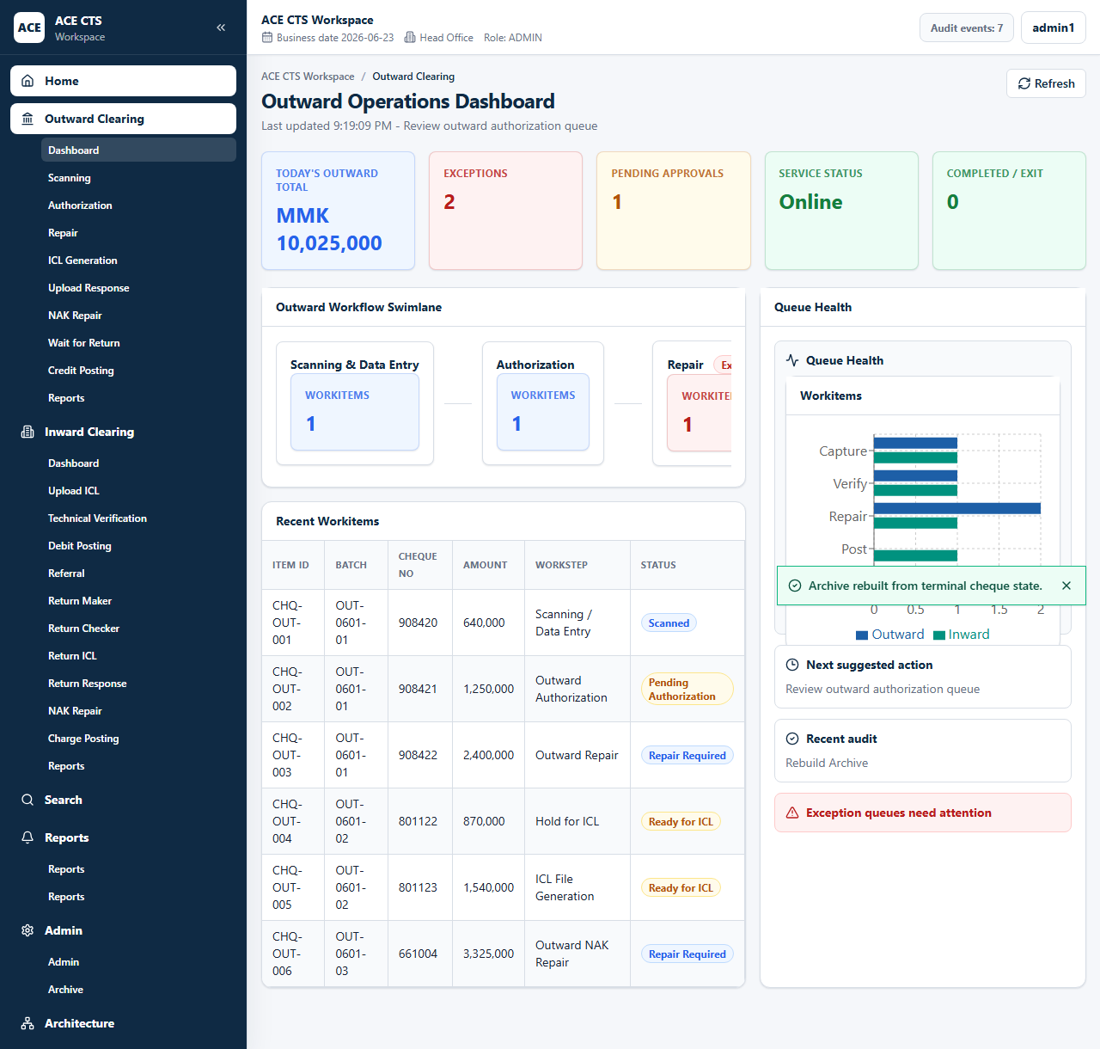
Figure 12: ACE CTS Outward Process Flow (Indicative and subject to change)

2.1.2 ACE CTS Inward Process Flow
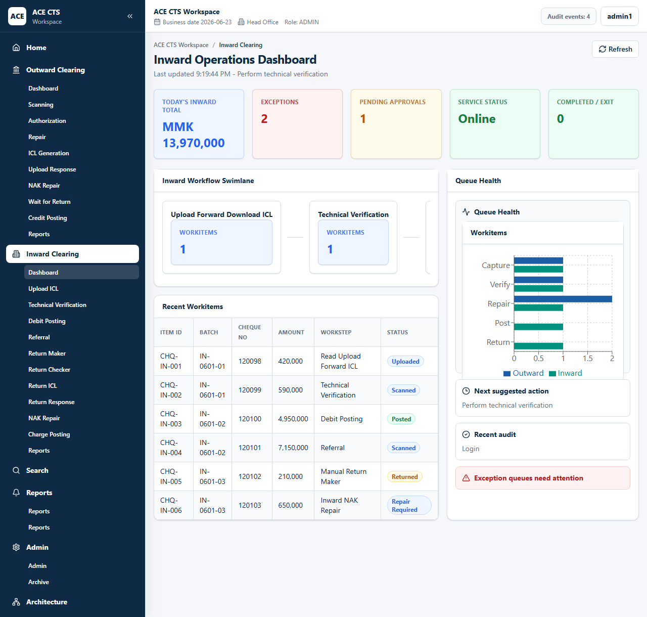
Figure 32: ACE CTS Inward Process Flow (Indicative and subject to change)

User Classes and Characteristics
User Class | Characteristics
MAKER | Outward scanning, outward repair, technical verification, manual return maker, outward NAK repair, inward NAK repair, upload ICL
CHECKER | Outward authorization, referral, manual return checker
ADMIN | All functional pages, admin settings, audit trail, archive, reset, role and queue management
SERVICE | Background service identity for scheduled audit events and interface processing

3. Solution Features

3.1 Login Page

Description
ACE CTS shall provide a secure login page for authenticated access to authorized functions.

Screenshot / Figure
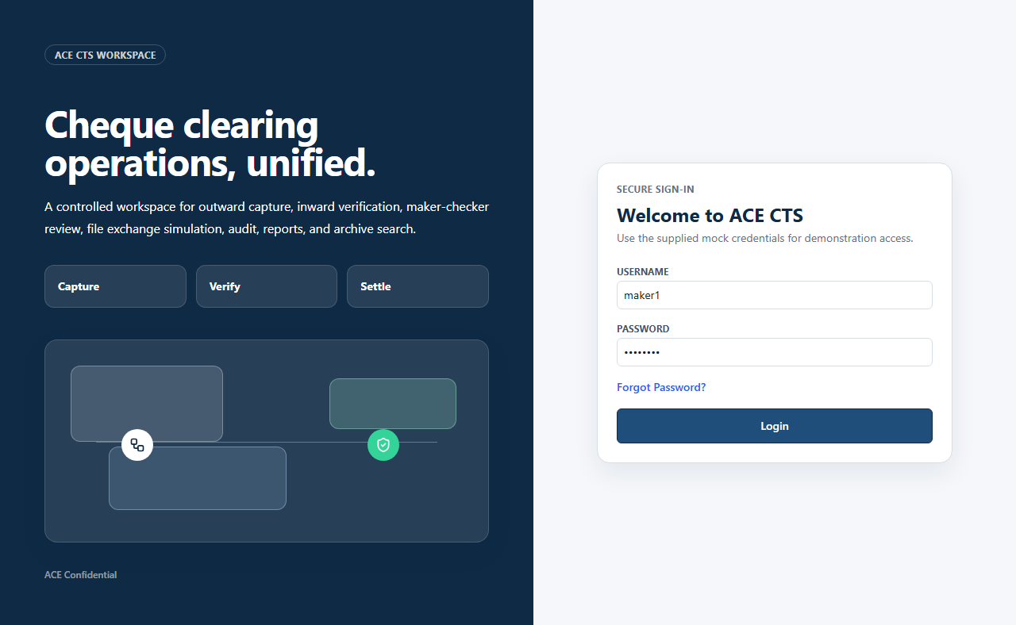
Figure 1: ACE CTS Login Page (Indicative and subject to change)

Priority
High

Integration Touch Point
ACE CTS shall validate user credentials against the Bank-approved identity source. Interface specifications shall be finalized with the Bank.

Functional Requirement
ACE CTS shall provide the Login Page function with the workflow, validation, audit, and role controls described herein.

Actors
All active users

Field Details / Control Behaviour
S. No. | Field Name | Field Type | Control Behaviour | Mandatory | Remarks
1 | Username | Text | Editable | Yes | User login identifier
2 | Password | Password | Editable / masked | Yes | User password
3 | Forgot Password | Action link | Selectable | No | Initiates password assistance process

Options / Buttons
S. No. | Option / Button | Behaviour | Validation / Confirmation | Target Work-step
1 | Login | Authenticates the user and opens the authorized landing page | Invalid credentials shall show an alert | Role-based dashboard

Validation Rules
Username and password shall be required. Invalid credentials shall not create a session.

Confirmation Messages
ACE CTS shall display confirmation messages before committing irreversible or workflow-moving actions where indicated.

Target Work-step(s)
Routing Criteria | Target Work-step
Valid login | Authorized dashboard
Invalid login | Login page with alert

Audit Trail Requirement
Successful and unsuccessful access attempts shall be auditable subject to Bank security policy.

3.2 Logout

Description
ACE CTS shall provide user menu options for password change and logout.

Screenshot / Figure
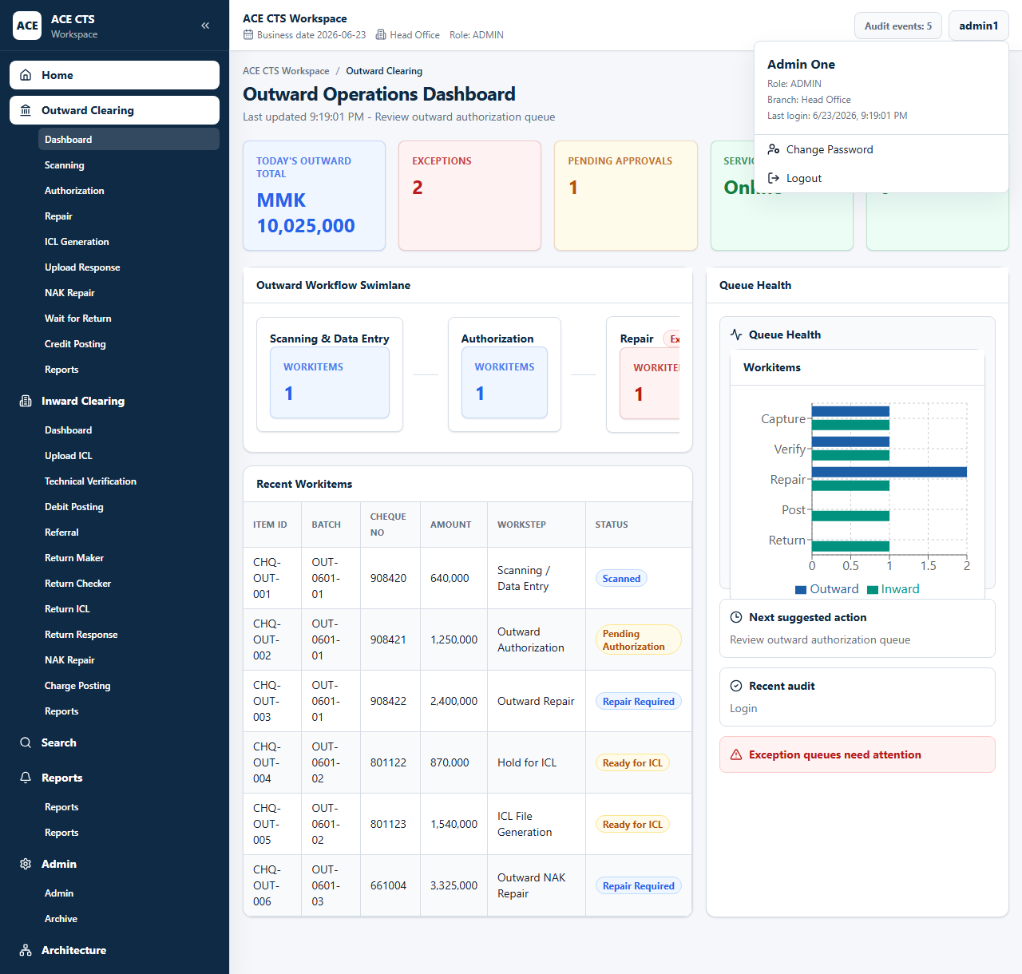
Figure 3: ACE CTS User Menu with Logout and Change Password Options (Indicative and subject to change)

Priority
High

Integration Touch Point
ACE CTS shall support integration with the Bank session management policy.

Functional Requirement
ACE CTS shall provide the Logout function with the workflow, validation, audit, and role controls described herein.

Actors
Authenticated users

Field Details / Control Behaviour
S. No. | Field Name | Field Type | Control Behaviour | Mandatory | Remarks
1 | User Name | Display | Read-only | No | Shows logged-in user
2 | Role | Display | Read-only | No | Shows assigned role
3 | Branch | Display | Read-only | No | Shows assigned branch

Options / Buttons
S. No. | Option / Button | Behaviour | Validation / Confirmation | Target Work-step
1 | Change Password | Opens password change page | None | Change Password
2 | Logout | Clears session and returns user to login | Session shall be ended | Login Page

Validation Rules
Logout shall terminate the active session and prevent protected page access without re-authentication.

Confirmation Messages
ACE CTS shall display confirmation messages before committing irreversible or workflow-moving actions where indicated.

Target Work-step(s)
Routing Criteria | Target Work-step
Logout selected | Login Page

Audit Trail Requirement
Logout shall be captured in audit trail.

3.3 Change Password

Description
ACE CTS shall allow a user to change his or her password after successful login.

Screenshot / Figure
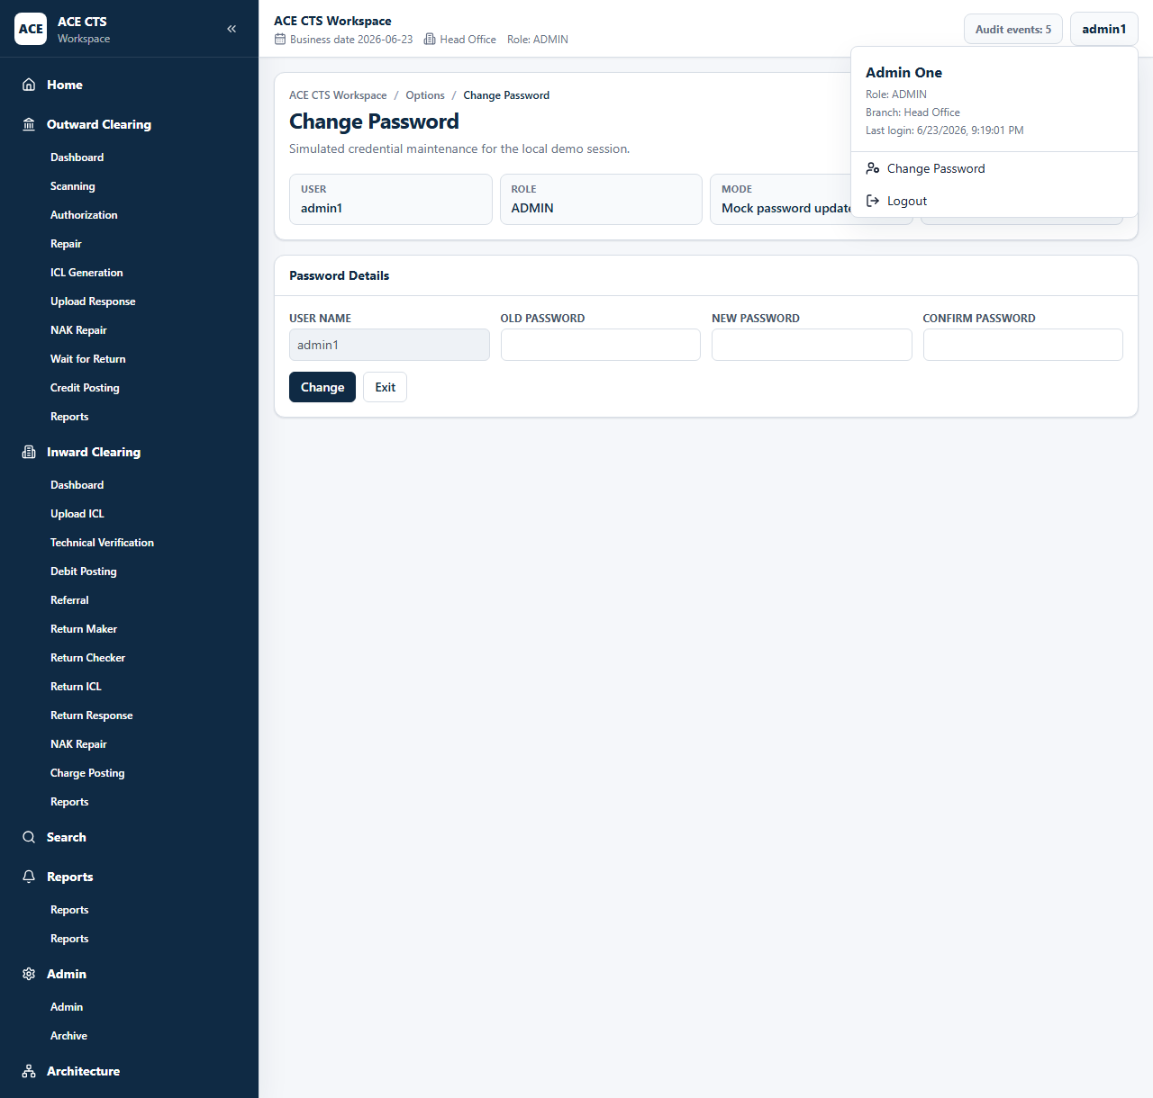
Figure 4: ACE CTS Change Password Page (Indicative and subject to change)

Priority
High

Integration Touch Point
ACE CTS shall apply the Bank password policy and identity-management interface when finalized.

Functional Requirement
ACE CTS shall provide the Change Password function with the workflow, validation, audit, and role controls described herein.

Actors
Authenticated users

Field Details / Control Behaviour
S. No. | Field Name | Field Type | Control Behaviour | Mandatory | Remarks
1 | User Name | Text | Disabled | No | Current user
2 | Old Password | Password | Editable | Yes | Existing password
3 | New Password | Password | Editable | Yes | New password
4 | Confirm Password | Password | Editable | Yes | Must match new password

Options / Buttons
S. No. | Option / Button | Behaviour | Validation / Confirmation | Target Work-step
1 | Change | Submits password change | New and confirm password must match | Dashboard
2 | Exit | Leaves page without change | None | Dashboard

Validation Rules
Old password shall be verified. New password and confirmation shall match before update.

Confirmation Messages
ACE CTS shall display confirmation messages before committing irreversible or workflow-moving actions where indicated.

Target Work-step(s)
Routing Criteria | Target Work-step
Password changed | Dashboard
Validation failed | Change Password Page

Audit Trail Requirement
Password change shall create an audit event without storing password values.

3.4.1 Outward Dashboard & Menu

Description
ACE CTS shall display outward workitem counts, workflow tiles, process navigation, and current work queues.

Screenshot / Figure
Figure 12: ACE CTS Outward Process Flow (Indicative and subject to change)

Priority
High

Integration Touch Point
ACE CTS shall present operational queue data from the application database.

Functional Requirement
ACE CTS shall provide the Outward Dashboard & Menu function with the workflow, validation, audit, and role controls described herein.

Actors
Maker, Checker, Admin

Field Details / Control Behaviour
S. No. | Field Name | Field Type | Control Behaviour | Mandatory | Remarks
1 | Workitem Count | Display tile | Read-only | No | Shows queue count by work-step
2 | Recent Workitems | Grid | Read-only | No | Shows outward items
3 | Workitems Chart | Chart | Read-only | No | Shows queue trend by category

Options / Buttons
S. No. | Option / Button | Behaviour | Validation / Confirmation | Target Work-step
1 | Workflow Tile | Opens selected outward work-step | Role access applies | Selected queue

Validation Rules
Dashboard counts shall refresh when workitems move between workflow stages.

Confirmation Messages
ACE CTS shall display confirmation messages before committing irreversible or workflow-moving actions where indicated.

Target Work-step(s)
Routing Criteria | Target Work-step
Tile selected | Selected outward work-step

Audit Trail Requirement
Dashboard access may be logged according to Bank audit policy.

3.4.2 Scanning and Data Entry

Description
ACE CTS shall capture outward cheque images, create batches, fetch credit account details, validate MICR and amount data, and submit valid batches to authorization.

Screenshot / Figure
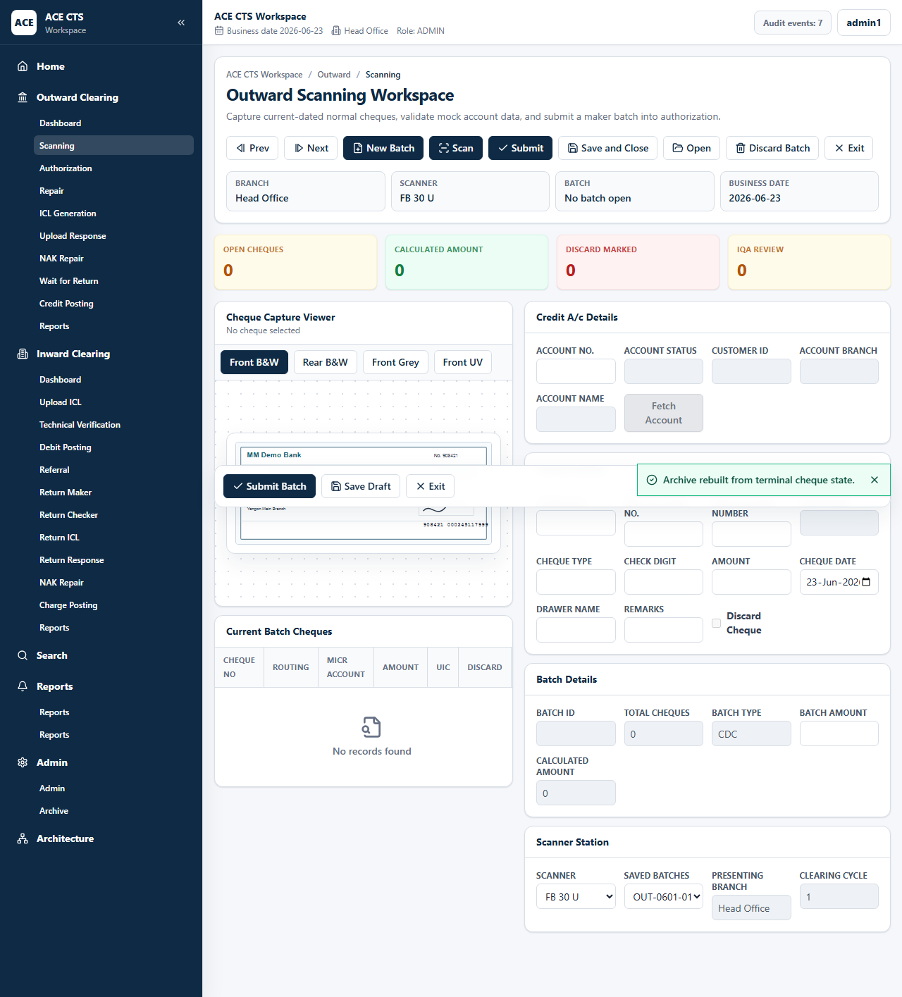
Figure 13: ACE CTS Scanning and Data Entry Screen without Data (Indicative and subject to change)
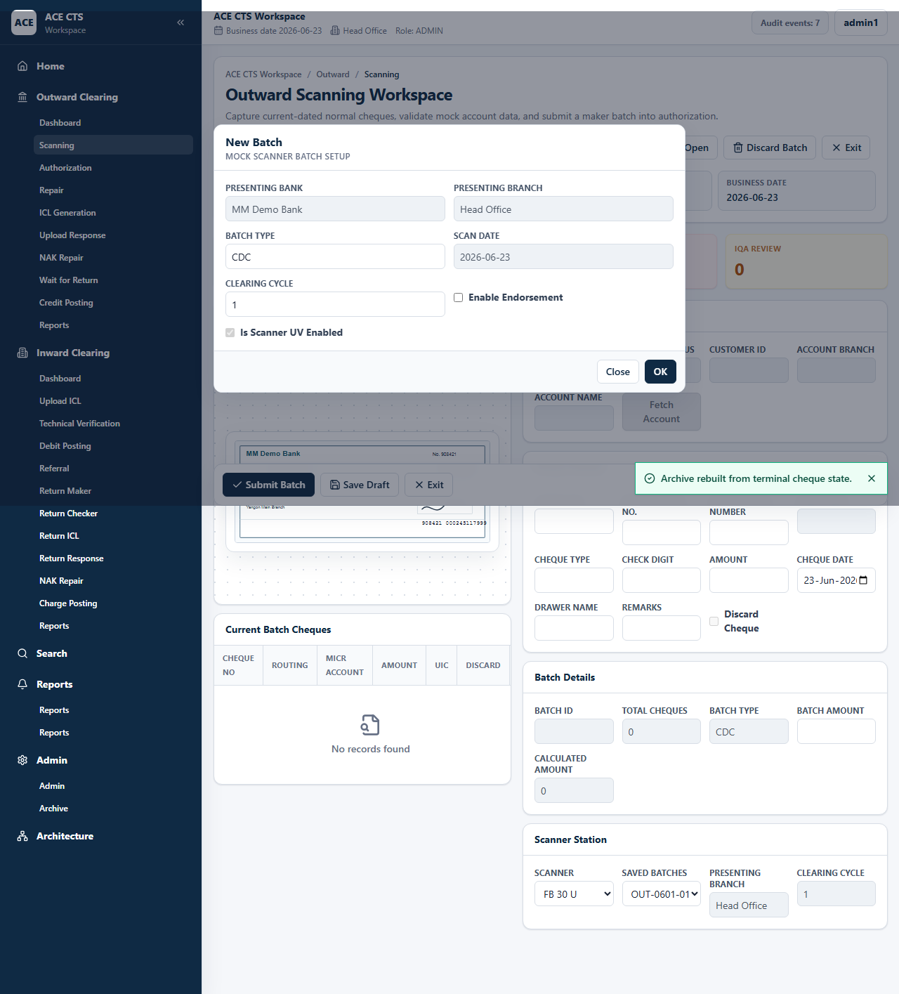
Figure 14: ACE CTS New Batch Window (Indicative and subject to change)
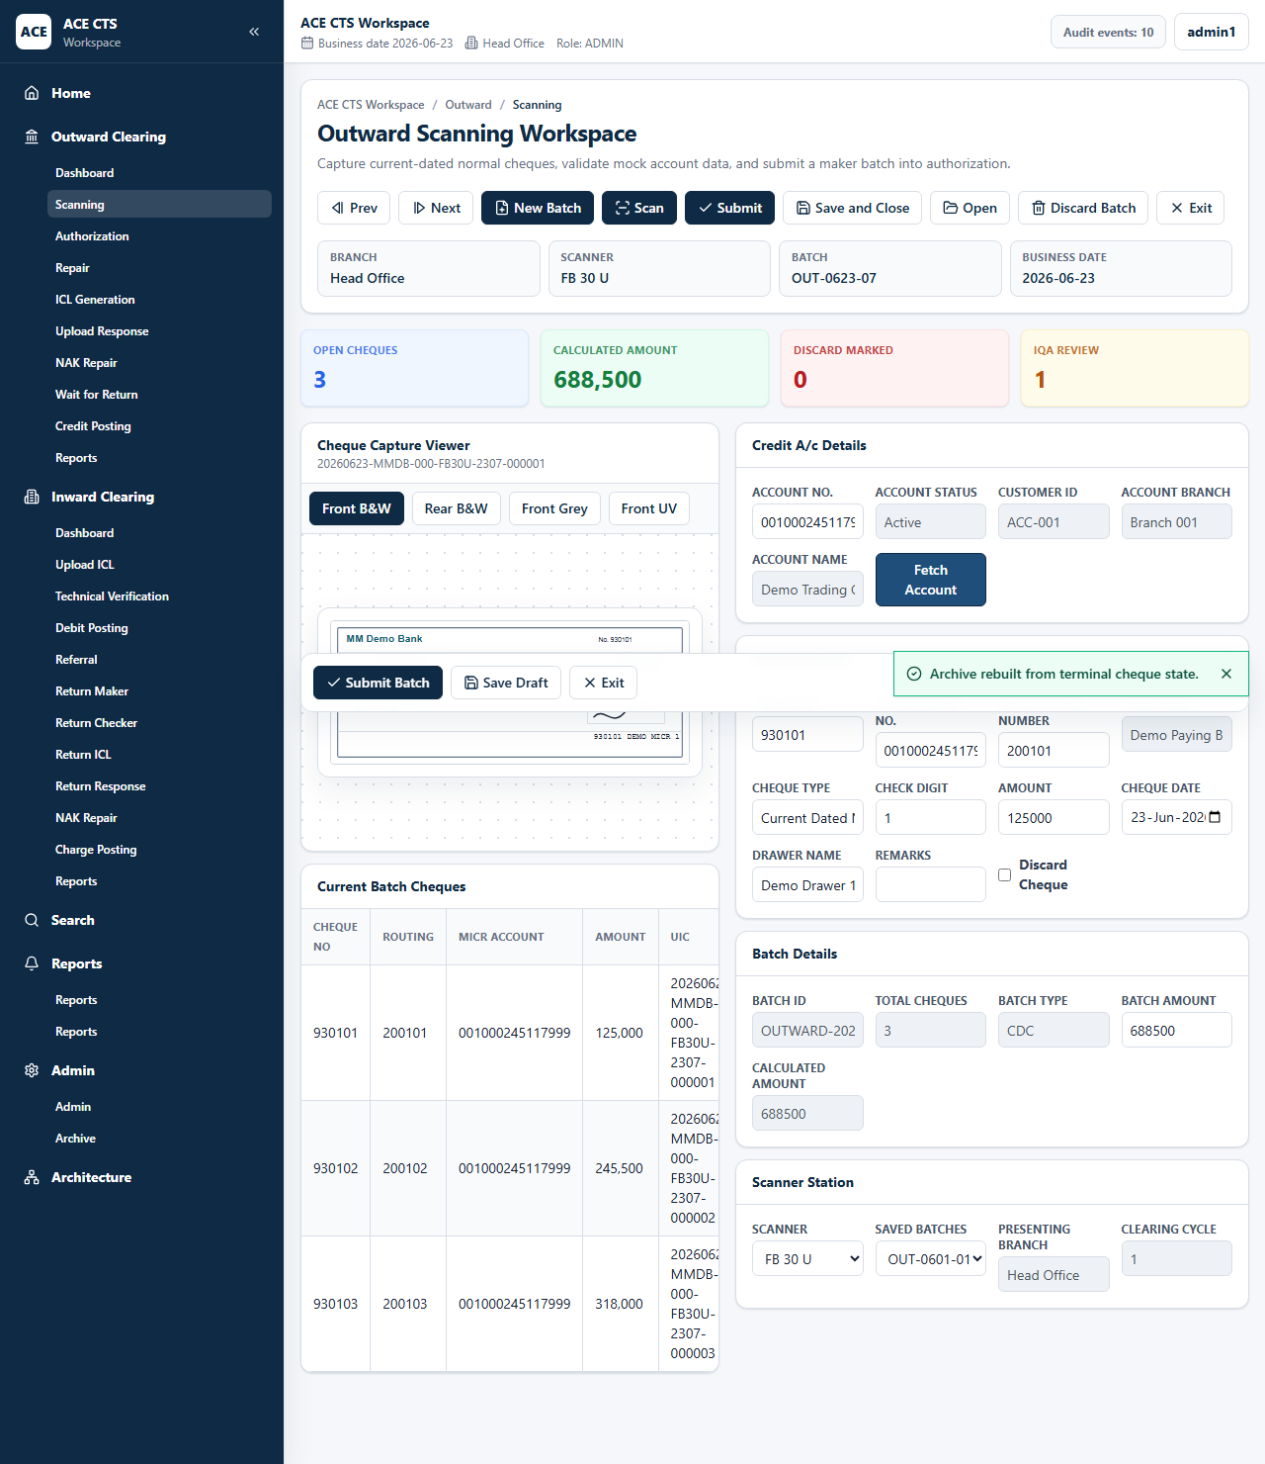
Figure 15: ACE CTS Scanning and Data Entry Screen with Cheques (Indicative and subject to change)
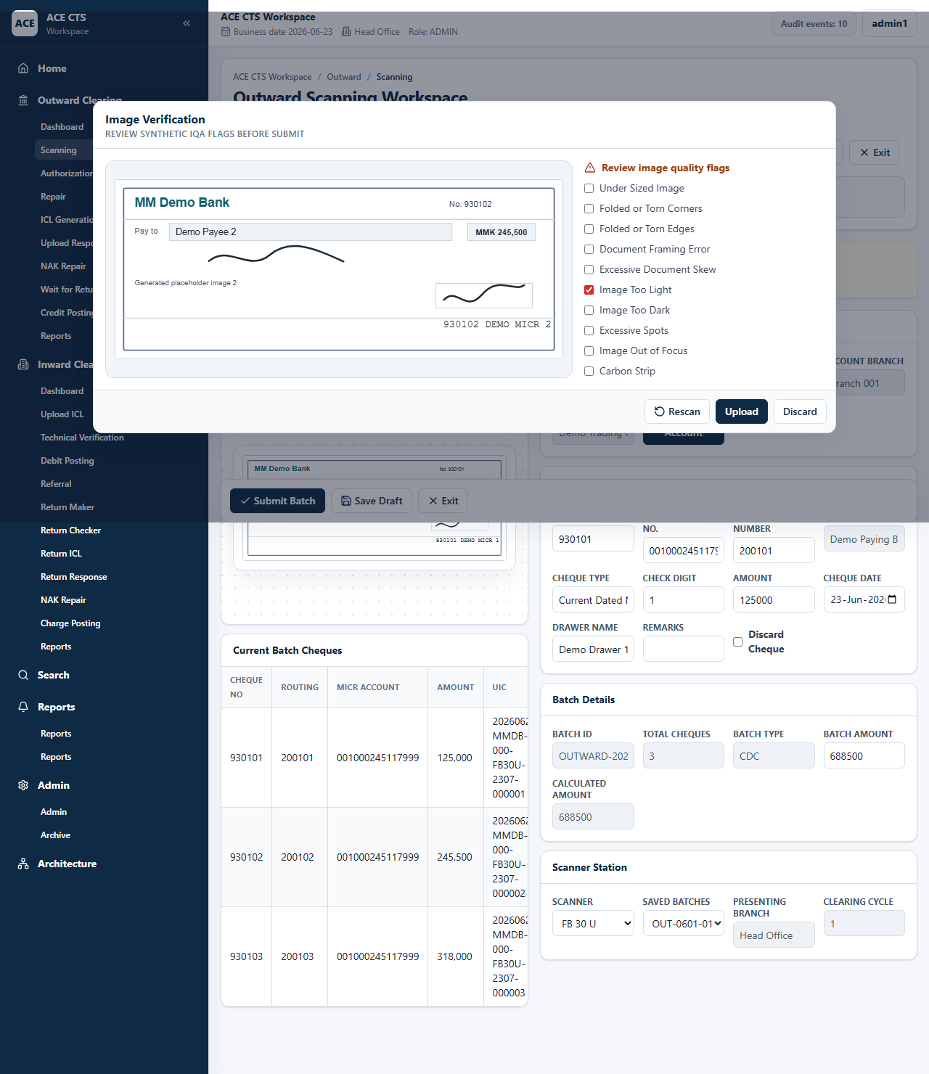
Figure 16: ACE CTS Image Quality Analysis Window (Indicative and subject to change)
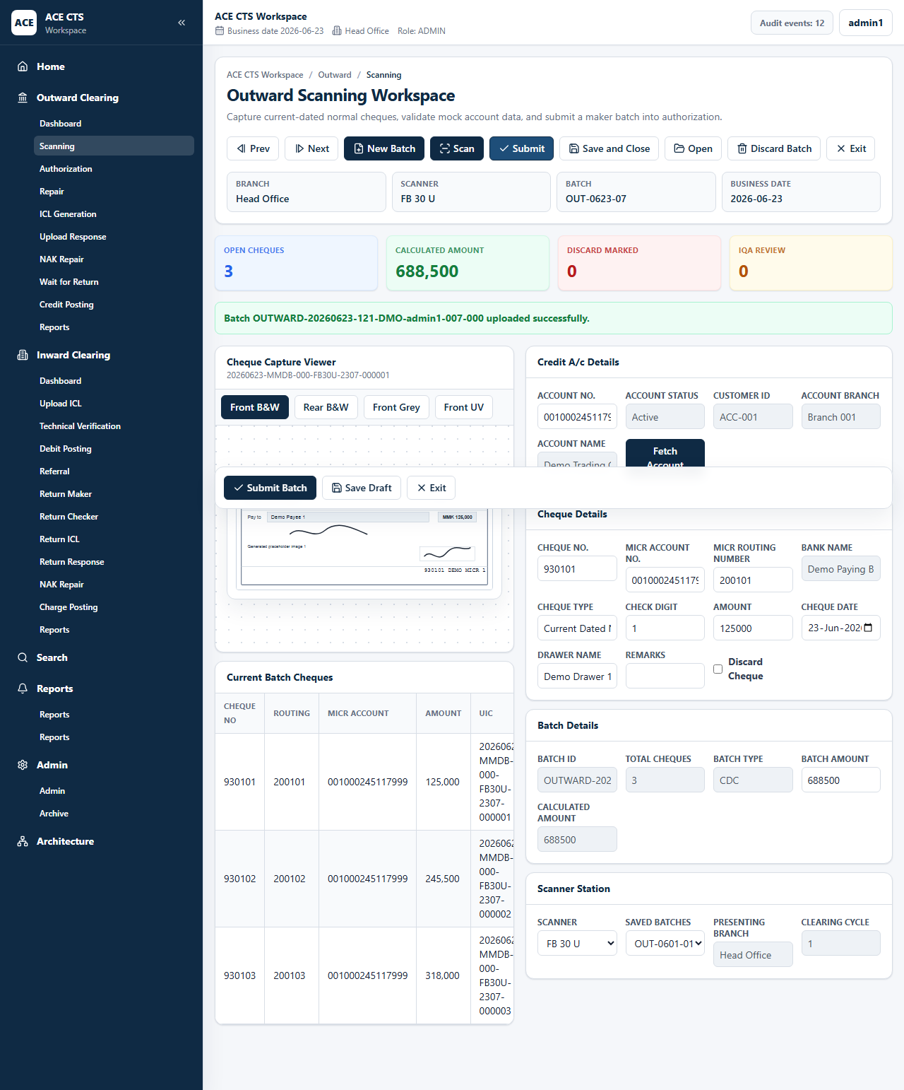
Figure 17: ACE CTS Batch Upload Success Message (Indicative and subject to change)

Priority
High

Integration Touch Point
ACE CTS shall integrate with cheque scanners and CBS. Scanner, CBS, and endorsement specifications shall be finalized with the Bank.

Functional Requirement
ACE CTS shall provide the Scanning and Data Entry function with the workflow, validation, audit, and role controls described herein.

Actors
Maker, Admin

Field Details / Control Behaviour
S. No. | Field Name | Field Type | Control Behaviour | Mandatory | Remarks
1 | Account No. | Text | Editable | Yes | Credit account number
2 | Account Status / Customer ID / Branch / Name | Display | Disabled | No | Returned by CBS lookup
3 | Cheque No. | Text | Editable | Yes | MICR cheque number
4 | MICR Account No. | Text | Editable | Yes | MICR account number
5 | MICR Routing Number | Text | Editable | Yes | Routing number
6 | Amount | Amount | Editable | Yes | Cheque amount
7 | Cheque Date | Date | Editable | Yes | Issue date
8 | Drawer Name / Remarks | Text | Editable | Conditional | Drawer and exception notes
9 | Batch Amount | Amount | Editable | Yes | Must match calculated amount
10 | Scanner | List | Selectable | Yes | Scanner station selection

Options / Buttons
S. No. | Option / Button | Behaviour | Validation / Confirmation | Target Work-step
1 | New Batch | Creates a new outward batch | Batch details required | Scanning
2 | Scan | Captures cheque images | Batch must be open | Scanning
3 | Fetch Account | Retrieves credit account details | Account must exist and be valid | Scanning
4 | Submit | Validates and uploads batch | IQA, duplicate, stale, in-house, routing, and amount checks | Outward Authorization
5 | Save and Close | Stores draft batch | None | Scanning
6 | Discard Batch | Marks batch cheques discarded | Remarks required for discarded items | Discard

Validation Rules
ACE CTS shall validate duplicate cheques, stale cheques, in-house cheques, representment rules, routing number format, junk MICR characters, image quality flags, account fetch completion, and batch amount balancing.

Confirmation Messages
ACE CTS shall display confirmation messages before committing irreversible or workflow-moving actions where indicated.

Target Work-step(s)
Routing Criteria | Target Work-step
Valid batch submitted | Outward Authorization
Discard selected | Discard / archive
Validation failed | Scanning and Data Entry

Audit Trail Requirement
Batch creation, scan, account fetch, save, discard, IQA handling, and submit shall be audited.

3.4.3 Outward Authorization

Description
ACE CTS shall provide FIFO checker review of submitted outward batches with image viewer, account data, cheque details, and maker-checker controls.

Screenshot / Figure
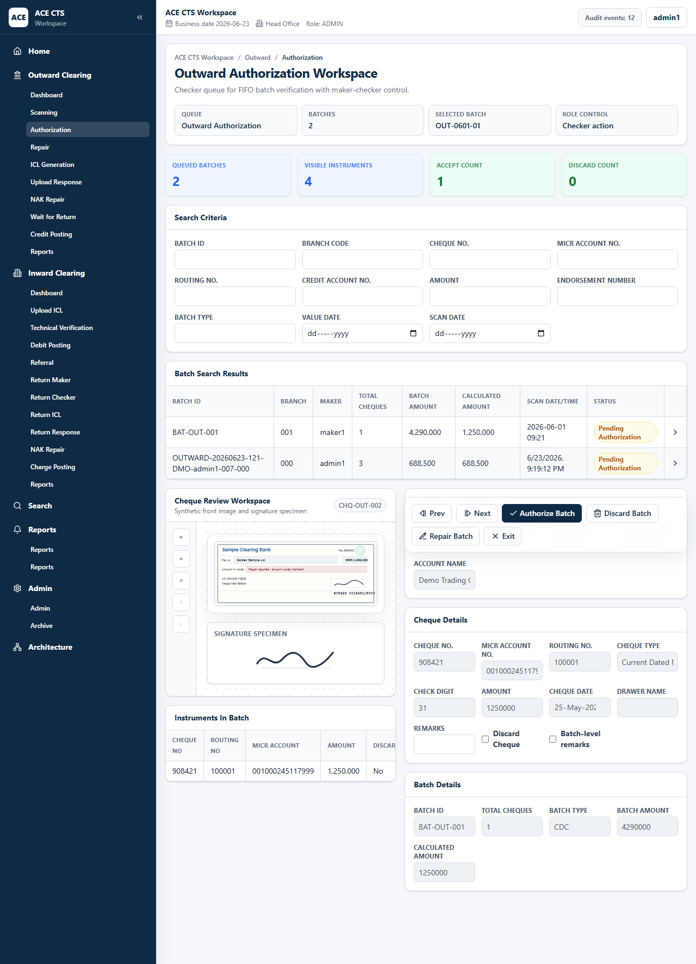
Figure 18: ACE CTS Outward Authorization Search (Indicative and subject to change)
Figure 19: ACE CTS Outward Authorization Detail (Indicative and subject to change)
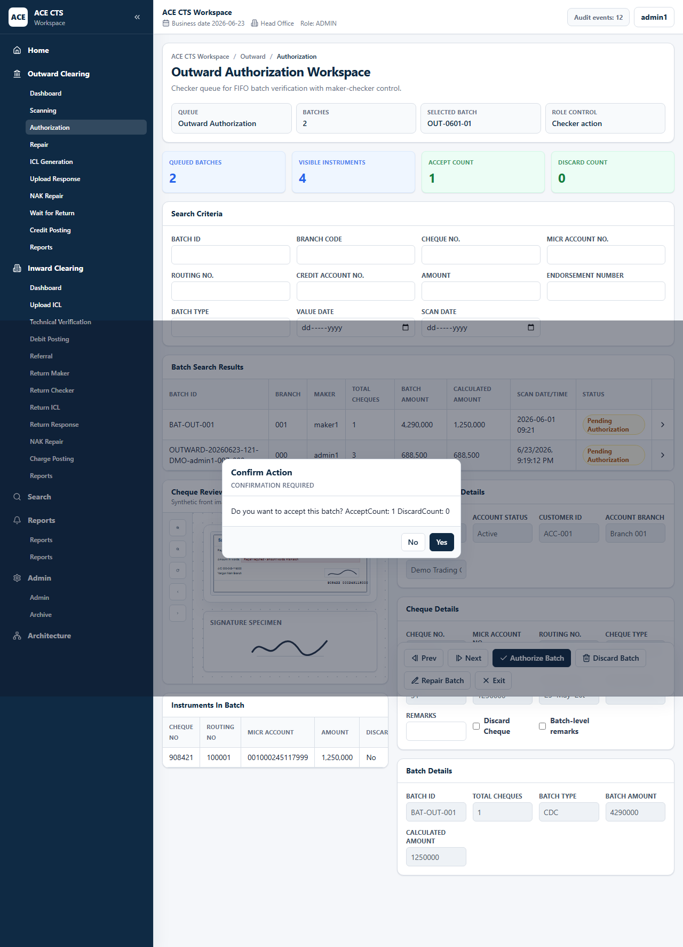
Figure 20: ACE CTS Outward Authorization Confirmation (Indicative and subject to change)

Priority
High

Integration Touch Point
ACE CTS shall maintain maker-checker controls through the user and queue access model.

Functional Requirement
ACE CTS shall provide the Outward Authorization function with the workflow, validation, audit, and role controls described herein.

Actors
Checker, Admin

Field Details / Control Behaviour
S. No. | Field Name | Field Type | Control Behaviour | Mandatory | Remarks
1 | Search Criteria | Text/date fields | Editable | No | Batch, branch, cheque, MICR, routing, account, amount, endorsement, type, value date, scan date
2 | Credit Account Details | Display | Disabled | No | Account values
3 | Cheque Details | Display/edit by permission | Disabled for authorization | No | Cheque data under review
4 | Batch Details | Display | Disabled | No | Batch balancing details

Options / Buttons
S. No. | Option / Button | Behaviour | Validation / Confirmation | Target Work-step
1 | Authorize Batch | Accepts batch | Confirmation required and maker-checker restriction applies | Hold for ICL File Generation
2 | Repair Batch | Sends batch to maker repair | Confirmation required | Outward Repair
3 | Discard Batch | Discards batch | Confirmation required | Discard
4 | Exit | Leaves page | Confirmation required | Dashboard

Validation Rules
The same maker shall not authorize his or her own batch unless Bank policy allows an administrator override.

Confirmation Messages
ACE CTS shall display confirmation messages before committing irreversible or workflow-moving actions where indicated.

Target Work-step(s)
Routing Criteria | Target Work-step
Authorized | Hold for ICL File Generation
Repair requested | Outward Repair
Discarded | Discard

Audit Trail Requirement
Authorization, repair return, and discard decisions shall be audited.

3.4.4 Outward Repair

Description
ACE CTS shall allow makers to correct checker-returned outward batches and send them back for authorization.

Screenshot / Figure
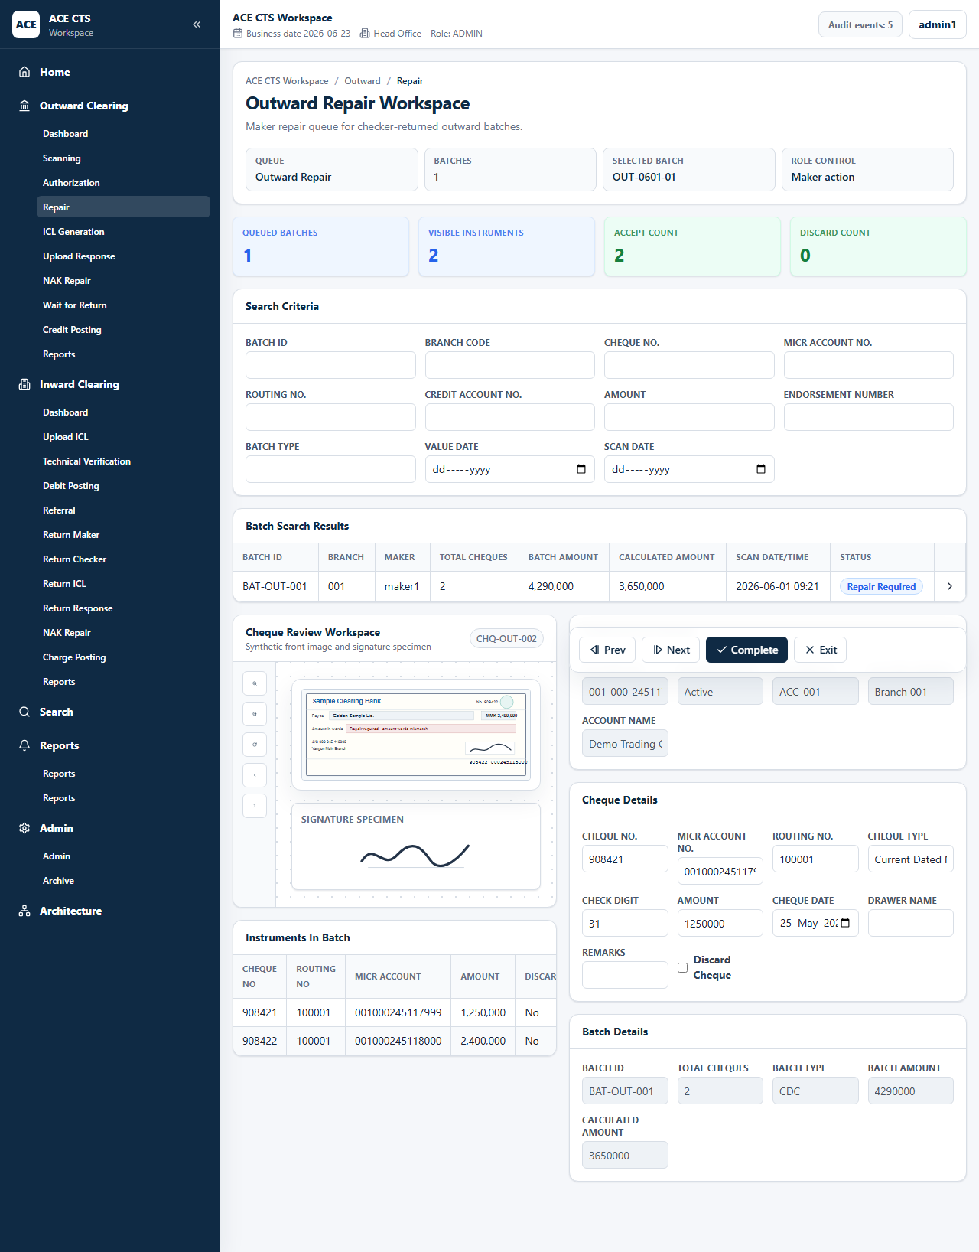
Figure 21: ACE CTS Outward Repair Search (Indicative and subject to change)
Figure 22: ACE CTS Outward Repair Detail (Indicative and subject to change)

Priority
High

Integration Touch Point
ACE CTS shall retain original and repaired values for audit review where required.

Functional Requirement
ACE CTS shall provide the Outward Repair function with the workflow, validation, audit, and role controls described herein.

Actors
Maker, Admin

Field Details / Control Behaviour
S. No. | Field Name | Field Type | Control Behaviour | Mandatory | Remarks
1 | Search Criteria | Text/date fields | Editable | No | Batch and cheque filters
2 | Cheque Details | Text/date/checkbox | Editable | As applicable | Correctable fields
3 | Remarks | Text | Editable | Conditional | Repair note

Options / Buttons
S. No. | Option / Button | Behaviour | Validation / Confirmation | Target Work-step
1 | Complete | Completes repair and routes batch back | No-change confirmation if no data changed | Outward Authorization
2 | Exit | Leaves repair page | Confirmation required | Dashboard

Validation Rules
ACE CTS shall require confirmation when repair is completed without field changes.

Confirmation Messages
ACE CTS shall display confirmation messages before committing irreversible or workflow-moving actions where indicated.

Target Work-step(s)
Routing Criteria | Target Work-step
Repair complete | Outward Authorization

Audit Trail Requirement
Repair completion and changed-field status shall be audited.

3.4.5 Hold for ICL File Generation

Description
ACE CTS shall hold authorized outward instruments until the value date is due for ICL generation.

Screenshot / Figure
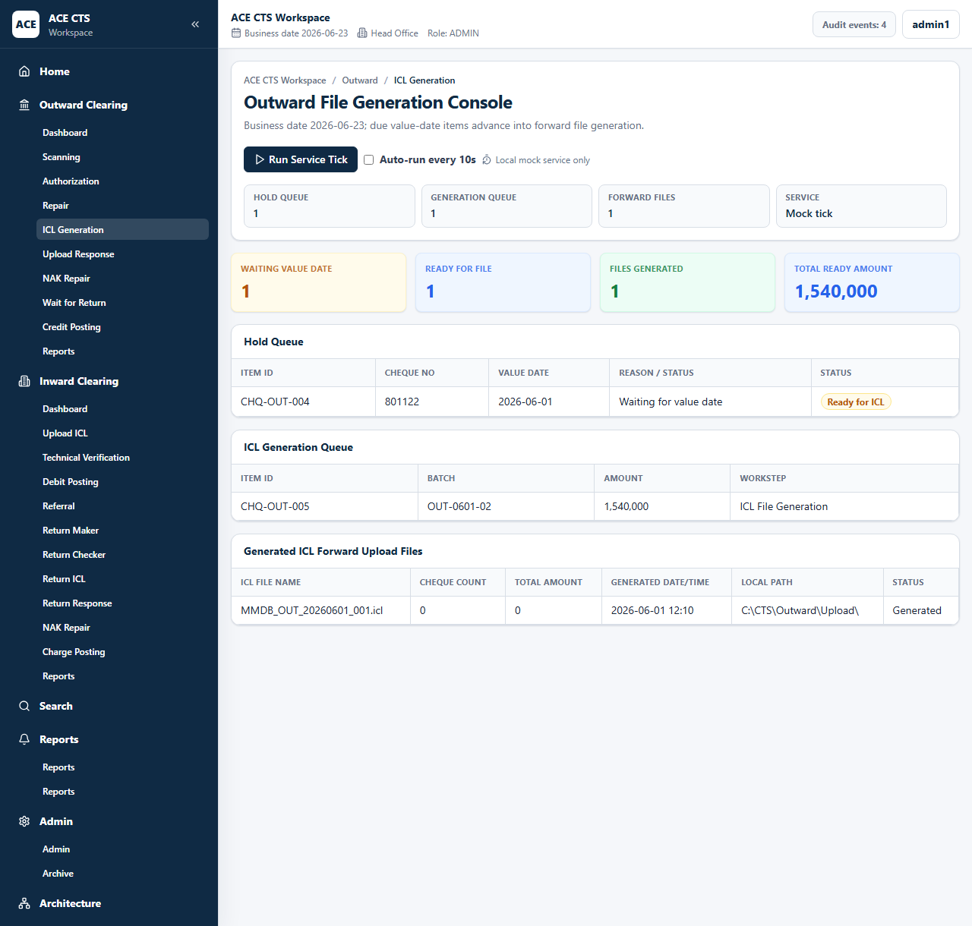
Figure 23: ACE CTS Hold for ICL File Generation (Indicative and subject to change)

Priority
High

Integration Touch Point
ACE CTS shall use business date and clearing-cycle configuration approved by the Bank.

Functional Requirement
ACE CTS shall provide the Hold for ICL File Generation function with the workflow, validation, audit, and role controls described herein.

Actors
Service, Admin

Field Details / Control Behaviour
S. No. | Field Name | Field Type | Control Behaviour | Mandatory | Remarks
1 | Item ID / Cheque No. | Grid | Read-only | No | Held items
2 | Value Date | Date | Read-only | No | Generation eligibility
3 | Reason / Status | Display | Read-only | No | Due or waiting status

Options / Buttons
S. No. | Option / Button | Behaviour | Validation / Confirmation | Target Work-step
1 | Run Service Tick | Processes due held items | Due-date rule applies | ICL File Generation

Validation Rules
Only due value-date instruments shall advance for file generation.

Confirmation Messages
ACE CTS shall display confirmation messages before committing irreversible or workflow-moving actions where indicated.

Target Work-step(s)
Routing Criteria | Target Work-step
Due item | ICL File Generation
Not due | Hold for ICL File Generation

Audit Trail Requirement
Service movement from hold to ICL generation shall be audited.

3.4.6 ICL File Generation / Forward Upload File

Description
ACE CTS shall generate outward forward upload ICL files with cheque counts, total amount, generated date/time, file path, and upload status.

Screenshot / Figure
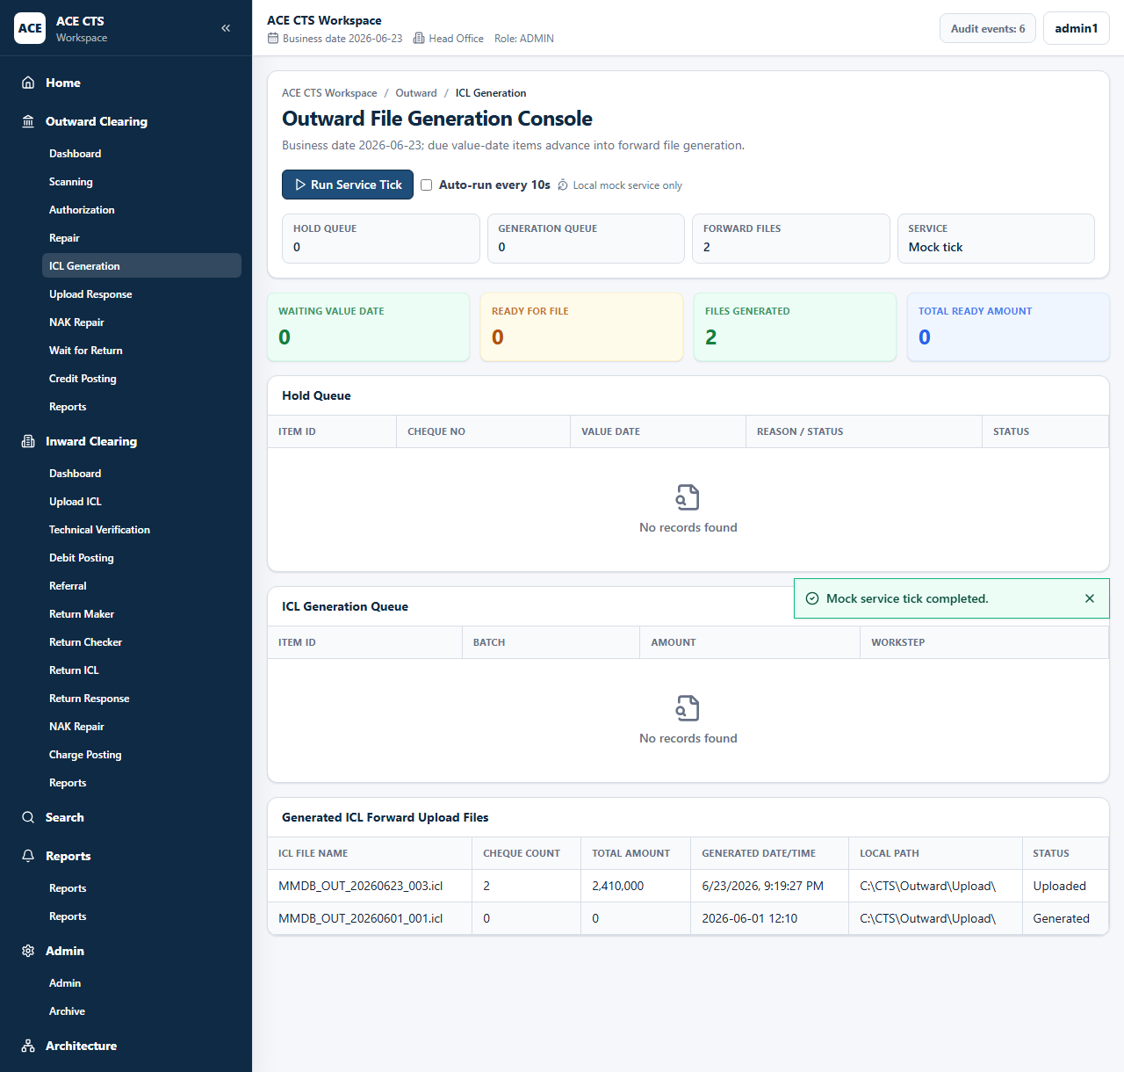
Figure 24: ACE CTS ICL File Generation (Indicative and subject to change)

Priority
High

Integration Touch Point
ACE CTS shall exchange ICL files with the Clearing House / CBM. File naming, encryption, signing, and transport specifications shall be finalized with the Bank.

Functional Requirement
ACE CTS shall provide the ICL File Generation / Forward Upload File function with the workflow, validation, audit, and role controls described herein.

Actors
Service, Admin

Field Details / Control Behaviour
S. No. | Field Name | Field Type | Control Behaviour | Mandatory | Remarks
1 | ICL File Name | Grid | Read-only | No | Generated file
2 | Cheque Count | Number | Read-only | No | Included items
3 | Total Amount | Amount | Read-only | No | File total
4 | Local Path | Text | Read-only | No | Bank-approved output path

Options / Buttons
S. No. | Option / Button | Behaviour | Validation / Confirmation | Target Work-step
1 | Run Service Tick | Generates file for ready items | Eligible items required | Forward Upload File Response

Validation Rules
File count and total amount shall reconcile with included instruments.

Confirmation Messages
ACE CTS shall display confirmation messages before committing irreversible or workflow-moving actions where indicated.

Target Work-step(s)
Routing Criteria | Target Work-step
File generated | Forward Upload File Response

Audit Trail Requirement
Generated file name, count, amount, and path shall be audited.

3.4.7 Forward Upload File Response

Description
ACE CTS shall record Clearing House / CBM responses for outward forward upload files at file and per-cheque level.

Screenshot / Figure
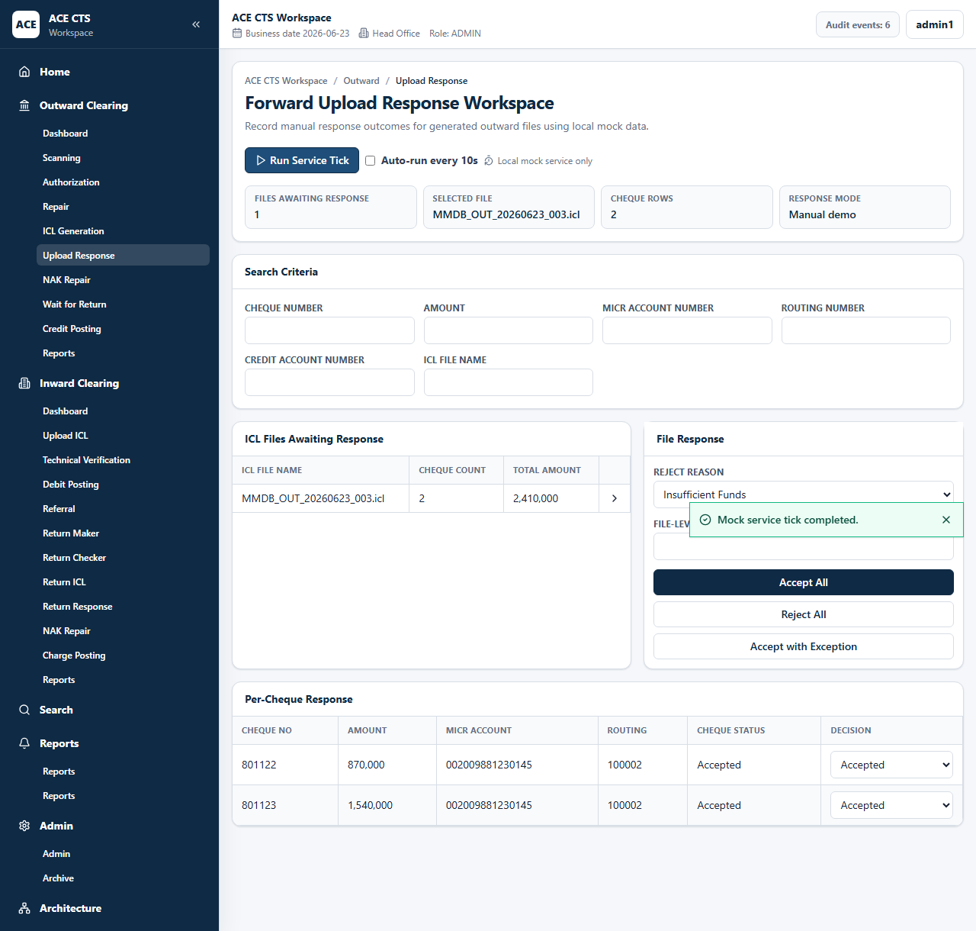
Figure 25: ACE CTS Forward Upload File Response (Indicative and subject to change)
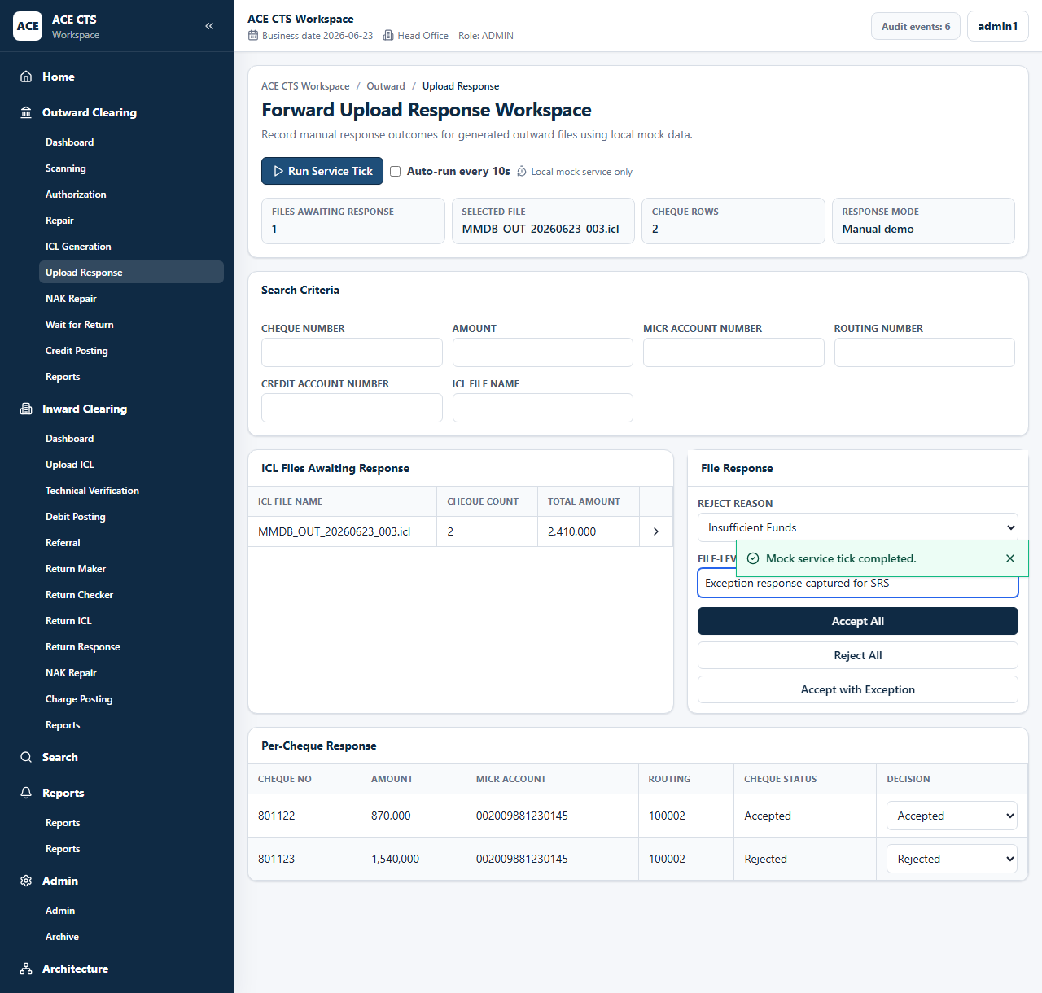
Figure 26: ACE CTS Forward Upload File Response with Exception (Indicative and subject to change)

Priority
High

Integration Touch Point
ACE CTS shall receive or record Clearing House / CBM acknowledgement and negative acknowledgement response details.

Functional Requirement
ACE CTS shall provide the Forward Upload File Response function with the workflow, validation, audit, and role controls described herein.

Actors
Operations user, Admin

Field Details / Control Behaviour
S. No. | Field Name | Field Type | Control Behaviour | Mandatory | Remarks
1 | Search Criteria | Text fields | Editable | No | Cheque, amount, MICR, routing, credit account, file name
2 | Reject Reason | List | Selectable | Conditional | Required for rejected response
3 | File-level Remarks | Text | Editable | Conditional | Required for rejected response
4 | Per-cheque Decision | List | Selectable | Yes | Accepted or Rejected

Options / Buttons
S. No. | Option / Button | Behaviour | Validation / Confirmation | Target Work-step
1 | Accept All | Marks file cheques accepted | Confirmation through action | Wait for Return
2 | Reject All | Marks file cheques rejected | Reason and remarks required | Outward NAK Repair
3 | Accept with Exception | Accepts file with selected rejected cheques | Rejected items require reason and remarks | Wait for Return / Outward NAK Repair

Validation Rules
Rejected file or cheque decisions shall require reject reason and remarks.

Confirmation Messages
ACE CTS shall display confirmation messages before committing irreversible or workflow-moving actions where indicated.

Target Work-step(s)
Routing Criteria | Target Work-step
Accepted | Wait for Return
Rejected | Outward NAK Repair
Accepted with exception | Mixed routing by cheque decision

Audit Trail Requirement
Response decision, reason, remarks, count, and file reference shall be audited.

3.4.8 Outward NAK Repair

Description
ACE CTS shall allow repair of outward items rejected by Clearing House / CBM before regenerating upload files.

Screenshot / Figure
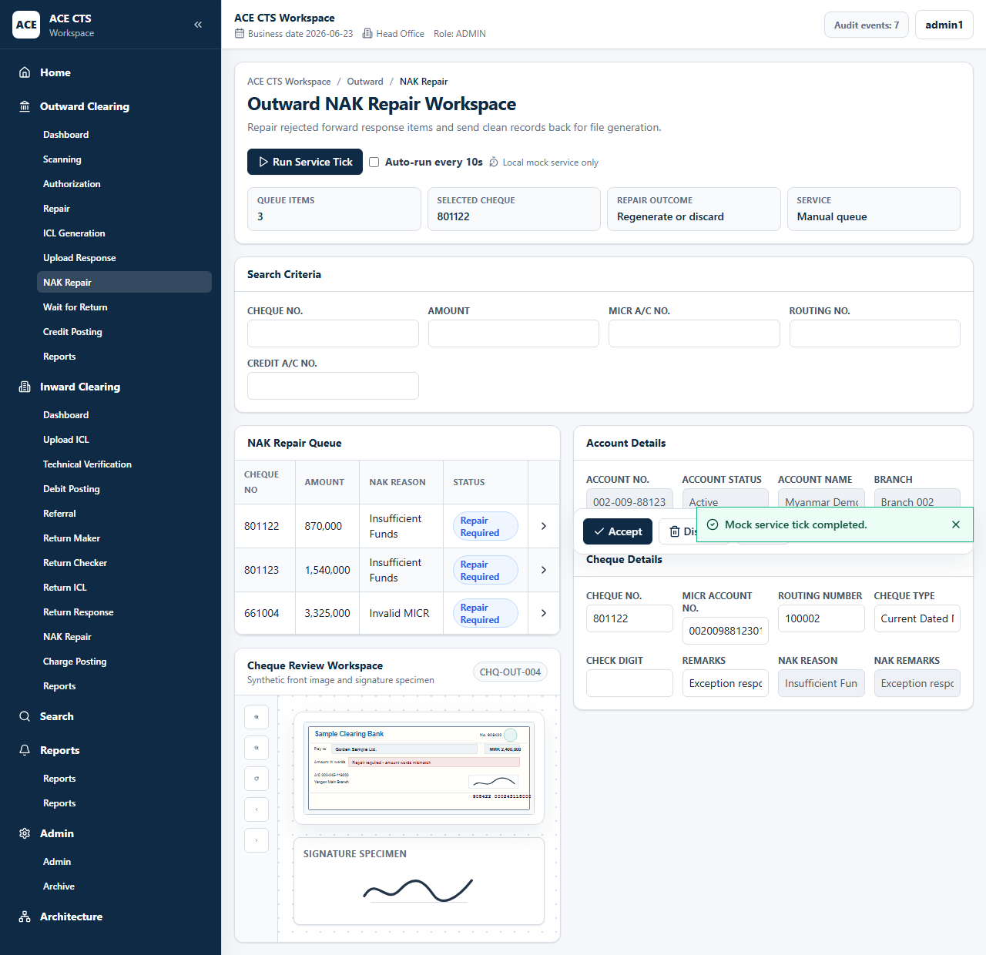
Figure 27: ACE CTS Outward NAK Repair (Indicative and subject to change)

Priority
High

Integration Touch Point
ACE CTS shall preserve Clearing House / CBM negative acknowledgement details with the repaired instrument.

Functional Requirement
ACE CTS shall provide the Outward NAK Repair function with the workflow, validation, audit, and role controls described herein.

Actors
Maker, Admin

Field Details / Control Behaviour
S. No. | Field Name | Field Type | Control Behaviour | Mandatory | Remarks
1 | Search Criteria | Text | Editable | No | Queue filters
2 | Cheque Details | Text | Editable | Yes | Correctable cheque fields
3 | NAK Reason / Remarks | Display | Disabled | No | Response reason and remarks

Options / Buttons
S. No. | Option / Button | Behaviour | Validation / Confirmation | Target Work-step
1 | Accept | Completes NAK repair | Valid data required | ICL File Generation
2 | Discard | Discards item | Remarks required | Discard
3 | Exit | Leaves page | None | Dashboard

Validation Rules
Discard from NAK repair shall require remarks.

Confirmation Messages
ACE CTS shall display confirmation messages before committing irreversible or workflow-moving actions where indicated.

Target Work-step(s)
Routing Criteria | Target Work-step
Accepted | ICL File Generation
Discarded | Discard

Audit Trail Requirement
NAK repair accept and discard actions shall be audited.

3.4.9 Wait for Return

Description
ACE CTS shall hold CBM-accepted outward cheques while awaiting return download status before cutoff.

Screenshot / Figure
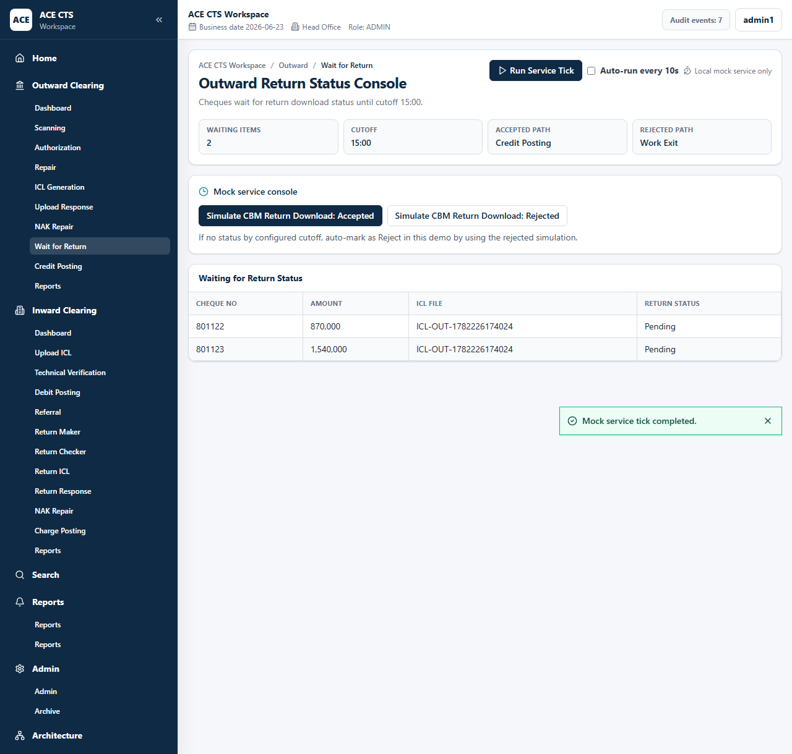
Figure 28: ACE CTS Wait for Return (Indicative and subject to change)

Priority
High

Integration Touch Point
ACE CTS shall exchange return status files with Clearing House / CBM.

Functional Requirement
ACE CTS shall provide the Wait for Return function with the workflow, validation, audit, and role controls described herein.

Actors
Service, Admin

Field Details / Control Behaviour
S. No. | Field Name | Field Type | Control Behaviour | Mandatory | Remarks
1 | Cheque No. | Grid | Read-only | No | Waiting cheque
2 | Amount | Amount | Read-only | No | Cheque amount
3 | ICL File | Text | Read-only | No | Forward file reference
4 | Return Status | Display | Read-only | No | Pending, accepted, or rejected

Options / Buttons
S. No. | Option / Button | Behaviour | Validation / Confirmation | Target Work-step
1 | Process Return Download | Applies returned status file | Valid response required | Credit Posting / Work Exit

Validation Rules
ACE CTS shall apply cutoff handling for items without return status according to Bank rules.

Confirmation Messages
ACE CTS shall display confirmation messages before committing irreversible or workflow-moving actions where indicated.

Target Work-step(s)
Routing Criteria | Target Work-step
Return accepted | Credit Posting
Return rejected | Work Exit / return handling

Audit Trail Requirement
Return download result and count shall be audited.

3.4.10 Credit Posting

Description
ACE CTS shall generate credit posting files for accepted outward cheques and complete the outward work item.

Screenshot / Figure
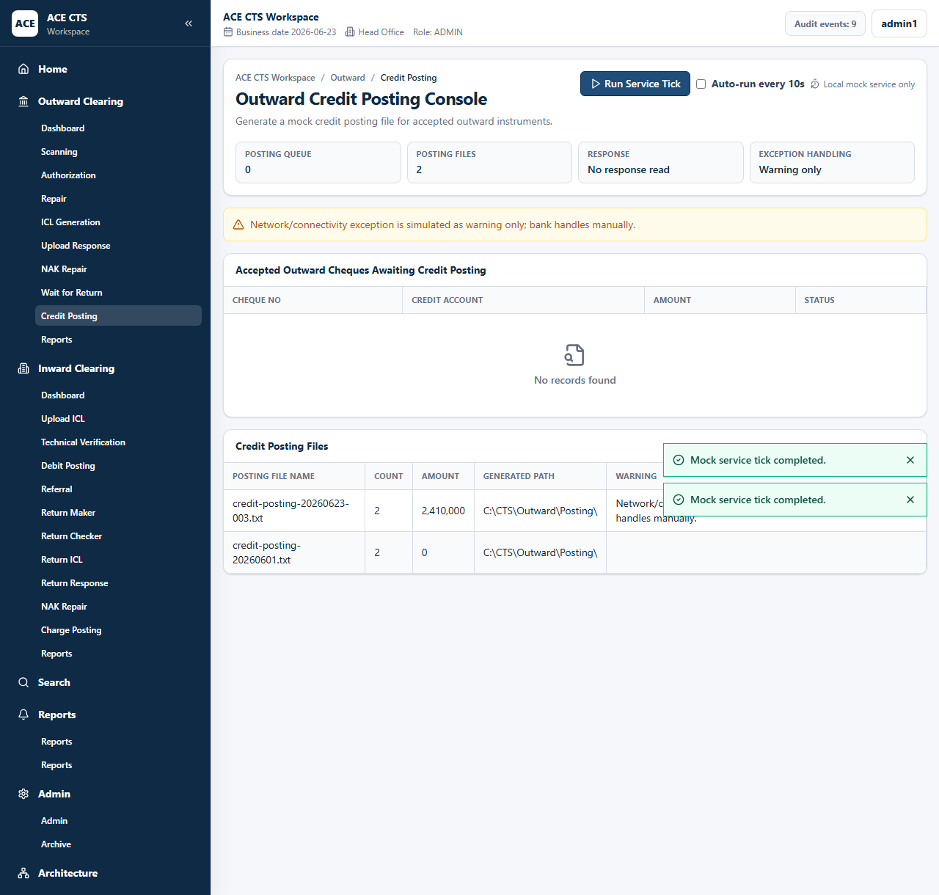
Figure 29: ACE CTS Credit Posting (Indicative and subject to change)

Priority
High

Integration Touch Point
ACE CTS shall integrate with CBS for outward credit posting. File format and response handling shall be finalized with the Bank.

Functional Requirement
ACE CTS shall provide the Credit Posting function with the workflow, validation, audit, and role controls described herein.

Actors
Service, Admin

Field Details / Control Behaviour
S. No. | Field Name | Field Type | Control Behaviour | Mandatory | Remarks
1 | Credit Account | Grid | Read-only | No | Beneficiary account
2 | Amount | Amount | Read-only | No | Posting amount
3 | Posting File Name | Grid | Read-only | No | Generated CBS file
4 | Generated Path | Text | Read-only | No | Bank-approved output path

Options / Buttons
S. No. | Option / Button | Behaviour | Validation / Confirmation | Target Work-step
1 | Run Service Tick | Generates credit posting file | Eligible accepted items required | Work Exit

Validation Rules
Posting file count and amount shall reconcile with included instruments.

Confirmation Messages
ACE CTS shall display confirmation messages before committing irreversible or workflow-moving actions where indicated.

Target Work-step(s)
Routing Criteria | Target Work-step
Posting generated | Work Exit

Audit Trail Requirement
Credit posting file generation shall be audited.

3.4.11 Outward Reports

Description
ACE CTS shall provide outward clearing reports with search criteria, output preview, and controlled downloads.

Screenshot / Figure
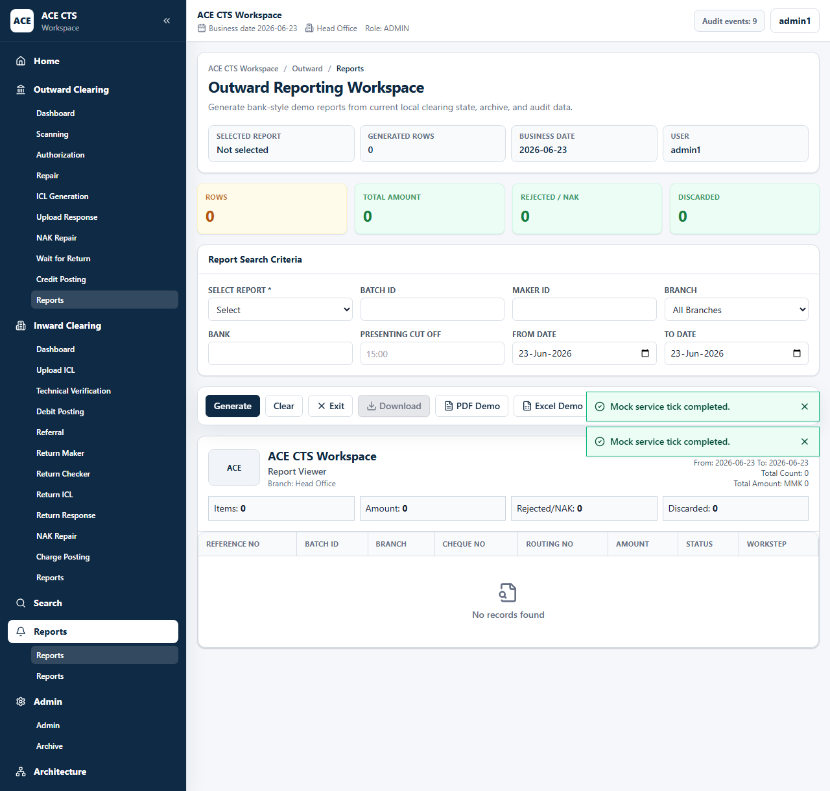
Figure 30: ACE CTS Outward Reports Search (Indicative and subject to change)
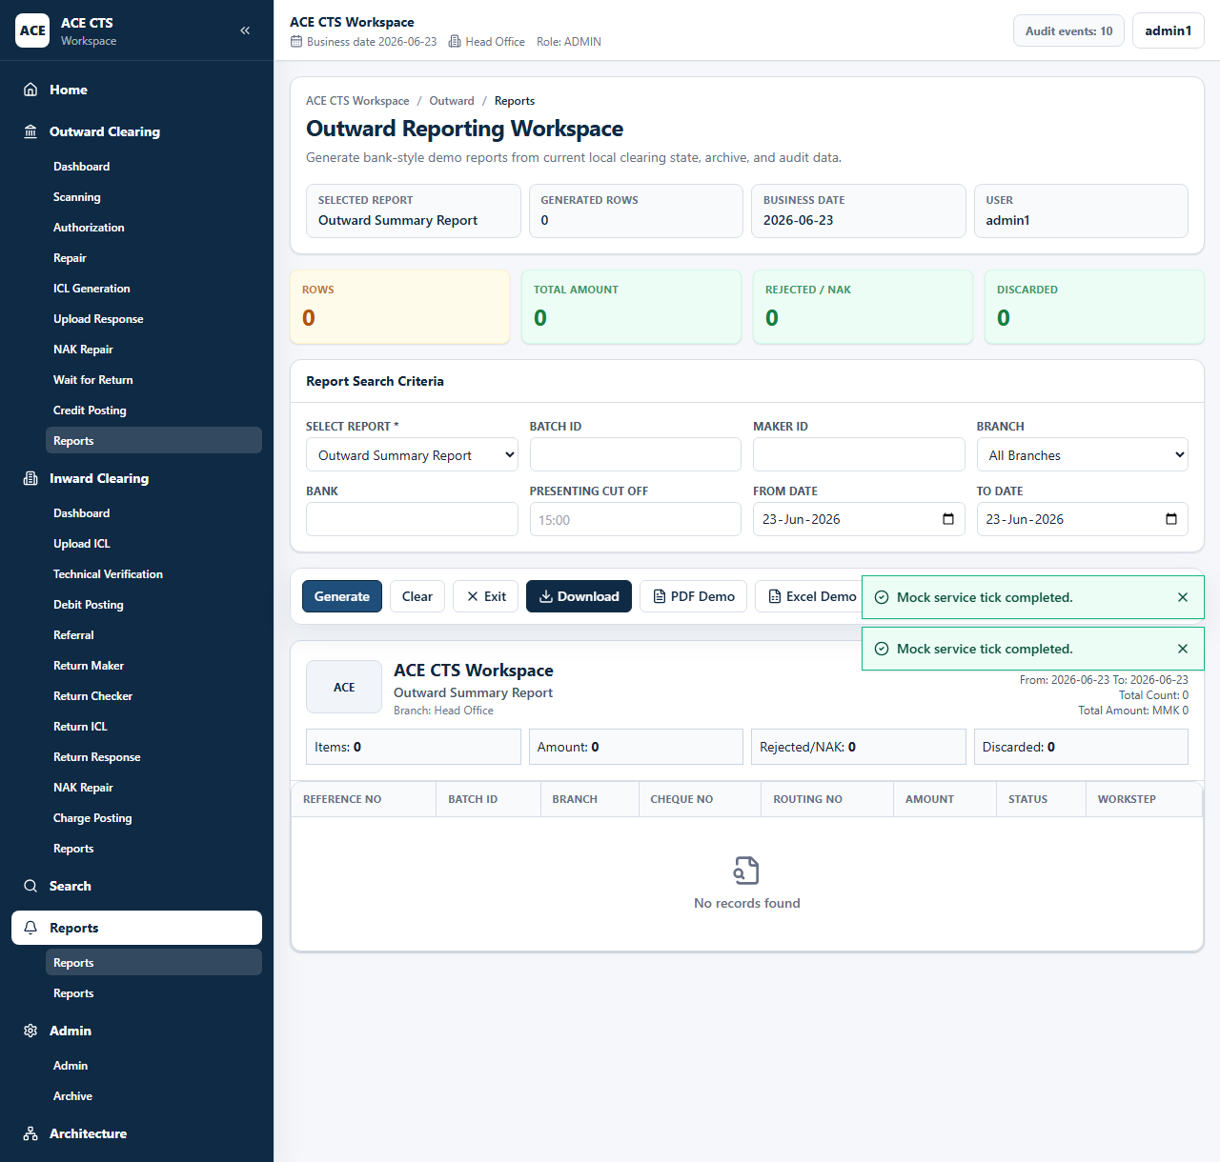
Figure 31: ACE CTS Outward Report Output (Indicative and subject to change)

Priority
High

Integration Touch Point
ACE CTS shall provide report extracts in Bank-approved formats.

Functional Requirement
ACE CTS shall provide the Outward Reports function with the workflow, validation, audit, and role controls described herein.

Actors
Maker, Checker, Admin

Field Details / Control Behaviour
S. No. | Field Name | Field Type | Control Behaviour | Mandatory | Remarks
1 | Select Report | List | Selectable | Yes | Outward report type
2 | Batch ID / Maker ID / Branch / Bank / Cutoff | Search criteria | Editable | No | Filters report output
3 | From Date / To Date | Date | Editable | Yes | Report period

Options / Buttons
S. No. | Option / Button | Behaviour | Validation / Confirmation | Target Work-step
1 | Generate | Creates report output | Report type required | Report output
2 | Clear | Clears criteria | None | Search
3 | Download / PDF / Excel | Exports generated report | Report must be generated | Download
4 | Exit | Leaves reports | None | Dashboard

Validation Rules
Report type shall be mandatory. Date criteria shall be applied to returned results.

Confirmation Messages
ACE CTS shall display confirmation messages before committing irreversible or workflow-moving actions where indicated.

Target Work-step(s)
Routing Criteria | Target Work-step
Generate | Report output

Audit Trail Requirement
Report generation and download shall be audited.

3.5.1 Inward Dashboard & Menu

Description
ACE CTS shall display inward queue counts, process navigation, workflow tiles, charts, and recent workitems.

Screenshot / Figure
Figure 32: ACE CTS Inward Process Flow (Indicative and subject to change)

Priority
High

Integration Touch Point
ACE CTS shall present operational inward queue data from the application database.

Functional Requirement
ACE CTS shall provide the Inward Dashboard & Menu function with the workflow, validation, audit, and role controls described herein.

Actors
Maker, Checker, Admin

Field Details / Control Behaviour
S. No. | Field Name | Field Type | Control Behaviour | Mandatory | Remarks
1 | Workflow Tiles | Display/action | Selectable | No | Queue counts
2 | Recent Workitems | Grid | Read-only | No | Inward items
3 | Workitems Chart | Chart | Read-only | No | Queue distribution

Options / Buttons
S. No. | Option / Button | Behaviour | Validation / Confirmation | Target Work-step
1 | Workflow Tile | Opens selected inward work-step | Role access applies | Selected queue

Validation Rules
Counts shall update when inward items move between work-steps.

Confirmation Messages
ACE CTS shall display confirmation messages before committing irreversible or workflow-moving actions where indicated.

Target Work-step(s)
Routing Criteria | Target Work-step
Tile selected | Selected inward work-step

Audit Trail Requirement
Dashboard access may be logged according to Bank audit policy.

3.5.2 Read and Upload ICL File / Forward Download File

Description
ACE CTS shall import inward forward download ICL files received from Clearing House / CBM and route instruments to technical verification.

Screenshot / Figure
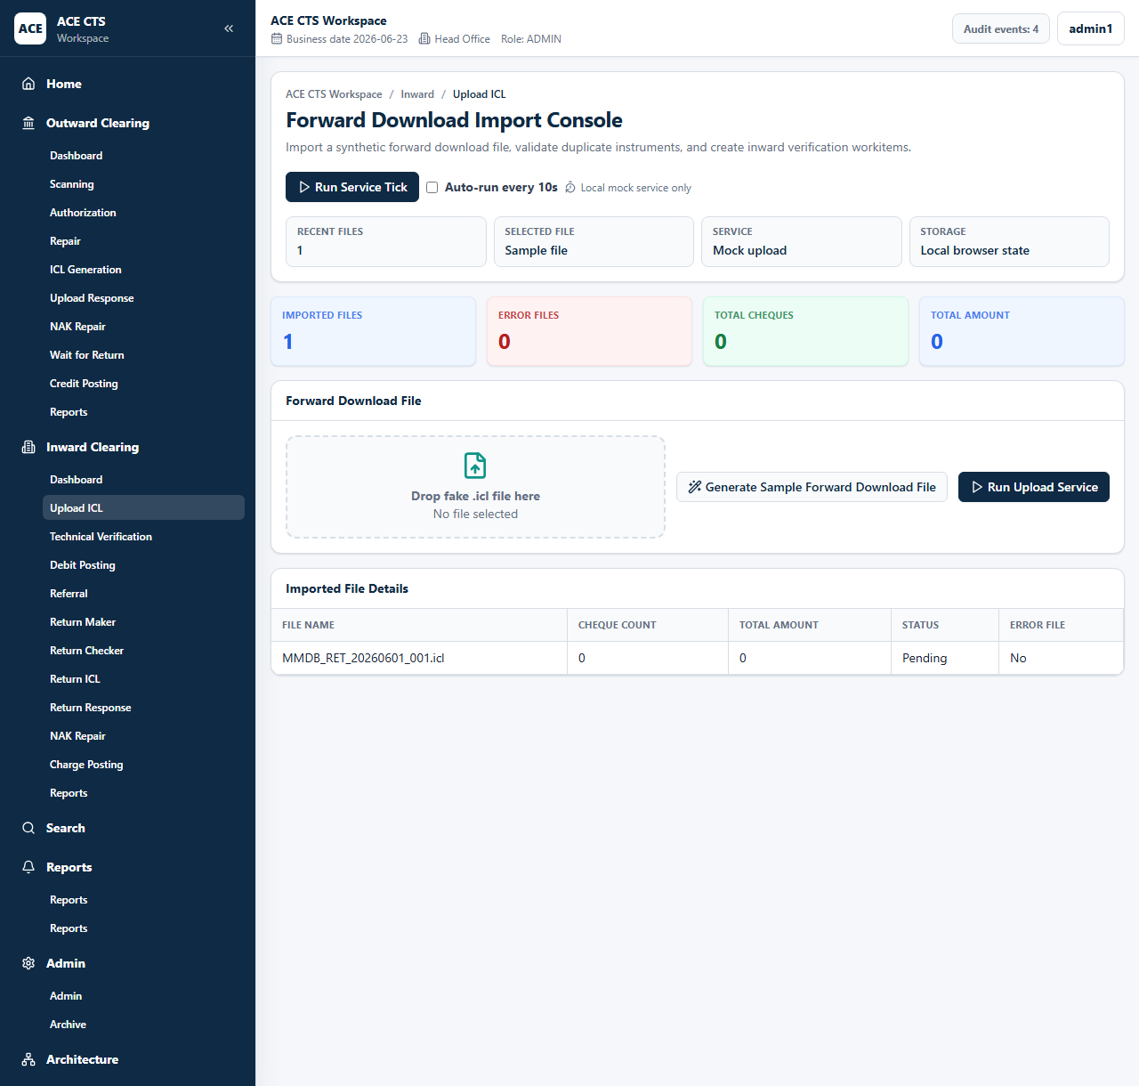
Figure 33: ACE CTS Read and Upload ICL File (Indicative and subject to change)
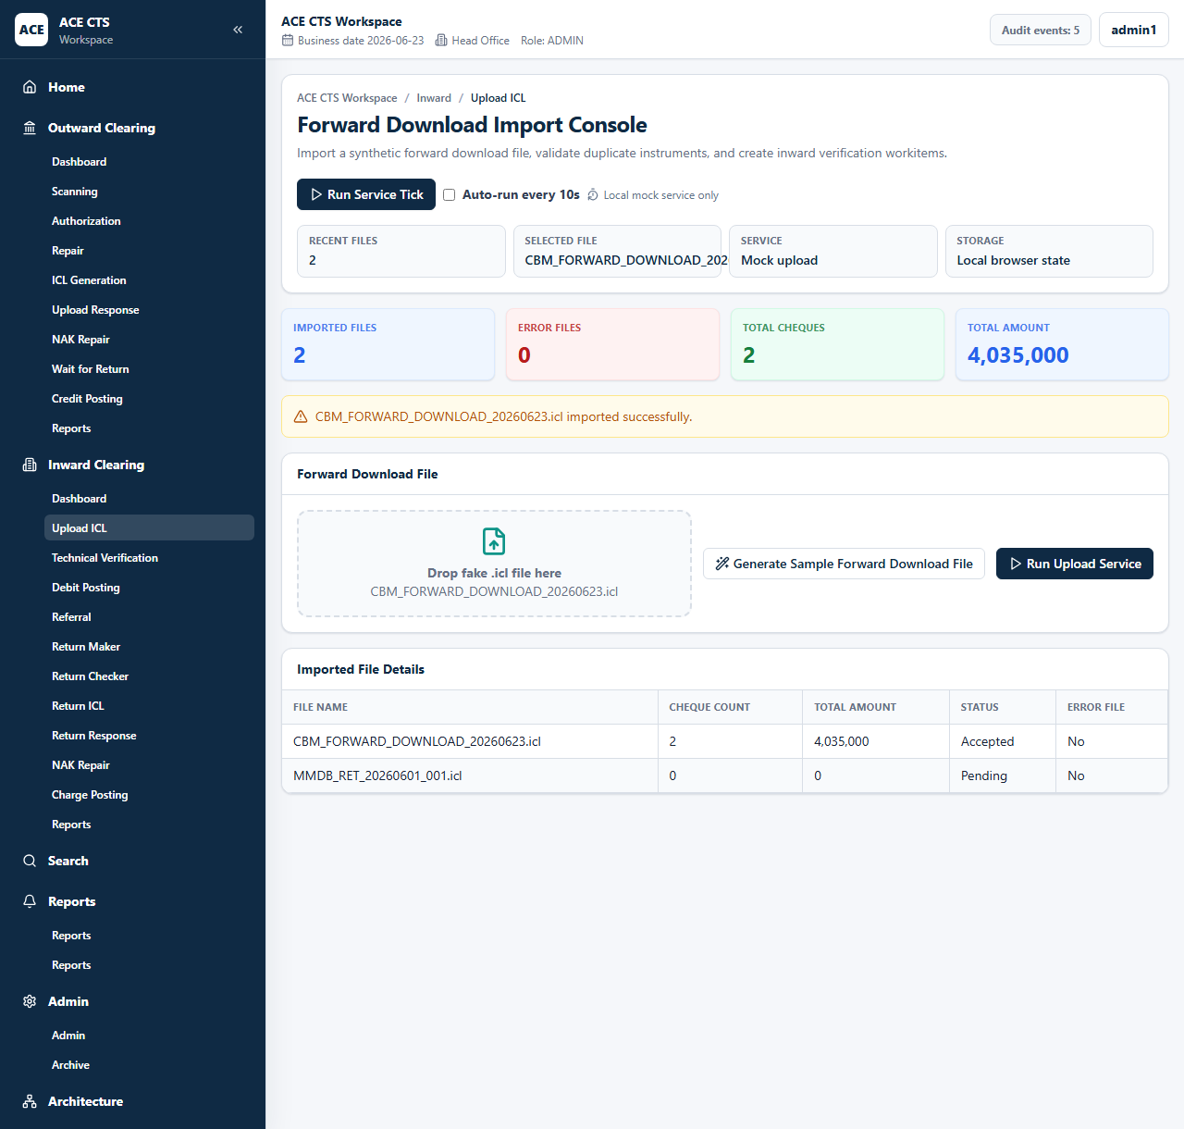
Figure 34: ACE CTS Uploaded Forward Download File (Indicative and subject to change)

Priority
High

Integration Touch Point
ACE CTS shall exchange ICL files with Clearing House / CBM. Final interface specifications shall be finalized with the Bank.

Functional Requirement
ACE CTS shall provide the Read and Upload ICL File / Forward Download File function with the workflow, validation, audit, and role controls described herein.

Actors
Maker, Service, Admin

Field Details / Control Behaviour
S. No. | Field Name | Field Type | Control Behaviour | Mandatory | Remarks
1 | Forward Download File | File input | Selectable | Yes | ICL input file
2 | Imported File Details | Grid | Read-only | No | File name, count, amount, status, error file

Options / Buttons
S. No. | Option / Button | Behaviour | Validation / Confirmation | Target Work-step
1 | Generate Sample Forward Download File | Stages file name for upload | None | Upload ICL
2 | Run Upload Service | Imports file | File validation and duplicate checks | Technical Verification

Validation Rules
ACE CTS shall validate file format, duplicate file reference, and duplicate cheque information.

Confirmation Messages
ACE CTS shall display confirmation messages before committing irreversible or workflow-moving actions where indicated.

Target Work-step(s)
Routing Criteria | Target Work-step
Valid file | Technical Verification
Invalid or duplicate file | Error handling queue / audit

Audit Trail Requirement
ICL import success and failure shall be audited.

3.5.3 Technical Verification

Description
ACE CTS shall provide inward technical verification with cheque image, signature image, CBS account details, reject reason, and remarks.

Screenshot / Figure
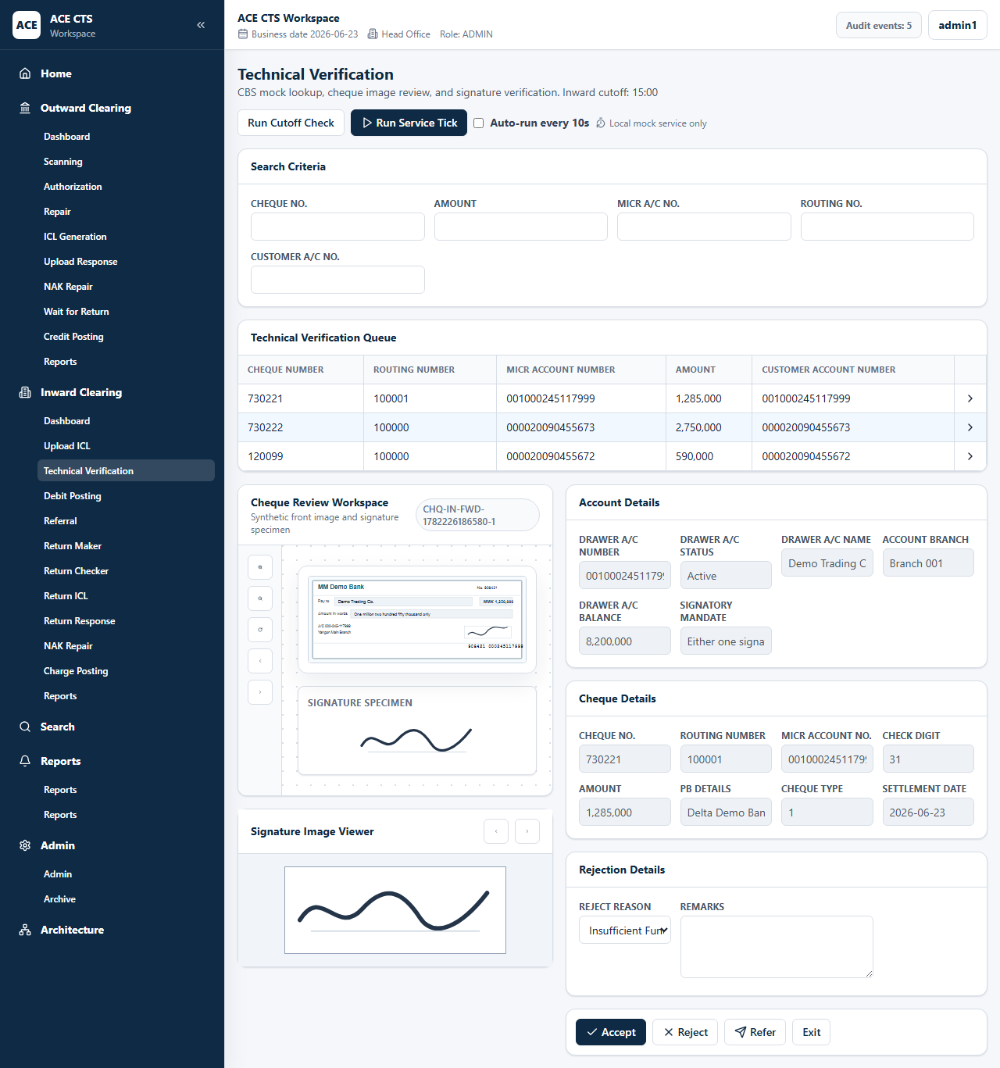
Figure 35: ACE CTS Technical Verification Search (Indicative and subject to change)
Figure 36: ACE CTS Technical Verification Detail (Indicative and subject to change)
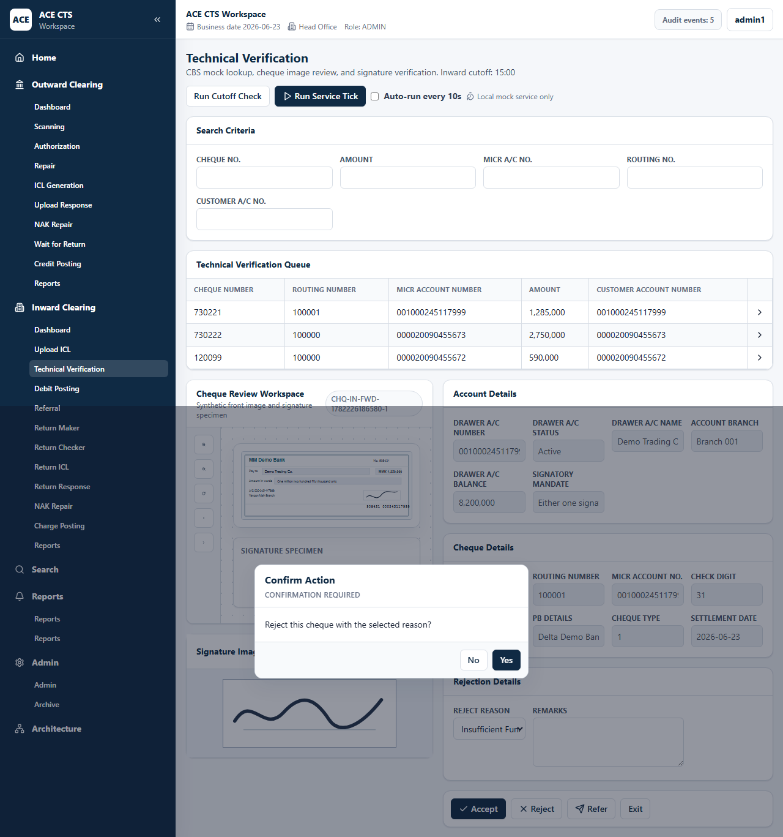
Figure 37: ACE CTS Technical Verification Reject Window (Indicative and subject to change)

Priority
High

Integration Touch Point
ACE CTS shall integrate with CBS for account, balance, status, stop payment, and signature details.

Functional Requirement
ACE CTS shall provide the Technical Verification function with the workflow, validation, audit, and role controls described herein.

Actors
Maker, Admin

Field Details / Control Behaviour
S. No. | Field Name | Field Type | Control Behaviour | Mandatory | Remarks
1 | Search Criteria | Text | Editable | No | Cheque, amount, MICR, routing, customer account
2 | Account Details | Display | Disabled | No | Drawer account and balance
3 | Cheque Details | Display | Disabled | No | Cheque and settlement details
4 | Reject Reason / Remarks | List/text | Editable | Conditional | Required for Reject or Refer

Options / Buttons
S. No. | Option / Button | Behaviour | Validation / Confirmation | Target Work-step
1 | Accept | Accepts cheque | Confirmation required | Debit Posting
2 | Reject | Rejects cheque | Reason and remarks required | Return ICL Creation
3 | Refer | Refers cheque to checker | Reason and remarks required | Referral
4 | Run Cutoff Check | Applies cutoff auto-return rule | Cutoff time applies | Return ICL Creation

Validation Rules
Reject and refer shall require reason and remarks. PO handling may hide sensitive balance and signature details where applicable.

Confirmation Messages
ACE CTS shall display confirmation messages before committing irreversible or workflow-moving actions where indicated.

Target Work-step(s)
Routing Criteria | Target Work-step
Accept | Debit Posting
Reject | Return ICL Creation
Refer | Referral

Audit Trail Requirement
Technical accept, reject, refer, and cutoff actions shall be audited.

3.5.4 Debit Posting

Description
ACE CTS shall generate debit posting files for accepted inward cheques.

Screenshot / Figure
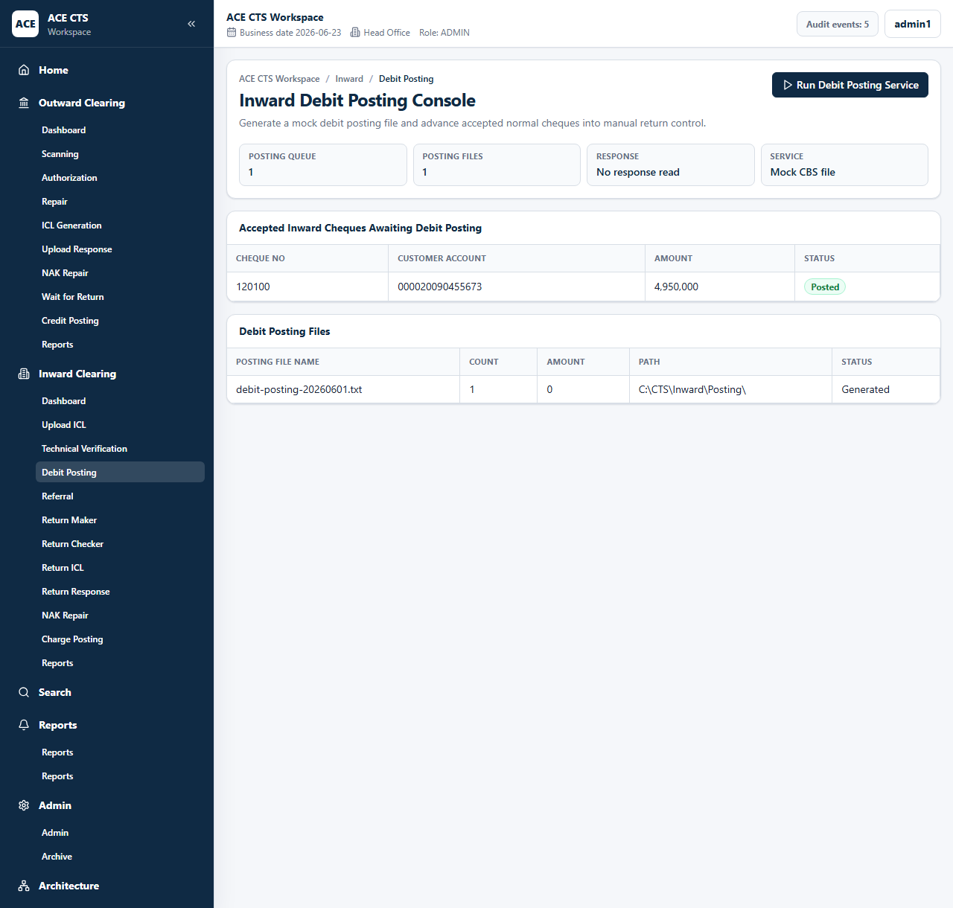
Figure 38: ACE CTS Debit Posting (Indicative and subject to change)

Priority
High

Integration Touch Point
ACE CTS shall integrate with CBS for debit posting. Interface specifications shall be finalized with the Bank.

Functional Requirement
ACE CTS shall provide the Debit Posting function with the workflow, validation, audit, and role controls described herein.

Actors
Service, Admin

Field Details / Control Behaviour
S. No. | Field Name | Field Type | Control Behaviour | Mandatory | Remarks
1 | Customer Account | Grid | Read-only | No | Account to debit
2 | Amount | Amount | Read-only | No | Debit amount
3 | Posting File Name / Count / Amount / Path | Grid | Read-only | No | Generated posting file details

Options / Buttons
S. No. | Option / Button | Behaviour | Validation / Confirmation | Target Work-step
1 | Run Debit Posting Service | Generates debit posting file | Eligible items required | Manual Return Maker

Validation Rules
Posting file count and amount shall reconcile with accepted inward cheques.

Confirmation Messages
ACE CTS shall display confirmation messages before committing irreversible or workflow-moving actions where indicated.

Target Work-step(s)
Routing Criteria | Target Work-step
Posted | Manual Return Maker

Audit Trail Requirement
Debit posting file generation and item inclusion shall be audited.

3.5.5 Referral

Description
ACE CTS shall allow branch/checker referral review of inward items with account/signature details.

Screenshot / Figure
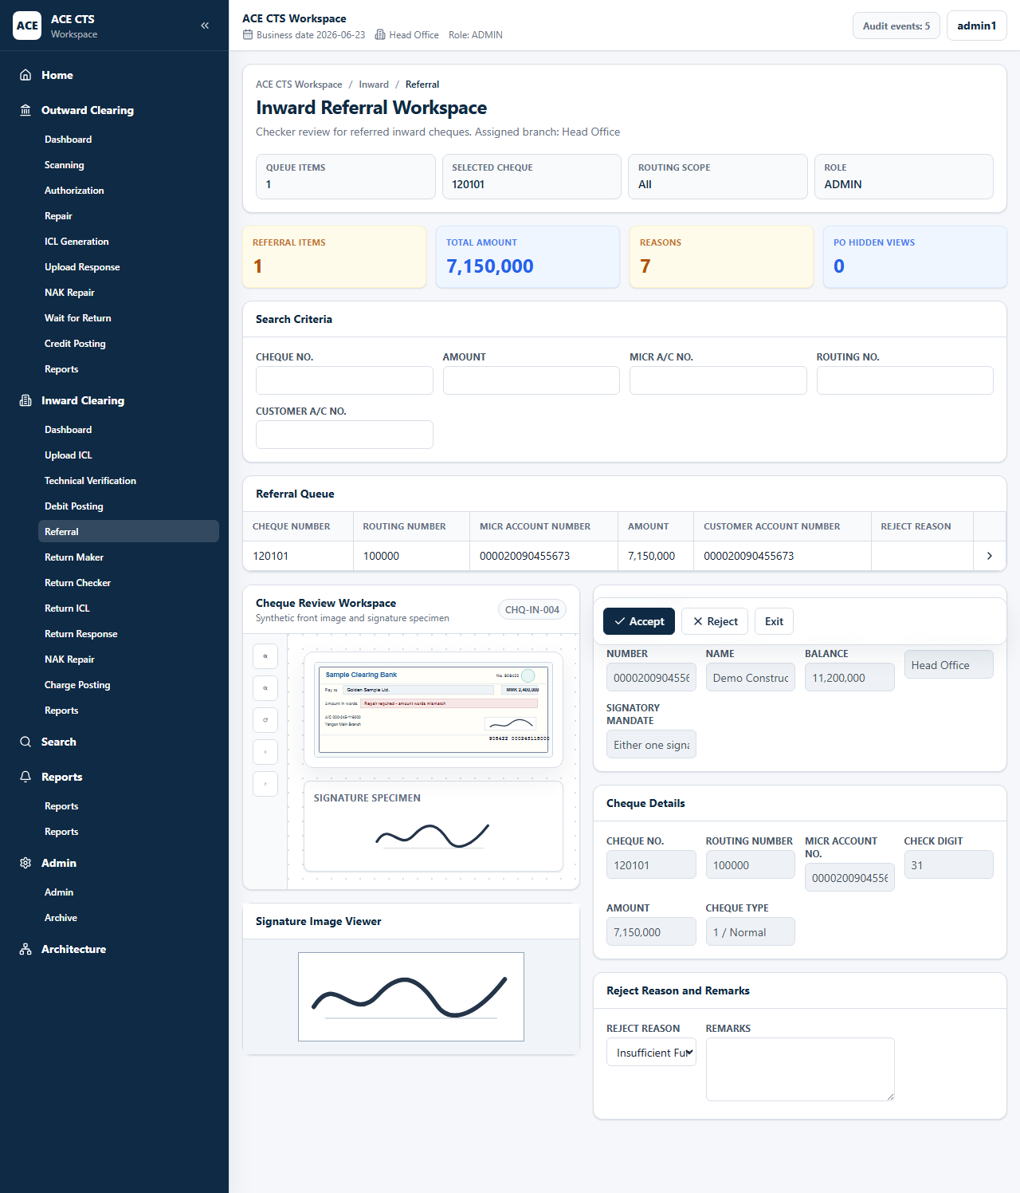
Figure 39: ACE CTS Referral Search (Indicative and subject to change)
Figure 40: ACE CTS Referral Detail (Indicative and subject to change)

Priority
High

Integration Touch Point
ACE CTS shall retrieve account and signature data from CBS or the Bank signature source.

Functional Requirement
ACE CTS shall provide the Referral function with the workflow, validation, audit, and role controls described herein.

Actors
Checker, Admin

Field Details / Control Behaviour
S. No. | Field Name | Field Type | Control Behaviour | Mandatory | Remarks
1 | Search Criteria | Text | Editable | No | Queue filters
2 | Account Details | Display | Disabled | No | Drawer account data
3 | Reject Reason / Remarks | List/text | Editable | Conditional | Required for reject

Options / Buttons
S. No. | Option / Button | Behaviour | Validation / Confirmation | Target Work-step
1 | Accept | Accepts referred cheque | Confirmation required | Debit Posting
2 | Reject | Rejects referred cheque | Reason and remarks required | Return ICL Creation
3 | Exit | Leaves page | None | Dashboard

Validation Rules
Referral reject shall require reason and remarks.

Confirmation Messages
ACE CTS shall display confirmation messages before committing irreversible or workflow-moving actions where indicated.

Target Work-step(s)
Routing Criteria | Target Work-step
Accept | Debit Posting
Reject | Return ICL Creation

Audit Trail Requirement
Referral accept and reject shall be audited.

3.5.6 Manual Cheque Return - Maker

Description
ACE CTS shall allow a maker to manually return an accepted inward cheque before cutoff.

Screenshot / Figure
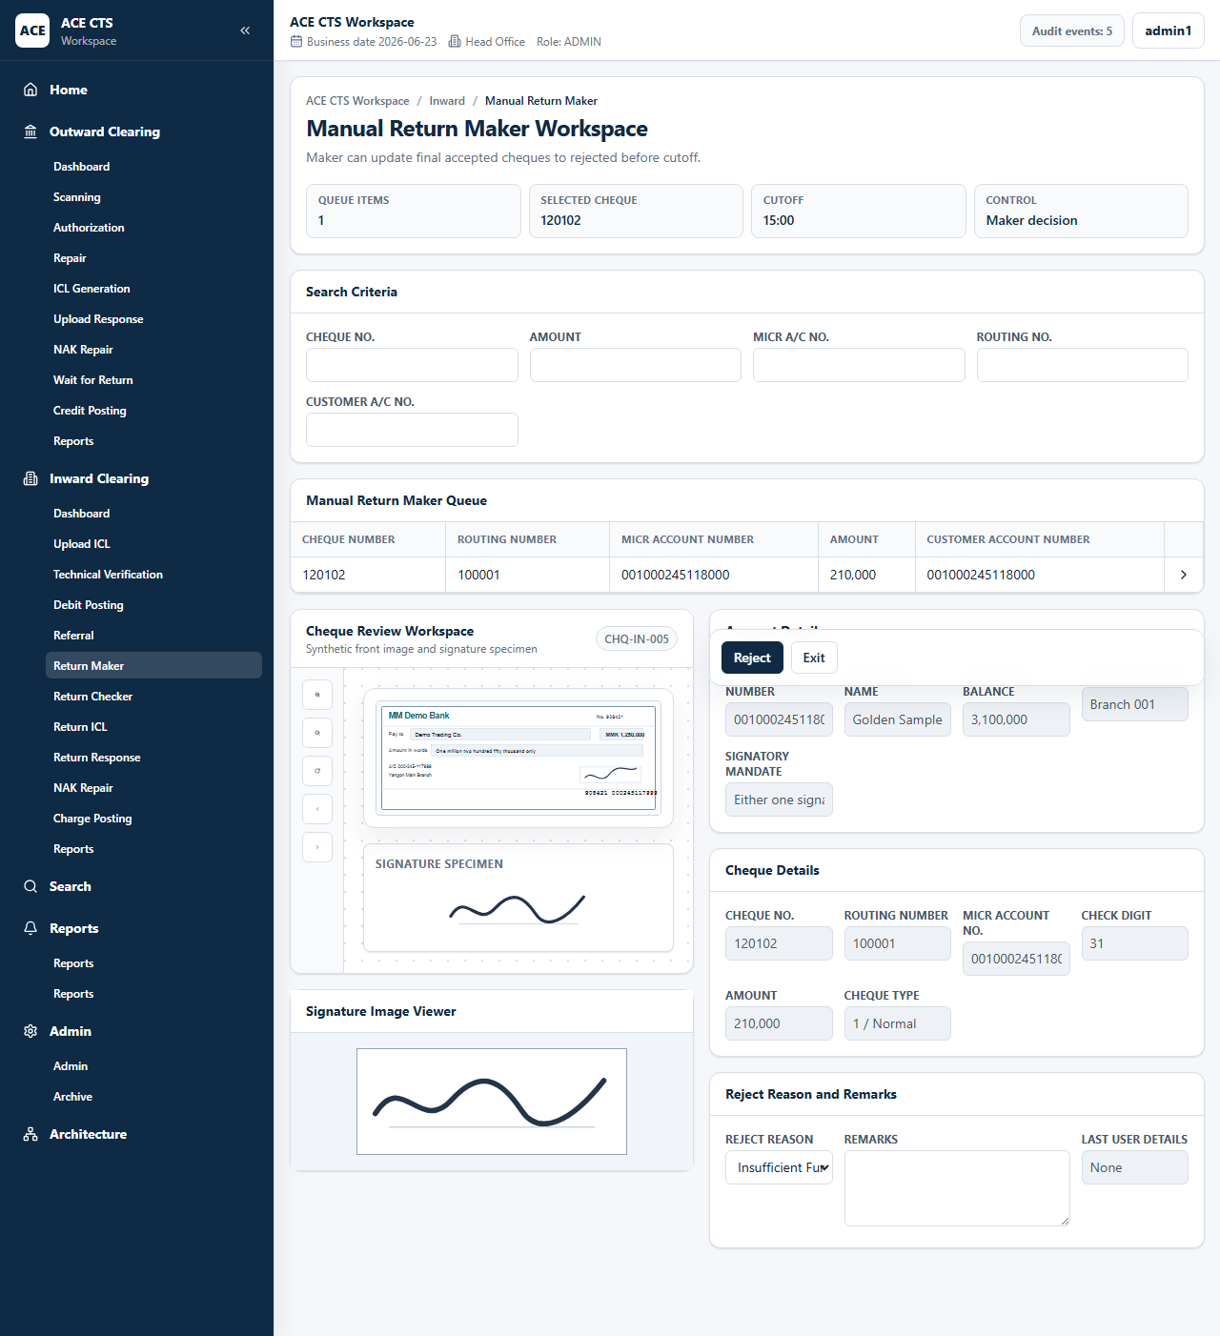
Figure 41: ACE CTS Manual Return Maker Search (Indicative and subject to change)
Figure 42: ACE CTS Manual Return Maker Detail (Indicative and subject to change)

Priority
High

Integration Touch Point
ACE CTS shall apply cutoff and Bank return reason configuration.

Functional Requirement
ACE CTS shall provide the Manual Cheque Return - Maker function with the workflow, validation, audit, and role controls described herein.

Actors
Maker, Admin

Field Details / Control Behaviour
S. No. | Field Name | Field Type | Control Behaviour | Mandatory | Remarks
1 | Search Criteria | Text | Editable | No | Queue filters
2 | Reject Reason | List | Selectable | Yes | Return reason
3 | Remarks | Text | Editable | Yes | Maker remarks

Options / Buttons
S. No. | Option / Button | Behaviour | Validation / Confirmation | Target Work-step
1 | Reject | Submits maker return decision | Reason and remarks required | Manual Return Checker
2 | Exit | Leaves page | None | Dashboard

Validation Rules
Manual return maker decision shall require reason and remarks.

Confirmation Messages
ACE CTS shall display confirmation messages before committing irreversible or workflow-moving actions where indicated.

Target Work-step(s)
Routing Criteria | Target Work-step
Reject | Manual Return Checker

Audit Trail Requirement
Maker return decision shall be audited.

3.5.7 Manual Cheque Return - Checker

Description
ACE CTS shall allow checker approval or rejection of manual return maker decisions.

Screenshot / Figure
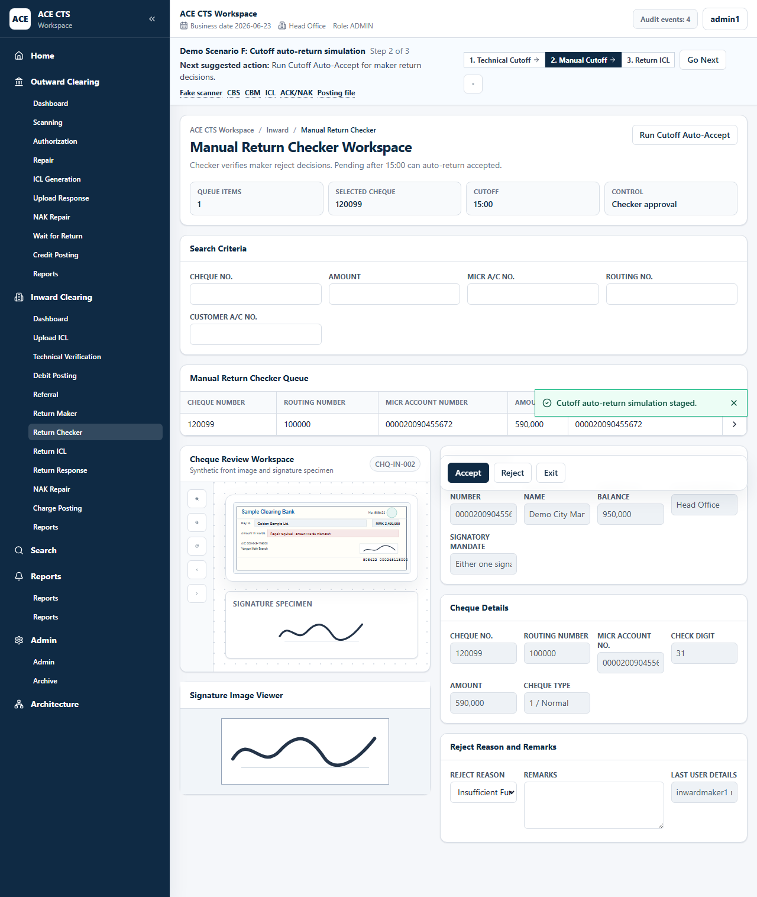
Figure 43: ACE CTS Manual Return Checker Search (Indicative and subject to change)
Figure 44: ACE CTS Manual Return Checker Detail (Indicative and subject to change)

Priority
High

Integration Touch Point
ACE CTS shall apply Bank maker-checker and cutoff policy.

Functional Requirement
ACE CTS shall provide the Manual Cheque Return - Checker function with the workflow, validation, audit, and role controls described herein.

Actors
Checker, Admin

Field Details / Control Behaviour
S. No. | Field Name | Field Type | Control Behaviour | Mandatory | Remarks
1 | Search Criteria | Text | Editable | No | Queue filters
2 | Last User Details | Display | Disabled | No | Maker decision details
3 | Reject Reason / Remarks | Display/edit | Read-only or editable | Conditional | Return decision information

Options / Buttons
S. No. | Option / Button | Behaviour | Validation / Confirmation | Target Work-step
1 | Accept | Accepts maker return decision | Maker-checker rule applies | Return ICL Creation
2 | Reject | Rejects maker return decision | Maker-checker rule applies | Manual Return Maker
3 | Run Cutoff Auto-Accept | Auto-accepts pending maker decisions after cutoff | Cutoff rule applies | Return ICL Creation

Validation Rules
The same user shall not check his or her own manual return decision unless Bank policy defines an administrator override.

Confirmation Messages
ACE CTS shall display confirmation messages before committing irreversible or workflow-moving actions where indicated.

Target Work-step(s)
Routing Criteria | Target Work-step
Accept | Return ICL Creation
Reject | Manual Return Maker

Audit Trail Requirement
Manual return checker decision shall be audited.

3.5.8 ICL Return Upload File Creation

Description
ACE CTS shall generate inward return upload ICL files for Pay/No Pay instruments.

Screenshot / Figure
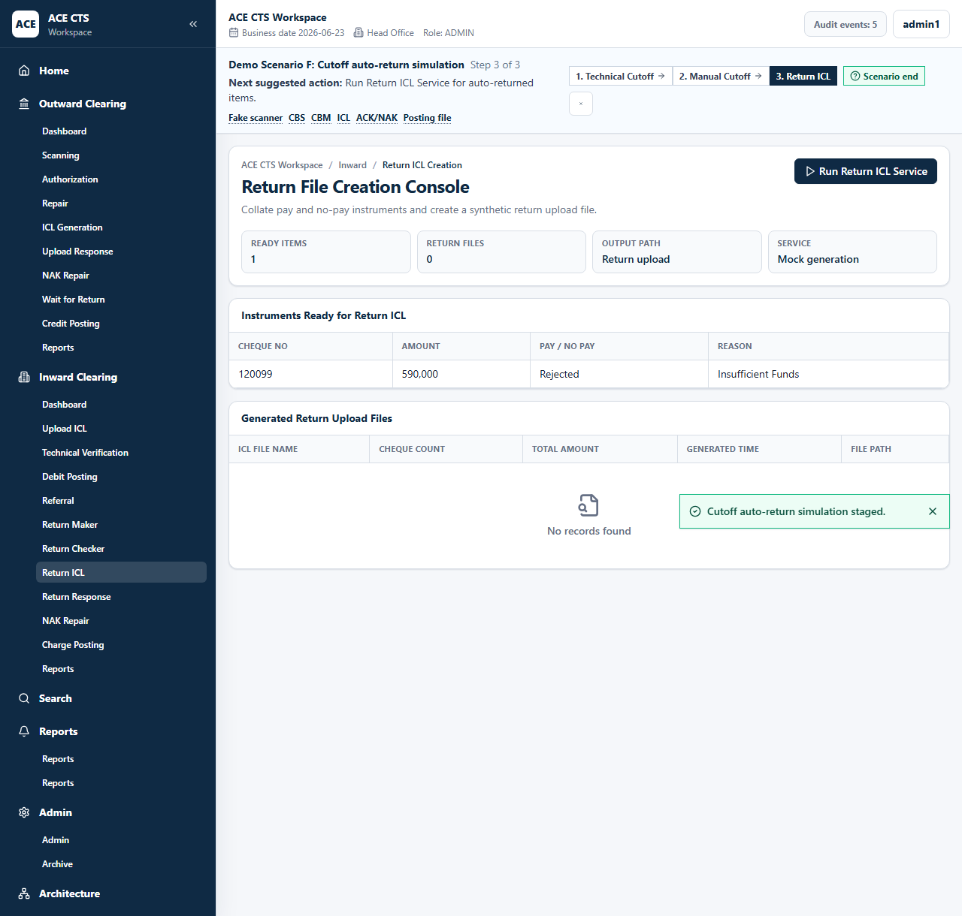
Figure 45: ACE CTS ICL Return Upload File Creation (Indicative and subject to change)

Priority
High

Integration Touch Point
ACE CTS shall exchange return ICL files with Clearing House / CBM.

Functional Requirement
ACE CTS shall provide the ICL Return Upload File Creation function with the workflow, validation, audit, and role controls described herein.

Actors
Service, Admin

Field Details / Control Behaviour
S. No. | Field Name | Field Type | Control Behaviour | Mandatory | Remarks
1 | Ready Instruments | Grid | Read-only | No | Cheque, amount, pay/no pay, reason
2 | Generated Return Upload Files | Grid | Read-only | No | File name, count, amount, time, path

Options / Buttons
S. No. | Option / Button | Behaviour | Validation / Confirmation | Target Work-step
1 | Run Return ICL Service | Generates return upload file | Eligible return items required | Return Upload File Response

Validation Rules
Return file count and amount shall reconcile with included instruments.

Confirmation Messages
ACE CTS shall display confirmation messages before committing irreversible or workflow-moving actions where indicated.

Target Work-step(s)
Routing Criteria | Target Work-step
File generated | Return Upload File Response

Audit Trail Requirement
Return upload file generation shall be audited.

3.5.9 Return Upload File Response

Description
ACE CTS shall capture Clearing House / CBM response for inward return upload files.

Screenshot / Figure
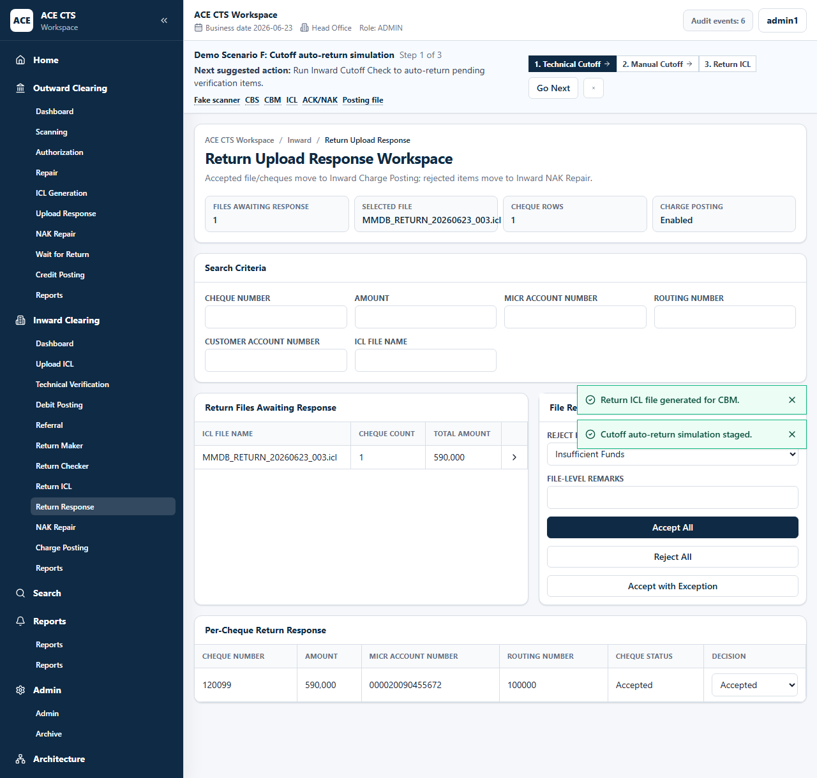
Figure 46: ACE CTS Return Upload File Response (Indicative and subject to change)
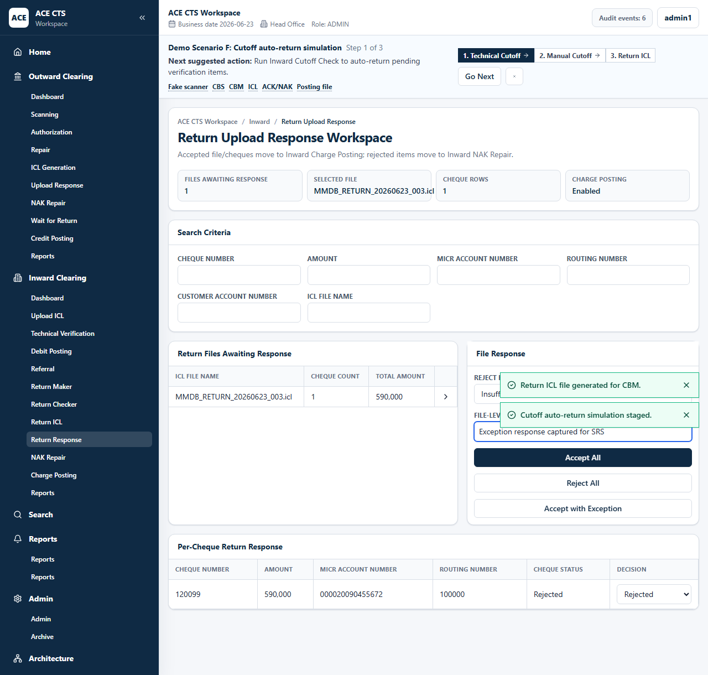
Figure 47: ACE CTS Return Upload File Response with Exception (Indicative and subject to change)

Priority
High

Integration Touch Point
ACE CTS shall receive or record Clearing House / CBM return upload acknowledgement details.

Functional Requirement
ACE CTS shall provide the Return Upload File Response function with the workflow, validation, audit, and role controls described herein.

Actors
Operations user, Admin

Field Details / Control Behaviour
S. No. | Field Name | Field Type | Control Behaviour | Mandatory | Remarks
1 | Search Criteria | Text | Editable | No | Cheque, amount, MICR, routing, account, file
2 | Reject Reason | List | Selectable | Conditional | Required for rejected response
3 | File-level Remarks | Text | Editable | Conditional | Required for rejected response
4 | Per-cheque Decision | List | Selectable | Yes | Accepted or rejected

Options / Buttons
S. No. | Option / Button | Behaviour | Validation / Confirmation | Target Work-step
1 | Accept All | Accepts return upload response | Confirmation through action | Charge Posting / Work Exit
2 | Reject All | Rejects file response | Reason and remarks required | Inward NAK Repair
3 | Accept with Exception | Routes per-cheque exceptions | Rejected items require reason and remarks | Mixed routing

Validation Rules
Rejected response decisions shall require reason and remarks.

Confirmation Messages
ACE CTS shall display confirmation messages before committing irreversible or workflow-moving actions where indicated.

Target Work-step(s)
Routing Criteria | Target Work-step
Accepted | Inward Charge Posting or Work Exit
Rejected | Inward NAK Repair

Audit Trail Requirement
Return response decisions shall be audited.

3.5.10 Inward NAK Repair

Description
ACE CTS shall allow repair of inward return upload items rejected by Clearing House / CBM.

Screenshot / Figure
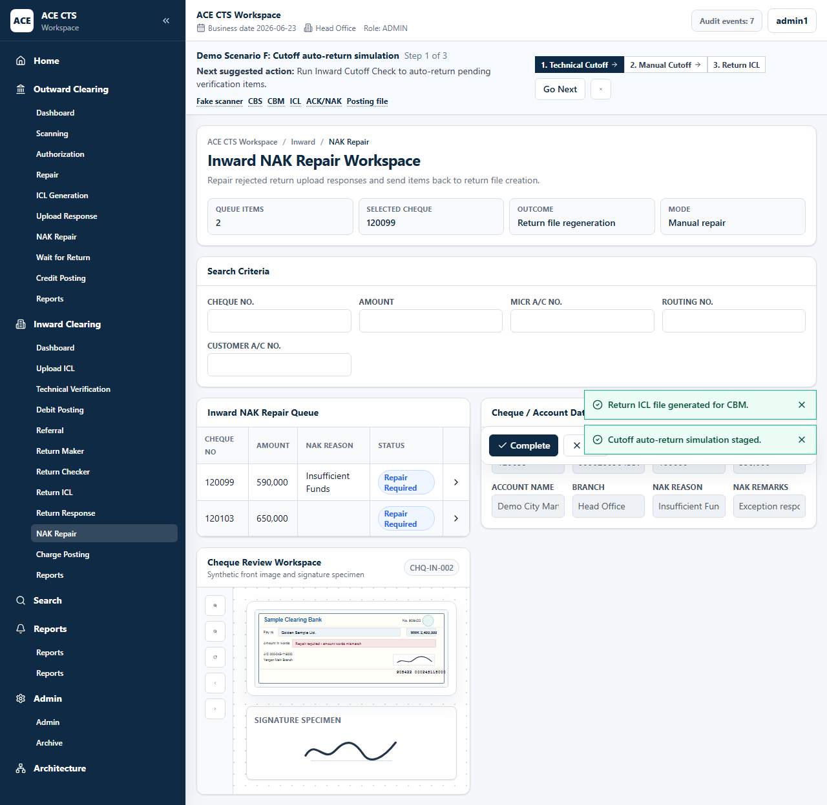
Figure 48: ACE CTS Inward NAK Repair (Indicative and subject to change)

Priority
High

Integration Touch Point
ACE CTS shall retain Clearing House / CBM NAK details with the item.

Functional Requirement
ACE CTS shall provide the Inward NAK Repair function with the workflow, validation, audit, and role controls described herein.

Actors
Maker, Admin

Field Details / Control Behaviour
S. No. | Field Name | Field Type | Control Behaviour | Mandatory | Remarks
1 | Search Criteria | Text | Editable | No | Queue filters
2 | Cheque / Account Data | Display | Disabled | No | Cheque and NAK details

Options / Buttons
S. No. | Option / Button | Behaviour | Validation / Confirmation | Target Work-step
1 | Complete | Completes repair | Valid data required | Return ICL Creation
2 | Exit | Leaves page | None | Dashboard

Validation Rules
Only inward NAK repair queue items shall be available on this page.

Confirmation Messages
ACE CTS shall display confirmation messages before committing irreversible or workflow-moving actions where indicated.

Target Work-step(s)
Routing Criteria | Target Work-step
Complete | Return ICL Creation

Audit Trail Requirement
Inward NAK repair completion shall be audited.

3.5.11 Inward Charge Posting

Description
ACE CTS shall generate charge posting files for inward items that require charge posting.

Screenshot / Figure
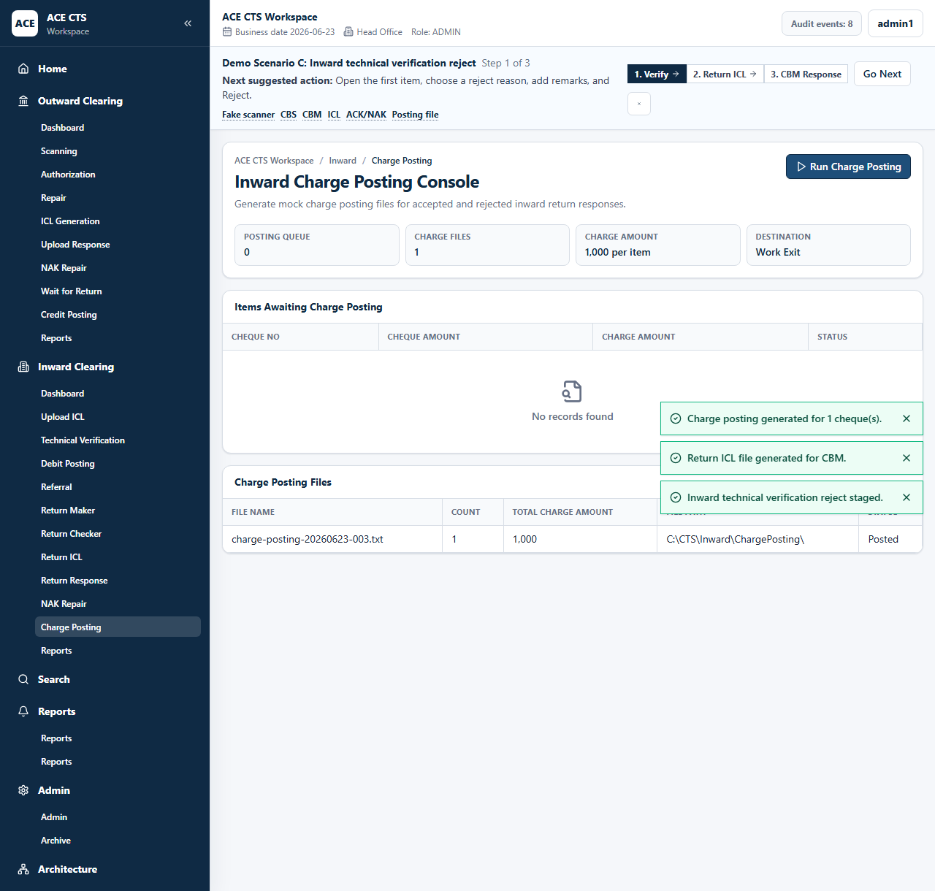
Figure 49: ACE CTS Inward Charge Posting (Indicative and subject to change)

Priority
High

Integration Touch Point
ACE CTS shall integrate with CBS for charge posting.

Functional Requirement
ACE CTS shall provide the Inward Charge Posting function with the workflow, validation, audit, and role controls described herein.

Actors
Service, Admin

Field Details / Control Behaviour
S. No. | Field Name | Field Type | Control Behaviour | Mandatory | Remarks
1 | Charge Amount | Amount | Read-only | No | Configured charge
2 | Charge Posting Files | Grid | Read-only | No | File, count, total charge amount, path, status

Options / Buttons
S. No. | Option / Button | Behaviour | Validation / Confirmation | Target Work-step
1 | Run Charge Posting | Generates charge posting file | Eligible charge items required | Work Exit

Validation Rules
Charge count and total amount shall reconcile with included items and configured charge amount.

Confirmation Messages
ACE CTS shall display confirmation messages before committing irreversible or workflow-moving actions where indicated.

Target Work-step(s)
Routing Criteria | Target Work-step
Posting generated | Work Exit

Audit Trail Requirement
Charge posting generation shall be audited.

3.5.12 Inward Reports

Description
ACE CTS shall provide inward clearing reports with search criteria, output preview, and controlled downloads.

Screenshot / Figure
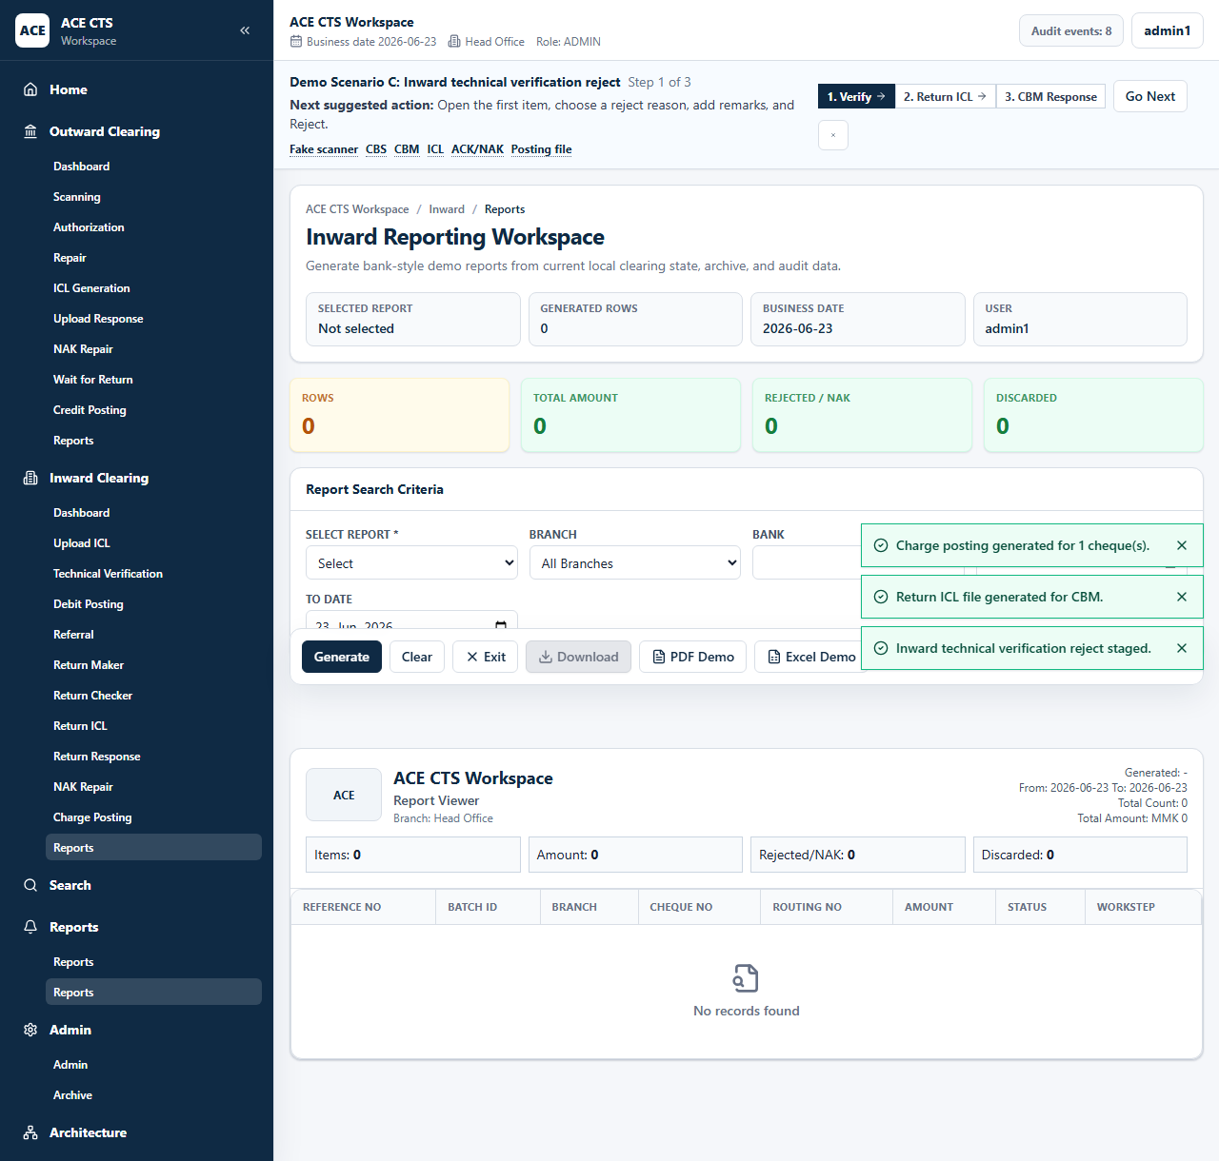
Figure 50: ACE CTS Inward Reports Search (Indicative and subject to change)
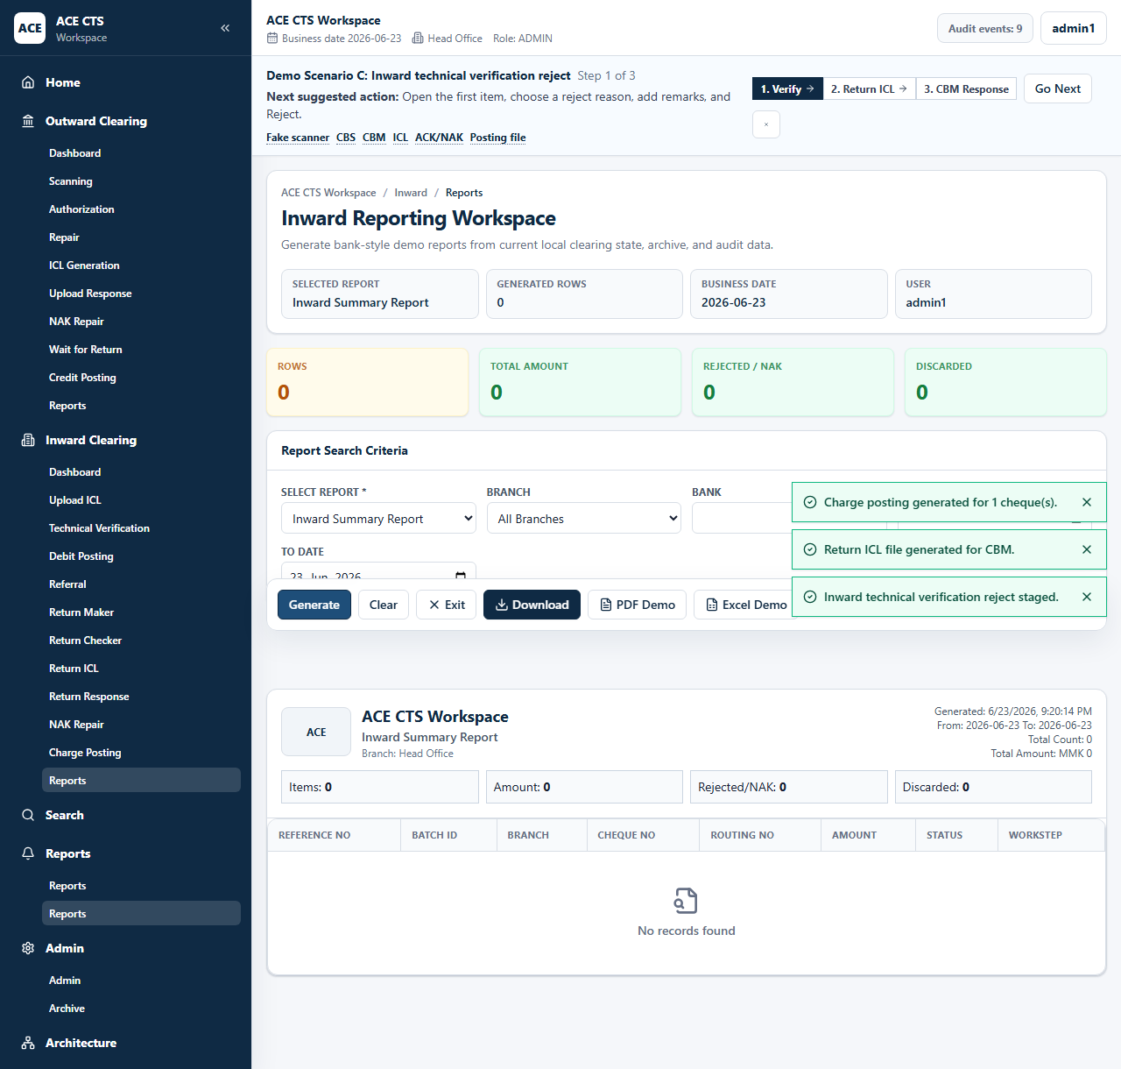
Figure 51: ACE CTS Inward Report Output (Indicative and subject to change)

Priority
High

Integration Touch Point
ACE CTS shall provide inward report extracts in Bank-approved formats.

Functional Requirement
ACE CTS shall provide the Inward Reports function with the workflow, validation, audit, and role controls described herein.

Actors
Maker, Checker, Admin

Field Details / Control Behaviour
S. No. | Field Name | Field Type | Control Behaviour | Mandatory | Remarks
1 | Select Report | List | Selectable | Yes | Inward report type
2 | Branch / Bank / Date Range | Search criteria | Editable | No | Filters report output

Options / Buttons
S. No. | Option / Button | Behaviour | Validation / Confirmation | Target Work-step
1 | Generate | Creates report output | Report type required | Report output
2 | Clear | Clears criteria | None | Search
3 | Download / PDF / Excel | Exports generated report | Report must be generated | Download
4 | Exit | Leaves reports | None | Dashboard

Validation Rules
Report type shall be mandatory. Date criteria shall be applied to returned results.

Confirmation Messages
ACE CTS shall display confirmation messages before committing irreversible or workflow-moving actions where indicated.

Target Work-step(s)
Routing Criteria | Target Work-step
Generate | Report output

Audit Trail Requirement
Report generation and download shall be audited.

3.6.4 Search Interface

Description
ACE CTS shall provide a general cheque search with process, routing, MICR, cheque, customer account, amount, date, and endorsement filters.

Screenshot / Figure
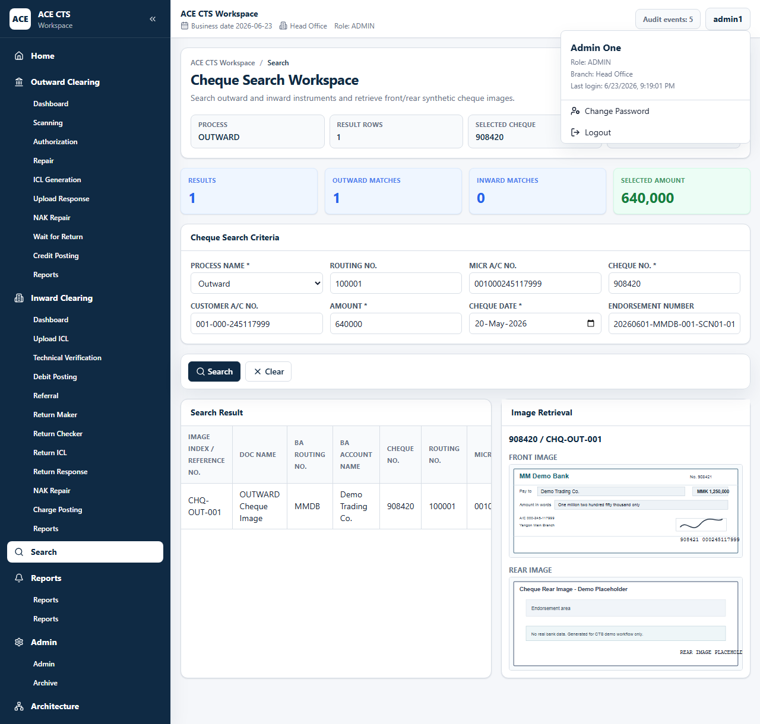
Figure 5: ACE CTS Cheque Search (Indicative and subject to change)
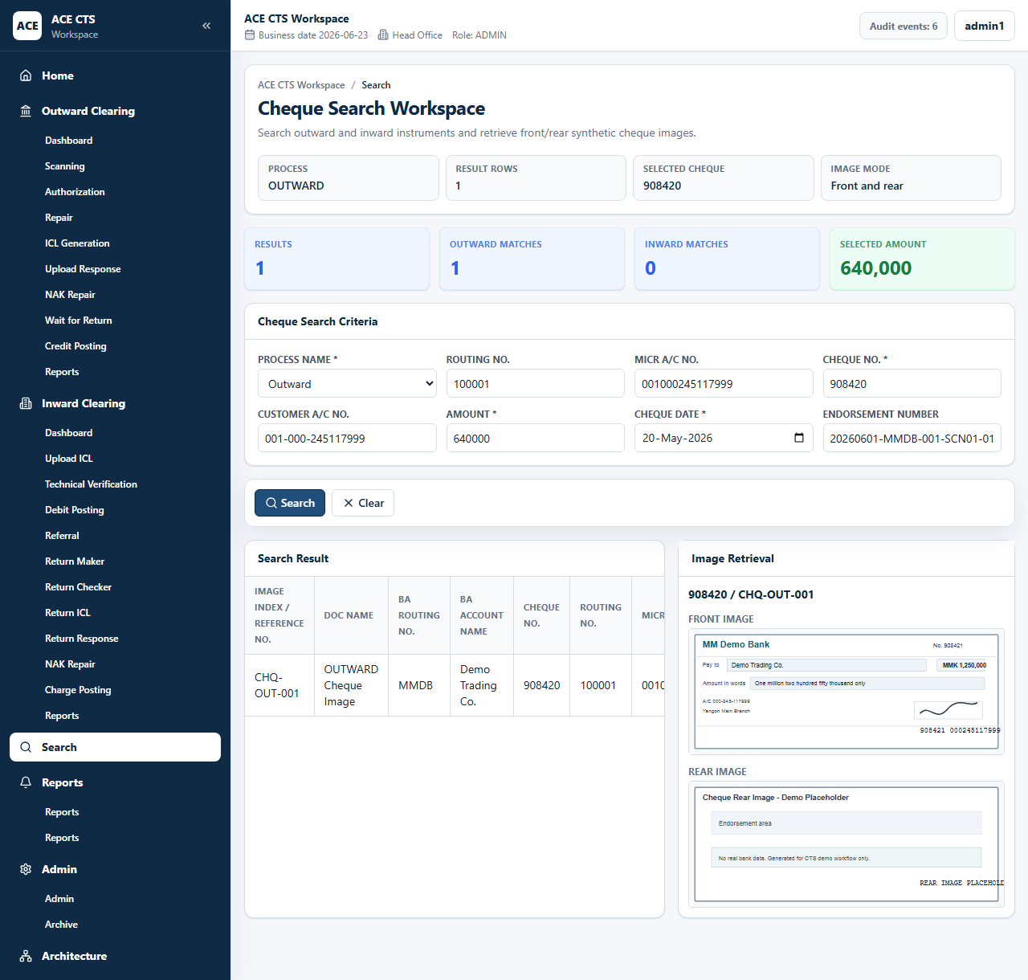
Figure 6: ACE CTS Cheque Search Image Viewer (Indicative and subject to change)

Priority
High

Integration Touch Point
ACE CTS shall search indexed cheque and archive records according to retention policy.

Functional Requirement
ACE CTS shall provide the Search Interface function with the workflow, validation, audit, and role controls described herein.

Actors
Maker, Checker, Admin

Field Details / Control Behaviour
S. No. | Field Name | Field Type | Control Behaviour | Mandatory | Remarks
1 | Process Name | List | Selectable | No | All, outward, inward
2 | Routing No. / MICR A/c No. / Cheque No. | Text | Editable | Conditional | Search identifiers
3 | Customer A/c No. / Amount / Cheque Date / Endorsement Number | Text/date | Editable | Conditional | Additional filters

Options / Buttons
S. No. | Option / Button | Behaviour | Validation / Confirmation | Target Work-step
1 | Search | Runs search and displays result grid | At least one useful criterion should be supplied by policy | Search Result
2 | Clear | Clears criteria | None | Search

Validation Rules
Search criteria shall be applied exactly to available cheque records.

Confirmation Messages
ACE CTS shall display confirmation messages before committing irreversible or workflow-moving actions where indicated.

Target Work-step(s)
Routing Criteria | Target Work-step
Result selected | Cheque image viewer

Audit Trail Requirement
Search and image viewing may be audited based on Bank policy.

3.6.2 Archival

Description
ACE CTS shall support archival lookup of terminal cheque records with associated images and audit trail.

Screenshot / Figure
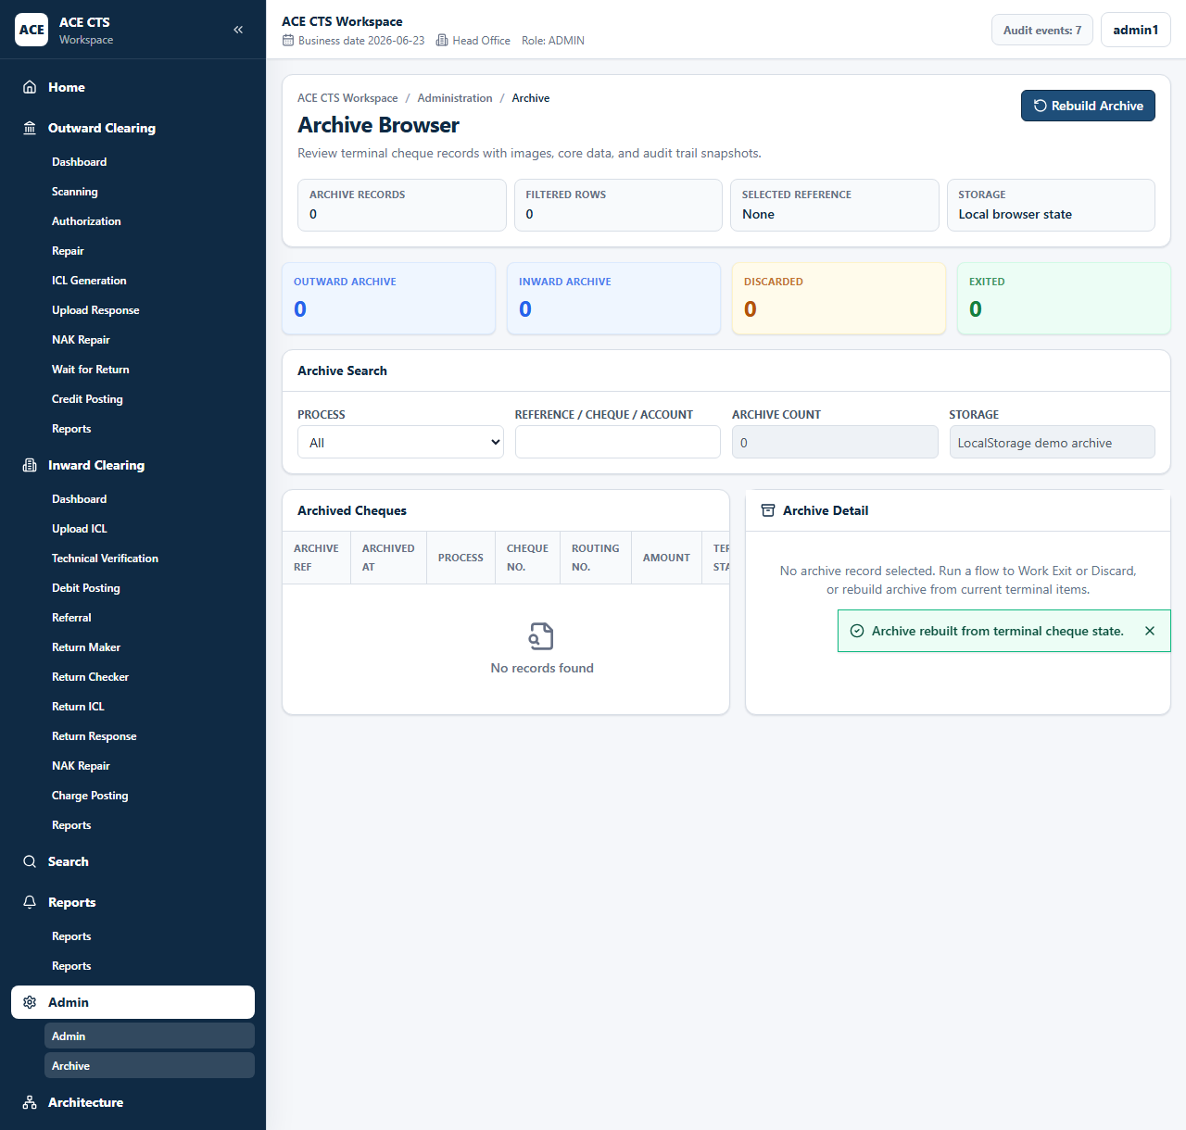
Figure 10: ACE CTS Archive Browser (Indicative and subject to change)

Priority
High

Integration Touch Point
ACE CTS shall support Bank-approved archival storage, indexing, and retrieval.

Functional Requirement
ACE CTS shall provide the Archival function with the workflow, validation, audit, and role controls described herein.

Actors
Admin

Field Details / Control Behaviour
S. No. | Field Name | Field Type | Control Behaviour | Mandatory | Remarks
1 | Archive Search | Search criteria | Editable | No | Process and reference filters
2 | Archive Count | Display | Read-only | No | Number of archived records

Options / Buttons
S. No. | Option / Button | Behaviour | Validation / Confirmation | Target Work-step
1 | Rebuild Archive | Rebuilds archive index from completed records | Admin access required | Archive Browser

Validation Rules
Only completed, exited, or discarded items shall be archived.

Confirmation Messages
ACE CTS shall display confirmation messages before committing irreversible or workflow-moving actions where indicated.

Target Work-step(s)
Routing Criteria | Target Work-step
Archived record selected | Archive detail

Audit Trail Requirement
Archive rebuild and record access shall be audited.

3.6.7 Admin Module

Description
ACE CTS shall provide user management, role assignment, queue visibility, settings, audit log, service controls, archive access, and reset functions.

Screenshot / Figure
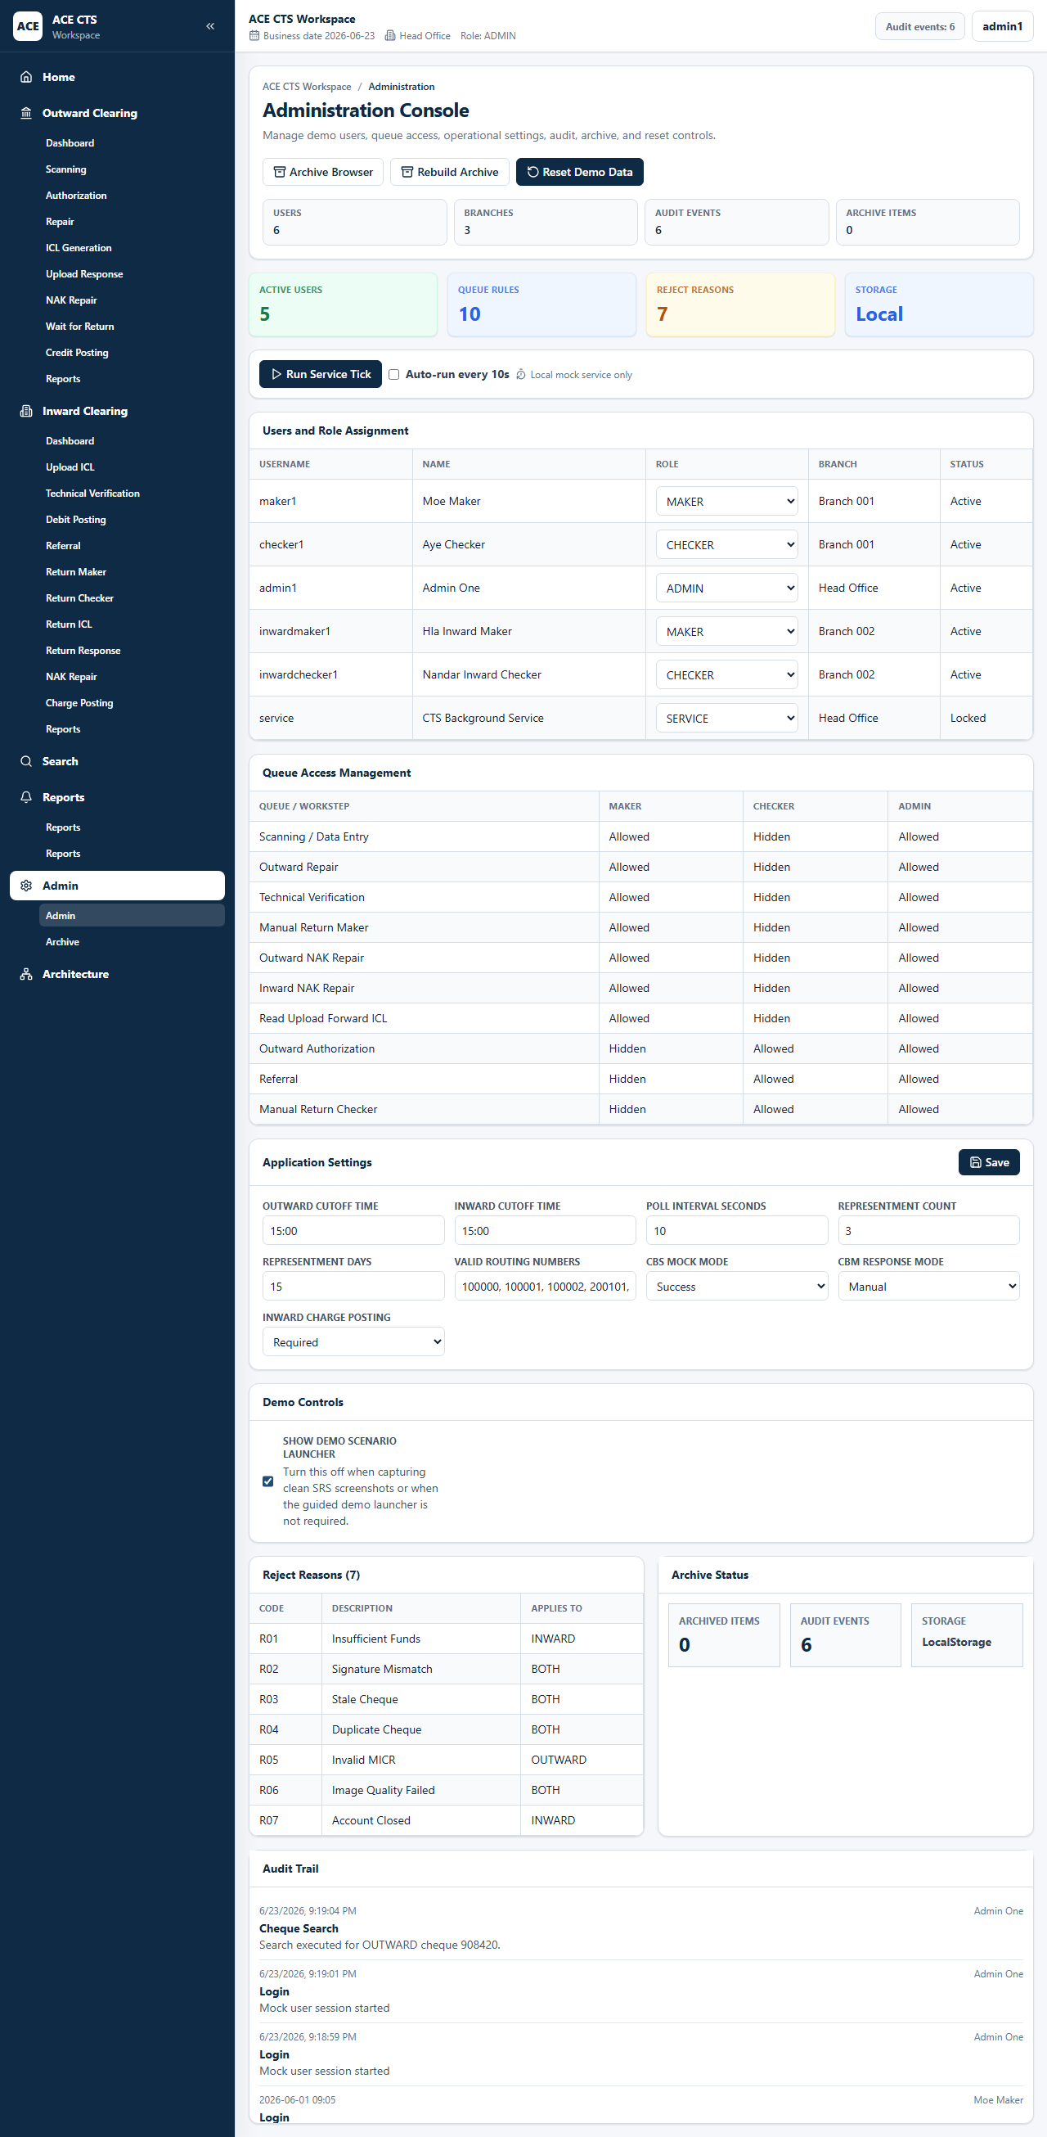
Figure 7: ACE CTS Admin Dashboard (Indicative and subject to change)
Figure 8: ACE CTS Admin Settings (Indicative and subject to change)
Figure 9: ACE CTS Audit Log (Indicative and subject to change)

Priority
High

Integration Touch Point
ACE CTS shall support Bank-defined user, role, queue, parameter, and system-administration controls.

Functional Requirement
ACE CTS shall provide the Admin Module function with the workflow, validation, audit, and role controls described herein.

Actors
Admin

Field Details / Control Behaviour
S. No. | Field Name | Field Type | Control Behaviour | Mandatory | Remarks
1 | Users and Role Assignment | Grid/list | Editable by admin | Yes | User role and status
2 | Queue Access Management | Display | Read-only | No | Role-based queue access
3 | Application Settings | Configuration | Editable by admin | Yes | Cutoff, poll interval, representment, routing, CBS/CBM settings
4 | Audit Log | Grid | Read-only | No | Audit events

Options / Buttons
S. No. | Option / Button | Behaviour | Validation / Confirmation | Target Work-step
1 | Save Settings | Saves configuration changes | Valid values required | Admin
2 | Reset Demo Data | Restores configured seed state | Admin confirmation policy recommended | Admin
3 | Rebuild Archive | Rebuilds archive index | Admin access required | Archive
4 | Archive | Opens archive browser | None | Archive Browser

Validation Rules
Only administrators shall access admin functions. Settings shall be validated before saving.

Confirmation Messages
ACE CTS shall display confirmation messages before committing irreversible or workflow-moving actions where indicated.

Target Work-step(s)
Routing Criteria | Target Work-step
Settings saved | Admin
Archive selected | Archive Browser

Audit Trail Requirement
User role updates, settings changes, archive rebuild, reset, and admin service actions shall be audited.

3.6.5 Dashboard
ACE CTS shall provide dashboard views showing workitem counts, workflow navigation, charts, and recent workitems for authorized users.
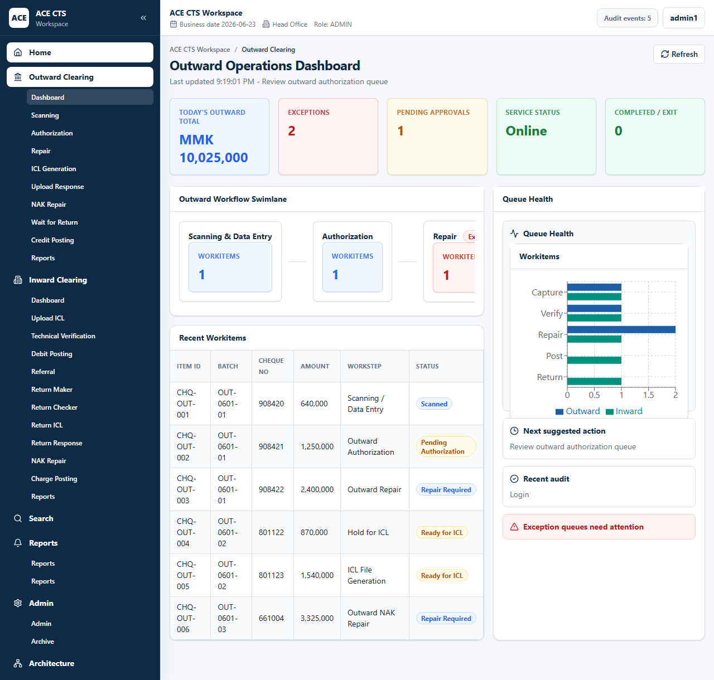
Figure 2: ACE CTS Home Dashboard (Indicative and subject to change)

4. External Interface Requirements
ACE CTS shall integrate with CBS, scanner stations, Clearing House / CBM file exchange, secure user access, and Bank-approved communication channels. Final interface specifications shall be finalized with the Bank.

5. Other Nonfunctional Requirements
ACE CTS shall satisfy Bank-approved performance, security, audit, availability, maintainability, backup, DR, and operational support requirements.

6. Appendix A: Deployment Diagram
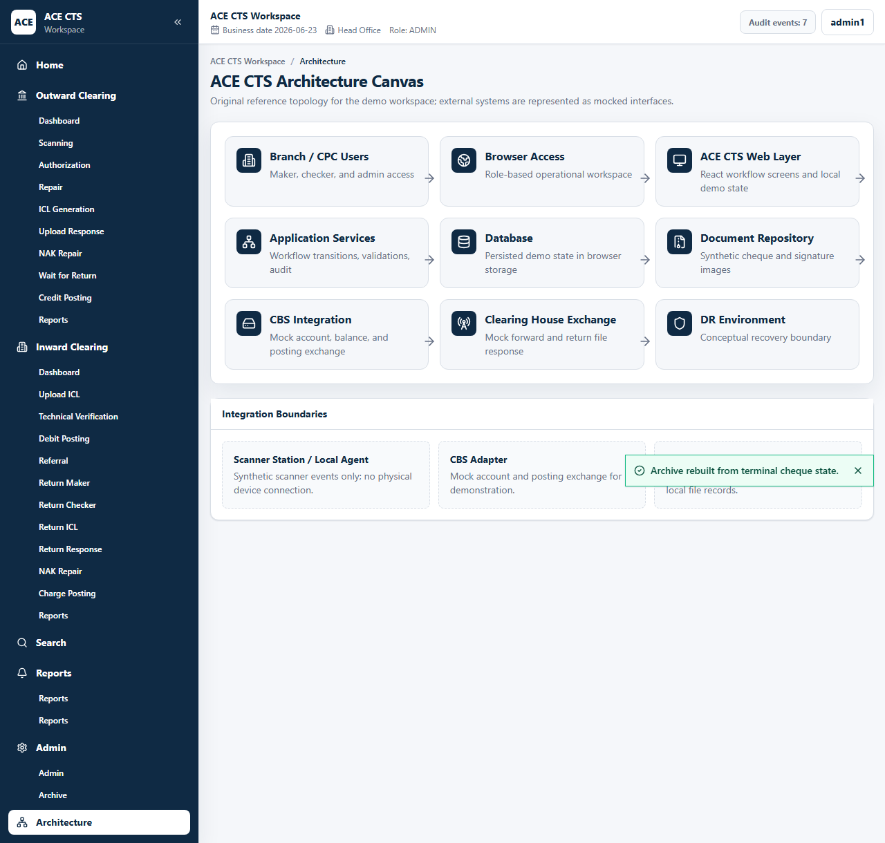
Figure 11: ACE CTS Architecture Canvas (Indicative and subject to change)
Final infrastructure, high availability, active/passive design, DR, recovery targets, firewall policy, certificate policy, and monitoring shall be confirmed with Bank IT.

7. Appendix B: Open Items
S. No. | Open Item | Owner | Resolution Requirement
1 | CBS interface specification | Bank / ACE Technology | Finalize before build
2 | Clearing House / CBM file specification | Bank / ACE Technology | Finalize file handling
3 | Scanner specification | Bank | Confirm hardware and driver
4 | HA/DR topology | Bank IT | Confirm production architecture

8. Appendix C: Integration Touch Points
Touch Point | Requirement
CBS Account Lookup | Fetch account, status, balance, and signature data
CBS Posting | Exchange debit, credit, and charge posting data
Clearing House / CBM | Exchange ICL and response files
Scanner Stations | Capture images, MICR, IQA, and endorsement data

9. Appendix D: List of Reject Reasons
Code | Description | Applies To
R01 | Insufficient Funds | Inward
R02 | Signature Mismatch | Both
R03 | Stale Cheque | Both
R04 | Duplicate Cheque | Both
R05 | Invalid MICR | Outward
R06 | Image Quality Failed | Both
R07 | Account Closed | Inward

10. Appendix E: Account Types and Status
Type / Status | Usage
Active | Eligible subject to Bank rules
Dormant | Requires Bank-defined handling
Inactive | Requires Bank-defined handling
Closed | Reject or return according to Bank rules
PO Cheque | PO-specific handling where applicable

11. Appendix F: New Reports
Outward Reports | Inward Reports
Outward Summary Report | Inward Introduction Report
Outward Return Report | Inward Summary Report
Negative Acknowledgement Report | Inward Clearing Report Referral
Outward Discard Cheques Report | Inward Clearing Report
Cheque Introduced in the System | Inward Return Report
Outward Cheque Honored | Auto Return Report
CB Accepted Cheques | Inward NAK Report
Return Advice Generation | Inward Pending Report

12. User Listing Requirement
Role / Queue | Required Access
MAKER | Outward scanning, outward repair, technical verification, manual return maker, outward NAK repair, inward NAK repair, upload ICL
CHECKER | Outward authorization, referral, manual return checker
ADMIN | All functional pages, admin settings, audit trail, archive, reset, role and queue management
SERVICE | Background service identity for scheduled audit events and interface processing

