

PreDomS

Prediction of Domains from Sequence

**Supervisor:**

Dr. Sahar Fazal

**Co-Supervisor:**

Sir Atif Aftab Ahmed Jilani

**Group Members:**

Syeda Anna Shahid (BI061004)

Sualeha Khan (BI061011)

**Approval**

This document has been checked and corrected for the mistakes. Now I approve this document for submission.

____________

**Dr. Sahar Fazal**

**(Project Supervisor)**

____________

**Sir Atif Aftab Ahmed Jilani**

**(Project Co-Supervisor)**

Revision History

|  |  |  |  |
| --- | --- | --- | --- |
| **Date** | **Issue** | **Description** | **Authors** |
| 05/03/09 | 1.0 | Project Vision | Syeda Anna Shahid  Sualeha Khan |
| 09/03/09 | 1.0 | Project SRS |
| 09/03/09 | 1.0 | Supplementary Specification |
| 04/04/09 | 1.1 | Revised Project SRS |
| 04/04/09 | 1.0 | Use Case Model |
| 16/04/09 | 1.1 | Use Case Model Revised |
| 27/04/09 | 1.0 | System Sequence Diagrams |
| 04/05/09 | 1.1 | System Sequence Diagrams Revised |
| 11/05/09 | 1.0 | System Contracts |
| 18/05/09 | 1.0 | Sequence Diagrams |
| 18/05/09 | 1.1 | Contracts revised |
| 22/05/09 | 1.1 | Sequence Diagrams Revised |
| 22/05/09 | 1.0 | Activity Diagrams |
| 1/12/09 | 1.2 | System Sequence Diagrams Revised |
| 4/12/09 | 1.2 | Contracts revised |
| 19/12/09 | 1.2 | Sequence Diagrams Revised |

Table of Contents

Chapter 1 9

Introduction 9

1. Overview 10

2. Purpose 10

3. Scope 10

4. Problem Statement 10

5. Motivation 11

Chapter 2 12

Vision 12

1. Objective 13

2. Scope 13

3. Positioning 13

3.1 Business Opportunity 13

3.2 Problem Statement 13

3.3 Product Position Statement 14

4. Product Overview 14

4.1 Product Perspective 14

4.2 Summary of Capabilities 15

4.3 Assumptions and Dependencies 15

Chapter 3 16

Software Requirement Specification 16

1. Purpose 17

2. Product Description 17

3. Product Objectives 17

4. User Description 17

4.1 User Demographics 17

4.2 User Profiles 18

4.3 Key User Needs 18

4.4 Alternatives and Competition 19

5. Feature Attributes 19

6. Product Features 20

7. Functional Requirements 20

Chapter 4 24

Use Case Model 24

1. Use Case Diagram 26

2. High Level Use Cases 27

3. Low Level Use Cases 36

4. Traceability Matrix 70

Chapter 5 72

User Interfaces 72

1. Login: 73

2. Main Menu*:* 73

*3.* Manage Transcription*:* 74

4. Manage Translation: 74

5. Manage Secondary Structure: 75

6. Manage Domain: 75

7. Perform Prediction*:* 76

7.1 Domain Settings*:* 77

7.2 Domain Output: 77

7.3 Secondary Structure Output: 78

*8.* View/Delete Process Result*:* 78

*9.* Manage Sequences*:* 79

9.1 Add Sequence: 79

9.2 View/Delete Sequence: 80

*10.* Manage Users*:* 80

10.1 Register User: 81

10.2 View/Disable User: 81

*10.3* Update User*:* 82

Chapter 6 83

Supplementary Specification 83

1. Introduction 84

2. Purpose 84

3. Scope 84

4. Definitions, Acronyms and Abbreviations 84

5. Usability 84

5.1 Navigation 84

5.2 Language 85

5.3 Aesthetics 85

5.4 User Friendly Interface 85

6. Performance 85

6.1 Response time for each process 85

6.2 Simultaneous Users 85

7. Supportability 85

7.1 Adaptability 85

7.2 Coding Standards 85

7.3 Naming Conventions 85

8. Design Constraints 86

8.1 Development tools 86

9. Other Performance Requirements 86

9.1 Platform Requirements 86

Chapter 7 87

Domain Model 87

*1.* Domain Model 89

Chapter 8 90

System Sequence Diagrams 90

*1.* Transcription*:* 92

*2.* Transcription Manager*:* 93

*3.* Translation*:* 94

*4.* Translation Manager*:* 95

*5.* Secondary Structure Prediction*:* 96

6. Secondary Structure Manager 97

7. Domain Prediction 98

8. Domain Manager 99

9. User Manager 100

10. Register User 101

11. Update User Information 101

12. Search User 102

13. Sequence Manager 103

Chapter 9 104

Operational Contracts 104

*1.* Manage Domain 106

*2.* Manage User 108

*3.* Manage Sequence 112

Chapter 10 115

Interaction Diagrams 115

*1.* Manage Transcription 117

1.1 Transcription 117

1.2 Add Transcription Result 118

1.3 View Transcription Result 119

1.4 Delete Transcription Result 120

*2.* Manage Translation 121

1.1 Translation 121

1.2 Add Translation Result 122

1.3 Delete Translation Result 123

1.4 View Translation Result 124

*3.* Manage Secondary Structure 125

3.1 Secondary Structure Prediction 125

3.2 Add Secondary Structure Result 126

3.3 View Secondary Structure Result 127

3.4 Delete Secondary Structure Result 128

*4.* Manage Domain 129

4.1 Domain Prediction 129

4.2 Add Domain 130

4.3 View Domain 131

4.4 Delete Domain 132

5. Manage Sequences 133

Chapter 11 142

Class Diagram 142

Chapter 12 146

Activity Diagrams 146

1. Transcription 148

2. Domain Prediction 149

# Chapter 1

## Introduction

# Overview

The structural and functional unit of proteins sequence is called domain. A protein can have one or more domains and its function is determined by the type of domains it constitutes. Therefore, domain prediction is of vital importance.

**PreDomS System** will be a toolkit, concerned specifically with proteins. PreDomS will provide the user with the freedom to predict domains when sequence is given as input. Other than domains, user will be able to perform some other operations as well like; transcription, translation and secondary structure prediction.

# Purpose

The purpose of PreDomS is to predict domains on the basis of sequence only, without using 3D structural information of proteins. It will provide the user the ease of performing different biological operations on a single platform which will save the time and resources for switching between different tools and software. It will support the usage of any type of the three sequences i.e. DNA, RNA and AA sequence as input to perform any operation.

# Scope

PreDomS will be dealing with following operations:

* Transcription of cDNA sequence
* Translation of mRNA sequence
* Prediction of secondary structure
* Prediction of domains
* Maintaining the record of the operations being performed
* Maintaining record of the users
* Maintaining a database of sequences

# Problem Statement

Predicting domains is a task which is tricky and of vital importance. PreDomS will provide the ease of domain prediction when only sequence data is available. Moreover, it will be beneficial for researchers who need to avoid hectic act of switching between different tools for the purpose of transcription, translation and secondary structure prediction and domain prediction.

# Motivation

Several methods for predicting domain boundaries from amino acid sequence have been proposed on the basis of a multiple sequence alignment. But these methods can only be successful in identifying domains if the sequence has detectable similarity to other sequence fragments in publicly available domain databases or, when the length of the unknown domains does not substantially deviate from the average of known protein structures.

Whereas, many domain prediction methods and tools take structural information as input which may be in the form of PDB file like Scooby Domain, CATH, SCOP, DIAL but our method allows the user to enter simple sequence information and predict domains within the target protein sequence. In other words, PreDomS will be a toolkit to predict domains on the basis of sequence information only.

The tools and software for the transcription, translation and prediction of different structures are available independently on different platforms. But these operations need to be available at a single stage because they depend upon each other. The records of operations performed by a user must be maintained for future reference. Therefore, PreDomS will be equipped with the qualities of maintaining its user’s database as well as provide four dependent operations on a single display place. A database of sequences will also be maintained in PreDomS to provide the user an ease to get the required sequence and use it on the same platform.

# Chapter 2

## Vision

# Objective

The objective of PreDomS is to predict domains on the basis of sequence only, without using 3D structural information of proteins. PreDomS will also provide the freedom to use any type of the three sequences i.e. DNA, RNA and AA sequence as input to perform any operation and provide the user the ease of performing different biological operations on a single platform. Using single platform will save the time and resources for switching between different tools and software.

# Scope

PreDomS will be able to handle three types of inputs i.e. DNA, RNA and AA sequence. It will provide the service of; Transcription for DNA sequence to yield RNA sequence, Translation to yield AA sequence with freedom of DNA or RNA sequence as input, Prediction of secondary structure of protein from DNA, RNA or AA sequence. Domain prediction provided by the PreDomS will be based on sequence only. Moreover records of the performed operations will be maintained for each user in a database according the choice of the user.

# Positioning

## Business Opportunity

This will be non-commercial software which will benefit the researchers (including bioinformaticians and researchers), the graduate and undergraduate students of different areas (e.g. bioinformatics, protein chemistry and proteomics) which involve secondary structure and domain prediction.

## Problem Statement

|  |  |
| --- | --- |
| The problem of | Transcribing and translating sequences, predicting secondary structure and predicting domains with accuracy |
| affects | Bioinformaticians and researchers because, a single platform for all these activities is not available. Other than this, researchers will be given a provision to predict domains on the basis of sequence only. |
| The impact of which is | Excess of time and resources consumption due to searching and installing more than one software and switching between them |
| A successful solution would | To develop software that provides the ease of protein function prediction required by most of the researchers. |

## 

## Product Position Statement

|  |  |
| --- | --- |
| For | Life sciences institutions or research centers |
| Who | Work on structure and function of proteins |
| The PreDomS | A computer based biological toolkit concerned with protein function |
| That | Will predict domains on the basis of sequence and perform other biological operations including transcription, translation and secondary structure prediction given any of the three types of input sequence on a single processor. |
| Unlike | DOMAC server which does not provide the results instantly and DIAL which is a web server for the identification of structural domains given the three-dimensional coordinates of a protein. |
| Our product | Will predict domains without having the need for the three dimensional structural information of protein and provide the results directly to the user instantly |

# Product Overview

A protein domain prediction tool which will predict protein secondary structure, allow users to enter any one of the three kinds of inputs i.e. DNA, RNA or Amino Acid sequence.

## Product Perspective

PreDomS will allow the user to predict the domains in a protein using the sequence alone and also provides facility of 3 other related operations. The PreDomS will perform its function independent of the non-redundant databases. This product will have different modules which are stated as follows:

* Module 1:
* Transcription
  + - (DNA->RNA->Protein)
* Module 2:
* Translation
  + - (RNA->Protein)
* Module 3:
* Protein secondary structure prediction
* Module 4:
* Domain prediction

## Summary of Capabilities

This tool can initiate its process from transcription, translation or direct by protein sequence depending upon the input. It predicts the protein secondary structure and makes it basis for the domain prediction by running one of the multiple algorithms depending upon researcher’s choice.

## Assumptions and Dependencies

This tool is suitable for windows operating system and is a desktop application. Thus, it needs to get installed on the system before use.

# Chapter 3

## Software Requirement Specification

# Purpose

The purpose of this document is to collect, analyse and define requirements related to software to be developed. It also collects and analyses the features of the software. This document also provides a vision of the features and facilities that are provided to the end user.

# Product Description

The product to be developed is toolkit software given the acronym name, PreDomS which stands for the Prediction of Domains from Sequence. PreDomS is specifically concerned with proteins which mainly predicts the domains present in a protein. Other than domain prediction, it also provides the user with the facility of performing operations like transcription, translation and secondary structure prediction.

# Product Objectives

The objective behind developing this product is to predict domains of those proteins whose structural information is not available as well as the others and to provide a single platform for multiple biological operations.

# User Description

## User Demographics

Research work is increasing day by day and becoming rapid than the past because the use of knowledge extracted from bioinformatics i.e. dealing with the biological data with the help of software and tools. PreDomS is also an application of bioinformatics that will help to predict domains in a protein which are the functional unit of proteins by giving its sequence. It will play a significant role in proteomics research centres where the target market space are CEMB (Centre of Excellence in Molecular Biology, Lahore) currently working on plant pharmacology, [Swiss Institute of Bioinformatics](http://www.isb-sib.ch/) (SIB), KRL (Kahutta Research Laboratories, Islamabad), EMBL (European Molecular Biology Laboratories) holding a number of projects which will benefit from the functionalities and EBI (European Bioinformatics Institute).

## User Profiles

|  |  |  |  |
| --- | --- | --- | --- |
| **Name** | **Description** | **Responsibilities** | **User Defined Success** |
| **Bioinformatician/ Researcher** | They usually need to use different programs to test the accuracy and nearest possibility of a predicted domain. PreDomS will reduce their work to use only one tool and get different results. | Bioinformatician is a scientist who uses bioinformatics tools to achieve some goals according to his/her field. Researcher uses bioinformatics principles (for efficiency) to solve biological problems in integration with wet laboratory work. | Domains predicted are close to reality or experimental results. |
| **Student** | Many tools available require lengthy trainings thus helping students along with burdening them. | Students are inclined to use tools so as to create assignments easily and use them in their research based projects. | Tool is user friendly, requires less training and is simple. |

## 

## Key User Needs

|  |  |  |
| --- | --- | --- |
| Problem Reason | Solution Required By the User | Solution |
| **To find secondary structure of a protein so that, it can be used to predict the main target (domains)** | Prediction of secondary structure elements with accuracy so that they can be further processed | PreDomS provides the reliable prediction of secondary structure elements and makes them basis for the prediction of the main target |
| **To find domains in a protein which are its functional units and thus, help a protein express itself.** | An efficient and reliable solution to domain prediction problem | PreDomS which is a trustworthy tool for domain prediction and gives its output with accuracy |

## Alternatives and Competition

There are tools available for the prediction of protein domains which either depend upon the structural information of protein e.g. DIAL or need detectable similarity of the protein 3D or 2D structure fragment to the solved proteins e.g. Scooby Domain Prediction Program but still there is a need of a software or tool that must be able to predict domains of the unsolved proteins which have no detectable similarity to already available protein tertiary structure. There are other programs which make prediction on the basis of similarity of sequence fragments to the solved proteins yet are not independent of databases of known protein information.

The tools available for protein domain prediction only provide the single facility of predicting domains. As transcription, translation, secondary structure prediction and domain prediction are related processes for the analysis of proteins, they are collected at one place in PreDomS and in none other software.

# Feature Attributes

|  |  |  |  |  |
| --- | --- | --- | --- | --- |
|  | F.1 | F.2 | F.3 | F.4 |
| **Feature** | **Input manipulation to amino acid sequence** | **Secondary Structure Prediction** | **Domain prediction** | **Prediction Result Display** |
| **Benefit** | Critical | Critical | Critical | Important |
| **Effort** | High effort but time taking. | High effort, Much time taking, Much resource needed. | High effort, Most time taking, high resources needed. | Medium effort and time taking. |
| **Risk** | Medium | High | High | Low |
| **Stability** | Stable | Not Stable | Not Stable | Not Stable |

# Product Features

This tool will make process initiation depending upon the user input because, it will provides the freedom of giving cDNA, mRNA or Amino Acid sequence as input. On the input basis it will perform transcription, translation or direct protein secondary structure prediction and the domain prediction.

It will provide the user, the chance to predict domain by using a method which takes sequence as input. Thus, it will provide a simple way of predicting domains by simply giving sequence as input. Other than this, it will provide a single platform supporting multiple biological operations.

It will also maintain the record of its users as well for security purpose so that only authenticated users can log in.

# Functional Requirements

**Module 1:**

* Transcription

This module involves the conversion of DNA sequence to RNA sequence

|  |  |  |
| --- | --- | --- |
| **Reference No.** | **Function** | **Category** |
| R1.1 | Input sequence identified to be DNA sequence | Evident |
| R.1.2 | Perform transcription and view the result | Evident |
| R.1.3 | Add transcription result to database | Evident |
| R.1.4 | View previously performed and added transcription results from database | Evident |
| R.1.5 | Delete previously performed transcription results from database | Hidden |

**Module 2:**

* Translation

Translation is the conversion of RNA sequence to amino acid sequence

|  |  |  |
| --- | --- | --- |
| **Reference No.** | **Function** | **Category** |
| R2.1 | Sequence identified to be RNA sequence | Evident |
| R2.2 | Perform translation and view the result | Evident |
| R2.3 | Add performed translation result to database | Evident |
| R2.4 | View previously performed and added translation results from database | Evident |
| R2.5 | Delete previously performed translation results from database | Hidden |

**Module 3:**

* **Secondary Structure Prediction**

This module involves the prediction of secondary structure elements of proteins.

|  |  |  |
| --- | --- | --- |
| **Reference No.** | **Function** | **Category** |
| R3.1 | Input sequence identified to be amino acid sequence | Evident |
| R3.2 | Find a-helices in the sequence if any | Hidden |
| R3.3 | Find b-sheets in the sequence if any | Hidden |
| R3.4 | Find turns in the sequence if any | Hidden |
| R3.5 | Display the result | Evident |
| R3.6 | Add performed secondary structure prediction result to database | Evident |
| R3.7 | View previously performed and added secondary structure prediction results from database | Evident |
| R3.8 | Delete previously performed secondary structure prediction results from database | Hidden |

**Module 4:**

* **Domain Prediction**

This module deals with finding the functional units of proteins which are known as domains. Domains are very important parts of proteins because; they determine the function and structure of a protein.

|  |  |  |
| --- | --- | --- |
| **Reference No.** | **Function** | **Category** |
| R4.1 | Identify the number of domains | Hidden |
| R4.2 | Display the number of domains | Evident |
| R4.3 | Add performed domain prediction result to database | Hidden |
| R4.4 | View previously performed and added domain prediction results from database | Evident |
| R4.5 | Delete previously performed domain prediction results from database | Hidden |

**Module 5:**

* **User Management**

|  |  |  |
| --- | --- | --- |
| **Reference No.** | **Function** | **Category** |
| R5.1 | Maintain the record of users to authenticate them | Hidden |
| R5.2 | Register new users | Evident |
| R5.3 | View record of users | Evident |
| R5.4 | Disable previously entered users who have lost their legality | Hidden |
| R5.5 | Update the record of users | Hidden |

**Module 6:**

* **Sequence Management**

|  |  |  |
| --- | --- | --- |
| **Reference No.** | **Function** | **Category** |
| R6.1 | Maintain the record of sequences | Hidden |
| R6.2 | Add new sequences | Evident |
| R6.3 | View previously added sequences | Evident |
| R6.4 | Delete previously entered sequences | Hidden |

# Chapter 4

## Use Case Model

This chapter shows and describes all the functional requirements of the system through use case diagram, high level use cases and expanded use cases. It also shows GUI translating each use case. It also includes traceability matrix which maps each requirement to use cases.

# Use Case Diagram



# High Level Use Cases

|  |  |
| --- | --- |
| **Use Case** | Start up |
| **Actor** | Researcher |
| **Type** | Primary |
| **Description** | A researcher powers on PreDomS system to prepare it for use. |

|  |  |
| --- | --- |
| **Use Case** | Authenticate User |
| **Actor** | Researcher |
| **Type** | Primary |
| **Description** | Researcher enters his username and password. System authenticates the username and password and logs the researcher in the system. |

|  |  |
| --- | --- |
| **Use Case** | Manipulate Sequence |
| **Actors** | Researcher |
| **Type** | Primary |
| **Description** | Researcher selects the type of input he wants to enter. Researcher enters the sequence. System filters the sequence according to the type of sequence mentioned. |

|  |  |
| --- | --- |
| **Use Case** | Transcribe Input |
| **Actor** | Researcher |
| **Type** | Primary |
| **Description** | Researcher selects the option to Transcribe Input. Researcher enters the sequence and selects its type. System verifies the sequence to be the DNA sequence. The cDNA sequence is processed by the system using transcription, a process, which involves the conversion of DNA sequence to mRNA sequence. Options to view, add the result of the process or either to go back or exit the system is shown to the researcher. |

|  |  |
| --- | --- |
| **Use Case** | Translate Input |
| **Actor** | Researcher |
| **Type** | Primary |
| **Description** | Researcher selects the option Translate Input. Researcher enters the sequence and selects its type. System verifies the sequence type and if it’s not mRNA sequence then, then converts it into mRNA sequence. mRNA sequence is processed by the system and converted to Amino Acid sequence by the process of translation. Options to view, add the result of the process or; either to go back or exit the system is shown to the researcher. |

|  |  |
| --- | --- |
| **Use Case** | Predict Secondary Structure |
| **Actor** | Researcher |
| **Type** | Primary |
| **Description** | Researcher selects the option to predict secondary structure. Researcher enters the sequence and selects its type. System verifies the sequence type and if it’s not AA sequence then converts it into AA sequence. System searches the sequence for a-helices and b-sheets. Turns are identified and therefore, on these bases secondary structure is predicted. The results are displayed by the system. Options to view, add the result of the process or either to go back or exit the system is shown to the researcher. |

|  |  |
| --- | --- |
| **Use Case** | Predict Domain |
| **Actors** | Researcher |
| **Type** | Primary |
| **Description** | Researcher selects the option to predict domain. System asks the researcher to enter the amino acid sequence or takes the amino acid sequence from the previous operation in case of the latter option. System predicts the domain boundaries and shows the results to the researcher. Options to add the result of the process or either to go back or exit the system is shown to the researcher. |

|  |  |
| --- | --- |
| **Use Case** | Manage Transcription |
| **Actors** | Researcher |
| **Type** | Primary |
| **Description** | Researcher selects the option to manage transcription. System provides the option to the researcher to manage transcription by, adding a transcription result, viewing transcription result, deleting transcription result, from the database. |

|  |  |
| --- | --- |
| **Use Case** | Add Transcription Result |
| **Actors** | Researcher |
| **Type** | Primary |
| **Description** | Researcher selects add transcription result option to add the result of transcription. If the process is already performed system will add it to the researcher’s account, if not, then the system will ask the researcher to transcribe some input to add its results. After transcribe input use case, system will show the option to add transcription result. After selection of this option system will add the result to researcher’s account and will display a success message. |

|  |  |
| --- | --- |
| **Use Case** | View Transcription Result |
| **Actors** | Researcher |
| **Type** | Primary |
| **Description** | Researcher selects the option to view transcription result. System asks the researcher the specification of the result he wants to view. Researcher enters the required information. System searches for the required result in database, and displays the transcription result to the researcher. |

|  |  |
| --- | --- |
| **Use Case** | Delete Transcription Result |
| **Actors** | Researcher |
| **Type** | Primary |
| **Description** | Researcher selects the option to delete transcription result. System asks the researcher the specification of the result he wants to delete. Researcher enters the required information. System searches for the required result in database and performs the delete operation. After deletion, success message is displayed to the researcher. |

|  |  |
| --- | --- |
| **Use Case** | Manage Translation |
| **Actors** | Researcher |
| **Type** | Primary |
| **Description** | Researcher selects the option to manage translation. System provides the option to the researcher to manage translation by, adding a translation result, viewing translation result, deleting translation result, from the database. |

|  |  |
| --- | --- |
| **Use Case** | Add Translation Result |
| **Actors** | Researcher |
| **Type** | Primary |
| **Description** | Researcher selects add translation result option to add the result of translation. If the process is already performed system will add it to the researcher’s account, if not, then the system will ask the researcher to transcribe some input to add its results. After translate input use case, system will show the option to add translation result. After selection of this option system will add the result to researcher’s account and will display a success message. |

|  |  |
| --- | --- |
| **Use Case** | View Translation Result |
| **Actors** | Researcher |
| **Type** | Primary |
| **Description** | Researcher selects the option to view translation result. System asks the researcher the specification of the result he wants to view. Researcher enters the required information. System searches for the required result in database, and displays the translation result to the researcher. |

|  |  |
| --- | --- |
| **Use Case** | Delete Translation Result |
| **Actors** | Researcher |
| **Type** | Primary |
| **Description** | Researcher selects the option to delete translation result. System asks the researcher the specification of the result he wants to delete. Researcher enters the required information. System searches for the required result in database and performs the delete operation. After deletion, success message is displayed to the researcher. |

|  |  |
| --- | --- |
| **Use Case** | Manage Secondary Structure Prediction |
| **Actors** | Researcher |
| **Type** | Primary |
| **Description** | Researcher selects the option to manage secondary structure prediction. System provides the option to the researcher to manage secondary structure prediction by, adding secondary structure prediction result, viewing secondary structure prediction result, deleting secondary structure prediction result, from the database. |

|  |  |
| --- | --- |
| **Use Case** | Add Secondary Structure Result |
| **Actors** | Researcher |
| **Type** | Primary |
| **Description** | Researcher selects add secondary structure result option to add the result of secondary structure prediction. If the process is already performed system will add it to the researcher’s account, if not, then the system will ask the researcher to predict secondary structure to add its results. After predict secondary structure use case, system will show the option to add secondary structure prediction result. After selection of this option system will add the result to researcher’s account and will display a success message. |

|  |  |
| --- | --- |
| **Use Case** | View Secondary Structure Result |
| **Actors** | Researcher |
| **Type** | Primary |
| **Description** | Researcher selects the option to view secondary structure prediction result. System asks the researcher the specification of the result he wants to view. Researcher enters the required information. System searches for the required result in database, and displays the secondary structure result to the researcher. |

|  |  |
| --- | --- |
| **Use Case** | Delete Secondary Structure Result |
| **Actors** | Researcher |
| **Type** | Primary |
| **Description** | Researcher selects the option to delete secondary structure prediction result. System asks the researcher the specification of the result he wants to delete. Researcher enters the required information. System searches for the required result in database and performs the delete operation. After deletion, success message is displayed to the researcher. |

|  |  |
| --- | --- |
| **Use Case** | Manage Domain Prediction |
| **Actors** | Researcher |
| **Type** | Primary |
| **Description** | Researcher selects the option to manage domain prediction. System provides the option to the researcher to manage domain prediction by, adding domain prediction result, viewing domain prediction result, deleting domain prediction result, from the database. |

|  |  |
| --- | --- |
| **Use Case** | Add Domain Prediction Result |
| **Actors** | Researcher |
| **Type** | Primary |
| **Description** | Researcher selects add domain prediction result option to add the result of domain prediction. If the process is already performed system will add it to the researcher’s account, if not, then the system will ask the researcher to predict domains to add its results. After predict domains use case, system will show the option to add domain prediction result. After selection of this option system will add the result to researcher’s account and will display a success message. |

|  |  |
| --- | --- |
| **Use Case** | View Domain Prediction |
| **Actors** | Researcher |
| **Type** | Primary |
| **Description** | Researcher selects the option to view domain prediction result. System asks the researcher the specification of the result he wants to view. Researcher enters the required information. System searches for the required result in database, and displays the domain prediction result to the researcher. |

|  |  |
| --- | --- |
| **Use Case** | Delete Domain Prediction Result |
| **Actors** | Researcher |
| **Type** | Primary |
| **Description** | Researcher selects the option to delete domain prediction result. System asks the researcher the specification of the result he wants to delete. Researcher enters the required information. System searches for the required result in database and performs the delete operation. After deletion, success message is displayed to the researcher. |

|  |  |
| --- | --- |
| **Use Case** | Manage Users |
| **Actors** | Administrator, Researcher |
| **Type** | Primary |
| **Description** | Administrator or Researcher selects the option to manage users. System displays the options to register, search, update user information and disable user. Administrator or researcher selects one of the options. |

|  |  |
| --- | --- |
| **Use Case** | Register User |
| **Actors** | Researcher |
| **Type** | Primary |
| **Description** | Researcher selects the option to register user. System takes user description, adds the user in the database and displays a success message. |

|  |  |
| --- | --- |
| **Use Case** | Search User |
| **Actors** | Administrator |
| **Type** | Primary |
| **Description** | Administrator selects the option to search user. System takes either user name or user id from the administrator to search a registered researcher. System then displays the results. Administrator selects one of the results to display detail information of the researcher. System displays selected researcher’s detail information. |

|  |  |
| --- | --- |
| **Use Case** | Update User Information |
| **Actors** | Researcher |
| **Type** | Primary |
| **Description** | Researcher selects the option to update user information. System displays user’s current information and provide option to modify each except the researcher’s id. Researcher modifies according to his/her will. System updates the information in database and displays a success message. |

|  |  |
| --- | --- |
| **Use Case** | Disable User |
| **Actors** | Administrator |
| **Type** | Primary |
| **Description** | Administrator selects the option to disable the researcher. System changes the status of researcher to disabled and displays a success message. |

|  |  |
| --- | --- |
| **Use Case** | Manage Sequences |
| **Actors** | Administrator |
| **Type** | Primary |
| **Description** | Administrator selects the option to manage sequences. System displays the options to add sequence, view sequence and delete sequence. Administrator selects one of the options. |

|  |  |
| --- | --- |
| **Use Case** | Add Sequences |
| **Actors** | Administrator |
| **Type** | Primary |
| **Description** | Administrator selects the option to add sequence. System takes the sequence along with its specification, adds in the database and displays a success message. |

|  |  |
| --- | --- |
| **Use Case** | Search Sequence |
| **Actors** | Administrator, Researcher |
| **Type** | Primary |
| **Description** | Administrator or Researcher selects the option to search sequence. System takes either sequence title or sequence id as input to search the sequence. System then displays the success message. System provides the option to either view the sequence or delete it. |

|  |  |
| --- | --- |
| **Use Case** | View Sequence |
| **Actors** | Administrator, Researcher |
| **Type** | Primary |
| **Description** | Administrator selects the option to view sequence. System displays the specified sequence. Researcher can use this sequence to perform some operation. |

|  |  |
| --- | --- |
| **Use Case** | Delete Sequence |
| **Actors** | Administrator |
| **Type** | Primary |
| **Description** | Administrator selects the option to delete sequence. System deletes the specified sequence and displays a success message. |

# Low Level Use Cases

**Use Case:** Transcribe Sequence

**Scope:** PreDomS (Prediction of Domains from Sequence).

**Primary Actor:** Researcher

**Overview:** The DNA sequence is processed by the system using transcription, a process, which involves the conversion of DNA sequence to RNA sequence.

**Stakeholders and Interests:**

**Researcher:** Wants accurate and immediate transcription.

**Pre-condition:** Sequence must be cDNA sequence.

**Success Guarantee:** DNA sequence is converted to RNA sequence by the process of transcription.

**Cross Reference:**

**Use Cases:** Manipulate Input

**Functions:** R.1.1, R.1.2, R.1.3

|  |  |
| --- | --- |
| **Actor Action** | **System Response** |
| 1. Researcher selects the type of sequence he wants to enter. |  |
| 2. Researcher enters the sequence, sequence title and selects start process option. |  |
|  | 3. System transcribes the input sequence to mRNA sequence and displays a message to inform the researcher that the process has been performed. |
|  | 4. System displays the following options to the user:   * View the result * Add the result * Back to main menu * Exit |
| 5. If ,   * View the result, is selected perform Sub flow: *View the Result* * Add the result, is selected perform Sub flow: *Add the result* * Back to main menu, is selected perform Sub flow: *Back to main menu* * Exit, is selected perform Sub flow: *Exit* |  |

**Alternatives:**

2. Researcher enters an incorrect sequence type

1. System displays a message to the researcher for incorrect sequence type and allows him to perform a new operation.

**Sub flow: View the Result**

|  |  |
| --- | --- |
| **Actor Action** | **System Response** |
|  | 1. System displays the result of transcription to the researcher. |

**Sub flow: Add the Result**

|  |  |
| --- | --- |
| **Actor Action** | **System Response** |
|  | 1. System adds the result of transcription to the database; assigns it an id and displays a success message for addition. |

**Sub flow: Back to Main Menu**

|  |  |
| --- | --- |
| **Actor Action** | **System Response** |
|  | 1. System returns back to the main menu |

**Sub flow: Exit**

|  |  |
| --- | --- |
| **Actor Action** | **System Response** |
|  | 1. System is closed. |

**Use Case:** Translate Sequence

**Scope:** PreDomS (Prediction of Domains from Sequence)

**Primary Actor:** Researcher

**Overview:** mRNA sequence is processed by the system and converted to Amino Acid sequence by the process of translation.

**Stakeholders and Interests:**

**Researcher:** Wants accurate and immediate translation to AA sequence.

**Pre-condition:** Sequence must be mRNA or cDNA sequence.

**Success Guarantee:** AA sequence for the given sequence has been predicted.

**Cross Reference:**

**Use Cases:** Manipulate Input

**Functions:** R2.1, R2.2,R2.3

|  |  |
| --- | --- |
| **Actor Action** | **System Response** |
| 1. Researcher selects the type of sequence he wants to enter. |  |
| 2. Researcher enters the sequence, title and selects start process option. |  |
|  | 3. System performs translation on the sequence entered as input. |
|  | 4. System displays the following options to the user:   * View the result * Add the result * Back to main menu * Exit |
| 5. If ,   * View the result, is selected perform Sub flow: *View the Result* * Add the result, is selected perform Sub flow: *Add the result* * Back to main menu, is selected perform Sub flow: *Back to main menu* * Exit, is selected perform Sub flow: *Exit* |  |

**Alternatives:**

2. Researcher enters an incorrect sequence type

1. System displays a message to the researcher for incorrect sequence type and allows him to perform a new operation.

**Sub flow: View the Result**

|  |  |
| --- | --- |
| **Actor Action** | **System Response** |
|  | 1. System displays the result of translation to the researcher. |

**Sub flow: Add the Result**

|  |  |
| --- | --- |
| **Actor Action** | **System Response** |
|  | 1. System adds the result of translation to the database; assigns it an id and displays a success message for addition of added result. |

**Sub flow: Back to Main Menu**

|  |  |
| --- | --- |
| **Actor Action** | **System Response** |
|  | 1. System returns back to the main menu |

**Sub flow: Exit**

|  |  |
| --- | --- |
| **Actor Action** | **System Response** |
|  | 1. System is closed. |

**Use Case:** Predict Secondary Structure

**Scope:** PreDomS (Prediction of Domains from Sequence)

**Primary Actor:** Researcher

**Overview:** System searches the sequence for a-helices and b-sheets. Turns are identified and therefore, on these bases secondary structure is predicted. The result is displayed by the system.

**Stakeholders and Interests:**

**Researcher:** Wants accurate and immediate prediction of secondary structure.

**Pre-condition:** Sequence must be an amino acid, mRNA or cDNA sequence.

**Success Guarantee:** Secondary structure elements are predicted.

**Cross Reference:**

**Use Cases:** Manipulate Input

**Functions:** R3.1, R3.2, R3.3, R3.4, R3.5,R3.6

|  |  |
| --- | --- |
| **Actor Action** | **System Response** |
| 1. Researcher selects the type of sequence he wants to enter. |  |
| 2. Researcher enters the sequence, title and selects start process option. |  |
|  | 3. System applies algorithm for secondary structure prediction on the sequence entered as input. |
|  | 4. System identifies a-helices in the sequence. |
|  | 5. System identifies b-sheets in the sequence. |
|  | 6. System identifies turns in the sequence. |
|  | 7. System displays the following options to the user:   * View the result * Add the result * Back to main menu * Exit |
| 8. If ,   * View the result, is selected perform Sub flow: *View the Result* * Add the result, is selected perform Sub flow: *Add the result* * Back to main menu, is selected perform Sub flow: *Back to main menu* * Exit, is selected perform Sub flow: *Exit* |  |

**Alternatives:**

2. Researcher enters an incorrect sequence type

1. System displays a message to the researcher for incorrect sequence type and allows him to perform a new operation.

**Sub flow: View the Result**

|  |  |
| --- | --- |
| **Actor Action** | **System Response** |
|  | 1. System displays the result of secondary structure to the researcher. |

**Sub flow: Add the Result**

|  |  |
| --- | --- |
| **Actor Action** | **System Response** |
|  | 1. System adds the result of secondary structure to the database; assigns it an id and displays a success message for addition of added result. |

**Sub flow: Back to Main Menu**

|  |  |
| --- | --- |
| **Actor Action** | **System Response** |
|  | 1. System returns back to the main menu |

**Sub flow: Exit**

|  |  |
| --- | --- |
| **Actor Action** | **System Response** |
|  | 1. System is closed. |

**Use Case:** Predict Domains

**Scope:** PreDomS (Prediction of Domains from Sequence)

**Primary Actor:** Researcher

**Overview:** Researcher enters the sequence as input. System verifies the input and applies the algorithm for domain prediction on it. Results of the prediction are displayed to the user according to his choice.

**Stakeholders and Interests:**

**Researcher:** Wants accurate and immediate prediction of domains.

**Pre-condition:** Amino acid sequence has been entered and verified.

**Success Guarantee:** Domains are predicted.

**Cross Reference:**

**Use Cases:** Manipulate Input

**Functions:** R4.1, R4.2, R4.3

|  |  |
| --- | --- |
| **Actor Action** | **System Response** |
| 1. Researcher enters the sequence, title and selects start process option. |  |
|  | 2. System uses the algorithm to identify the domains and the number of domains in for the sequence entered as input. |
|  | 3. System displays the domains and number of domains found. |
|  | 4. System displays the following options to the user:   * Add the result * Back to main menu * Exit | |
| 5. If ,   * Add the result, is selected perform Sub flow: *Add the result* * Back to main menu, is selected perform Sub flow: *Back to main menu* * Exit, is selected perform Sub flow: *Exit* |  | |

**Alternatives:**

2. Researcher enters an incorrect sequence type

1. System displays a message to the researcher for incorrect sequence type and allows him to perform a new operation.

**Sub flow: Add the Result**

|  |  |
| --- | --- |
| **Actor Action** | **System Response** |
|  | 1. System adds the result of domain prediction to the database; assigns it an id and displays a success message for addition along with the id of added result. |

**Sub flow: Back to Main Menu**

|  |  |
| --- | --- |
| **Actor Action** | **System Response** |
|  | 1. System returns back to the main menu |

**Sub flow: Exit**

|  |  |
| --- | --- |
| **Actor Action** | **System Response** |
|  | System is closed. |

**Use Case:** Manage Transcription

**Scope:** PreDomS (Protein Domain Prediction Software)

**Primary Actor:** Researcher

**Overview:** System provides the option to the researcher to manage transcription by, adding transcription result, viewing transcription result or deleting transcription result; from the database.

**Stakeholders and Interests**

**Researcher:** Wants accurate results of the transcription performed.

**Success Guarantee:** Transcription has been performed successfully and success message has been displayed.

**Cross Reference:**

**Use Cases:** Manipulate Input, Add Transcription Result, View Transcription Result, Delete Transcription Result

**Functions:** R1.1, R1.2, R1.3, R1.4, R1.5

|  |  |
| --- | --- |
| **Actor Action** | **System Response** |
| 1. Researcher selects the option of manage transcription |  |
|  | 2. System displays the following options to the user:   * Add result * View result * Delete result |
| If ,   * Add result option is selected sub flow *Add transcription result* begins. * View result option is selected sub flow *View* *transcription result* begins. * Delete result option is selected sub flow *Delete* *transcription result* begins. |  |

**Sub flow: Add Transcription Result**

|  |  |
| --- | --- |
| **Actor Action** | **System Response** |
|  | 1. System provides the option to the researcher to perform transcription so that it can be added to the database. |
|  | 2. *Use Case: Transcribe Input* |
| 3. Researcher selects the option to add the result once transcription has been performed and add result option has been displayed. |  |
|  | 4. System stores the query sequence, the resulting sequence and its specification in the account of the researcher through database. |
|  | 5. System displays a success message. |

**Sub flow: View Transcription Result**

|  |  |
| --- | --- |
| **Actor Action** | **System Response** |
|  | 1. System asks the researcher the specification of the result he wants to view from the database. |
| 2. Researcher specifies the desired result and selects the process. |  |
|  | 3. System displays the success message for the search. |
| 4. Researcher selects to view the result. |  |
|  | 5. System displays the desired result to the researcher. |

**Alternatives**

3. The desired result is not found.

1.1 System displays an error message which informs the researcher that the desired result was not found.

1.2 Repeat step 1.

**Sub flow: Delete Transcription Result**

|  |  |
| --- | --- |
| **Actor Action** | **System Response** |
|  | 1. System asks the researcher the specification of the result he wants to delete from the database. |
| 2. Researcher specifies the desired result and selects the process. |  |
|  | 3. System displays the success message for the search. |
| 4. Researcher selects to perform deletion. |  |
|  | 5. System displays a confirmation message to let the researcher confirm that the specified result needs to be deleted. |
| 6. Researcher assures the system to delete the result. |  |
|  | 7. System deletes the result from the database and displays a success message. |

**Alternatives:**

3. The desired result is not found.

1.1 System displays an error message which informs the researcher that the desired result was not found.

1.2 Repeat step 1.

**Use Case:** Manage Translation

**Scope:** PreDomS (Protein Domain Prediction Software)

**Primary Actor:** Researcher

**Overview:** System provides the option to the researcher to manage translation by, adding translation result, viewing translation result or deleting translation result; from the database.

**Stakeholders and Interests**

**Researcher:** Wants accurate results of the translation performed.

**Success Guarantee:** Translation has been performed successfully and success message has been displayed.

**Cross Reference:**

**Use Cases:** Manipulate Input, Add Translation Result, View Translation Result, Delete Translation Result

**Functions:** R2.1, R2.2, R2.3, R2.4,R2.5

|  |  |
| --- | --- |
| **Actor Action** | **System Response** |
| 1. Researcher selects the option of manage translation |  |
|  | 2. System displays the following options to the user:   * Add result * View result * Delete result |
| If ,   * Add result option is selected sub flow *Add translation result* begins. * View result option is selected sub flow *View* *translation result* begins. * Delete result option is selected sub flow *Delete* *translation result* begins. |  |

**Sub flow: Add Translation Result**

|  |  |
| --- | --- |
| **Actor Action** | **System Response** |
|  | 1. System provides the option to the researcher to perform translation so that it can be added to the database. |
|  | 2. *Use Case: Translate Input* |
| 3. Researcher selects the option to add the result once translation has been performed and add result option has been displayed. |  |
|  | 4. System stores the query sequence, the resulting sequence and its specification in the account of the researcher through database. |
|  | 5. System displays a success message. |

**Sub flow: View Translation Result**

|  |  |
| --- | --- |
| **Actor Action** | **System Response** |
|  | 1. System asks the researcher the specification of the result he wants to view from the database. |
| 2. Researcher specifies the desired result and selects the process. |  |
|  | 3. System displays the success message for the search. |
| 4. Researcher selects to view the result. |  |
|  | 5. System displays the desired result to the researcher. |

**Alternatives**

3. The desired result is not found.

1.1 System displays an error message which informs the researcher that the desired result was not found.

1.2 Repeat step 1.

**Sub flow: Delete Translation Result**

|  |  |
| --- | --- |
| **Actor Action** | **System Response** |
|  | 1. System asks the researcher the specification of the result he wants to delete from the database. |
| 2. Researcher specifies the desired result and process. |  |
|  | 3. System displays the success message for the search. |
| 4. Researcher selects to perform deletion. |  |
|  | 5. System displays a confirmation message to let the researcher confirm that the specified result needs to be deleted. |
| 6. Researcher assures the system to delete the result. |  |
|  | 7. System deletes the result from the database and displays a success message. |

**Alternatives:**

3. The desired result is not found.

1.1 System displays an error message which informs the researcher that the desired result was not found.

1.2 Repeat step 1.

**Use Case:** Manage Secondary Structure Prediction

**Scope:** PreDomS (Protein Domain Prediction Software)

**Primary Actor:** Researcher

**Overview:** System provides the option to the researcher to manage secondary structure prediction by, adding secondary structure result, viewing secondary structure result or deleting secondary structure result; from the database.

**Stakeholders and Interests**

**Researcher:** Wants accurate results of the secondary structure prediction performed.

**Success Guarantee:** Secondary structure prediction has been performed successfully and success message has been displayed.

**Cross Reference:**

**Use Cases:** Manipulate Input, Add Secondary Structure Result, View Secondary Structure Result, Delete Secondary Structure Result

**Functions:** R3.1, R3.2, R3.3, R3.4, R3.5,R3.6, R3.7, R3.8

|  |  |
| --- | --- |
| **Actor Action** | **System Response** |
| 1. Researcher selects the option of manage secondary structure prediction |  |
|  | 2. System displays the following options to the user:   * Add result * View result * Delete result |
| If ,   * Add result option is selected sub flow *Add secondary structure result* begins. * View result option is selected sub flow *View* *secondary structure result* begins. * Delete result option is selected sub flow *Delete* *secondary structure result* begins. |  |

**Sub flow: Add Secondary Structure Result**

|  |  |
| --- | --- |
| **Actor Action** | **System Response** |
|  | 1. System provides the option to the researcher to perform secondary structure prediction so that it can be added to the database. |
|  | 2. *Use Case: Predict Secondary Structure* |
| 3. Researcher selects the option to add the result once secondary structure has been predicted and add result option has been displayed. |  |
|  | 4. System stores the query sequence, the resulting sequence and its specification in the account of the researcher through database. |
|  | 5. System displays a success message. |

**Sub flow: View Secondary Structure Result**

|  |  |
| --- | --- |
| **Actor Action** | **System Response** |
|  | 1. System asks the researcher the specification of the result he wants to view from the database. |
| 2. Researcher specifies the desired result and selects the process. |  |
|  | 3. System displays the success message for the search. |
| 4. Researcher selects to view the result. |  |
|  | 5. System displays the desired result to the researcher. |

**Alternatives**

3. The desired result is not found.

1.1 System displays an error message which informs the researcher that the desired result was not found.

1.2 Repeat step 1.

**Sub flow: Delete Secondary Structure Result**

|  |  |
| --- | --- |
| **Actor Action** | **System Response** |
|  | 1. System asks the researcher the specification of the result he wants to delete from the database. |
| 2. Researcher specifies the desired result and process. |  |
|  | 3. System displays the success message for the search. |
| 4. Researcher selects to perform deletion. |  |
|  | 5. System displays a confirmation message to let the researcher confirm that the specified result needs to be deleted. |
| 6. Researcher assures the system to delete the result. |  |
|  | 7. System deletes the result from the database and displays a success message. |

**Alternatives:**

3. The desired result is not found.

1.1 System displays an error message which informs the researcher that the desired result was not found.

1.2 Repeat step 1.

**Use Case:** Manage Domain Prediction

**Scope:** PreDomS (Protein Domain Prediction Software)

**Primary Actor:** Researcher

**Overview:** System provides the option to the researcher to manage domain prediction by, adding domain prediction result, viewing domain prediction result or deleting domain result; from the database.

**Stakeholders and Interests**

**Researcher:** Wants accurate results of the domain prediction performed.

**Success Guarantee:** Domain prediction has been performed successfully and success message has been displayed.

**Cross Reference:**

**Use Cases:** Manipulate Input, Add Domain Prediction Result, View Domain Prediction Result, Delete Domain Prediction Result

**Functions:** R4.1, R4.2, R4.3, R4.4, R4.5

|  |  |
| --- | --- |
| **Actor Action** | **System Response** |
| 1. Researcher selects the option of manage domain prediction |  |
|  | 2. System displays the following options to the user:   * Add result * View result * Delete result |
| If ,   * Add result option is selected sub flow *Add domain prediction result* begins. * View result option is selected sub flow *View* *domain prediction result* begins. * Delete result option is selected sub flow *Delete* *domain prediction result* begins. |  |

**Sub flow: Add Domain Prediction Result**

|  |  |
| --- | --- |
| **Actor Action** | **System Response** |
|  | 1. System provides the option to the researcher to perform domain prediction so that it can be added to the database. |
|  | 2. *Use Case: Predict Domains* |
| 3. Researcher selects the option to add the result once domains have been predicted and add result option has been displayed. |  |
|  | 4. System stores the query sequence, the resulting sequence and its specification in the account of the researcher through database. |
|  | 5. System displays a success message. |

**Sub flow: View Domain Prediction Result**

|  |  |
| --- | --- |
| **Actor Action** | **System Response** |
|  | 1. System asks the researcher the specification of the result he wants to view from the database. |
| 2. Researcher specifies the desired result and selects the process. |  |
|  | 3. System displays the success message for the search. |
| 4. Researcher selects to view the result. |  |
|  | 5. System displays the desired result to the researcher. |

**Alternatives**

3. The desired result is not found.

1.1 System displays an error message which informs the researcher that the desired result was not found.

1.2 Repeat step 1.

**Sub flow: Delete Domain Prediction Result**

|  |  |
| --- | --- |
| **Actor Action** | **System Response** |
|  | 1. System asks the researcher the specification of the result he wants to delete from the database. |
| 2. Researcher specifies the desired result and process. |  |
|  | 3. System displays the success message for the search. |
| 4. Researcher selects to perform deletion. |  |
|  | 5. System displays a confirmation message to let the researcher confirm that the specified result needs to be deleted. |
| 6. Researcher assures the system to delete the result. |  |
|  | 7. System deletes the result from the database and displays a success message. |

**Alternatives:**

3. The desired result is not found.

1.1 System displays an error message which informs the researcher that the desired result was not found.

1.2 Repeat step 1.

**Use Case:** Manage User

**Scope:** PreDomS (Protein Domain Prediction Software)

**Primary Actor:** Researcher, Administrator

**Overview:** Administrator or Researcher selects the option to manage users. System displays the options to search user and update user information while in case of administrator it also displays the option of register user. Administrator/Researcher selects one of the options.

**Stakeholders and Interests**

**Researcher:** Wants to get the operation performed quickly and easily.

**Administrator:** Wants to maintain security and integrity of all the users.

**Success Guarantee:**

* The selected operation has executed
* Database is updated
* System has shown success message.

**Cross Reference:**

**Use Cases:** Register User, Search User, Update User Information, Disable User

**Functions:** R5.1,R 5.2,R 5.3, R 5.4, R 5.5

|  |  |
| --- | --- |
| **Actor Action** | **System Response** |
| 1. Researcher or administrator selects the option to manage user. |  |
|  | 2. System displays the following options to the user:   * Search User * Update User Information * Register User |
|  | 3. System disables the option of *Register User* and *Search User* if the current user is a researcher. |
| 4. If ,   * Search User, is selected Sub flow: *Search User begins* * Update User Information, is selected Sub flow: *Update User Information* begins. * Register User,is selected Subflow: *Register User* begins. |  |

**Sub flow: Search User**

|  |  |
| --- | --- |
| **Actor Action** | **System Response** |
|  | 1. System confirms that the current user is an administrator. |
|  | 2. System takes researcher’s ID or researcher’s name to search for a registered user. |
| 3. Administrator enters the ID of the researcher to be searched or enters the name of the researcher. |  |
|  | 4. System takes the entered description and searches it in the database. |
|  | 5. System displays the results of the search and provides the following options to the administrator;   * Disable User * View User Information * Back to Main * Exit |
| 6. If,   * Disable User is selected, Sub flow: *Disable User* begins. * View User Information is selected, Sub flow: *View User Information* begins. * Back to Main is selected, Sub flow: *Back to Main* begins * Exit is selected, Sub flow: *Exit* begins |  |

**Alternatives:**

1. The current user is not an administrator.

1.1 System displays an error message which informs the user that he/she does not have privileges to have desired facility.

1.2 System returns to the main menu.

5. The required result was not found.

5.1 System will show a message that no result was found.

**Sub flow: Disable User**

|  |  |
| --- | --- |
| **Actor Action** | **System Response** |
| 1. Administrator selects the user to be disabled, listed in search results. |  |
| 2. Administrator selects the disable user option. |  |
|  | 3. System asks the administrator to confirm if he is sure to disable the user. |
| 4. Administrator tells that he is sure to disable the user. |  |
|  | 4. System changes the status of the researcher to disabled. |
|  | 5. System displays a success message. |

**Alternatives:**

3. Administrator cancels the disable operation.

3.1 System returns to the search results.

**Sub flow: View User Information**

|  |  |
| --- | --- |
| **Actor Action** | **System Response** |
| 1. Administrator selects the user from the list of search results to display its information. |  |
| 2. Administrator selects the option of view user information. |  |
|  | 3. System displays the information of the selected user. |

**Sub flow: Update User Information**

|  |  |
| --- | --- |
| **Actor Action** | **System Response** |
| 1. User selects the option to update his/her information. |  |
|  | 2. System displays the following information of the user who is logged in currently:   * Name * Password * ID * Telephone No. * Address |
|  | 3. System displays areas to enter new telephone number, password and address of user. |
| 4. User enters the new telephone number, password and/or address and selects to update them. |  |
|  | 5. System asks the user if he/she is sure to make the entered changes. |
| 6. User confirms the request for making changes. |  |
|  | 7. System updates the information required to be modified and displays a success message |
|  | 8.System displays following options to user;   * Back to Main * Exit |
| 9.If,   * Back to Main is selected, Sub flow: *Back to Main* begins. * Exit is selected, Sub flow: *Exit* begins. |  |

**Alternatives:**

6a. User enters no changes.

6.1 System shows an error message that no changes have been entered.

6.2 System returns to step 1.

6b. The new password entered is different from the confirmed password.

6.1 System shows an error message that password confirmation has failed and asks the

user to try again.

6.2 System returns to step 1.

**Sub flow: Back to Main Menu**

|  |  |
| --- | --- |
| **Actor Action** | **System Response** |
|  | 1. System returns back to the main menu |

**Sub flow: Exit**

|  |  |
| --- | --- |
| **Actor Action** | **System Response** |
|  | System is closed. |

**Sub flow: Register User**

|  |  |
| --- | --- |
| **Actor Action** | **System Response** |
| 1. Researcher or Administrator selects the option to register user. |  |
|  | 2. System asks the description of the researcher which include:   * ID * Name * Password * Telephone No. * Address |
|  | 3. System sets the role of new user to researcher if the current user is researcher. |
|  | 4. System displays the option of selecting a role of new user to be an administrator or a researcher if the current user is administrator. |
| 5. Researcher enters the required information and selects the appropriate option. |  |
|  | 6. System creates a new account in the database and stores the information of the researcher. |
|  | 7. System displays a success message. |

**Alternatives:**

2a. Confirmation password and password do not match.

2.1 System shows an error message that password confirmation has failed.

2.2 System returns to step 1.

6a. A user with the same ID already exists.

6.1 System shows a message to enter some other id.

6.2 System returns to step 1.

**Use Case:** Manage Sequences

**Scope:** PreDomS (Protein Domain Prediction Software)

**Primary Actor:** Researcher, Administrator

**Overview:** Administrator or Researcher selects the option to manage sequences. System displays the options to add, view or delete sequence. Administrator/Researcher selects one of the options.

**Stakeholders and Interests**

**Researcher:** Wants to get the operation performed quickly and easily.

**Administrator:** Wants to maintain security and integrity of all the users.

**Success Guarantee:**

* The selected operation has executed
* Database is updated
* System has shown success message.

**Cross Reference:**

**Use Cases:** Add Sequence, Search Sequence, View Sequence, Delete Sequence

**Functions:** R6.1,R6.2,R6.3,R6.4

|  |  |
| --- | --- |
| **Actor Action** | **System Response** |
| 1. Researcher or administrator selects the option to manage sequences. |  |
|  | 2. System displays the following options to the user:   * Add Sequence * Search Sequence |
| 3. If ,   * Add Sequence, is selected Sub flow: *Add Sequence* begins * Search Sequence, is selected Sub flow: *Search Sequence* begins. |  |

**Sub flow: Add Sequence**

|  |  |
| --- | --- |
| **Actor Action** | **System Response** |
|  | 1. System confirms that the current user is an administrator. |
| 2. Administrator enters the sequence along with its specification. |  |
| 3. Administrator selects enter to add the provided information. |  |
|  | 4. System assigns the sequence an ID and adds it to database. |
|  | 5. System displays success message. |
|  | 6. System provides the following options;   * Back to Main * Exit |
| 7. 6. If,   * Back to Main is selected, Sub flow: *Back to Main* begins * Exit is selected, Sub flow: *Exit* begins |  |

**Sub flow: Back to Main Menu**

|  |  |
| --- | --- |
| **Actor Action** | **System Response** |
|  | 1. System returns back to the main menu |

**Sub flow: Exit**

|  |  |
| --- | --- |
| **Actor Action** | **System Response** |
|  | System is closed. |

**Sub flow: Search Sequence**

|  |  |
| --- | --- |
| **Actor Action** | **System Response** |
|  | 1. System takes sequence’ ID and name to search for a sequence. |
| 2. Administrator or researcher enters the ID or the name of the sequence to be searched. |  |
|  | 3. System takes the entered description and searches it in the database. |
|  | 4. System displays the results of the search and provides the following options;   * View Sequence * Delete Sequence * Back to Main * Exit |
| 6. If,   * View Sequence is selected, Sub flow: *View Sequence* begins. * Delete Sequence is selected, Sub flow: *Delete Sequence* begins. * Back to Main is selected, Sub flow: *Back to Main* begins * Exit is selected, Sub flow: *Exit* begins |  |

**Alternatives:**

4. The required result was not found.

4.1 System will show a message that no result was found.

4.2 System provides the following options;

* Back to Main
* Exit

**Sub flow: View Sequence**

|  |  |
| --- | --- |
| **Actor Action** | **System Response** |
| 1. Administrator or researcher selects to view the found result. |  |
|  | 2. System displays the information of the found result. |
|  | 3.System displays following options to administrator;   * Back to Main * Exit |
| 4.If,   * Back to Main is selected, Sub flow: *Back to Main* begins. * Exit is selected, Sub flow: *Exit* begins. |  |

**Sub flow: Delete Sequence**

|  |  |
| --- | --- |
| **Actor Action** | **System Response** |
| 1. Administrator selects to delete the found sequence. |  |
|  | 3. System confirms the administrator to delete the sequence. |
| 2. Administrator confirms his will. |  |
|  | 4. System deletes the sequence from the database. |
|  | 5. System displays a success message. |

**Sub flow: Back to Main Menu**

|  |  |
| --- | --- |
| **Actor Action** | **System Response** |
|  | 1. System returns back to the main menu |

**Sub flow: Exit**

|  |  |
| --- | --- |
| **Actor Action** | **System Response** |
|  | System is closed. |

# Traceability Matrix

|  |  |  |  |  |  |  |  |  |  |  |  |  |  |  |  |  |  |  |  |  |  |  |  |  |  |  |  |  |  |  |  |  |  |  |  |  |
| --- | --- | --- | --- | --- | --- | --- | --- | --- | --- | --- | --- | --- | --- | --- | --- | --- | --- | --- | --- | --- | --- | --- | --- | --- | --- | --- | --- | --- | --- | --- | --- | --- | --- | --- | --- | --- |
|  | | **Requirements** | | | | | | | | | | | | | | | | | | | | | | | | | | | | | |  | | | | |
| **Use Cases** | | **Sub flows** | | R 1.1 | R 1.2 | R 1.3 | R 1.4 | R 1.5 | R 2.1 | R 2.2 | R 2.3 | R 2.4 | R 2.5 | R 3.1 | R 3.2 | R 3.3 | R 3.4 | R 3.5 | R 3.6 | R 3.7 | R 3.8 | R 4.1 | R 4.2 | R 4.3 | R 4.4 | R 4.5 | R 5.1 | R 5.2 | R 5.3 | R 5.4 | R 5.5 | |  |  |  |  |
| Manage Transcription | | Add Transcription Result | | √ | √ | √ |  |  |  |  |  |  |  |  |  |  |  |  |  |  |  |  |  |  |  |  |  |  |  |  |  | |  |  |  |  |
| View Transcription Result | |  |  |  | √ |  |  |  |  |  |  |  |  |  |  |  |  |  |  |  |  |  |  |  |  |  |  |  |  | |  |  |  |  |
| Delete Transcription Result | |  |  |  |  | √ |  |  |  |  |  |  |  |  |  |  |  |  |  |  |  |  |  |  |  |  |  |  |  | |  |  |  |  |
| Manage Translation | | Add Transcription Result | |  |  |  |  |  | √ | √ | √ |  |  |  |  |  |  |  |  |  |  |  |  |  |  |  |  |  |  |  |  | |  |  |  |  |
| View Transcription Result | |  |  |  |  |  |  |  |  | √ |  |  |  |  |  |  |  |  |  |  |  |  |  |  |  |  |  |  |  | |  |  |  |  |
| Delete Transcription Result | |  |  |  |  |  |  |  |  |  | √ |  |  |  |  |  |  |  |  |  |  |  |  |  |  |  |  |  |  | |  |  |  |  |
| Manage Secondary Structure Prediction | | Add Secondary Structure Result | |  |  |  |  |  |  |  |  |  |  | √ | √ | √ | √ | √ | √ |  |  |  |  |  |  |  |  |  |  |  |  | |  |  |  |  |
| View Secondary Structure Result | |  |  |  |  |  |  |  |  |  |  |  |  |  |  |  |  | √ |  |  |  |  |  |  |  |  |  |  |  | |  |  |  |  |
| Delete Secondary Structure Result | |  |  |  |  |  |  |  |  |  |  |  |  |  |  |  |  |  | √ |  |  |  |  |  |  |  |  |  |  | |  |  |  |  |
| Manage Domain Predicton | | Add Domain Prediction Result | |  |  |  |  |  |  |  |  |  |  |  |  |  |  |  |  |  |  | √ | √ | √ |  |  |  |  |  |  |  | |  |  |  |  |
| View Domain Prediction Result | |  |  |  |  |  |  |  |  |  |  |  |  |  |  |  |  |  |  |  |  |  | √ |  |  |  |  |  |  | |  |  |  |  |
| Delete Domain Prediction Result | |  |  |  |  |  |  |  |  |  |  |  |  |  |  |  |  |  |  |  |  |  |  | √ |  |  |  |  |  | |  |  |  |  |
| Transcribe Sequence | | | | √ | √ | √ |  |  |  |  |  |  |  |  |  |  |  |  |  |  |  |  |  |  |  |  |  |  |  |  |  | |  |  |  |  |
| Translate Sequence | | | |  |  |  |  |  | √ | √ | √ |  |  |  |  |  |  |  |  |  |  |  |  |  |  |  |  |  |  |  |  | |  |  |  |  |
| Predict Secondary Structure | | | |  |  |  |  |  |  |  |  |  |  | √ | √ | √ | √ | √ | √ |  |  |  |  |  |  |  |  |  |  |  |  | |  |  |  |  |
| Predict Domains | | | |  |  |  |  |  |  |  |  |  |  |  |  |  |  |  |  |  |  | √ | √ | √ |  |  |  |  |  |  |  | |  |  |  |  |
| Manage Sequences | Add Sequence | | |  |  |  |  |  |  |  |  |  |  |  |  |  |  |  |  |  |  |  |  |  |  |  |  |  |  |  |  | | √ | √ |  |  |
| View Sequence | | |  |  |  |  |  |  |  |  |  |  |  |  |  |  |  |  |  |  |  |  |  |  |  |  |  |  |  |  | | √ |  | √ |  |
| Delete Sequence | | |  |  |  |  |  |  |  |  |  |  |  |  |  |  |  |  |  |  |  |  |  |  |  |  |  |  |  |  | | √ |  |  | √ |
| Manage User | Register User | | |  |  |  |  |  |  |  |  |  |  |  |  |  |  |  |  |  |  |  |  |  |  |  | √ | √ |  |  |  | |  |  |  |  |
| Update User Information | | |  |  |  |  |  |  |  |  |  |  |  |  |  |  |  |  |  |  |  |  |  |  |  | √ |  |  |  | √ | |  |  |  |  |
| Search User | | Disable User |  |  |  |  |  |  |  |  |  |  |  |  |  |  |  |  |  |  |  |  |  |  |  | √ |  |  | √ |  | |  |  |  |  |
| View User Information |  |  |  |  |  |  |  |  |  |  |  |  |  |  |  |  |  |  |  |  |  |  |  | √ |  | √ |  |  | |  |  |  |  |

# Chapter 5

## User Interfaces

# Login:

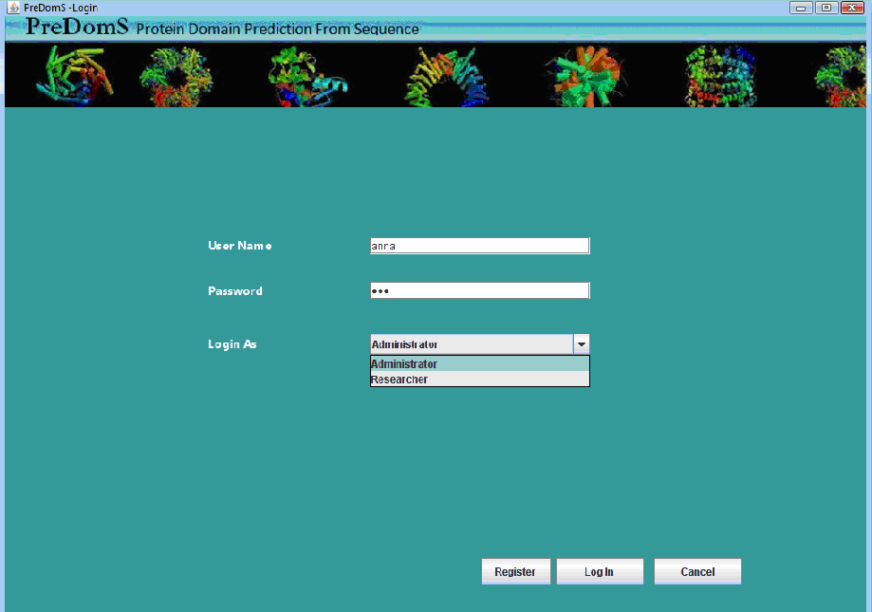

# Main Menu*:*

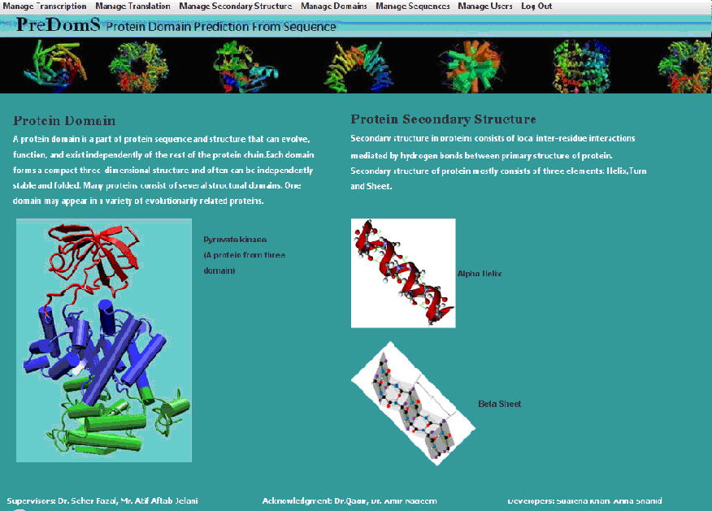

# Manage Transcription*:*

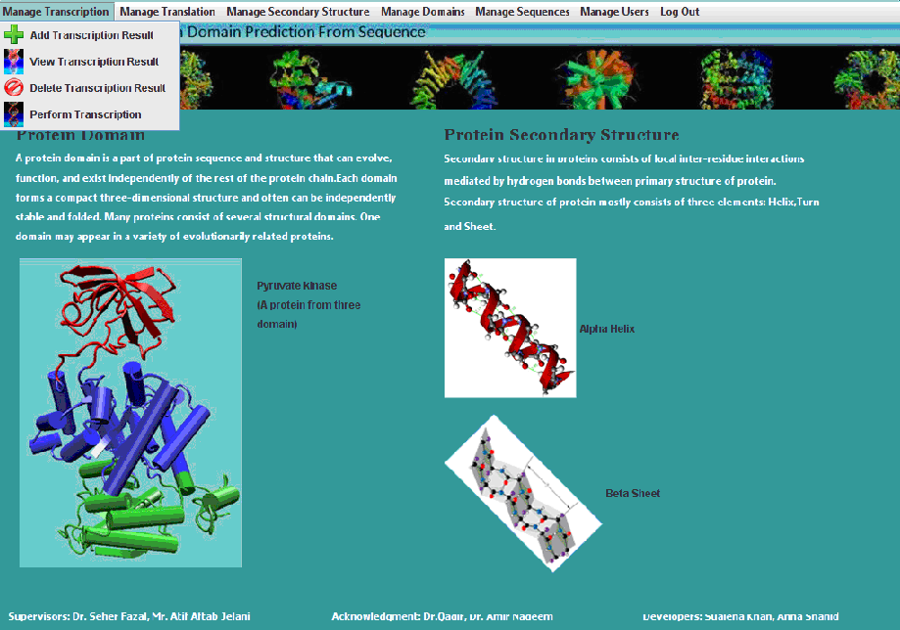

# Manage Translation:

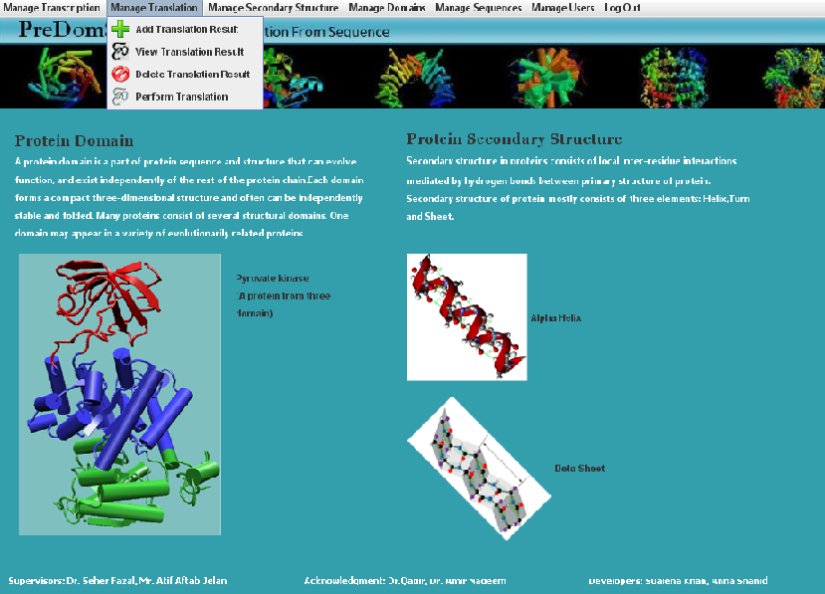

# Manage Secondary Structure:

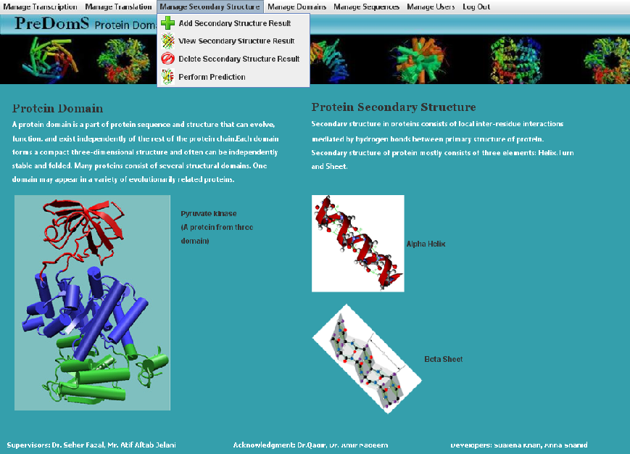

# Manage Domain:

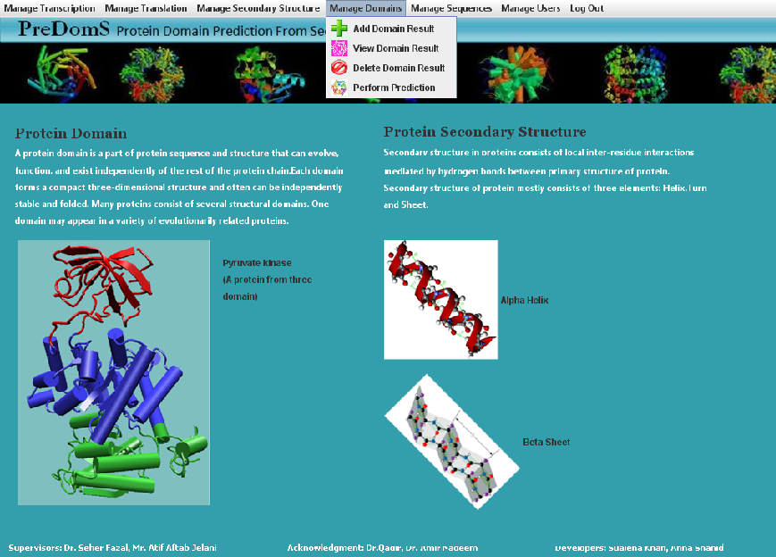

# Perform Prediction*:*

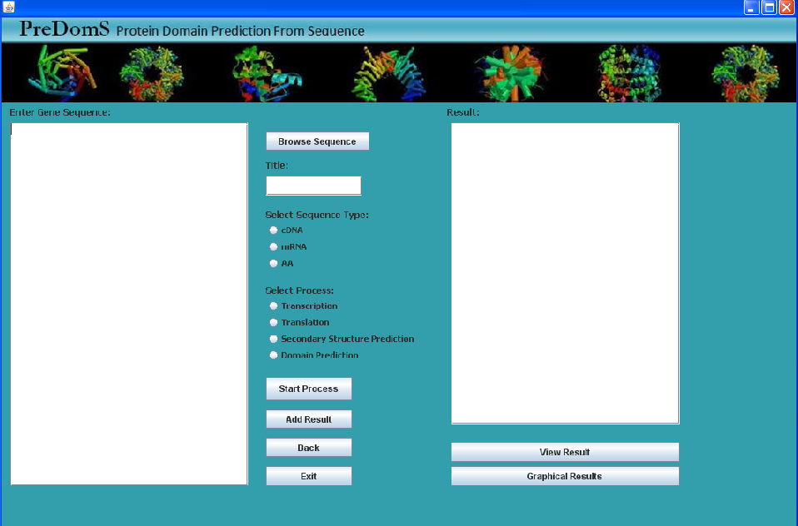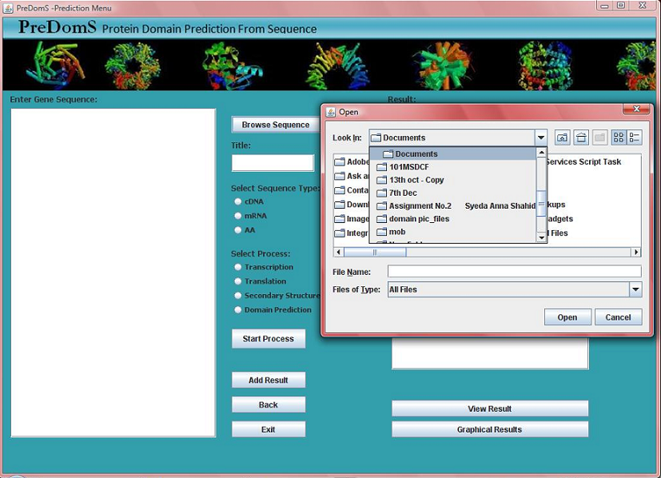

## Domain Settings*:*

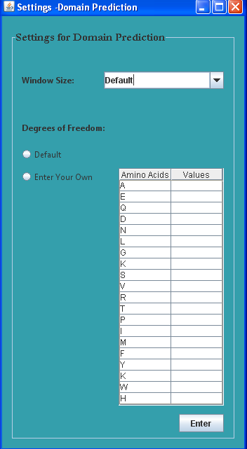

## Domain Output:

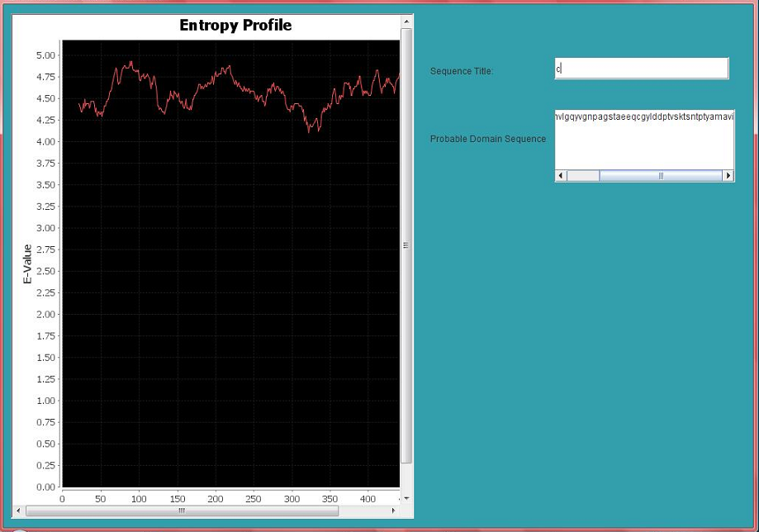

## 

## Secondary Structure Output:

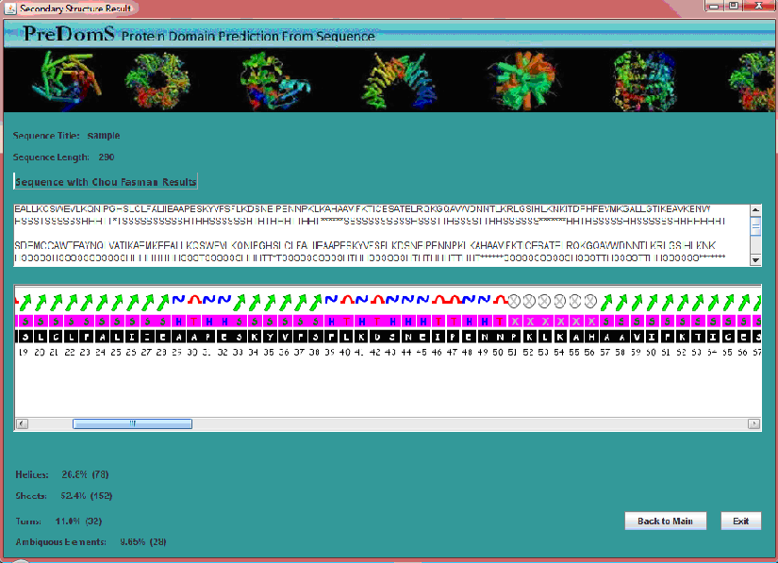

# View/Delete Process Result*:*

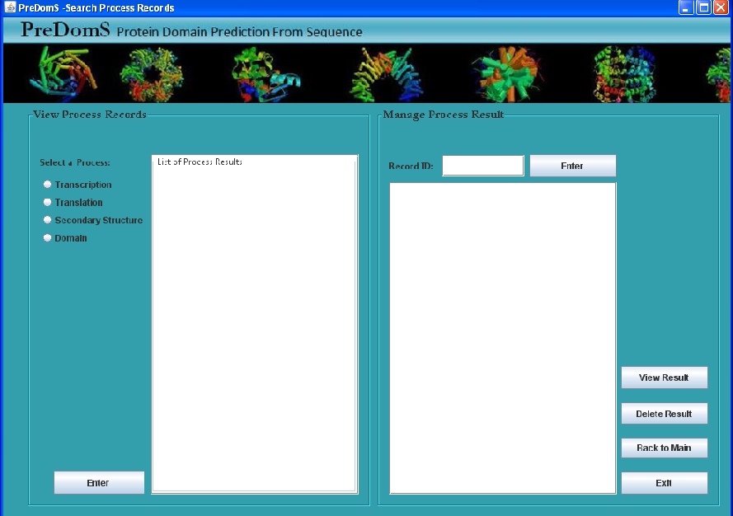

# Manage Sequences*:*

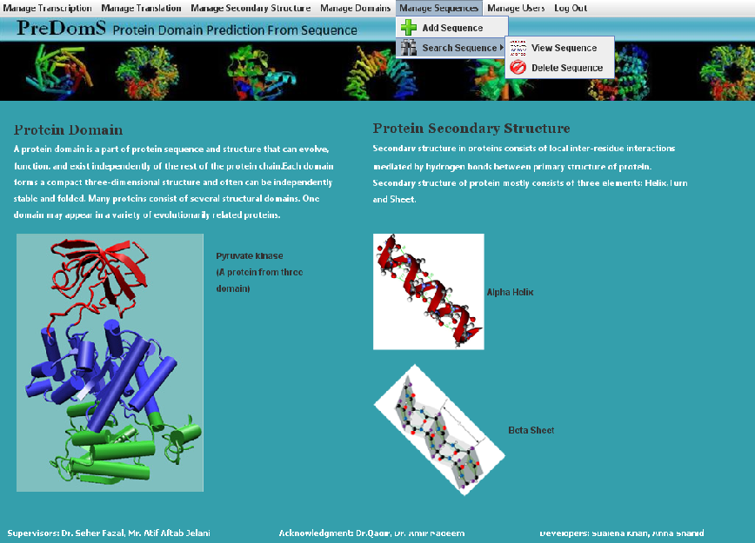

## Add Sequence:

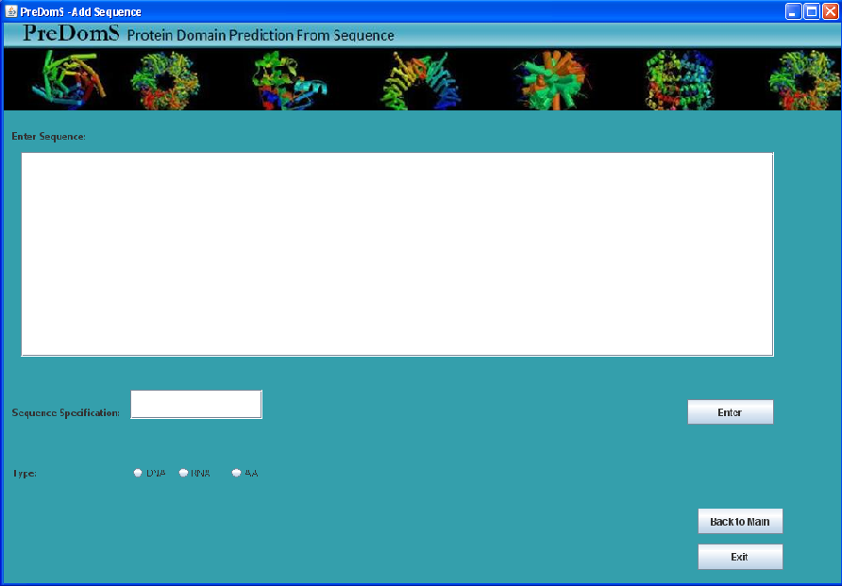

## View/Delete Sequence:

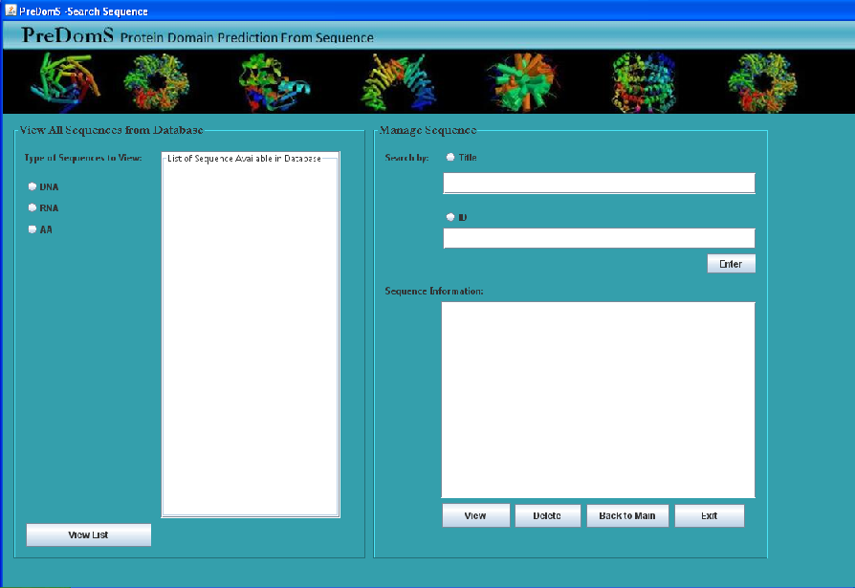

# Manage Users*:*

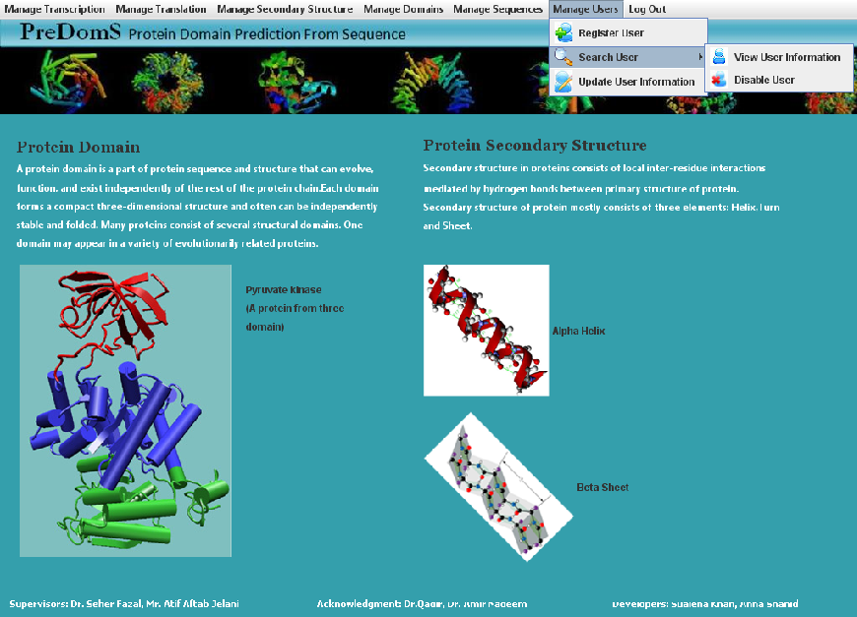

## Register User:

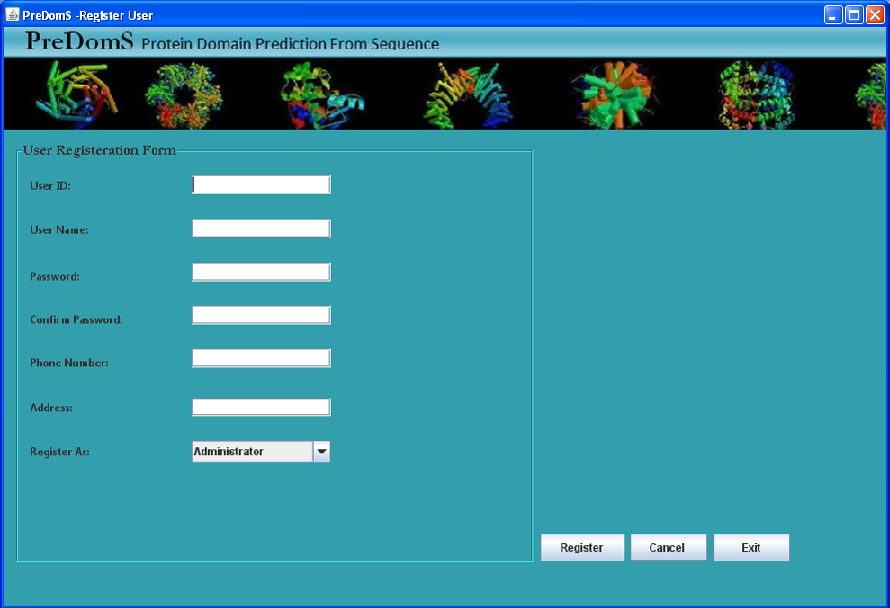

## View/Disable User:

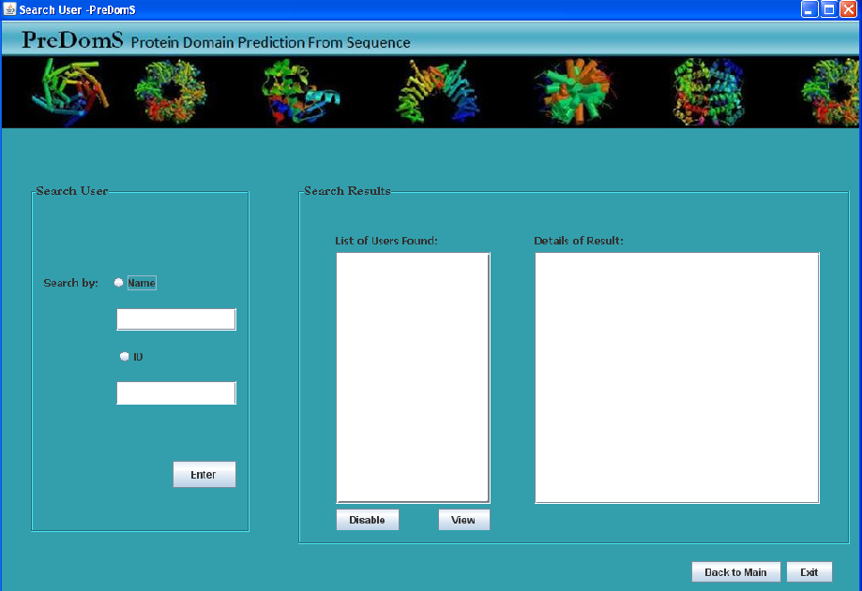

## Update User*:*

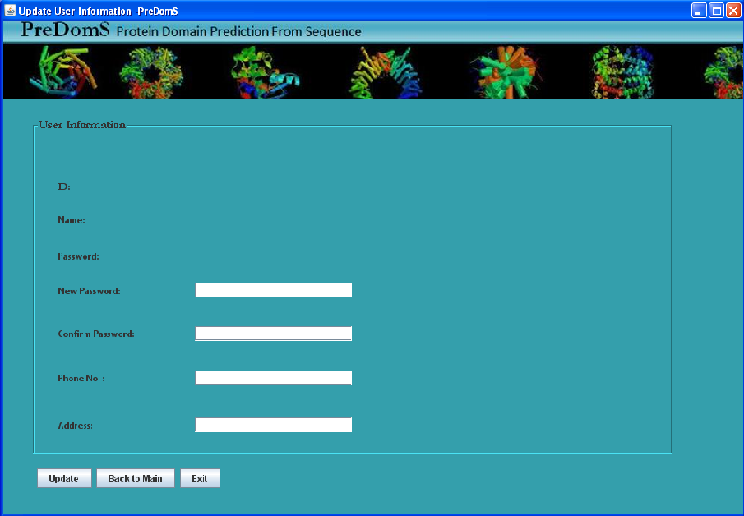

# Chapter 6

## Supplementary Specification

# Introduction

This document is the repository of all PreDomS non-functional requirements.

# Purpose

The purpose of the supplementary specification is to capture the following information:

* + Feature sets and capabilities that need to be offered to the researchers.
  + Quality attributes of the system such as usability, reliability, performance, and supportability requirements.
  + The supplementary specifications along with the use case model will serve as input to the developers, designers, and other groups working on the system.

# Scope

The supplementary specification applies to PreDomS which will be developed by the students of Muhammad Ali Jinnah University.

The PreDomS will allow its researchers to predict protein secondary structure and domains all on a single platform.

This specification defines the non-functional requirements of the system; such as reliability, usability, performance, and supportability.

# Definitions, Acronyms and Abbreviations

**a-helices:** The first constituent of secondary structure of proteins.

**b-sheets:** The second constituent of secondary structure of proteins.

**Domain:** Domain is the element in protein structure which has a specific function.

# Usability

## Navigation

* + The user should never arrive on a dead-end frame with no more navigational options.
  + Short descriptive titles at the top of each page will be used so the user has a clear understanding of where they are on the tool.

## Language

* + English language will be used so that, all users will have an equal chance of understandability.

## 

## Aesthetics

* + The tool should be aesthetically pleasing.

## User Friendly Interface

* + Guidance about the type of format supported as input will be mentioned near the input field for user convenience.

# Performance

## Response time for each process

As researchers wish to have the results quickly, so each process will produce result in minimum a millisecond to about 1 minute time according to the process. Process of Domain prediction will take maximum of about 1 minute to produce result.

## Simultaneous Users

System will be a desktop application, therefore does not support simultaneous users.

# Supportability

## Adaptability

Different users will be able to enter different types of inputs like: cDNA, mRNA or amino acid sequence as input. The system will verify the input and further processing will be done according to the input.

## Coding Standards

Standard Java coding style will be used for maintenance supportability

## Naming Conventions

Java naming conventions will be followed

# Design Constraints

## Development tools

* NetBeans IDE
* mySQL

# Other Performance Requirements

## Platform Requirements

* Windows NT/2000/XP/Vista

# Chapter 7

## Domain Model

This chapter contains domain model which identifies the objects in the system domain and relates them to each other.

# Domain Model



# Chapter 8

## System Sequence Diagrams

This chapter contains systems sequence diagrams which defines system events in the form of actor action and system response. System Sequence Diagrams are made according to the expanded use cases. This chapter consists of system sequence diagrams for; transcription manager, translation manager, secondary structure manager, domain manager, sequence manager and user manager.

# Transcription*:*



# Transcription Manager*:*



# Translation*:*



# Translation Manager*:*



# Secondary Structure Prediction*:*



# Secondary Structure Manager



# Domain Prediction



# Domain Manager



# User Manager



# Register User



# Update User Information



# Search User

# 



# Sequence Manager



# Chapter 9

## Operational Contracts

This chapter contains operational contracts for the system. Each contract is translated by a call in the system sequence diagram and identifies the changes that happen when an operation occurs. This chapter contains operational contracts for; domain management, sequence management and user management.

# Manage Domain

**Contract Name:** startPred(sequence,winLength,vals)

**Cross Reference:** Use Case: Manage Domain

**Pre-Condition:** User has chosen the option to predict domains.

User has logged in.

User has entered sequence.

**Responsibilities:** To predict domains in the entered sequence.

**Post-Condition:** An instance of *Sequence* was created.

*PreDomS_Manager* was associated to *DomainManager.*

*Sequence.seqTitle* was set to the entered title.

*Sequence.seqType* was set to the entered type.

*Sequence.seq* was set to the sequence entered.

An instance of *Domain* was created.

*DomainManager* was associated to *Domain.*

*Domain* was associated to *ResultantDomain.*

**Contract Name:** addDomain(currentUserId)

**Cross Reference:** Use Case: Manage Domain

**Pre-Condition:** User has chosen the option to Manage Domain.

User has logged in.

The domain prediction has been made.

**Responsibilities:** To add domains to domain database.

**Post-Condition:** *PreDomS_Manager* was associated to *DomainManager.*

*DomainManager* was associated with *Domain.*

*DomainManager* was associated with the *DBHandler.*

*DBHandler* was associated to *DomainRequestHandler.*

*DomainRequestHandler* was associated to *DBManager.*

An instance of *ConnectionManager* was created.

*DBManager* was associated with *ConnectionManager.*

**Contract Name:** view(domainID, uId)

**Cross Reference:** Use Case: Manage Domain

**Pre-Condition:** User has chosen the option to Manage Domains.

User has logged in.

The domain database has some domains present in it.

**Responsibilities:** To view domain from domain database.

**Post-Condition:** *PreDomS_Manager* was associated to *DomainManager.*

*DomainManager* was associated with the *DBHandler.*

*DBHandler* was associated with *DomainRequestHandler.*

An instance of *DBManager* was created.

*DomainRequestHandler* was associated to *DBManager.*

An instance of *ConnectionManager* was created.

*DBManager* was associated with *ConnectionManager.*

**Contract Name:** delete (Did, uId)

**Cross Reference:** Use Case: Manage Domain

**Pre-Condition:** User has chosen the option to Manage Domains.

User has logged in.

The domain database has some domains present in it.

**Responsibilities:** To delete domain from domain database.

**Post-Condition:** *PreDomS_Manager* was associated to *DomainManager.*

*DomainManager* was associated with the *DBHandler.*

*DBHandler* was associated with *DomainRequestHandler.*

An instance of *DBManager* was created.

*DomainRequestHandler* was associated to *DBManager.*

An instance of *ConnectionManager* was created.

*DBManager* was associated with *ConnectionManager.*

# Manage User

**Contract Name:** enterUserSpec (name)

**Cross Reference:** Use Case: Manage User

**Pre-Condition:** Current user is an administrator.

Administrator is logged in.

Administrator has chosen the option to search user.

The ID for the user to be searched must exist in database.

**Responsibilities:** To take the specification of user to be searched from administrator

to the DBHandler

**Post-Condition:** *PreDomS_Manager* was associated with *UserManager.*

*UserManager* was associated to *DBHandler.*

*DBHandler* was associated to *UserRequestHandler.*

An instance of *DBManager* was created.

*UserRequestHandler* was associated to *DBManager.*

An instance of *ConnectionManager* was created.

*DBManager* was associated with *ConnectionManager.*

**Contract Name:** disable(id)

**Cross Reference:** Use Case: Manage User

**Pre-Condition:** Current user is an administrator.

Administrator is logged in.

The user to be disabled has been searched.

**Responsibilities:** To disable a user’s account.

**Post-Condition:** *PreDomS_Manager* was associated with *ManageUser.*

*ManageUser* was associated with *DBHandler.*

*DBHandler* was associated with *UserRequestHandler.*

An instance of *DBManager* was created.

*UserRequestHandler* was associated to *DBManager.*

An instance of *ConnectionManager* was created.

*DBManager* was associated with *ConnectionManager.*

**Contract Name:** viewInfo(id)

**Cross Reference:** Use Case: Manage User

**Pre-Condition:** Current user is an administrator.

Administrator is logged in.

The user to be viewed has been searched.

**Responsibilities:** To view the information of a user stored in the database.

**Post-Condition:** *PreDomS_Manager* was associated to the *UserManager.*

*UserManager* was associated with *DBHandler.*

*DBHandler* was associated with *UserRequestHandler.*

An instance of *DBManager* was created.

*UserRequestHandler* was associated to *DBManager.*

An instance of *ConnectionManager* was created.

*DBManager* was associated with *ConnectionManager.*

**Contract Name:** updateInfo (info)

**Cross Reference:** Use Case: Manage User

**Pre-Condition:** User is logged in.

User has chosen the option to update information.

**Responsibilities:** To update information of the current user.

**Post-Condition:** *PreDomS_Manager* was associated with *UserManager.*

*UserManager* was associated with *DBHandler.*

*DBHandler* was associated with *UserRequestHandler.*

An instance of *DBManager* was created.

*UserRequestHandler* was associated to *DBManager.*

An instance of *ConnectionManager* was created.

*DBManager* was associated with *ConnectionManager.*

## 

**Contract Name:** enterUserInfo (fields)

**Cross Reference:** Use Case: Manage User

**Pre-Condition:** User has chosen the option to register.

User has filled the form of registration.

**Responsibilities:** To store the information, provided by the user, in the database for

registration.

**Post-Condition:** *PreDomS_Manager* was associated with *UserManager.*

*User_Manager* was associated with *User.*

*User.id* was set to the user entered value.

*User.name* was set to the user entered value.

*User.address* was set to the user entered value.

*User.phone_no* was set to the user entered value.

*User.password* was set to the user entered value.

*User.role* was set to the user specified value.

*UserManager* was associated with *User.*

*UserManager* was associated with *DBHandler.*

*DBHandler* was associated with *UserRequestHandler.*

An instance of *DBManager* was created.

*UserRequestHandler* was associated to *DBManager.*

An instance of *ConnectionManager* was created.

*DBManager* was associated with *ConnectionManager.*

# Manage Sequence

**Contract Name:** addSeq(seq,title,type)

**Cross Reference:** Use Case: Manage Sequence

**Pre-Condition:** User has selected the option to Manage Sequence.

User has logged in.

**Responsibilities:** To add a sequence to the database.

**Post-Condition:** *PreDomS_Manager* was associated to *SequenceManager*.

An instance of *Sequence* was created.

*SequenceManager* was associated to *Sequence*.

*Sequence.seq* was set to the entered sequence.

*Sequence.sequenceTitle* was set to the entered title.

*Sequence.seqType* was set to the chosen option.

*SequenceManager* was associated with *DBHandler.*

*DBHandler* was associated to the *SequenceRequestManager.*

*SequenceRequestManager* was associated with *DBManager.*

An instance of *ConnectionManager* was created.

*DBManager* was associated with *ConnectionManager.*

**Contract Name:** searchSeq(info)

**Cross Reference:** Use Case: Manage Sequence

**Pre-Condition:** User has chosen the option to Manage Sequence.

User has logged in.

The sequence database has some sequences present in it.

**Responsibilities:** To search a sequence in the database of sequences.

**Post-Condition:** *PreDomS_Manager* was associated to the *SequenceManager.*

*SequenceManager* was associated to the *DBHandler.*

*DBHandler* was associated with *SequenceRequestHandler.*

*SequenceRequestManager* was associated with *DBManager.*

An instance of *ConnectionManager* was created.

*DBManager* was associated with *ConnectionManager.*

**Contract Name:** delete (id)

**Cross Reference:** Use Case: Manage Sequence

**Pre-Condition:** User has chosen the option to Manage Sequence.

User has logged in.

The sequence database has some sequences present in it.

**Responsibilities:** To delete a sequence from the sequence database.

**Post-Condition:** *PreDomS_Manager* was associated to *SequenceManager.*

*SequenceManager* was associated with the *DBHandler.*

*DBHandler* was associated with *SequenceRequestHandler.*

*SequenceRequestManager* was associated with *DBManager.*

An instance of *ConnectionManager* was created.

*DBManager* was associated with *ConnectionManager.*

# Chapter 10

## Interaction Diagrams

This chapter contains sequence diagrams which show the sequence of actions that occur in a system when an operation is performed. It also shows the creation of objects and the way they communicate with other classes. This section contains sequence diagrams for; transcription management, translation management, secondary structure management, domain management, user management and sequence management.

# Manage Transcription

## Transcription

1**.2. Add Transcription Result**



**1.3 View Transcription Result**



**1.4 Delete Transcription Result**



***2.*Manage Translation**

**2.1 Translation**



**2.2 Delete Translation Result**



**2.3 Add Translation Result**



**2.4 View Translation Result**



**3.Manage Secondary Structure**

**3.1Secondary Structure Prediction**



**3.2 Add Secondary Structure Result**

**3.3View Secondary Structure Result**



**3.4Delete Secondary Structure Result**



**4. Manage Domain**



**4.1 Domain Prediction**



**4.2 Add Domain**



## 4.3 View Domain



## 4.4 Delete Domain



# 5. Manage Sequences

**5.1 Add Sequence**



**5.2 Search Sequence**

**6.Manage Users**



**6.1 Add User**



**6.2 Update User**



**6.3 Search User**



**6.4 Disable User**



**6.5 View User**



# Chapter 11

## Class Diagram

This chapter contains the class diagram identified for the PreDomS. It includes the handler classes and shows the relationship between each class. The classes contain the data and operations associated with them.



# Chapter 12

## Activity Diagrams

This chapter contains activity diagrams which show the change in the state of objects. This section contains activity diagram about transcription process and domain prediction and shows the sequence in which both these processes occur. **1. Transcription**



# Domain Prediction

