Each Names Invariant and English description.

1) Student must have one or more ability to be register.

2) A trainer receives one Assistant if there are 3-5 students with 2-3 abilities.

3) A trainer receives two Assistant if there are 5 students with more than 3 abilities.

How the Invariants are formulated in OCL.

1. context Student

inv reg:

numberofability >= 1 implies registration.registrationStatus='registered'

1. context Trainer

inv assign1:

(students->select(numberofability >=2 and numberofability <=3 )->size() >=3 and

students->select(numberofability >=2 and numberofability <=3 )->size() <5 )implies assistant->size() = 1

1. context Trainer

inv assign2:

(students->select(numberofability >3 and numberofability <=5 )->size() >=5 and

students->select(numberofability >3 and numberofability <=5 )->size() <15 )implies assistant->size() = 2

Object models which violate the invariants

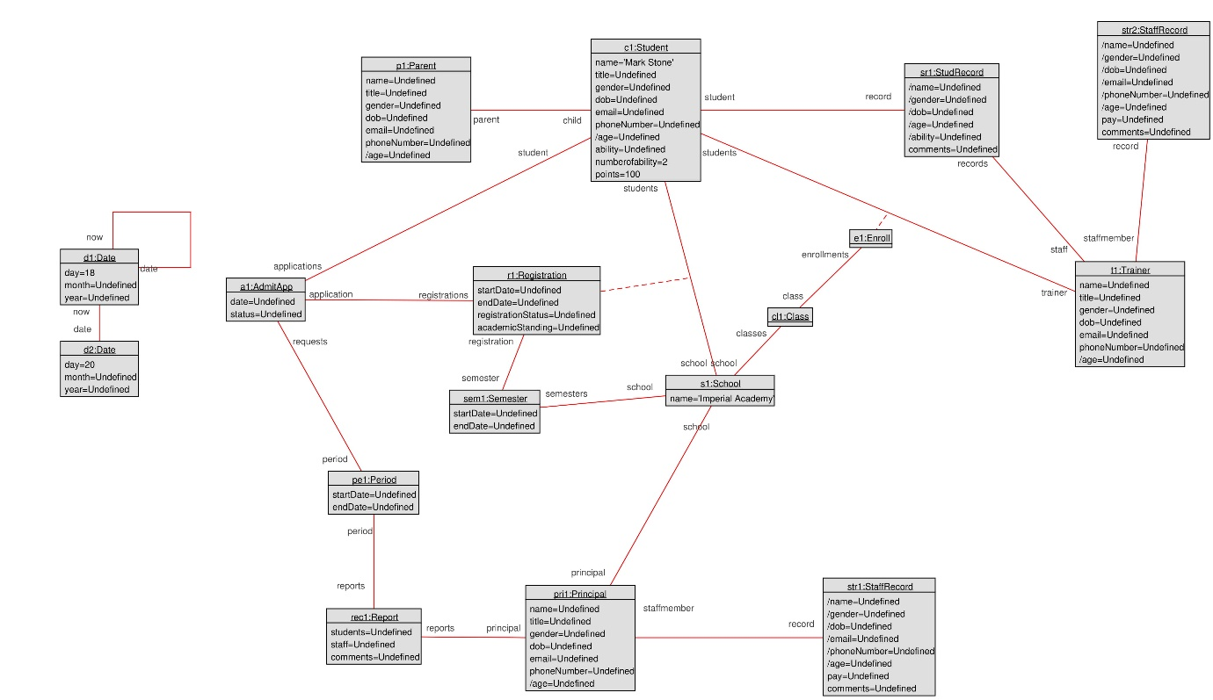

Figure : object model for inv 1

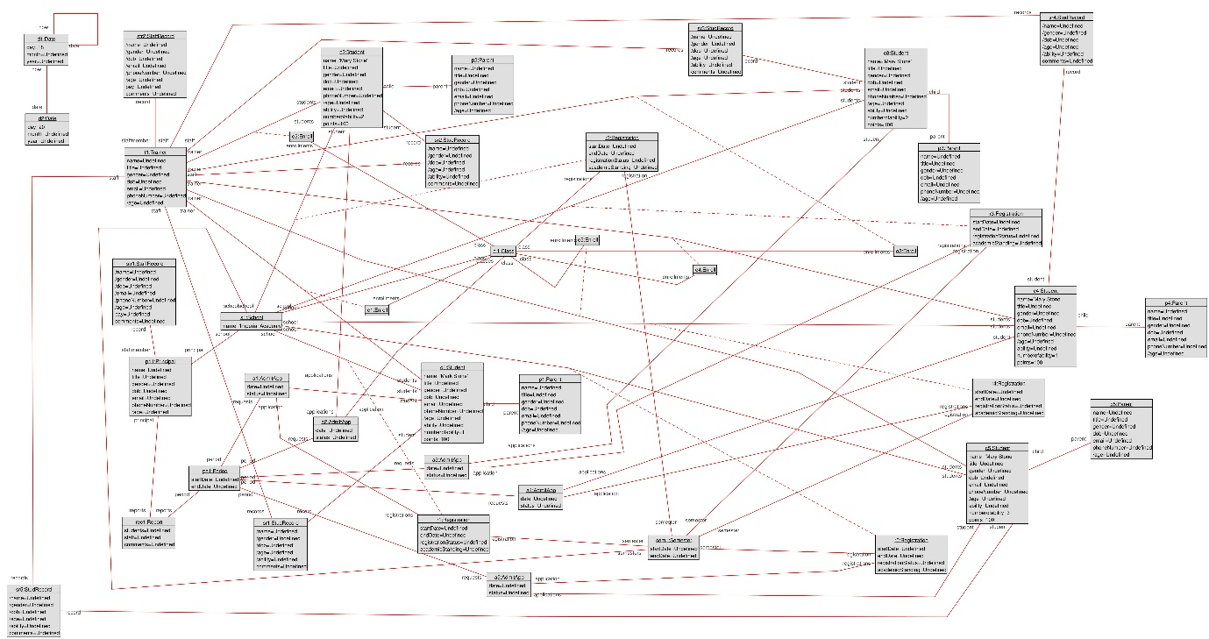

Figure : object model for inv 2

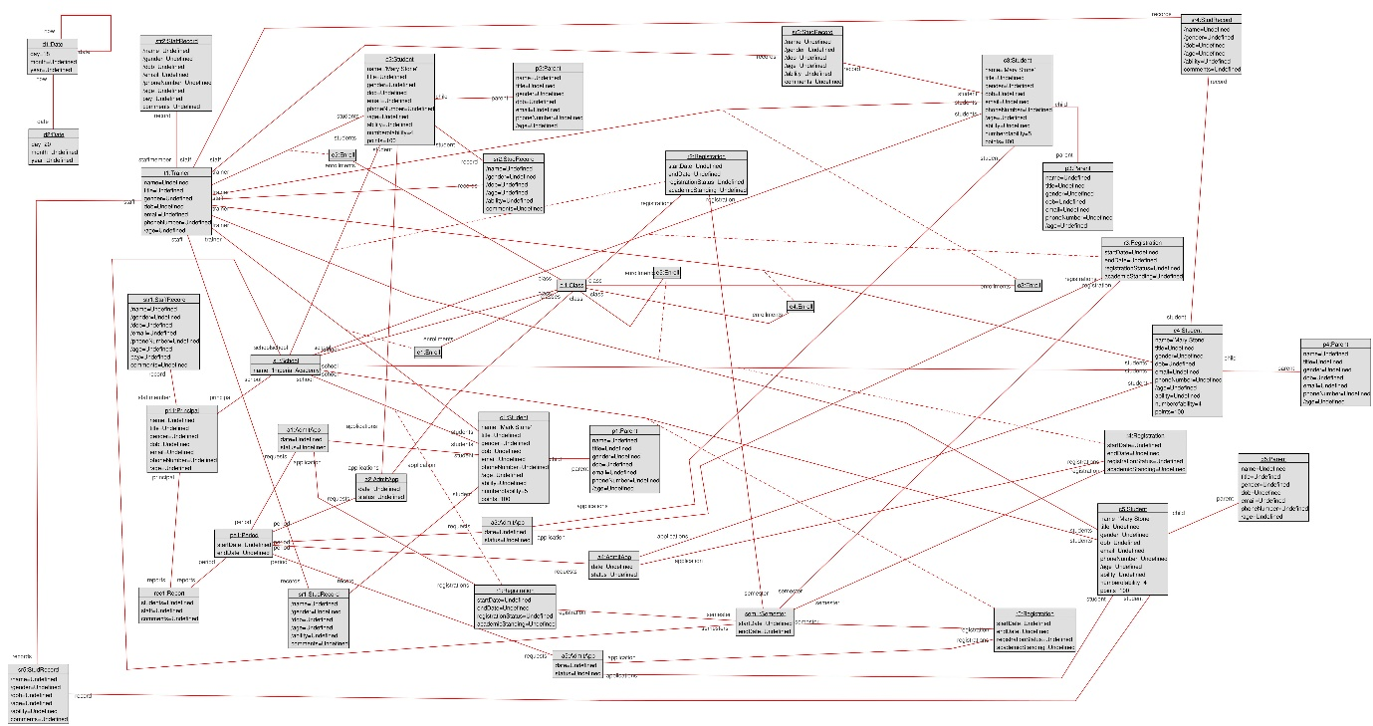

Figure : object model for inv 3

Explanation for why the object model violates the invariant

1. The object model in figure one violates the invariant because a student has an ability but the student status has not change to registered.
2. The object model in figure two violates the invariant because there are more than two students with 2-3 abilities but no assistance has be assign to the trainer.
3. The object model in figure three violates the invariant because there are five students with more than 3 abilities but no assistance has be assign to the trainer.