*Project plan*

Fontys University of Applied Sciences

|  |
| --- |
| **Date** : 09/02/2023 |
| **Version** : 1.0 |
| **State** : In progress |
| **Author**  : Anna Kadurina |

Version history

|  |  |  |  |  |
| --- | --- | --- | --- | --- |
| **Version** | **Date** | **Author** | **Changes** | **State** |
| 1.0 | 09/02/2023 | Anna Kadurina | First version of the document | In progress |
|  |  |  |  |  |

Table of Contents

Project assignment 3

Context 3

Problem description 3

Goal of the project 3

Scope and preconditions 3

Scope 3

Preconditions 4

Strategy 4

Research questions and methodology 5

Research questions 5

End products 6

Project organization 7

Stakeholders and developer 7

Stakeholders 7

Developer 7

Communication 7

Activities and time plan 8

Phases of the project 8

Time plan and milestones 8

Testing strategy and configuration management 9

Testing strategy 9

Test environment and required sources 9

Configuration management 9

Risks 9

Risk and mitigation 9

# Project assignment

## Context

GetawayGo is a company similar to the worldwide famous Airbnb and Booking businesses. GetawayGo is now working as an agency to please the customers’ needs.

## Problem description

The problems that the company faces are unsatisfied guests and hosts, hard management of the properties, less customers and lack of popularity.

## Goal of the project

The goal of the GetawayGo project is to develop a user-friendly application that allows the travelers to find short-term accommodations all around the world. The aim is to create a platform that will please the needs of both hosts and guests. The preferred situation after the implementation wоuld be a thriving and efficient application that will allow the users to easily list their properties or book a place that meets their needs. The advantages of this project are satisfying the travelers’ needs, promoting tourism, and generating income for the owners of the properties. From an ICT point of view, the project offers a lot of possibilities, such as search features and filters, reviews on the properties, detailed information and chat. Alongside, the hosts will have useful statistics to track the bookings of their properties.

## Scope and preconditions

### Scope

|  |  |
| --- | --- |
| **Inside scope:** | **Outside scope:** |
| A web-based application that allows the hosts to list their properties and the guests to find suitable accommodation | Travel-related services such as car rentals and booking of flights |
| Customized search bar and filters | User training |
| Review system to provide feedback |  |
| Statistics for the hosts and administration |  |
| Chat between users |  |
| User management and property management for the administration to have control over what is published on the platform |  |
| Responsiveness |  |
| Good performance |  |
| Usability |  |

### Preconditions

* Funding to develop, launch and maintain the platform
* Deadline of the project is 23rd of June
* The programming languages are Java, JavaScript, HTML, CSS
* Regular meetings with client

## Strategy

1. Create a product backlog that prioritizes features based on their value
2. Define the scope of each sprint
3. Estimate the time needed to implement each user story
4. Sprint meetings at the end of each sprint with the client to get feedback on the progress of the project
5. Deliver at the end of each sprint a product that is fully tested

I am choosing the Scrum apprоach because it can be easily adapted for a solo developer. It allows you to be flexible and adapt to changes due to the client’s or user’s needs throughout the whole project. By using this strategy, problems can be easily identified to improve the efficiency of the workflow. It results in pleasing the wishes of the client and adjusting to the changes that they make, finishing with a high-quality product.

## Research questions and methodology

### Research questions

1. What do users expect from an accommodation website?
2. What do hosts expect when listing their property on a platform?
3. What features and functionalities are most important for users when they are searching for a short-term accommodation and how can the application meet those needs?
4. How do users decide which place to book? What are the factors that influence their choice?
5. How can the application handle large amount of data?
6. What are the best practices to test the application?

Methodology

Analysis – research similar applications and their features. Conduct user research – such as already existing research, also conduct interviews and surveys to determine what people expect from such application. The analysis uses the Field methods - Explore user requirements, Interview, Observation, Survey, Task analysis, Problem analysis and Stakeholder analysis. Also, the library method - Competitive analysis.

Design – creating user stories to guide the design process, also prioritizing the tasks based on the results. Develop architectural structure of the application and interface design. Workshop methods used: Prototyping, IT architecture sketching and Requirements prioritization.

Implementation – implementing using the Scrum, conducting testing to detect any problems. Lab methods used: System test, Unit test, Usability testing and Security test.

Evaluation – different types of testing to determine the reliability of the application. As well as, user testing to validate if the platform is user-friendly or not. Showroom methоds used: Product review, Ethical check. Lab methods: Usability testing, Security test and System test.

## End products

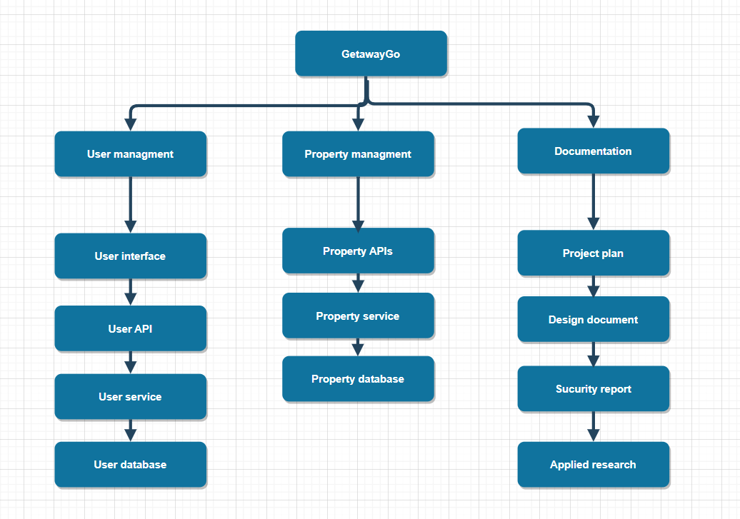

# Project organization

## Stakeholders and developer

### Stakeholders

* Client – primary stakeholder that is involved in the decisions, the budget and any changes that may occur during the process
* Developer – responsible for designing, building, testing and deployment of the system. The satisfaction of the developer depends on the technology that is used and pleasing the client’s needs with the end product of each sprint

### Developer

My name is Anna Kadurina, and I am currently studying at Fontys University of Applied Sciences. At this moment I am in semester 3 of Software Engineering. My contact email is: a.kadurina@student.fontys.nl.

## Communication

The communication between the developer and the client will happen at the end of each sprint to get feedback on the end product, as well as throughout the sprint to discuss features and the progress of the application.

# Activities and time plan

## Time plan

The project will consist of 6 sprints, each with length of 3 weeks. Stand-up will be done at the end of each sprint, as well as demo.

|  |  |  |  |
| --- | --- | --- | --- |
| **Sprint name** | **Effort** | **Start date** | **End date** |
| Sprint 1 | Project planning, analysis, research, and initial version of the application | 06/02/2023 | 03/03/2023 |
| Sprint 2 | Designing the initial architecture, continuing implementation | 03/03/2023 | 24/03/2023 |
| Sprint 3  Sprint 4  Sprint 5 | Implementing the features that are within the scope of each sprint and continuously testing to deliver at the end of each sprint a finished product. | 24/03/2023 | 03/06/2023 |
| Sprint 6 | Finalization, deployment and submission of the project and documents | 03/06/2023 | 23/06/2023 |

# Testing strategy and configuration management

## Testing strategy

For the GetawayGo project, the testing strategy will involve unit testing, integration testing, end-to-end testing, and acceptance testing to determine whether the system is acceptable for delivery. The goal will be to achieve at least 80% code coverage. Alongside, quality testing will be done with SonarQube, resulting in improving the code quality and reliability of the application.

## Test environment and required sources

I plan to make use of the CI/CD environment. I am going to use a containerization tool like Docker, as well as SonarQube for quality testing.

## Configuration management

I will use 2 separate GIT repositories for my frontend and backend. Alongside with that, I will make use of Jira to track the issues and plan better. Furthermore, CI/CD approach will be used.

# Risks

## Risk and mitigation

|  |  |  |
| --- | --- | --- |
| **Risk** | **Prevention activities** | **Mitigation** |
| Sudden unavailability of the client | Regular communication and backup contact | Resolving the issue or continuing the process with the backup contact |
| Personal issues | Regular communication | Quickly resolving the issues and continuing the process as soon as possible |
| Technical difficulties | Regularly backing up code | Quickly identifying the issues, restoring from the backup |
| Quality issues with the code | Following code standards | Quickly resolving the issues, performing tests |
| Stakeholder conflicts | Regular communication and proper decision making | Finding the best solution to resolve the conflict, researching to find the most optimal way |
| Poor communication | Regular meetings at the end of each sprint and throughout the sprint | Identify the problem and schedule meeting as soon as possible to get back on track |
| Scope misunderstandings | Proper communication about what should be in the scope of the project | Communicate the issues with the client, apply changes to the timeline |