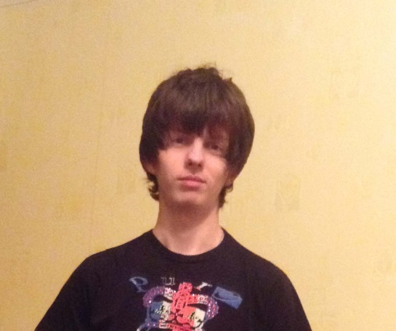 Nikita Sirik

Tel: +38(068)498-95-18

E-mail: [countrytramp@mail.ru](mailto:countrytramp@mail.ru)

Skype: jlamer3

Date of birth: 13/02/1994

City: Kharkov

**Objective**

I pretend to the position of a Junior Front-End Developer. I like programming, creating web sites and finding the necessary solutions. I'm interested in broadening and deepening my skills development within the company.

**Skills and knowledge**

Programming languages : HTML 5, CSS 2.1/3, JavaScript

Frameworks: jQuery, jQueryUI , Twitter Bootstrap, LESS

English : pre-intermediate

- Theoretical knowledge of the Backbone, Underscore

- Work with Git

- Adobe Photoshop on the level needed for work

- Semantic valid markup

- Fixed Page Layout/Flexible Page Layout

- Understanding of the Responsive page layout

- Object Oriented Programming (basic)

**Examples of works**

https://github.com/countrytramp/Sirik-Nikita/tree/master/Examples_of_works

**Work experience**

02.2013 - 09.2014

Manager of the company “SeoLight”

Responsibilities:

-work with clients

-promotion of seo services in the CIS

**Education**

09.2011 - 06.2016

V. N. Karazin Kharkiv National University

Specialty: politology

**Additional education**:

09.2014 – 02.2015

Courses “SourceIT”

Specialty : Front-end

**Hobby**

Watching movies, listening to music, reading books, playing video games, fitness facilities