**1. Explain in your own non-ChatGPTed words what's the pros of using Ansible as opposed to an AMI template.**

When using ansible you can insert your instances in all kind of differentgroups using tags (one instance can be in many grioups) and once you have your desired group you can configure all of them in one click based on the yaml file and if upgrade needed you can always adjust the yaml file an rerun it again on desired hosts. It uses roles, tags, variables in a very dynamic and clear way.

**2. Explain in your own non-ChatGPTed words what's the cons of using Ansible as opposed to an AMI template.**

ansible depends a lot on perfect ssh conection but it no always the case, can take time with all the keys and firewalls on the way.

Need to create all the files, take care of the inventory and roles.

**I'm sorry, but I wrote my yaml file in Ubuntu ec2 and not amazon linux…**

**Also,**

*** In reality I checked on the same instance just with different tags, and did the check with managed (tag) = anna so it will use only my server because I have a key only to it.

**For the first instance check I used:**Name = mysql-test-aws-annap-01

*** checked what could work using: apt-cache madison mysql-server ***

Service = **mysql-server**

Version = **8.0.43-0ubuntu0.24.04.1**

Restart – Sunday at 6:00 am

Output:

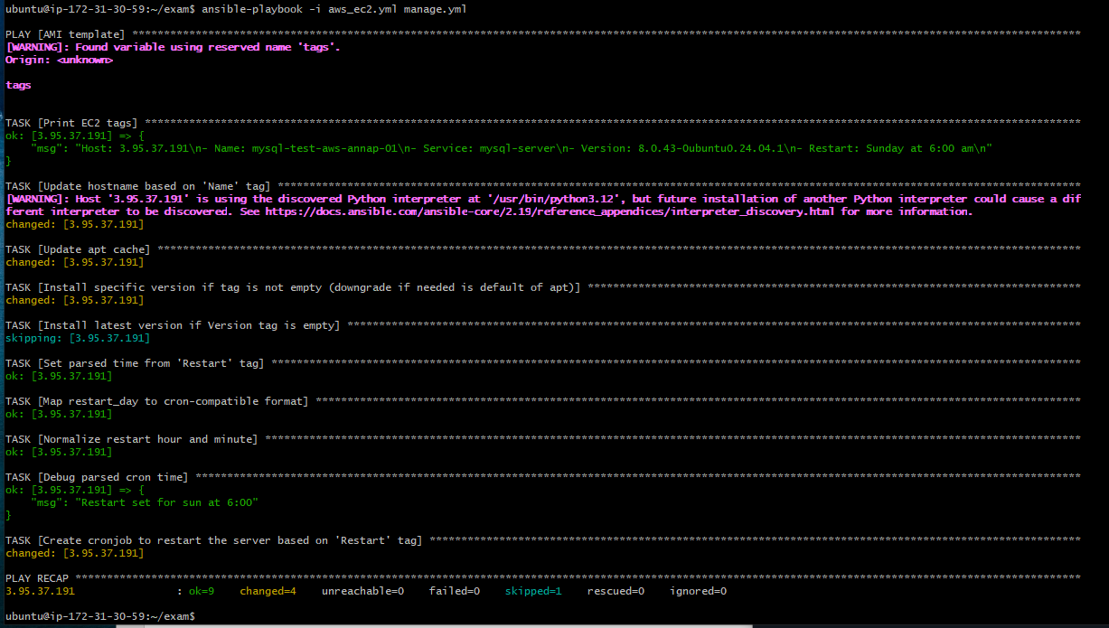

**For the second instance check I used:**Name = nginx-test-aws-anna-06

*** checked what could work using: apt-cache madison nginx ***

Service = nginx

Version = **8.0.43-0ubuntu0.24.04.1**

Restart – Sunday at 6:00 am

Output:

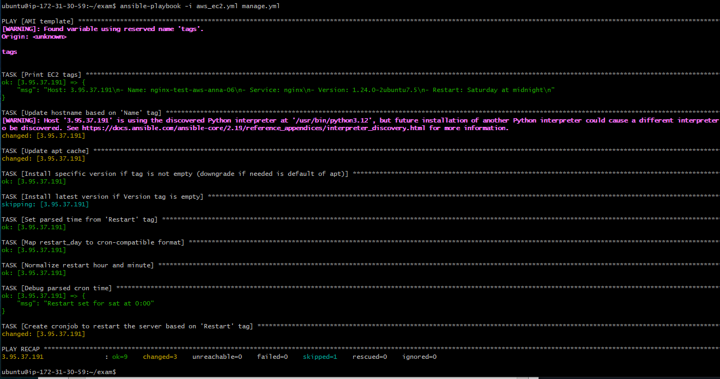

A snapshot of the slave server after the second run (that's why it has the second hostname)

