**Back end load testing report**

**Jsonplaceholder API applications**

**1. The purpose of the test:**

Check the operation of the **Jsonplaceholder application** when it reaches the pre-max load level of 100 thread and measures the response time on a short interval up to 2 minutes.

**2. Task:**

Test

**3. Load profile parameters:**

1. Number of users - 100 (load ~ 80-90% of the maximum)

2. Duration - 1 min 5 0 sec.

3. Load profile steadily increasing with an increase of 20 users every 24 seconds.

4. Actions to be taken:

* GET request in progress
* POST request in progress
* P UT request in progress
* PATCH request in progress
* DELETE request in progress

**4. Test progress**

Three iterations were carried out with the launch of tests. When the peak load was reached, the application server did not work correctly, since there was both a point and saturation ( requests without server responses ), when the peak load of 100 users was reached, the response time of the request increased to 15.5 seconds, at the time of load reduction it increased to 50 seconds.

**5. Additional information**

Graph A shows point and saturation, requests made by the GET and POST methods didn’t get a response from the server, namely the GET request at 40 users per second, POST - the saturation point is noted at 60 users per second.

At the same time, in Chart B no distortion of the load model was found.

**Graphics**

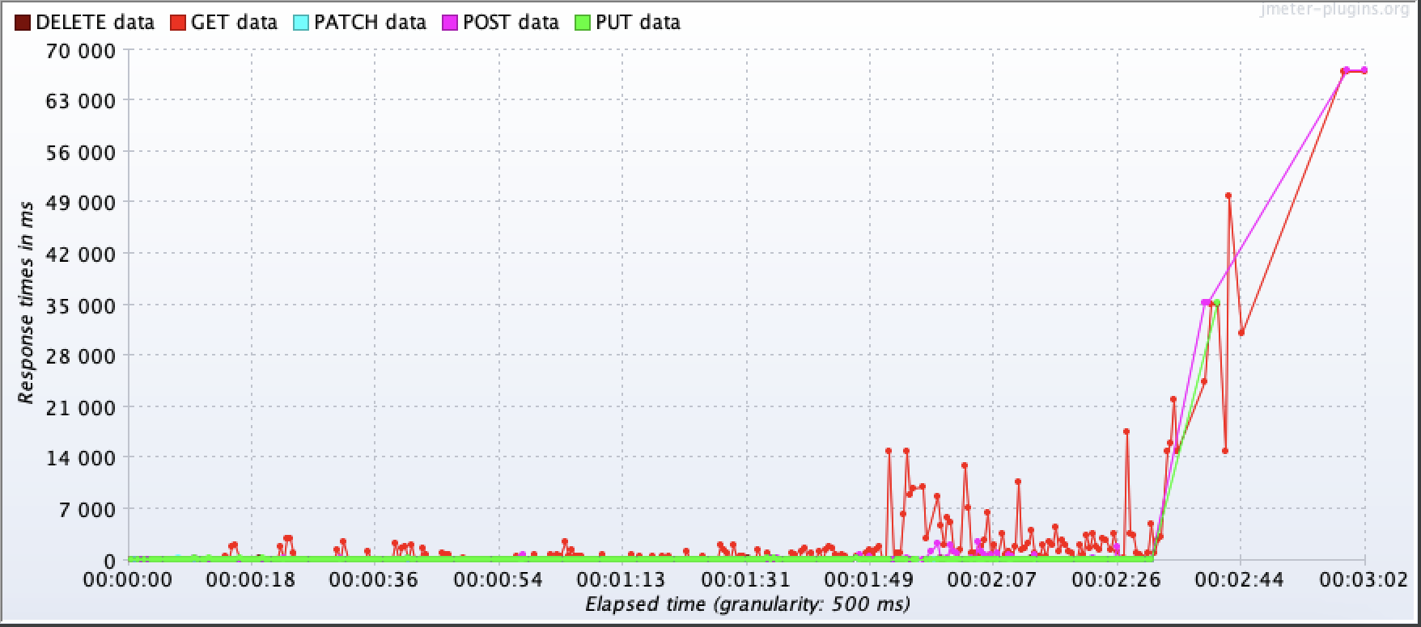

**Graph B**

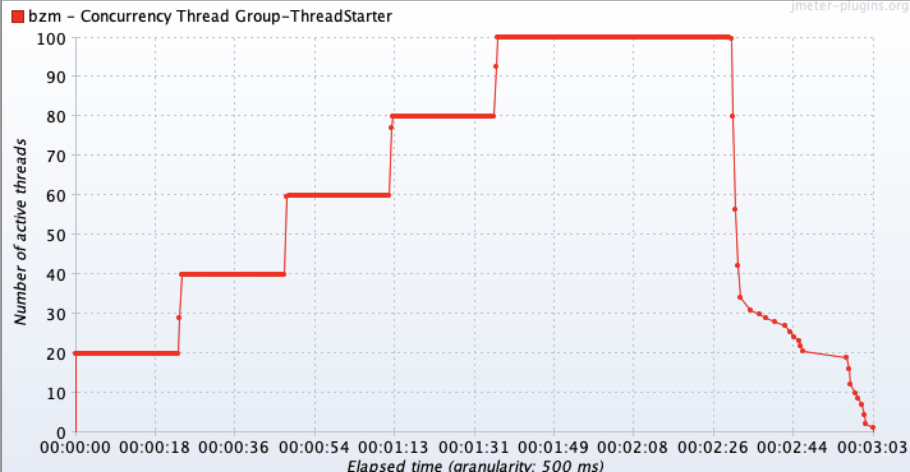

Graph C shows the errors that occurred when the load average peak was reached, the requested requests were left without a response from the server.

**Chart C**

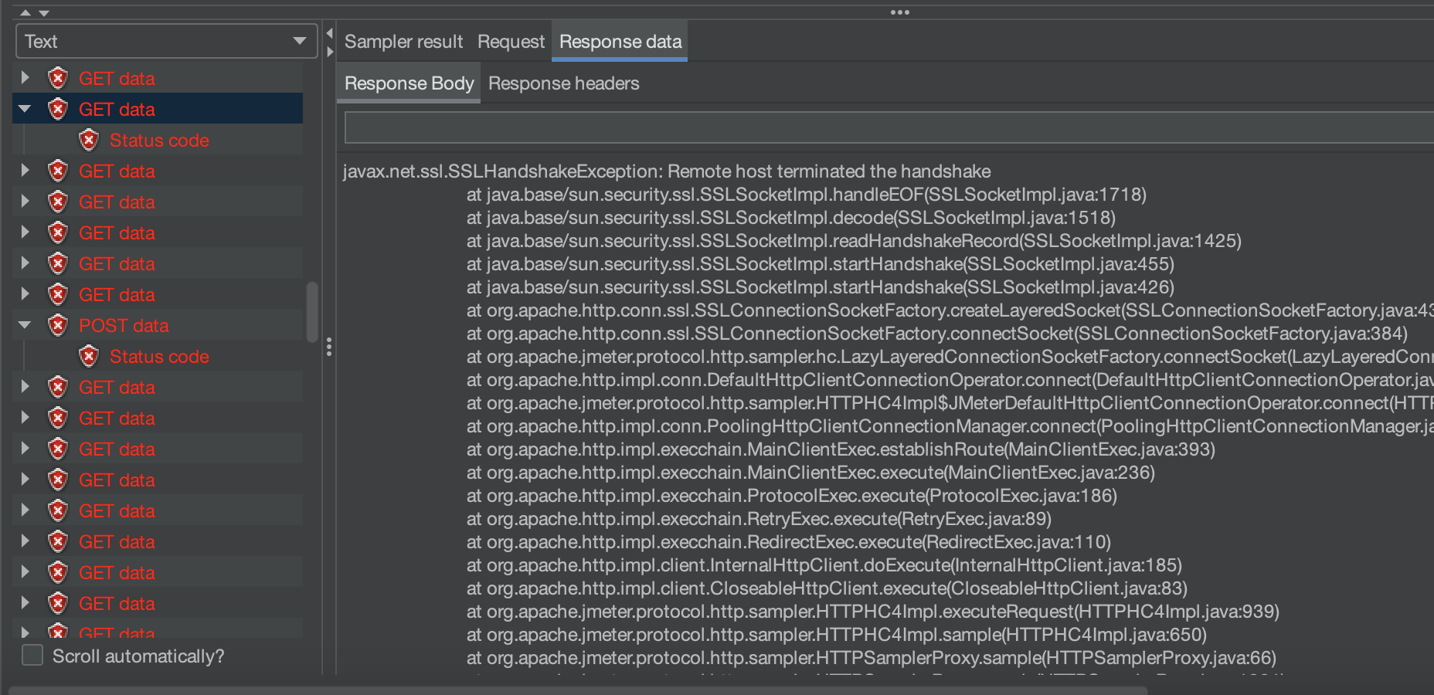

Therefore, in Graph D, due to saturation points, the response speed from the server increases to 67 seconds when the peak load is reached.

**Graph D**

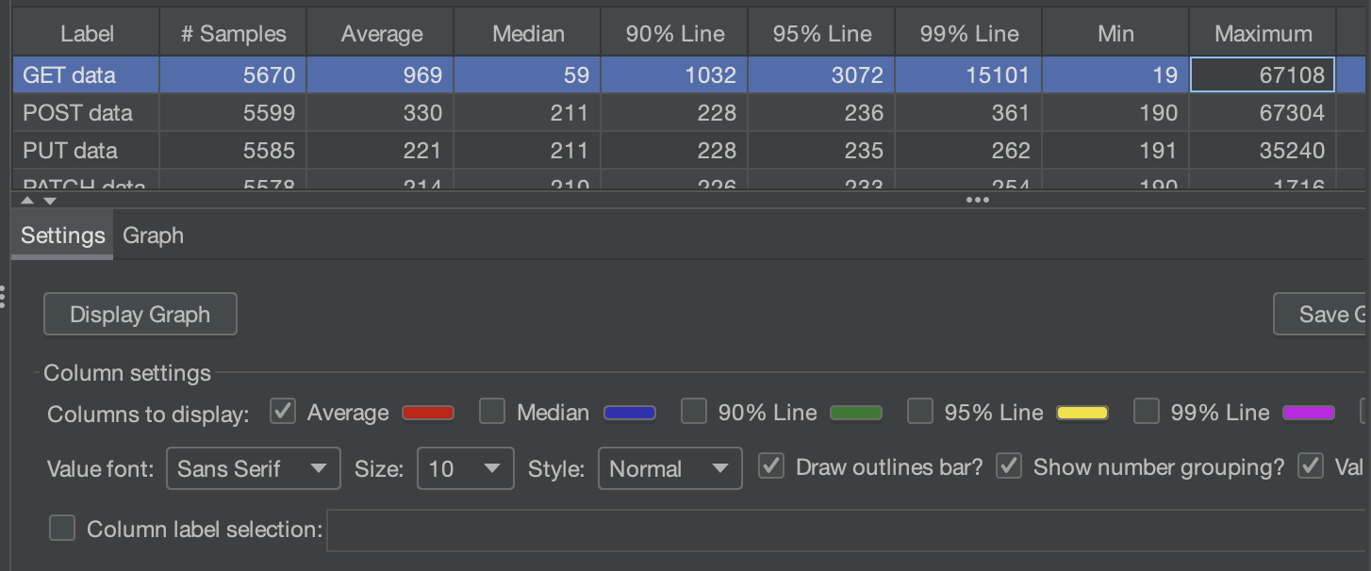

**6. Conclusions and recommendations**

**The application does not work correctly in the declared load range, the system is degraded at an average load, and with a subsequent increase in load, the situation is aggravated. These errors are not related to the logic of the application. There are server-side configuration issues.**

Server-side **optimization is recommended.**