**Suggestions**

* When admin User redirects to Change discount screen, I suggest show the latest discounts, if there are.
* I suggest that Course Type by default be Fundamental.
* I suggest that all field’s names should be the same size.
* I suggest showing the initial cost of the course then the discount(*Price should be shown already discounted(take*)- Not preferred)
* When a user buys a course, I suggest showing a message.
* I suggest that is not possible to write invalid data.
* I suggest this message don’t appear or change,When we don’t have discount ‘You have 0 discount. Discounted price is displayed’
* When Change Discount I suggest reset all fields.

**Requirement clarifications**

* **Clarify ‘discount which is numeric’ requirement.(Can write in the discount field -10 or 4.2?)** **and are there max( min) value of digits?**
* **What is course_count for.**
* **Clarify Non functional requirments**
* **Clarify ‘course_count field which is numeric’ requirement( Can write in the course_count field -11 or 9.2222?)**  **and are there max(min.) value of digits?**
* **When Change Discount function is fail, what action does the software ?**
* **When a user buys a course, what action does the software ?**
* **When don’t have discount ,what action does the software?**

**Bug Report**

**Bug ID:** 1

**Bug Summary: Wrong notification when Changes Discount**

**Environment/URL: https://qwallity-exam.onrender.com/**

**Version**: 1

**Browser:** Google Chrome

**Submit Date:** 27/01/2023

**Reporter:** Anna Soghomonyan

**Steps to Reproduce:**

1. Open the URL

2.Login as admin

3. Navigate to profile

4.Click Change Discount button

5.Select Course Type

6. Write discount 8

7. Write course count 3

8. Click the Change Discount button

**Expected Result:** See notification – ‘Discount changes’

**Actual Result:** Discount is changed

**Screenshot/video:** Screenshot is attached

**References:** Requirement

**Severity:** Low

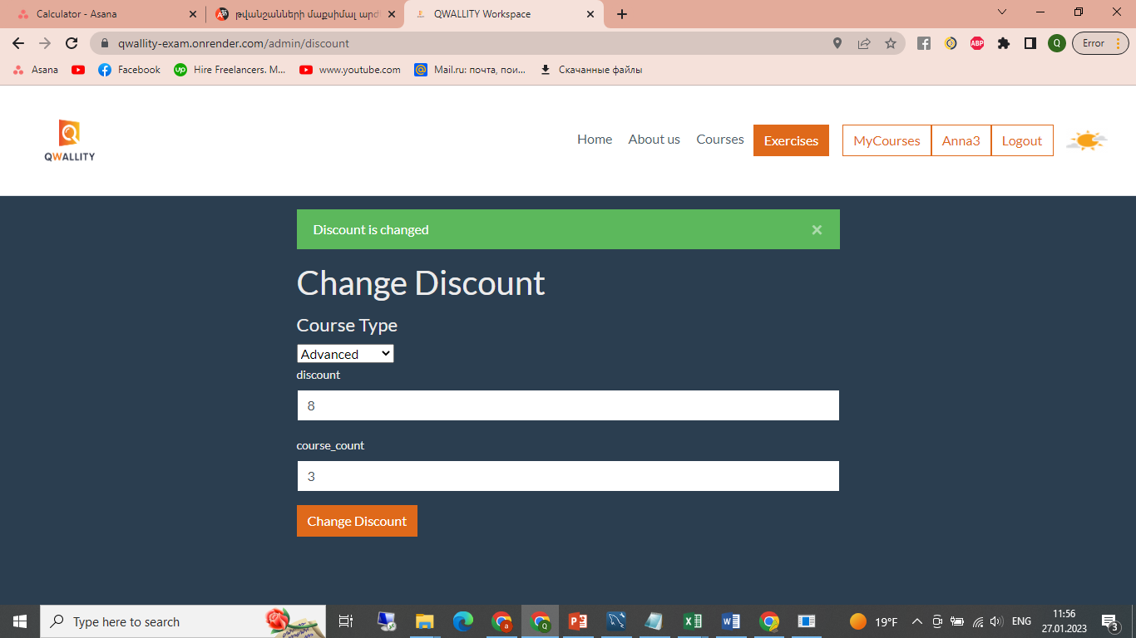

**Bug ID:** 2

**Bug Summary: Fundamental Course Type change,when click Change Discount button**

**Environment/URL: https://qwallity-exam.onrender.com/**

**Version**: 1

**Browser:** Google Chrome

**Submit Date:** 27/01/2023

**Reporter:** Anna Soghomonyan

**Steps to Reproduce:**

1. Open the URL

2.Login as admin

3. Navigate to profile

4.Click Change Discount button

5.Select Fundamental Course Type

6. Write discount 8

7. Write course count 3

8. Click the Change Discount button

**Expected Result:** Course Type is Fundamental

**Actual Result:** Course Type is Advanced

**Screenshot/video:** Screenshot is attached

**Severity:** Medium

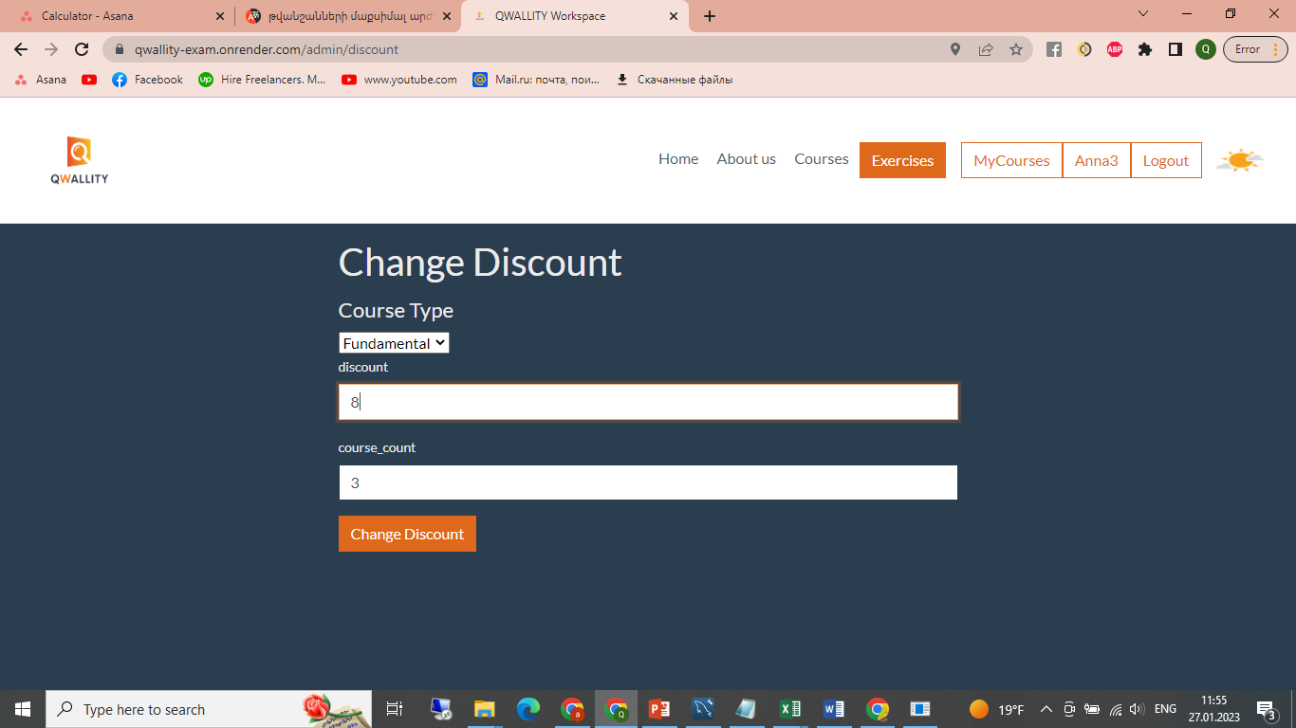



**Bug ID: 3**

**Bug Summary: Invalid data in the course_count field**

**Environment/URL: https://qwallity-exam.onrender.com/**

**Version**: 1

**Browser:** Google Chrome

**Submit Date:** 27/01/2023

**Reporter:** Anna Soghomonyan

**Steps to Reproduce:**

1. Open the URL

2.Login as admin

3. Navigate to profile

4.Click Change Discount button

5.Select Fundamental Course Type

6. Write discount 6

7. Write invalid data in the course_count(1%,’ ', Adf)

8. Click the Change Discount button

**Expected Result:** Discount change failed

**Actual Result:** Discount is changed

**Screenshot/video:** Screenshot is attached

**Notes:** In the database course count updated 1

**Severity:** High

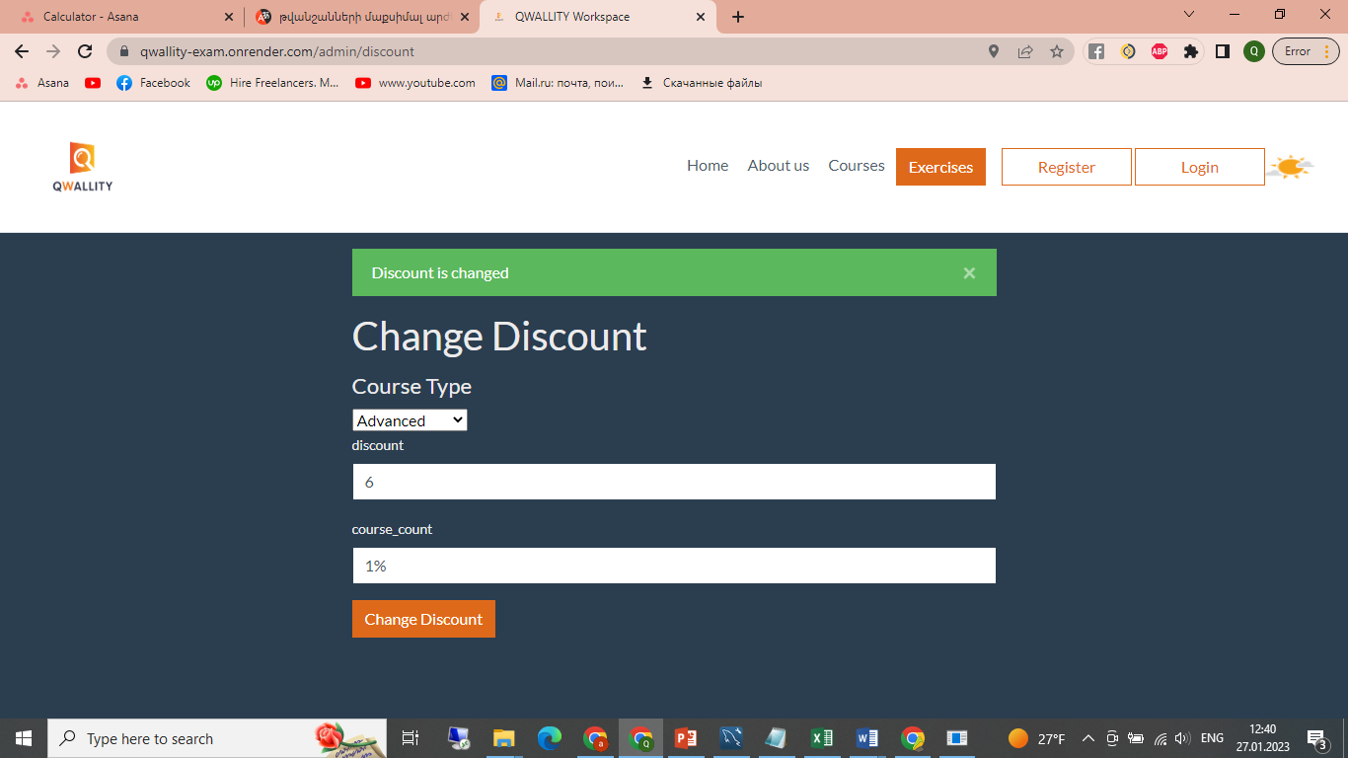

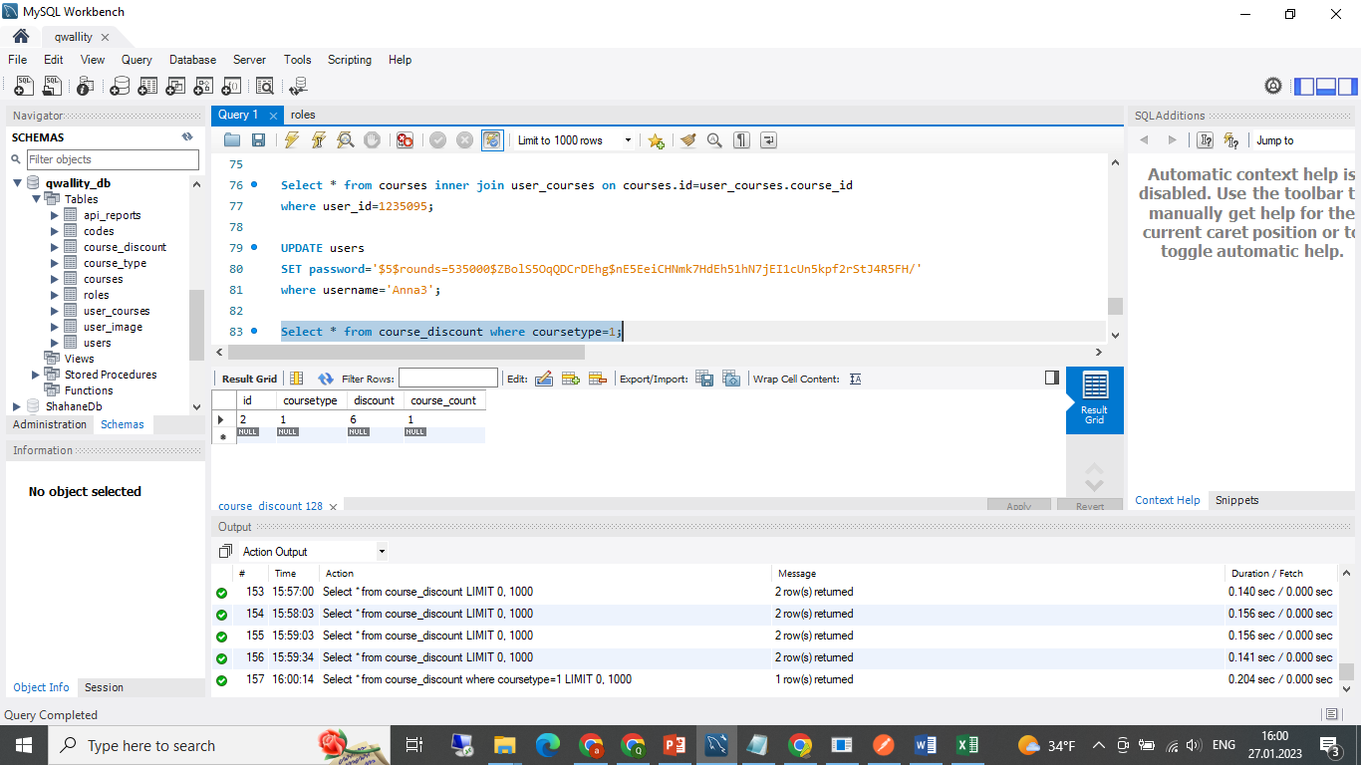

**Bug ID:** 4

**Bug Summary: Invalid data in the discount field .**

**Environment/URL: https://qwallity-exam.onrender.com/**

**Version**: 1

**Browser:** Google Chrome

**Submit Date:** 27/01/2023

**Reporter:** Anna Soghomonyan

**Steps to Reproduce:**

1. Open the URL

2.Login as admin

3. Navigate to profile

4.Click Change Discount button

5.Select Advanced Course Type

6. Write invalid data in the discount (2%,’ ’,two)

7. Write course count 1

8. Click the Change Discount button

**Expected Result:** Discount change failed

**Actual Result:** Discount is changed

**Screenshot/video:** Screenshot is attached

**Notes:** In the database discount updated 0

**Severity:** High

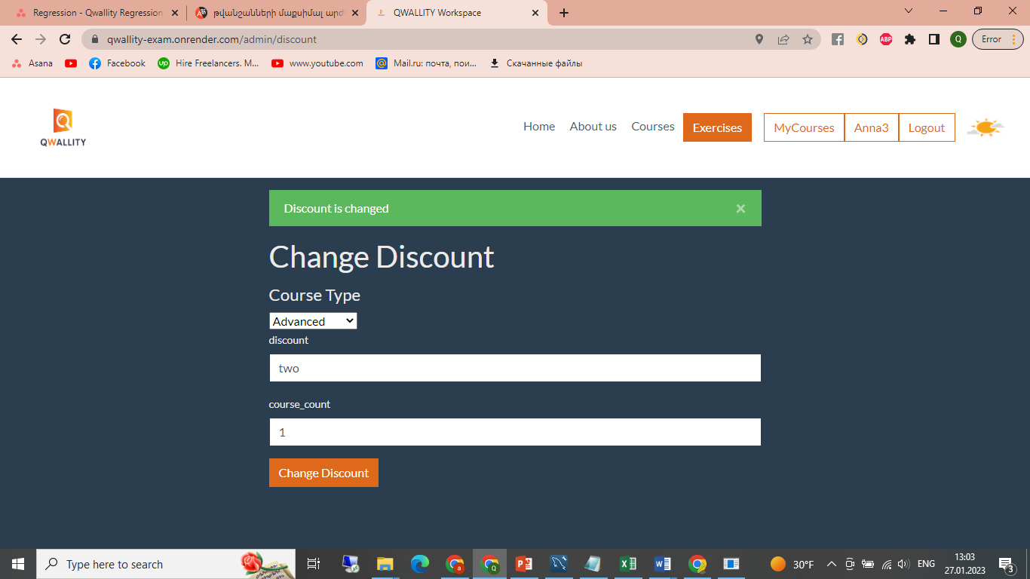

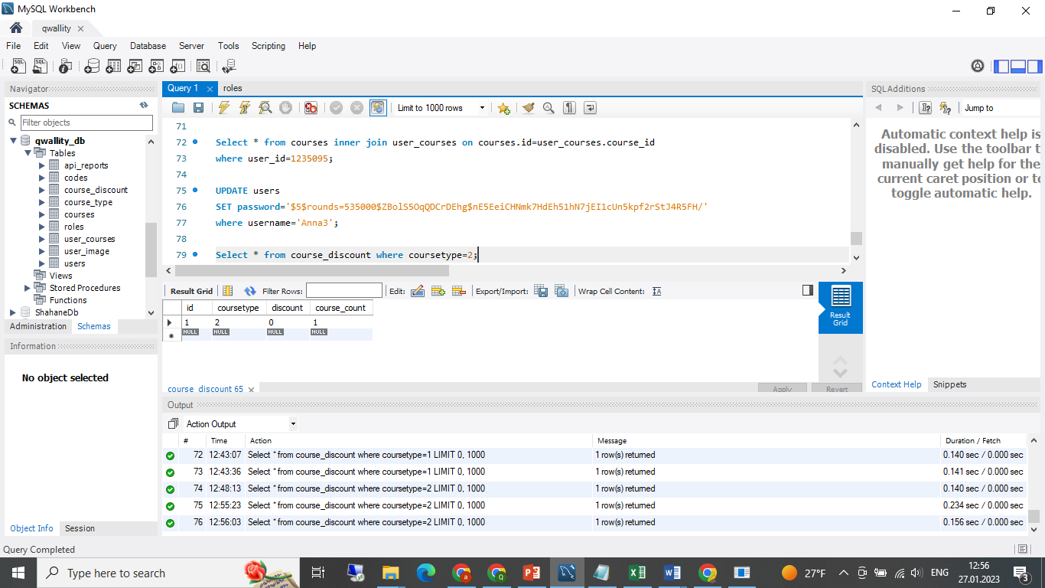

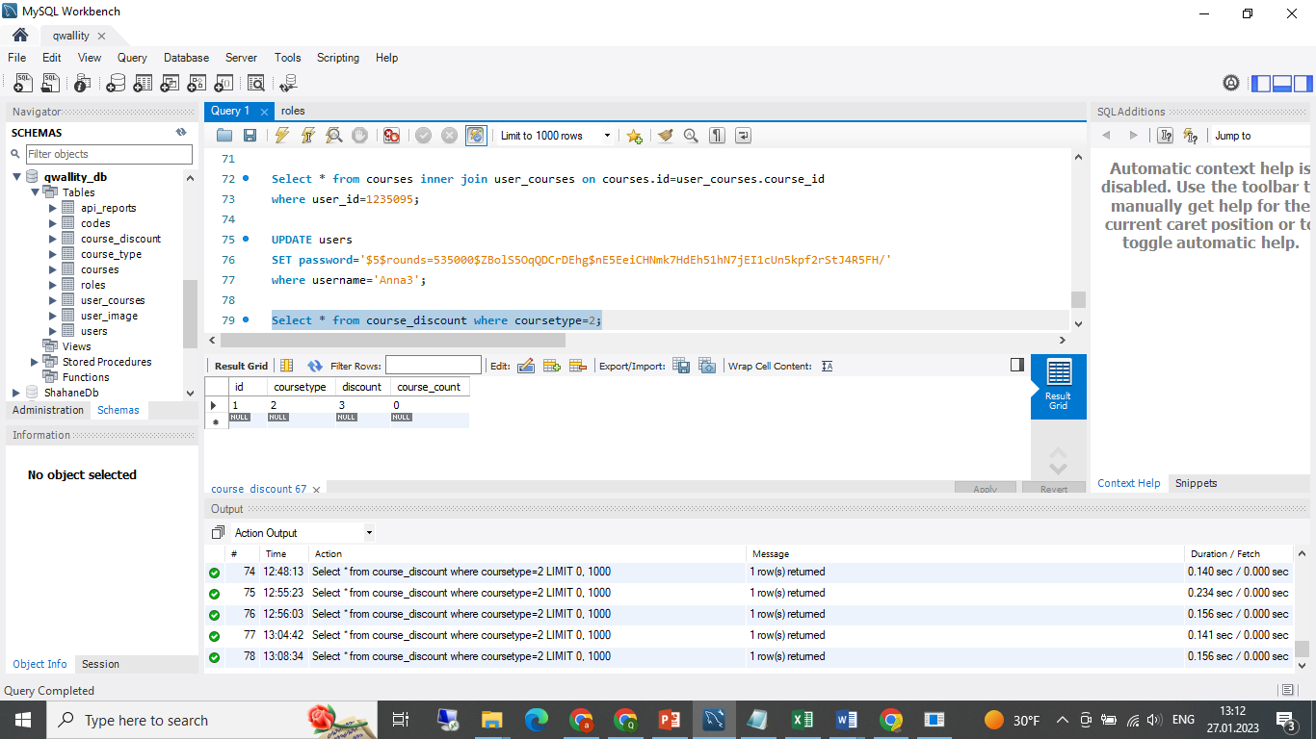

**Bug ID:** 5

**Bug Summary: Fail Update course by given course_id,when done api testing**

**Environment/URL:** <https://qwallity-exam.onrender.com/swagger/#/>

**Operation System:** Windows

**Version**: 1

**Browser:** -

**Submit Date:** 27/01/2023

**Reporter:** Anna Soghomonyan

**Steps to Reproduce:**

1. Open swagger URL

2.Open the postman

3. Create collection

4.Add request

5.Send request

**Expected Result:** Updated successful

**Actual Result:** Internal server error

**Screenshot/video:** Screenshot is attached

**Severity:** High

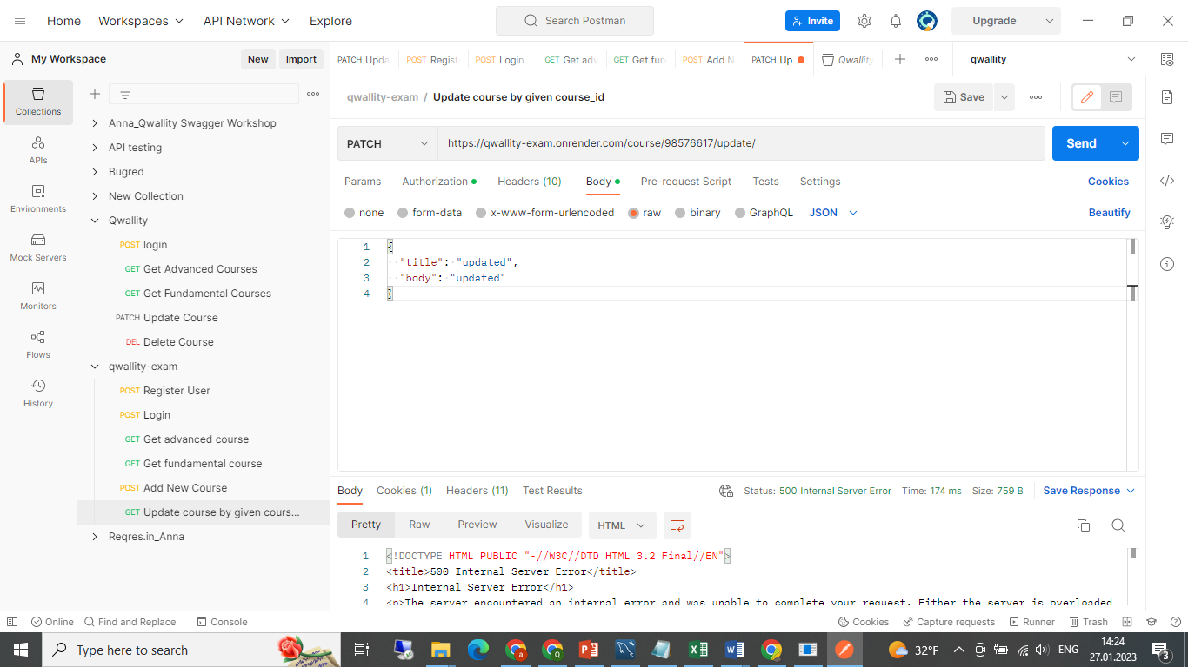

**Bug ID:** 6

**Bug Summary: Fail Delete course by given course_id,when done api testing**

**Environment/URL:** <https://qwallity-exam.onrender.com/swagger/#/>

**Operation System:** Windows

**Version**: 1

**Browser:** -

**Submit Date:** 27/01/2023

**Reporter:** Anna Soghomonyan

**Steps to Reproduce:**

1. Open swagger URL

2.Open the postman

3. Create collection

4.Add request

5.Send request

**Expected Result:** Deleted successful

**Actual Result:** Internal server error

**Screenshot/video:** Screenshot is attached

**Severity:** High

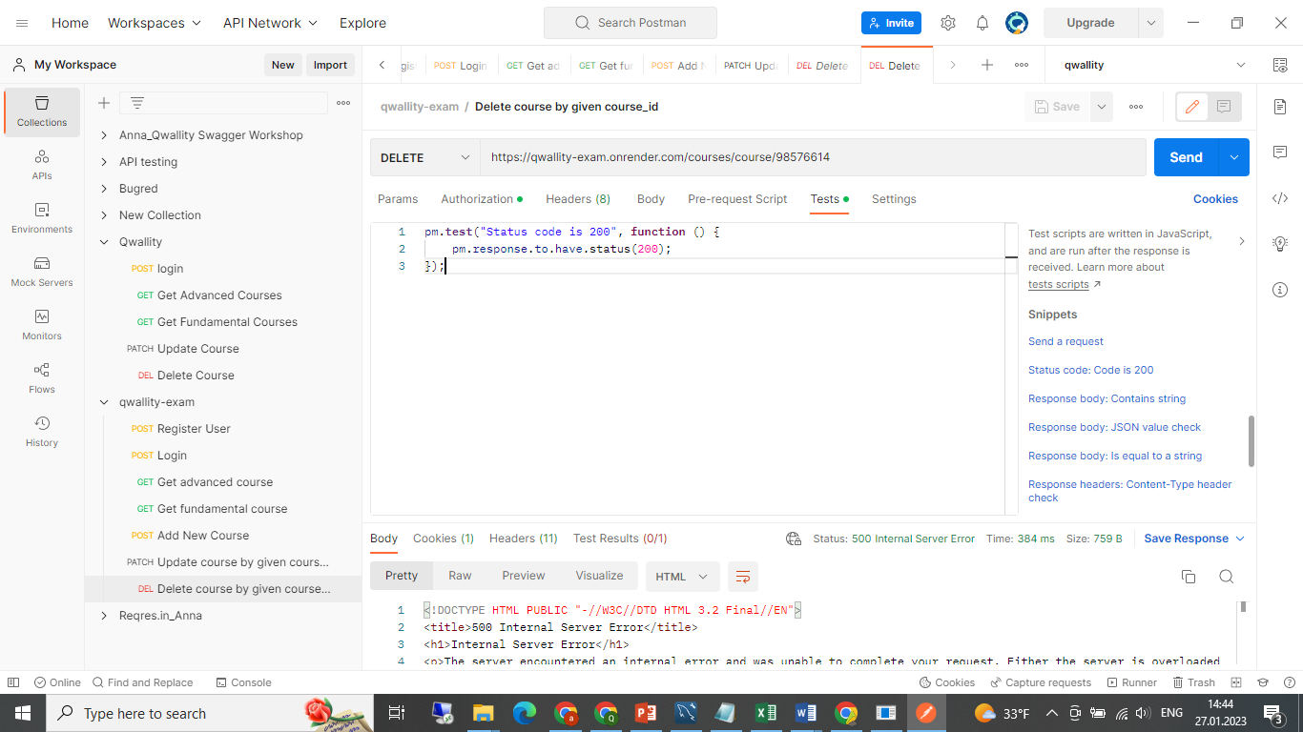

**Bug ID:** 7

**Bug Summary: Get User's Courses call is incorrect**

**Environment/URL:** <https://qwallity-exam.onrender.com/swagger/#/>

**Operation System:** Windows

**Version**: 1

**Browser:** -

**Submit Date:** 27/01/2023

**Reporter:** Anna Soghomonyan

**Steps to Reproduce:**

1. Open swagger URL

2.Open the postman

3. Create collection

4.Add request

5.Send request

**Expected Result:** See all courses

**Actual Result:** Only first course

**Screenshot/video:** Screenshot is attached

**Severity:** High

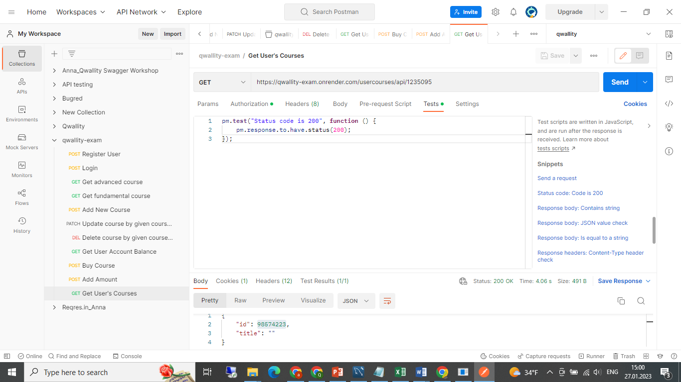

**Bug ID:** 8

**Bug Summary: Set Discount call is incorrect**

**Environment/URL:** <https://qwallity-exam.onrender.com/swagger/#/>

**Operation System:** Windows

**Version**: 1

**Browser:** -

**Submit Date:** 27/01/2023

**Reporter:** Anna Soghomonyan

**Steps to Reproduce:**

1. Open swagger URL

2.Open the postman

3. Create collection

4.Add request

5.Send request

**Expected Result:** Discount was created

**Actual Result:** 10% discount is set for 2 course type, but really don’t update discount

**Screenshot/video:** Screenshot is attached

**Severity:** High

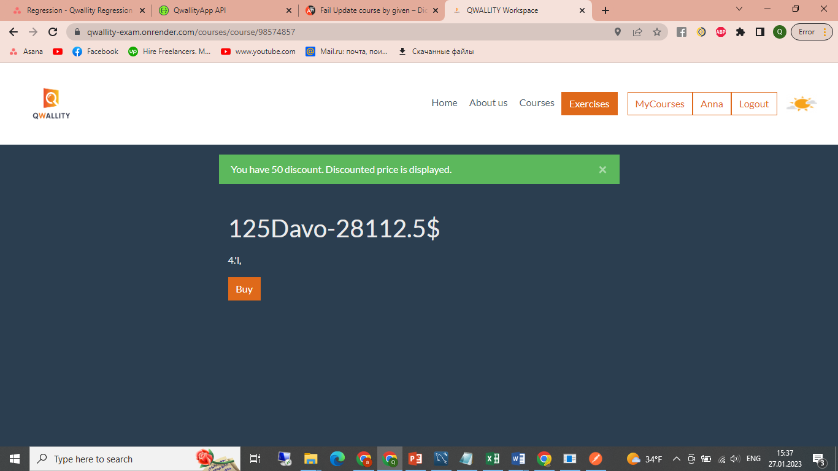

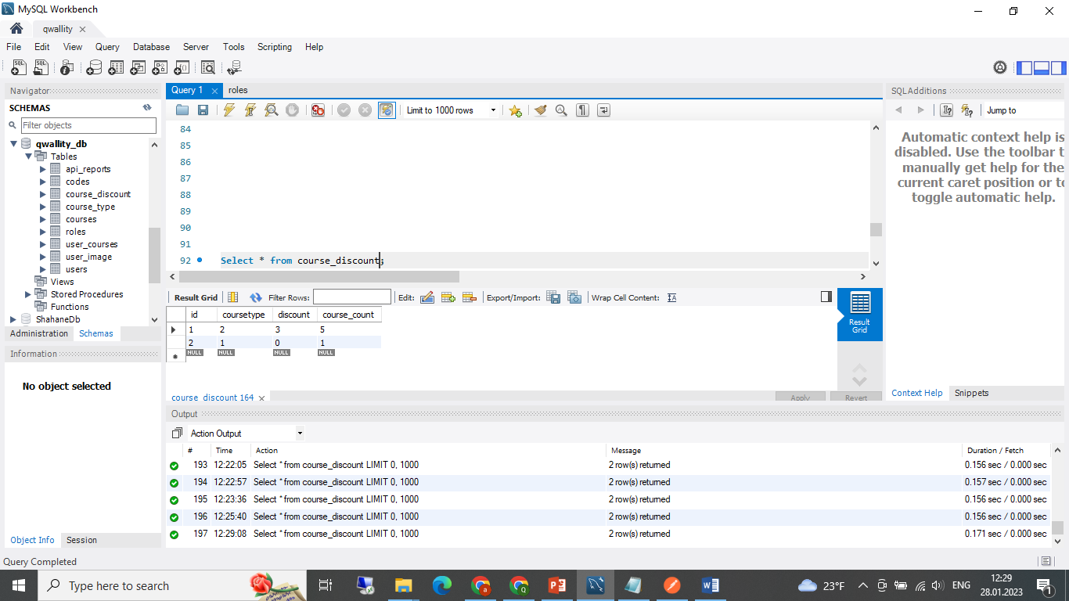

**Bug ID: 9**

**Bug Summary: Wrong price when discount is negative**

**Environment/URL: https://qwallity-exam.onrender.com/**

**Version**: 1

**Browser:** Google Chrome

**Submit Date:** 27/01/2023

**Reporter:** Anna Soghomonyan

**Steps to Reproduce:**

1. Open the URL

2.Login as admin

3. Navigate to profile

4.Click Change Discount button

5.Select Advanced Course Type

6. Write discount -10

7. Write course_count1

8. Click the Change Discount button

**Expected Result:** Discount change failed

**Actual Result:** Discount is changed

**Screenshot/video:** Screenshot is attached

**Notes:** Can write negative value?

**Severity:** High

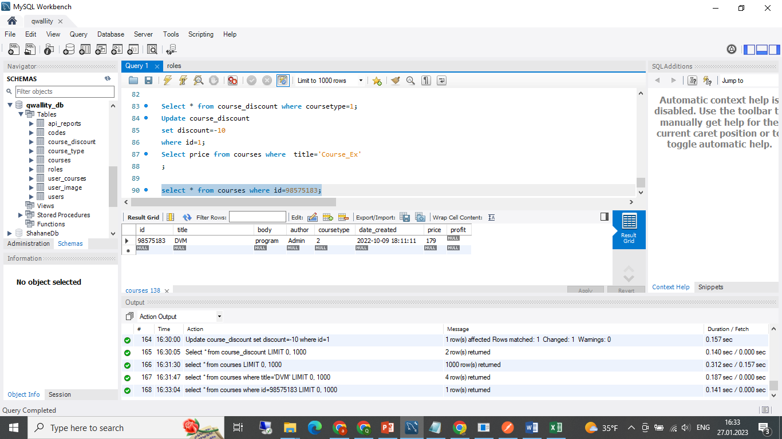

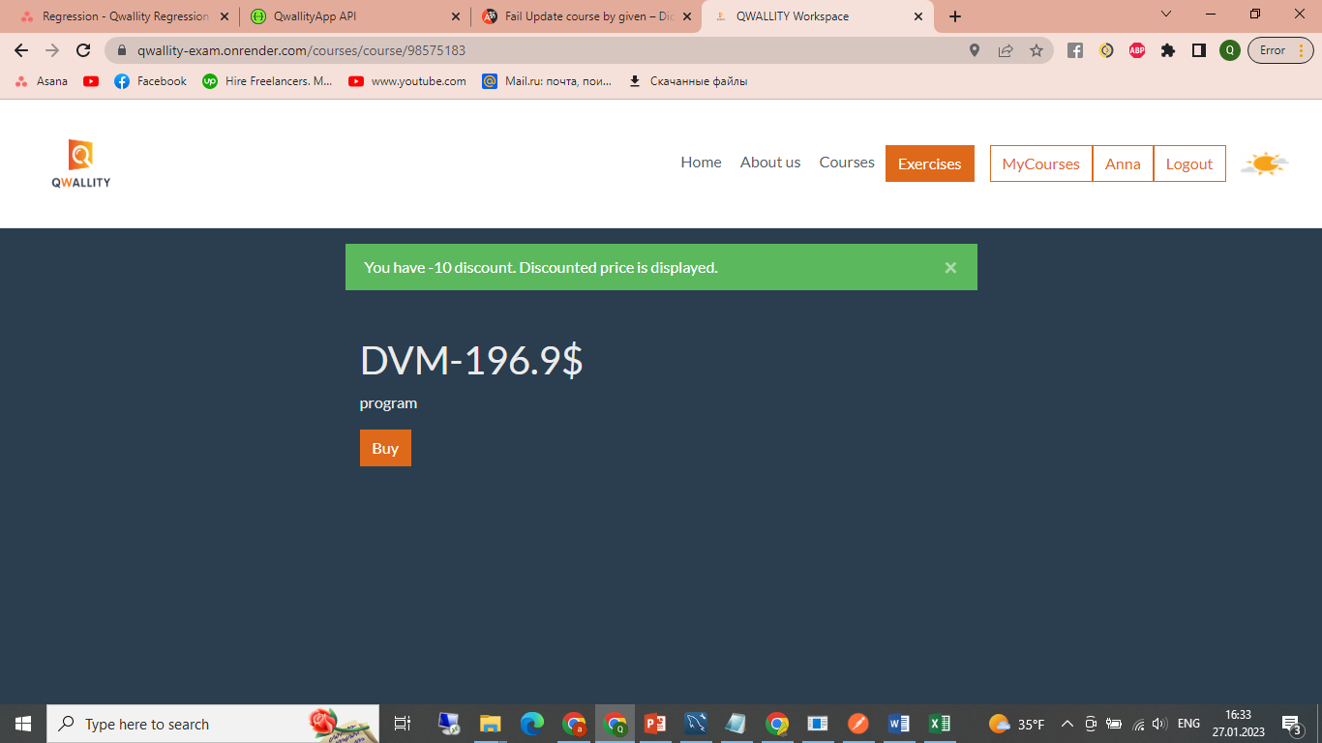 **179 – (-10*179/100)=196.9**

**Bug ID: 10**

**Bug Summary: Wrong buy function’s notification**

**Environment/URL: https://qwallity-exam.onrender.com/**

**Version**: 1

**Browser:** Google Chrome

**Submit Date:** 27/01/2023

**Reporter:** Anna Soghomonyan

**Steps to Reproduce:**

1. Open the URL

2.Login as non admin

3. Navigate to Courses

4.Click Fundamental

5.Select Course Type

6. Select course and then click buy

**Expected Result:** ’You have xxx discount. Discounted price displays.’

**Actual Result:** You have xxx discount. Discounted price is displayed.

**Screenshot/video:** Screenshot is attached

**References:** Requirement

**Severity:** Low

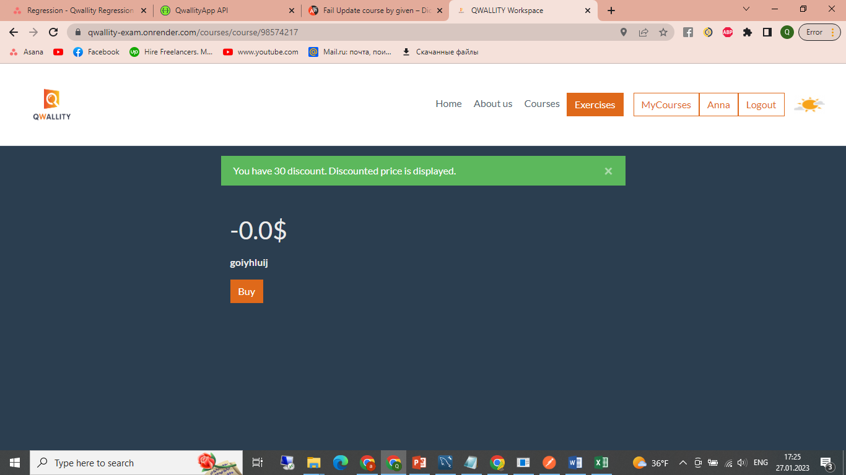

**Bug ID:** 11

**Bug Summary: Non admin user can add course by app call**

**Environment/URL:** <https://qwallity-exam.onrender.com/swagger/#/>

**Operation System:** Windows

**Version**: 1

**Browser:** -

**Submit Date:** 27/01/2023

**Reporter:** Anna Soghomonyan

**Steps to Reproduce:**

1. Open swagger URL

2.Open the postman

3. Create collection

4.Add request

5.Send request

**Expected Result:** New course add failed

**Actual Result:**

author": "an",

   "body": "new",

    "coursetype": "1",

    "id": "98576644",

    "price": 100,

    "title": "new"

**Screenshot/video:** Screenshot is attached

**Severity:** High

